Student workbook - How can we solve problems when moving?
Name:
Class:

Overview of lessons 1 and 2
You will
- Compare different types of throws and identify which ones are easier and harder (lesson 1).
- Predict possible outcomes while using different types of throws and pieces of equipment (lessons 1-2).

Resources

Lessons 1-2
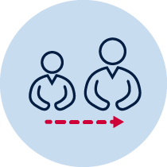
- Help from an adult
- A soft object to throw (for example, soft ball, pair of socks, soft toy, scrunched-up paper)
- An object or landmark to create a target for the object to hit (for example, bucket, a long piece of string laid in a circle, an ‘X’ formed by two pieces of tape/material, a t-shirt laid on the ground, a chair/bench, a wall, a tree)
- Refer to ‘Snakes alive’ game card for suggestions of what this activity could look like. (Sport Australia, 2019. Playing for life) Images are included in this workbook for guidance. Images are included in this student workbook for guidance.

Lesson 1 – Snakes alive
Play the game ’Snakes alive’.
Students:
- Choose a safe playing area where you can throw a number of soft objects.
- Select 5 different soft objects to throw.
- Choose a ‘starting point’ where you will throw the objects from.
- Underarm throw one object at a time, aiming to place each object behind the previous one. This will form a ‘snake’.
  - Underarm throw the first object and mark where it lands. This creates the ‘head’ of the snake.
  - Underarm throw the next object trying to land it before the ‘head’.
  - Repeat the underarm throws with your remaining throwing objects.
- Repeat the game using an overarm throw.
- Repeat the game using a throwing style of your choice.
- Repeat the game 3 times for each throwing style.

Snakes alive
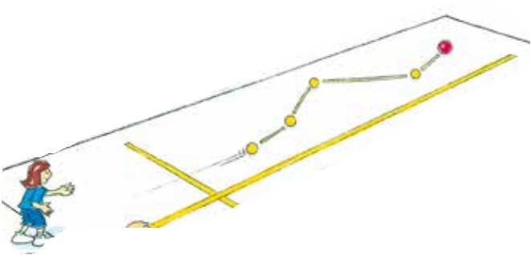  Sport Australia 2019, Playing for life | First throw  Last throw
Discuss the following reflective questions with your teacher or parent/caregiver.
- What type of throw was easier? Why?
- What type of throw was harder? Why?
- Which object was easier to throw? Why?
- Which object was harder to throw? Why?
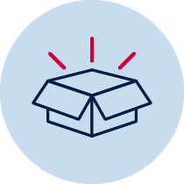 Resources
- 5 soft objects to throw (for example, soft ball, pair of socks, soft toy, scrunched-up paper)

Lesson 2 – Snakes alive challenge
Students:
- Choose a safe playing area where you can throw a number of soft objects.
- Select 5 different soft objects to throw.
- Look at the pictures below for an example of how to throw overarm. Focus on these steps while throwing
- EYE (Eyes focused on target area throughout the throw.)
- SIDE-ON (Stand side-on to target area.)
- STEP FORWARD (Step towards target area with opposite foot to throwing arm.)
- FOLLOW THROUGH (Throwing arm follows through, down and across the body.)
Refer to Fundamental Movement Skills in Action p.194.
- Play ‘Snakes alive’ using a variety of throws depending on distance (one handed underarm, two handed underarm or overarm)
Discuss the following reflective questions with your teacher or parent/caregiver.
- Which object was easier to throw? Why?
- Which object was harder to throw? Why?

Resources
- Soft objects to throw (for example, soft ball, pair of socks, soft toy, scrunched-up paper)

