How can I keep myself and others safe?
PDHPE Stage 1 workbook lesson 1-2
Name:
Class:

Overview – Lesson 1 and 2
You will
- identify ways to keep myself safe (lesson 1)
- Identify situations that are an emergency and who can help you (lesson 2)

Resources

Lesson 1-2
- Help from an adult
- Lead pencil/coloured pencils or crayons
- Access to a device (optional)

Lesson 1 – Safe travel
During this activity you will identify and explore ways to keep yourself safe when travelling to school.
  - Discuss with your teacher or parent/caregiver the following questions.
- Why is important to be safe when travelling in a car?
- Why is it important for you to sit in a booster seat?
- Why should a grown up always check that you are buckled up properly?

  - Complete one of the activities below. If you have access to a device and the internet completed the digital activity.
Digital activity - Complete the epuzzle activity by clicking the link and scrolling down to the ‘EveryBODY’ buckle up activity on the Safety Town website.
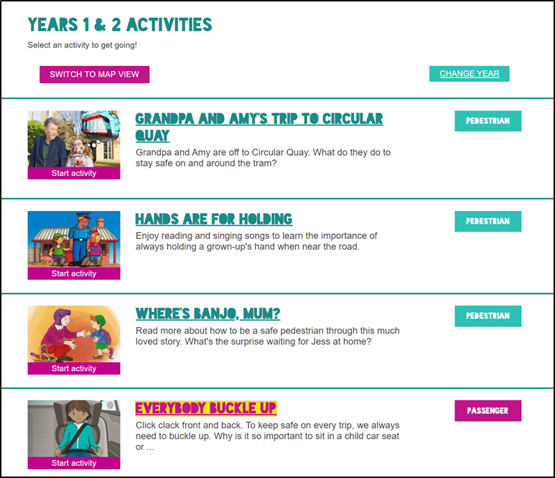
Activity sourced from Safety Town
Non-digital activity - Draw a picture of yourself safely buckled up in the booster seat.
When you are buckled up in the correct car seat for your age and size, you are well protected if involved in a crash. This is because the seatbelt crosses the strong bones in your shoulders and hips and helps keep you protected in the seat. Draw a picture of yourself safely buckled up in the booster seat below. Make sure you draw the seatbelt in the correct position on your body.
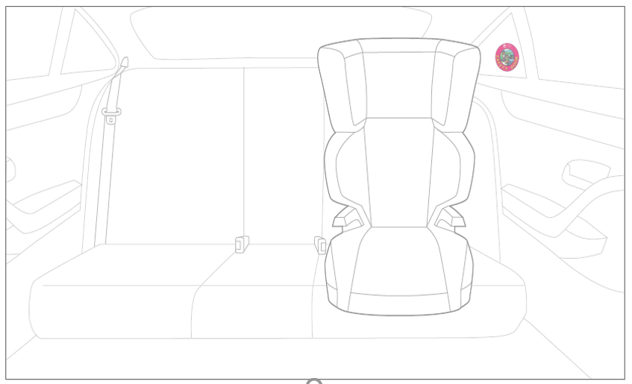
Image from Safety Town
1.3Wearing a seatbelt is just one to stay safe while travelling in a car. Discuss with your teacher or parent/caregiver others ways you can keep yourself and others safe. Think of behaviours and actions as well as equipment.
List ways that you can keep safe when travelling in the car.
____________________________________________________________________________________________________________________________________________________________________________

1.4 You can travel to school in many different ways. You have looked at how to stay safe when travelling in a car. In the table below there are 3 other ways of getting to school.
Draw and label a picture that shows how you would stay safe when travelling to school in each of the 3 ways.
Explain to your teacher or parent/caregiver how you are being safe in your drawings.
Table 1 Safe ways of travelling to school
Ways of travelling to school | How can I stay safe travelling to school
Riding your bike, scooter or skateboard.

Walking to school.
Travelling by bus to school.
1.5 Tick or colour the box that best suits your answer for each of the four success criteria.
Table 2 Self-reflection
Success criteria | I need help to learn to |  |  | I am still learning to |  | I have learned to
1. Identify ways to safe when travelling to school by car

2. Identify ways to stay safe when travelling to school by riding your bike, scooter or skateboard.
3. Identify ways to stay safe when walking to school.

4. Identify ways to stay safe when travelling to school by bus.

Lesson 2 – Emergencies and who can help
During this activity you will identify what is an emergency and who can help you.
2.1 An accident is something that happens that isn’t expected or intended. A bad accident often damages something or injures someone.
An emergency can be caused by;
- A big accident. For example, someone is knocked out (unconscious) at soccer.
- A serious illness. For example, severe asthma attack.
- An allergic reaction. For example, peanuts, bee stings.
Discuss the difference between emergencies (big accidents) and non-emergencies (little accidents).
2.2Draw a tick next to the scenario that is an emergency (big accident). Draw a cross next to the scenario that is not an emergency (little accident).
- a favourite toy breaks _______
- a person is lost in the bush_______
- you graze your knee ________
- someone is knocked out at soccer_______
- a house is on fire _______
- a car crash ______

What are some things you could do in an emergency? Record you responses.
____________________________________________________________________________________________________________________________________________________________________________

2.3 There are people and services you can seek help from in an emergency. Write or draw these people or services around the shape below.
People and services that can support me in an emergency.
2.4 In the table below are pictures of the emergency services (Police, Ambulance and Fire). It is important to be able to identify who they are.
Draw a line to match the emergency services people to their label and vehicle.
Table 1 Emergencies services
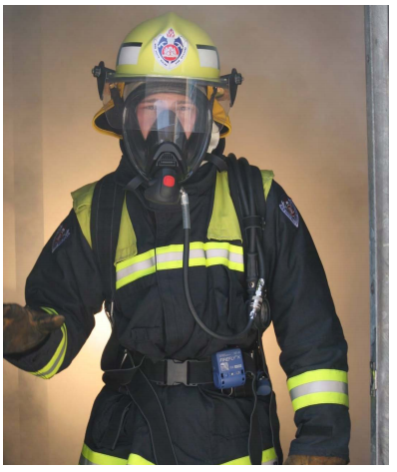 | Ambulance  Officer |  |  | 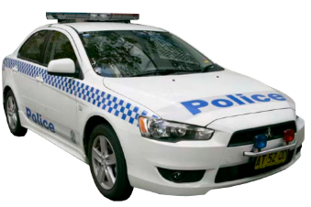
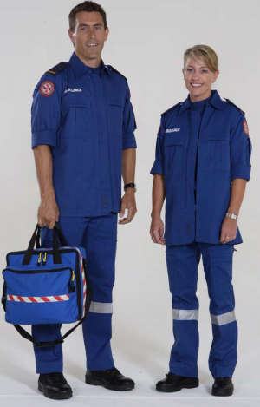 |  | Police Officer |  | 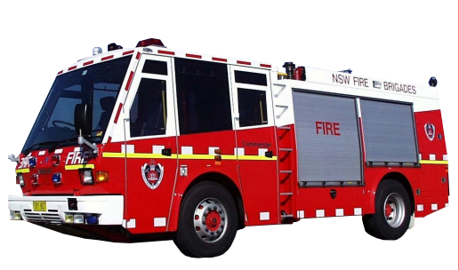
 |  | Fire Fighter |  | 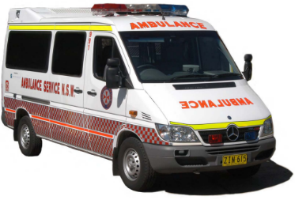
Credit: NSW Ambulance www.ambulance.nsw.gov.au

2.5In an emergency you may need to call the Police, Ambulance or Fire Brigade .Write the phone number that you should call in an emergency _____________
2.6 Read the scenarios and circle which emergency services should be called to help you in each scenario.
Table 2 Emergencies and who can help
Scenario | Circle which emergency service you would call for help
Your mum or dad’s car has been broken into. Who should they call? | Police  Ambulance  Fire Brigade
You are at the park and your friend has fallen off the play equipment and broken their leg. The adults are helping your friend and ask you to call for help. | Police  Ambulance  Fire Brigade
You look out the window and see a fire at the next door neighbour’s house. Your parents have rushed next door to help. They have asked you to call for help? | Police  Ambulance  Fire Brigade

2.7 Tick or colour the box that best suits your answer for each of the four success criteria.
Table 3 Self-reflection
Success criteria | I need help to learn to |  |  | I am still learning to |  | I have learned to
1. Identify the difference between an emergency and a non-emergency.

2. Identify who can help in emergencies.
3. Identify the different emergency services and when they can help.

4. Identify how to contact emergency services.

