How can I use tactics to be successful in games? – Stage 1
PDHPE unit – 10 weeks

Table of Contents
Big idea and key concept 2
Essential question 2
Unit description 2
Contextual statement 2
Propositions in action 3
Skills in focus 4
Self-management skills (S) 4
Interpersonal skills (I) 4
Movement skills (M) 4
Lesson 1 – Tactical use of movement 5
Key inquiry questions and syllabus content 6
Teaching and learning activities 6
Lesson 2 - Tactical use of movement 11
Key inquiry questions and syllabus content 12
Teaching and learning activities 12
Lesson 3 – Tactical use of space and position 17
Key inquiry questions and syllabus content 18
Teaching and learning activities 18
Lesson 4 - How do my decisions impact on others? 24
Key inquiry questions and syllabus content 25
Teaching and learning activities 26
Lesson 5 - Tactical use of time 30
Key inquiry questions and syllabus content 31
Teaching and learning activities 31
Lesson 6 – Tactical use of time 36
Key inquiry questions and syllabus content 36
Teaching and learning activities 37
Lesson 7 – Tactical use of equipment 41
Key inquiry questions and syllabus content 41
Teaching and learning activities 42
Lesson 8 – Tactical use of equipment 46
Key inquiry questions and syllabus content 47
Teaching and learning activities 47
Activity 3 50
Activity 4 50
Lesson 9 – Adjusting tactics 51
Key inquiry questions and syllabus content 52
Teaching and learning activities 52
Lesson 10 – Adjusting tactics 56
Teaching and learning activities 56
Appendix 1 – Self assessment 60
Appendix 2 – Evaluation 61
Appendix 3 – Glossary 63
Appendix 4 – Assessment framework 64
Appendix 5 – Images to support key terms 67
Appendix 6 – Physical literacy cluster markers 82
Movement competencies 82
Tactical movement 82
Motivation and behavioural skills 82
Personal and social attributes 82
Appendix 7 – Attributions 83

Outcomes and other syllabus material in this document are copyright.
PDHPE K-10 Syllabus © NSW Education Standards Authority (NESA) for and on behalf of the Crown in right of the State of New South Wales 2018.

Big idea and key concept
The big idea is the over-arching concept that is being addressed or challenged throughout the unit.
Tactical application of movement concepts influences success in a game. Spatial awareness, relationships with people, objects and space.

Essential question
This question drives both teaching and learning within the unit. Every activity should be working towards answering this question:
How can I use tactics to be successful?

Unit description
Students test and apply various tactics incorporating movement, space, time, equipment and rules to improve their chance of success in territory games. They perform and combine movement skills and sequences to solve games-based problems. For example, they test where and how they move in space to evaluate which strategy improved their chances of success.

Contextual statement
Developing an understanding of tactics will support students to make decisions in more dynamic game-based movement environments. It will also allow students to apply movement skills and sequences in a more effective way.
Improving their ability to select, apply and modify tactical decisions will increase students’ chances of success in games. Achieving regular success contributes positively to student’s lifelong participation in physical activity.

Propositions in action
This describes how specific propositions are embedded throughout the unit of work. The 5 propositions are outlined on pages 24-25 of the PDHPE K-10 syllabus.
Focus on educative purpose
Students develop their knowledge, understanding and skills of how to select and apply appropriate tactics/strategies to be successful in game play. They start to understand how movement, space, time, equipment choice and rule changes impact their tactics.
Take a strengths-based approach
Students will be encouraged to draw upon their own strengths and capabilities to further strengthen their knowledge, skills and understandings while they explore how to effectively select and apply various tactics in game play.
Value movement
Students participate in a wide range of movement experiences to develop skills across all 3 domains and understand how these skills can transfer to different contexts.
Activities are modified to meet the student needs and interests while maintaining relevancy and engagement in tactical game play. Students explore tactics and strategies to learn what can influence their level of success in game play.

Skills in focus
What specific skills are being learned, developed and applied throughout this unit of work? Refer to pages 27-30 of the PDHPE K-10 syllabus.
Self-management skills (S)
- Self-awareness
  - reflective practice.
- Decision making and problem solving
  - finding solutions to problems
  - analysis.
Interpersonal skills (I)
- Communication
  - giving and receiving feedback.
- Collaboration, inclusion and relationship-building
  - recognising and using their own abilities and strengths and those of others.
Movement skills (M)
- Fundamental and specialised movement skills and concepts
  - Non-locomotor skills (body control, body positioning, spatial awareness, direction, force, precision)
  - Locomotor skills (travel, rhythm, body control, coordination, safe landing, agility, direction, object locomotion).
- Tactical and creative movement
  - selecting, applying, transferring, adapting and evaluating movement skills
  - applying movement concepts, rules, strategies and tactics
  - assessing rules, strategies and tactics and how they influence movement and performance when applied across different movement contexts.
- Health and fitness enhancing movement
  - managing risk and promoting safety
  - participating actively.

Lesson 1 – Tactical use of movement
Lesson 1 – Assessment framework
Outcome | Unit learning goals  Students are learning to | Evidence of learning  Students can
PD1-4 performs movement skills in a variety of sequences and situations | - perform different locomotor movements with increasing fluency and accuracy. | - perform locomotor movements effectively within game rules and boundaries (Activity 1, 2, 3).
PD1-5 proposes a range of alternatives to solve movement challenges through participation in a range of activities | - identify appropriate tactics to influence achievement in games and physical activities.  - reflects on previous performances to identify factors that may contribute to future success. | - identify tactics that will improve chances of success by effectively using the locomotor movement/s allowed in a game (Activity 1, 2, 3).  - identify strategies that may contribute to future success in a fast-start game or movement challenge (Activity 2).
PD1-10 describes and practises interpersonal skills to promote inclusion to make themselves and others feel they belong | - work cooperatively with a partner or group when practising new skills. | - interact positively with peers by showing respect to them and their contributions, collaborating to share knowledge and ideas to achieve a common goal (Activity 1, 2, 3).
PD1-11 incorporates elements of space, time, objects, effort and people in creating and performing simple movement sequences | - identify, select and use specific movement sequences, appropriate timing, correct positioning, use of space and tactics specific to equipment in a range of games | - select and use open space effectively to improve chances of success in a game (space within boundaries and/or space away from opponents) (Activity 1, 2, 3).

Key inquiry questions and syllabus content
What are the different ways we can move our body?
- Demonstrate movement skills and movement sequences in a variety of contexts, for example:
  - perform locomotor skills using different body parts to travel in different directions for example, walking, running, galloping, hopping, sliding, skipping, jumping, leaping, rolling.
How can we move and improve our involvement in physical activity?
- Propose a range of alternatives and test their effectiveness when solving movement challenges, for example:
  - identify appropriate tactics to influence achievement in games and physical activities
  - compare different types of movements and identify which ones are easier and harder, for example, locomotor, non-locomotor and object control skills
  - predict possible outcomes of alternative actions and decide which is likely to be the most effective
  - reflect on performance and identify and demonstrate ways to perform a skill more successfully.

Teaching and learning activities
Equipment:
- Markers
- coloured bibs
Vocabulary:
- tactic, movement, tag, freeze, boundaries, decisions, successful.

Activity 1 – Frost and thaw (Fast start)
Students use locomotor movements to move within a defined space with boundaries. One player is designated as ‘Frost’, another is ‘Thaw’.
- Frost tries to tag as many students as possible.
- Once tagged, they must freeze on the spot, holding a balanced position.
- Thaw can melt these students by touching them. Students can then re-join the game.
Discussion
Explore the questions:
- How did you move so you avoided bumping into other students?
- What if the boundaries were smaller? How would this affect the way you move?
- What if there was a lot more frosts than thaws? How would this affect the way you move?
- What if there was a lot more thaws than frosts? How would this affect the way you move?
Teacher notes
A fast start activity provides an opportunity to engage in moderate to vigorous physical activity (huff ‘n’ puff):
- Explore and practise movement skills (fundamental and specialised movement skills and concepts, tactical and creative movement, health and fitness enhancing movement).
- Reinforce an inclusive learning environment that supports positive interactions and ongoing collaboration.
- Become familiar with equipment and space.
- Use age and stage appropriate language and concepts that act as a ‘hook’ to engage students.
Discussion
Explain to students that when participating in games people need to make decisions in order to be successful for example, where to run, how to move, speed of movement, when to pass, who to pass to, how hard to pass. These decisions are called tactics. Tactics are a plan, idea or action to successfully achieve a goal or outcome during a movement activity.
Discuss with students:
- What do you think success looks like when playing a game? Students may suggest it means winning or getting the ‘best result’. This may form part of being successful.
Emphasise with students that success can also mean improving their ability to perform a movement skill, increasing their knowledge, increasing their confidence, learning to communicate more effectively with others, improving their decision-making to solve a movement challenge.
It does not have to mean ‘winning’. When students discuss questions during lessons or reflect at the completion of the lesson, they may consider that they have been successful for various reasons.

Activity 2 – Animal tag
Mark out a playing area of 30 metres x 30 metres. Mark one ‘animal enclosure’ in each corner about 3 metres x 3 metres. Select one student to be the zookeeper and one to be the monkey.
Divide the remaining students into four animal groups. Each group chooses an animal and a movement for the game. For example, kangaroos can two-foot jump, cheetahs can run, horses can gallop, flamingos can hop, turtles can walk slowly, elephants can stomp, crab can side gallop, antelope can skip.
- To begin, the animals are set free to move around using their chosen movement style. The ‘zookeeper’ must try to lock the animals up by tagging them. If tagged, animals must return to their respective enclosure. While the zookeeper is trying to lock up all the animals, the monkey must try to let all caged animals loose by tagging them in their enclosure.
- The game ends when either all the animals are captured, when the monkey has released all the animals or the designated game time has expired.
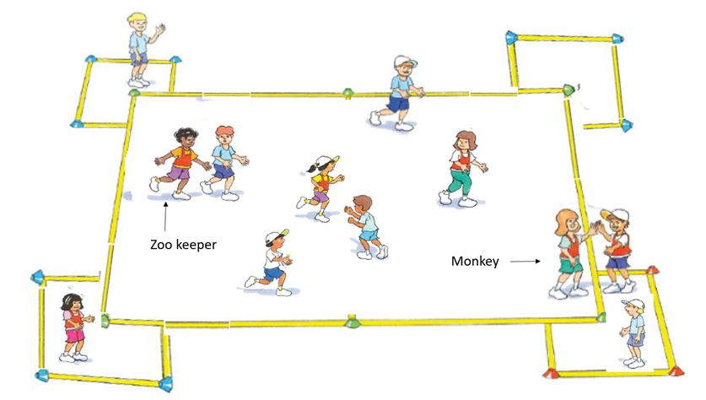
‘Animal tag – Illustration 1’, Adapted from ‘Playing for life’ – Australian Sports Commission, https://www.sportaus.gov.au.
Teacher notes
The size of the playing area can be adjusted to suit the number of students, student ability or difficulty of the game. Animal movements used may be changed or adapted to increase/decrease challenge and/or meet student interest.
Discussion
Explore the questions:
- What if the number of zookeepers increased? Which animal do you think would be most successful/least successful? What makes you say that?
- How did you move your body to avoid the zookeeper? Sample student answers may include, hopped in a zig zag pattern, jumped to the side, dodged, weaved, ducked, changed direction, stopped and started.
- Repeat the game several times allowing students to perform different movement styles to compare how they were able to use them most effectively.

Activity 3 – Animal tag
Pose the questions, ‘If you could pick one animal ‘movement style to be successful in the game which one would it be? What makes you say that?’
Repeat the game. Allow students to select their animal ‘movement style’ based on what they think they can use most effectively.
Variations
- Cages in the middle of the playing area
- Increase the number of monkeys and/or zookeepers
- Students suggest new animals and movement styles
- Change the movement styles of the zookeeper and/or monkey.
Reflection
Students reflect upon the learning in this activity/lesson and consider how it contributes towards answering the essential question: How can I use tactics to be successful in games?

Lesson 2 – Tactical use of movement
Lesson 2 – Assessment framework
Outcome | Unit learning goals  Students are learning to: | Evidence of learning  Students can:
PD1-4 performs movement skills in a variety of sequences and situations | - perform different locomotor movements with increasing fluency and accuracy. | - perform locomotor movements effectively within game rules and boundaries (Activity 1, 2, 3).
PD1-5 proposes a range of alternatives to solve movement challenges through participation in a range of activities | - identify appropriate tactics to influence achievement in games and physical activities.  - reflect on previous performances to identify factors that may contribute to future success. | - identify tactics that will improve chances of success by effectively using the locomotor movement/s allowed in a game (Activity 1, 2, 3).  - identify strategies that may contribute to future success in a fast-start game or movement challenge (Activity 2).
PD1-10 describes and practises interpersonal skills to promote inclusion to make themselves and others feel they belong | - work cooperatively with a partner or group when practising new skills. | - interact positively with peers by showing respect to them and their contributions, collaborating to share knowledge and ideas to achieve a common goal (Activity 1, 2, 3).
PD1-11 incorporates elements of space, time, objects, effort and people in creating and performing simple movement sequences | - identify, select and use specific movement sequences, appropriate timing, correct positioning, use of space and tactics specific to equipment in a range of games | - select and use open space effectively to improve chances of success in a game (space within boundaries and/or space away from opponents) (Activity 1, 2, 3).

Key inquiry questions and syllabus content
What are the different ways we can move our body?
Demonstrate movement skills and movement sequences in a variety of contexts, for example, perform locomotor skills using different body parts to travel in different directions, such as, walking, running, galloping, hopping, sliding, skipping, jumping, leaping, rolling.
How can we move and improve our involvement in physical activity?
Propose a range of alternatives and test their effectiveness when solving movement challenges, for example:
- Identify appropriate tactics to influence achievement in games and physical activities.
- Compare different types of movements and identify which ones are easier and harder, for example, locomotor, non-locomotor and object control skills.
- Predict possible outcomes of alternative actions and decide which is likely to be the most effective.
- Reflect on performance and identify and demonstrate ways to perform a skill more successfully.
- Use strategies to work in group situations when participating in physical activities, for example, work cooperatively with a partner when practising new skills.

Teaching and learning activities
Equipment – markers.
Resources – see Appendix 1.
Vocabulary – tactic, movement, tag, successful.

Activity 1 – Frost and thaw
Refer to instructions in Lesson 1 – Activity 1. During this fast start frequently change the students’ style of movement. For example, in game one ‘Frosts’ run and ‘Thaws’ hop, in game 2 allow students in each role/character to swap the movements used. This will allow students to explore how their knowledge, understanding and skills have developed further.
Discussion
Explore the questions:
- Which movement was the easiest for you to perform and be successful in the game? What makes you say that?
- Which movement was the hardest for you to perform and be successful in the game? What makes you say that?
- Which movement was your favourite? What makes you say that?
Teacher notes
In Activity 1, movement styles can be varied. For example, ‘Frosts’ may perform a two-footed jump while ‘Thaws’ skip. The purpose of this is to allow students to evaluate the most effective way/s to move in a game and understand that adjusting our movement can be a tactic used to improve our chances of success in a game.
Changing boundary size may also assist students in developing an understanding of appropriate selection of movement by increasing or decreasing the amount of space in the playing area.

Activity 2 – Very hungry caterpillar relay
- Mark out a designated playing area about 20 metres x 20 metres.
- Students line-up along one side of the playing area.
- •The whole class runs across the playing area in groups with the number of students as instructed by the teacher. Students will run across the playing area five times.
  - Run one – solo
  - Run two – in pairs holding hands
  - Run three – three students holding hands
  - Run four – four students holding hands
  - Run five – five students holding hands
- Remind students that they must maintain hand-holding on each run. At the end of each run ask students to explain how their movement changed with the addition of more students. Sample student answers may include – with more joining the caterpillar movements needed to be slower; everyone needed to run in the same direction; we needed to take into consideration other students speed and movement.

Teacher notes
The aim is for students to understand that their movement may need to be adapted to allow all students to complete the challenge safely and successfully. This will also allow students to recognise that their own strengths may be different to others student’s and the importance of communication amongst peers to complete the challenge.
It may not be acceptable in some student cultures to hold hands especially of the opposite sex. If this is not culturally appropriate, a variation may include using a ball, cloth, ring or a tag that allows each student to hold one side of the object.
Discussion
Explore – What ways can you effectively adjust your movements to successfully complete the challenge as a group? Explain how they would be successful.

Activity 3 – Very hungry caterpillar tag game
- Mark out a playing area 20 metres x 20 metres (this can be adjusted to suit student ability and difficulty of the game). Select one student to be the tagger (head of the caterpillar).
- All remaining students (are fruit) move about the playing area while the tagger (head or the end of caterpillar) tries to tag them. As each student is tagged they join the back of the caterpillar.
- Only the first and last student of the caterpillar can tag with their free hand. A maximum of 4 students per caterpillar. When a fifth student is tagged the caterpillar splits into two separate caterpillars. If the caterpillars break (drop hands) they cannot tag students until they have re-joined.
- The game continues until all students are tagged.
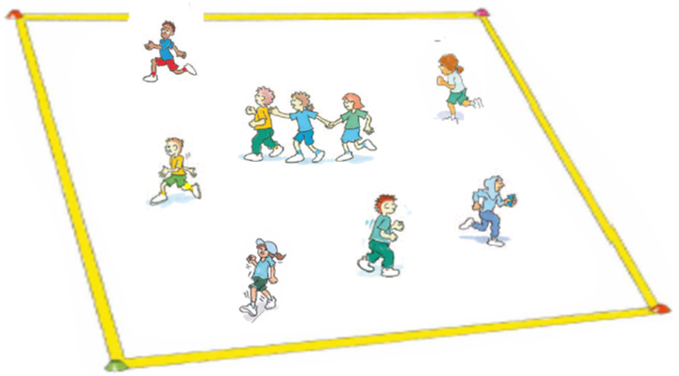
‘The hungry caterpillar game – Illustration 1’, Adapted from ‘Playing for life’ – Australian Sports Commission, https://www.sportaus.gov.au.
Teacher notes
Remind students about maintaining hand contact while moving in a safe manner.
Discussion
Explore the questions:
- What if you are allowed longer caterpillars?
  - How would this change the caterpillars’ movements?
  - How would this change the fruit’s movements?
- What if the playing area was larger? How would this affect the movement of the caterpillar and the fruit?
- What if the playing area was much smaller? How would this affect the movement of the caterpillar and the fruit?

Variations
Change the movement styles of the caterpillars and the fruit. For example, caterpillars walk, fruit hop.

Reflection
Students reflect upon the learning in this activity/lesson and consider how it contributes towards answering the essential question How can I use tactics to be successful in games? by completing the self–assessment in Appendix 1. Alternatively, the self–assessment in ‘Appendix 1’ may be adapted using one or more of the assessment tools available via the Digital Learning Selector.

Lesson 3 – Tactical use of space and position
Lesson 3 – Assessment framework
Outcomes | Unit learning goals  Students are learning to: | Evidence of learning  Students can:
PD1-4 performs movement skills in a variety of sequences and situations | - perform different locomotor movements with increasing fluency and accuracy. | - perform locomotor movements effectively within game rules and boundaries (Activity 1).
PD1-5 proposes a range of alternatives to solve movement challenges through participation in a range of activities | - identify appropriate tactics to influence achievement in games and physical activities.  - reflect on previous performances to identify factors that may contribute to future success. | - identify tactics that will improve chances of success by effectively using the locomotor movement/s allowed in a game (Activity 3).  - identify strategies that may contribute to future success in a fast-start game or movement challenge (Activity 2).
PD1-10 describes and practises interpersonal skills to promote inclusion to make themselves and others feel they belong | - work cooperatively with a partner or group when practising new skills. | - interact positively with peers by showing respect to them and their contributions, collaborating to share knowledge and ideas to achieve a common goal (Activity 1, 3).
PD1-11 incorporates elements of space, time, objects, effort and people in creating and performing simple movement sequences | - identify, select and use specific movement sequences, appropriate timing, correct positioning, use of space and tactics specific to equipment in a range of games | - select and use open space effectively to improve chances of success in a game (space within boundaries and/or space away from opponents) (Activity 2, 3).

Key inquiry questions and syllabus content
What are the different ways we can move our body?
Demonstrate movement skills and movement sequences in a variety of contexts for example:
- perform locomotor skills using different body parts to travel in different directions, for example, walking, running, galloping, hopping, sliding, skipping, jumping, leaping, rolling
- use a variety of equipment to perform object control skills to send, control and receive objects, for example, bouncing, rolling, throwing, catching, kicking, striking, dribbling, rolling.
How can we move and improve our involvement in physical activity?
Propose a range of alternatives and test their effectiveness when solving movement challenges for example:
- identify appropriate tactics to influence achievement in games and physical activities
- compare different types of movements and identify which ones are easier and harder, such as locomotor, non-locomotor and object control skills
- predict possible outcomes of alternative actions and decide which is likely to be the most effective
- reflect on performance and identify and demonstrate ways to perform a skill more successfully.
- use strategies to work in group situations when participating in physical activities for example,
- work cooperatively with a partner when practising new skills.

Teaching and learning activities
Equipment – markers, 1 ball per pair
Vocabulary – tactic, success, space, movement, chase, tap, opposite, goal

Activity 1 – Odds and evens (Fast start)
- Set out a playing area approximately 20 metres x 20 metres.
- Divide class into 2 teams called ‘Odds’ and ‘Evens’.
- Teams spread out into their own half of the playing area. One student from each team stands at the centre spot.
- These two students play ‘Odds and evens’ by tapping one closed fist 3 times on the open palm of their other hand, on the third tap, students point either one or two fingers towards their partner.
- The teacher quickly adds how many fingers were pointed by all students and calls out to the class if the total number of fingers shown is either odd or even. For example, all students pointed fingers adds up to 27. This means the ‘Odds’ team wins.
- Students from the winning team then chase their partner from other team, who turn and run to the line behind them. 1 point is scored for a tag or 1 point for crossing the line without being tagged.
- Count points scored for each team and repeat the game.
Variations
- Increase/decrease the size of the playing area.
- Change the locomotor movement used by each team, for example, run, jump, hop, skip, gallop, animal walk.
Discussion
Explore the questions,
- How did you stand when playing the game against your partner?
- Did your positioning change after each round? What makes you say that?
Explore the idea that using space within the playing area can be an effective tactic to achieve success in games.

Activity 2- Caterpillar run
- Form groups of 6 students with one ball per group.
- Students stand in 2 parallel lines approximately 1.5 metres apart. Students stand opposite one person from the other line.
- One line of students is called the blue group and the other line of students is called the red group.
- Students standing on the same coloured parallel line should be positioned so they can touch fingers with the person next to them (with arms stretched out).
- The ball starts at one end of the blue line. Student 1 passes the ball to student 2 who is opposite them on the red line.
- After passing the ball the student 1 runs to the end of the blue line. Student 2, now holding the ball, passes it diagonally to the next player on the blue line, then runs to the end of the red line.
- The zig-zag passing pattern continues until the group has made it to the end of the designated lines (teacher can determine the length of the blue and red parallel lines based on student skill levels and available space). Groups can race against each other or the clock.
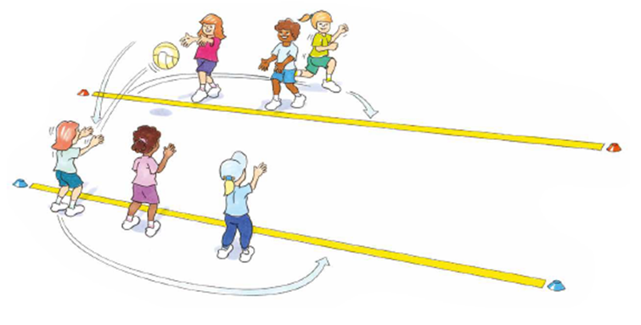
‘Caterpillar run – Illustration 1’, Adapted from ‘Playing for life’ – Australian Sports Commission, https://www.sportaus.gov.au.
Teacher notes
The aim of this activity is for students to understand that they need to place themselves in a position that allows them to catch the ball comfortably. This includes the appropriate distance and enough space away from other students. It also allows for students to begin to understand that timing of a pass is important.
Discussion
Explore the questions,
- What if you stood too close to the person on the opposite line? Sample student answers may include, I would be too close to receive a pass safely and successfully which means I may drop the ball.
- What if you stood too far away from the person on the opposite line? Sample student answers may include, I may not receive the pass before it bounces as the thrower may not be able to reach me with their throw.
Variations
- Increase/decrease the distance between students
- Vary the size and/or shape of the ball
- Increase the number of team member and the number of ball.

Activity – Roll a goal
In pairs, students aim to score as many goals as possible by rolling the ball through their partner’s feet. After each roll (successful or unsuccessful) both students must move to another space within the playing area and swap roles. The focus is to move to space that allows a direct line between the roller and the goal (partner’s feet).
If there is another student between the roller and the goal, then it will be very difficult or impossible to score a goal. Students should also be looking to transfer the understanding from the previous activity where they identify appropriate distances between the thrower and catcher as well as a suitable amount of space required to throw and catch comfortably.
Discussion
Explore the questions:
- Where did you move so you could place the goal (feet) in a position so your partner could roll-a-goal? Why? Sample student answers may include, away from other students so there was a clear line to my partner.
- What were the challenges in finding a suitable space to place your goal (feet)? Sample student answers may include, other people kept getting in the way. How did you overcome this? Was it effective? Sample student answers may include, we looked for space away from other people, we moved into space where we could pass the ball without it hitting other people.
- How did you communicate with your partner to be successful in this activity? Sample student answers may include, we pointed to areas we could move to, we called out to each other so we knew where to go.

Teacher notes
The aim of this activity is for students to understand that where they move in the playing area in relation to other students will greatly influence whether they will be able to pass and receive the ball successfully with their partner. This builds upon the previous activity where students explore the appropriate distance to throw and catch directly to another person as well as having enough space to perform the actions comfortably.
Variations
- Increase/decrease the size of the playing area
- Change the type of roll used. For example, 1-hand or 2-hand, facing forwards, backwards or sideways
- Allow pairs to throw and catch
- Increase/decrease the size of the goal created with the feet
- Change the size and/or shape of the ball
Discussion
Explain that in many games such as soccer and netball, to be successful students need to position themselves in space to make it easier for team members to pass the ball to them.

Reflection
Students reflect upon the learning in this activity/lesson and consider how it contributes towards answering the essential question ‘How can I use tactics to be successful in games?

Lesson 4- How do my decisions impact on others?
Lesson 4 – Assessment framework
Outcome | Unit learning goals  Students are learning to: | Evidence of learning  Students can:
PD1-4 performs movement skills in a variety of sequences and situations | - perform different locomotor movements with increasing fluency and accuracy. | - perform locomotor movements effectively within game rules and boundaries (Activity 1).
PD1-5 proposes a range of alternatives to solve movement challenges through participation in a range of activities | - identify appropriate tactics to influence achievement in games and physical activities.  - reflect on previous performances to identify factors that may contribute to future success. | - identify tactics that will improve chances of success by effectively using the locomotor movement/s allowed in a game (Activity 2, 3).  - identify strategies that may contribute to future success in a fast-start game or movement challenge (Activity 2, 3).
PD1-10 describes and practises interpersonal skills to promote inclusion to make themselves and others feel they belong | - work cooperatively with a partner or group when practising new skills. | - interact positively with peers by showing respect to them and their contributions, collaborating to share knowledge and ideas to achieve a common goal (Activity 1, 2, 3).
PD1-11 incorporates elements of space, time, objects, effort and people in creating and performing simple movement sequences | - identify, select and use specific movement sequences, appropriate timing, correct positioning, use of space and tactics specific to equipment in a range of games | - select and use open space effectively to improve chances of success in a game (space within boundaries and/or space away from opponents) (Activity 2, 3).  - select and demonstrate an appropriate time to pass a ball to a team member to improve chances of success in a game (Activity 2, 3).

Key inquiry questions and syllabus content
What are the different ways we can move our body?
Demonstrate movement skills and movement sequences in a variety of contexts for example:
- perform locomotor skills using different body parts to travel in different directions for example, walking, running, galloping, hopping, sliding, skipping, jumping, leaping, rolling
- use a variety of equipment to perform object control skills to send, control and receive objects for example, bouncing, rolling, throwing, catching, kicking, striking, dribbling, rolling.
How can we move and improve our involvement in physical activity?
Propose a range of alternatives and test their effectiveness when solving movement challenges for example:
- Identify appropriate tactics to influence achievement in games and physical activities
- Compare different types of movements and identify which ones are easier and harder, for example, locomotor, non-locomotor and object control skills
- Predict possible outcomes of alternative actions and decide which is likely to be the most effective
- Reflect on performance and identify and demonstrate ways to perform a skill more successfully.
Use strategies to work in group situations when participating in physical activities for example work cooperatively with a partner when practising new skills.

Teaching and learning activities
Equipment – markers, balls appropriate for students to pass each other and catch.
Resources – see appendix 1
Vocabulary – tactic, space, movement, attack, defend

Activity 1 – Odds and evens (Fast start)
Refer to instructions in Lesson 3 – Activity 1. Different sample questions are provided below to explore how knowledge, understanding and skills have developed further.
Teacher notes
Reflect on the questions and answers from the fast start in lesson 3 prior to playing. This is activity aims to focus students on the importance of space and position.
Variations
- Increase/decrease the size of the playing area
- Increase the number ‘frosts’ and ‘thaws’
- Students use different locomotor movements. For example, jump, hop, skip, gallop, animal walk.

Activity 2 – Run the gauntlet (skill development)
In pairs students,
- Stand side-on 1-2 metres apart and pass a ball ten times.
- Stand side-on 1-2 metres apart and pass a ball while walking forward.
- Stand side-on 1-2 metres apart and pass a ball while running.
Repeat the above sequence with greater distance between students (this should be determined by student’s skill level).
Teacher notes
The distance between students should vary to cater for individual student skill level.

Discussion
Explore the questions,
- Which movement was easier when passing the ball?
- What if you played a game where you are not allowed to drop the ball, which movement would you choose? What makes you say that?

Activity 3 – Run the gauntlet (game)
- Divide class into groups of 6.
- Set up a playing area approximately 10 metres across and 30 metres long.
- Using markers, create 4 ‘lines’ going across playing area, evenly split.
- One defender stands on each line. Defenders are only allowed to move along their line, not forwards or backwards.
- A pair of students (attackers) stand at the start of the playing area with a ball (or bean bag).
- The attacking pair move (walk or run) to the first line, with the aim to cross the line with the ball without being tagged. The defender tries to tag the person with the ball.
- The attacker may carry or pass the ball to their partner if they think they are going to be tagged. Once the attacker has carried the ball across the line the defender can no longer tag one of the pair.
- The attackers score 1 point if they pass a defender without being tagged.
- The defender scores 1 point if they tagged the attacker with the ball. If tagged, the attacking pair continue trying to pass each defender until they have reached the end line.
- Once they reach the end the attackers swap with 2 defenders, until all 3 pairs have had a turn as attackers.
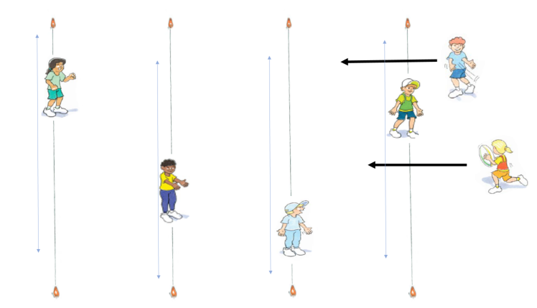
‘Run the gauntlet– Illustration 1’, Adapted from ‘Playing for life’ – Australian Sports Commission, https://www.sportaus.gov.au.
Variations
- If the ball is dropped attackers start again
- Increase/decrease the width of the playing area
- Increase the number of defenders on a line
- Increase the number of attackers
- Use a bean bag or different size/shape ball
- Provide a time limit for the attackers to complete the challenge
- Change the locomotor movement – for example, attackers must hop, defenders must side gallop.
Discussion
Explore the questions
- How did the attackers use the space to be successful? Sample student answers may include, we spread out so the defender had a long way to move to tag us.
- What were the challenges of being a defender? Sample student answers may include, it was difficult to cover all the space quickly enough.
- What if you had 2 defenders? How would this change the attackers’ tactics? Sample student answers may include, they may choose to change their movements such as dodge and side-step. They may have to pass more than once.

Reflection
Students reflect upon the learning in this activity/lesson and consider how it contributes towards answering the essential question ‘How can I use tactics to be successful in games?’ by completing the self–assessment on ‘Appendix 1’. Alternatively, the self–assessment in ‘Appendix 1’ may be adapted using one or more of the assessment tools available via the Digital Learning Selector.

Lesson 5- Tactical use of time
Lesson 5 – Assessment framework
Outcomes | Unit learning goals  Students are learning to: | Evidence of learning  Students can:
PD1-5 proposes a range of alternatives to solve movement challenges through participation in a range of activities | - identify appropriate tactics to influence achievement in games and physical activities.  - reflect on previous performances to identify factors that may contribute to future success. | - identify tactics that will improve chances of success by effectively using the locomotor movement/s allowed in a game (Activity 2, 3, 4).  - identify strategies that may contribute to future success in a fast-start game or movement challenge (Activity 2).
PD1-10 describes and practises interpersonal skills to promote inclusion to make themselves and others feel they belong | - work cooperatively with a partner or group when practising new skills. | - interact positively with peers by showing respect to them and their contributions, collaborating to share knowledge and ideas to achieve a common goal (Activity 3, 4).
PD1-11 incorporates elements of space, time, objects, effort and people in creating and performing simple movement sequences | - identify, select and use specific movement sequences, appropriate timing, correct positioning, use of space and tactics specific to equipment in a range of games | - select and demonstrate an appropriate time to pass a ball to a team member to improve chances of success in a game (Activity 2, 3, 4).

Key inquiry questions and syllabus content
What are the different ways we can move our body?
Demonstrate movement skills and movement sequences in a variety of contexts, for example:
- perform locomotor skills using different body parts to travel in different directions for example, walking, running, galloping, hopping, sliding, skipping, jumping, leaping, rolling
- use a variety of equipment to perform object control skills to send, control and receive objects for example, bouncing, rolling, throwing, catching, kicking, striking, dribbling, rolling.
How can we move and improve our involvement in physical activity?
Propose a range of alternatives and test their effectiveness when solving movement challenges for example,
- identify appropriate tactics to influence achievement in games and physical activities
- compare different types of movements and identify which ones are easier and harder, for example, locomotor, non-locomotor and object control skills
- predict possible outcomes of alternative actions and decide which is likely to be the most effective
- reflect on performance and identify and demonstrate ways to perform a skill more successfully.
Use strategies to work in group situations when participating in physical activities for example,
- work cooperatively with a partner when practising new skills.

Teaching and learning activities
Equipment – markers,3 long skipping ropes per group, 6 hoops per group (optional), 1 ball per student which can be bounced
Vocabulary – tactic, movement, time, tag, bounce, control, avoid

Activity 1 – Bounce it (Fast start)
Select and mark a playing area large enough for the students to move comfortably around in without obstructing each other.
All students move around bouncing a ball. At any time, students try to touch someone else’s ball without losing control of their own. For each touch students score 1 point.
Teacher notes
The focus of this activity is for students to identify the best time to try and tap an opponent's ball and when they should concentrate on maintaining control of their own. It also allows students to apply and adapt tactics previously covered such as:
- The tactical use of space and position
  - where they bounce the ball in the game
  - where to position their body in relation to the ball
  - moving into space to avoid being tapped
- The tactical use of movement
  - Type and speed of movement while they are bouncing (running rather than walking).
Variations
- Change the size and/or shape of balls
- Change the locomotor movements used (for example, run and bounce the ball, walk and bounce the ball, skip and bounce the ball)
- Increase/decrease the size of the playing area
Discussion
Explore the questions,
- How did you avoid someone touching your ball? Sample student answers may include, I positioned the ball on the side of my body away from others, I moved into space away from others.
- How could you refine your tactics to be more successful? Sample student answers may include, I could change my movement to include moving backwards and sideways.
Explore with students how the timing of their movement can affect success. Sample student answers may include, running into a space to receive a pass can influence whether the pass is successful or not.

Activity 2 – Leaping lava
Divide the class into groups of 8 students with 3 long skipping ropes.
In each group:
- Three pairs of students (6 in total). Each pair hold a skipping rope, wriggling it from side to side on the ground replicating flowing lava. Spread pairs out with approximately 5 metres between each pair.
- The remaining 2 students run from one end to the other across the ropes. Each student needs to time their jump over each rope so they do not touch it. If the rope is touched, they start again. Ropes are not to be lifted off the ground so as to avoid tripping the other students.
- Once students have completed one run through they swap roles. Ensure all students have the opportunity to jump the lava.
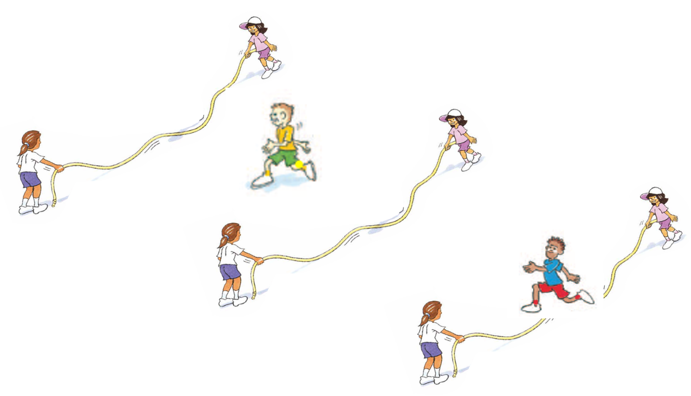
‘Leaping lava– Illustration 1’, Adapted from ‘Playing for life’ – Australian Sports Commission, https://www.sportaus.gov.au.

Discussion
Explore the questions:
- What did you do to ensure you missed the rope? Sample student answers may include, I did not jump immediately I watched it first, I timed my jump accurately to miss the rope.
- What if you had to do this in pairs? Explain what your tactics would be. Sample student answers may include, students would communicate when to go, hold hands and swing arms to stay in time with each other, coordinate movements in order to jump at the same time.
Variations
- Change the swing of the rope.
- Students run under the drawbridge (rope lifted and lowered slowly by students – this speed can also vary).
- Hoops at either side of the rope as a target for players to jump in to.
- Races between groups or apply time a limit to complete the challenge.

Activity 3 – Partner leaping lava
Groups play leaping lava by running and jumping with their partner. Pairs continue to swap roles after each run.

Activity 4 – Group leaping lava
Students play leaping lava again, running and jumping in groups of 4 (two pairs join to jump at the same time). The game continues until all students have had a turn at jumping in a group.
Teacher notes
To create competition, points may be awarded for a successful run.

Reflection
Students reflect upon the learning in this activity/lesson and consider how it contributes towards answering the essential question ‘How can I use tactics to be successful in games?

Lesson 6 – Tactical use of time
Lesson 6 – Assessment framework
Outcomes | Unit learning goals  Students are learning to: | Evidence of learning  Students can:
PD1-5 proposes a range of alternatives to solve movement challenges through participation in a range of activities | - identify appropriate tactics to influence achievement in games and physical activities.  - reflect on previous performances to identify factors that may contribute to future success. | - identify the use of space and time to effectively pass a ball, improving the chance of success in a game (Activity 2,3).  - identify strategies that may contribute to future success in a fast-start game or movement challenge (Activity 1, 3).
PD1-11 incorporates elements of space, time, objects, effort and people in creating and performing simple movement sequences | - identify, select and use specific movement sequences, appropriate timing, correct positioning, use of space and tactics specific to equipment in a range of games | - select and use an appropriate time to perform a specific locomotor movement that improves chances of success in a game, for example jumping (Activity 2, 3, 4).

Key inquiry questions and syllabus content
What are the different ways we can move our body?
Demonstrate movement skills and movement sequences in a variety of contexts for example:
- perform locomotor skills using different body parts to travel in different directions for example, walking, running, galloping, hopping, sliding, skipping, jumping, leaping, rolling
- use a variety of equipment to perform object control skills to send, control and receive objects for example, bouncing, rolling, throwing, catching, kicking, striking, dribbling, rolling.
How can we move and improve our involvement in physical activity?
Propose a range of alternatives and test their effectiveness when solving movement challenges for example,
- identify appropriate tactics to influence achievement in games and physical activities
- compare different types of movements and identify which ones are easier and harder, for example, locomotor, non-locomotor and object control skills
- predict possible outcomes of alternative actions and decide which is likely to be the most effective
- reflect on performance and identify and demonstrate ways to perform a skill more successfully.
Use strategies to work in group situations when participating in physical activities for example, work cooperatively with a partner when practising new skills.

Teaching and learning activities
Equipment – markers, 1 ball per student (able to be bounced)
Resource – Appendix 1
Vocabulary – tactic, movement, time, pass, success, control, pass, kick, throw, attacker, defender, possession

Activity 1- Bounce it (Fast start)
Refer to instructions in Lesson 5 - Activity 1. Different sample questions are provided below to explore how knowledge, understanding and skills have developed further.
Discussion
Explore the questions,
- If your ball was touched a lot, how did you change your tactics?
- If you were unable to touch someone else’s ball, what could you change?
- What allowed you to be successful in maintaining control of your ball?
Ask students what tactics they have used in previous lessons. For example, changing the way they move (running slowly, dodging) and/or use space (running into an area that is away from other students).
Explain that timing is an effective tactic to achieve success in games. Timing when to pass, kick or throw an object to your team mate, timing when to move, and changing your tactics depending on how much time you have.

Activity 2 – Keep the ball (skill development)
Divide students into pairs. Each pair has two markers 3 metres apart.
- Player A stands 2 metres away, perpendicular from the markers with a large soft ball (netball). Player B runs from the first marker to the second marker.
- Player A must time their pass to player B so they receive the ball as they reach the marker. Player B returns the pass and runs back to the first marker.
- Player A must time their pass again to player B so they receive the ball as they reach the first marker. Pairs attempt to complete ten passes without dropping the ball.
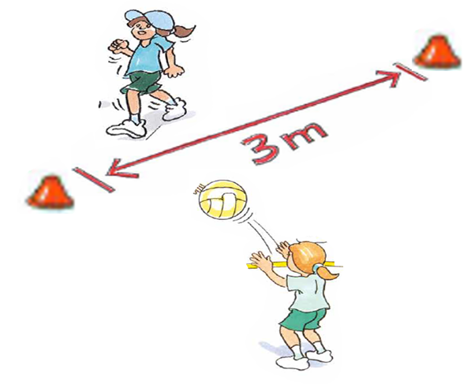
Keep the ball – Illustration 1’, Adapted from ‘Playing for life’ – Australian Sports Commission, https://www.sportaus.gov.au.
Discussion
Explain that to ‘time a pass’ means to choose the right/best time to pass the ball. Explore the questions,
- When is the most appropriate time to pass the ball? Sample student answers may include, when my team member is in open space away from defenders, I have a clear path to my team member to pass the ball, when team members are ready (looking at the ball carrier with hands ready to catch).
- Why is it important to time a pass in a game that has two teams? Sample student answers may include, to make it difficult for the opposition to get the ball, this will increase our chances of being successful as a team because we can keep the ball.

Activity 3 – Keep the ball (game)
Mark a playing area approximately 10 metres x 10 metres.
- Divide class into groups of about 7. Five students are attackers and two defenders.
- The attackers score a point for every successful pass.
The person with the ball cannot move, defenders and attackers without the ball can move around freely. Change defenders after 2-3 minutes.
Repeat the game until all students have had a turn of defending.
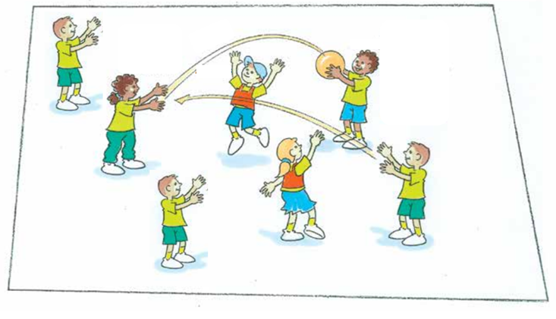
‘Keep the ball – Illustration 2’, Adapted from ‘Playing for life’ – Australian Sports Commission, https://www.sportaus.gov.au.
Teacher notes
Keep a higher ratio of attackers to defenders to allow for regular success in maintaining possession of the ball and emphasise the importance to move into ‘open space’ (away from defenders).

Discussion
Explore the questions:
- When passing the ball, what did you do that improved your team's chances of success? Sample student answers may include, looking at the person I was passing to; passing to a person who was not too far away.
- When passing the ball, what could other team members do to improve your team's chances of success? Sample student answers may include, team members were watching with hands ready for the pass; moved into space away from defenders.
Variations
- Change the team sizes (5 v 3, 4 v 3, 3 v 2)
- Select a number of passes to score a point. For example, 5 passes scores 1 point
- If the ball is dropped restart the count.
Reflection
Students reflect upon the learning in this activity/lesson and consider how it contributes towards answering the essential question How can I use tactics to be successful in games? by completing the self–assessment on Appendix 1. Alternatively, the self–assessment in ‘Appendix 1’ may be adapted using one or more of the assessment tools available via the Digital Learning Selector.

Lesson 7 – Tactical use of equipment
Lesson 7 – Assessment framework
Outcomes | Unit learning goals  Students are learning to: | Evidence of learning  Students can:
PD1-4 performs movement skills in a variety of sequences and situations | - perform different locomotor movements with increasing fluency and accuracy. | - perform locomotor movements effectively within game rules and boundaries (Activity 1).
PD1-5 proposes a range of alternatives to solve movement challenges through participation in a range of activities | - identify appropriate tactics to influence achievement in games and physical activities. | - identify tactics to effectively use the piece/s of equipment and improve chances of success in a game (Activity 2).
PD1-10 describes and practises interpersonal skills to promote inclusion to make themselves and others feel they belong | - work cooperatively with a partner or group when practising new skills. | - interact positively with peers by showing respect to them and their contributions, collaborating to share knowledge and ideas to achieve a common goal (Activity 1).
PD1-11 incorporates elements of space, time, objects, effort and people in creating and performing simple movement sequences | - identify, select and use specific movement sequences, appropriate timing, correct positioning, use of space and tactics specific to equipment in a range of games | - select and use tactics that will improve chances of success relevant to the equipment being used (Activity 2, 3).

Key inquiry questions and syllabus content
What are the different ways we can move our body?
Demonstrate movement skills and movement sequences in a variety of contexts for example,
- perform locomotor skills using different body parts to travel in different directions for example, walking, running, galloping, hopping, sliding, skipping, jumping, leaping, rolling
- use a variety of equipment to perform object control skills to send, control and receive objects, for example, bouncing, rolling, throwing, catching, kicking, striking, dribbling, rolling.
How can we move and improve our involvement in physical activity?
- propose a range of alternatives and test their effectiveness when solving movement challenges for example,
  - identify appropriate tactics to influence achievement in games and physical activities
  - compare different types of movements and identify which ones are easier and harder for example, locomotor, non-locomotor and object control skills
  - predict possible outcomes of alternative actions and decide which is likely to be the most effective
  - reflect on performance and identify and demonstrate ways to perform a skill more successfully.
- use strategies to work in group situations when participating in physical activities for example,
  - work cooperatively with a partner when practising new skills.

Teaching and learning activities
Equipment –various sized pieces of equipment - balls (tennis balls, soccer balls, basket balls, AFL balls), hoops, braids, cones
Vocabulary – tactic, movement, success, defend, attack

Activity 1 – Rescue (Fast start)
Divide the class into teams of 4. Place two markers about 10 metres apart in front of each team.
- On a whistle student 1 runs to the marker and back again to collect student 2.
- Linking arms (or holding hands), they both run around the marker and back to collect student 3. This continues until the whole team runs around the marker and back together.
- Repeat the relay as a ‘drop off’ relay.
Discussion
Explore the questions – How did you adjust the way you moved as more people joined your team?
Ask students to recall some tactics they have used in the unit so far by answering the question “What have you thought about or done in the games that have helped you be successful?” Sample student answers may include, using space, changing movement, timing your running. Introduce the idea that selecting equipment and/or the ways we use it can be a tactic that helps improve the chance of being successful.
You may refer to the image below to describe/discuss how different pieces of equipment can be held and used differently.
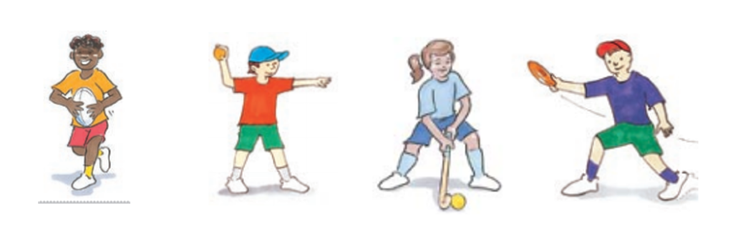
‘Rescue – Illustration 1’, Adapted from ‘Playing for life’ – Australian Sports Commission, https://www.sportaus.gov.au.

Activity 2 – Keep the ball (Game)
Refer to instructions in Lesson 6 – Activity 3.
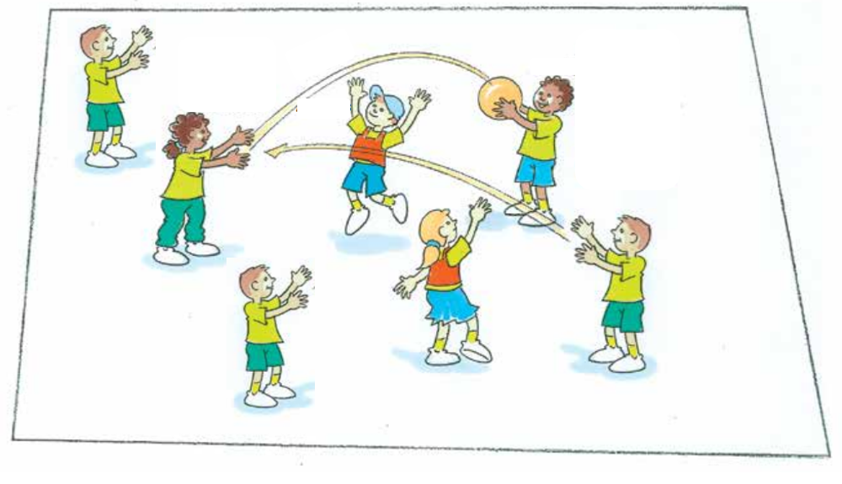
‘Keep the ball– Illustration 1’, Adapted from ‘Playing for life’ – Australian Sports Commission, https://www.sportaus.gov.au.• Adapted from Playing for life
Teacher notes
Repeat the game ‘Keep the ball’ that was played in the previous lesson using a wide range of equipment. As per the instructions in Lesson 6 – Activity 3, rotate students so they perform roles of attacker and defender.
After all students have performed both roles discuss the sample questions before changing the piece of equipment used. This game can be repeated several times. Equipment to use may include a netball, tennis ball, bean bag, large inflatable ball, hoop, frisbee, vortex.
On the last rotation allow students to select the piece of equipment they would like to use. This may be different for each pair/group of attackers.
Discussion
Explore the questions,
- How did you adjust your tactics to use the new piece of equipment effectively in the game? Sample student answers may include, it was harder to carry so I had to use two hands and place it behind my body away from the defender; or, it was light and easy to hold and pass so we were able to pass it longer distances.
- How did you adjust your tactics when defending when the new piece of equipment was introduced? Was it effective? What makes you say that? Sample student answers may include, the object/ball was hard for the attackers to pass so they had to be closer to each other. This meant I could try to intercept it or block the pass more easily.
Reflection
Students reflect upon the learning in this activity/lesson and consider how it contributes towards answering the essential question How can I use tactics to be successful in games?

Lesson 8 – Tactical use of equipment
Lesson 8 – Assessment framework
Outcomes | Unit learning goals  Students are learning to: | Evidence of learning  Students can:
PD1-4 performs movement skills in a variety of sequences and situations | - perform different locomotor movements with increasing fluency and accuracy. | - perform locomotor movements effectively within game rules and boundaries (Activity 1).
PD1-5 proposes a range of alternatives to solve movement challenges through participation in a range of activities | - identify appropriate tactics to influence achievement in games and physical activities.  - reflects on previous performances to identify factors that may contribute to future success. | - identify the use of space and time to effectively pass a ball, improving the chance of success in a game (Activity 2, 3, 4).  - identify strategies that may contribute to future success in a fast-start game or movement challenge (Activity 1, 2).
PD1-10 describes and practises interpersonal skills to promote inclusion to make themselves and others feel they belong | - work cooperatively with a partner or group when practising new skills. | - interact positively with peers by showing respect to them and their contributions, collaborating to share knowledge and ideas to achieve a common goal (Activity 1, 2, 3, 4).
PD1-11 incorporates elements of space, time, objects, effort and people in creating and performing simple movement sequences | - identify, select and use specific movement sequences, appropriate timing, correct positioning, use of space and tactics specific to equipment in a range of games | - select and use tactics that will improve chances of success relevant to the equipment being used (Activity 2, 3, 4).

Key inquiry questions and syllabus content
What are the different ways we can move our body?
Demonstrate movement skills and movement sequences in a variety of contexts for example:
- perform locomotor skills using different body parts to travel in different directions for example, walking, running, galloping, hopping, sliding, skipping, jumping, leaping, rolling
- use a variety of equipment to perform object control skills to send, control and receive objects for example, bouncing, rolling, throwing, catching, kicking, striking, dribbling, rolling.
How can we move and improve our involvement in physical activity?
Propose a range of alternatives and test their effectiveness when solving movement challenges for example,
- identify appropriate tactics to influence achievement in games and physical activities
- compare different types of movements and identify which ones are easier and harder for example, locomotor, non-locomotor and object control skills
- predict possible outcomes of alternative actions and decide which is likely to be the most effective
- reflect on performance and identify and demonstrate ways to perform a skill more successfully
- use strategies to work in group situations when participating in physical activities for example,
- work cooperatively with a partner when practising new skills.

Teaching and learning activities
Equipment – variety of equipment to play scoop ball (balls, braids, ropes, skipping ropes), markers.
Resources – Appendix 1.
Vocabulary – tactic, equipment, runner, tag.

Activity 1 – Rescue (Fast start)
Refer to instructions in Lesson 7 – Activity 1. Different sample questions are provided below to explore how knowledge, understanding and skills have developed further.
Discussion
Explore the questions,
- How did you adjust the way you moved and/or linked as a team to be successful?
- How would you change your tactics for another game?
- Explore the idea that the way someone uses a piece of equipment can improve the chance of success. For example,
  - a netballer may use a two-handed chest pass, a shoulder pass or a bounce pass depending on the game situation. You may refer to the images below as an example.
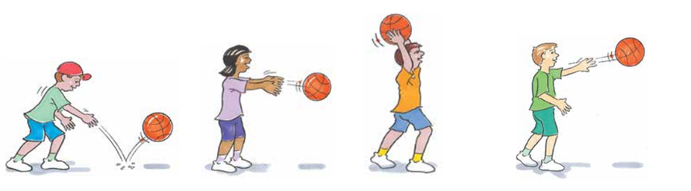
‘Rescue – Illustration 2’, Adapted from ‘Playing for life’ – Australian Sports Commission, https://www.sportaus.gov.au.

Activity 2 – Scoop tag
- Mark a playing area 10 metres x 10 metres per group. Divide students into groups of 8 to make 4 pairs.
- Each pair designates a runner and a tagger.
Runners carry their ball and attempt to avoid their partner who is a ‘tagger’.
If the tagger touches the runner’s ball they call out Touch or Yes. The tagged runner must immediately perform a roll ball (place their ball/piece of equipment on the ground between their feet and step over it).
The students swap roles after a tag so the runner becomes the tagger.
The tagger scoops the ball up and continues playing as a runner.
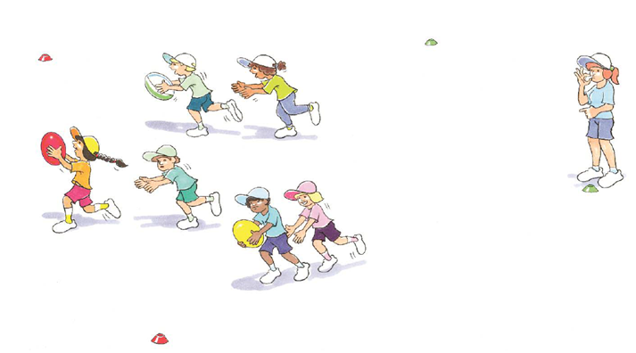
‘Scoop tag – Illustration 1’, Adapted from ‘Playing for life’ – Australian Sports Commission, https://www.sportaus.gov.au.
Teacher notes
This game is played in the corresponding Early Stage 1 unit of learning. In this Stage 1 unit taggers must tag the ball instead of just the person. This means both students must adjust their tactics in order to:
- protect the ball so they cannot be touched (ball carrier)
- touch the ball when the other player is protecting it (tagger)
It important that when playing Activity 2 and Activity 3 students only chase and tag their partner. All taggers will be able to tag all runners in Activity 4.
Discussion
Explore the questions,
- What tactics did you use to protect the ball and therefore avoid being tagged? Sample student answers may include, I tucked it under my arm, I held it out in front of me in two hands, I held it over my head.
- What if the item was not a football? Would your tactics change? Sample student answers may include, it would depend on the item as to how I changed my tactics.

Activity 3
- Play the game several more times, changing the item being carried each time. For example, tennis ball, soccer ball, bean bag, braid, bucket, skipping rope, hoop.
- Following each game with a new piece of equipment, explore the question with the students, ‘How did your tactics change with that piece of equipment?’ (Remember to ask for responses from both the taggers and runners).

Activity 4
Play the game again, with students selecting their own piece of equipment, however students are not allocated a partner. All taggers may tag all runners.
Discussion
Explore the question, ‘Did your tactics change when the rule that all taggers can tag all runners changed? Explain’. Sample student answers may include, I had to watch out all around me instead of just my partner, I had to hold the piece of equipment closer to me.
Reflection
Students reflect upon the learning in this activity/lesson and consider how it contributes towards answering the essential question ‘How can I use tactics to be more successful in games?’ by completing the self–assessment on ‘Appendix 1’. Alternatively, the self–assessment in ‘Appendix 1’ may be adapted using one or more of the assessment tools available via the Digital Learning Selector.

Lesson 9 – Adjusting tactics
Lesson 9 – Assessment framework
Outcomes | Unit learning goals  Students are learning to: | Evidence of learning  Students can:
PD1-4 performs movement skills in a variety of sequences and situations | - perform different locomotor movements with increasing fluency and accuracy. | - perform locomotor movements effectively within game rules and boundaries (Activity 1).
PD1-5 proposes a range of alternatives to solve movement challenges through participation in a range of activities | - identify appropriate tactics to influence achievement in games and physical activities.  - reflects on previous performances to identify factors that may contribute to future success. | - identify tactics that will improve chances of success by effectively using the locomotor movement/s allowed in a game (Activity 2, 3).  - identify strategies that may contribute to future success in a fast-start game or movement challenge (Activity 2).
PD1-10 describes and practises interpersonal skills to promote inclusion to make themselves and others feel they belong | - work cooperatively with a partner or group when practising new skills. | - interact positively with peers by showing respect to them and their contributions, collaborating to share knowledge and ideas to achieve a common goal (Activity 1).
PD1-11 incorporates elements of space, time, objects, effort and people in creating and performing simple movement sequences | - identify, select and use specific movement sequences, appropriate timing, correct positioning, use of space and tactics specific to equipment in a range of games | - select and use tactics that will improve chances of success relevant to the rule changes in a game (Activity 2, 3).

Key inquiry questions and syllabus content
What are the different ways we can move our body?
Demonstrate movement skills and movement sequences in a variety of contexts for example:
- perform locomotor skills using different body parts to travel in different directions, for example, walking, running, galloping, hopping, sliding, skipping, jumping, leaping, rolling
- use a variety of equipment to perform object control skills to send, control and receive objects, for example, bouncing, rolling, throwing, catching, kicking, striking, dribbling, rolling.
How can we move and improve our involvement in physical activity?
Propose a range of alternatives and test their effectiveness when solving movement challenges for example:
- identify appropriate tactics to influence achievement in games and physical activities
- compare different types of movements and identify which ones are easier and harder, for example, locomotor, non-locomotor and object control skills
- predict possible outcomes of alternative actions and decide which is likely to be the most effective
- reflect on performance and identify and demonstrate ways to perform a skill more successfully.
Use strategies to work in group situations when participating in physical activities for example, work cooperatively with a partner when practising new skills.

Teaching and learning activities
Equipment – markers, variety of ball (including footballs for the beginning of the game)
Vocabulary –tactic, movement, tag, challenging, rule, attack, defend

Teacher notes
Lessons 9 and 10 are designed to allow students to identify that if rule changes occur in games, tactics may also need to be changed to improve chances of success.
Discussion
Explore the discussion,
- What if there were more bobcats than builders?
- What if there were more builders than bobcats?
- What rules could we change to make the game challenging? Sample student answers may include, builders must use their feet to stand the marker back up and/or increase the number of markers.

Variations
- Balance a ball on the marker. The bobcats turn the marker over and place the ball inside.
- Increase/decrease the playing area
- Place a braid in a hoop or bucket. Bobcats take the braid out of the hoop, builders place the braid back inside the hoop.
Discussion
Explore the idea that when rules change, they can impact on whether the tactics used in game are successful or not. Remind students that while playing this next game, they should think about what tactics they use and how they may be changed to suit the rules of the game.

Activity 2 – Tricky touch down
Create several games with up to 8 students in each game.
In each game, organise students into two groups at diagonal points of the 10 metres x 10 metres playing area. (This may vary depending on the skill level of the students.)
- Attackers line up behind a marker holding a football each.
- One attacker enters the field, while the next attacker waiting calls out which line the attacker must run to, either A or B. The attacker then tries to evade the defender and put the ball down over one of the lines.
- A defender can only enter a playing area once an attacker has entered the area.
- When an attacker has run over one of the lines without being touched, they score a point. If the defender touches the attacker they score a point.
- Swap roles when all attackers have had a turn.
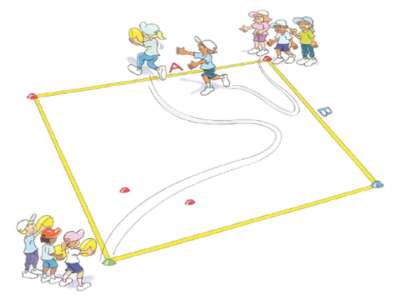
‘Tricky touch down – Illustration 1’, Adapted from ‘Playing for life’ – Australian Sports Commission, https://www.sportaus.gov.au.
Discussion
Explore the questions,
- What rules could we change? For example, the defender starts in the square.
- What if we changed the rules? How would that affect the tactics used? Sample student answers may include, the attacker will have less time and need to employ different movement tactics such as dodge rather than running straight.
Teacher notes
Rules can be incorporated in all aspects of the game, including type of equipment, positioning of students, number of students, time limits, movement styles, scoring systems. These can be suggested to students to prompt thinking.
Activity 3
Repeat the game, Tricky touch downs, implementing the suggested rule changes from the students.
Discussion
Explore the questions:
Did the rule changes influence your tactics as:
- an attacker? How?
- a defender? How?
Reflection
Students reflect upon the learning in this activity/lesson and consider how it contributes towards answering the essential question ‘How can I use tactics to be successful in games?

Lesson 10 – Adjusting tactics
Lesson 10 – Assessment framework
Outcomes | Unit learning goals  Students are learning to: | Evidence of learning  Students can:
PD1-4 performs movement skills in a variety of sequences and situations | - perform different locomotor movements with increasing fluency and accuracy. | - perform locomotor movements effectively within game rules and boundaries (Activity 1).
PD1-5 proposes a range of alternatives to solve movement challenges through participation in a range of activities | - identify appropriate tactics to influence achievement in games and physical activities. | - identify tactics that will improve chances of success by effectively using the locomotor movement/s allowed in a game (Activity 2, 3).
PD1-10 describes and practises interpersonal skills to promote inclusion to make themselves and others feel they belong | - work cooperatively with a partner or group when practising new skills. | - interact positively with peers by showing respect to them and their contributions, collaborating to share knowledge and ideas to achieve a common goal (Activity 1).
PD1-11 incorporates elements of space, time, objects, effort and people in creating and performing simple movement sequences | - identify, select and use specific movement sequences, appropriate timing, correct positioning, use of space and tactics specific to equipment in a range of games | - select and use tactics that will improve chances of success relevant to the rule changes in a game (Activity 2, 3).

Teaching and learning activities
What are the different ways we can move our body?
Demonstrate movement skills and movement sequences in a variety of contexts for example:
- perform locomotor skills using different body parts to travel in different directions, for example, walking, running, galloping, hopping, sliding, skipping, jumping, leaping, rolling
- use a variety of equipment to perform object control skills to send, control and receive objects, for example, bouncing, rolling, throwing, catching, kicking, striking, dribbling, rolling.
How can we move and improve our involvement in physical activity?
- Propose a range of alternatives and test their effectiveness when solving movement challenges for example:
  - Identify appropriate tactics to influence achievement in games and physical activities.
  - Compare different types of movements and identify which ones are easier and harder, such as locomotor, non-locomotor and object control skills.
  - Predict possible outcomes of alternative actions and decide which is likely to be the most effective.
  - Reflect on performance and identify and demonstrate ways to perform a skill more successfully.
Use strategies to work in group situations when participating in physical activities for example, work cooperatively with a partner when practising new skills.
Equipment – markers, appropriate equipment to suit rule challenges.
Resources – Appendix 1.
Vocabulary – tactic, movement, tag, success, rule.

Activity 1 -Bobcats and builders (Fast start)
Refer to instructions in Lesson 9 – Activity 1. Revisit the rules changes discussed last week and implement one or more where appropriate. Different sample questions are provided below to explore how knowledge, understanding and skills have developed further.

Discussion
Explore the questions,
- How did the rule changes affect the game? Explain.
- Were you more successful with the rule changes in place? What makes you say that?
- Review the idea that when rules change they can impact on the tactics used in games. Explore with students the nominated rule changes and impact of tactics on the game ‘Tricky touch down’ played in lesson 9.

Activity 2
- As a class select a game and discuss possible rule changes. The game may be one that has been played in this unit of learning over previous weeks or one that is familiar to the class.
- Ensure the game is a tag or invasion game. An invasion game requires two or more teams to score by progressing past the opposition to score a point/goal/try.
- Select one rule change and play the game with students applying their own tactical changes.
Teacher notes
Where appropriate, allow students to select the games.
Discussion
Explore the questions
- How did your tactics change?
- Did these changes help you be more successful in the game? What makes you say that?

Activity 3
Playing the same game select and implement another rule change. Allow students to discuss and plan how they might adjust their tactics.
Discussion
Explore the questions,
- How did your tactics change?
- Did these changes help you be more successful in the game? What makes you say that?
Reflection
Students reflect upon the learning in this activity/lesson and consider how it contributes towards answering the essential question How can I use tactics to be successful in games? by completing the self–assessment on Appendix 1. Alternatively, the self–assessment in ‘Appendix 1’ may be adapted using one or more of the assessment tools available via the Digital Learning Selector.

Appendix 1 – Self assessment
Self-assessment table
Success criteria | I need help to learn to: | I am still learning to: | I have learned to:
By the end of lesson 2 | Identify ways to move that will improve my chances of being successful in a game. | Identify ways to move that will improve my chances of being successful in a game. | Identify ways to move that will improve my chances of being successful in a game.
By the end of lesson 2 | Use movement effectively in a game. | Use movement effectively in a game. | Use movement effectively in a game.
By the end of lesson 4 | Identify ways to use space effectively that will improve my chances of being successful in a game. | Identify ways to use space effectively that will improve my chances of being successful in a game. | Identify ways to use space effectively that will improve my chances of being successful in a game.
By the end of lesson 4 | Use space effectively in a game. | Use space effectively in a game. | Use space effectively in a game.
By the end of lesson 6 | Identify ways to use time effectively to improve my chances of being successful in a game. | Identify ways to use time effectively to improve my chances of being successful in a game. | Identify ways to use time effectively to improve my chances of being successful in a game.
By the end of lesson 6 | Use time effectively in a game. | Use time effectively in a game. | Use time effectively in a game.
By the end of lesson 8 | Identify ways to use equipment effectively to improve my chances of success in games. | Identify ways to use equipment effectively to improve my chances of success in games. | Identify ways to use equipment effectively to improve my chances of success in games.
By the end of lesson 8 | Use equipment effectively. | Use equipment effectively. | Use equipment effectively.
By the end of lesson 10 | Identify the most effective tactics to be successful when the rules of games have changed. | Identify the most effective tactics to be successful when the rules of games have changed. | Identify the most effective tactics to be successful when the rules of games have changed.
By the end of lesson 10 | Use tactics effectively in response to rule changes. | Use tactics effectively in response to rule changes. | Use tactics effectively in response to rule changes.

Appendix 2 – Evaluation
Teacher analysis of the teaching and learning in the entire unit of work. Sample questions to address include are below.
Evaluation | Teacher notes
How well did the class demonstrate understanding of key concepts? | Write notes here.
What concepts/topics will I need to revisit to support student understanding? | Write notes here.
When will these concepts be revisited? | Write notes here.
How well were student learning needs met? | Write notes here.
Did all students have opportunities to demonstrate their knowledge, understanding and skills? | Write notes here.
Did adjustments provide adequate and appropriate access to all activities by all students? | Write notes here.
Were the resources used accessible for all students? | Write notes here.
Which activities in the learning sequence will I need to adapt to ensure better achievement of learning goals? | Write notes here.
Did the learning sequence provide sufficient opportunities to make quality assessment judgements about student achievement? | Write notes here.

Did the learning sequence provide sufficient opportunities to make quality assessment judgements about student achievement?
Teacher notes:
Which activities and tasks were most engaging and effective?
Teacher notes:
Did the adjustments provide adequate and appropriate access to all activities by all students?
Teacher notes:

Appendix 3 – Glossary
Boundaries – A line which marks the limits of an area
Territory games – Games, usually team based, which the purpose is to invade the opponent’s territory and score points while keeping the opposing teams points to a minimum.
Locomotor skills – Locomotor movement is when you move from one place to another. Locomotor skills include walking, climbing, rolling, balancing, sliding, jogging, running, leaping, jumping, hopping, dodging, galloping, skipping, floating and moving the body through water to safety.
Modified games – Games or sports that are simplified to suit the skills, strategic understandings and characteristics of students through changes to the game’s constraints such as rules, equipment and/or the sizer of the playing area.
Non-locomotor skills – Moving on the spot without any change in location. These skills include bending, stretching, twisting, turning, swinging, inverted supports, landing/stopping, balancing.
Tackle/tackling – Tackle/tackling is a generic term used when a student attempts to gain/re-gain possession of the ball/object from an opposition student. Under no circumstances should students make physical contact with another student to achieve this.
Tactical knowledge – An understanding of when, how and why to apply tactics in game situations.
Tactics - A change(s) to a plan or idea during a movement activity to successfully achieve a goal or outcome.
Tag game – Tag is a game involving two or more players' chasing other players in an attempt to ‘tag’ and mark them out of play, usually by touching with a hand.

Appendix 4 – Assessment framework
Outcomes | Student learning goals  Students are learning to: | Evidence of learning (EoL)  Students can:
What syllabus outcomes will be assessed throughout this unit of work? Refer to pages 14-19 of the PDHPE K-10 syllabus. | What students are expected to know, understand and do as a result of the learning within this unit of work. These are derived from the identified syllabus outcomes. | What specific behaviours you will expect to observe and use as an indicator of student learning towards the Student learning goals and syllabus outcomes. These are derived from the Student learning goals, NSW Physical Literacy Continuum K-10 cluster markers and cluster examples. Refer to Appendix 2 for more detail.
PD1-4 performs movement skills in a variety of sequences and situations. | Perform different locomotor movements with increasing fluency and accuracy. | Perform locomotor movements effectively within game rules and boundaries:  - Lesson 1 – Activity 1, 2, 3  - Lesson 2 – Activity 1, 2, 3  - Lesson 3 – Activity 1  - Lesson 4 – Activity 1  - Lesson 7 – Activity 1  - Lesson 8 – Activity 1  - Lesson 9 – Activity 1  - Lesson 10 – Activity 1.
PD1-5 proposes a range of alternatives to solve movement challenges through participation in a range of activities. | Identify and use appropriate tactics to influence achievement in games and physical activities. | - Identify tactics that will improve chances of success by effectively using the locomotor movement/s allowed in a game (Lesson 1 – Activity 1, 2, 3 Lesson 2 – Activity 1, 2, 3)  - Identify tactics to use open space effectively that improve chances of success in a game (space within boundaries and/or space away from opponents) (Lesson 3 – Activity 3, Lesson 4 – Activity 2, 3)  - Identify an appropriate time/s to perform specific locomotor movement/s to improve chances of success in a game. For example, jumping (Lesson 5 – Activity 2, 3, 4)  - Identify the use of space and time to effectively pass a ball, improving the chance of success in a game (Lesson 6 – Activity 2,3)  - Identify tactics to effectively use the piece/s of equipment and improve chances of success in a game (Lesson 7 – Activity 2, Lesson 8 – Activity 2, 3, 4)  - Identify tactics that will improve chances of success by considering the rule changes in a game (Lesson 9 – Activity 2, 3, Lesson 10 – Activity 2, 3)
PD1-5 | Reflects on previous performances to identify factors that may contribute to future success. | Identify strategies that may contribute to future success in a fast-start game or movement challenge  - Lesson 1 – Activity 2  - Lesson 2 – Activity 2, 3  - Lesson 3 – Activity 2  - Lesson 4 – Activity 2, 3  - Lesson 5 – Activity 2  - Lesson 6 – Activity 1, 3  - Lesson 8 – Activity 1, 2  - Lesson 9 – Activity 2)
PD1-10 describes and practises interpersonal skills to promote inclusion to make themselves and others feel they belong. | Work cooperatively with a partner or group when practising new skills. | Interact positively with peers by showing respect to them and their contributions, collaborating to share knowledge and ideas to achieve a common goal:  Lesson 1 – Activity 1, 2, 3  Lesson 2 – Activity 1, 2, 3  Lesson 3 – Activity 1, 3  Lesson 4 – Activity 1, 2, 3  Lesson 5 – Activity 3, 4  Lesson 7 – Activity 1  Lesson 8 – Activity 1, 2, 3, 4  Lesson 9 – Activity 1  Lesson 10 – Activity 1)
PD1-11 incorporates elements of space, time, objects, effort and people in creating and performing simple movement sequences. | Identify, select and use specific movement sequences, appropriate timing, correct positioning, use of space and tactics specific to equipment in a range of games. | - Select and use open space effectively to improve chances of success in a game (space within boundaries and/or space away from opponents) (Lesson 3 – Activity 2, 3, Lesson 4 – Activity 2, 3)  - Select and demonstrate an appropriate time to pass a ball to a team member to improve chances of success in a game (Lesson 4 – Activity 2, 3, Lesson 5 – Activity 2, 3, 4)  - Select and use an appropriate time to perform a specific locomotor movement that improves chances of success in a game, for example jumping (Lesson 6 – Activity 2, 3, 4)  - Select and use tactics that will improve chances of success relevant to the equipment being used (Lesson 7 – Activity 2, 3, Lesson 8 – Activity 2, 3, 4)  - Select and use tactics that will improve chances of success relevant to the rule changes in a game (Lesson 9 – Activity 2, 3, Lesson 10 – Activity 2, 3).

Appendix 5 – Images to support key terms
These images are licensed under CC BY NC ND 3.0 AU. Image modified with the permission of the Australian Sports Commission (for use in this publication only).
Tag – to touch an opponent with your hand or other safe object.
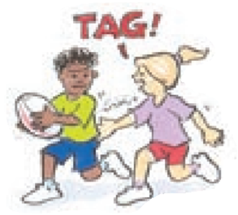
‘Tag illustration’, Adapted from ‘Playing for life’ – Australian Sports Commission, https://www.sportaus.gov.au.
Attackers – team who are to trying score, usually with the ball/object.
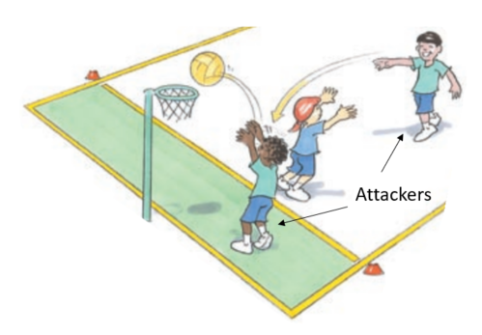
‘Attackers illustration’, Adapted from ‘Playing for life’ – Australian Sports Commission, https://www.sportaus.gov.au.

Defenders – team trying to stop the opposition from scoring.
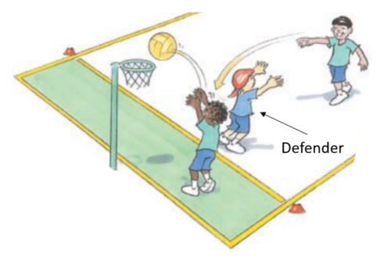
‘Defenders illustration’, Adapted from ‘Playing for life’ – Australian Sports Commission, https://www.sportaus.gov.au.
Equipment – items used to play a game.
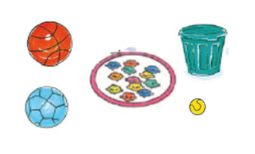
‘Equipment illustration’, Adapted from ‘Playing for life’ – Australian Sports Commission, https://www.sportaus.gov.au.

Space – an area away from other players.
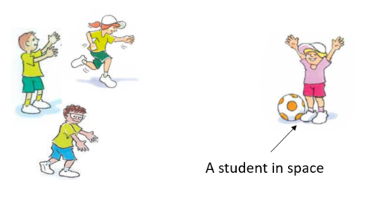
‘Space illustration’, Adapted from ‘Playing for life’ – Australian Sports Commission, https://www.sportaus.gov.au.
Boundaries – the limit of the playing area.
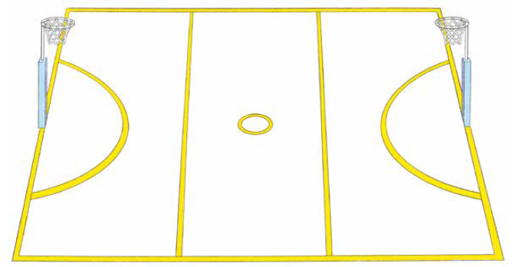
‘Boundaries illustration’, Adapted from ‘Playing for life’ – Australian Sports Commission, https://www.sportaus.gov.au.

Roll ball – to roll a ball under the foot, from front to back.
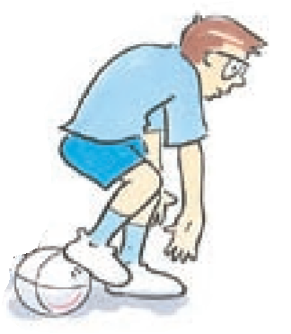
‘Roll ball illustration’, Adapted from ‘Playing for life’ – Australian Sports Commission, https://www.sportaus.gov.au.
Scoop up – to pick the ball up off the ground while moving.
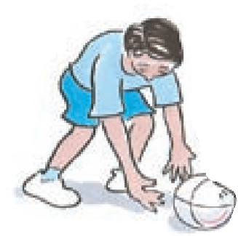
‘Scoop-up illustration’, Adapted from ‘Playing for life’ – Australian Sports Commission, https://www.sportaus.gov.au.

Intercept –to take possession of the ball when the opposition have passed it, usually with a throw, strike or kick.
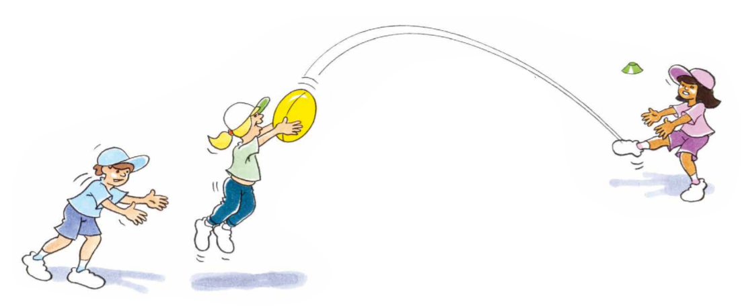
‘Intercept illustration’, Adapted from ‘Playing for life’ – Australian Sports Commission, https://www.sportaus.gov.au.
Team – players who are working together to achieve the same goal.
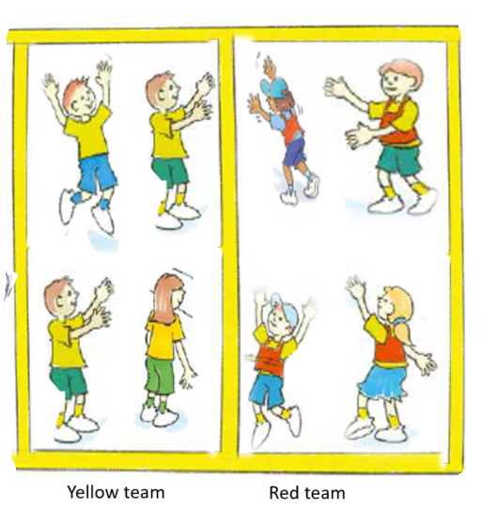
‘Team illustration’, Adapted from ‘Playing for life’ – Australian Sports Commission, https://www.sportaus.gov.au.
Scoring – to achieve the aim of the game, usually by putting an object in a goal or over a line.
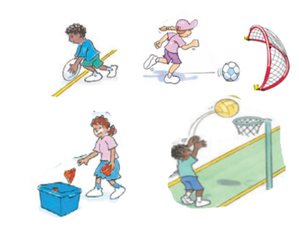
‘Scoring illustration’, Adapted from ‘Playing for life’ – Australian Sports Commission, https://www.sportaus.gov.au.
Dodging – changing directions quickly to avoid an opponent.
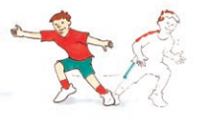
‘Dodging illustration’, Adapted from ‘Playing for life’ – Australian Sports Commission, https://www.sportaus.gov.au.

Kick – to hit an object with the foot.
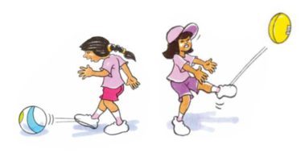
‘Kick illustration’, Adapted from ‘Playing for life’ – Australian Sports Commission, https://www.sportaus.gov.au.
Throw – to release a ball with force from a hand.
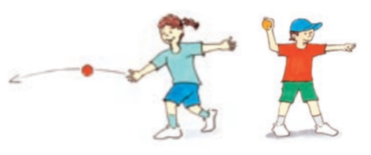
‘Throw illustration’, Adapted from ‘Playing for life’ – Australian Sports Commission, https://www.sportaus.gov.au.

Catch – using hands to prevent a ball from hitting the ground.
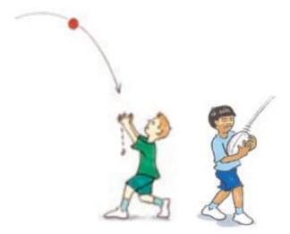
‘Catch illustration’, Adapted from ‘Playing for life’ – Australian Sports Commission, https://www.sportaus.gov.au.
Bounce – to drop or throw a ball to the ground and retain possession.
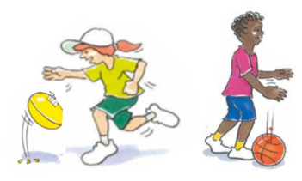
‘Bounce illustration’, Adapted from ‘Playing for life’ – Australian Sports Commission, https://www.sportaus.gov.au.

Balance an object – to keep one object on top of another without it hitting the ground or falling over.
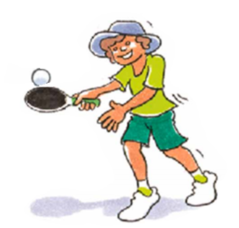
‘Balance an object illustration’, Adapted from ‘Playing for life’ – Australian Sports Commission, https://www.sportaus.gov.au.
Pass – when an object or ball is sent to a team mate, usually by throw, strike or kick.
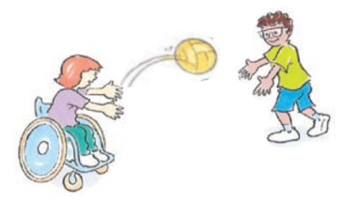
‘Pass illustration’, Adapted from ‘Playing for life’ – Australian Sports Commission, https://www.sportaus.gov.au.

Receive – to get a ball from a team mate, usually from a throw, strike or kick.
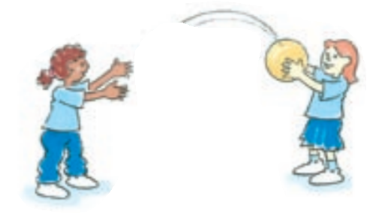
‘Receive illustration’, Adapted from ‘Playing for life’ – Australian Sports Commission, https://www.sportaus.gov.au.
Run – a locomotor movement alternating legs to move across the ground.
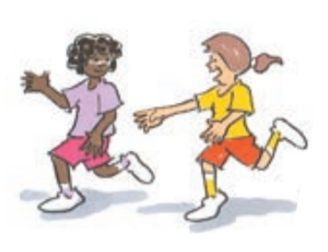
‘Run illustration’, Adapted from ‘Playing for life’ – Australian Sports Commission, https://www.sportaus.gov.au.

Jump – a locomotor movement using two feet to spring up into the air or across the ground.
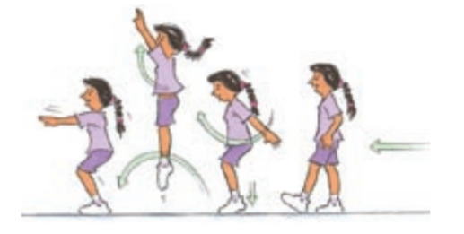
‘Jump illustration’, Adapted from ‘Playing for life’ – Australian Sports Commission, https://www.sportaus.gov.au.
Hop – a locomotor movement using the same foot touching the ground.
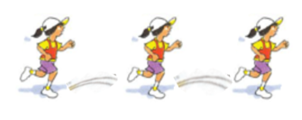
‘Hop illustration’, Adapted from ‘Playing for life’ – Australian Sports Commission, https://www.sportaus.gov.au.

Skip – a locomotor movement using a step-hop pattern or a term used when jumping over a rope.
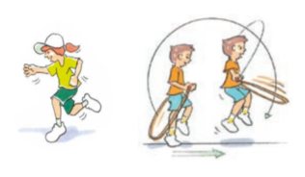
‘Skip illustration’, Adapted from ‘Playing for life’ – Australian Sports Commission, https://www.sportaus.gov.au.
Balance – to maintain stability and avoid falling over.
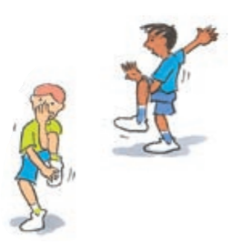
‘Balance illustration’, Adapted from ‘Playing for life’ – Australian Sports Commission, https://www.sportaus.gov.au.

Leap – a locomotor movement using a long stride from one foot and landing on the other.
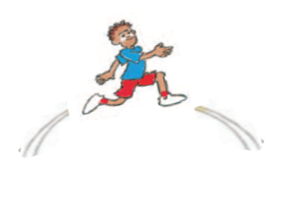
‘Leap illustration’, Adapted from ‘Playing for life’ – Australian Sports Commission, https://www.sportaus.gov.au.
Rolling – to rotate an object or person across the ground.
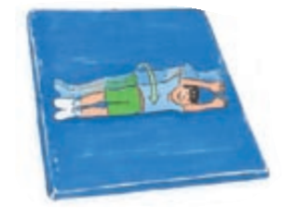
‘Rolling illustration’, Adapted from ‘Playing for life’ – Australian Sports Commission, https://www.sportaus.gov.au.

Striking – to hit an object or ball with another object such as a bat.
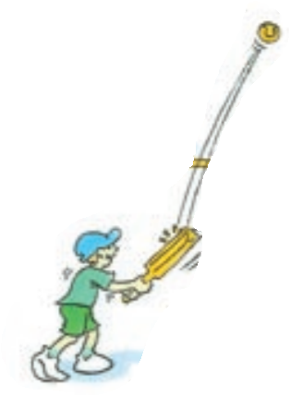
‘Striking illustration’, Adapted from ‘Playing for life’ – Australian Sports Commission, https://www.sportaus.gov.au.
Bend – to move the body by making the joint angles smaller.
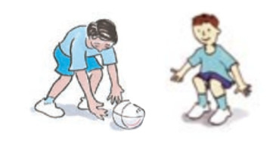
‘Bend illustration’, Adapted from ‘Playing for life’ – Australian Sports Commission, https://www.sportaus.gov.au.

Twist – to rotate the body around a central point.
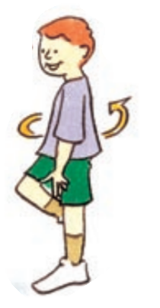
‘Twist illustration’, Adapted from ‘Playing for life’ – Australian Sports Commission, https://www.sportaus.gov.au.

Appendix 6 – Physical literacy cluster markers
The following NSW Physical Literacy Continuum K-10 cluster markers guided the development of the ‘Evidence of Learning’ (EoL) as observable behaviours to address the Student learning goals and identified syllabus outcomes.

Movement competencies
- Demonstrates correct coordination of arms and legs to propel the body, for example, arms drive forward and back in opposition to legs when running.
- Demonstrates proficiency in locomotor movement skills when practised in isolation.

Tactical movement
- Applies different movement skills and concepts to achieve success within the rules of a physical activity, for example, uses dodge to avoid others and move into space.
- Identifies appropriate tactics within a physical activity to influence achievement or success.

Motivation and behavioural skills
- Demonstrates motivation to try new physical activities.
- Persists in a range of physical activities regardless of success.
- Works independently on familiar skills and physical activities.

Personal and social attributes
- Follows instructions, rules and safety procedures in physical activities.
- Demonstrates cooperative behaviour towards others during physical activity.

Appendix 7 – Attributions
© State of New South Wales (Department of Education), 2021. All material in this resource, except as identified below, is licensed under the Creative Commons Attribution 4.0 International Licence. To view a copy of this licence, visit http://creativecommons.org/licenses/by/4.0/.’
Material that is not licensed under the Creative Commons Attribution 4.0 International Licence:
The following images by Australian Sports Commission – https://www.sportaus.gov.au are licensed under CC BY NC ND 3.0 AU. These images have been modified with the permission of the Australian Sports Commission (for use in this publication only):
- Page 10 – Animal tag illustration 1.
- Page 16 – Hungry caterpillar game illustration 1.
- Page 21 – Caterpillar run illustration 1.
- Page 29 – Run the gauntlet illustration 1.
- Page 34 – Leaping lava illustration 1.
- Page 39 – Keep the ball illustration 1.
- Page 40 – Keep the ball illustration 2.
- Page 44 – Rescue illustration 1.
- Page 44 – Rescue illustration 2.
- Page 50 – Scoop tag illustration 1.
- Page 55 – Tricky touch down illustration 1.
- Page 63 – Tag illustration, Attackers illustration.
- Page 64 – Defenders illustration, Equipment illustration.
- Page 65 – Space illustration, Boundaries illustration.
- Page 66 – Roll ball illustration, Scoop-up illustration.
- Page 67 – Intercept illustration, Team illustration.
- Page 68 – Scoring illustration, Dodging, illustration.
- Page 69 – Kick illustration, Throw illustration.
- Page 70 – Catch illustration, Bounce illustration.
- Page 71 – Balance objects illustration, Pass illustration.
- Page 72 – Receive illustration, Run illustration.
- Page 73 – Jump illustration, Hop illustration.
- Page 74 – Skip illustration, Balance illustration.
- Page 74 – Leap illustration, Rolling illustration.
- Page 76 – Striking illustration, Bend illustration.
- Page 77 – Twist illustration.

