**PDHPE FACULTY**

**ASSESSMENT TASK COVERSHEET**

Stage 4 - Year 7

|  |
| --- |
| TOPIC/MODULE: Netball |

|  |
| --- |
| WEIGHTING:25% (Marked out of 35) |

|  |
| --- |
| DUE DATE: |

|  |
| --- |
| TIME ALLOWED: Assessment to take place in two lesson (preparation may occur in previous lessons) |

|  |
| --- |
| OUTCOMES: |

A student:

* 1. Demonstrates and refines movement skills in a range of contexts and environments

**4.12** Assesses risk and social influences and reflects on personal experience to make informed decisions

**4.14** Engages successfully in a wide range of movement situations that displays an understanding of how and why people move

|  |
| --- |
| PHYSICAL LITERACY CONTINUUM MARKERS: |

**Cluster 5:**

**Aspect – Tactical Movement (Thinking in Action)**

Applies multiple tactics appropriately to achieve success within a range of physical activities.

**Aspect – Movement Competencies (Combinations)**

Selects from a range of movement skills and applies the most appropriate skill in dynamic physical activity contexts.

|  |
| --- |
| TASK: |

**What do I have to do? (Description of task)**

Students will be assessed in two parts:

**Part 1 (Self Assessment):** Solving a tactical problem and maintaining possession of the ball.

1. Students will be given a diagram of a netball game scenario, for which they have to select the correct attacking option based on player positioning. Students will be required to draw arrows on the court demonstrating player movement options that will enable the attacking team to maintain possession and advance play forward (2 marks).
2. Write a supporting statement explaining your decisions and player movements to show your understanding of the correct attacking option based on the situation (3 marks).

**Part 2 (Technical Assessment):** Students will be assessed on their ability to perform movement competencies that are an integral part of the game of netball.

These competencies include:

1. Passing (9 marks)
2. Catching (9 marks)
3. Shooting (9 marks)

Students will have the opportunity to practice and refine these skills in a range of teaching and learning activities, including modified games.

This assessment will be conducted by the teacher and take place over two lessons towards the end of this unit.

**What do I need to do the task? (Resources)**

* Student information sheet
* Knowledge of the skills of netball
* Movement skill competence and confidence

**How will I be assessed? (Criteria for assessing performance)**

Students will be assessed on their ability to:

* Display knowledge and understanding of the skills required to play netball
* Demonstrate tactical awareness during game play
* Perform movement skills in a variety of challenging contexts

**How will I know how well I’ve done? (Feedback)**

Students will receive written feedback from the teacher on the marking criteria sheet.

**How will this help me in future learning in PDHPE? (Future directions)**

Students will be better able to perform skills in netball and will hopefully transfer such skills positively to other invasion games.

|  |
| --- |
| SPECIAL PROVISIONS: |

Students who have successfully applied for special provisions for their assessment tasks MUST see their course teacher within a week of receiving this notification to organise the resources and requirements of the special provisions. Failure to do this may mean the required resources are unavailable on the day of the assessment task.

|  |
| --- |
| ASSESSMENT CRITERIA: |

**You will be marked on how well you meet the criteria below.**

**Name: ___________________________ Class: ___________________**

|  |  |
| --- | --- |
| MARKING CRITERIA: |  |

|  |  |  |  |  |
| --- | --- | --- | --- | --- |
|  | **Part 1: Self Assessment** | | | |
| **Tactical Awareness** | **0** | **1** | **2** | **3** |
| **Diagram**  **(2 Marks)** | No Effort | * Illustration demonstrates developing proficiency to maintain possession and advance forward. * Labelling of diagram is unclear. | * Illustration demonstrates proficient strategy/tactics to maintain possession and advance forward. * Diagram is clearly labelled with arrows indicating player and ball movement. |  |
| **Supporting Statement**  **(3 Marks)** | No Effort | * Developing proficiency in decision making with the ball (where, when and how to pass and shoot) and without the ball (when and where to move, identifying space). | * Approaching proficiency in decision making with the ball (where, when and how to pass and shoot) and without the ball (when and where to move, identifying space). | * Demonstrates proficient decision making with the ball (where, when and how to pass and shoot) and without the ball (when and where to move, identifying space). |

|  |  |  |  |  |
| --- | --- | --- | --- | --- |
| **Part 2: Technical Assessment** | | | | |
| **Skill:** | **Criteria:** | **Developing Proficiency**  **1** | **Approaching Proficiency**  **2** | **Proficient**  **3** |
| **Passing:** | Demonstrates a range of passing types (e.g. chest or bounce). |  |  |  |
| Chooses correct passing type for game situation. |  |  |  |
| Accurate delivery to intended target. |  |  |  |
| **Catching:** | Eyes up and hands ready to anticipate pass. |  |  |  |
| Finding open space to receive pass. |  |  |  |
| Safe catching technique that effectively maintains possession. |  |  |  |
| **Shooting:** | Open to receive pass from teammate. |  |  |  |
| Displays an effective shooting stance and technique. |  |  |  |
| Displays an effective shooting release and trajectory. |  |  |  |
| **Values/**  **Behaviour:** | Displays enthusiasm during team play and works effectively with peers. |  |  |  |
| **Sub-total:** |  |  |  |  |
| **Total:** | **/30** | | | |

|  |  |
| --- | --- |
| **Total Marks** | |
| **Part 1: Self Assessment** | **___________/5** |
| **Part 2: Technical Assessment** | **___________/30** |
| **Total:** | **___________/35** |

|  |  |  |  |  |
| --- | --- | --- | --- | --- |
| **Grade** | | | | |
| **A** | **B** | **C** | **D** | **E** |
| **35-30** | **29-22** | **21-14** | **13-6** | **5-0** |

**Achievement of Outcomes in the Task:**

|  |  |  |  |
| --- | --- | --- | --- |
| * 1. Demonstrates and refines movement skills in a range of contexts and environments | | | |
| **Not Evident** | **Working Towards** | **Achieved** | **Working Beyond** |
| Assesses risk and social influences and reflects on personal experience to make informed decisions  **4.12** | | | |
| **Not Evident** | **Working Towards** | **Achieved** | **Working Beyond** |
| **4.14** Engages successfully in a wide range of movement situations that displays an understanding of  how and why people move | | | |
| **Not Evident** | **Working Towards** | **Achieved** | **Working Beyond** |

**Comments: ____________________________________________________________________________________________________________________________________________________________________________________________**

**Mark: ____ / 35 Grade: ____ Signed: _____________ Date: ___________**

# LEICHHARDT CAMPUS

# PDHPE FACULTY

STUDENT FEEDBACK SHEET

ASSESSMENT TASK:

|  |
| --- |
| STUDENT: |
|  |
| TOPIC / MODULE: |

|  |
| --- |
| WEIGHTING |

|  |  |
| --- | --- |
| TASK RANK 25% | TASK AVERAGE (optional) |

Results of Assessment Tasks can only be queried at the time tasks are returned. You should therefore see your teacher immediately if you have any concerns about the marks awarded to you.

|  |
| --- |
| COMMENT |

# STUDENT PEER ASSESSMENT

**Year 7 Invasion Game: Solving a Tactical Problem (Netball)**

**Name: _____________________________ Date: _________________________________**

|  |
| --- |
| TASK: Solving a tactical problem and maintaining possession of the ball. |

|  |
| --- |
| OUTCOMES: |

A student:

* 1. Demonstrates and refines movement skills in a range of contexts and environments

**4.12** Assesses risk and social influences and reflects on personal experience to make informed decisions

**4.14** Engages successfully in a wide range of movement situations that displays an understanding of how and

why people move

|  |
| --- |
| PHYSICAL LITERACY CONTINUUM MARKERS: |

**Cluster 5:**

**Aspect – Tactical Movement (Thinking in Action)**

Applies multiple tactics appropriately to achieve success within a range of physical activities.

**Aspect – Movement Competencies (Combinations)**

Selects from a range of movement skills and applies the most appropriate skill in dynamic physical activity contexts.

|  |
| --- |
| Scenario: Selecting the correct attacking option based on the game situation. |

You are the attacking team during a game of netball. The WD (wing defence) has possession of the ball. Indicate player and ball movement to maintain possession and continue forwards towards your goal.

Draw arrows on the court to indicate where your teammates should move, and where the ball should be passed.

Write a statement to **explain** your placements.

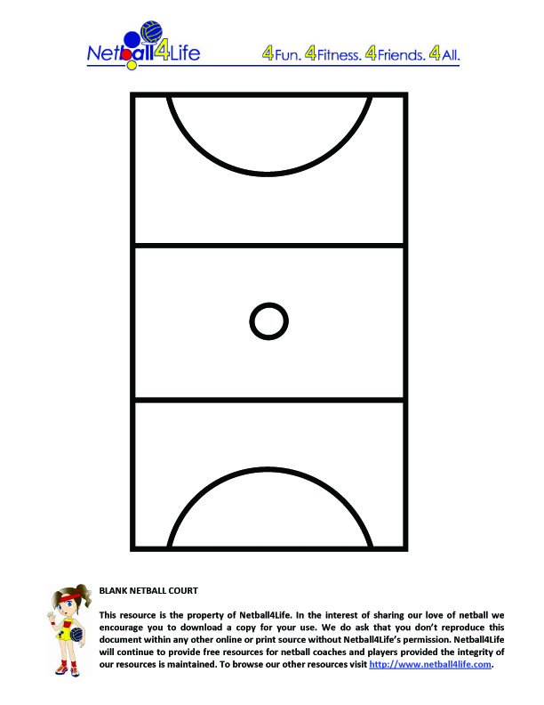

**Key:**

**Attacking team**

***X***

 **GA**

***X* Defending team**

***X***

 **WA**

***X***

 **C**

**Player Movement**

**Ball Movement**

**-------->**

**Supporting Statement:** Write a supporting statement **explaining** your decisions and player movements to show your understanding of the correct attacking option based on the scenario.

***X***

 **WD**

|  |  |
| --- | --- |
| **Part 1: Total Marks /5** | **Signed:** |