PDHPE ES1 student workbook – lessons 3 and 4
Name:
Class:

How do I build positive relationships with others?
You will:
- Identify that people have different thoughts, feelings and responses (Lesson 3)
- participate in a range of activities and explain which ones you enjoyed (Lesson 3)
- recognise that being kind, fair and respectful to others can support wellbeing
(Lesson 4)
- recognise how it feels to be included and excluded from activities ( Lesson 4)

Resources
- help from an adult
- pencil
- coloured pencils or crayons

Lesson 3 – Different responses
During this activity you will explore how people think, feel and respond to situations.
3.1 Discuss with your teacher or parent/caregiver how you felt during the below situation.
- How did you feel on your first day of school this year?
- How do you feel about eating breakfast?
- How do you feel about eating vegetables for dinner?
- How do you feel about tidying your bedroom?
3.2 Survey 2 people. This could be a parent/caregiver, brother, sister, friend, a family member. You might need to call them if they are not in your house.
Record who you surveyed and write their response in the table.
Table 4 Different responses (continues onto the next page).
Person one’s name:
Situation | Response
How did you feel on my first day of school this year?
How do you feel about eating breakfast?
How do you feel about eating vegetables for dinner?
How do you feel about tidying your bedroom?
Table 4 Different responses continued
Person two’s name:
Scenario | Response
How did you feel on my first day of school this year?
How do you feel about eating breakfast?
How do you feel about eating vegetables for dinner?
How do you feel about tidying your bedroom?
Discuss the following questions with your teacher or parent/carer.
- Did anyone have the same feelings or response as you in the situations?
- Why do you think people felt the same or different to you?
- Why do people have different feelings, thoughts and responses?
3.3 Complete the following activities.
- 10 star jumps
- Count to 20
- Read a page in a book
- Throw and catch an object 10 times with a parent/caregiver
Discuss the following questions with your teacher parent/caregiver.
- Which activity did you enjoy the most? Why?
- Which activity did you enjoy the least? Why?
3.4 Have 2 people complete the following activities and answer the questions.
- 10 star jumps
- Count to 20
- Read a page in a book

Record who completed the activities and their response to the questions.
Table 5 Different responses
Person 1:
Question | Response
Which activity did you enjoy the most? Why
Which activity did you enjoy the least? Why?
Person 2:
Question | Response
Which activity did you enjoy the most? Why?
Which activity did you enjoy the least? Why?

Discuss the following questions with your teacher or parent/caregiver.
- Did anyone enjoy the same activity as you?
- Did anyone have the same least favourite activity as you?
- Why do people have different feelings, thoughts and responses towards these activities?
- Does everyone enjoy the same things? Why/why not?
- Does everyone feel the same things? Why/why not?

Lesson 4 – Kindness and inclusion
During this activity you will recognise that being kind, fair and respectful to others can support wellbeing. You will also recognise how it feels to be included and excluded.
4.1 Discuss the following questions with your teacher or parent/caregiver.
- What does it mean when someone is kind? How does that make you feel?
- What does it mean when someone is unkind? How does that make you feel?
Think of a time when you were kind to someone and draw a picture of you doing this. For example, sharing your toys with another person.
Explain to a teacher or parent/carer what you are doing in the picture and how you and the other person felt.
4.2 Discuss the following questions with your teacher or parent/caregiver.
- What do we mean when we say someone is being fair?
- How does it feel when someone is being fair?
- Can you think of a time when you were fair to someone or someone was fair to you?
Draw a picture of you being fair to someone or someone being fair to you. For example, taking turns in a game.
Explain to a teacher or parent/carer what you are doing in the picture and how you and the other person felt.
4.3 Look at this picture of the child being excluded (left out) from the game. Discuss with your teacher or parent/carer how do you think the child being excluded (left out) is feeling?
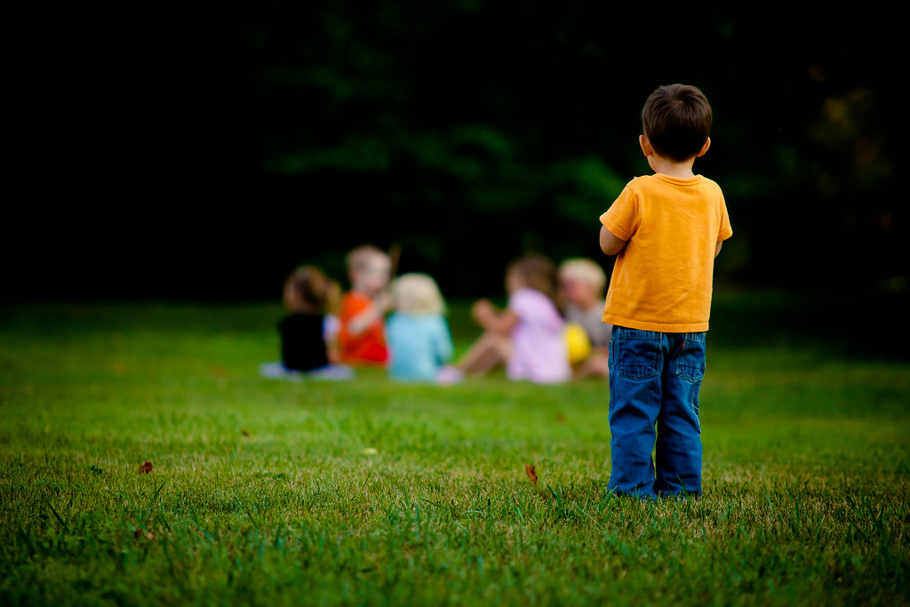
Image from flickr.com
Draw a face on the circle to match how the child being excluded is feeling?
Look at the picture above again and discuss with your teacher or parent/carer what could be done to help the child feel better?

4.4 Look at the picture of the group of students playing. Discuss with your teacher or parent/carer the following questions.
- What do you think is happening?
- How do you think the group of children are all feeling? Why?
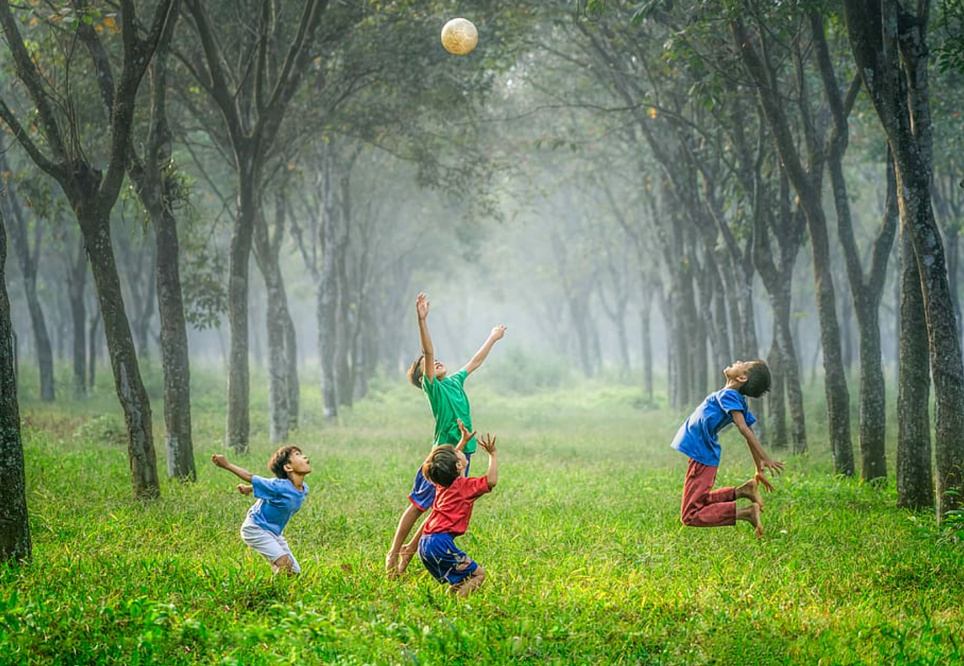
Image from wallpaper flare
Draw your own face on the circle to match how you are feeling when you are included in activities.

