How can we solve problems when moving?
Student workbook Early Stage 1
Name:
Class:

Overview of lessons 1 and 2
You will
- explore possible solutions to accurately throwing an object towards a target (lessons 1-2)

Resources

Lessons 1-2
- 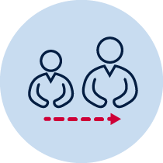help from an adult
- A soft object to throw (for example, soft ball, pair of socks, soft toy, scrunched-up paper)
- An object or landmark to create a target for the object to hit (for example, bucket, a long piece of string laid in a circle, an ‘X’ formed by two pieces of tape/material, a t-shirt laid on the ground, a chair/bench, a wall, a tree)
- Refer to 'Hit the target' game card for suggestions of what this activity could look like. (Sport Australia, 2019. Playing for life)

Lesson 1 – Throwing for accuracy
- 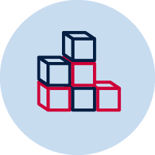Create a target that you can safely throw a soft object towards. Choose a ‘starting point’ where you will throw the object from.
- Throw the object towards the target. You should aim to hit the target. Pick up the object from where it landed and throw the object again until the target has been hit.
- Repeat the challenge 5 times attempting to hit the target in a fewer number of throws.
Throwing for accuracy examples
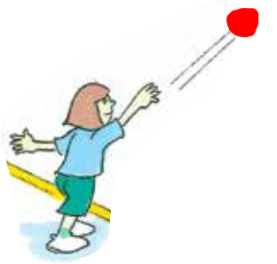

- Record how many throws it took to hit the target.
Table 1 Throwing for accuracy
Throwing accuracy | Attempt 1 | Attempt 2 | Attempt 3 | Attempt 4 | Attempt 5
How many throws did you it take to hit the target?
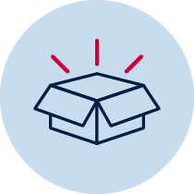 Resources
- A soft object to throw (for example, soft ball, pair of socks, soft toy, scrunched-up paper)
- An object or landmark to create a target for the object to hit (for example, bucket, a long piece of string laid in a circle, an ‘X’ formed by two pieces of tape/material, a t-shirt laid on the ground, a chair/bench, a wall, a tree)
Lesson 2

Activity 1 - Using different throws
- Throw your object and attempt to hit the target in as few throws as possible. Have 5 attempts using each type of throw.
- Record how many throws are used in each attempt for each throw.

Table 2 Using different throws
Type of throw | Attempt 1 | Attempt 2 | Attempt 3 | Attempt 4 | Attempt 5
Overarm throw
One handed underarm throw
Two handed underarm throw

Discuss the following reflective questions with your teacher or parent/caregiver.
- What type of throw was successful? Why?
- What type of throw was unsuccessful? Why?
- Describe how you moved your body with each type of throw you used.
Resources
- A soft object to throw (for example, soft ball, pair of socks, soft toy, scrunched-up paper)
- An object or landmark to create a target for the object to hit (for example, bucket, a long piece of string laid in a circle, an ‘X’ formed by two pieces of tape/material, a t-shirt laid on the ground, a chair/bench, a wall, a tree)
Lesson 2

Activity 2 – Adjusting your throw
- Throw your object and attempt to hit the target in as few throws as possible.
- Perform each type of throw 5 times from each ‘starting point’.
- Record the number of throws to hit the target from each ‘starting point’.

Table 3 Adjusting your throw
Type of throw | Start point 1 | Start point 2 | Start point 3 | Start point 4 | Start point 5
Overarm throw
One handed underarm throw
Two handed underarm throw

Discuss the following reflective questions with your teacher or parent/caregiver.
- What type of throw was successful? Why?
- What type of throw was unsuccessful? Why?
- Describe how you moved your body with each type of throw you used
Resources –
- A soft object to throw (for example, soft ball, pair of socks, soft toy, scrunched-up paper)
- An object or landmark to create a target for the object to hit (for example, bucket, a long piece of string laid in a circle, an ‘X’ formed by two pieces of tape/material, a t-shirt laid on the ground, a chair/bench, a wall, a tree)

