PDHPE Stage 4 – Child Protection Education

Resources – Establishing and maintaining respectful relationships online and offline
Contents
Cards: Building respectful relationships 3
Cards: How do I know? 9
Cards: Am I ready? 10
Age groups 10
Teacher notes: Am I ready? Regarding consent 12
Sex and emotional readiness 12
Sex and the law 13
Cards: What consent sounds like? 15
Cards: Types of power 16
Cards: Consent? Yes or No? 18
Teacher notes: Consent? Yes or No? Scenarios 19
Scenario 1: Manny and Lina 19
Scenario 2: Dimitri and Alana 21
Scenario 3: Ayla and Ahmed 21
Scenario 4: Sam and Alex 22
Cards: Consent? Yes or No? Scenarios 23
Worksheet: Consent? Yes or No? 25
Scenario 1: Manny and Lina 25
Scenario 2: Dimitri and Alana 26
Scenario 3: Ayla and Ahmed 27
Scenario 4: Sam and Alex 27
Worksheet: Gut instincts placemat activity 28
Teacher notes: The good, the bad, the ugly 29
Cards: The good, the bad, the ugly 31
Sorting activity 31
Worksheet: Taking action scenarios 34
Scenario 1 34
Scenario 2 34
Scenario 3 34
Scenario 4 34
Worksheet: Assertiveness advice 35
Act by ... 35
Tell or talk it over with ... 35
Plan for the future by ... 35
Worksheet: Trust, Talk, Take control 36
The model 36
How to put it into action: 36
Trust your gut 37
Cards: Respectful relationships in an online continuum 38
Signs 38

Cards: Building respectful relationships
Humour | Empathy
Safe | Love

Equality | Freedom
Honesty | Trust

Consent | Negotiation
Sharing | Acceptance

Independence | Difference
Comfortable | Loyal

Confidence | Forgiveness
Support | Individuality

Respect | Acceptance
Growth | Protect

Cards: How do I know?
Helps me with my homework | Sits next to me | Won’t sit next to me
Sends someone to  tell me that he or she likes me | Calls me by my name | Has sex with me
Doesn’t want me to see my friends | Makes me feel OK when I say what I really think rather than feeling like they’ll dump me | I feel like I can be myself
Won’t kiss me | Gets really jealous if  I talk to other people | Talks to me
Phones me | Brushes against me when we pass by each other | Shares important secrets and feelings
Smiles at me | Wants to spend time  with me | Listens to me
Asks my opinion | Laughs at me | Puts me down
Invites me to be a friend on social networking | Throws paper at me | Sends me a smiley text
Wants to hold my hand | Wants me to give her/him oral sex | Keeps me a secret from their friends
Holds my hand when  no one is around | Kisses me | Borrows my calculator during class

Cards: Am I ready?

Age groups
AGE  14 | AGE  16 – 18
AGE  12 – 13 | AGE  15
AGE  22 – 30 | AGE  36 – 40
AGE  19 – 21 | AGE  31 – 35

Teacher notes: Am I ready? Regarding consent
Below are just two aspects involved in determining the appropriate age for a sexual relationship. There are countless more, such as family and religious values, cultural expectations etc.

Sex and emotional readiness
Sex is meant to be:
- something you decide to do when you’re ready to
- something that makes both participants feel good
- something both people agree to and are mentally old enough to be able to consent to
- something you can interrupt or stop at any time
- safe (because you’re both prepared with condoms to protect you from sexually transmissible
- infections and unwanted pregnancy)
- something you are legally old enough to engage in
- honest – emotionally and factually honest
- mutual – a shared, two-way intimate experience.
Sex isn’t meant to be:
- the only way to prove that you love someone
- something you feel pressured or forced into
- something you do because ‘everyone else is doing it’
- something that makes you feel used
- about using someone else for sex alone.

Sex and the law

Age of consent
There are no laws about when you can start to have a relationship with someone else but there are laws about when you can start to have sex.
If you are 12 to 15 years of age, a person can’t have sex with you, touch you sexually or perform a sexual act in front of you if they are more than two years older than you – even if you agree. And that means two years exactly. If they are two years and four days older, it is still against the law.
At 16 to 17 years of age, a person who is caring for you or supervising you, like a teacher, youth worker or foster carer, can’t have sex with you, sexually touch you or perform a sexual act in front of you – even if you agree – unless they are married to you.

When one person does not agree to sex
As well as imposing age limits, the law says that two people can’t have sex unless they both agree (consent) to. If you don’t agree and someone threatens you or touches you sexually they are breaking the law.
If someone has sex with you or touches you sexually when you are asleep, unconscious or so affected by alcohol or drugs that you are not able to agree, it is still sexual assault.

Mobile phone pictures and the risks of ‘sexting’
‘Sexting’ or sending ‘sext’ messages refers to situations where nude and/or sexual images are taken on a mobile phone, tablet, web-cam or other device, often by young people and their friends. This is a crime if the photo includes a person under the age of 18. ‘Sexting’ is already leading to young people being charged by the police with child pornography offences.
Taking or sending pictures of your friends on your mobile phone or other device, or posting them online, especially if they are not fully dressed and even if they agree, could end up with you being charged by police for committing a criminal offence.
Adapted from the Victoria Legal Aid website – https://www.legalaid.vic.gov.au/.

Useful websites
- ‘Love: the good, the bad and the ugly’ produced by the Domestic Violence Centre Victoria http://lovegoodbadugly.com/
- Online safety information produced by the Australian Government https://info.australia.gov.au/information-and-services/public-safety-and-law/online-safety
Recommended legal resources for teachers and students
Am I old enough? is a handy booklet for young people about the law. Order or download for free at: https://www.legalaid.vic.gov.au/find-legal-answers/sex-and-law
Young people and the law is a teachers’ kit. Order or download for free at: https://www.legalaid.vic.gov.au/find-legal-answers/free-publications-and-resources/sex-young-people-and-law-education-kit

Cards: What consent sounds like?
What consent sounds like
What consent doesn’t sound like

Cards: Types of power
Sort the cards into piles, what consent sounds like and what consent doesn’t sound like.
"YES!" | "No"
"Yassssss" | "Stop"
"Absolutely" | "Maybe"
"That sounds great" | "I'm not sure"
"That feels awesome" | "I don't want to"
"Let's do that more" | "I don't think I'm ready"
"I'd like to ..." | "Can we slow things down"
"Would you please ..." | Pulling away or resisting
"I want to keep doing this" | Being silent or not responding
"I'm enjoying this" | Agreeing to go on a date
"Can we ..." | Not showing interest in you
Source: Kids Helpline: https://kidshelpline.com.au/teens/issues/what-consent

Cards: Consent? Yes or No?
Mutual  You both need to agree,  every single time. | Freely given  A choice you make without pressure, guilt or threats.
Informed  You understand what’s about  to happen. | Certain & Clear  It’s a YES, not a ‘maybe’ or  ‘I think so’ or ‘I guess so’.
Enthusiastic  You’re excited and WANT  to do the sexual activity. | Reversible  You can stop or change  your mind at any time.
Specific  Saying yes to one thing doesn’t mean yes to everything. | Ongoing  You need it before and during  the activity, as well as next time!
Source: Kids Helpline https://kidshelpline.com.au/teens/issues/what-consent

Teacher notes: Consent? Yes or No? Scenarios
Table 1 – What is consent?
Mutual  You both need to agree, every single time. | Freely given  A choice you make without pressure, guilt or threats. | Informed  You understand what’s about to happen. | Certain & Clear  It’s a YES, not a ‘maybe’ or ‘I think so’ or ‘I guess so’.
Enthusiastic  You’re excited and WANT to do the sexual activity. | Reversible  You can stop or change your mind at any time. | Specific  Saying yes to one thing doesn’t mean yes to everything. | Ongoing  You need it before and during the activity, as well as next time!
Source: Kids Helpline https://kidshelpline.com.au/teens/issues/what-consent

Scenario 1: Manny and Lina
Manny is 18 and Lina is 15 and they have been dating for 6 months.
Manny has had sex before and is super keen for things to “get moving” with Lina. Manny invites Lina over to his house one weekend night when his parents are out of town. Alone in the house, Manny talks with Lina about wanting to have sex and Lina tells him she’s not ready.
He gets a bit angry and says he’s not sure how much longer he can wait. A little later while making out in Manny’s room, he asks her again about having sex. Lina looks away and says “I guess so”. Things start to happen; Lina freaks out and says “stop!”. Manny replies with a frustrated “but you said yes?!!”.
- Is this consent?
No. Lina did not clearly indicate consent verbally or non-verbally. Also, when one person says “Stop” the other person has to listen otherwise they are breaking the law.
- Is it OK to withdraw consent?
Yes. It is ok to change your mind at any time.
- Is it OK to consent to some things and not others?
Yes. It is OK to say yes to some things and not others.

Scenario 2: Dimitri and Alana
Dimitri and Alana meet at the school disco, they are both 15.
They are having fun telling jokes and talking about movies they have both seen recently. Dimitri reaches over to kiss Alana. Alana enjoys it. Dimitri then starts to touch Alana. Alana does like it for a little while and then she starts feeling a little uncomfortable and unsure with where things are headed.
She tells Dimitri she doesn’t want to go any further right now. Dimitri ignores her and continues.
- Is this consent?
No. When one person says “Stop” the other person has to listen otherwise they are breaking the law.
- Is it OK to withdraw consent?
Yes. It is ok to change your mind at any time.
- Is it OK to consent to some things and not others?
Yes. It is OK to say yes to some things and not others.
- Will the experience be a positive experience for both of them?
No. They are likely to feel uncomfortable, regretful, violated.

Scenario 3: Ayla and Ahmed
On the weekend, Ayla goes out with Ahmed to the movies. Ayla is 13 years old and Ahmed is 17 years old.
After the movie Ayla and Ahmed make out. Ahmed then asks Ayla if she wants to have sex with him. She says yes. She really likes Ahmed and feels ready. They haven’t been drinking alcohol.
- Is this consent?
No. One person is under the legal age of consent (16 years old).
- Would the outcome be different if the gender of the people was the opposite?
In NSW it does not matter. Ayla could be the 17 year old and the outcome would be the same.

Scenario 4: Sam and Alex
Sam and Alex are a same-sex couple. They have been going out for one year now. They have been next door neighbours since they were little, so they know each other really well and really care for each other.
Sam is 13 and Alex is 15. Recently they have been talking about having sex together. They discuss what is OK and what is not OK with each other.
- Is this consent?
Yes, they are only talking at the moment.
- Is this legal?
Yes.
- If they have sex, will the experience be a positive experience for both of them?
Yes. It is consensual. Technically it is not legal because they are under the age of 16. However, if the situation was reported and investigated, it is unlikely to become a legal issue because it is ethically a consenting situation and the age difference between the two individuals is small indicating there is no power struggle.

Cards: Consent? Yes or No? Scenarios
Scenarios Scenario 1: Manny and Lina
Manny is 18 and Lina is 15 and they have been dating for 6 months.
Manny has had sex before and is super keen for things to “get moving” with Lina. Manny invites Lina over to his house one weekend night when his parents are out of town. Alone in the house, Manny talks with Lina about wanting to have sex and Lina tells him she’s not ready.
He gets a bit angry and says he’s not sure how much longer he can wait. A little later while making out in Manny’s room, he asks her again about having sex. Lina looks away and says “I guess so”. Things start to happen; Lina freaks out and says “stop!”. Manny replies with a frustrated “but you said yes?!!”.
Scenario 2: Dimitri and Alana
Dimitri and Alana meet at the school disco, they are both 15.
They are having fun telling jokes and talking about movies they have both seen recently. Dimitri reaches over to kiss Alana. Alana enjoys it. Dimitri then starts to touch Alana. Alana does like it for a little while and then she starts feeling a little uncomfortable and unsure with where things are headed.
She tells Dimitri she doesn’t want to go any further right now. Dimitri ignores her and continues.
Scenario 3: Ayla and Ahmed
On the weekend, Ayla goes out with Ahmed to the movies. Ayla is 13 years old and Ahmed is 17 years old.
After the movie Ayla and Ahmed make out. Ahmed then asks Ayla if she wants to have sex with him. She says yes. She really likes Ahmed and feels ready. They haven’t been drinking alcohol.
Scenario 4: Sam and Alex
Sam and Alex are a same-sex couple. They have been going out for one year now. They have been next door neighbours since they were little, so they know each other really well and really care for each other.
Sam is 13 and Alex is 15. Recently they have been talking about having sex together. They discuss what is OK and what is not OK with each other.

Worksheet: Consent? Yes or No?
Table 2 – What is consent?
Mutual  You both need to agree, every single time. | Freely given  A choice you make without pressure, guilt or threats. | Informed  You understand what’s about to happen. | Certain & Clear  It’s a YES, not a ‘maybe’ or ‘I think so’ or ‘I guess so’.
Enthusiastic  You’re excited and WANT to do the sexual activity. | Reversible  You can stop or change your mind at any time. | Specific  Saying yes to one thing doesn’t mean yes to everything. | Ongoing  You need it before and during the activity, as well as next time!
Source: Kids Helpline https://kidshelpline.com.au/teens/issues/what-consent

Scenario 1: Manny and Lina
Table 3 – Scenario 1 consent answers
Mutual  __ Yes __ N __ N/A | Freely given  __ Yes __ N __ N/A | Informed  __ Yes __ N __ N/A | Certain & Clear  __ Yes __ N __ N/A
Enthusiastic  __ Yes __ N __ N/A | Reversible  __ Yes __ N __ N/A | Specific  __ Yes __ N __ N/A | Ongoing  __ Yes __ N __ N/A
- Is this consent?
- Is it OK to withdraw consent?
- Is it OK to consent to some things and not others?

Scenario 2: Dimitri and Alana
Table 4 – Scenario 2 consent answers
Mutual  __ Yes __ N __ N/A | Freely given  __ Yes __ N __ N/A | Informed  __ Yes __ N __ N/A | Certain & Clear  __ Yes __ N __ N/A
Enthusiastic  __ Yes __ N __ N/A | Reversible  __ Yes __ N __ N/A | Specific  __ Yes __ N __ N/A | Ongoing  __ Yes __ N __ N/A
- Is this consent?
- Is it OK to withdraw consent?
- Is it OK to consent to some things and not others?
- Will the experience be a positive experience for both of them?

Scenario 3: Ayla and Ahmed
Table 5 – Scenario 3 consent answers
Mutual  __ Yes __ N __ N/A | Freely given  __ Yes __ N __ N/A | Informed  __ Yes __ N __ N/A | Certain & Clear  __ Yes __ N __ N/A
Enthusiastic  __ Yes __ N __ N/A | Reversible  __ Yes __ N __ N/A | Specific  __ Yes __ N __ N/A | Ongoing  __ Yes __ N __ N/A
- Is this consent?
- Would the outcome be different if the gender of the people was the opposite?

Scenario 4: Sam and Alex
Table 6 – Scenario 4 consent answers
Mutual  __ Yes __ N __ N/A | Freely given  __ Yes __ N __ N/A | Informed  __ Yes __ N __ N/A | Certain & Clear  __ Yes __ N __ N/A
Enthusiastic  __ Yes __ N __ N/A | Reversible  __ Yes __ N __ N/A | Specific  __ Yes __ N __ N/A | Ongoing  __ Yes __ N __ N/A
- Is this consent?
- Is this legal?
- If they have sex, will the experience be a positive experience for both of them?

Worksheet: Gut instincts placemat activity
List the physical and emotional signs of Alana’s ‘gut instincts’, both positive and negative, for each scene in the scenario.
Scene 1: Dimitri and Alana meet at the school disco; they are both 15. They are having fun telling jokes and talking about movies they have both seen recently. | Scene 2: Dimitri reaches over to kiss Alana. Alana enjoys it.
Scene 3: Dimitri then starts to touch Alana. Alana does like it for a little while and then she starts feeling a little uncomfortable and unsure with where things are headed. | Scene 4: She tells Dimitri she doesn’t want to go any further right now. Dimitri ignores her and continues.

Teacher notes: The good, the bad, the ugly
Table 7 – The good, the bad, the ugly sorting activity
Good | Bad | Ugly
I can see my friends or family whenever I want. | I feel overwhelmed by what they want. | I have to watch what I do or say around them.
I feel ok about saying ‘no’ to things I don’t want to do. | I feel stuck in this relationship. | I’m worried about what my partner might do if I tried to leave them.
My partner likes introducing me to his/her friends. | I hate it when my partner talks to other guys/girls. | My partner makes me feel scared of them.
They like me for who I am. | I wish my partner was different. | My partner pressures or guilt-trips me into sex.
They listen to me and care about my opinions. | I wish we didn’t see so much of each other. | They snoop and read my texts or messages.
We spend our spare time together. | I worry that my partner is cheating on me.
When we go out, we decide together what we’re doing. | They get jealous of who I hang out with.
When we’re together, I feel like I can be myself. | They ignore me when their mates are around.
When we’re together, we laugh and have fun. | We have the same fights over and over again.
With sex and affection, I can say what I like and don’t like. | When we’re hanging out, I wish I was somewhere else.

Cards: The good, the bad, the ugly

Sorting activity
Sort the statements into three piles good, bad or ugly.
I feel overwhelmed by what they want. | I feel stuck in this relationship.
I hate it when my partner talks to other guys/girls. | I wish my partner was different.
I wish we didn’t see so much of each other. | I worry that my partner is cheating on me.
They get jealous of who I hang out with. | They ignore me when their mates are around.
We have the same fights over and over again. | When we’re hanging out, I wish I was somewhere else.
I can see my friends or family whenever I want. | I feel ok about saying ‘no’ to things I don’t want to do.
My partner likes introducing me to his/her friends. | They like me for who I am.
They listen to me and care about my opinions. | We spend our spare  time together.
When we go out, we decide together what we’re doing. | When we’re together, I feel like I can be myself.
When we’re together, we laugh and have fun. | With sex and affection, I can say what I like and don’t like.
I have to watch what I do or say around them. | I’m worried about what my partner might do if I tried to leave them.
My partner makes me feel scared of them. | My partner pressures or guilt-trips me into sex.
They snoop and read my texts or messages.

Worksheet: Taking action scenarios

Scenario 1
Meg’s boyfriend won’t let her talk to other boys at school. If she does, he won’t speak to her or he gets really angry and yells. Meg feels really scared and avoids her male friends.

Scenario 2
Ali has liked Tara for ages and she finally agreed to go out with him. He really impressed her with a great first date which also included chocolates and her favourite flowers. Tara is nice to Ali when they are alone but she makes fun of him and puts her down in front of her friends and on her socials. Ali is feeling really down and doesn’t know what to do.
✂ - - - - - - - - - - - - - - - - - - - - - - - - - - - - - - - - - - - - - - - - - - - - - - - - - - - - - - - - - - - - - - -

Scenario 3
Leah and Joanie have been together for a year now. Joanie is Leah’s first real girlfriend and she is very into her. She is really worried about Leah cheating on her so is always checking up on what she is up to via her socials, and has even checked her phone messages when Leah is in the shower. She threatens to harm herself if Joanie breaks up with her. Joanie feels very trapped.

Scenario 4
Jack and Jess have been going out for a couple of months now. Jack tells Jess he will dump her if she does not have sex with him soon. He is sick of waiting. Jess is afraid of losing him so thinks she should have sex with him.

Worksheet: Assertiveness advice
If I were supporting the person in the scenario to be assertive, I would encourage them to:

Act by ...

Tell or talk it over with ...

Plan for the future by ...

Worksheet: Trust, Talk, Take control

The model
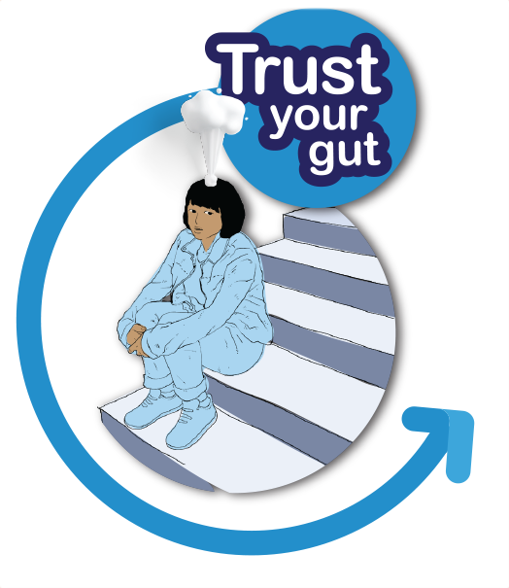1 | 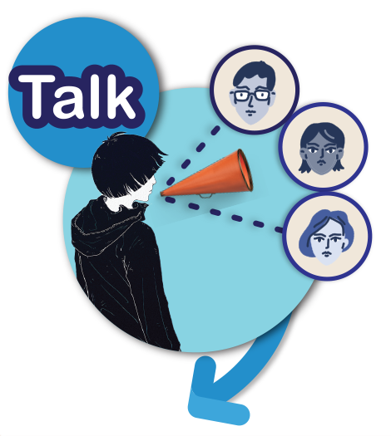2 | 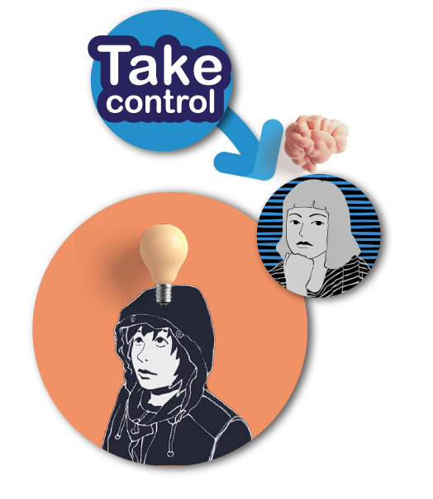3
- your feelings, thoughts and  - your reading of the situation | - talk about it to someone in your network | - by using your own plan  - become comfortable and safe.

The best course of action is the one that keeps us safe and
reduces our risk of being harmed.

How to put it into action:
- What’s my gut feeling?
- Who will I talk to?
If they aren’t available or aren’t helpful, who will I talk to next?
- My plan to become comfortable and safe is:
I know it will help me if I TRUST, TALK, TAKE CONTROL.

Trust your gut
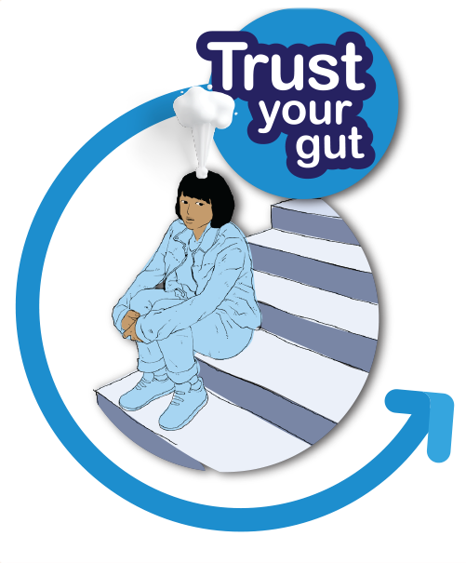1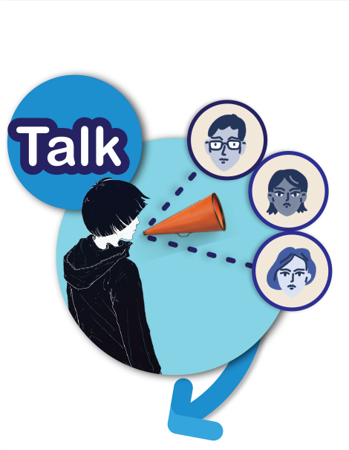2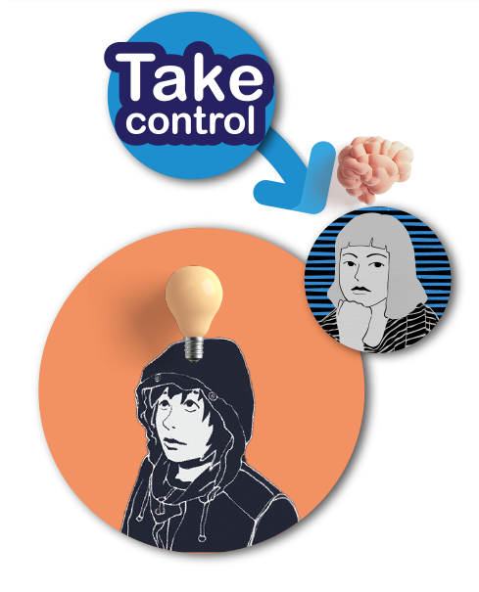3
Images adapted from “imagination-fairy-tale-creativity”, “fantasy-girl-sea-change-sea-breeze” and “creativity-thinking-painting” by CDD20 and are licensed in accordance with the Pixabay License.

Cards: Respectful relationships in an online continuum

Signs
Strongly agree
Agree

Disagree
Strongly disagree

