PDHPE

Stage 3: Child Protection Education

Resources

Power to Protect

Contents
Worksheet: Tropical island items for survival 2
Cards: Accidental Harm or Abuse? 4
Cards: Yes, sometimes, unsure and no 8
Worksheet: Physical abuse activity 10
Worksheet: Consent activity 12
Practise telling scenarios 13
Images of bedrooms 15
Cards: Emotional Abuse and Neglect 16
Worksheet: Kinds of feelings 21
At risk or not at risk scenarios 22
Teacher notes: Child Protection terms and Definitions cards 24
Cards: Child Protection terms and Definitions 26
Carly’s bus trip scenario 29
Tips for Saying No 31
Cards: Definition match 33
Worksheet: Carly and Rory scenario 36
Copyright register 38

Worksheet: Tropical island items for survival
1

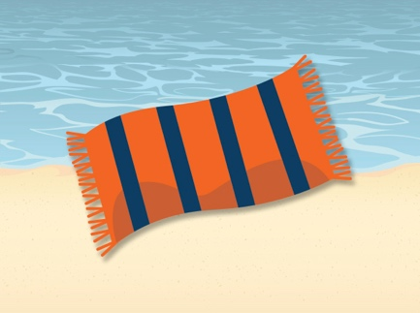2  A towel | 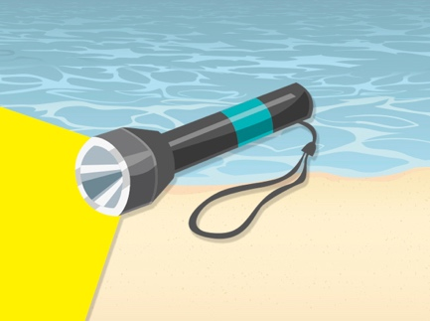3  Torch with 2 batteries | 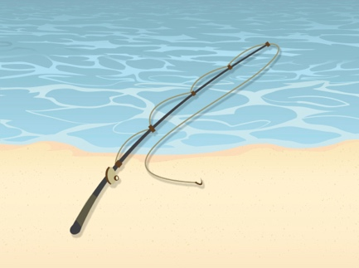4  A fishing rod
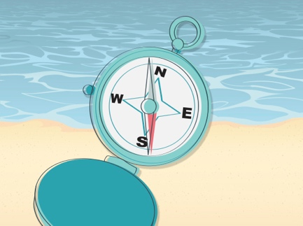5  A compass | 6  2 boxes of chocolate bars | 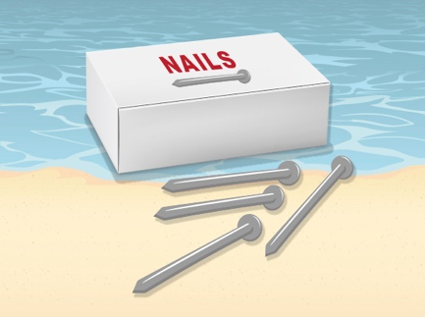7  Box of nails
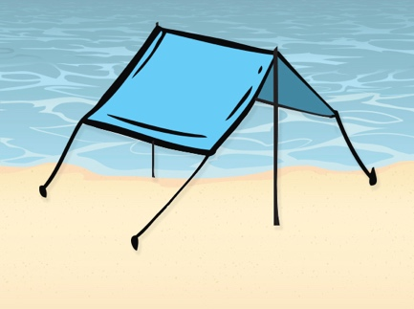  5 square metres of  plastic sheeting | 8  A pen | 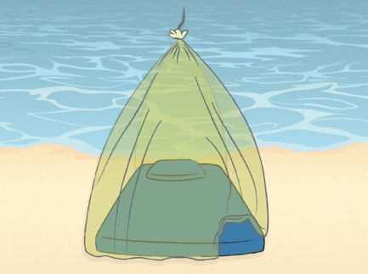  Mosquito netting for  1 person
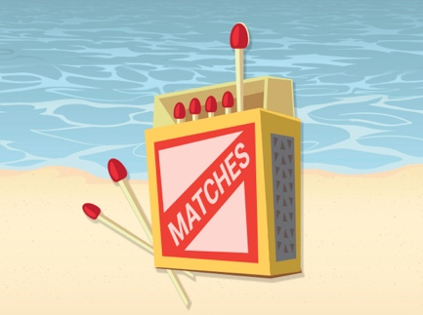9  A box of matches | 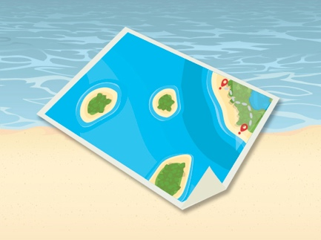10  Map of the campgrounds  and surrounding islands | 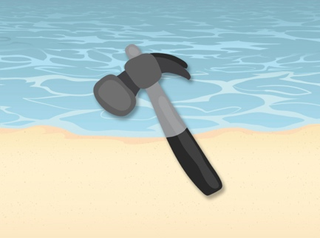11  A small hammer
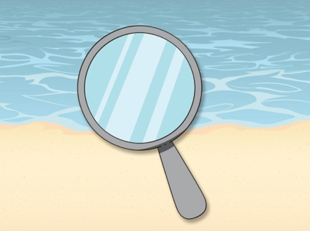12  A small mirror | 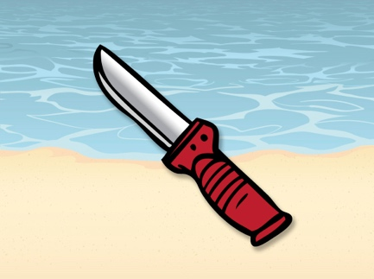13  Sharp peeling knife | 14  A pair of scissors
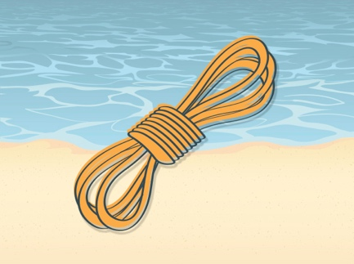15  10 metres of rope | 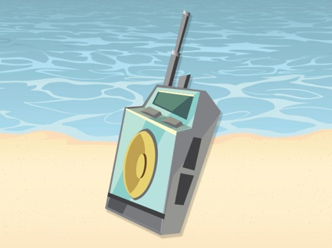16  A small walkie talkie with batteries | 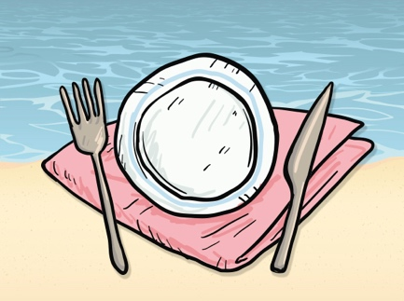17  A plate
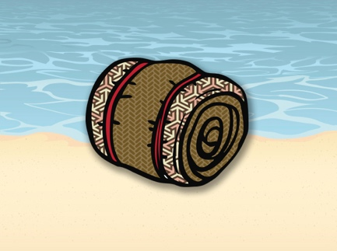18
A small blanket

Cards: Accidental Harm or Abuse?

Charlotte slips when she is tagged playing softball.
As she lands she fractures her wrist.
Someone from Sam’s sports team
insults and teases Sam every week.
Another student pushes the door open
when Yoko is in the toilet and tries to touch
Yoko’s private parts.
Pat knocks over something valuable
and her parents yell loudly at her
and tell her she was being careless.
Mick is chased and kicked by an older student
on his way home.
May falls over when she is bumped by her father
when they are playing a game on a slippery floor.
Ted can’t find his carer after school, one afternoon.
After fifteen minutes the carer turns up
and explains that he was delayed by traffic.
During an argument, Ellen’s friend calls her
a nasty name and upsets Ellen.
Annie is knocked over by a classmate running past.
Hamish’s babysitter often tells him that
his parents go out a lot because they think
Hamish is a pain to have around.
An angry carer pushes Sid against the heater
and holds him there for several minutes.
Anne is hit in the face with a basketball
thrown from another game.

Cards: Yes, sometimes, unsure and no
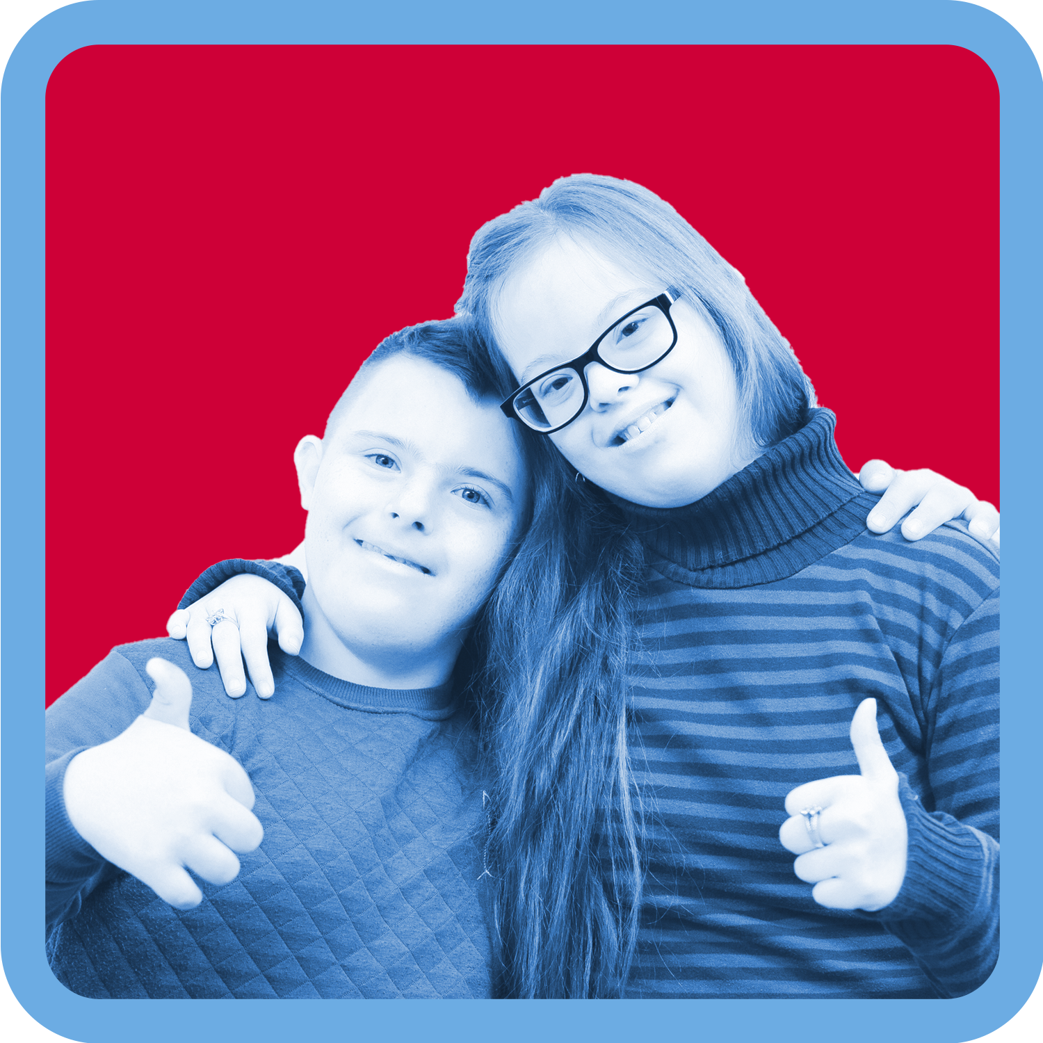19
Yes
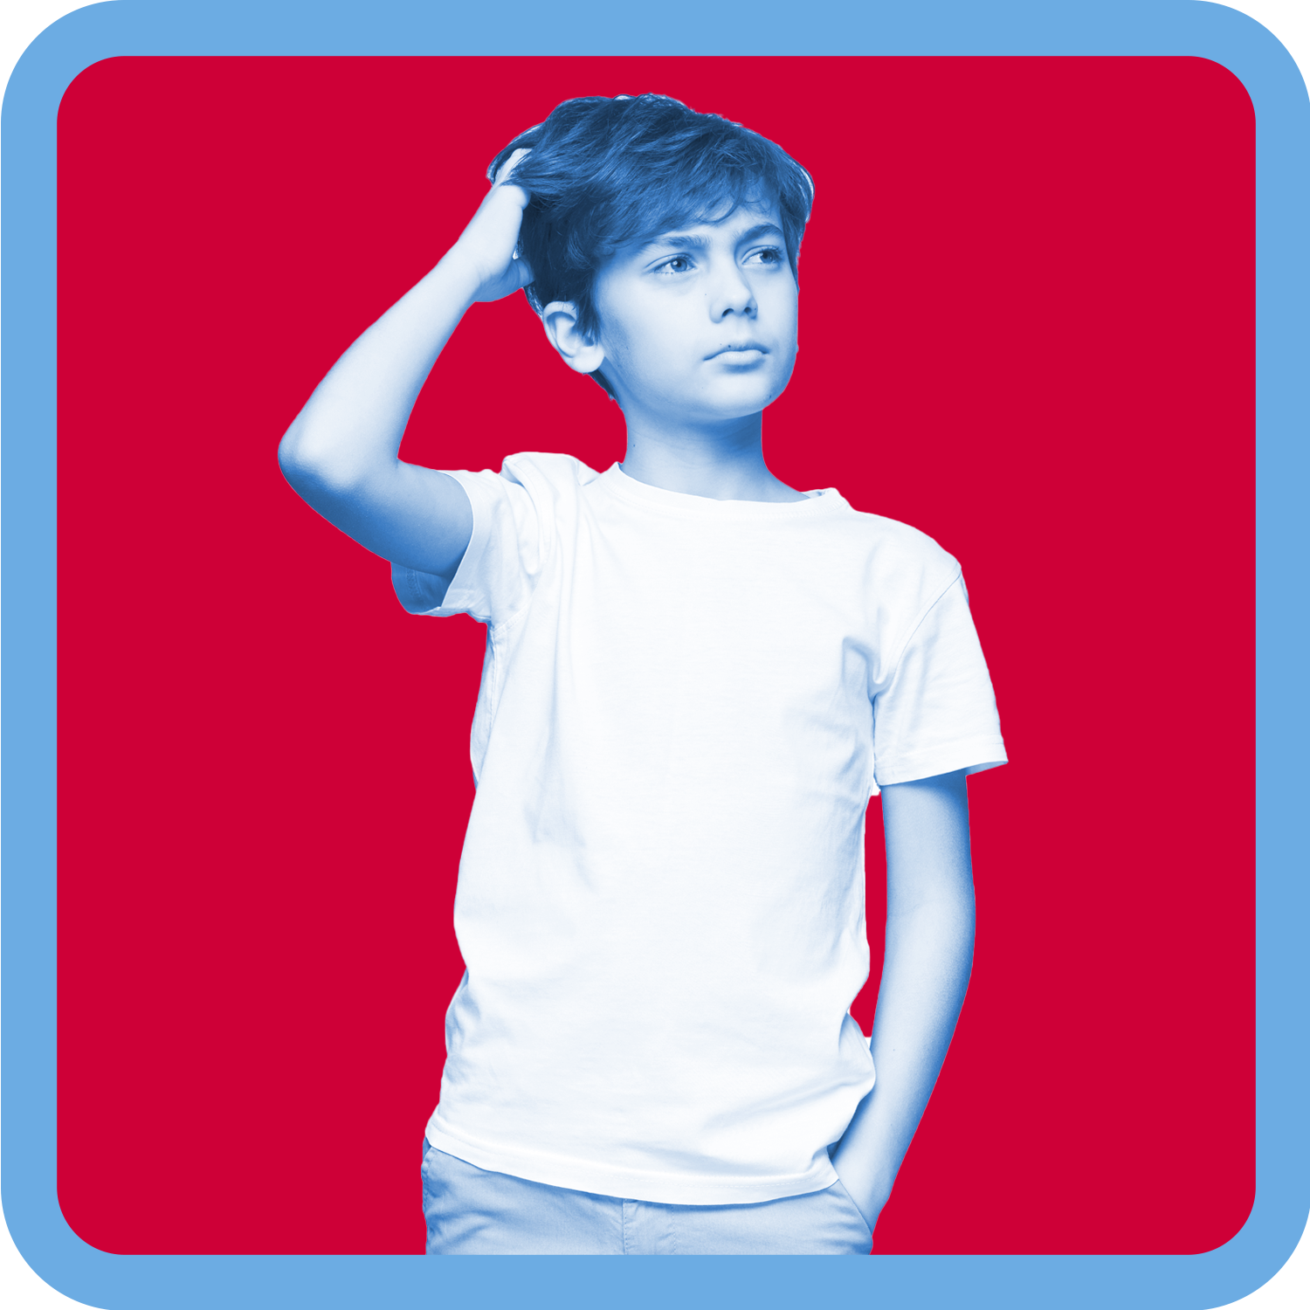20
Unsure
21
Sometimes
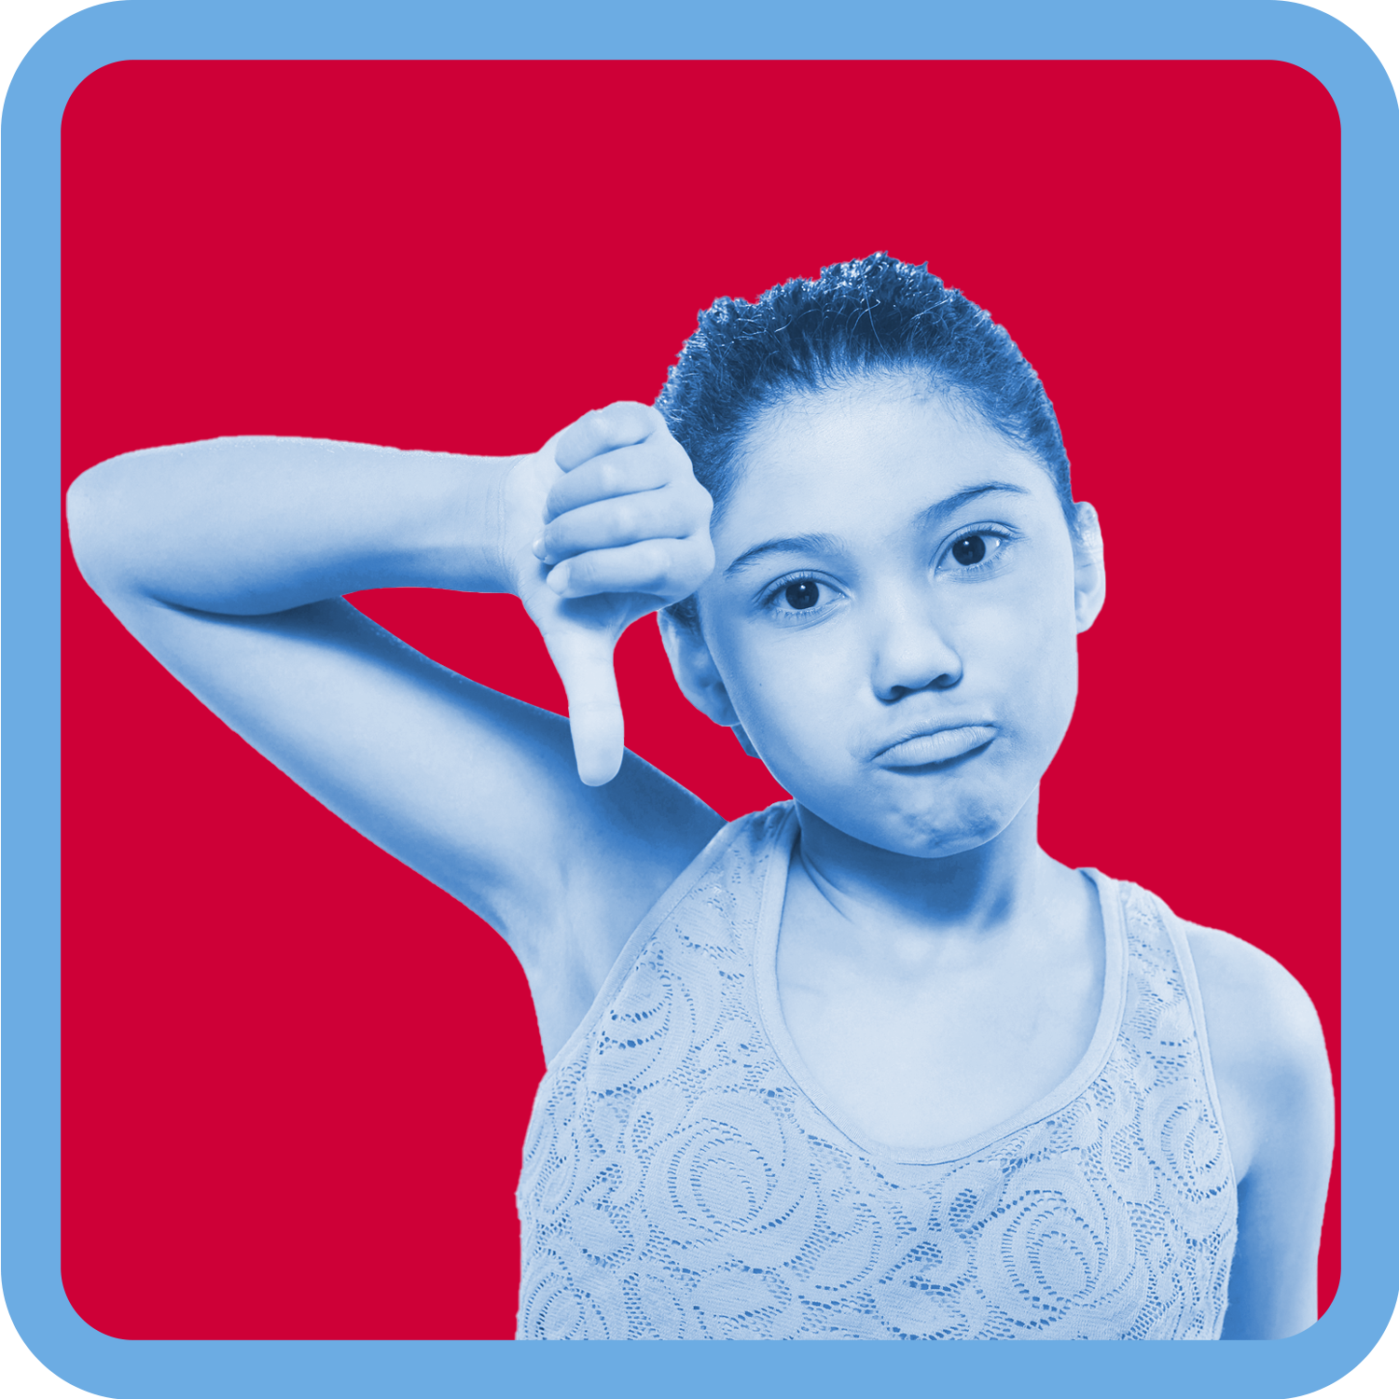22
No

Worksheet: Physical abuse activity
Read the scenario and complete the tasks at the end.
Mr Straker handed Eric the note. Eric wished he didn’t have to take the note home. Mr Straker was sending a note home because Eric didn’t hand in his homework, again. Eric knew his Mum was going to be mad.
He had wanted to hand in his homework but he hadn’t finished it. Every night Eric had to look after his little brother and baby sister and put them to bed. His Mum was always busy and she was always tired. If Eric left his brother and sister alone so he could finish his homework they would start to fight and cry. Then Eric’s Mum would yell at him, for a long time. Sometimes Eric’s Mum got very angry and while she was yelling at him she would throw things around the room. Once she threw a plate at Eric and it hit him on the face and cut him above his eye. Eric never knew what his mother would do when she got angry.
That night Eric’s mother had just made a cup of hot coffee. He put the note on the table and went to his room. Eric heard his Mum open the note and start shouting. He heard her chair crash backwards on the floor as she stood up very quickly. Eric was worried. She stormed into Eric’s room yelling. She told him he was lazy and stupid and that he never did anything right. She said he was an embarrassment and that he made her life very difficult.
Eric tried to explain why he hadn’t done his homework. His mother screamed and told him she didn’t want to hear his excuses. She threw her cup of coffee at Eric. The hot coffee burnt Eric’s arm. He screamed. She told him to stop whimpering, then she left the room.
The next day Eric’s Mum said she was sorry. She told Eric that she’d been having a hard time at work and that he just made her so cross sometimes. She told Eric that if he made breakfast and cleaned it up properly he could go to the park and play with his friends.

Tasks
Eric didn’t feel like seeing his friends.
- Highlight any evidence of physical abuse to a character.
- Record the effects the physical abuse might have on the character?
- Record the feelings or body signals the character might be feeling before, during and after the abuse?
- Record how you could respond to the abuse if you were this character?

Worksheet: Consent activity
Scenarios | Was consent given?
Reg put his arm around Carol. Carol tried to move his arm but Reg held on tight. | Yes__ No __
Sara’s older sister said ‘Do you want a hug?’ Sara said ‘Yes’ and wrapped her arms around her sister. | Yes__ No __
Amarli’s friend took a photo of her while she was sleeping and put it up on social media. | Yes__ No __
Fran and James were on a date.  Fran grabbed James’ hand as they were skating. James felt weird because his parents were with them. | Yes__ No __
‘Jack, can I borrow your pencil?’ asked Sharni.  ‘Sure.’ replied Jack. | Yes__ No __
Mibin asked Meeka if he could give her a hug.  Meeka shrugged her shoulders. | Yes__ No __

Practise telling scenarios
You are with an older neighbour. They start to rub your bottom. You ask them to stop but they keep rubbing your bottom. You run away.
Practise a way of telling a trusted adult about this.

Your parents sometimes go out and leave you with a babysitter. One day your babysitter gives you a kiss goodnight but starts to cuddle you tightly. You don’t like it and ask them to stop. They tell you it’s ok because you like each other. They start kissing you more and they touch your private parts.
Practise a way of telling a trusted adult about this.

An online friend has been sending you pictures of them naked. You don’t know this person in real life but they pressured you to send some naked photos back to them. You did and now they are asking you to do things in the photos with your body that you don’t want to. They have threatened that if you don’t they will send your photos to all your friends and family.
Practise a way of telling a trusted adult about this.

You have a family member that has been touching your private parts. You have asked them to stop but they haven’t. Lately they have been making you touch them too.
Practise a way of telling a trusted adult about this.

Your older friend has been showing you a website with naked people doing things to each other. One day they force you to do some of the things that people were doing on the website. You feel sick, scared and guilty for letting it happen.
Practise a way of telling a trusted adult about this.

Every week your parents drop you off to train for sport. They are often late picking you up and your coach waits with you. The last few times the coach has started touching your private parts while you have been waiting to be picked up. Your coach has been messaging you saying how you are special and that you’re the best player on the team. They have been buying you gifts and have told you to keep it a secret so the other players don’t get jealous.
Practise a way of telling a trusted adult about this.

Images of bedrooms
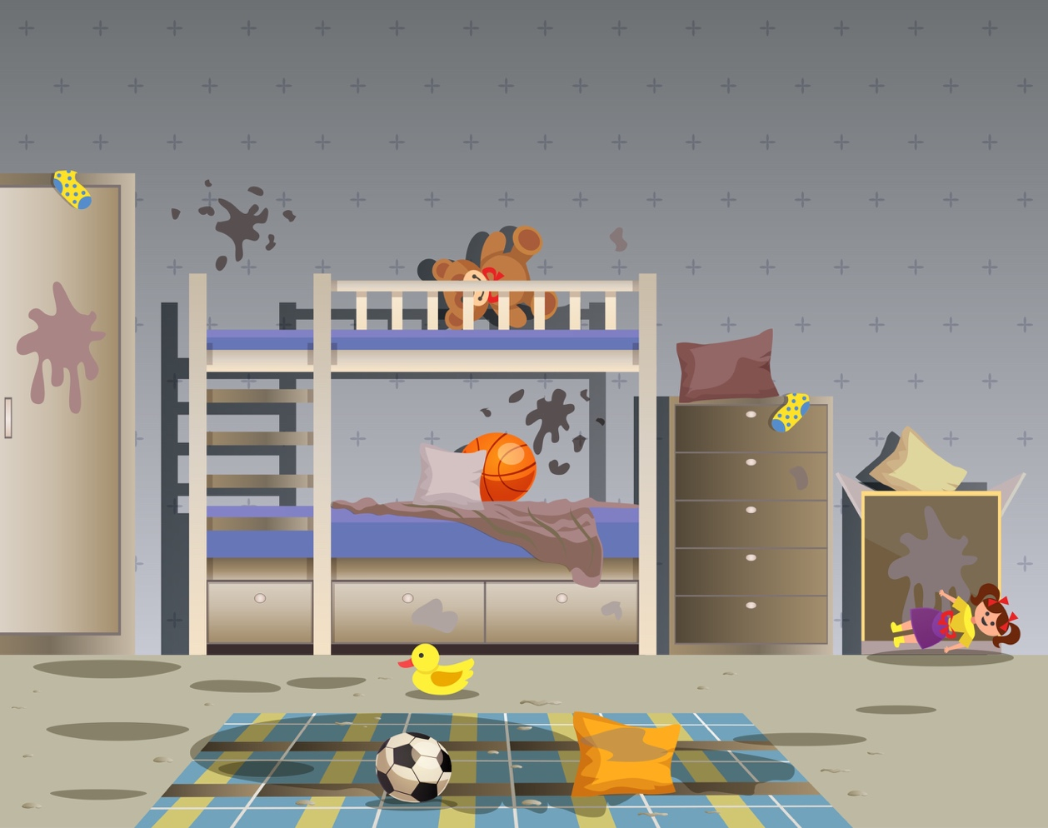23

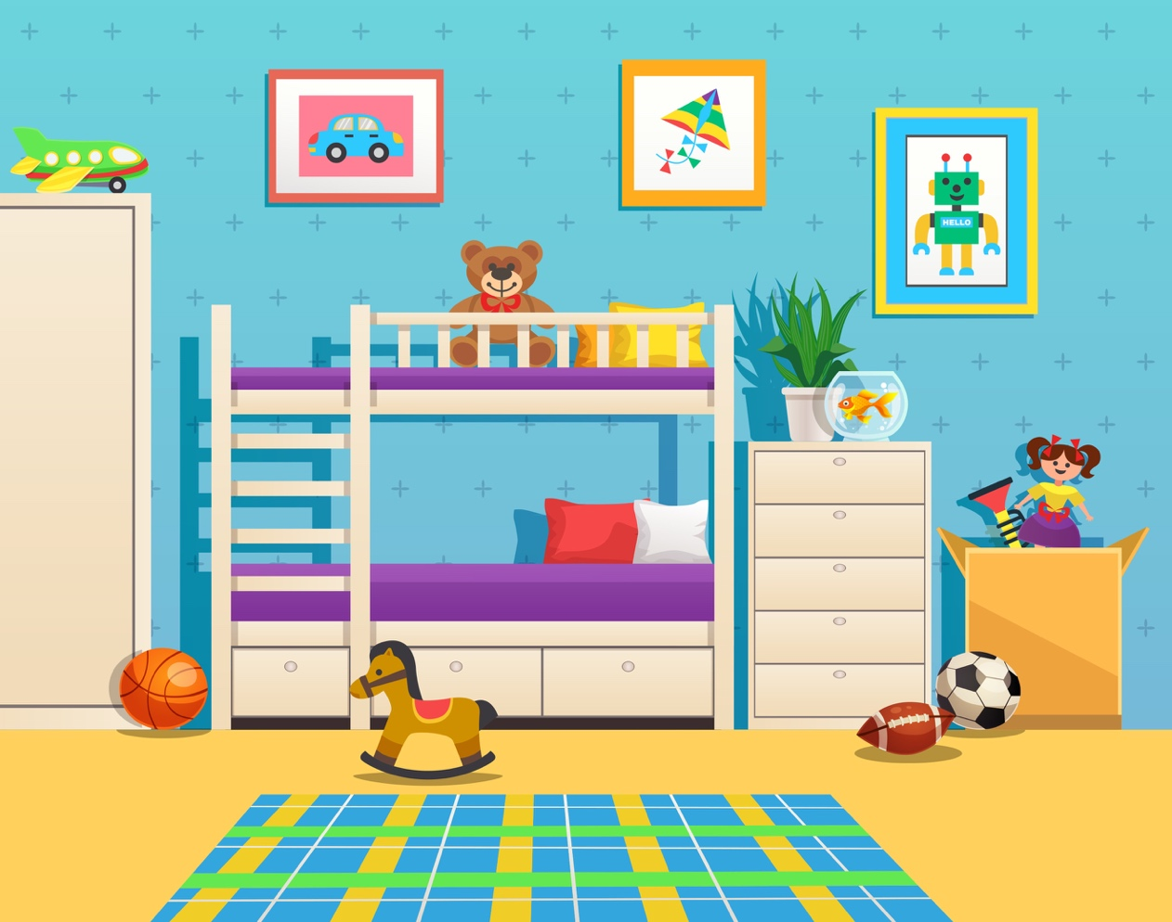23

Cards: Emotional Abuse and Neglect
Read each scenario to the class and ask students to place it under the heading that they think the scenario represents.

Emotional abuse
Neglect
No abuse
Unsure

Parents constantly saying a child is stupid and hopeless. | A Carer always blaming a child for every problem.
Caregivers always ignoring a child. | A Parent always telling  a child to put away toys after playing.
A Father sending their child to their room  for getting in trouble  at school. | A Mother regularly threatening and scaring a child.
A child not being fed breakfast every day. | A Babysitter locking a child in a room or the car for long periods of time.
Parents missing the school concert. | A Mother yelling at a child when the child comes home  two hours late.
Parents never holding, touching or hugging  a child. | A Father not letting  a child have friends  to play with.
A Carer not providing clean clothes for  their child. | Parents leaving  a young child home alone all night.
A Mother always telling  a child they wish they were never born. | Parents telling a child that he or she is evil  or bad.
A Father never letting  a twelve-year-old child go to the shops alone. | A Carer shouting at  a small child when  the child tries to run onto the road.

Worksheet: Kinds of feelings
Match the kinds of feelings to the definition.

Kinds of feelings
Mixed  Feelings | Confused Feelings
Uncomfortable Feelings | Changing Feelings

Definitions
Experiencing different or opposite feelings at the same time. For example – feeling proud that your friend won an award but being envious of his or her success.

When a feeling changes (usually unexpectedly or suddenly). For example – trusting someone and then seeing that person steal something of yours.

When you are unsure about how you feel or about what to think. For example – when you are getting different messages from the same person about whether you are their friend or not.

When you feel uneasy, surprised, a bit worried or nervous. For example – when someone you don’t know very well gives you a big hug.

At risk or not at risk scenarios
Scenario 1
You are going to the movies with a friend. You are waiting outside for your friend to pick you up and no one is around. A group of young people appear and start teasing you.
Scenario 2
You are on the way home from training when it starts raining. The coach suggests you take a short cut with him around the back of some old deserted factories.
Scenario 3
There is a fight in your home between two family members who lose their tempers during an argument. They become physically violent.
Scenario 4
An online friend begins asking you for a lot of personal information, such as where you live and when your parents are at home. You don’t give the friend any information.
Scenario 5
You are at home alone and a neighbour comes over to visit. He says he just wants some company, someone to talk to. Your family rule is not to open the door to anyone if you are home alone.

Scenario 6
You are playing in the playground after school when a classmate and some students you know from another school come to play.
Scenario 7
You know your friend carries a knife in his school bag. He has asked you not to tell anyone.
Scenario 8
You feel extremely uncomfortable at a party when a friend comes and dances with you so that you aren’t alone.

Teacher notes: Child Protection terms and Definitions cards
Terms | Definitions
bribes | Giving gifts or promising gifts and expecting favours in return.
threats | Words or actions which are meant to force another person to do, or not do, something.
secrets | Something that is hidden or concealed from others so they do not know about it.
aggression | Angry or violent behaviour or feelings.
body signals | A response in the body that is sending a message about how we are feeling.
inappropriate touch | A touch that makes you feel unsafe, uncomfortable or gives you no feelings.
consent | Giving permission for something to happen.
sexual abuse | Looking at, showing or touching the sexual parts of the body without permission.
mixed feelings | Experiencing different or opposite feelings at the same time
confused feelings | When you are unsure about how you feel or about what to think.
physical abuse | Non-accidental physical act that causes harm or injury to a person by another person.
neglect | Not paying attention to, or showing no care for, something or someone.
emotional abuse | Deliberate harm of someone’s thoughts or feelings.
uncomfortable feelings | When you feel uneasy, surprised, a bit worried or nervous. For example – when someone you don’t know very well gives you a big hug.
care | To look after and provide for the needs of someone or something.
rights | Things all children should have. There is no ‘question’ or ‘maybe’ about it - children should have these things.
protection | Keeping someone or something safe.
abuse of power | Doing something, making something happen or making someone else do something that is unfair, not ok and does not respect the rights of others.
respect | Treating people the way you want to be treated. Being caring and kind, and thinking and acting in a way that shows others you care about them and their feelings
active listening | Listening to what is being said and considering what the other person is saying.
support networks | People we can trust to support us when we need help.
changing feelings | When a feeling changes (usually unexpectedly or suddenly.

Cards: Child Protection terms and Definitions

bribes | secrets
threats | aggression
body signals | inappropriate touch
consent | sexual abuse
mixed feelings | confused feelings
physical abuse | neglect
emotional abuse | uncomfortable feelings
care | rights
protection | abuse of power
respect | active listening
support networks | changing feelings

Giving gifts or promising gifts and expecting favours in return. | Words or actions which are meant to force another person to do, or not do, something.
Something that is hidden or concealed from others so they do not know about it. | Angry or violent behaviour or feelings.
A response in the body that is sending a message about how we are feeling. | A touch that makes you feel unsafe, uncomfortable or gives you no feelings.
Giving permission for something to happen. | Looking at, showing or touching the sexual parts of the body without permission.
Experiencing different or opposite feelings at the same time | When you are unsure about how you feel or about what to think.
Non-accidental physical act that causes harm or injury to a person by another person. | Not paying attention to, or showing no care for, something or someone.
Deliberate harm of someone’s thoughts or feelings. | When you feel uneasy, surprised, a bit worried or nervous. For example – when someone you don’t know very well gives you a big hug.
To look after and provide for the needs of someone or something. | Things all children should have. There is no ‘question’ or ‘maybe’ about it - children should have these things.
Keeping someone or something safe. | Doing something, making something happen or making someone else do something that is unfair, not ok and does not respect the rights of others.
Treating people the way you want to be treated. Being caring and kind, and thinking and acting in a way that shows others you care about them and their feelings. | Listening to what is being said and considering what the other person is saying.
People we can trust to support us when we need help. | When a feeling changes (usually unexpectedly or suddenly).

Carly’s bus trip scenario
Carly caught the bus to school every day. Her Dad walked with her to the bus stop and waited with her until the bus came. While they were waiting they often talked about things they might do on the weekend and about anything else that came up.
The stop after Carly’s is her friend Margi’s stop. Margi and Carly sit together on the bus and usually look at funny photos of Margi’s dogs on her phone. Sometimes they just sit and talk, tell jokes or read their own books.
Carly and Margi repeat this on the way home from school, except sometimes one of them is too tired to talk so they just sit and relax. Often they’ll talk about how their day at school was and what happened in class.
One day Margi was sick and didn’t get on the bus so Carly had the seat to herself. Carly noticed that a classmate, Bob, sat in front of her. Bob smiled and said hello.
When the bus arrived at school, Carly stood up to leave. An older kid from another school flicked up Carly’s skirt and a bunch of other kids started laughing. Carly felt her face go hot and someone yelled out ‘Look at her face!’ and more laughter erupted. Carly held her skirt tight and rushed off the bus.
On the way home, Carly saw the older kid from the other school. He smiled at her and called her up the back of the bus. Carly felt uncomfortable about him but she walked up the back anyway. He introduced himself as Rory and asked if she wanted to sit with him. Carly said ‘No thanks.’ and sat in her normal seat.
As the bus pulled out of the stop, Rory came and sat next to Carly. Carly felt her heart start to beat faster and her face flush hot. Rory grabbed Carly’s skirt again and pulled it up. Carly pushed it back down and told Rory to stop. Rory laughed.
Rory got off at his bus stop and Carly felt her fists relax a little. Her heart was still racing and her chest was tight. Carly did not like today’s bus ride.

Margi was away again the next day and Carly felt worried about Rory getting on the bus and sitting next to her. Sure enough, Rory got on the bus, sat next to Carly and said ‘Thanks for saving me a seat’. Rory handed Carly a present and told her it was something he got especially for her. Carly thought maybe Rory was sorry for lifting her skirt and had bought her something to say sorry. Carly accepted the gift and opened it. It was a beautiful silver bracelet. Carly said ‘Thank you, but I can’t take this’. Rory insisted she have it because he bought it especially for her. Carly began to think that maybe Rory was actually nice.
Rory sat beside Carly and didn’t once try to lift her skirt. When the bus arrived at her school Carly went to stand up. Rory stopped her and said ‘You’ll have to give me a thank you kiss for the bracelet first.’ Carly froze and said ‘No.’
Carly couldn’t concentrate at school that day. She kept looking at the bracelet and thinking about what Rory had said. Carly liked the bracelet and she liked that Rory had given it to her but she didn’t want to kiss him.
When Carly got on the bus Rory was waiting for her. He was sitting on the window side so Carly thought it would be ok to sit next to him. Bob, her friend from school, sat in his usual spot in front of them. When Carly sat down Rory put his arm around Carly. Carly tried to move his arm but Rory held her tight. Rory said ‘I’ve been waiting for my kiss.’ Carly pushed harder and told Rory to stop. Bob heard Carly, turned around and saw Rory trying to kiss Carly. Bob stood up and told Rory to stop. Rory laughed and said ‘She’s my girlfriend.’ Bob said he didn’t care, Carly had asked him to stop and he needed to stop. Rory let go of Carly and said ‘Whatever. I want my bracelet back’ and pulled it off Carly’s wrist. Carly got up and moved to the front of the bus. Bob followed her and asked her if she was ok. Bob said he would tell the bus driver about Rory if she wanted him to.

Tips for Saying No
If you find yourself in a position where your peers are pressuring you to do something that you don’t want to do you can use these tips to help you to say ‘no’.

1 | Just say no or no thanks in a strong, assertive way.
2 | Say you don’t want to and give facts or a reason for saying no.
3 | Give a reason why it’s a bad idea.  For example: No, I don’t want to do that because it’s not worth getting in trouble for.
4 | Make an excuse.  It doesn’t matter if the excuse is true or not, just be confident. You might say you can’t because your parents are taking you somewhere and you need to be home or you have something else to do.
5 | Talk to someone about it.  You could talk to your close friends about the pressure and decide to stick together and support each other in saying no together. You could talk to your parents or another trusted adult about how to handle it.
6 | Suggest another idea.  For example: It’s a nice day, why don’t we go to the park/swimming/riding. This gives everyone a different option.
7 | Use humour or make a joke about it.
8 | Ignore the suggestion and start talking about something else.
9 | Leave the group or situation.  You can just leave without saying anything or make up an excuse.
10 | Ask a lot of questions. Why, what, how, when, who?  They might just give up and not pressure you anymore.

Cards: Definition match
bullying | consent
emotional abuse | gender stereotypes
harassment | neglect
non-verbal | physical abuse
respect | risk
safe | sexual abuse
unsafe | verbal

When someone or a group of people who have more power  than you, repeatedly use words  or actions to hurt you. | Getting permission to do something.
Continually using words and actions that hurt a child’s feelings and thoughts. | An idea about what it means  to be a boy or a girl or a woman  or a man and how people will act, based on the group to which they belong.
Continuous acts which are not wanted and offend or humiliate  a person.  An example is annoying someone again and again and again. | Not paying attention to, or showing no care for, something or someone.
Not involving or using words or speech. | Non-accidental physical act that causes harm or injury to a person by another person or people.
Being caring and kind and thinking and acting in a way that shows others you care about them and their feelings. | A situation that might cause danger, harm or loss.
Protected from or not exposed to danger or risk. | Looking at, showing or touching  the sexual parts of the body  without permission.
In danger of being hurt or harmed. | Use of words to send a message.

Worksheet: Carly and Rory scenario
Carly had been avoiding Rory since he harassed her on the bus. She had started to catch a different bus to school. It meant she had to walk further to the bus stop but she told her Dad that it was so she could catch the bus with a new friend she had. She hadn’t told her Dad about Rory.
One weekend Carly and her friends had organised to meet for a friend Margi’s birthday. They were all going to meet at the skate park and hang out. Carly was looking forward to Margi’s party. They hadn’t seen each other as much since Carly started catching a different bus to Margi.
Carly had told Margi about what happened with Rory. Margi got really angry and wanted to do something but she was worried about Rory being on her bus. Carly said it was ok and that as long as she didn’t catch the bus anymore it would be ok.
Carly’s Dad dropped her at the skate park and said he’d pick her up at 2pm. There were a few other people from school that Carly knew so she went to hang out with them. As she walked over she could see a group of older kids sitting on their bikes. When she got close to the group she heard a voice say ‘Hey, there’s my girlfriend. Where have you been Carly? I’ve missed you’ and then the group laughed. Carly felt her heart race, it was Rory.
Carly quickly walked past to her friends. Rory and his friends were still laughing at her. Rory kept looking at her and blowing her kisses. Carly felt uncomfortable and wanted to go home. Carly’s friends noticed Rory’s behaviour and asked Carly if she was ok. Carly said if she ignored him he would stop.
Rory did stop for a while but when some of her friends had left to go home, Rory came over. He put his arm around Carly but Carly pushed him away. Rory told Carly to relax and that he was just being nice and she was lucky he liked her because there were plenty of girls that would love to be his girlfriend. Rory rode back to his group and said something. They all looked over at Carly and a few of them laughed and one even gave Rory a high five.

- Pretend you are either:
- One of Carly’s friends that witnessed the things Rory was saying and doing
- Someone who was in Rory’s group who heard the things Rory was saying to or about Carly or
- Someone that didn’t belong to either group and you noticed what was happening between Rory and Carly.
- Discuss ways you could respond to what you were seeing or hearing.
- Write down the actions you would take to stop Rory from harassing Carly or to help Carly. What could you do to show upstander behaviour?
- Practise demonstrating this response with your partner.

Copyright register
- Island: Background vector created by freepik – www.freepik.com
Capsized boat: Background vector created by freepik – www.freepik.com
- Towel: Color vector created by terdpongvector – www.freepik.com
- Torch: Tools vector created by freepik – www.freepik.com
- Fishing rod: Abstract vector created by macrovector – www.freepik.com
- Compass: Tools vector created by freepik – www.freepik.com
- Box chocolate: Mockup vector created by vectorpocket – www.freepik.com
- Box for nails: Mockup vector created by freepik – www.freepik.com
- Pen: Ribbon vector created by macrovector – www.freepik.com
- Box of matches: Abstract vector created by macrovector – www.freepik.com
- Map: Travel vector created by freepik – www.freepik.com
- Hammer Color vector created by terdpongvector – www.freepik.com
- Mirror: Hand vector created by freepik – www.freepik.com
- Sharp knife: Tools vector created by freepik – www.freepik.com
- Scissors: Banner vector created by katemangostar – www.freepik.com
- Rope: Tools vector created by freepik – www.freepik.com
- Walkie-talkie: Background vector created by macrovector – www.freepik.com
- Plate: Food vector created by freepik – www.freepik.com
- Rolled blanket: Color vector created by terdpongvector – www.freepik.com
- Yes: Children photo created by freepik – www.freepik.com
- Unsure: Children photo created by freepik – www.freepik.com
- Sometimes: Camera photo created by drobotdean – www.freepik.com
- No: Background photo created by freepik – www.freepik.com
- Kid’s bedroom: Kids vector created by macrovector – www.freepik.com

