PDHPE Stage 1 – Child Protection Education

# Resources – Strengths and strategies for safety



Contents

Teacher notes: Strengths cards 2

Cards: Strengths 3

Cards: How does it rate? (Labels) 7

Same but different images 8

Worksheet: See, Think, Wonder 10

Cards: Number cards (1 – 10) 11

Images of different types of families 14

Support network templates 17

Cards: Yes, sometimes, no and uncertain 20

Babies images 21

Cards: Body signals 23

Soft animal toy images 25

Cards: Safe and unsafe touch situations 26

Cards: Touch flashcards 29

Cards: Secrets 31

Cards: Yes and no feelings 33

No feelings 33

Yes feelings 34

Teacher notes: Definition match 36

Cards: Definition match 37

Cards: What would you do? 40

Copyright register 42

## Teacher notes: Strengths cards

|  |  |
| --- | --- |
| Strengths | Definition |
| Honest | You tell the truth even when it is not easy. |
| Funny | You try to cheer people up by making them laugh. |
| Forgiving | You accept your friends’ apologies. |
| Kind | You help others and use kind words. |
| A leader | You help your group work well together. |
| Brave | You are able to do what is important even when you feel scared. |
| Self-control | You can do what is important even if you don’t want to. |
| Notice others | You think of how others might be feeling. |
| Assertive | You are able to say things in a strong, clear and fair way. |
| Fair | You include everyone and you follow the rules. |
| Determined | You keep trying even when it gets hard. |
| Curious | You like to learn new things and ask questions. |
| Patient | You can wait for your turn even if it takes a while. |
| Generous | You are good at sharing and giving. |
| Creative | You like to come up with new ideas and new ways of doing things. |
| Persistent | You keep trying even if you fail. |
| Notice myself | You notice how you are feeling and how that makes you behave. |
| Good listener | You listen to others ideas and how they feel. |

## Cards: Strengths

|  |  |
| --- | --- |
| Honest | Fair |
| Funny | Determined |
| Forgiving | Curious |
| Kind | Patient |
| A leader | Generous |
| Brave | Creative |
| Self-control | Persistent |
| Notice others | Notice myself |
| Assertive | Good listener |

|  |  |
| --- | --- |
| **Honest**  You tell the truth even when it is not easy. | **Fair**  You include everyone and you follow the rules. |
| **Funny**  You try to cheer people up by making them laugh. | **Determined**  You keep trying even when it gets hard. |
| **Forgiving**  You accept others’ apologies. | **Curious**  You like to learn new things and ask questions. |
| **Kind**  You help others and use kind words. | **Patient**  You can wait for your turn even if it takes a while. |
| **A leader**  You help your group work well together. | **Generous**  You are good at sharing and giving. |
| **Brave**  You are able to do what is important even when you feel scared. | **Creative**  You like to come up with new ideas and new ways of doing things. |
| **Self-control**  You can do what is important even if you  don’t want to. | **Persistent**  You keep trying even if you fail. |
| **Notice others**  You think of how others might be feeling. | **Notice myself**  You notice how you are feeling and how that makes you behave. |
| **Assertive**  You are able to say things in a strong, clear and  fair way. | **Good listener**  You listen to others ideas and how they feel. |

## Cards: How does it rate? (Labels)

|  |  |
| --- | --- |
| A boy faces sideways with a mouth-opened joyful smile. His fisted arms are thrust out straight above his head.1 | A mid shot of a girl and boy holding each other around the shoulders, smiling, with their heads tilted toward each other, and both giving a thumbs up sign.2 |
| Love it | Like it |
| A boy faces sideways with an expression of uncertainty on his face. His left hand is ruffling the back of his head and his right hand is in his trouser pocket.3 | A mid shot of a girl with a determined expression on her face. Her head slightly tilted to the right, holding her right hand to the right side of her forehead with a thumbs down sign.4 |
| Unsure | Don’t like it |

## Same but different images

|  |  |
| --- | --- |
| Four children are sitting in their seats at the movies. A young girl in the nearest seat looking at you and smiling with her hand placed on the side of her mouth. A large box of popcorn is on her armrest tray. Next to her is an older girl with a drink in her armrest tray. She and the other two children (a boy and a girl) are looking at the movie screen and smiling.  27 | A large bunch of fresh-looking broccoli.  28 |
| Going to the movies | Broccoli |
| Two partly opened chocolate with nut bars are lying on a board with a few broken pieces scattered about. | A young boy and a young girl are crouching with a piece of rubbish in one hand which they are about to place in the opened rubbish bags they are holding with the other hand.  29 |
| Chocolate | Cleaning |
| Side view of three young children eating ice cream from a cone. The middle girl is looking up and licking the ice cream and the other two are looking at their ice creams, which they are holding away from their mouths.  30 | A young boy wearing glasses is sitting at a desk with a large book opened in front of him. His right hand is placed on the book holding a pencil. His left elbow is resting on the left page of the book. He is leaning his head onto his left fist and looking up with a frustrated expression.  31 |
| Eating ice cream | Homework |
| Blocks of multi-coloured lego spread out on a wooden floor.  32 | A mid shot of a young girl embracing a small dog with her head tilted onto the dog’s head and a happy smile on her face.  33 |
| Lego | Patting a dog |
| An electronic video gaming console resting on a keyboard.  34 | A teacher speaking to a group of school children in a classroom. All the children are seated on the floor looking up attentively at the teacher. |
| Playing online | School |
| The face and front paws of a large stuffed teddy bear jutting out from a toy box with the lid of the toy box resting at an angle from the middle of the teddy bear’s head.  26 | Mum, dad and young daughter are playing in a swimming pool. The young girl sits in a pink blow-up ring between her parents.  35 |
| Stuffed toys | Swimming at the pool |

## Worksheet: See, Think, Wonder

Three rows of image and space for writing thoughts.
Row 1: Icon of an eye within a pink circle is positioned above the words ‘See. What do you see?
Row 2: Icon of an quizzical stylised face within a pink circle is positioned above the words ‘Think. What do you think is going on? The face has a hand scratching its chin and a thought bubble above.
Row 3: Icon of a question mark within a pink circle is positioned above the words ‘Wonder. What does it make you wonder?

## Cards: Number cards (1 – 10)

|  |  |
| --- | --- |
| A red bicycle standing upright with a white handle with black handlebars grips, a black seat, and black tyres.5 | A medium-haired large dog sits near a fluffy cat. The dog is dark brown with a white chest, white and tan paws, floppy brown ears and a large black nose. Standing next to it is a ginger cat with white markings on its chest and face, and its bushy tail erect.6 |
| 1 bike | 2 pets |
| 3 shoes7 | Four different sport balls, a yellow tennis ball, a white and black round soccer ball, a brown oval football with white laces and a white stripe at each end and an orange basketball with black stripes.8 |
| 3 shoes | 4 balls |

|  |  |
| --- | --- |
| Five different coloured front zip-up hoodies with side pockets. One is displayed in each corner and the last in the centre. Each colour (red, orange, white, army-green and blue) has the same v-stripe pattern from shoulder to chest, cuff and waist band but in a contrasting colour.9 | Six different styles of beanies are tied to two pieces of rope. Each piece of rope is slung from left to right on a diagonal. The smaller top rope has two colourful styles of beanies tied to it. The longer bottom rope has four colourful styles of beanies tied to it.10 |
| 5 hoodies | 6 beanies |
| A portrait of a family of seven members including the father, mother, teenage daughter, teenage son and young daughter, and their pet dog and cat. | Eight award ribbons are pinned up on a board in three, haphazard, horizontal rows. The awards are in various colours representing first and best (blue and gold) second place (red) and third place (green). There are four blue and gold ribbons, one gold, two red and one green.11 |
| 7 family members | 8 awards |

|  |  |
| --- | --- |
| Nine different toys are displayed on three wooden shelves. On the top shelf are four toys: a yellow rubber duck, a green wind-up tyrannosaurus rex dinosaur, a small brown and yellow train engine with a matching brown and yellow car. On the middle shelf are two toys: a multi-coloured patterned train engine and a small colourful kite with a long tail of bows hanging down from the shelf. On the bottom shelf are three toys: a blue and purple metallic retro robot, a black and white soccer ball and a yellow and blue single propellered plane with red targets painted on its wings and tail.12 | Ten books are stacked on two brown shelves. On the top shelf are two colourfully spined books lying flat next two books standing upright. On the bottom shelf are five books standing upright and showing their colourful spines. Stuck to the shelf beneath these books is a post-it note with a heart drawing. The sixth book on the shelf is a large book leaning against the wall with its front cover showing. On the cover is line drawing of mountain peaks above the word WONDER and a large drawing of a whale. A post-it note with a drawing of a light bulb is stuck on the lower corner of the large book.13 |
| 9 toys | 10 books |

## Images of different types of families

|  |  |
| --- | --- |
| A portrait of five family members. The mother and father are the main carers of three adopted children from different cultural backgrounds. Their two sons are five and one years old and their daughter is three years old. | An extended family portrait of five members at the university graduation of their eldest daughter. The mother, father and grandmother share the care of two younger children, a 14-year-old boy and a nine-year-old girl. |
| A portrait of seven family members The mother and father are from different cultural backgrounds and are the main carers of their five children, four-year-old twin daughters, a newborn daughter and two sons aged 10 years and 8 years old. | A portrait of four family members with their pets, a miniature poodle and fluffy white cat. The mother and father are the main carers of their two daughters. One daughter is a late teenager the younger is a girl of 12 years. |
| A portrait of four family members and their pet blue heeler dog. A single mother is the main carer of three children, a 17-year-old daughter sitting in a wheelchair, a 14-year-old son and a seven-year-old son. | A portrait of a stepfamily. A divorced mother and father stand either side of their 16-year-old daughter at her 16th birthday. The birthday girl holds the tie of a pink helium balloon with the words ‘sweet 16’. Her 12-year-old brother stands on the other side their mother. Their father and his partner stand behind and their three-year-old daughter who stands on a chair holding the tie of a pink helium balloon with the words ‘sweet 16’. |
| A portrait of three family members and their pet border collie dog. The mother is sitting in a wheelchair beside the father. In front is their five-year-old son and their pet dog. | A portrait of three family members. Two fathers stand besides each other. In front of them, standing on a chair and holding the tie of a pink-helium balloon, is their five-year-old daughter. |
| A portrait of five family members. The grandmother and grandfather are the main carers of three granddaughters. The eldest granddaughter is a late teenager, the middle granddaughter is 11 years old and the youngest is seven years old. | A portrait of four family members. Two mothers are the main carers of their 10-year-old son and two-month-old baby daughter. |
| A wedding portrait of a multicultural couple and their extended family. The bride’s mother, father and teenaged sister and brother pose with their grandfather. The groom’s large family of brothers and sisters, uncles and aunts and cousins pose alongside his mother, father and grandmother. | |

## Support network templates



A line illustration of large flower with four red-lined petals and a blue centre. The petals represent four people identified as the student’s network of trusted people. The blue centre represents adults in the student’s home.

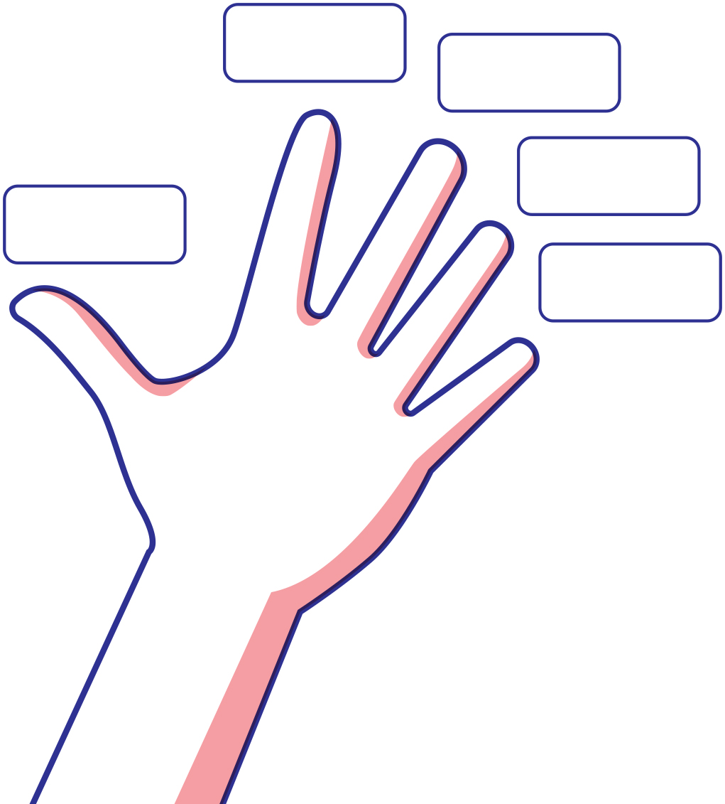

## Cards: Yes, sometimes, no and uncertain

|  |  |
| --- | --- |
| A mid shot of a girl and boy holding each other around the shoulders, smiling, with their heads tilted toward each other, and both giving a thumbs up sign.2 | A mid shot of a young girl with long hair wearing a beanie, with her arms at shoulder level. Her right hand is touching her right cheek giving a thumbs-down sign and her left hand is near her left ear giving a thumbs up sign. 14 |
| Yes | Sometimes |
| A mid shot of a girl with a determined expression on her face. Her head slightly tilted to the right, holding her right hand to the right side of her forehead with a thumbs down sign.4 | A boy faces sideways with an expression of uncertainty on his face. His left hand is ruffling the back of his head and his right hand is in his trouser pocket.3 |
| No | Uncertain |

## Babies images

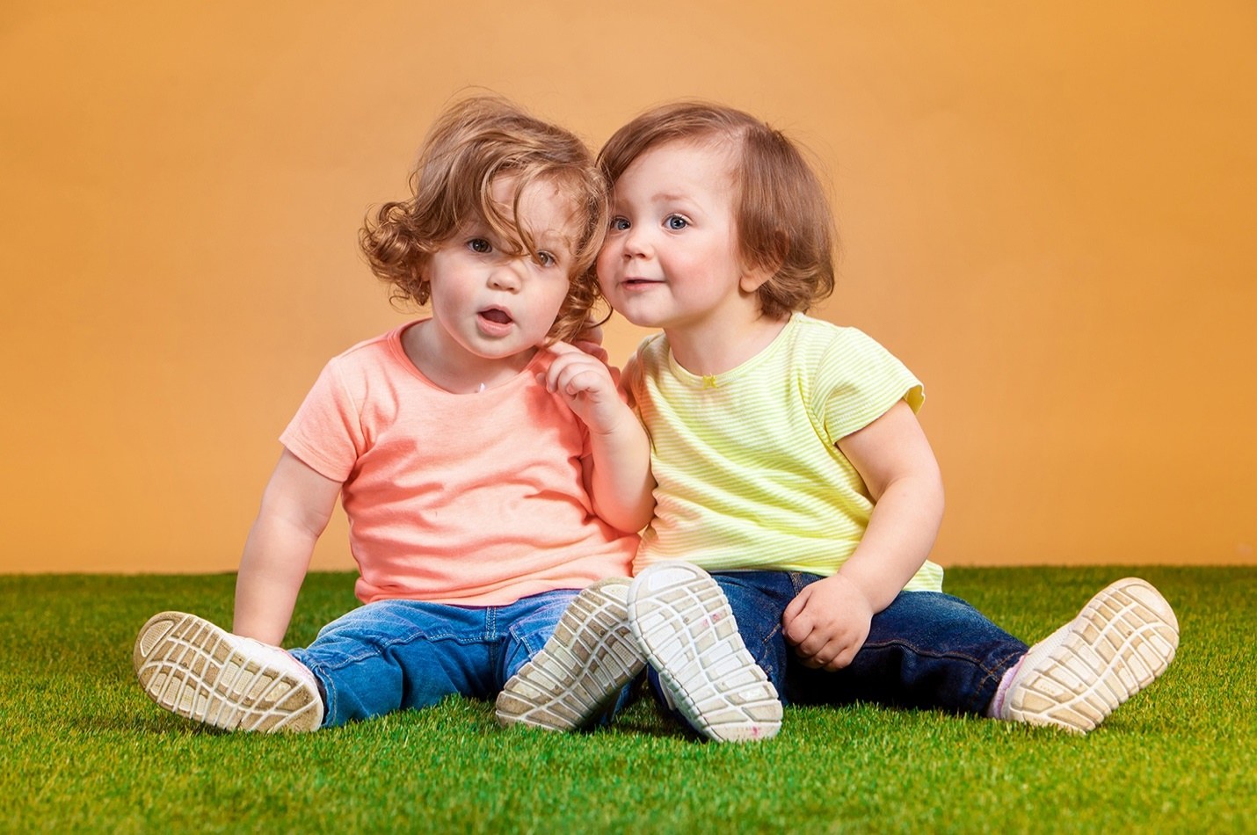15

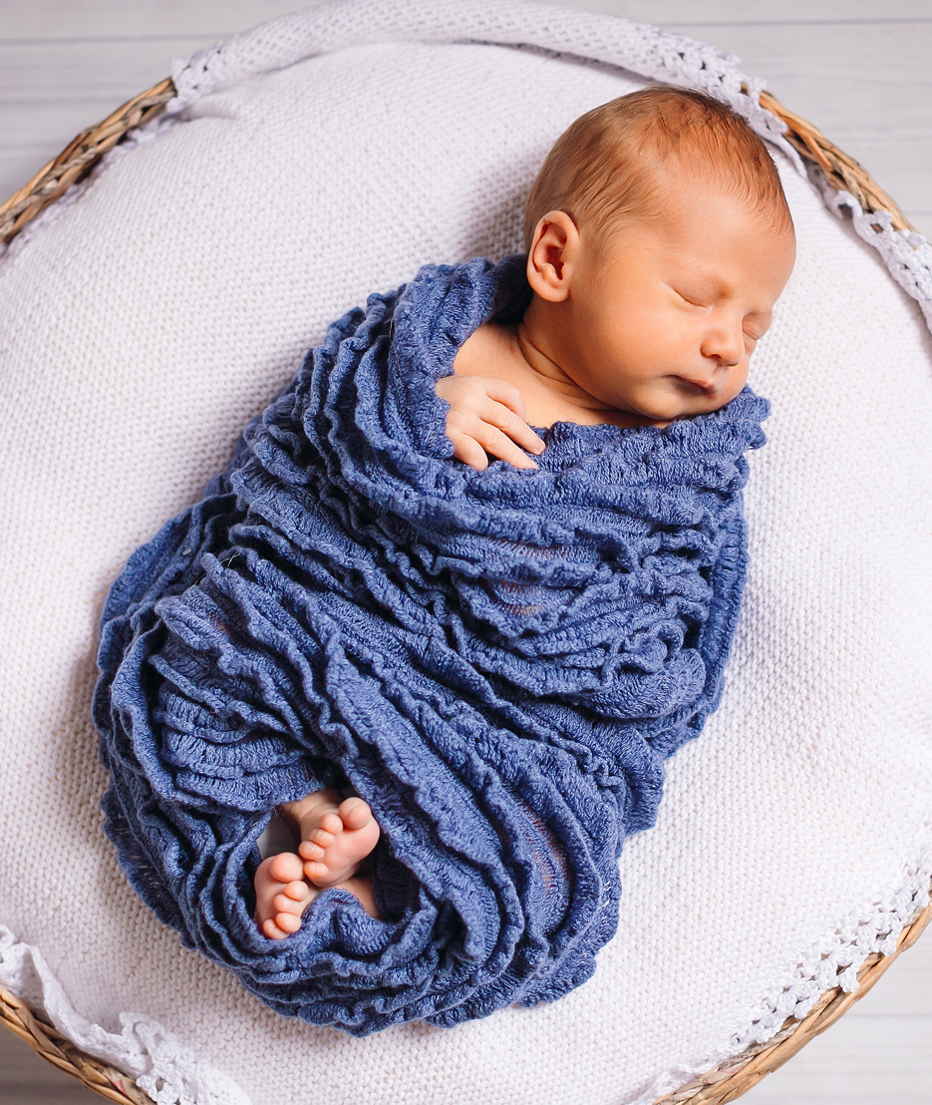16­

## Cards: Body signals

|  |  |
| --- | --- |
| A mid-shot of a nervous teenage girl with both arms bent at the elbows, her hands placed at her shoulders with fingers crossed on both her hands. Superimposed over her belly is a view inside her stomach with colourful flying butterflies to indicate she is nervous.5 | A mid shot profile of a young boy with his mouth opened gasping for air. Symbols of swirls and arrows describe his inhaled and exhaled breath as fast.6 |
| Butterflies in your tummy | Quick breathing |
| Girl holding hands to her chest as though she is in pain7 | A full length shot of a young boy standing with his hands on his head and his eyes and mouth wide open. Squiggle lines near his knees indicate that he is shaking at the knees. 8 |
| Racing heart | Shaky knees |
| A mid shot of a young girl with a sad expression on her face, wearing a beanie and a scarf. Her arms are crossed tightly over her chest and her shoulders are hunched. Squiggly lines down the side of her upper arms indicate that she is shivering with cold. 9 | A mid shot of a young boy looking down with a sad expression on his face, his left hand is pressed against his tummy and his right arm is straight beside him. Superimposed over his belly is a view inside his stomach which is full of colourful wriggling worms indicating unrest. 10 |
| Cold-shivery body | Squirmy tummy |
| A head and shoulders shot of a young boy holding his right hand up with lots of droplets of water in his palm.11 | A young girl gazes upwards pressing her hand against her tilted forehead. He forehead is flushed red indicating pain.12 |
| Sweaty hands | Warm body |

## Soft animal toy images

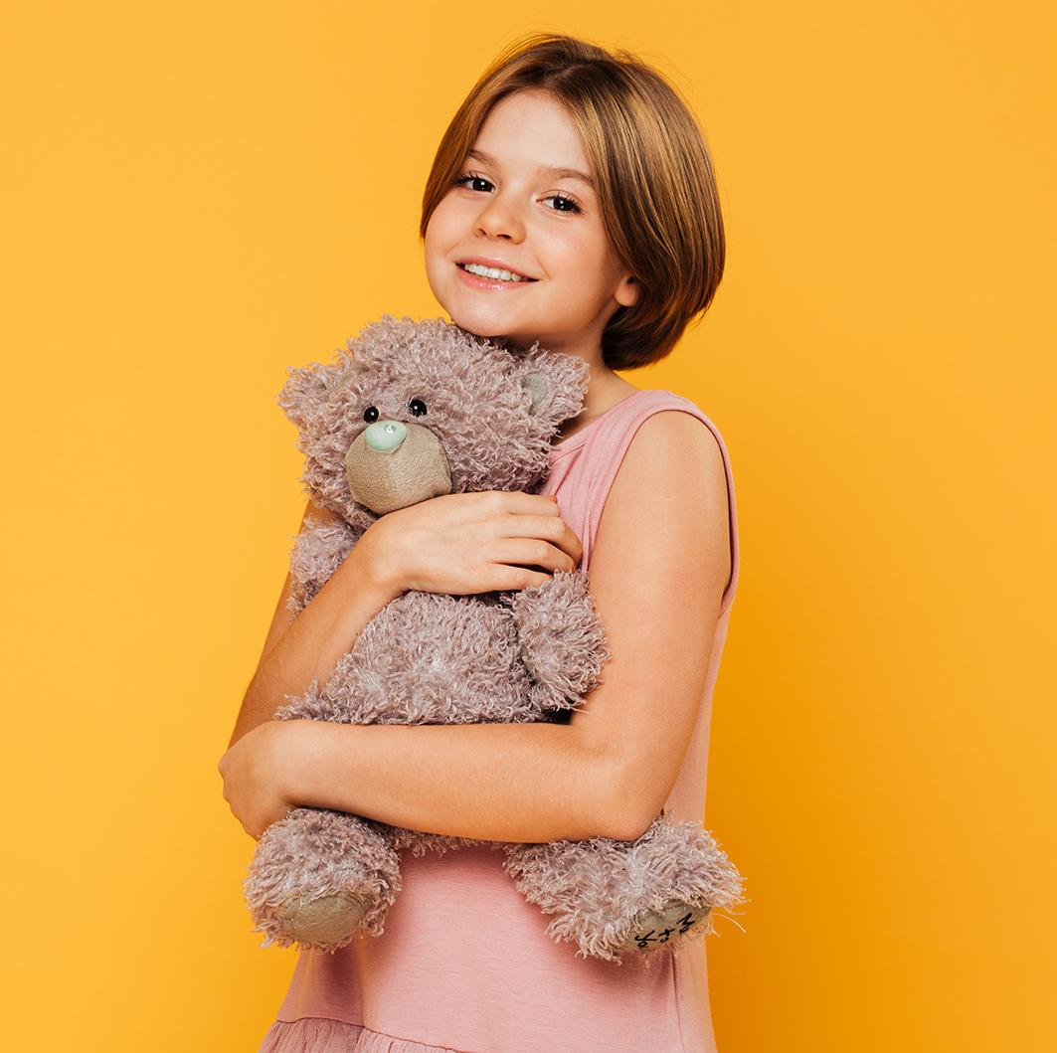25

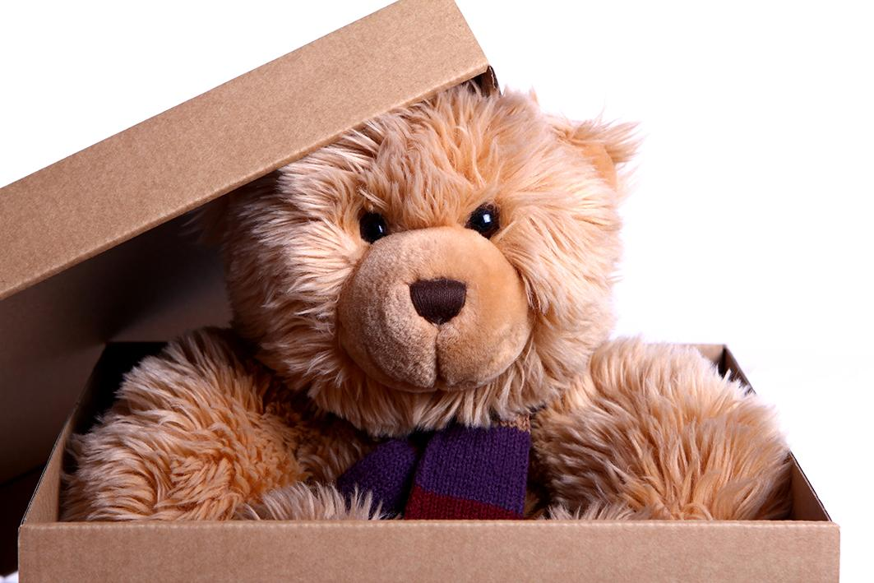 26

## Cards: Safe and unsafe touch situations

As a class read through the safe and unsafe situation touch cards. Work together to sort the situations into safe and unsafe.

|  |  |
| --- | --- |
| Georgie likes to stay at her cousin’s house with her little cousins. Georgie’s older cousin loves playing soccer. When Georgie plays too, her cousin kicks the ball really hard at her. Georgie asks her cousin to kick it softer but her cousin keeps doing it and says it’s part of the game and she has to get used to it. | Jenson loves reading books. Every night he reads to his Dad. He sits on his Dad’s lap as he reads, and his Dad puts his arm around him. Jenson loves reading time. |
| Jesse catches the bus home from school every day. When Jesse is waiting in line to catch the bus another student stands in the line in front of him. When Jesse asks this student not to push in, they push Jesse. | Zane’s uncle visits often. He makes Zane sit on his lap and read his home reader. Zane doesn’t like sitting on his uncle’s lap to read but his uncle won’t let him go. |
| Shontelle fell over in the playground and hit her head. Her friends help her to the sick bay. The teacher there checks Shontelle’s head and applies an icepack. | Maya goes to tennis coaching.  Her coach shows her how to hold her tennis racquet. Sometimes her hands are in the wrong place on the racquet and her coach needs to move them. |
| Shaun’s sister is younger than him. They were playing a game together but when Shaun won the game his sister got angry at him. She started kicking and punching him. | Xavier’s friends have a special greeting they use when they see each other. It includes a high five, fist pump and a pat on the back. |
| Sebastion and his Mum are playing together. His Mum grabs him and starts tickling him. He laughs and tries to tickle her back. | Carly’s parents have their friends over for parties and barbeques all the time. She doesn’t like one of her parent’s friends that comes over. He comes into her room  and makes her give him a kiss goodnight. Carly only likes kissing her Mum and Dad goodnight. |
| Sienna was playing with her friends at school. Her friend Josie wanted Sienna to only play with her and no one else. Josie grabbed Sienna’s arm, squeezed it really tight and tried to pull Sienna away from the group. | Meeka goes to her Dad’s three nights a week. She misses her Dad when she doesn’t see him. When she’s there she gets as many hugs from her Dad as she can. |

## Cards: Touch flashcards

|  |
| --- |
| who |
| touch |
| what |
| how |
| when |

## Cards: Secrets

As a class read the secrets cards and sort them into either a secret you should keep or a secret you shouldn’t keep.

|  |  |
| --- | --- |
| **Card 1**  Mum and Dad find out that Mum is going to have a baby. Everyone is very happy. They don’t want you to tell anyone yet. They have told you not to tell anyone until just before the baby is born. | **Card 2**  The music teacher at school is leaving. Everyone will miss him. Your class is planning a farewell party for him. They don’t want him to find out yet. |
| **Card 3**  You stay at your friend’s house. The older brother asks you to take your clothes off and have a bath with him. He tells you that you must never tell anyone or you’ll be in trouble. | **Card 4**  Everyone in your family likes the lady next door. She is kind and gives your family lemons from her tree. Mum and Dad say that she is a bit strange because she talks to her tree. They have told you not to tell your friends about this. |
| **Card 5**  Your friend from school is sick. You all make a card and the teacher sends it in the mail. If you see your friend before he gets it, you can’t tell him about the card. | **Card 6**  Your Grandad’s favourite drink is pink lemonade. Everyone in your family thinks this is funny. Your Grandad laughs about it too. When it is ‘pink’ day at school your family asks you not to talk about it at news time. |
| **Card 7**  When your Dad gets angry, he often hits you. Mum and Dad have told you never to tell. | **Card 8**  Your coach often touches the private parts of your body when you are training. The coach does this to your friends too. The coach has threatened to stop coaching your team if anyone ever tells about this. |

## Cards: Yes and no feelings

### No feelings

|  |  |  |
| --- | --- | --- |
| A young girl looking annoyed. Her left hand on her left hip and her right arm at shoulder height is bent at the elbow, and she is pointing up with her pointer finger.36 | **An older boy looking confused. His head is tilted to the left and he is scratching his hair with his left fingers.**37 | A head shot of a teenage girl. Her eyes are tightly closed and her is mouth opened wide with her tongue sticking all the way out in disgust.38 |
| Angry | Confused | Disgusted |
| A girl stiffly holds her hands up with her fingers splayed either side of her face. Her eyes and mouth are wide open with fright.39 | A young girl with a frustrated expression on her face. She is scratching both sides of her head with her fingers.40 | A boy looking down with a grumpy expression. His shoulders are hunched, and his arms are crossed across his chest.41 |
| Frightened, afraid, scared | Frustrated | Grumpy |
| A sad young girl with her eyes closed and her head tilted to the left resting her forehead on the fist of her left hand.42 | A left-sided view of a sad, young girl sitting on her own against a post. with her arms around her knees 43 | A young, nervous girl looking down and biting the nails of her right fingers.44 |
| Hurt | Lonely | Nervous |
| A shocked young boy with raised eyebrows and wide-opened eyes, pressing the palms of his hands tightly against his opened mouth.45 | A sad, young boy with his eyes closed and his head tilted to the right, resting the right side of his face on the back of his right hand.46 | A concerned, young girl with her head tilted to the right, resting the right side of her face on the palm of her right hand. Her eyes are downcast.47 |
| Shocked | Unhappy, sad | Worried |

### Yes feelings

|  |  |  |
| --- | --- | --- |
| A face of a teenage girl. Her head is titled slightly to the right. She is looking directly at you with calm eyes and a wide, peaceful smile.48 | A mid shot of a boy with a huge smile on his face jumping up with excitement. His arms are raised above his head and his fingers are spread wide.49 | The head and shoulders shot of a happy-faced girl with a big smile and eyes looking confidently at you.50 |
| Peaceful, calm | Excited | Happy |
| A girl and an older woman enjoying a loving hug. The girl has a peaceful smile on her face.51 | A boy, head slightly tinted to the left, smiling with pride, and giving a thumbs-up sign with his left hand.52 | The head and shoulders of a smiling girl with her head tilted to her right. Her arms are folded across her chest and she is clutching the ends of her twisted long hair in each hand.53 |
| Loved, safe | Proud | Shy |
| A close-up on the faces of a girl and boy looking at you. Their eyes and mouth are opened wide with surprise.54 |  |  |
| Surprised |  |  |

## Teacher notes: Definition match

As a class match the words to their definition.

|  |  |
| --- | --- |
| abuse | When someone does something on purpose to make someone else feel hurt or harm or to put them in danger. |
| body signals | A message our body gives us when we feel safe or unsafe. |
| bullying | When someone’s behaviour hurts or harms someone on purpose and it keeps happening. |
| harm | Injury or damage to someone or something. |
| No-Go-Tell | Steps children can use when they feel No feelings or are feeling unsafe. |
| No feelings | Feelings we get when we feel unsafe or uncomfortable. |
| respect | Being caring and kind and thinking and acting in a way that shows others you care about them and their feelings |
| secrets | Something that not everyone knows. |
| strengths | Tasks or actions that you do really well and find easy to do. |
| support network | People that we trust will help us when we need it. |
| Yes feelings | Feelings we get when we feel safe and comfortable. |

## Cards: Definition match

|  |  |
| --- | --- |
| abuse | no feelings |
| body signals | respect |
| bullying | secrets |
| harm | strengths |
| no-go-tell | support network |
| yes feelings |  |

|  |  |
| --- | --- |
| When someone does something on purpose to make someone else feel hurt or harm or to put them in danger. | Steps children can use when they feel No feelings or are feeling unsafe. |
| A message our body gives us when we feel safe or unsafe. | Feelings we get when we feel unsafe or uncomfortable. |
| When someone’s behaviour hurts or harms someone on purpose and it keeps happening. | Being caring and kind and thinking and acting in a way that shows others you care about them and their feelings |
| Injury or damage to someone or something. | Something that not everyone knows. |
| Tasks or actions that you do really well and find easy to do. | Feelings we get when we feel safe and comfortable. |
| People that we trust will help us when we need it. |  |

## Cards: What would you do?

Read the scenario on each card. After each card ask students to think about the strategies they have learnt that could help them to respond in each situation.

|  |  |
| --- | --- |
| Oliver’s parents are going out for dinner and Oliver’s babysitter is coming over to look after him. Last time his parents went out the babysitter touched Oliver’s private parts. What would you do if you were Oliver? | You are staying at your friend’s house. After dinner you and your friend go to have a bath. Your friend’s older brother comes in and watches you. He tells you that you must never tell anyone or you will be in trouble. What would you do? |
| Stella was hiding in her room. Her mum was very angry and was screaming bad words. Stella’s mum had hit her hard across the face and told her she wished she wasn’t there. What would you do if you were Stella? | Bindi and Charli are online gaming friends. They have been chatting for a while. Charli notices that Bindi has been saying really mean things to another online friend. This starts to happen every time they are online. One day Bindi tells their other friend that they can’t play the game with them today because they can’t play properly. What would you do if you were Charli? |

## Copyright register

1. Love it boy: Children photo created by freepik – [www.freepik.com](http://www.freepik.com)
2. Like it boy and girl: Children photo created by freepik – [www.freepik.com](http://www.freepik.com)
3. Don’t like it girl: Background photo created by freepik – [www.freepik.com](http://www.freepik.com)
4. Unsure boy: Children photo created by freepik – [www.freepik.com](http://www.freepik.com)
5. Red bike: Background vector created by freepik – [www.freepik.com](http://www.freepik.com)
6. Pet food bowl: Food vector created by stories – [www.freepik.com](http://www.freepik.com)

* 3 shoes – Banner vector created by pch.vector – www.freepik.com

1. Various sports balls: Sport vector created by macrovector – [www.freepik.com](http://www.freepik.com)
2. Various kids clothes: Winter vector created by freepik – [www.freepik.com](http://www.freepik.com)
3. Beanies: Fashion vector created by macrovector – [www.freepik.com](http://www.freepik.com)
4. Ribbons: Certificate vector created by freepik – [www.freepik.com](http://www.freepik.com)
5. Toys: Kids vector created by freepik – [www.freepik.com](http://www.freepik.com)  
   Shelves: Book vector created by freepik – [www.freepik.com](http://www.freepik.com)
6. Books and shelves: Book vector created by freepik – [www.freepik.com](http://www.freepik.com)
7. Sometimes: Camera photo created by drobotdean – [www.freepik.com](http://www.freepik.com)
8. Babies: People photo created by master1305 – [www.freepik.com](http://www.freepik.com)
9. Single baby: Background photo created by freepic.diller – [www.freepik.com](http://www.freepik.com/)
10. Butterflies in your tummy butterflies: Background photo created by freepik – [www.freepik.com](http://www.freepik.com)  
    butterflies in your tummy girl: Woman vector created by freepik – [www.freepik.com](http://www.freepik.com)
11. Quick breathing boy: Food photo created by diana.grytsku – www.freepik.com

* Racing heart girl: People photo created by wayhomestudio – [www.freepik.com](http://www.freepik.com)
* Shaky knees: Shaky knees boy: Cute photo created by drobotdean – [www.freepik.com](http://www.freepik.com)

1. Cold shivery body girl: Winter photo created by freepik – [www.freepik.com](http://www.freepik.com)
2. Squirmy tummy boy: Background photo created by freepik – [www.freepik.com](http://www.freepik.com)  
   Worms: Food photo created by freepik – [www.freepik.com](http://www.freepik.com)
3. Sweaty hands boy: School photo created by jcomp – [www.freepik.com](http://www.freepik.com)  
   Droplets: Water vector created by pch.vector – www. [www.freepik.com](http://www.freepik.com)
4. Warm body girl: Designed by jcomp – [www.freepik.com](http://www.freepik.com)
5. Girl hugging bear: Love photo created by drobotdean – [www.freepik.com](http://www.freepik.com)
6. Teddy bear in box: Christmas photo created by Racool_studio – [www.freepik.com](http://www.freepik.com)
7. Kids at movies: Designed by serhii – [www.freepik.com](http://www.freepik.com)
8. Broccoli: Food photo created by jcomp – [www.freepik.com](http://www.freepik.com)
9. Kids cleaning (picking up rubbish): Kids photo created by freepik – [www.freepik.com](http://www.freepik.com)
10. Kids eating ice cream: Kids photo created by freepik – [www.freepik.com](http://www.freepik.com)
11. Boy doing homework: Background photo created by photoroyalty – [www.freepik.com](http://www.freepik.com)
12. Lego blocks: Baby photo created by Kireyonok_Yuliya – [www.freepik.com](http://www.freepik.com)
13. Girl hugging dog: Dog photo created by master1305 – [www.freepik.com](http://www.freepik.com)
14. Gaming console: Business photo created by Racool_studio – [www.freepik.com](http://www.freepik.com)
15. Family in a pool: People photo created by rawpixel.com – [www.freepik.com](http://www.freepik.com)

* Angry: Education photo created by freepik – [www.freepik.com](http://www.freepik.com)
* Confused: People photo created by cookie_studio – [www.freepik.com](http://www.freepik.com)
* Disgusted: Woman photo created by cookie_studio – [www.freepik.com](http://www.freepik.com)
* Frightened: Kids photo created by freepik – www.freepik.com
* Frustrated: Girl photo created by freepik – [www.freepik.com](http://www.freepik.com)
* Grumpy: Designed by Freepik – [www.freepik.com](http://www.freepik.com)
* Sad/hurt: Girl photo created by freepik – [www.freepik.com](http://www.freepik.com)
* Lonely: People photo created by jcomp – [www.freepik.com](http://www.freepik.com)
* Nervous: Designed by pressfoto – [www.freepik.com](http://www.freepik.com)
* Shocked Designed by Freepik – [www.freepik.com](http://www.freepik.com)
* Unhappy: Designed by jcomp – [www.freepik.com](http://www.freepik.com)
* Worried: Designed by jcomp – [www.freepik.com](http://www.freepik.com)
* Peaceful/calm: Woman photo created by cookie_studio – [www.freepik.com](http://www.freepik.com)
* Excited: People photo created by jcomp – [www.freepik.com](http://www.freepik.com)
* Happy: Designed by Asier_Relampagoestudio – [www.freepik.com](http://www.freepik.com)
* Loved/safe: Family photo created by master1305 – [www.freepik.com](http://www.freepik.com)
* Proud: Designed by jcomp – [www.freepik.com](http://www.freepik.com)
* Shy: For websites: Designed by cookie_studio – [www.freepik.com](http://www.freepik.com)
* Surprised: People photo created by drobotdean – [www.freepik.com](http://www.freepik.com)

**© State of New South Wales (Department of Education), 2023**

The copyright material published in this resource is subject to the *Copyright Act 1968* (Cth) and is owned by the NSW Department of Education or, where indicated, by a party other than the NSW Department of Education (third-party material).

Copyright material available in this resource and owned by the NSW Department of Education is licensed under a [Creative Commons Attribution 4.0 International (CC BY 4.0) license](https://creativecommons.org/licenses/by/4.0/).

[](https://creativecommons.org/licenses/by/4.0/)

This license allows you to share and adapt the material for any purpose, even commercially.

Attribution should be given to © State of New South Wales (Department of Education), 2023.

Material in this resource not available under a Creative Commons license:

* the NSW Department of Education logo, other logos and trademark-protected material
* material owned by a third party that has been reproduced with permission. You will need to obtain permission from the third party to reuse its material.

**Links to third-party material and websites**

Please note that the provided (reading/viewing material/list/links/texts) are a suggestion only and implies no endorsement, by the New South Wales Department of Education, of any author, publisher, or book title. School principals and teachers are best placed to assess the suitability of resources that would complement the curriculum and reflect the needs and interests of their students.

If you use the links provided in this document to access a third-party's website, you acknowledge that the terms of use, including licence terms set out on the third-party's website apply to the use which may be made of the materials on that third-party website or where permitted by the *Copyright Act 1968* (Cth). The department accepts no responsibility for content on third-party websites.