Overcoming adversity and accepting support
Duration: 60 minutes

Purpose of the task
The difficult or adverse times in our lives help us appreciate when things go smoothly. Adversity is a part of our everyday lives. When we respond positively to challenges, our coping skills, strengths, character and perseverance emerge to get us through the tough times, move forward and move on. This takes practice.

Course outcomes
1.1 Assess personal strengths and skills to achieve positive outcomes in a range of challenging and changing situations.
1.2 Critically evaluate services and resources to identify sources of reliable information and support.
4.1 Demonstrate capacity to build resilience and adapt to manage current and future challenges.

What do we want students to know, understand or be able to do?
- Recognise ways to overcome adversity and manage complex situations, including the use of gratitude and mindfulness.
- Build capacity to support others to seek help.

Required resources and materials for preparation
Student activities are set around:
- Whole group and small group
- Individual activities
- Offline
Equipment required:
- butchers paper
- pens/textas
- post-it notes
- standard index or speech cards OR A5 sheets of paper (one per student)
- access to the internet and laptop/tablet/phone
- online access to:
  - au.reachout.com/building-better-coping-skills
  - http://au.reachout.com/all-about-gratitude#what
  - education.com/worksheets/mandalas
- Where to go for help worksheet
- Building my coping skills worksheet

Suggested content
Learning context | Content
Mental health and wellbeing  Focus: Developing self-efficacy and mental fitness | Building resilience  - seeking, accessing and accepting help and support  - empathising  - overcoming adversity  Positive wellbeing  - engagement and mindfulness
Mental health and wellbeing  Focus: Support for self and others | Skills and strategies for managing change and challenges  - stress management  - perspective taking  - influence and persuasion  Connecting and reaching out  - networks of online and offline support  - recognising when help is needed  - asking for and accepting help for self and others  - accessing services  - supporting others
Independence  Focus: Building self-concepts and independence | Self-management  - managing change and initiating contingency plans  - responsibility for self and actions

Teaching notes

Creating a safe and supportive learning environment
There are a number of strategies that can be used to create a supportive learning environment which enables students to feel safe to learn and ask questions. They include:
- making students aware at the beginning of Life Ready sessions that disclosing personal information that indicates they may be at risk of harm will be reported to the school principal in all instances. This includes personal disclosures related to instances of abuse, drug use, neglect or sexual activity under the legal age of consent.
- being aware that some parts of Life Ready can be confronting and sensitive for some students.
- enabling students to withdraw if they find issues personally confronting to protect them from making harmful disclosures. Equally, it is important to be prepared for issues that arise as a result of a student making a public disclosure in the classroom.
More information on creating a safe and supportive learning environment can be found on the Life Ready website.

Evaluating resources before use
Preview and evaluate all strategies, resources and teaching and learning approaches in full before use with students to determine suitability for student learning needs, stage of development and local school context. Consider the age, maturity, cultural background, sexuality, gender, sex, health and other characteristics of students in your care. Apply professional judgements to all strategies, teaching and learning approaches and resources including audio visual materials (e.g. videos, media clips and YouTube), interactive web-based content (e.g. games, quizzes and websites) and texts.
Use the resource review flowchart to decide about the suitability of teaching and learning resources.
Materials should be reviewed in full and endorsed by the school principal before use in NSW government schools.

Communication with parents and caregivers
Some aspects of Life Ready may be viewed as sensitive or controversial, such as learning about abuse, child protection, drugs, respectful relationships, sexual health, sexuality and violence. Inform parents and carers, prior to the occasion, of the specific details of the Life Ready program, so that parents and caregivers have time to exercise their rights of withdrawing their child from a particular session. In this regard, a parents or caregiver’s wish must be respected.
Establishing how parents and caregivers will be informed about programs and involved in consultation is a school-based decision. Where parents and caregivers indicate they wish to withdraw their child from a program it is useful to negotiate which parts of the Life Ready program they are concerned about. A sample information letter is available on the Life Ready website.

Learning experiences

Overcoming adversity

Class brainstorm
- What is adversity?
- What are ways we overcome adversity or get through tough times?
- What strengths, skills and strategies can we use to overcome adversity?
- Students use the 9 tips for coping with the hard stuff fact sheet from ReachOut.com to identify three strategies a young person could use to overcome adversity or get through tough times.
- Students use the Building my coping skills worksheet to reflect on the coping strategies they could use to overcome adversity and who they could seek help from.

Jigsaw: using gratitude as a coping skill
Students use the How and Why of practising gratitude Fact Sheet from ReachOut.com
- Working in groups of 4, each student is numbered 1-4.
- All students with number 1, group together. All students with number 2 group together etc.
- Each group is assigned one of the 4 sections from the fact sheet (listed below) to summarise their allocated section with one piece of butchers’ paper and pens/textas.
  - Group 1: What does gratitude mean? and What is gratitude?
  - Group 2: Benefits of gratitude
  - Group 3: Ways to increase gratitude
  - Group 4: What are the sorts of things I would be thankful for?
- Each group has 6 minutes to summarise the information.
- Each student records the summary as shared in the group (so they can share with their original group).
- Students re-group to their original groups where each student takes it in turn to share their section of the factsheet.

Small group discussion
- Students work in the same groups and discuss the questions below:
  - where do we see most gratitude here at school?
  - how is this gratitude expressed?
  - what could we do from tomorrow to have more gratitude expressed here at school?
- Share/discuss answers as a whole group.

Creating a hassle free zone through mindfulness
Note: Getting away from noise and distractions and honing in on a little ‘me time’ is a great way for people to build up their personal toolkit for overcoming adversity. One method of creating a hassle free zone is using mindfulness strategies such as mindful colouring.
- Students investigate (online) mindful colouring using the following questions as prompts for information:
  - what is mindful colouring?
  - how does it improve our coping skills or boost our resilience?
  - what are some alternative strategies to mindful colouring?
- Students complete a mindful colouring exercise (20-30mins). For this exercise, students will need to work in complete silence and be provided with textas or pencils to colour in with. Free colouring templates are available from online sites such as http://www.education.com/ worksheets/mandalas/
- As a group, discuss the questions below:
  - what emotions did you feel when completing the colouring in?
  - what did you think about?
  - did your thoughts pass through your mind or were you fixated on your thoughts?
  - what else could you do that would assist you in practicing mindfulness?

Accepting support

Group brainswarm
A ‘brainswarm’ is a brainstorm conducted in silence with post it notes. In brainswarming there is no critiquing of ideas, dominant voices or a reluctance to contribute. Students write their thoughts on post it notes over a period of 3 minutes. Students place each of their post it notes on the board so there is a collection of ideas.
- Students work together to move and place similar ideas together in themes on a designated space, such as a board.
  - Brainswarm 1: Why is support helpful for resilience?
  - Brainswarm 2: What concerns might young people have about accepting support/help?
- Discuss collective theme ideas as a group.
  - What was the most common idea the group came up with?
  - Are young people more willing to seek help online or offline? Give reasons.
  - How can we make seeking help easier for young people?
- Individually students complete the Where to go for help worksheet.

Connecting with others: small group work
- Connecting with others provides young people with greater opportunities for accepting and seeking help by building a network of people they can turn to during tough times.
Teacher preparation:
Search online for a series of famous quotes about the importance of connecting with others appropriate for senior students. Place quotes on standard 3” X 5” index cards (or A5 paper). Make two cards/sheets for each quote.
- Students are allocated or randomly select a card/sheet.
- Students read the card/sheet silently to themselves.
- Inform students that there is another student in the room with the same card and that their challenge is to find that student (If there is an odd number of students, teachers can take a card/sheet).
- Students are to find the student with the same card/sheet as they have. As a pair, discuss:
  - what does the quote mean to them?
  - how could this quote be used to encourage a young person to make connections with the intention to accept and seek help?

Where to go for help
Create a mind map of all the support places/people/organisations you can think of that are available to assist young people going through a tough time.
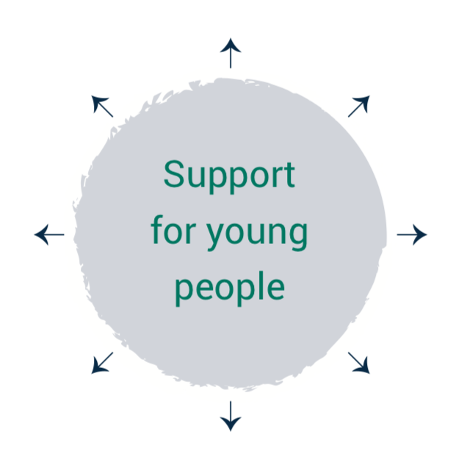
Using your mind map place your ideas under these categories below.
Home | School | In the local community | At sport/ activity clubs | Online | Other

Choose one category from the above table and write a short scenario of a 16-year-old requiring support.
Points to be covered:
- why the young person needs support?
- what coping strategies has the young person used themselves? What type of support is required?
- what are the first steps to take in seeking this support?
- how could a friend also help this person?
- how much (if anything) will support cost?
- is an appointment required?

Scenario:

Building my coping skills
Why are positive coping strategies useful?
________________________________________________________________________________
Finding the right coping strategy.
Using the information you find on ReachOut.com, choose three strategies you would consider trying as ways of overcoming adversity/getting through tough times.
Strategy One:
What is it all about?
Strategy Two:
What is it all about?
Strategy Three:
What is it all about?
Investigate what to do if you need further help.
Who can you talk to?
Who can you ask for help — at home or at school?

