Student workbook - How can we solve problems when moving?
Name:
Class:

Overview of lessons 3 and 4
Students will:
- adapt throwing techniques to cater for changing game settings and rules (lessons 3-4)
- propose and refine strategies to successfully complete a movement challenge (lessons 3-4)
- propose and apply changes to rules to create more inclusive play (lessons 3-4)
- recognise a number of possible solutions to a throwing challenge and justify which one is the most effective (lesson 4)

Resources
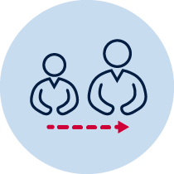
- help from an adult
- a soft object to throw (for example, soft ball, pair of socks, soft toy, scrunched-up paper)
- 3 objects or landmarks to create targets for objects to hit (for example, bucket, a long piece of string laid in a circle, an ‘X’ formed by two pieces of tape/material, a t-shirt laid on the ground, a chair/bench, a wall, a tree)
- 3 or more different unbreakable objects to act as an obstacle
- Refer to ‘Throlf’ game card for suggestions of what this activity could look like (Sport Australia, 2019. Playing for life)
Lesson 3 – Obstacle golf – advanced – opposite hand
3.1 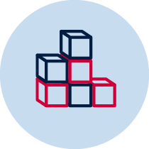Create 3 targets that you can safely throw a soft object towards. Choose a ‘starting point’ where you will throw the object from. Place each target at different distances from the ’starting point’.
Where possible, create targets that are different to ones created in previous lessons. Consider the size, shape and whether the object to be thrown needs to hit it or land inside it.
  - Choose or create at least one object that will act as an obstacle. The obstacle needs to be placed between the ’starting point’ and the target.
  - Discuss with your teacher or parent/caregiver
- How you modified your game in previous lessons to challenge your strengths
- Explain the scoring system you created to challenge your strengths
  - Your challenge is to create an inclusive learning environment by modifying rules and scoring systems. To do this you will play ‘Obstacle golf – advanced – opposite hand’. An inclusive environment is where everyone can participate regardless of their physical and mental abilities.
- Imagine your preferred hand is representing you while your opposite hand is representing one of your peers.
- Your preferred hand is the one you use to throw most of the time while your opposite hand is the hand you don’t usually use.
- Consider how your throwing may be more accurate when using your preferred hand and any differences in technique and success to when you use your opposite hand.
- Create rules and a scoring system that will allow both hands to be fairly evenly matched.
Example rules include, the preferred hand must take 3 steps back to take the first throw; the preferred hand uses the object that has many corners and bounces in many different directions; the preferred hand has first attempt so the opposite hand can evaluate their strategies and use them to plan their own strategies.
Example scoring systems include, the opposite hand receives one bonus throw that is not counted to the score; the opposite hand scores a bonus throw if they can get the object to rebound off the obstacle; the opposite hand scores bonus points when throwing overarm because it is more difficult than underarm.
  - Explain the rules and scoring system you have developed or modified to make the game of ’Obstacle golf – advanced – opposite hand’ inclusive and evenly matched.
______________________________________________________________________________________________________________________________________________________________________________________________________________
  - Discuss with your teacher or parent/caregiver how you plan to complete the challenge for each hand. Explain
- the type of throw/s you will use
- how you will use or avoid the obstacle
- how you will use the space available
- how you will adjust your body movements to apply different amounts of force.
Record your answer.
Preferred hand
______________________________________________________________________________________________________________________________________________________________________________________________________________
Opposite hand
______________________________________________________________________________________________________________________________________________________________________________________________________________
  - Play the game of ’Obstacle golf – advanced – opposite hand’.
Throw the object towards the target. You should aim to hit the target. Pick up the object from where it landed and throw the object again until the target has been hit.
Table 1 Obstacle golf examples
Obstacle golf examples
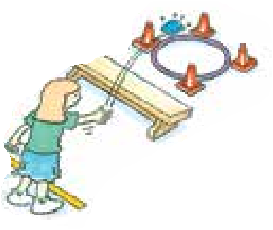  Sport Australia 2019, Playing for life | 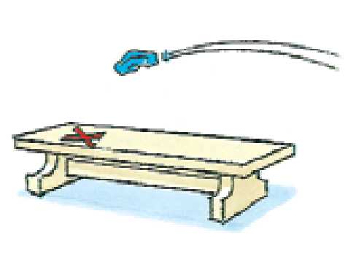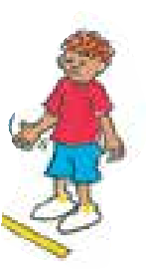 | 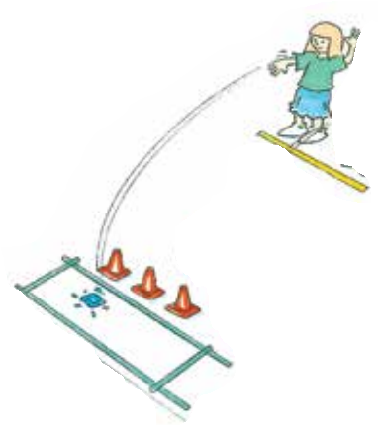
  - Record how many throws it took to hit the target.
Table 2 Obstacle golf advanced – opposite hand
How many throws did you it take to hit the target? | Attempt 1 | Attempt 2 | Attempt 3 | Attempt 4 | Attempt 5
Target 1 – preferred hand
Target 1 – opposite hand
Target 2 – preferred hand
Target 2 – opposite hand
Target 3 – preferred hand
Target 3 – opposite hand
  - Repeat the challenge 5 times for each of the 3 targets
  - Reflect upon your performance in the game of ’Obstacle golf – advanced – opposite hand’.
- Explain how you refined your strategy and throwing technique during the game of to effectively use the rules and scoring system.
- Explain any changes you would suggest to make the game more inclusive
Target 1 -______________________________________________________________________________________________________________________________________________________________________________________________________________
Target 2 -______________________________________________________________________________________________________________________________________________________________________________________________________________
Target 3 -______________________________________________________________________________________________________________________________________________________________________________________________________________
Lesson 4 – Obstacle golf – finding a solution
4.1 Create 3 targets that you can safely throw a soft object towards. Choose a ‘starting point’ where you will throw the object from. Place each target at different distances from the ’starting point’.
Where possible, create targets that are different to ones created in previous lessons. Consider the size, shape and whether the object to be thrown needs to hit it or land inside it.
  - Choose or create at least one object that will act as an obstacle. The obstacle needs to be placed between the ’starting point’ and the target.
  - Choose or create at least one object that you can safely throw towards the target.
  - Discuss with your teacher or parent/caregiver
- How you modified your game in previous lessons to challenge your strengths
- Explain the scoring system you created to challenge your strengths
  - Your challenge is to
- identify and trial a number of possible solutions to solving the challenge of hitting the target using as few throws as possible.
- adapt and apply rules to maintain an inclusive learning environment.
To do this you will
- trial 3 different solutions for each player in the game and justify which one was most effective.
  - The two players are your preferred hand and your opposite hand, just as you did when you played ‘Obstacle golf – advanced – opposite hand’ in the previous lesson.
  - Imagine your preferred hand is representing you while your opposite hand is representing one of your peers.
  - Your preferred hand is the one you use to throw most of the time while your opposite hand will be the hand you don’t usually use.
  - Consider how your throwing may be more accurate when using your preferred hand and any differences in technique and success to when you use your opposite hand.
  - Explain the rules you will apply to make the game of ’Obstacle golf – advanced – opposite hand’ inclusive and evenly matched.
__________________________________________________________________________________________________________________________________________
  - Discuss with your teacher or parent/caregiver 3 different solutions that you will try for each target. Explain how you plan to modify the solution for each hand. Explain
- the type of throw/s you will use
- how you will use or avoid the obstacle
- how you will use the space available
- how you will adjust your body movements to apply different amounts of force.
Record which solution you think will be most effective for each hand.
Target 1
______________________________________________________________________________________________________________________________________________________________________________________________________________
Target 2
______________________________________________________________________________________________________________________________________________________________________________________________________________
Target 3
______________________________________________________________________________________________________________________________________________________________________________________________________________
  - Play the game of ’Obstacle golf – finding a solution’.
Throw the object towards the target. You should aim to hit the target. Pick up the object from where it landed and throw the object again until the target has been hit.
Table 3 Obstacle golf examples
Obstacle golf examples
Sport Australia 2019, Playing for life
  - Record how many throws it took to hit the target for each solution.
Table 4 Obstacle golf – finding a solution
How many throws did you it take to hit the target? | Solution 1 | Solution 2 | Solution 3
Target 1 – preferred hand
Target 1 – opposite hand
Target 2 – preferred hand
Target 2 – opposite hand
Target 3 – preferred hand
Target 3 – opposite hand
4.10 Reflect upon your performance in the game of ’Obstacle golf – finding a solution’ and discuss the following with your teacher or parent/caregiver.
- Which solution was most effective for each target? Justify your answer.
- Explain how you could refine your strategy and throwing technique for the least successful solution for each target. Record your response.
Target 1 -______________________________________________________________________________________________________________________________________________________________________________________________________________
Target 2 -______________________________________________________________________________________________________________________________________________________________________________________________________________
Target 3 -______________________________________________________________________________________________________________________________________________________________________________________________________________
  - Play the game again. Apply your refined strategy to the game of ’Obstacle golf – finding a solution’ and your identified targets. Attempt to improve upon the result that you achieved with your first attempt.
  - Discuss with your teacher or parent/caregiver how the refined strategy was more or less successful and why.
Resources
- A soft object to throw (for example, soft ball, pair of socks, soft toy, scrunched-up paper).
- 3 objects or landmarks to create a target for the object to hit (for example, bucket, a long piece of string laid in a circle, an ‘X’ formed by two pieces of tape/material, a t-shirt laid on the ground, a chair/bench, a wall, a tree).
- 3 or more different unbreakable objects to act as an obstacle.

