Student workbook – How do I build positive relationships with others?
Name:
Class:

Overview of lessons 3 and 4
You will
- explore and identify groups you belong to and the importance of making everyone feel they belong (lesson 3).
- recognise what it means to be inclusive and respectful to others (lesson 3)
- recognise how people feel when they are included or excluded from groups and activities (lesson 3)
- explore and identify what it means to cooperate and observe rules (lesson 4).

Resources
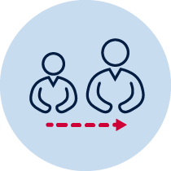
- Help from an adult
- Lead pencil/coloured pencils or crayon

Lesson 3 – We all belong
During this activity you will identify groups you belong to and why they are important. You will also recognise what it means to be inclusive and respectful to others.
3.1Discuss with your teacher or parent/caregiver the following questions.
- What groups do you belong to?
- Why is it important to belong to a group?
Inside the box, write or draw all the groups you belong to. For example, your class, school house, sports team.
Around the outside of box, write or draw why it is important to belong to a group. For example, make new friends, learn new skills, learn to cooperate, support.

List at least 2 other members of the same group and explain how you could make them feel included. For example, I shared pencils with my friend in class, I passed the ball to everyone in my soccer team or I cheered for my house mates at the swimming carnival. ________________________________________________________________________________________________________________________________________________________________________________________________
3.2Read the definitions of what it means to be included and excluded.
‘To be included means to invite another person to be part of something.’
‘To be excluded means to intentionally not include someone.’
Read the scenario.
Laura is a new student in your Stage 1 class. She has just moved to Australia from Japan. She doesn’t know anyone and is still learning to speak English. At lunch time Laura sits alone and looks upset. You return to class and she sits alone again at the back of the room.
Discuss with your teacher or parent/caregiver.
- How do you think Laura feels whilst sitting at the back of the room?
- How do you think you would feel if you were excluded?

What could you do to make Laura feel included? Record your answers around the circle.
What could you do to make Laura feel included?

Lesson 4 – How can I cooperate with others and observe rules?
During this activity you will demonstrate how to cooperate with others and observe rules.
4.1Discuss with your teacher or parent/caregiver what it means to cooperate with others?
You need to cooperate with others in many different ways. This can also be in many different places. Think of how you cooperate with others and where. Complete the table below. For example; at soccer training, coach, listen to the instructions.
Table 1 Cooperation
Place | Who I cooperate with | How I cooperate
Classroom
Playground
Home
4.2List 2 rules from your school, classroom or games you play. Discuss the following questions
- What happens when we follow the rules?
- What happens when we ignore the rules?
For example, a rule in netball is don’t run with the ball. Following the rules makes the game safe and fun. Ignoring the rules means it may be dangerous, you will be penalised and may upsets others.
Table 2 Rules
Rule | What happens when we follow the rules? | What happens when we ignore the rules?
School/classroom
Game/sport

4.3Hendrix doesn’t know the rules of the game, feels excluded and has asked Amity if he has to follow them. Discuss how Amity should answer Hendrix. Respond in the speech bubble.
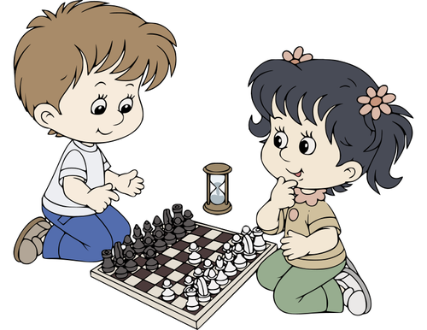

Hi Amity
I don’t understand the rules of this game. I feel excluded. Do I have to follow the rules?

Image from publicdomainvectors.org

