How can we solve problems when moving?
PDHPE Stage 3Student workbook
Name:
Class:

Overview of lessons 1 and 2
Students will:
- Refine throwing skills to perform specialised movements related to target games (lessons 1-2).
- Recognise and consider a number of solutions to target games and justify which solution is most appropriate or effective (lessons 1-2).
- Explain the rationale for particular rules, strategies and tactics (lesson 2).

Resources

Lessons 1-2
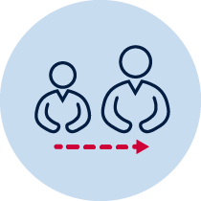
- help from an adult
- a soft object to throw (for example, soft ball, pair of socks, soft toy, scrunched-up paper)
- 3 objects or landmarks to create targets for objects to hit (for example, bucket, a long piece of string laid in a circle, an ‘X’ formed by two pieces of tape/material, a t-shirt laid on the ground, a chair/bench, a wall, a tree)
- 3 or more different unbreakable objects to act as an obstacle
- Refer to ‘Throlf’ game card for suggestions of what this activity could look like (Sport Australia, 2019. Playing for life)

Lesson 1 – Obstacle golf - intro
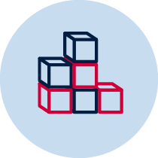
- Create 3 targets that you can safely throw a soft object towards. Choose a ‘starting point’ where you will throw the object from. Place each target at different distances from the ’starting point’.
- Choose or create at least one object that will act as an obstacle. The obstacle needs to be placed between the ’starting point’ and the target.
- Discuss with your teacher or parent/caregiver the type/s of throw you plan to use so you can hit the target in as few throws as possible. Predict which type of throw you think will be most effective. Example throwing styles include overarm, underarm, two-hand overhead, two-hand underhand, shoulder throw, your own throwing style.
- Explain your decisions.

Target 1 -______________________________________________________________________________________________________________________________________________________________________________________________________________
Target 2 -______________________________________________________________________________________________________________________________________________________________________________________________________________
Target 3 -______________________________________________________________________________________________________________________________________________________________________________________________________________
- Throw the object towards the target. You should aim to hit the target. Pick up the object from where it landed and throw the object again until the target has been hit.

Obstacle golf examples
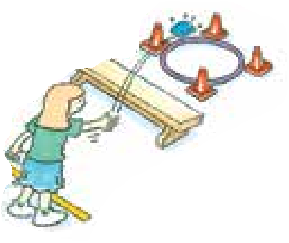  Sport Australia 2019, Playing for life | 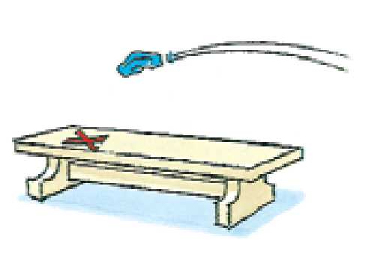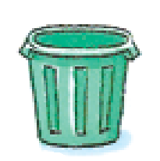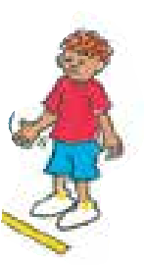 | 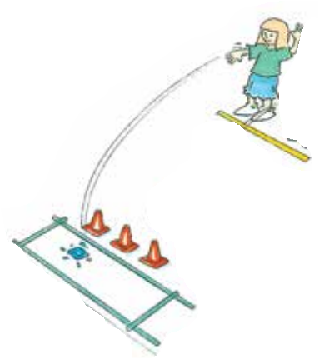

- Record how many throws it took to hit the target.
Table 1 Obstacle golf intro
How many throws did you it take to hit the target? | Attempt 1 | Attempt 2 | Attempt 3 | Attempt 4 | Attempt 5
Target 1
Target 2
Target 3

- Repeat the challenge 5 times for each of the 3 targets

- Explain how you refined your throwing during the game of ’Obstacle golf’ to effectively throw your object to the target.

Target 1 -______________________________________________________________________________________________________________________________________________________________________________________________________________
Target 2 -______________________________________________________________________________________________________________________________________________________________________________________________________________
Target 3 -______________________________________________________________________________________________________________________________________________________________________________________________________________
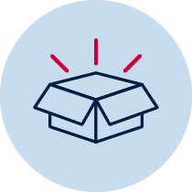 Resources
- A soft object to throw (for example, soft ball, pair of socks, soft toy, scrunched-up paper).
- 3 objects or landmarks to create a target for the object to hit (for example, bucket, a long piece of string laid in a circle, an ‘X’ formed by two pieces of tape/material, a t-shirt laid on the ground, a chair/bench, a wall, a tree).
- 3 or more different unbreakable safe objects to act as an obstacle.
Lesson 2 – Obstacle golf - advanced
- Create 3 targets that you can safely throw a soft object towards. Choose a ‘starting point’ where you will throw the object from. Place each target at different distances from the ’starting point’.
- Choose or create at least one object that will act as an obstacle. The obstacle needs to be placed between the ’starting point’ and the target.
- Discuss with your teacher or parent/caregiver your strengths when playing obstacle golf. For example, ”I am very consistent when throwing underarm at a target over a short distance” or ”I am very good at judging the appropriate amount of force to apply to my throws” or ”I am very good at rebounding the ball off the wall to avoid the obstacle.”
- Explain what you have identified as your strengths while playing ’Obstacle golf’.
______________________________________________________________________________________________________________________________________________________________________________________________________________
- Create or change at least one rule that will challenge your strength. Explain the rule you have created or changed. Explain your rule.
______________________________________________________________________________________________________________________________________________________________________________________________________________
- Create a different scoring system. For example, ”The amount of throws you record for each attempt is halved if you throw with your non-dominant hand” or ”The amount of throws you record for each attempt is doubled if you use object 1 as opposed to object 2.”
Remember: in obstacle golf, the fewer the throws used the better. Your dominant hand is the one you prefer to use when throwing. Non-dominant hand is the other hand.

Explain your new scoring system and how points are scored for easier and more difficult challenges.
______________________________________________________________________________________________________________________________________________________________________________________________________________
- Throw the object towards the target. You should aim to hit the target. Pick up the object from where it landed and throw the object again until the target has been hit.

Obstacle golf examples
Sport Australia 2019, Playing for life
- Record how many throws it took to hit the target.

Table 2 Obstacle golf advanced
How many throws did you it take to hit the target? | Attempt 1 | Attempt 2 | Attempt 3 | Attempt 4 | Attempt 5
Target 1
Target 2
Target 3
- Repeat the challenge 5 times for each of the 3 targets
- Explain how you refined your throwing during the game of ’Obstacle golf’ to effectively use the new rules and scoring system.

Target 1 -______________________________________________________________________________________________________________________________________________________________________________________________________________
Target 2 -______________________________________________________________________________________________________________________________________________________________________________________________________________
Target 3 -______________________________________________________________________________________________________________________________________________________________________________________________________________
Resources
- A soft object to throw (for example, soft ball, pair of socks, soft toy, scrunched-up paper).
- 3 objects or landmarks to create a target for the object to hit (for example, bucket, a long piece of string laid in a circle, an ‘X’ formed by two pieces of tape/material, a t-shirt laid on the ground, a chair/bench, a wall, a tree).
- 3 or more different unbreakable objects to act as an obstacle.

