How can we solve problems when moving?
PDHPE student workbook Stage 2
Name:
Class:

Overview of lessons 1 and 2
You will:
- Explore and practise different throwing techniques to propel objects towards a target (lesson 1-2)
- Predict the effectiveness of a range of throwing techniques by testing alternatives to solve a movement challenge (lesson 1-2).
- Explore how to combine different elements of effort, space and time with objects to successfully complete a throwing challenge (lesson 2)

Resources

Lessons 1-2
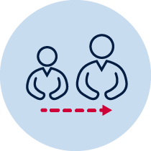
- Help from an adult
- A soft object to throw (for example, soft ball, pair of socks, soft toy, scrunched-up paper)
- 3 objects or landmarks to create targets for objects to hit (for example, bucket, a long piece of string laid in a circle, an ‘X’ formed by two pieces of tape/material, a t-shirt laid on the ground, a chair/bench, a wall, a tree)
- Refer to ‘Throlf’ game card for suggestions of what this activity could look like. (Sport Australia, 2019. Playing for life) Images are included in this student book for reference.
Lesson 1 – Throwing golf
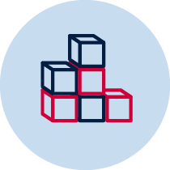
- Create 3 targets that you can safely throw a soft object towards. Choose a ‘starting point’ where you will throw the object from. Place each target at different distances from the ’starting point’.
- Discuss the following predictive questions before beginning each attempt:
  - Which throwing style do you think will be most effective? Why?
_______________________________________________________________________________________________________________________________________________________________________________________________________________
  - Which target will be the easiest to hit? Why?
_______________________________________________________________________________________________________________________________________________________________________________________________________________
- Throw the object towards the target. You should aim to hit the target. Pick up the object from where it landed and throw the object again until the target has been hit.

Throwing golf examples
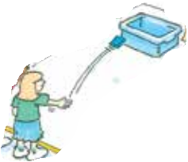  Sport Australia 2019, Playing for life | 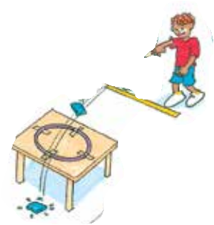 | 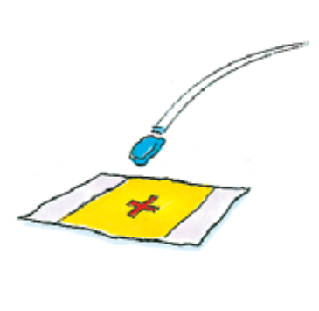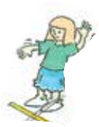

- Record how many throws it took to hit the target.
Table 1 Throwing golf
How many throws did you it take to hit the target? | Attempt 1  Underarm  throw | Attempt 2  Overarm  throw | Attempt 3  2-hand  overhand  throw | Attempt 4  2-hand  underhand  throw | Attempt 5  Your own  throwing  style
Target 1
Target 2
Target 3
- Repeat the challenge 5 times for each of the 3 targets

- Discuss the following reflective question after each attempt, ‘How did you adjust the amount of effort required for each throw?’
________________________________________________________________________________________________________________________________________________________________________________________________________________________
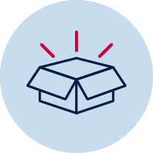
Resources
A soft object to throw (for example, soft ball, pair of socks, soft toy, scrunched-up paper).
- 3 objects or landmarks to create a target for the object to hit (for example, bucket, a long piece of string laid in a circle, an ‘X’ formed by two pieces of tape/material, a t-shirt laid on the ground, a chair/bench, a wall, a tree).
Lesson 2 – Obstacle golf
- Create 3 targets that you can safely throw a soft object towards. Choose a ‘starting point’ where you will throw the object from. Place each target at different distances from the ’starting point’.
- Choose or create at least one object that will act as an obstacle. The obstacle needs to be placed between the ’starting point’ and the target.
- Discuss the following predictive questions with your teacher or parent/caregiver before beginning each attempt. Record your answers below.
  - Which throwing styles will you use in these challenges? Explain when each throwing style would be most suitable?
______________________________________________________________________________________________________________________________________________________________________________________________________________
  - How can you adjust your throwing style to change the amount of effort you use to throw the object? Why will this be important?
______________________________________________________________________________________________________________________________________________________________________________________________________________
  - How can you adjust your throwing style to throw your object accurately and avoid the obstacle? Why will this be important? Explain how you plan to throw your object, for example, over, under, through the obstacle.
_______________________________________________________________________________________________________________________________________________________________________________________________________________
- Throw the object towards the target. You should aim to hit the target. Pick up the object from where it landed and throw the object again until the target has been hit.
Obstacle golf examples
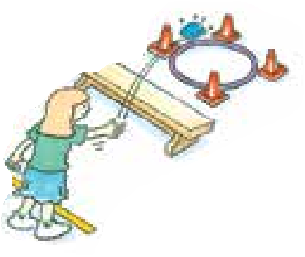  Sport Australia 2019, Playing for life | 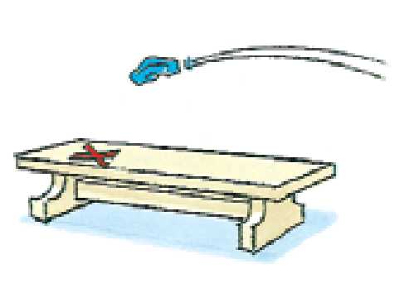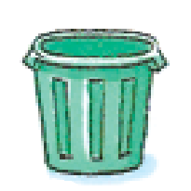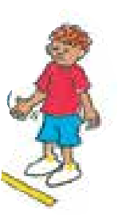 | 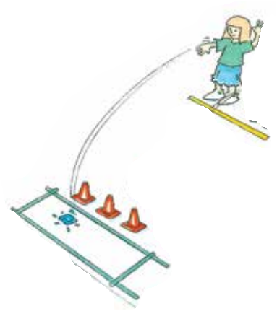

- Record how many throws it took to hit the target. Repeat the challenge 5 times for each of the 3 targets
Table 2 Obstacle golf
How many throws did you it take to hit the target? | Attempt 1 | Attempt 2 | Attempt 3 | Attempt 4 | Attempt 5
Target 1
Target 2
Target 3
Resources
- A soft object to throw (for example, soft ball, pair of socks, soft toy, scrunched-up paper).
- An object or landmark to create a target for the object to hit (for example, bucket, a long piece of string laid in a circle, an ‘X’ formed by two pieces of tape/material, a t-shirt laid on the ground, a chair/bench, a wall, a tree).
- Items that can be used as obstacles (for example a small stool, a bucket, toys)

