How can we solve problems when moving?
PDHPE Stage 2 student workbook
Name:
Class:

Overview of lessons 5 and 6
You will:
- Practise and compare different types of kick to propel objects towards a target or goal (lesson 5-6)
- predict the effectiveness of a range of types of kick to solve a movement challenge (lesson 5-6).
- adapt kicking skills to improve accuracy and control across different contexts (lesson 5-6)
- explore how to combine different elements of effort, space and time with objects to successfully complete a kicking challenge (lesson 6)
- select and use equipment appropriate for their learning environment (lesson 5-6)

Resources

Lessons 5-6
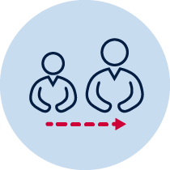
- Help from an adult
- A soft ball or object to kick (for example, soft ball, pair of socks, soft toy, scrunched-up paper)
- 3 objects or landmarks to create targets for objects to hit (for example, bucket, a long piece of string laid in a circle, an ‘X’ formed by two pieces of tape/material, a t-shirt laid on the ground, a chair/bench, a wall, a tree)
- Refer to ‘Throlf’ game card for suggestions of what this activity could look like. (Sport Australia, 2019. Playing for life) Images are included in this student book for reference.

Lesson 5 – Kicking golf
5.1 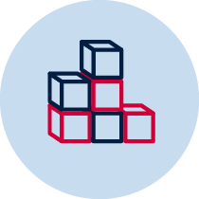 Create 3 targets or small goals that you can safely kick a soft ball/object towards. Choose a ‘starting point’ where you will kick the object from. Place each target/goal at different distances from the ’starting point’.
5.2Your challenge is to practise and compare three different types of kick. The three types of kick are
- kicking the ball on the ground
- kicking a ball off a tee (slightly raised off the ground). An example of a tee may be a cone/marker, a small pillow, several pieces of paper scrunched up and flattened slightly,
- kicking a ball out of your hands (also known as a ‘punt’)
Table 1 Kicking golf examples
Kicking golf examples
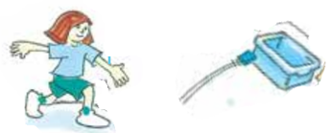  Sport Australia 2019, Playing for life | 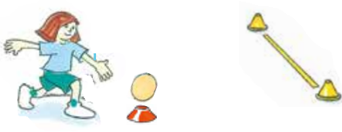 | 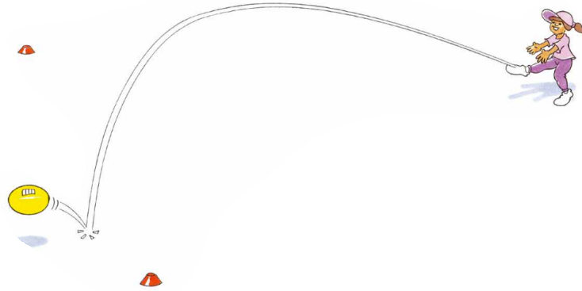
5.3 In previous lessons you have use a variety of throws to complete movement challenges. Discuss the following questions with your teacher or parent/caregiver
  - Which throwing style do you think was most effective? Why?
  - Do you think you can transfer anything you learned about throwing to similar challenges using the skill of kicking? Explain your answer
_______________________________________________________________________________________________________________________________________________________________________________________________________________

  - Which kicking style do you think will be most effective? Why? Explain your answer
_______________________________________________________________________________________________________________________________________________________________________________________________________________
5.4Play ‘kicking golf’. Kick the ball/object towards the target/goal. You should aim to hit the target or score a goal. Pick up the ball/object from where it landed and kick it again until you have hit the target or scored a goal.
Repeat the challenge 5 times for each of the 3 targets
5.5Record how many throws it took to hit the target.
Table 2 Kicking golf
How many kicks did you need to hit the target/score a goal? | Type of kick –  Kick on the ground |  |  |  |  | Type of kick -  Kick on a tee |  |  |  |  | Type of kick -  Kick out of hands
Target 1
Target 2
Target 3
  - Discuss the following questions with your teacher or parent/caregiver
  - Which type of kick was most successful? Why?
  - How did you adjust your body position to perform each type of kick differently?

  - How did you adjust the amount of force you used when kicking? Explain this answer
________________________________________________________________________________________________________________________________________________________________________________________________________________________
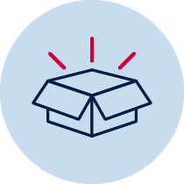
Resources
A soft ball or object to kick (for example, soft ball, pair of socks, soft toy, scrunched-up paper).
- 3 objects or landmarks to create a target or goal for the ball/object to hit or go through (for example, bucket, a long piece of string laid in a circle, an ‘X’ formed by two pieces of tape/material, a t-shirt laid on the ground, a chair/bench, a wall, a tree).
Lesson 6 – Obstacle kicking golf
6.1 Create 3 targets or small goals that you can safely kick a soft ball/object towards. Choose a ‘starting point’ where you will kick the object from. Place each target/goal at different distances from the ’starting point’.
  - Choose or create at least one object that will act as an obstacle for each target/goal. The obstacle needs to be placed between the ’starting point’ and the target/goal.
Table 3 Obstacle kicking golf examples
Obstacle kicking golf examples
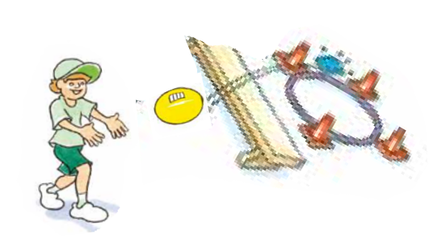  Sport Australia 2019, Playing for life | 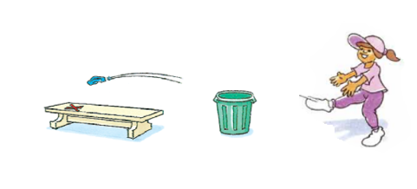 | 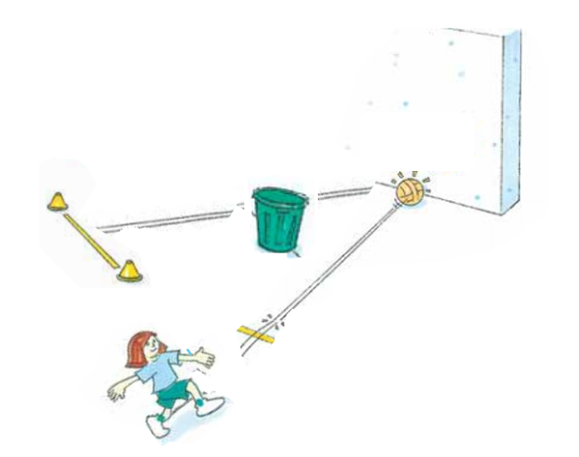

  - To play ‘Obstacle kicking golf’ you will be able to choose the kicking style you use for all of your kicks.
Discuss the following questions with your teacher or parent/caregiver before beginning. Record your answers below.
- Which kicking style did you prefer to use in the previous lesson? Why? (Choose from kicking on the ground, kicking from a tee, kicking out of your hand) Explain your answer.
______________________________________________________________________________________________________________________________________________________________________________________________________________
- Which kicking styles will you use in these challenges? Explain when each throwing style would be most suitable?
______________________________________________________________________________________________________________________________________________________________________________________________________________
- How can you adjust your kicking style to change the amount of effort you use to kick the ball/object? Why will this be important?
______________________________________________________________________________________________________________________________________________________________________________________________________________
- How can you adjust your throwing style to throw your object accurately and avoid the obstacle? Why will this be important? Explain how you plan to throw your object, for example, over, under, through the obstacle.
_______________________________________________________________________________________________________________________________________________________________________________________________________________
  - Play ‘Obstacle kicking golf’. Kick the ball/object towards the target/goal. You should aim to hit the target or score a goal. Pick up the ball/object from where it landed and kick it again until the target is hit or a goal is scored.
  - Record how many kicks it took to hit the target/score a goal. Repeat the challenge 5 times for each of the 3 targets
Table 4 Obstacle kicking golf
How many kicks did you it take to hit the target? | Attempt 1 | Attempt 2 | Attempt 3 | Attempt 4 | Attempt 5
Target 1
Target 2
Target 3
6.6Discuss the following questions with your teacher or parent/caregiver
  - Which type of kick was most successful? Why?
  - How would you adjust your kicking to improve your accuracy?
  - What adjustments do you think you should make to each target to make the challenge at the right level of challenge for you? Consider the distance of the target, the placement of the obstacle, the type of object used as an obstacle
6.7Play ‘Obstacle kicking golf’ again and apply the adjustments that you suggested.
  - Record how many kicks it took to hit the target/score a goal.
Repeat the challenge 5 times for each of the 3 targets
Table 5 Obstacle kicking golf
How many kicks did you it take to hit the target? | Attempt 1 | Attempt 2 | Attempt 3 | Attempt 4 | Attempt 5
Target 1
Target 2
Target 3
6.9Discuss the following question with your teacher or parent/caregiver
  - Were the changes you suggested successful? Why? Why not?

Resources
- A soft object to throw (for example, soft ball, pair of socks, soft toy, scrunched-up paper).
- An object or landmark to create a target for the object to hit (for example, bucket, a long piece of string laid in a circle, an ‘X’ formed by two pieces of tape/material, a t-shirt laid on the ground, a chair/bench, a wall, a tree).
- Items that can be used as obstacles (for example a small stool, a bucket, toys)

