Year 12 Mathematics Standard 2

Assessment task:
MS-M7 Rates and ratios and MS-N3 Critical path analysis

Driving question:
Design and plan a room

Outcomes
Standard 2
- MS2-12-3 interprets the results of measurements and calculations and makes judgements about their reasonableness, including the degree of accuracy and the conversion of units where appropriate
- MS2-12-4 analyses two-dimensional and three-dimensional models to solve practical problems
- MS2-12-8 solves problems using networks to model decision-making in practical problems
- MS2-12-9 chooses and uses appropriate technology effectively in a range of contexts, and applies critical thinking to recognise appropriate times and methods for such use
- MS2-12-10 uses mathematical argument and reasoning to evaluate conclusions, communicating a position clearly to others and justifying a response
This document references the Mathematics Standard Syllabus © NSW Education Standards Authority (NESA) for and on behalf of the Crown in right of the State of New South Wales, 2017.

Learning across the curriculum
- Critical and creative thinking
- Information and communication technology capability
- Literacy
- Numeracy
- Personal and social capability
- Work and enterprise

Context
As a contestant on a reality TV show you are required to renovate two rooms in a house. You must clear the chosen room of any existing structures, then design and plan a complete make over.
There are three key objectives for this task:
- Students are to renovate two rooms from a chosen house plan. Students are to obtain the measurements from scale drawing (floor plan), solve practical problems and make judgements on flooring, furnishing and overall design of their room.
- Students are to identify the activities that need to be completed in order to finish this project. All activities will need to be presented in an activity chart as well as a network diagram with all durations and interdependencies included.
- Students will need to make decisions using mathematical reasoning throughout the project.

Task
For this assessment task you will refer to the following house plan of the ‘Alpha’ from Davis Sanders Homes,
https://www.davissandershomes.com.au/home-designs/alpha/
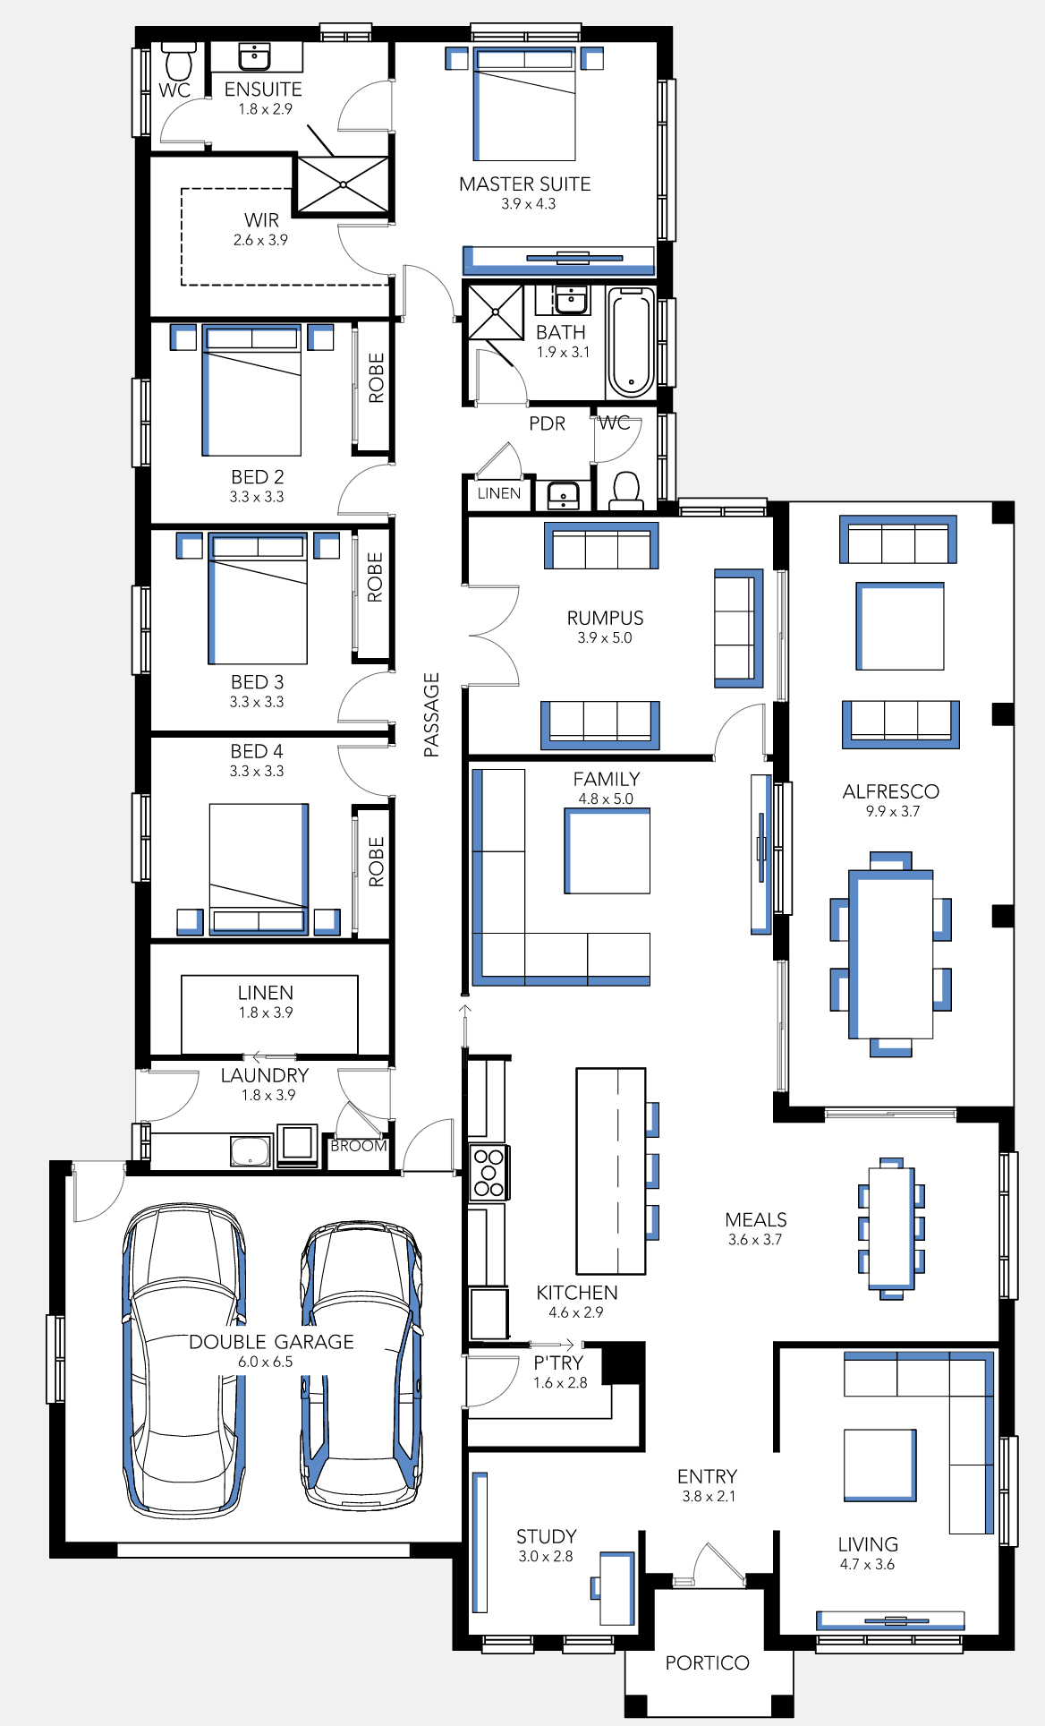
Permission to reproduce this plan provided by David Sanders Homes February 2020.

Part A – The rumpus room
The first room to be renovated will be the rumpus room. You are required to completely demolish the interior and then design and construct a new room. The activity chart for this renovation has been provided for you below:

Activity | Description | Immediate Prerequisite(s) | Duration  (Days)
A | Demolition | - | 1
B | Research furnishings | - | 3
C | Plaster | A | 2
D | Electronics | A | 1
E | Flooring | C, D | 1
F | Painting | E | 2
G | Purchase furnishings | B | 2
H | Dressing the room | F, G | 1

- Given the activity chart, prepare a network diagram making sure to include the durations of each activity. You can choose any of the three different methods for labelling your diagram and are able to use dummy activities if applicable.
- Perform a forward and backward scan and clearly show this on your network diagram.
- Use your network diagram to answer the following questions:
  - Calculate the minimum time to complete the entire renovation
  - Which activities lie on the critical path?
  - Are there any non-critical activities and if so, how long are their float times?
- Using the dimensions of the rumpus room from the floor plan above, you are to create a scaled plan of the room. Your plan must include the correct dimensions of the furniture and fittings that you plan to purchase.

Part B – Choose a room
Now it is your turn. Your task now is to choose another room within the house, but here is the catch... both rooms are to be renovated at the same time! The TV show is providing you with only one labourer ($250 per day), one plasterer ($550 per day), one electrician ($700 per day), one plumber ($640 per day if applicable) and one person to lay flooring ($500 per day). Each trades person will work an 8-hour day. You will be required to complete the rest of the activities yourself.

- Construct an activity chart for the second room using the above as a guideline only. Your chosen room may require additional activities (for example plumbing or cabinetry) and the durations may also differ.
- Use technology, like an online project manager program, to manage which room each trades person will be in, for how long and when. You must keep in mind that one person cannot be in two rooms simultaneously however you can research and purchase furnishings for both rooms at the same time. Trades people are charged for everyday that they are on site. Where possible, minimise the time the trades people spend on site.
- Calculate the cost of employing the trades people for their contributions to the renovation of the two rooms. Use the daily rates shown above for your calculations.

What to submit
- Scaled room design and network diagram for the rumpus room
- Activity chart and Gantt chart for the second room

Success criteria
Fluency, understanding and communication | Problem solving, reasoning and justification

Criteria | Working towards developing | Developing | Developed | Well developed | Highly developed
Part A  Network diagram - interdependencies and durations | Attempts to construct a network diagram without displaying durations. | Attempts to construct a network diagram with durations. | Constructs a network diagram that accurately displays all the durations and correct interdependencies.
Network diagram – forward and backward scan | Attempts to perform a forward and backward scan with errors shown in both processes. | Accurately performs and clearly displays either a forward scan with errors in the backward scan or vice versa. | Accurately performs and clearly displays a forward and backward scan.
Critical path analysis | Attempts to interpret their network diagram to determine the minimum completion time, critical path and float time of non-critical activities. | Demonstrates understanding by accurately interpreting their network diagram to determine the minimum completion time, critical path and float time of non-critical activities.
Scaled plan of the rumpus room | Attempts to construct an accurate scaled plan of the room with furniture and fittings not to scale. | Attempts to construct an accurate scaled plan of the room with furniture and fittings to scale. | Constructs an accurate scaled plan of the room with furniture and fittings to scale.
Part B  Activity chart and Gantt chart | Constructs an activity chart with minimal activities and missing or unrealistic interdependencies and durations. | Constructs an activity chart and has attempted to construct a Gantt chart with no evidence of an attempt to minimise the cost of the trades people. | Constructs a sophisticated activity chart and Gantt chart with no evidence of an attempt to minimise the cost of the trades people. | Constructs a sophisticated activity chart and Gantt chart with an attempt to minimise the cost of the trades people, supported by some mathematical argument. | Constructs a sophisticated activity chart and Gantt chart that minimises the cost of trades people, justified by strong mathematical argument.
Cost of trades | Attempts to calculate the cost of the trades people in accordance to the proposed Gantt chart. | Accurately calculates the cost of the trades people in accordance to the proposed Gantt chart.

Note to staff
The aim of the assessment task is to develop students’ deep content knowledge. This is reflected in the descriptors, working towards developing through to highly developed. The level of skill and understanding required in each part of the task is different; some parts require highly developed or well-developed skills, other parts only capture a developing skill set.
None of the working mathematically elements are distinct and when demonstrating one element, you are invariably demonstrating another. As an example, communication runs concurrently through all the other working mathematically elements. Students cannot respond to this assessment without communicating in some form. However, it is envisaged that there is a general progression through the working mathematically elements, starting with fluency and leading to understanding, problem solving, reasoning and justification, with increasingly higher levels of communication accompanying each element. Careful consideration has been given to the position of the success criteria statements so they reflect the working mathematically elements demonstrated.
This assessment task has been designed to illuminate the style of questions and the types of responses needed to elicit deep content knowledge, however, staff are encouraged to use and adapt the assessment task and the success criteria to their school context. Staff may like to enhance or amend sections of the task. Staff may like to adapt the rubric to assign marks to the descriptors in order to differentiate between responses that address the same statement. All changes are the responsibility of the staff using the assessment.

Technology
The following technology can be used throughout this unit to assist students in drawing networks:
- Graph creator
- Team Gantt
- Lucid chart
- Geogebra can also be used to create a network diagram with weightings as captions.

Students may use any spreadsheet program to complete the financial mathematics component of the task.

