2Mathematics Standard 2

MS-N2 Network concepts

Table of contents
Mathematics Standard 2 1
MS-N2 Network concepts 1
Table of contents 2
Syllabus outcomes 4
Outcomes 4
Content 4
Supplementary resources 6
Department of Education resources 6
NESA resources 6
Examination style questions 7
Sample question 1 7
Sample question 2 8
Sample question 3 9
Sample question 4 10
Sample question 5 11
Sample question 6 12
Sample question 7 13
Sample question 8 15
Sample question 9 16
Sample question 10 18
Sample question 11 19
Sample question 12 20
Sample question 13 21
Sample question 14 22
Sample question 15 24
Sample question 16 25
Sample question 17 26
Sample question 18 28
Sample question 19 29
Sample question 20 31
Solutions 32
Sample question 1 32
Sample question 2 32
Sample question 3 33
Sample question 4 33
Sample question 5 33
Sample question 6 34
Sample question 7 34
Sample question 8 35
Sample question 9 35
Sample question 10 36
Sample question 11 36
Sample question 12 36
Sample question 13 37
Sample question 14 37
Sample question 15 38
Sample question 16 38
Sample question 17 39
Sample question 18 40
Sample question 19 40
Sample question 20 41

Disclaimer
This document is to be used to supplement the support teachers are offering students undertaking HSC Mathematics courses. Questions can be printed off for students individually, with or without solutions, or as an entire booklet. Questions have been sourced from various states across Australia and the source of each question has been referenced. Permission to use these resources was provided in June 2020. Solutions for each of the questions can be found at the end of the document.
Outcomes
All outcomes referred to in this booklet are from Mathematics Standard Syllabus © 2017 NSW Education Standards Authority (NESA) for and on behalf of the Crown in right of the State of New South Wales.

Syllabus outcomes
The exam style questions presented in this document refer to the following outcomes and syllabus content.

Outcomes
A student:
- solves problems using networks to model decision-making in practical problems MS2-12-8
- chooses and uses appropriate technology effectively in a range of contexts, and applies critical thinking to recognise appropriate time and methods of such use MS2-12-9
- uses mathematical argument and reasoning to evaluate conclusions, communicating a position clearly to others and justifying a response MS2-12-10

Related Life Skills outcomes: MALS6-11, MALS6-12, MALS6-13, MALS6-14

Content
N2.1: Networks
Students:
- identify and use network terminology: vertices, edges, paths, the degree of a vertex, directed networks and weighted edges
- solve problems involving network diagrams
- recognises circumstances in which networks could be used, for example the cost of connecting various locations on a university campus with computer cables
- given a map, draw a network to represent the map, such as travel times for the stages of a planned journey
- draw a network diagram to represent information given in a table
- investigate and solve practical problems, for example planning a garbage bin collection route

N2.2: Shortest paths
Students:
- determine the minimum spanning tree of a given network with weighted edges
- determine the minimum spanning tree by using Kruskal’s or Prim’s algorithms or by inspection
- determine the definition of a tree and a minimum spanning tree for a given network
- use the minimum spanning trees to solve minimal connector problems, for example minimising the length of cable needed to provide power from a single power station to substations in several towns (ACMGM103)
- find the shortest path from one place to another in a network with no more than 10 vertices
- Identify the shortest path on a network diagram
- Recognise a circumstance in which a shortest path is not necessarily the best path or contained in any minimum spanning tree

Supplementary resources

Department of Education resources

Units of work
- N1 Networks and paths unit of work
- N2 Network concepts unit of work
- Exemplar question solutions (questions sourced from NESA Topic Guidance)

HSC Hub videos
- Drawing a network diagram (Duration: 5 minutes)
- Minimum spanning trees and shortest paths (Duration: 13 minutes)

NESA resources
- NESA Mathematics Standard 2 Networks Topic Guidance

Examination style questions

Sample question 1
Module 2 – Networks and decision mathematics
Question 1
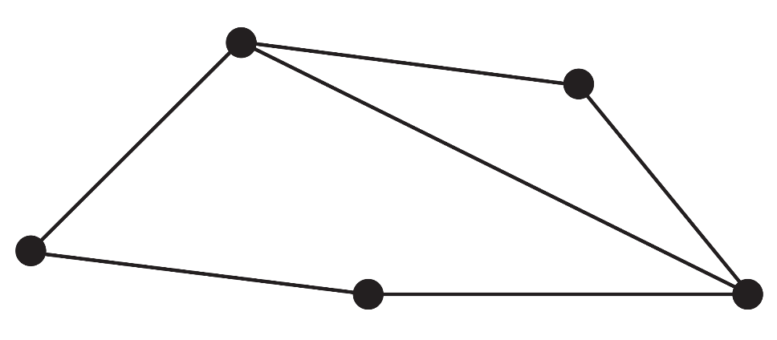
In the graph (network) shown above the sum of the degree of vertices is:
- 5
- 6
- 10
- 11
- 12

Source: © VCE 2019 Further Mathematics examination paper 1

Sample question 2
Module 2 – Networks and decision mathematics
Question 5
The following diagram shows the distances, in metres, along a series of cables connecting a main server to seven points, A to G, in a computer network.
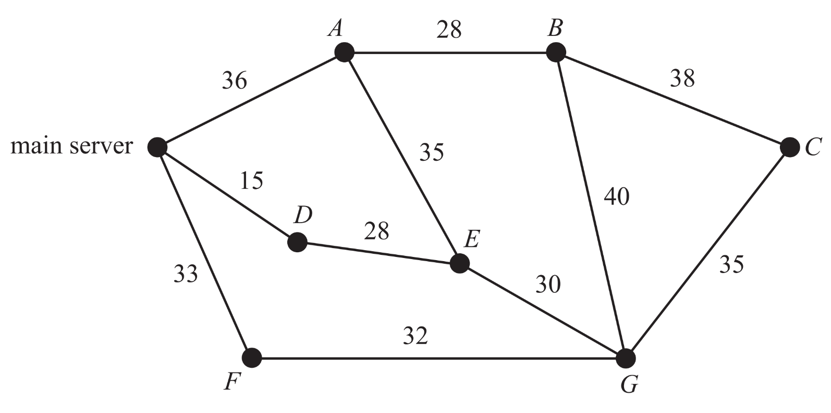
The minimum length of cable, in metres, required to ensure that each of the seven points is connected to the main server directly or via another point is
- 175
- 203
- 208
- 221
- 236

Source: © VCE 2019 Further Mathematics examination paper 1

Sample question 3
Module 2 – Networks and decision mathematics
Question 1
Consider the graph (network) with 5 isolated vertices shown below.
To form a tree, the minimum number of edges that must be added to the network is
- 1
- 4
- 5
- 6
- 10

Source: © VCE 2018 Further Mathematics examination paper 1

Sample question 4
Module 2 – Networks and decision mathematics
Question 4
Consider the graph (network) below.
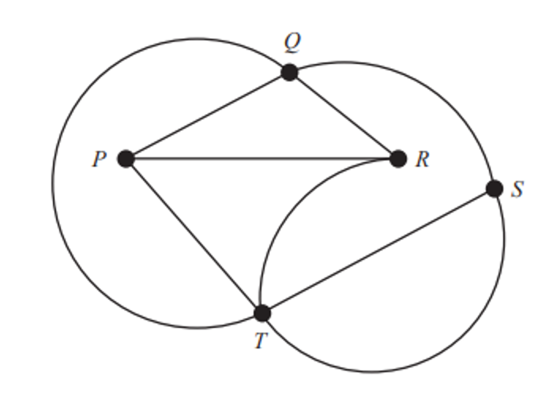
Which one of the following is not a path for this graph?
- PRQTS
- PQRTS
- PRTSQ
- PTQSR
- PTRQS

Source: © VCE 2018 Further Mathematics examination paper 1

Sample question 5
Module 2 – Networks and decision mathematics
Question 2
Two graphs (networks), labelled Graph 1 and Graph 2, are shown below:
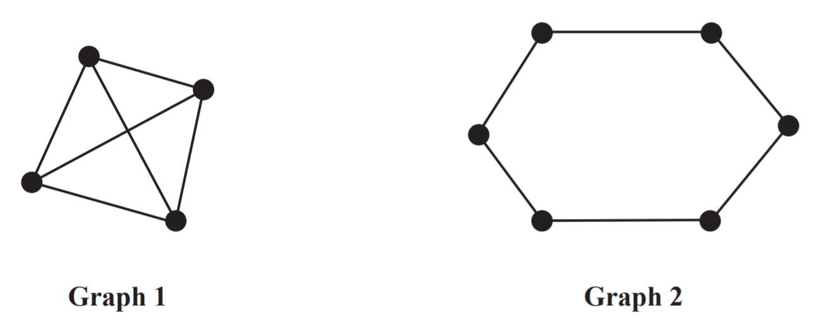
The sum of the degrees of the vertices of Graph 1 is
- two less than the sum of the degrees of the vertices of Graph 2
- one less than the sum of the degrees of the vertices of Graph 2
- equal to the sum of the degrees of the vertices of Graph 2
- one more than the sum of the degrees of the vertices of Graph 2
- two more than the sum of the degrees of the vertices of Graph 2

Source: © VCE 2017 Further Mathematics examination paper 1

Sample question 6
Module 2 – Networks and decision mathematics
Question 4
The minimum spanning tree for the network below includes the edge with the weight labelled k.
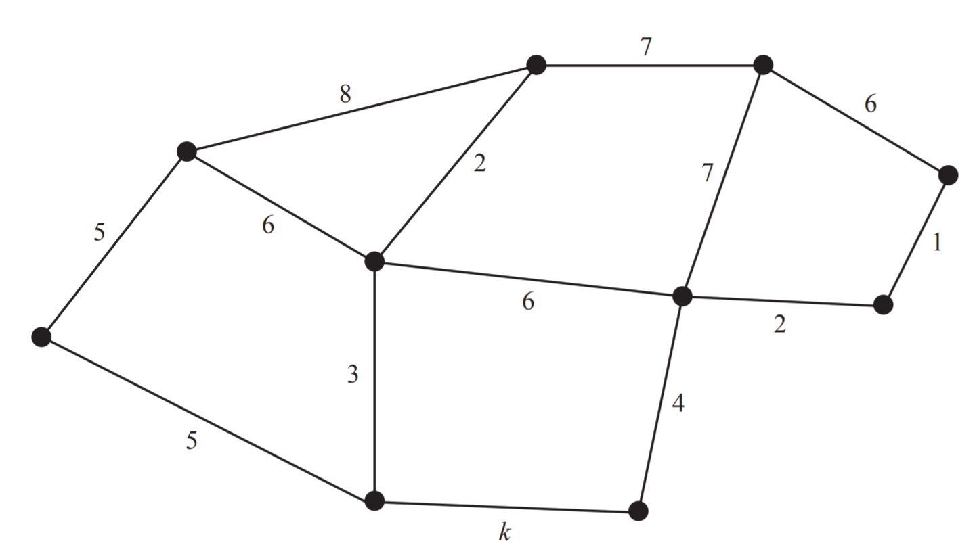
The total weight of all edges for the minimum spanning tree is 33. The value of k is
- 1
- 2
- 3
- 4
- 5

Source: © VCE 2016 Further Mathematics examination paper 1

Sample question 7
Module 5 – Networks and decision mathematics
Question 5
The graph below represents a friendship network. The vertices represent the four people in the friendship network: Kwan (K), Louise (L), Milly (M), and Narelle (N).
An edge represents the presence of a friendship between a pair of these people. For example, the edge connecting K and L shows that Kwan and Louise are friends.
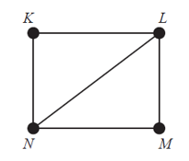
Which one of the following graphs does not contain the same information?

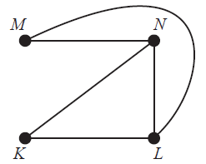

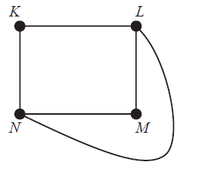
{Question continues on the next page}

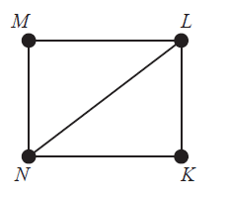

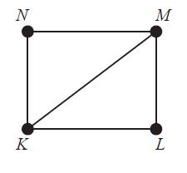

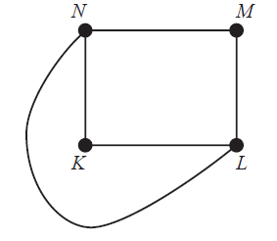

Source: © VCE 2015 Further Mathematics examination paper 1

Sample question 8
Module 5 – Networks and decision mathematics
Question 3
The diagram below shows the network of roads that Stephanie can use to travel between home and school.
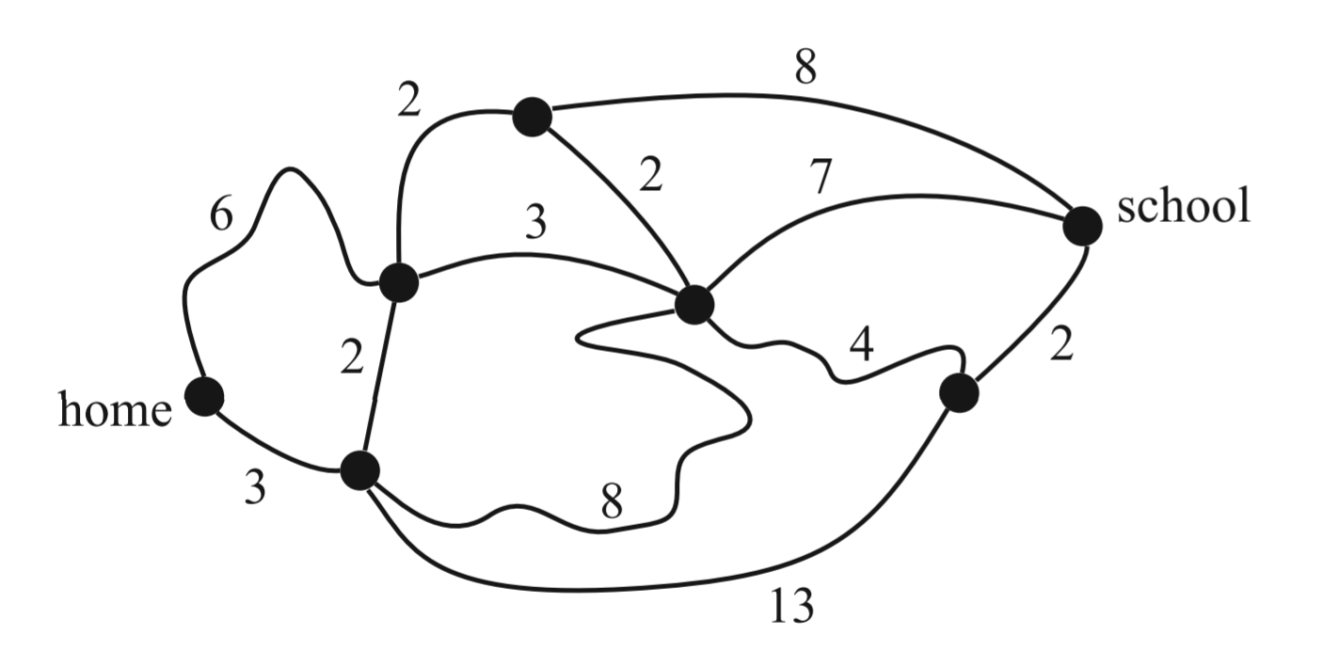
The numbers on the roads show the time, in minutes, that it takes her to ride a bicycle along each road. Using this network of roads, the shortest time that it will take Stephanie to ride her bicycle from home to school is:
- 12 minutes
- 13 minutes
- 14 minutes
- 15 minutes
- 16 minutes

Source: © VCE 2014 Further Mathematics examination paper 1

Sample question 9
Module 5 – Networks and decision mathematics
Question 5
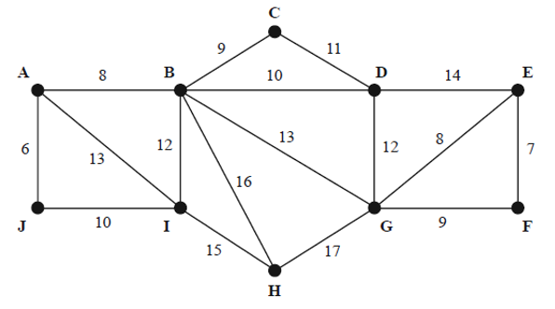
Which one of the following is a minimal spanning tree for the weighted graph (network) shown above?

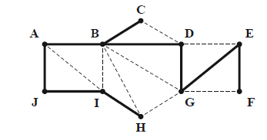

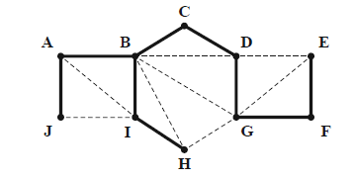
{Question continues on the next page}

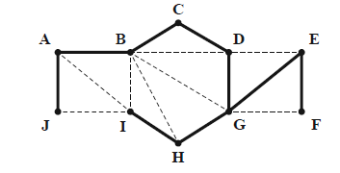

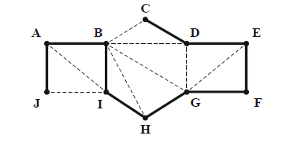

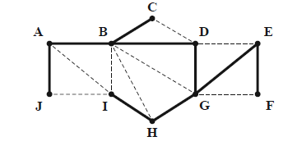
Source: © VCE 2014 Further Mathematics examination paper 1

Sample question 10
Module 5 – Networks and decision mathematics
Question 1
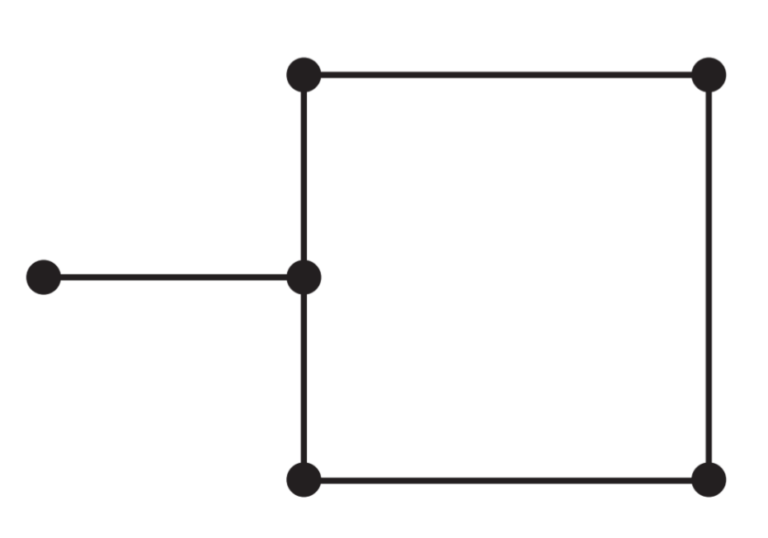
The sum of the degrees of all of the vertices in the graph (network) above is:
- 6
- 8
- 9
- 11
- 12

Source: © VCE 2012 Further Mathematics examination paper 1

Sample question 11
Module 2 – Networks and decision mathematics
Question 4 (2 marks)
Parcel deliveries are made between five nearby towns, P to T.
The roads connecting these five towns are shown on the graph (network) below. The distances, in kilometres, are also shown.
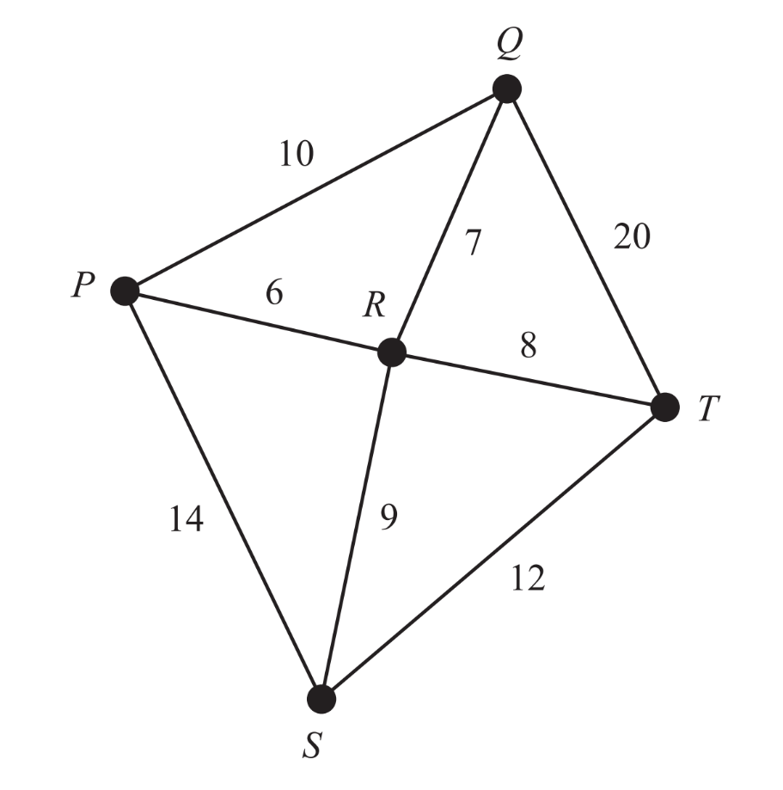
A road inspector will leave from town P to check all the roads and return to town P when the inspection is complete. He will travel the minimum distance possible.

- How many roads will the inspector have to travel on more than once? (1 mark)

- Determine the minimum distance, in kilometres, that the inspector will travel.
(1 mark)

Source: © VCE 2018 Further Mathematics examination paper 2

Sample question 12
Module 2 – Networks and decision mathematics
Question 1 (2 marks)
Bus routes connect six towns. The towns are Northend (N), Opera (O), Palmer (P), Quigley (Q), Rosebush (R) and Seatown (S).
The bus route below gives the cost, in dollars, of bus travel along these routes. Bai lives in Northend (N) and he will travel by bus to take a holiday in Seatown (S).
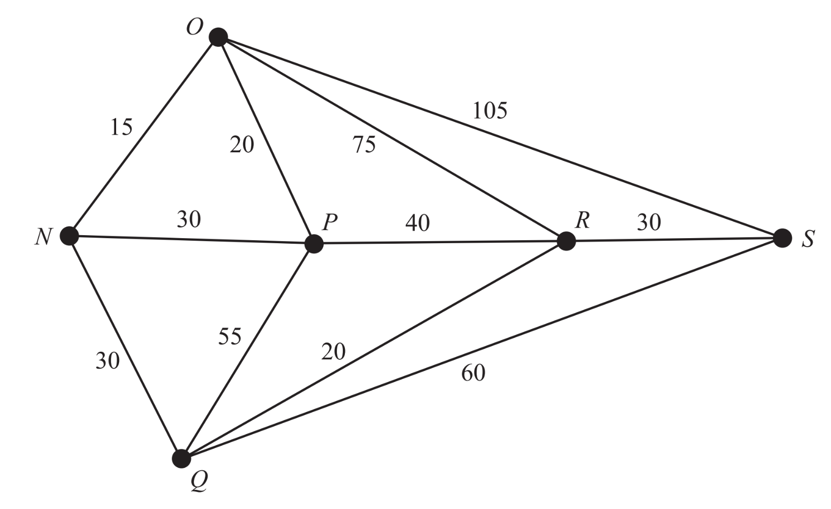
- Bai considers travelling by bus along the route Northend (N) - Opera (O) -
Seatown (S). How much will Bai need to pay? (1 mark)

- If Bai takes the cheapest route from Northend (N) to Seatown (S), which other towns will he pass through? (1 mark)

Source: © VCE 2017 Further Mathematics examination paper 2

Sample question 13
Module 2 – Networks and decision mathematics
Question 3 (2 marks)
While on holiday, four friends visit a theme park where there are nine rides. On the graph below, the positions of the rides are indicated by the vertices. The numbers on the edges represent the distances, in metres, between rides.
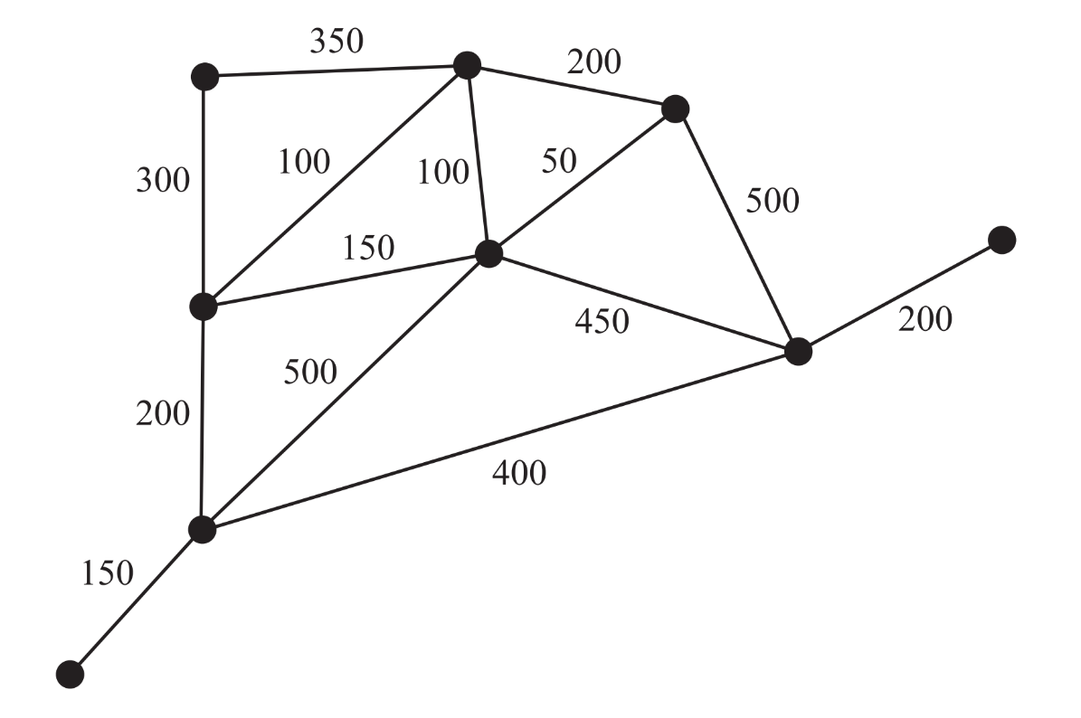
- Electrical cables are required to power the rides. These cables will form a connected graph. The shortest length of cable will be used.
- Give a mathematical term to describe a graph (network) that represents these cables. (1 mark)
- Draw in the graph (network) that represents these cable on the diagram below. (1 mark)
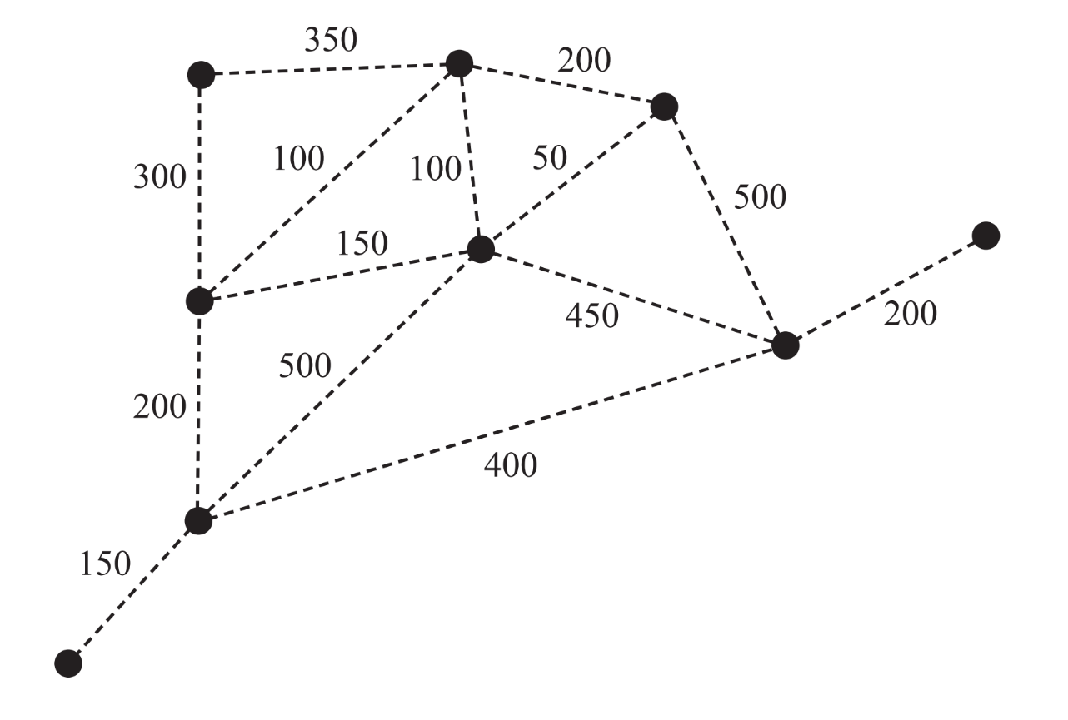
Source: © VCE 2017 Further Mathematics examination paper 2

Sample question 14
Module 5 – Networks and decision mathematics
Question 1 (4 marks)
A factory requires seven computer servers to communicate with each other through a connected network of cables.
The servers, J, K, L, M, N, O and P, are shown as vertices on the graph below.
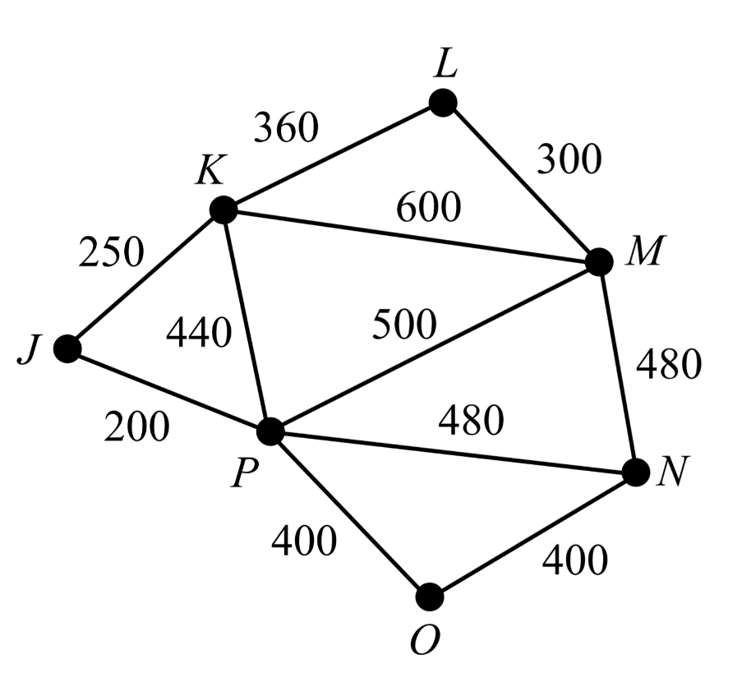
The edges on the graph (network) represent the cables that could connect adjacent computer servers.
The numbers on the edges show the cost, in dollars, of installing each cable.
- What is the cost, in dollars, of installing the cable between server L and server M?
(1 mark)

- What is the cheapest cost, in dollars, of installing cables between server K and server N? (1 mark)

- This questions is outside the scope of the NSW Mathematics Standard syllabus.

- The computer servers will be able to communicate with all the other servers as long as each server is connected by cable to at least one other server.
- The cheapest installation that will join the seven computer servers by cable in a connected network follows a minimum spanning tree.
Draw the minimum spanning tree on the plan below. (1 mark)

{Question continues on the next page}
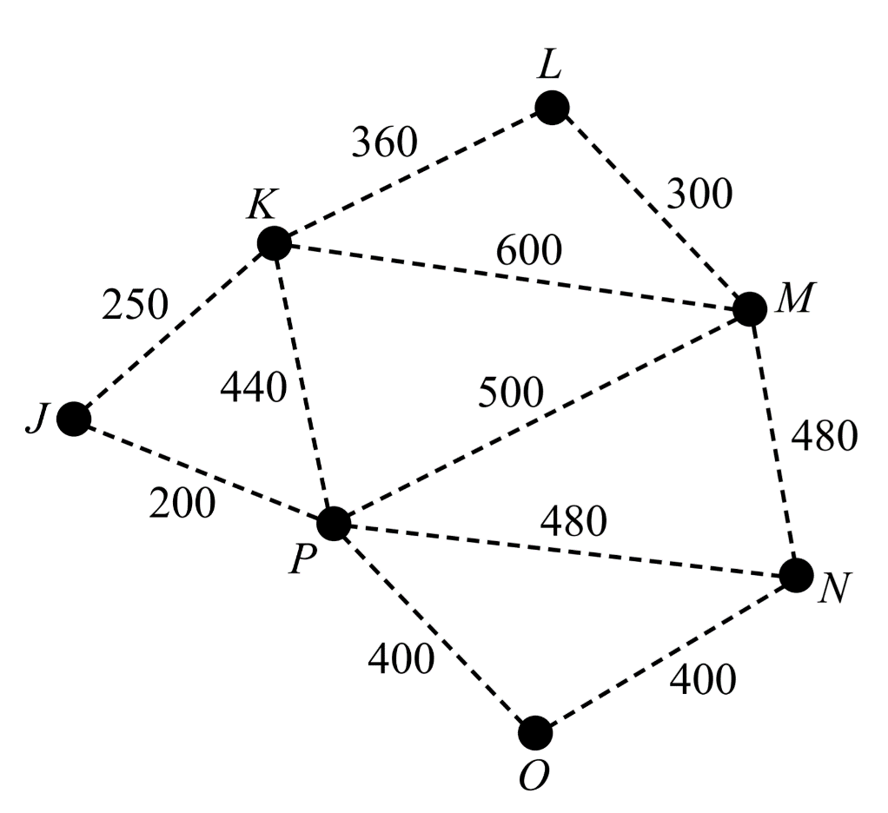
- The factory’s manager has decided that only six connected computer servers will be needed, rather than seven.
How much would be saved in installation costs if the factory removed computer server P from its minimum spanning tree network?
A copy of the graph (network) above is provided below to assist with your working. (1 mark)

Source: © VCE 2015 Further Mathematics examination paper 2

Sample question 15
Module 5 – Networks and decision mathematics
Question 1 (5 marks)
The vertices in the network diagram below show the entrance to a wildlife park and six picnic areas in the park: P1, P2, P3, P4, P5 and P6.
The numbers on the edges represent the lengths, in metres, of the roads joining these locations.
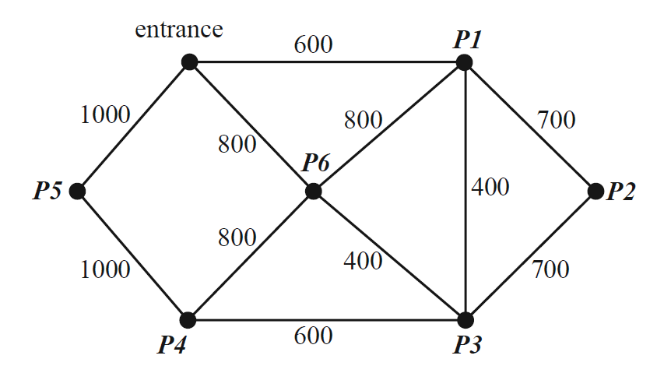

- In this graph, what is the degree of the vertex at the entrance to the wildlife park?
(1 mark)

- What is the shortest distance, in metres, from the entrance to picnic area P3?
(1 mark)

Source: © VCE 2013 Further Mathematics examination paper 2

Sample question 16
Module 5– Networks and decision mathematics
Question 1 (4 marks)
Water will be pumped from a dam to eight locations on a farm.
The pump and the eight locations (including the house) are shown as vertices in the network diagram below.
The numbers on the edges joining the vertices give the shortest distances, in metres, between locations.
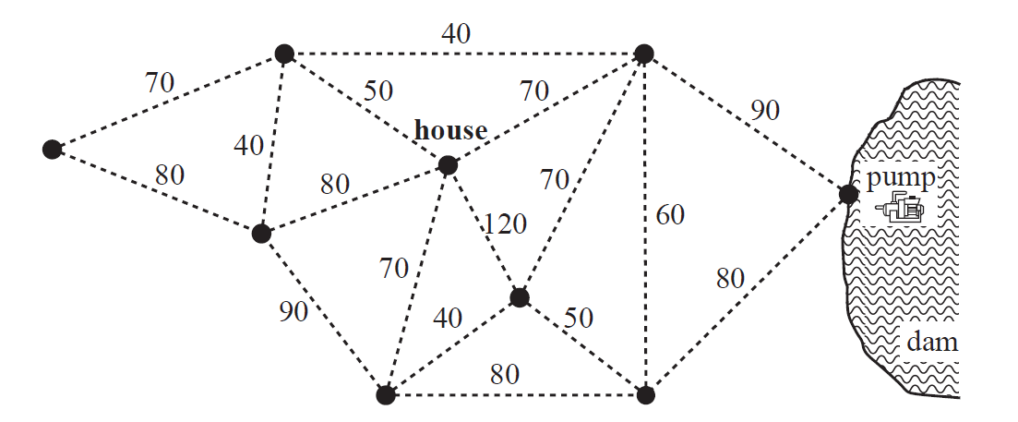
- Complete the following:
- Determine the shortest distance between the house and the pump. (1 mark)
- How many vertices on the network diagram have an odd degree? (1 mark)
- This question is outside the scope of the NSW Mathematics Standard syllabus.

- The total length of pipe that supplies water from the pump to the eight locations on the farm is a minimum. This minimum length of pipe is laid along some of the edges in the network.
- On the diagram above, draw the minimum length of pipe that is needed to supply water to all locations on the farm. (1 mark)
- What is the mathematical term that is used to describe this minimum length of pipe in part i? (1 mark)

Source: © VCE 2012 Further Mathematics examination paper 2

Sample question 17
Question 4 (9 marks)
A marine park has attractions with paths connecting them. The vertices on the graph (network) represent the attractions and the numbers on the edges represent the path distances (km) between the attractions. Visitors can either walk around the park or take one of the many shuttle busses that run between the attractions.
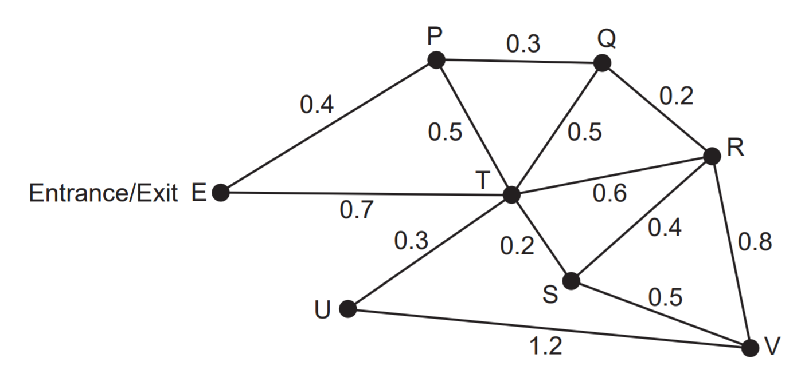
The manager of the marine park leaves his office, which is located at the entrance/exit (E) and walks to attraction V.
- Complete the following questions:
- Determine the shortest distance from E to V. (1 mark)
- If the manager needs to pick up some tools left at U on the way, determine the route he should take and the corresponding distance, given he wants to take the shortest route from E to V. (2 marks)

- This question is outside the scope of the NSW Mathematics Standard syllabus.

- Drinking water is already being supplied at E. The manager has recently received funding to establish drinking fountains at each attraction. For this to happen, pipelines will need to be laid along the paths to each attraction.

- Use Prim’s algorithm, or otherwise, to determine the minimum total length of pipelines. Highlight the required pipelines on the diagram below. (4 marks)

{Question continues on the next page}

- The manager has been told that a pipeline of length 0.2 km could be laid from S to U. How, if at all, will this affect the total length of pipelines that should be laid in order to maintain a minimum length? (2 marks)

Source: © WA SCSA 2019 Mathematics Applications calculator-free examination

Sample question 18
Question 1 (4 marks)
The weighted network below represents an orienteering map where the vertices represent the various stations and the edges represent bush tracks joining the stations. The distances on the edges are in metres. The organisers wish to install freshwater fountains at each station using the minimum length of piping necessary to connect the stations along the bush tracks.

- Highlight, on the diagram below, the bush tracks where the pipes should be installed. (2 marks)
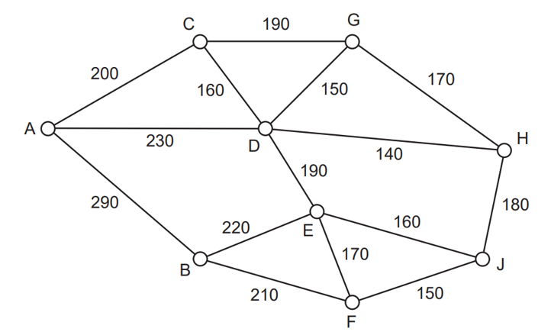
- Calculate the minimum length of piping required. (2 marks)

Source: © WA SCSA 2018 Mathematics Applications calculator-free examination

Sample question 19
Question 6 (7 marks)
- In the network diagram below, the nodes (vertices) represent towns and the numbers on the arcs (edges) represent the time taken (in minutes) to travel between them.
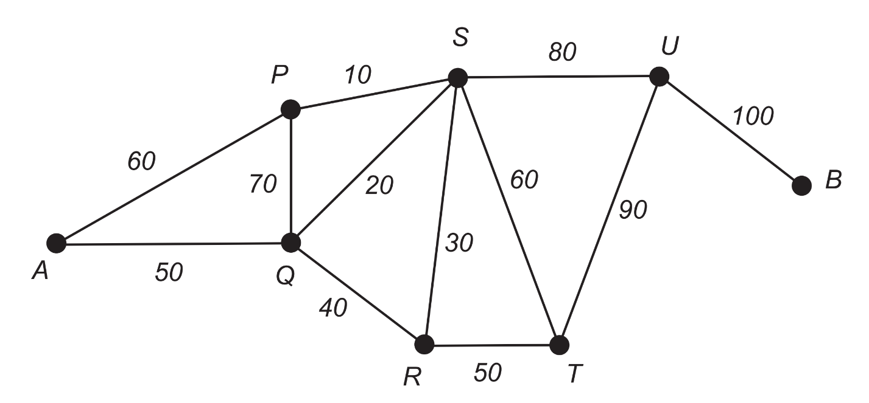
A driver leaves Town A and must deliver goods to all the towns in the shortest time, finishing at Town B. Determine the shortest time. (A town may be visited more than once). (3 marks)

- The network below shows the distances (in metres) between stations for a model railway track system.
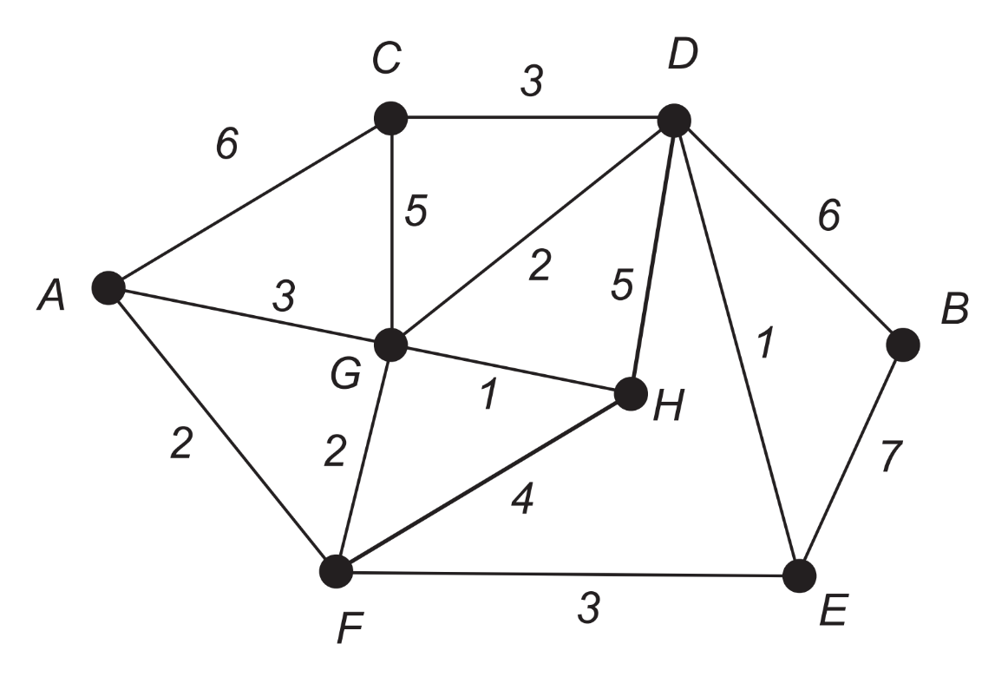
- Determine the minimal spanning tree for the network and draw this on the diagram below. (3 marks)

{Question continues on the next page}
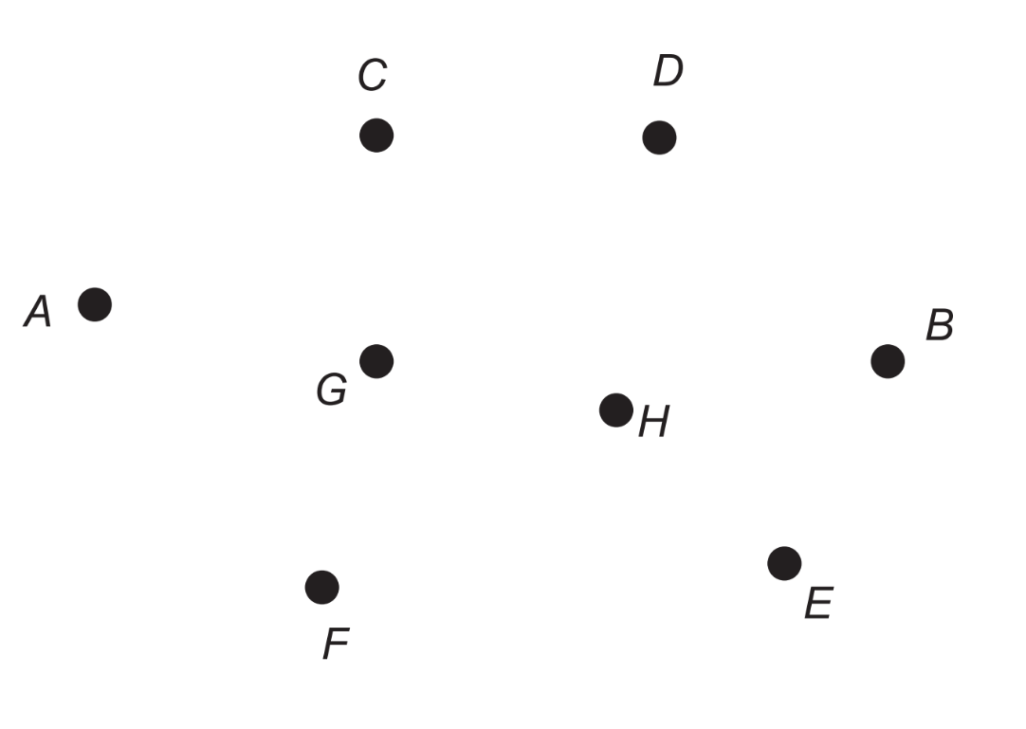
- State the length of the minimal spanning tree. (1 mark)

Source: © WA SCSA 2017 Mathematics Applications calculator-free examination

Sample question 20
Question 1 (5 marks)
Joe wishes to upgrade his sprinkler system using the least possible length of piping. The weighted graph (network) below shows the existing system. The numbers on the edges indicate the length of each pipe, in metres, between sprinklers A, B, C, D, E, F, G and H.
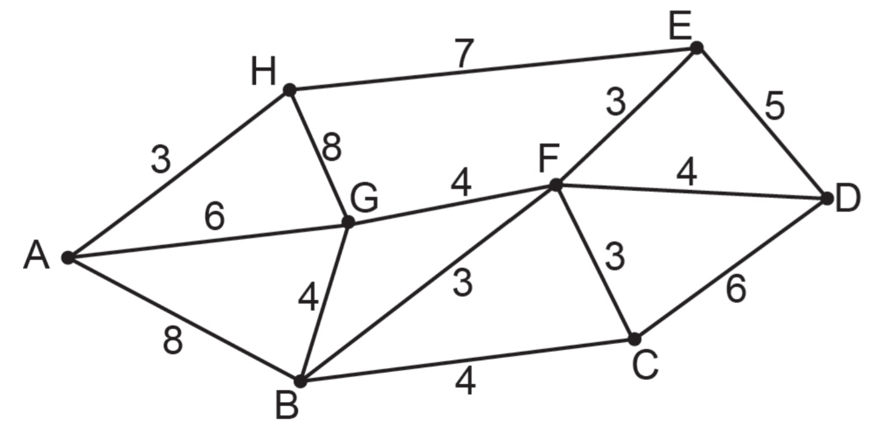
- This questions is outside the scope of the NSW Mathematics Standard syllabus.

- Show the use of Prim’s algorithm to establish a minimum spanning tree for the least length of piping required and draw this tree on the diagram below. (5 marks)

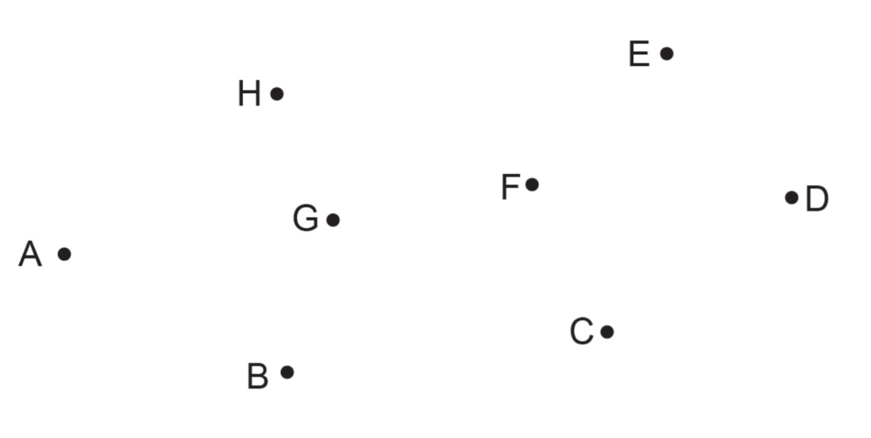

Source: © WA SCSA 2016 Mathematics Applications calculator-free examination

Solutions

Sample question 1
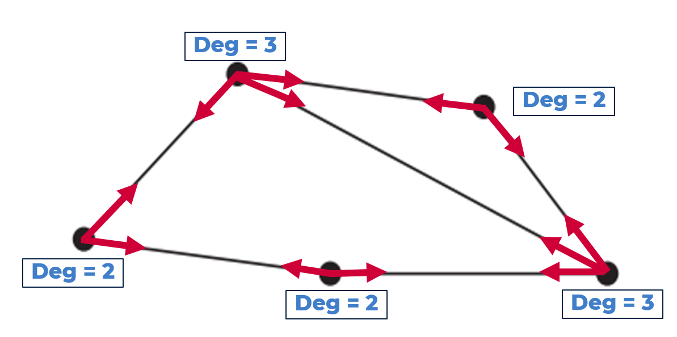
Sum of the degree of the vertices $=3+2+3+2+2$
$∴$ The sum of the degree of the vertices $=12$
Correct answer = E

Sample question 2
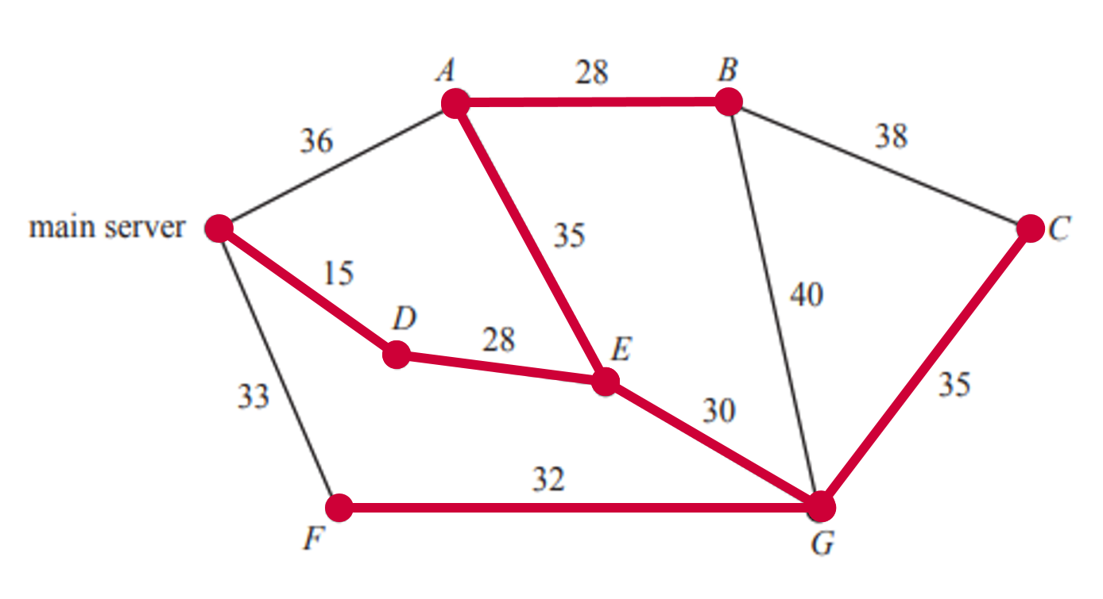
Minimum spanning tree $=203$
Correct answer = B

Sample question 3
Below are a few possible spanning trees.
Each spanning tree requires 4 edges.
Correct answer = B

Sample question 4
PTQSR is NOT a path as there is no direct edge that connects S to R.
Correct answer = D

Sample question 5
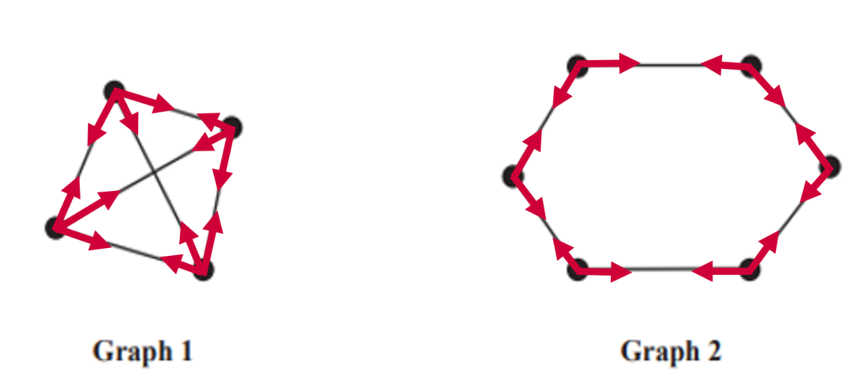
The sum of the degree of vertices in both Graph 1 and Graph 2 is 12.
Correct answer = C

Sample question 6
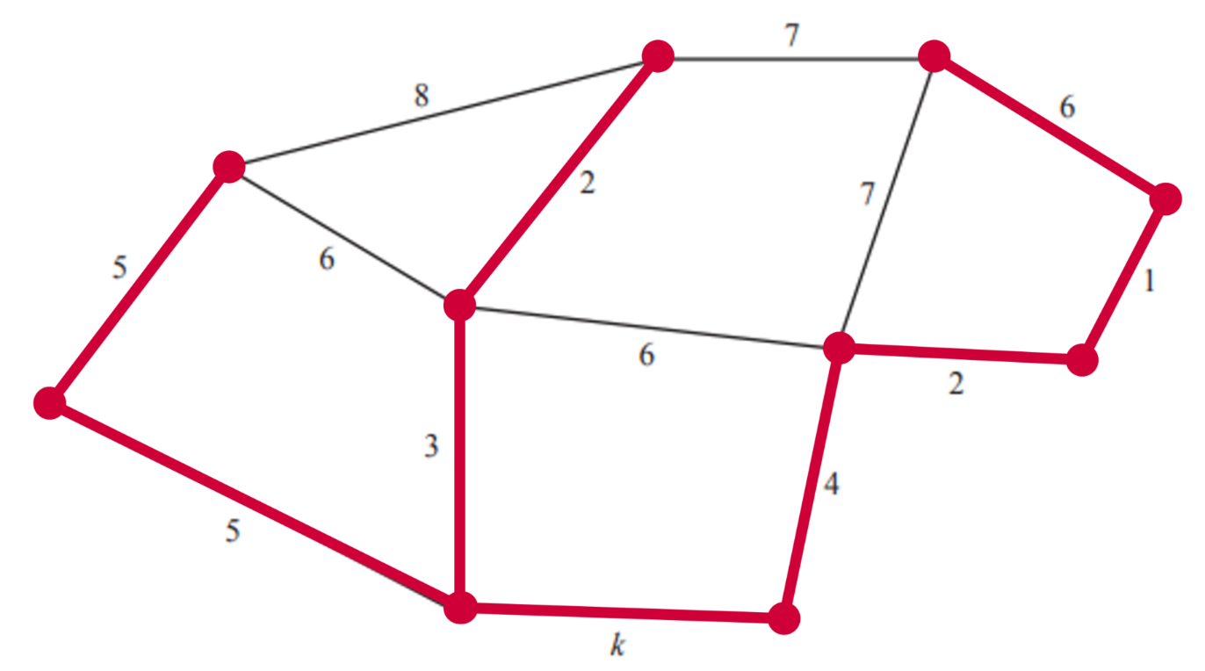
Minimum spanning tree (including $k$) $=28+k$
If the minimum spanning tree $=33$
$$28+k=33$$
$$∴k=5$$
Correct answer = E

Sample question 7
Note: The vertices are not labelled in the same positions as the original network diagram.
Network diagram D does not show a connection between N and L and it shows an additional connection between K and M that is not present in the original network diagram.
Correct answer = D

Sample question 8
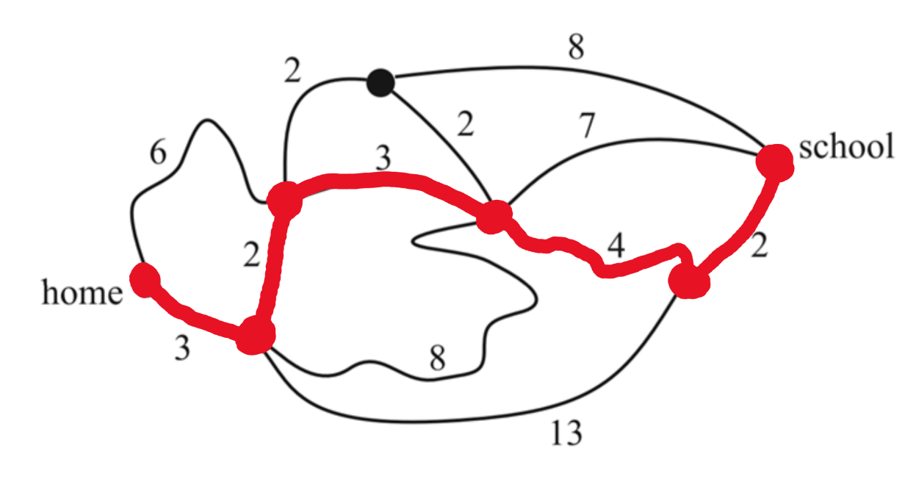
By inspection the shortest path is shown in the diagram above.
$3+2+3+4+2=14$ minutes
Correct answer = C

Sample question 9
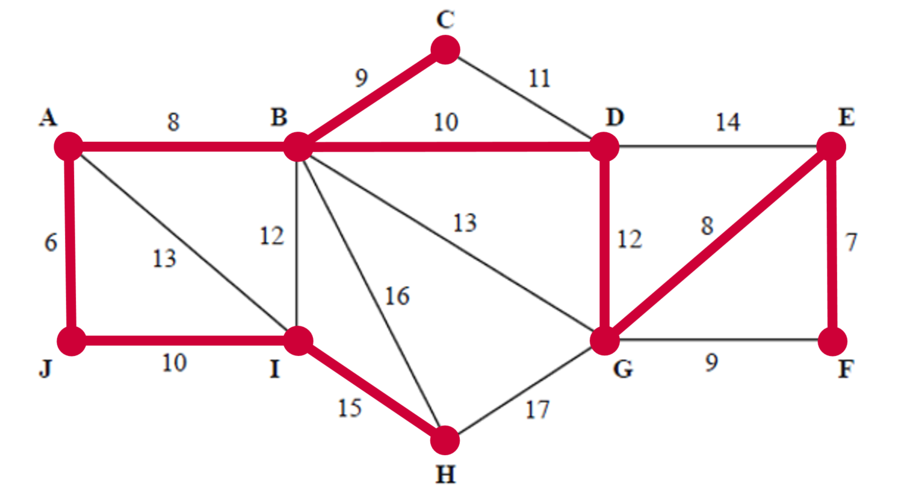
Using either Prim’s or Kruskal’s algorithm or by inspection the minimum spanning tree is represented above.
Correct answer = A

Sample question 10
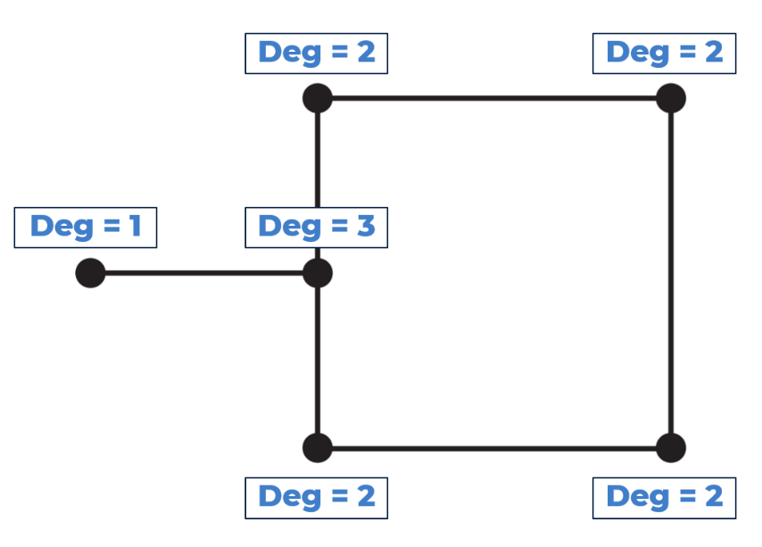
The sum of the degrees of the vertices is $1+3+2+2+2+2=12$
Correct answer = E

Sample question 11
- The path is P-Q-T-S-R-Q-P-S-T-R-P
PQ and ST will need to be travelled along twice each
$∴$ There are 2 edges that need to be travelled along more than once.

- The total distance travelled along P-Q-T-S-R-Q-P-S-T-R-P is:
$10+20+12+9+7+10+14+12+8+6=108$ km

Sample question 12
- $15+105=\$120$
- Bai would need to travel along the path N-Q-R-S.
$∴$ Bai would need to travel through Quigley and Rosebush as shown below.
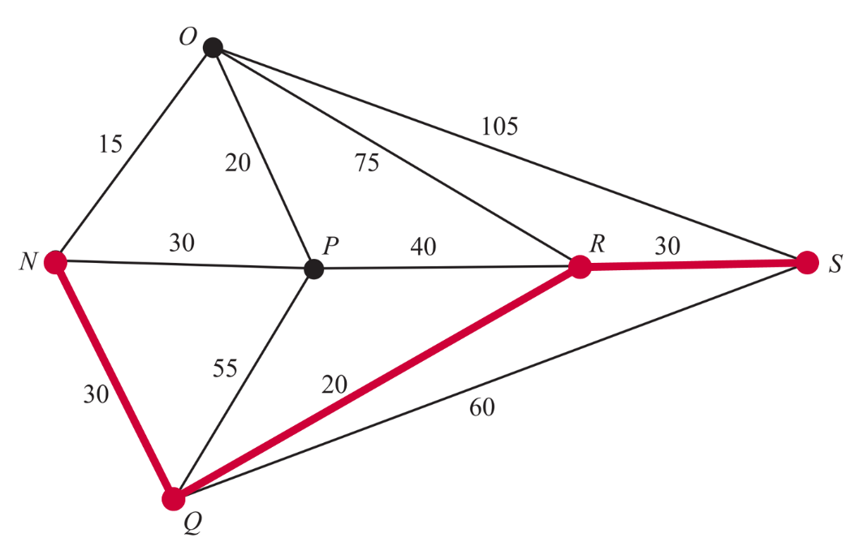

Sample question 13
- i. The term used to describe the shortest length of cable required is a minimum spanning tree.
ii. Below shows a minimum spanning tree for this network.
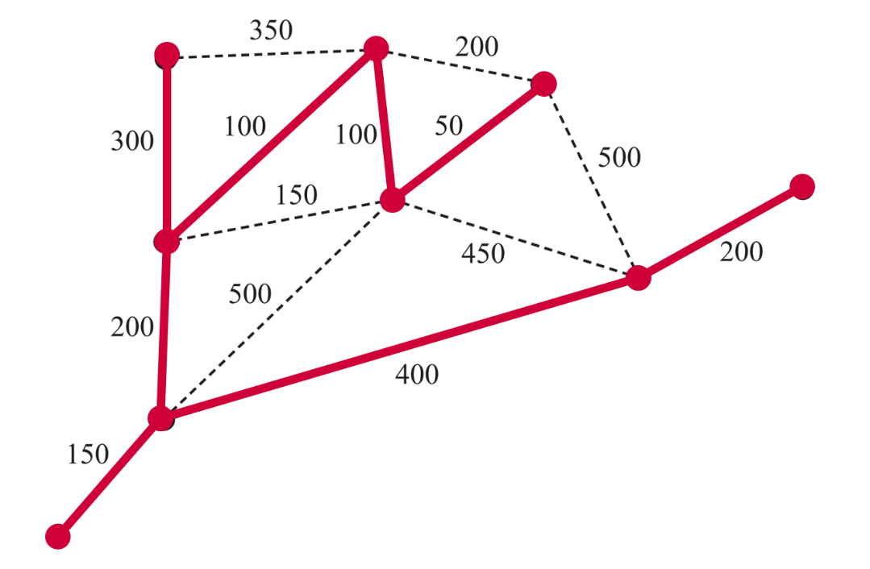

Sample question 14
- The edge connecting L and M has a weight of $300
- The cheapest path from K to N is via P.
$∴$ The cheapest path is $\$440+\$480=\$920$
- This questions is outside the scope of the NSW Mathematics Standard syllabus.
- See below:
- The minimum spanning tree is shown below
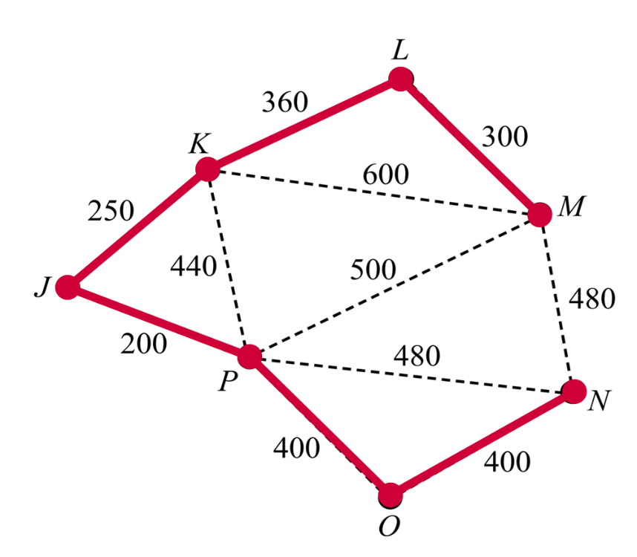
- Disconnecting J-P and O-P will reduce cost by $600 but must then add in N-M to add $480 back in.
$$480-600=-120$$
$∴$ $120 would be saved.
Source: © VCE 2015 Further Mathematics examination report exam 2

Sample question 15
- The red arrows show that there are three edges leading out of the vertex marked as the entrance.
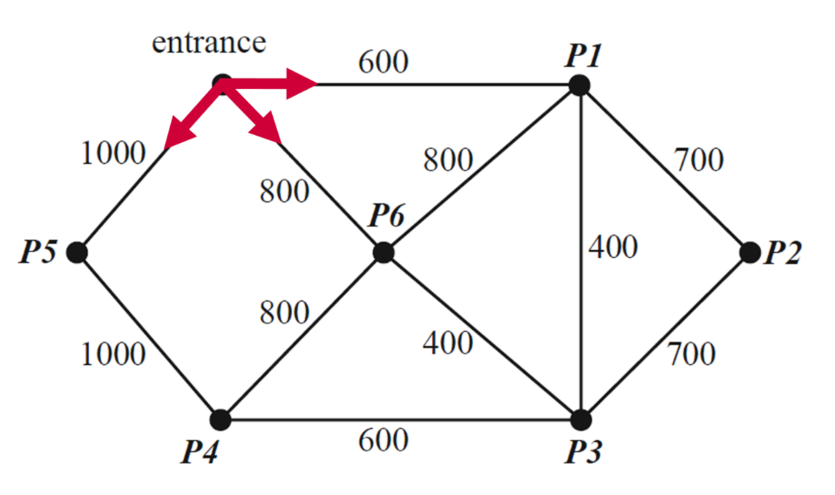
$∴$ The degree of the vertex at the entrance is 3.
- The shortest path could be determined using Dijkstra’s algorithm or by inspection.
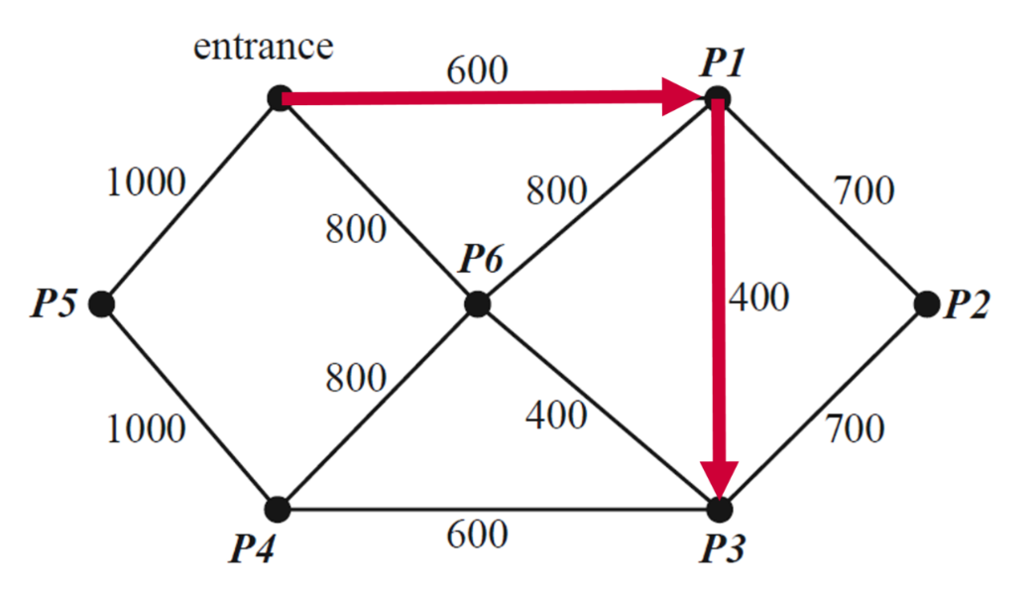
$∴$ The shortest path is 1000 metres.

Sample question 16
- See below:
- Shortest distance is shown below. $70+90=160$ metres
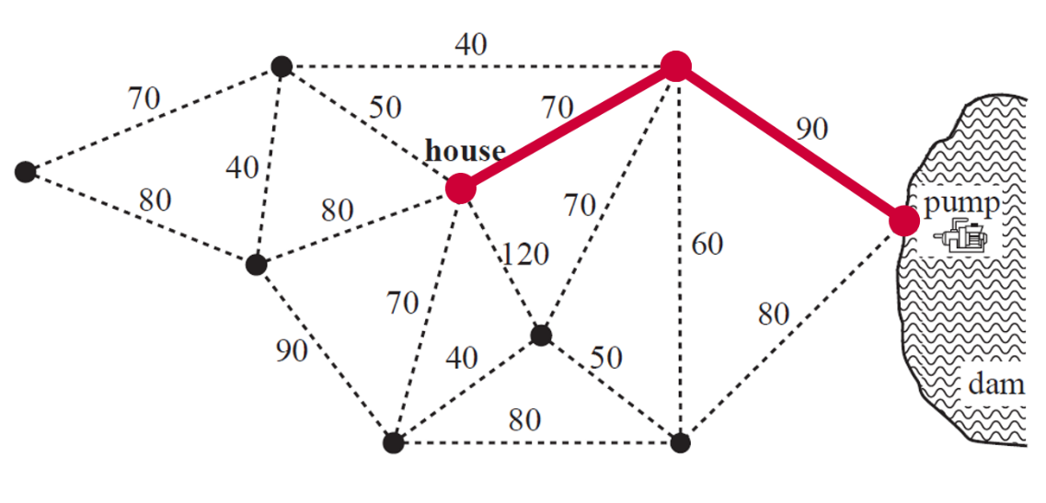
- There are 2 vertices that have a degree of 5 which is an odd number.
$∴$ There are 2 odd vertices as seen in the diagram below.
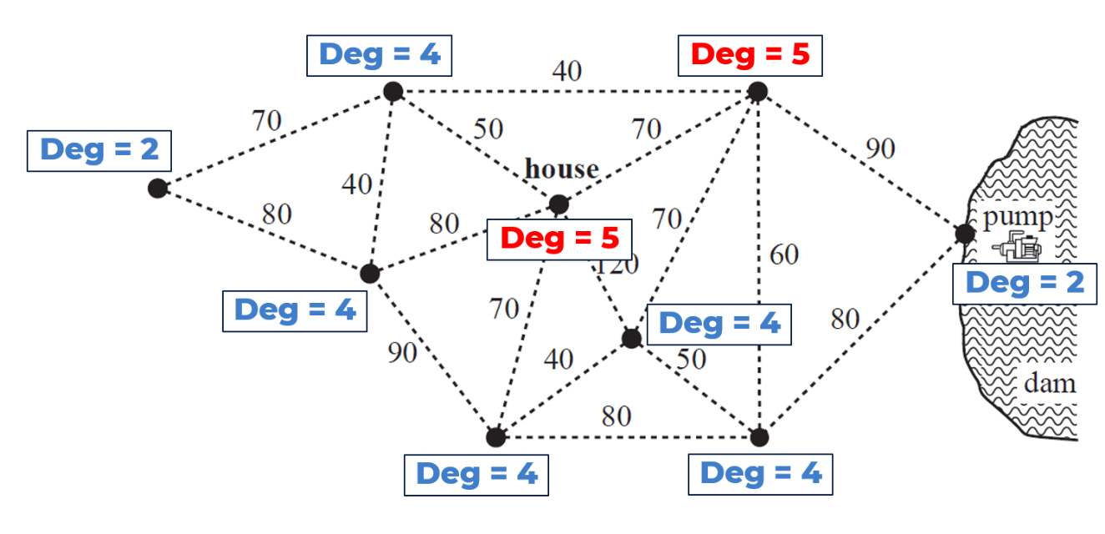
- See below:
- The minimum length of pipe needed is shown on the diagram below.
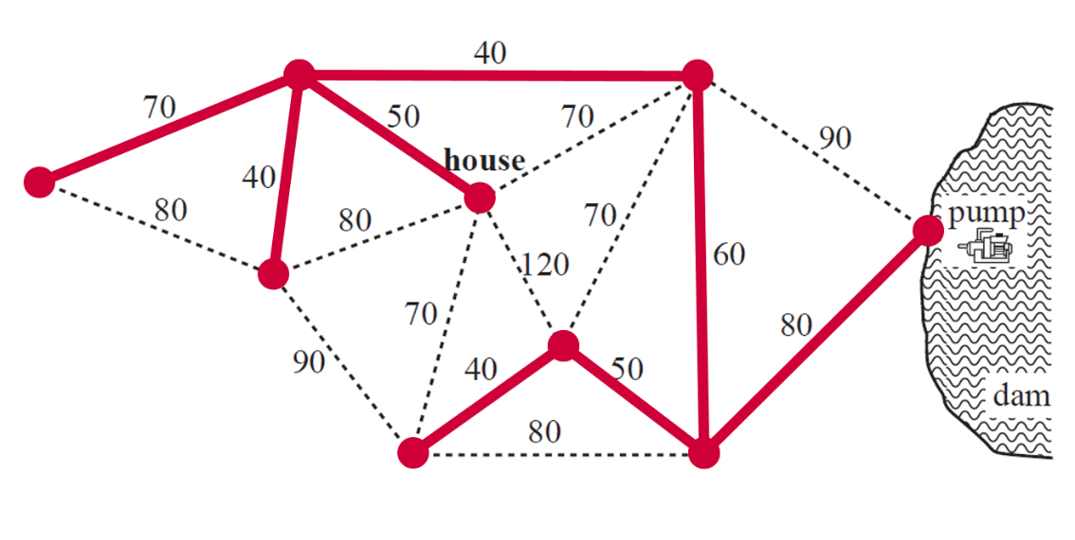
- The above diagram shows a minimum spanning tree.

Sample question 17
- See below:
- 1.4km
- ETUTSV Total 2km
- This questions is outside the scope of the NSW Mathematics Standard syllabus.
- See below:
- The minimum length is 2.3 km
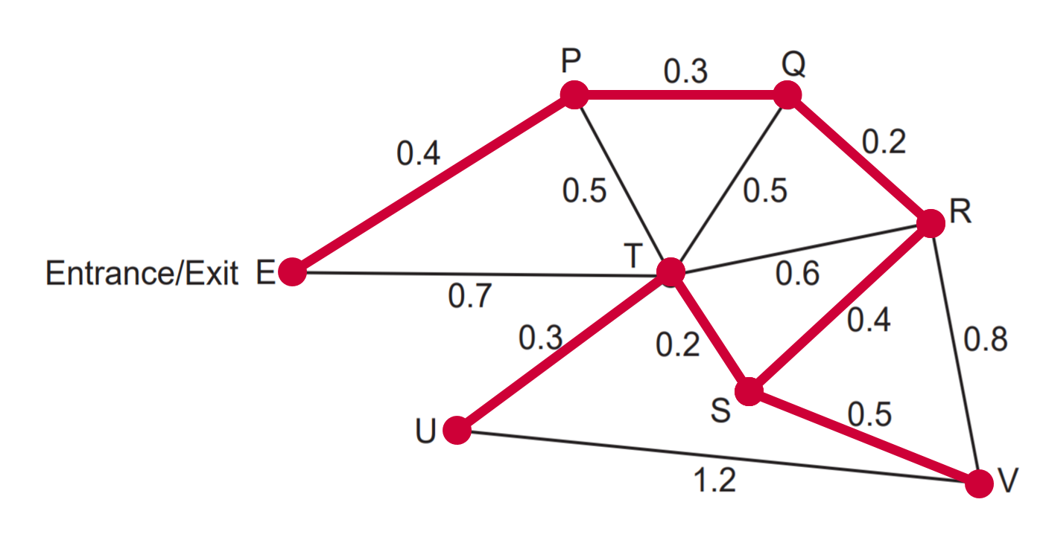
- The minimum length will decrease by 0.1 km (as SU would be used instead of TU).
Source: © WA SCSA 2019 Mathematics Applications calculator-free examination marking key

Sample question 18
- Answer is found using a minimum spanning tree. The correct minimum spanning tree is shown in the diagram below.
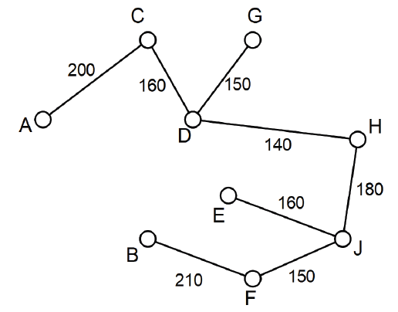
- Min distance = 200 + 160 + 150 + 140 + 180 + 160 + 150 + 210 = 1350 metres
Source: © WA SCSA 2018 Mathematics Applications calculator-free examination marking key

Sample question 19
- The shortest time will require the drive to follow along the path A-Q-S-P-S-R-T-U-B as shown in the diagram below.
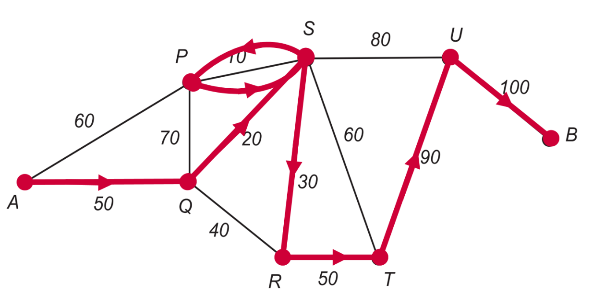
$∴$ The shortest time world be $50+20+10+10+30+50+90+100=360$ minutes
- See below:
- The minimum spanning tree is shown below
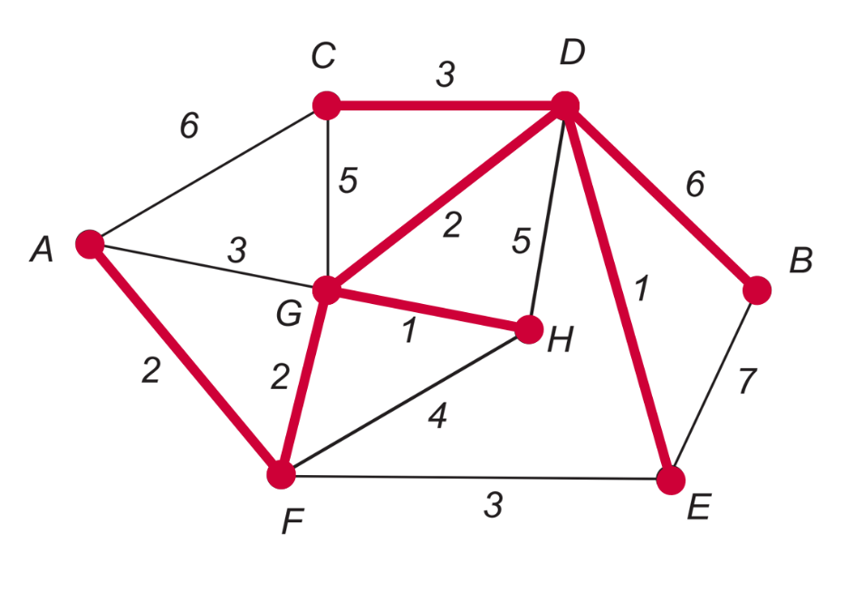
- The length of the minimum spanning tree is $2+2+1+2+3+1+6=17$ metres

Sample question 20
- This questions is outside the scope of the NSW Mathematics Standard syllabus.
- See the minimum spanning tree below:
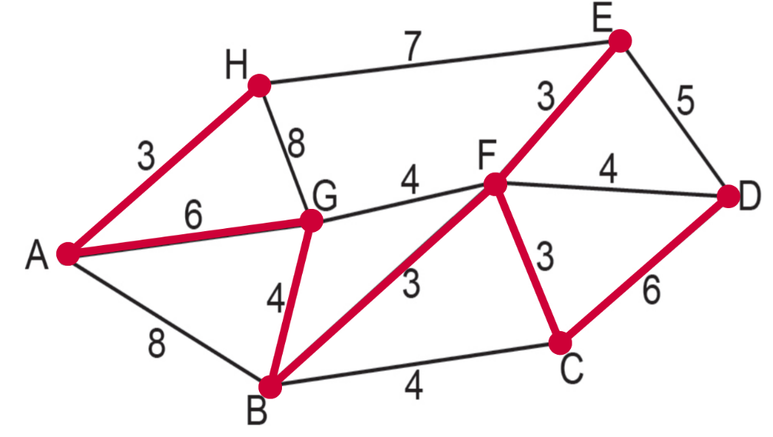
Solutions will vary as to how the students showed the use of Prim’s algorithm depending of which vertex they chose first.

