Mathematics Standard 2

MS-N3 Critical path analysis

Table of contents
Mathematics Standard 2 1
MS-N3 Critical path analysis 1
Table of contents 2
Syllabus outcomes 4
Outcomes 4
Content 4
Supplementary resources 5
Department of Education resources 5
Units of work 5
HSC Hub videos 5
NESA resources 5
Examination-style questions 6
Sample question 1 6
Sample question 2 7
Sample question 3 8
Sample question 4 9
Sample question 5 10
Sample question 6 11
Sample question 7 12
Sample question 8 13
Sample question 9 14
Sample question 10 15
Sample question 11 16
Sample question 12 17
Sample question 13 18
Sample question 14 19
Sample question 15 20
Sample question 16 21
Sample question 17 22
Sample question 18 23
Sample question 19 25
Sample question 20 26
Solutions 28
Sample question 1 28
Sample question 2 28
Sample question 3 29
Sample question 4 29
Sample question 5 30
Sample question 6 30
Sample question 7 30
Sample question 8 31
Sample question 9 32
Sample question 10 32
Sample question 11 32
Sample question 12 33
Sample question 13 34
Sample question 14 35
Sample question 15 36
Sample question 16 36
Sample question 17 37
Sample question 18 37
Sample question 19 38
Sample question 20 39

Disclaimer
This document is to be used to supplement the support teachers are offering students undertaking HSC Mathematics courses. Questions can be printed off for students individually, with or without solutions, or as an entire booklet. Questions have been sourced from various states across Australia and the source of each question has been referenced. Permission to use these resources was provided in June 2020. Solutions for each of the questions can be found at the end of the document.
Outcomes
All outcomes referred to in this booklet are from Mathematics Standard Syllabus © 2017 NSW Education Standards Authority (NESA) for and on behalf of the Crown in right of the State of New South Wales.

Syllabus outcomes
The examination-style questions presented in this document refer to the following outcomes and syllabus content.

Outcomes
A student:
- solves problems using networks to model decision-making in practical problems MS2-12-8
- chooses and uses appropriate technology effectively in a range of contexts, and applies critical thinking to recognise appropriate times and methods of such use MS2-12-9
- uses mathematical argument and reasoning to evaluate conclusions, communicating a position clearly to others and justifying a response MS2-12-10
Related Life Skills outcomes: MALS6-11, MALS6-12, MALS6-13, MALS6-14

Content
Students:
- construct a network to represent the duration and interdependencies of activities that must be completed during a particular project, for example a student schedule, or preparing a meal
- given activity charts, prepare network diagrams and use critical path analysis to determine the minimum time for a project to be completed
- use forward and backward scanning to determine the earliest starting time (EST) and latest starting time (LST) for each activity in the project (ACMGM105)
- understand why the EST for an activity could be zero, and in what circumstances it would be greater than zero
- calculate float times of non-critical activities (ACMGM108)
- understand what is meant by critical path
- use ESTs and LSTs to locate the critical path(s) for the project (ACMGM106)
- solve small-scale network flow problems, including the use of the ‘maximum-flow minimum-cut’ theorem, for example determining the maximum volume of oil that can flow through a network of pipes from an oil storage tank (the source) to a terminal (the sink) (ACMGM109)
- convert information presented in a table into a network diagram
- determine the flow capacity of a network and whether the flow is sufficient to meet the demand in various contexts

Supplementary resources

Department of Education resources

Units of work
- N3 Critical path analysis unit of work
- Exemplar question solutions (questions sourced from NESA Topic Guidance)

HSC Hub videos
- Critical path analysis (Duration: 11 minutes)
- Solving network flow problems (Duration: 6 minutes)

NESA resources
- NESA Mathematics Standard 2 Networks Topic Guidance

Examination-style questions

Sample question 1
Module 2 – Networks and decision making
Question 3
The flow of water through a series of pipes is shown in the network below.
The numbers on the edges show the maximum flow through each pipe in litres per minute.
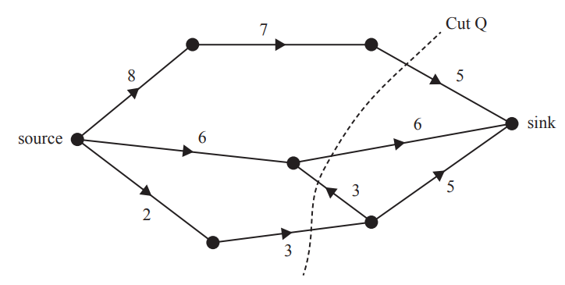
The capacity of Cut Q, in litres per minute, is:
- 11
- 13
- 14
- 16
- 17

Source: © VCAA 2019 Further Mathematics Written examination 1

Sample question 2
Module 2 – Networks and decision making
Question 8
The directed network below shows the sequence of activities, A to S, that is required to complete a manufacturing process.
The time taken to complete each activity, in hours, is also shown.
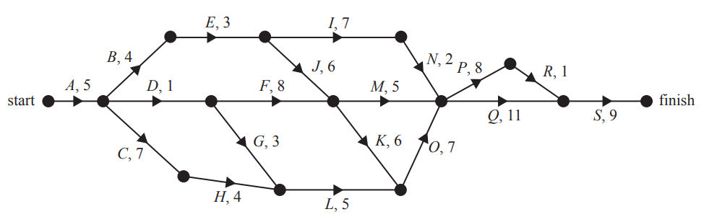
The number of activities that have a float time of 10 hours is:
- 0
- 1
- 2
- 3
- 4
Source: © VCAA 2019 Further Mathematics Written examination 1

Sample question 3
Module 2 – Networks and decision making
Question 5
The directed network below shows the sequence of 11 activities that are needed to complete a project. The time, in weeks, that it takes to complete each activity is also shown.
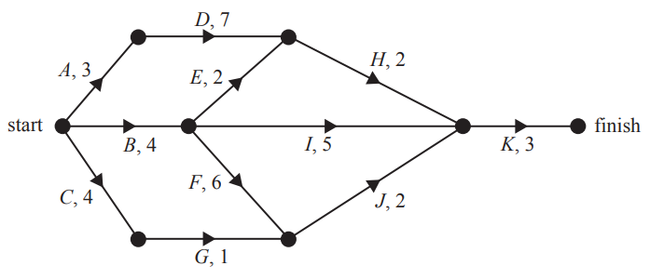
How many of these activities could be delayed without affecting the minimum completion time of the project?
- 3
- 4
- 5
- 6
- 7
Source: © VCAA 2018 Further Mathematics Written examination 1

Sample question 4
Module 2 – Networks and decision making
Question 7
A project requires nine activities (A-I) to be completed. The duration, in hours, and the immediate predecessor(s) of each activity are shown in the table below.

Activity | Duration (hours) | Immediate predecessor(s)
A | 4 | -
B | 3 | A
C | 7 | A
D | 2 | A
E | 5 | B
F | 2 | C
G | 4 | E, F
H | 5 | D
I | 3 | G, H

The minimum completion time for the project, in hours, is:
- 14
- 19
- 20
- 24
- 35
Source: © VCAA 2018 Further Mathematics Written examination 1

Sample question 5
Module 2 – Networks and decision making
Question 4
The directed graph below shows the sequence of activities required to complete a project. The time to complete each activity, in hours, is also shown.
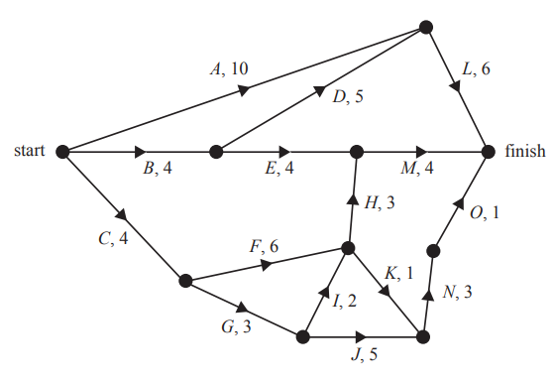
The earliest starting time, in hours, for activity N is:
- 3
- 10
- 11
- 12
- 13
Source: © VCAA 2017 Further Mathematics Written examination 1

Sample question 6
Module 2 – Networks and decision making
Question 5
To complete the project in minimum time, some activities cannot be delayed.
The number of activities that cannot be delayed is:
- 2
- 3
- 4
- 5
- 6
Source: © VCAA 2017 Further Mathematics Written examination 1

Sample question 7
Module 2 – Networks and decision making
Question 8
The flow of oil through a series of pipelines, in litres per minute, is shown in the network below.
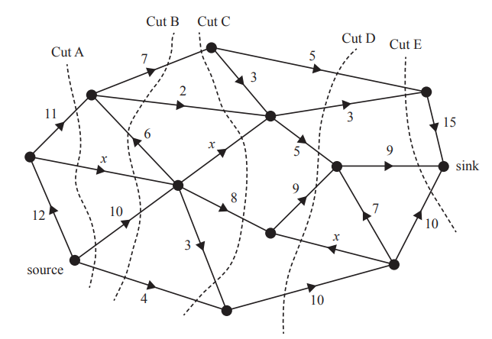
The weighting of three of the edges are labelled $x$.
Five cuts labelled A – E are shown on the network.
The maximum flow of oil from the source to the sink, in litres per minute, is given by the capacity of:
- Cut A if $x=1$
- Cut B if $x=2$
- Cut C if $x=2$
- Cut D if $x=3$
- Cut E if $x=3$
Source: © VCAA 2017 Further Mathematics Written examination 1

Sample question 8
Module 2 – Networks and decision making
Question 2
The following directed graph shows the flow of water, in litres per minute, in a system of pipes connecting the source to the sink.
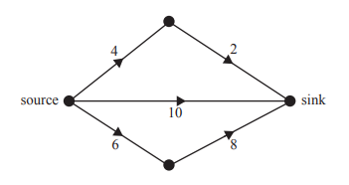
The maximum flow, in litres per minute, from the source to the sink is:
- 10
- 14
- 18
- 20
- 22
Source: © VCAA 2016 Further Mathematics Written examination 1

Sample question 9
Module 2 – Networks and decision making
Question 6
The directed graph below shows the sequence of activities required to complete a project. All times are shown in hours.
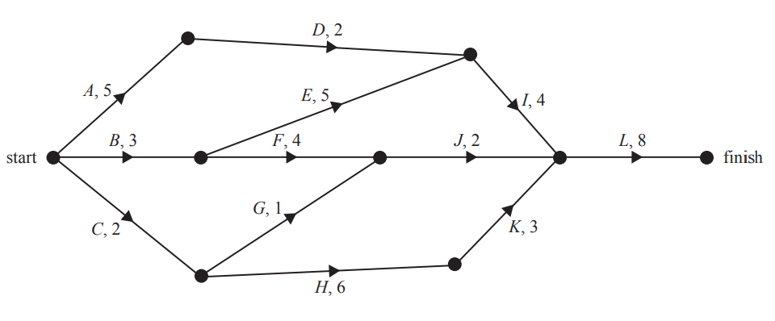
The number of activities that have exactly two immediate predecessors is:
- 0
- 1
- 2
- 3
- 4
Source: © VCAA 2016 Further Mathematics Written examination 1

Sample question 10
Module 2 – Networks and decision making
Question 7
There is one critical path for this project.
Three critical paths would exist if the duration of activity:
- I were reduced by two hours.
- E were reduced by one hour.
- G were increased by six hours.
- K were increased by two hours.
- F were increased by two hours.
Source: © VCAA 2016 Further Mathematics Written examination 1

Sample question 11
Module 2 – Networks and decision making
Question 3 (4 marks)
Fencedale High School is planning to renovate its gymnasium.
This project involves 12 activities, A to L.
The directed network below shows these activities and their completion times, in weeks.
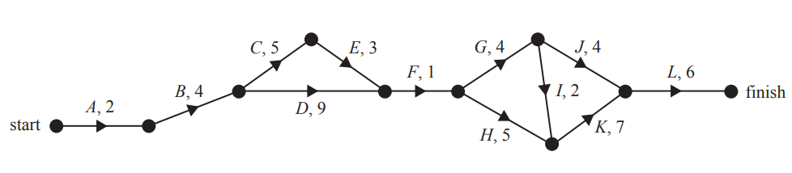
The minimum completion time for the project in 35 weeks.
- How many activities are on the critical path? (1 mark)

- Determine the latest start time of activity E. (1 mark)

- Which activity has the longest float time? (1 mark)

It is possible to reduce the completion time for activities C, D, G, H and K by employing more workers.

- The completion time for each of these five activities can be reduced by a maximum of two weeks. What is the minimum time, in weeks, that the renovation project could take? (1mark)
Source: © VCAA 2019 Further Mathematics Written examination 2

Sample question 12
Module 2 – Networks and decision making
Question 1 (3 marks)
The graph below shows the possible number of postal deliveries each day between the Central Mail Depot and the Zenith Post Office.
The unmarked vertices represent other depots in the region.
The weighting of each edge represents the maximum number of deliveries that can be made each day.
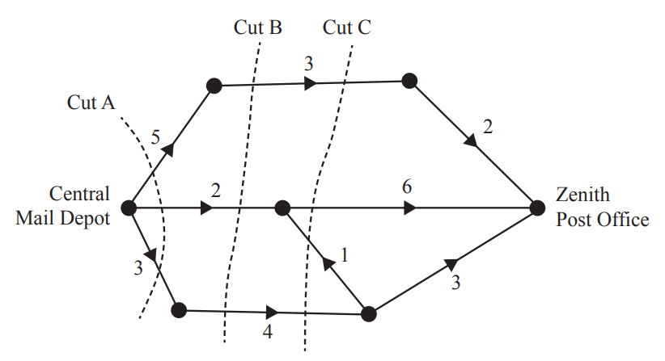

- Cut A, shown on the graph, has a capacity of 10. Two other cuts are labelled as Cut B and Cut C.
- Write down the capacity of Cut B. (1 mark)
- Write down the capacity of Cut C. (1 mark)

- Determine the maximum number of deliveries that can be made each day from the Central Mail Depot to the Zenith Post Office. (1 mark)
Source: © VCAA 2018 Further Mathematics Written examination 2

Sample question 13
Module 2 – Networks and decision making
Question 3 (4 marks)
At the Zenith Post Office all computer systems are to be upgraded.
This project involves 10 activities, A to J.
The directed network below shows these activities and their completion times, in hours.
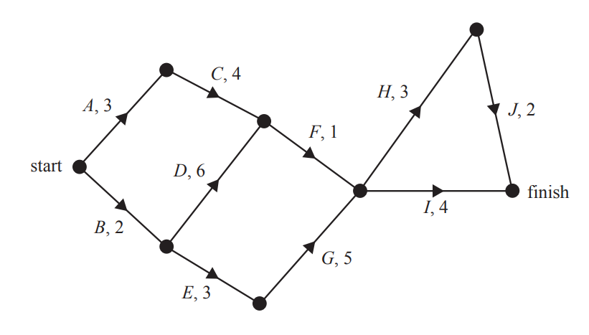
- Determine the earliest starting time, in hours, for activity I. (1 mark)

- The minimum completion time for the project is 15 hours.
Write down the critical path. (1 mark)

- Two of the activities have a float time of two hours.
Write down these two activities. (1 mark)

- For the next upgrade, the same project will be repeated but one extra activity will be added. This activity has a duration of one hour, an earliest starting time of five hours and a latest starting time of 12 hours.
Complete the following sentence by filling in the blank spaces provided.

The extra activity could be represented on the network above by a directed edge from the end of activity ____ to the start of activity ____. (1 mark)
Source: © VCAA 2018 Further Mathematics Written examination 2

Sample question 14
Module 2 – Networks and decision making
Question 4 (5 marks)
The rides at the theme park are set up at the beginning of each holiday season.
This project involves activities A to O.
The directed network below shows these activities and their completion times in days.
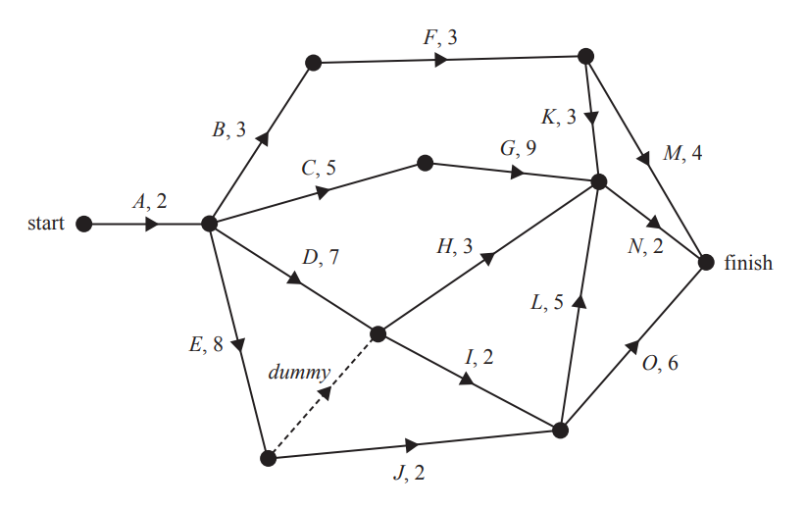
- Write down the two immediate predecessors of activity I. (1 mark)

- The minimum completion time for the project is 19 days.
- There are two critical paths. One of the paths is A-E-J-L-N.
Write down the other critical path. (1 mark)
- Determine the float times, in days, for activity F. (1 mark)

- The project could finish earlier if some activities were crashed.
Six activities, B, D, G, I, J and L, can all be reduced by one day.
The cost of this crashing is $1000 per activity.
- What is the minimum number of days in which the project could now be completed? (1 mark)
- What is the minimum cost of completing the project in this time? (1 mark)
Source: © VCAA 2017 Further Mathematics Written examination 2

Sample question 15
Module 2 – Networks and decision making
Question 3 (3 marks)
A new skateboard park is to be built in Beachton. This project involves 13 activities, A to M.
The directed network below shows these activities and their completion times in days.
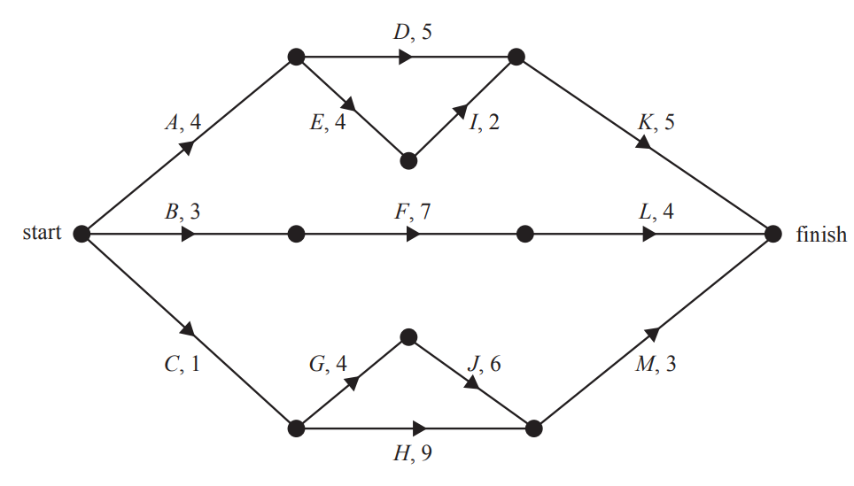
- Determine the earliest start time for activity M. (1 mark)

- The minimum completion time for the skateboard park is 15 days.
Write down the critical path for this project. (1 mark)

- Which activity has a float time of two days? (1 mark)
Source: © VCAA 2016 Further Mathematics Written examination 2

Sample question 16
Question 5 (8 marks)
The network below represents a construction project. The number on each edge gives the time, in hours, to complete the activity. Each activity requires one worker.
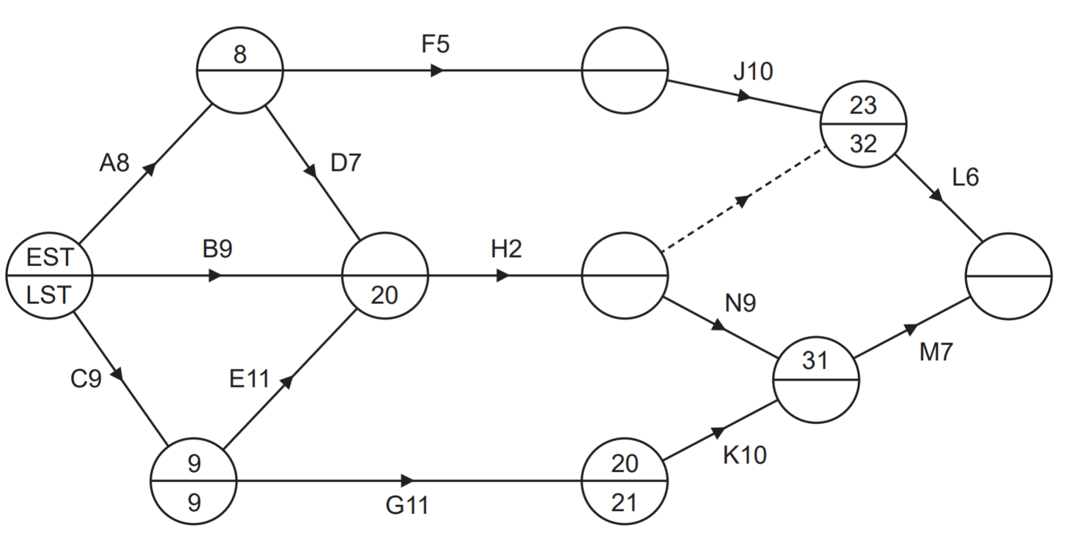
- Complete the precedence table below. (2 marks)

Activity | A | B | C | D | E | F | G | H | J | K | L | M | N
Time (hours) | 8 | 9 | 9 | 7 | 11 | 5 | 11 | 2 | 10 | 10 | 6 | 7 | 9
Immediate predecessors | - | - | - | A | C | A | C | B D E

- Complete the network showing the earliest starting time (EST) and the latest starting time (LST) for each vertex. (Note: the first vertex indicates which is the EST and the LST.) (2 marks)

- Determine the critical path and the minimum completion time for the project.
(2 marks)

- Calculate the float times for Activities D and F. (2 marks)
Source: © WA SCSA 2019 Mathematics Applications calculator-free examination

Sample question 17
Question 6 (7 marks)
Yana has booked three gardeners to landscape her garden. The table below shows the required activities, together with the times taken (in hours) and the immediate predecessors for each activity.

Activity | P | Q | R | S | T | U | V | W | X
Time (hours) | 2.5 | 1.5 | 3 | 1.5 | 1.5 | 2 | 2.5 | 2 | 2.5
Immediate predecessors | - | - | - | P | S, Q, U | R | T, X | P | R

- Complete the network diagram below, showing all tasks and durations. (3 marks)
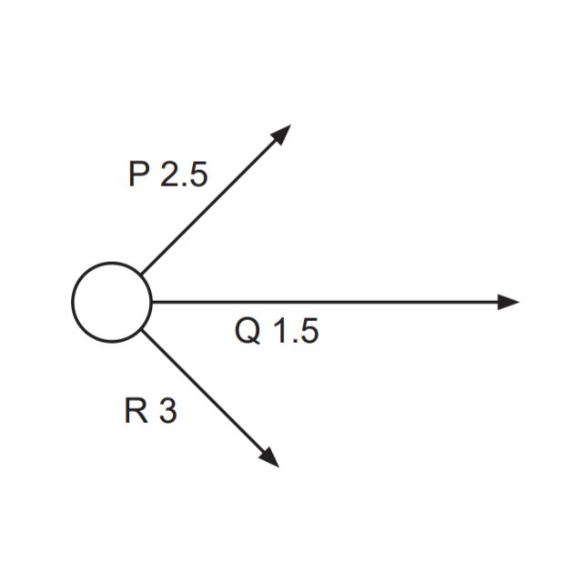
- Determine the critical path and the minimum completion time for the project.
(2 marks)

- Calculate the float time for:
- Activity W (1 mark)
- Activity U (1 mark)
Source: © WA SCSA 2018 Mathematics Applications calculator-free examination

Sample question 18
Question 11 (11 marks)
The following table, consisting of 11 activities, contains information for a project in a small manufacturing company.

Activity | Immediate predecessors | Time (hours)
A | - | 4
B | - | 5
C | A | 14
D | A | 7
E | - | 7
F | - | 5
G | B, C | 7
H | D | 6
J | E, F | 9
K | H, J | 10
L | G, K | 6

- Complete the project network below. (3 marks)
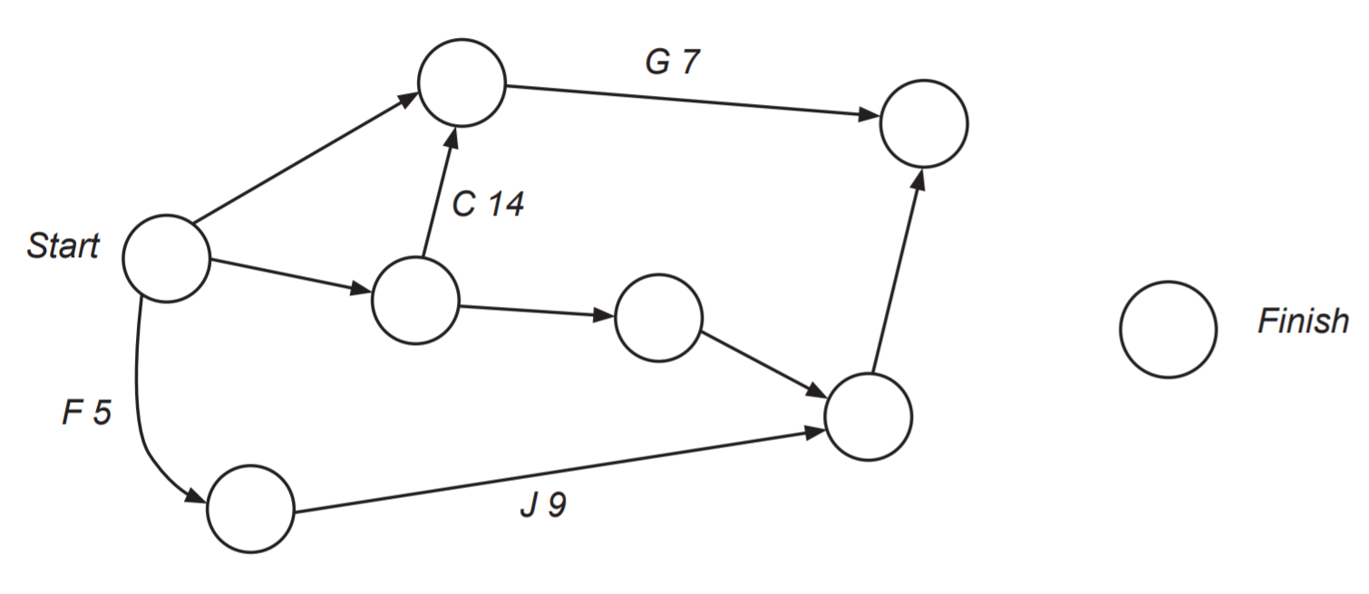
- State the critical path and the minimum completion time for this network. (2 marks)

- Determine the float time, earliest starting time, and latest starting time for Activity G. (3 mark)
- Due to some unforeseen problems with Activities G and J, one of these activities will require an extra three hours to complete. Which of the activities should be chosen for the completion time to be at a minimum? Justify your answer. (3 marks)

Source: © WA SCSA 2017 Mathematics Applications calculator-assumed examination

Sample question 19
Question 2 (7 marks)
A project consists of 11 activities, P to Z. The project network representing the scheduling of these activities is shown below. The times are in days.
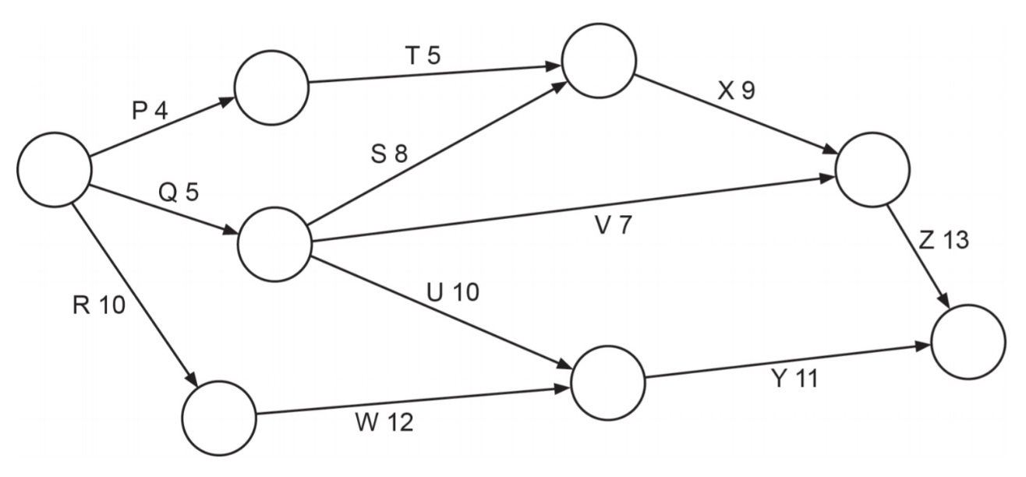
- State the critical path and the minimum completion time for this project. (2 marks)

- Determine the:
- Earliest starting time for Activity Y. (1 mark)
- Latest starting time for Activity V. (1 mark)
- Float time for Activity U. (1 mark)

- Activity W is delayed by three days. How, if at all, will this affect the critical path and minimum completion time for this project? A copy of the network is given below. (2 marks)
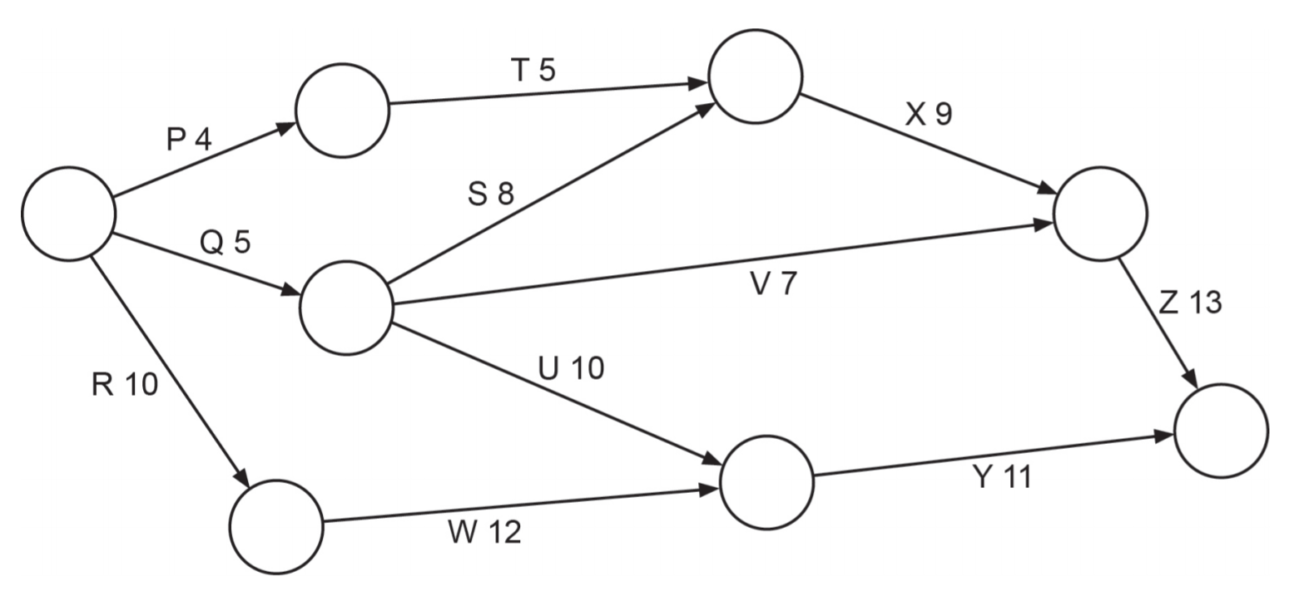

Source: © WA SCSA 2017 Mathematics Applications calculator-free examination

Sample question 20
Question 9 (8 marks)
The network below shows the maximum rate of water flow (in litres per minute) through a system of water pipes from a source at A.
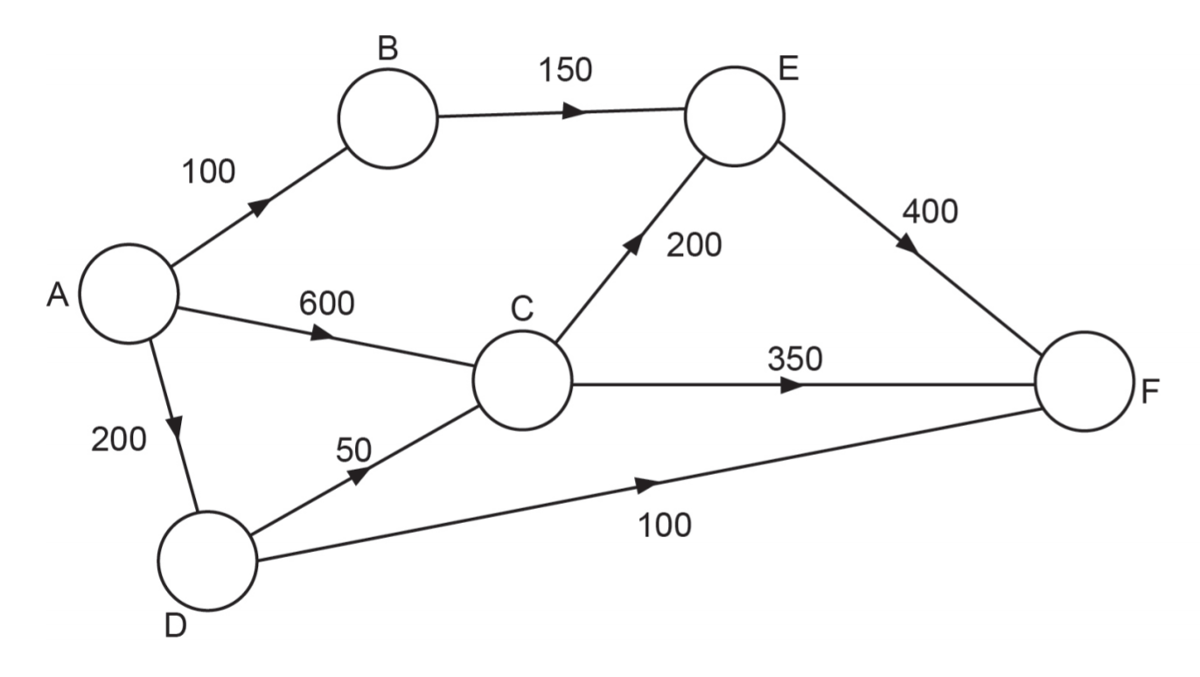
- What is the maximum amount of water that could be delivered to F, in litres per minute? (List each path used and the corresponding flow). (3 marks)

- Verify the maximum flow obtained in part (a) by showing a minimum cut on the given network. (1 mark)

- Relabel the network below, showing the flow you would direct along each pipe in order to achieve the maximum flow found in part (a) to point F. (1 mark)
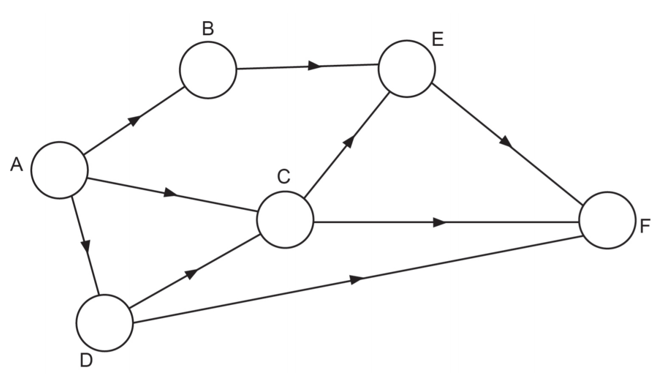
- When the maximum flow occurs from A to F, how much of the water, in litres per minute, passes through C? (1 mark)

- The water flow through C, as calculated in part (d), is reduced to a maximum of 480 litres per minute. In order to maintain the same maximum flow as that obtained in part (a), the capacity of a single pipe (arc) is to be increased by the least amount. Which pipe should be chosen, and by how much should its capacity be increased? (2 marks)

Source: © WA SCSA 2016 Mathematics Applications calculator-assumed examination

Solutions

Sample question 1
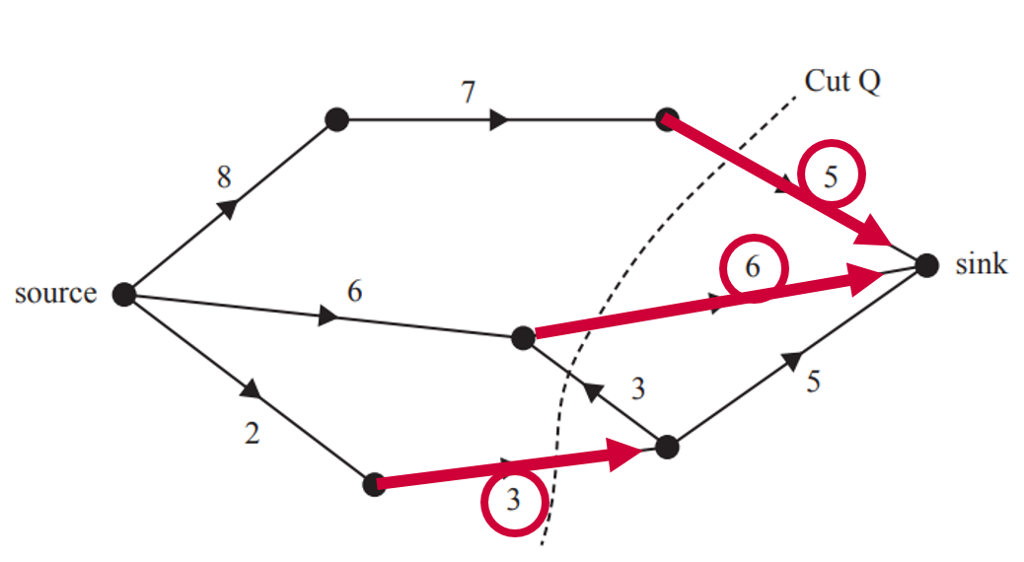
$$3+6+5=14$$
$∴$ The capacity of the cut is 14 litres per minute.
Correct answer = C

Sample question 2
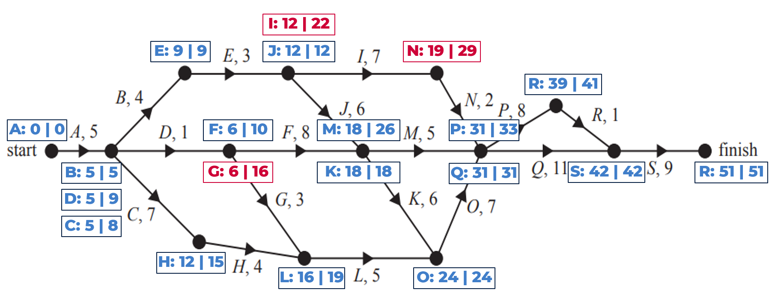
$∴$ Activities G, I and N all have a float time of 10 hours.
Correct answer = D

Sample question 3
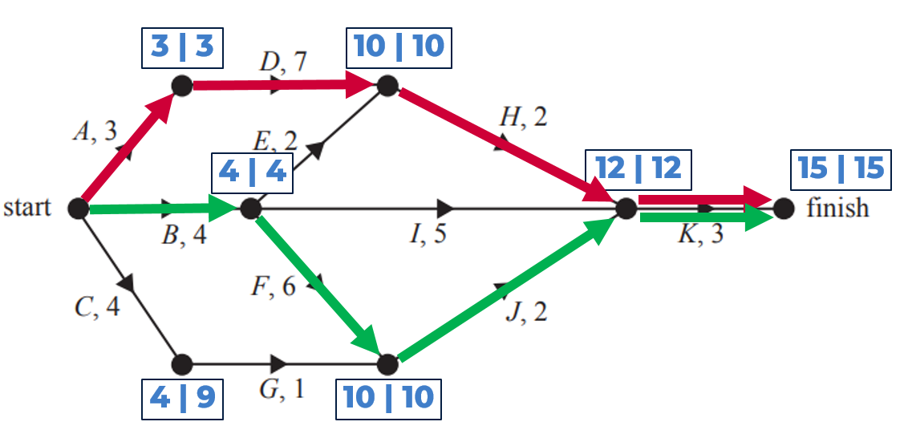
The only activities that do not lie on a critical path are C, G, E and I.
$∴$ There are 4 activities which could be delayed without affecting the minimum completion time.
Correct answer = B

Sample question 4
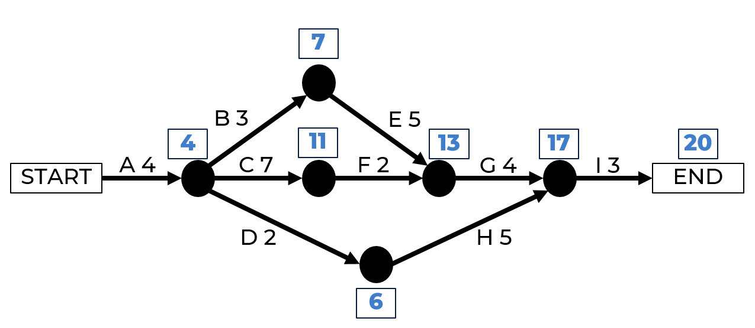
$∴$ The minimum completion time for the project is 20 hours.
Correct answer = C

Sample question 5
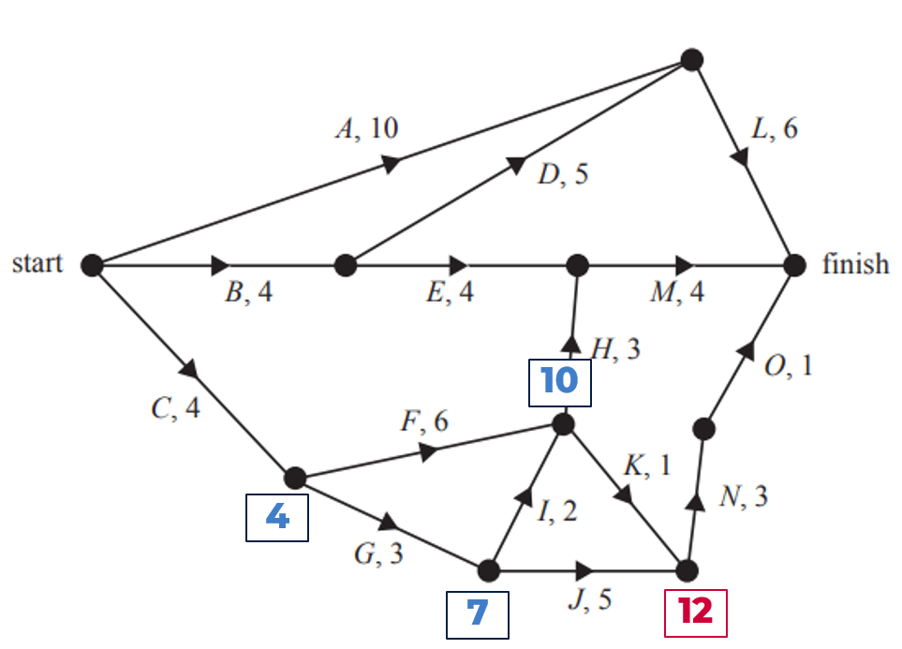
$∴$ The EST for activity N is 12 hours.
Correct answer = D

Sample question 6
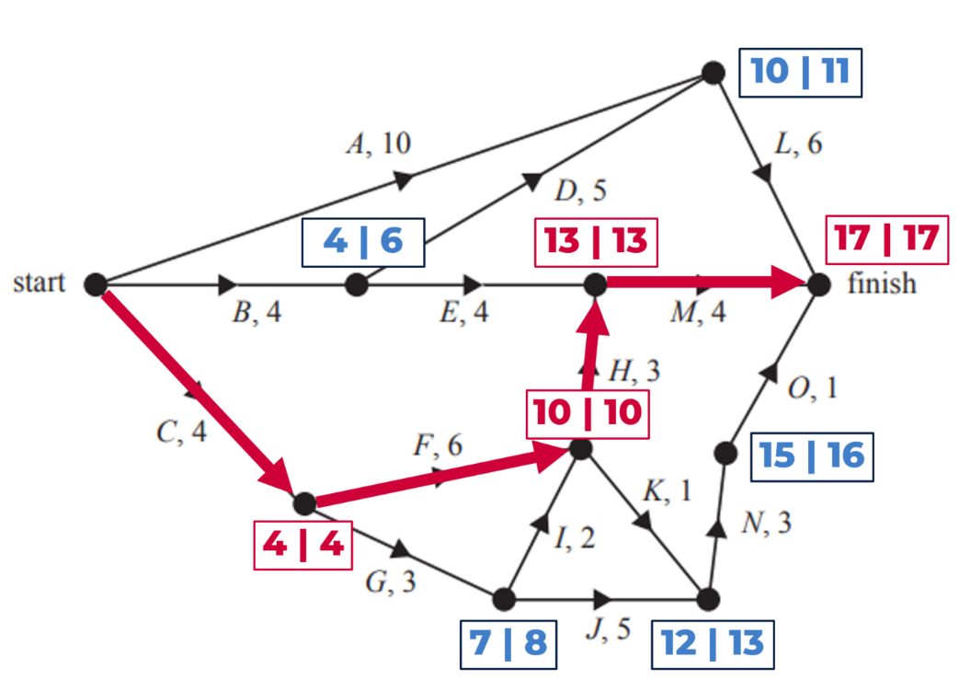
Activities C, F, H and M for the critical path.
$∴$ There are 4 activities which cannot be delayed.
Correct answer = C

Sample question 7
$$Cut A=11+x+10+4$$
$$Cut A=25+x$$
$$Cut B=7+2+x+10+4$$
$$Cut B=23+x$$
$$Cut C=7+2+x+8+3+4$$
$$Cut C=24+x$$
$$Cut D=5+3+5+9+10$$
$$Cut D=32$$
$$Cut E= 5+3+9+10$$
$$Cut E=27$$
Cut B will be the minimum cut whether $x=1, 2$ or $3$.
$∴$ Maximum flow is given by the minimum cut which is Cut B.
Correct answer = B

Sample question 8
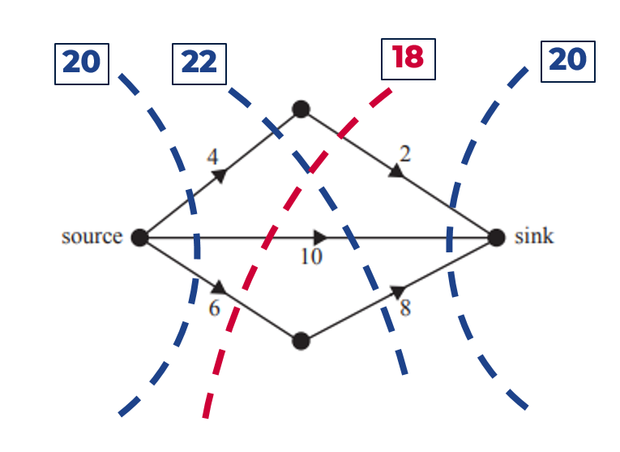
Maximum flow is given by the minimum cut. (See the red cut in the diagram above).
$∴$ The maximum flow is 18 litres per minute.
Correct answer = C

Sample question 9
Activities D and E are both immediate predecessors to activity I and activities F and G are both immediate predecessors to activity J.
$∴$ Activities I and J have exactly 2 immediate predecessors.
Correct answer = C

Sample question 10
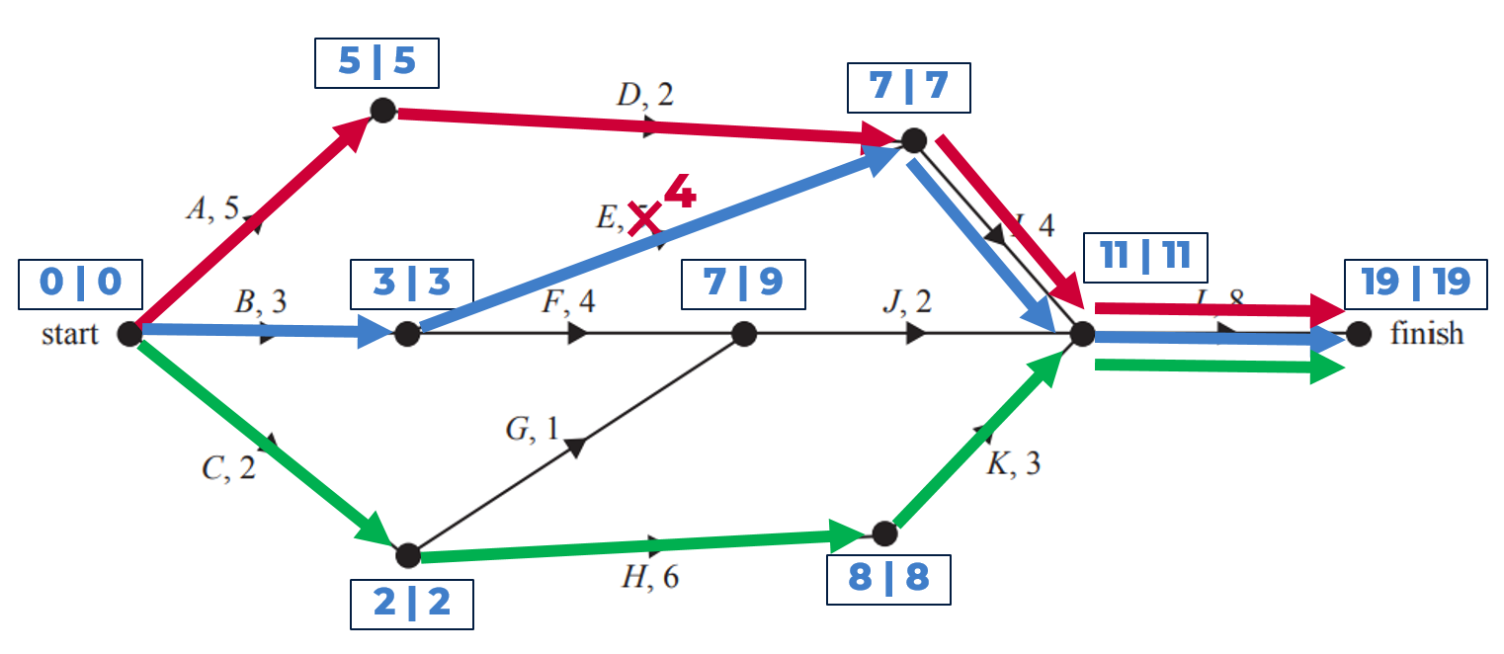
By reducing the duration of activity E by one hour from 5 to 4 the above three critical paths would exist.
Correct answer = B

Sample question 11
- Complete a forward and backward scan in order to determine the critical path.
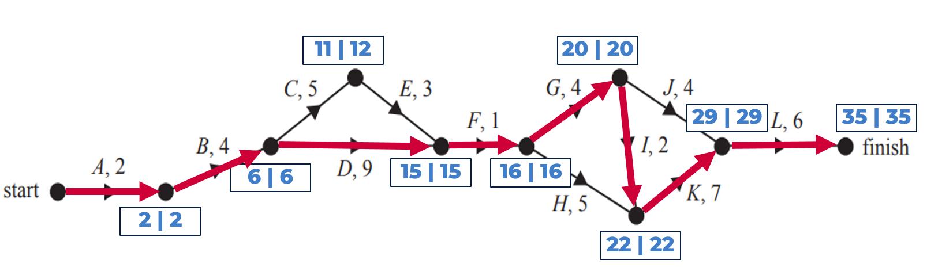
$∴$ There are 8 activities on the critical path as seen in the diagram above.

- The LST for activity E is 12 weeks.
- Activity J has the longest float time of 5 weeks.
- Reduce the duration of activities C, D, G, H and K by 2 weeks each and recalculate a forward scan in order to determine the new minimum completion time.
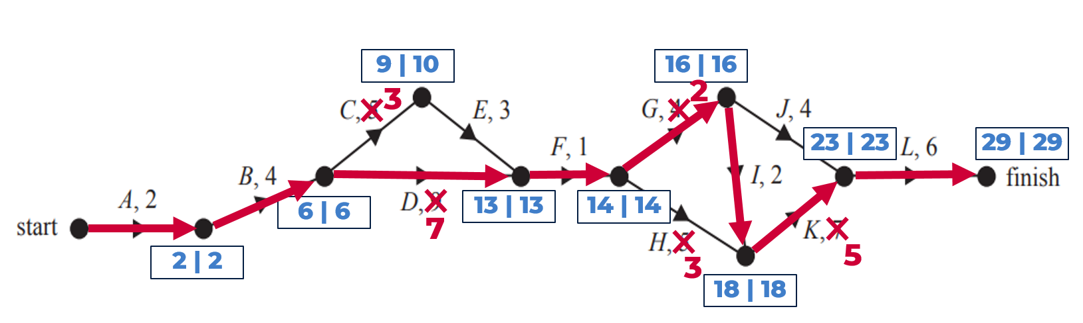
$∴$ The minimum completion time (as seen in the diagram above) is now 29 weeks.

Sample question 12
- Cut B: $3+2+4=9$
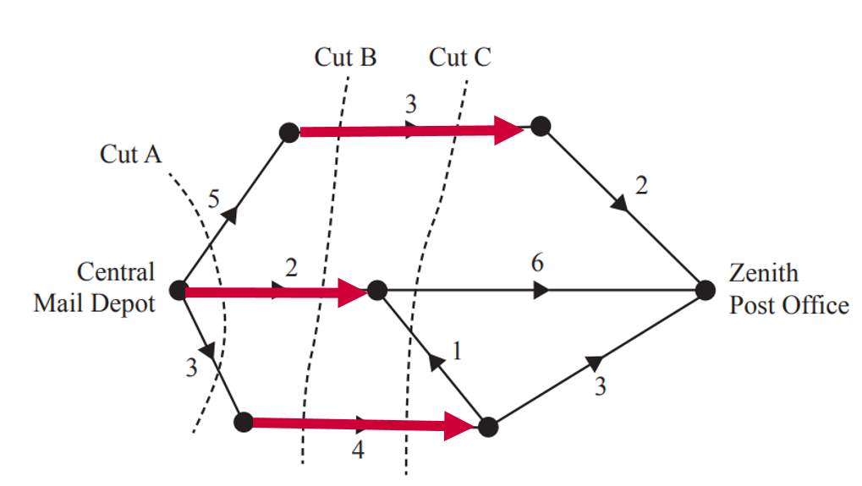
Cut C: $3+6+4=13$
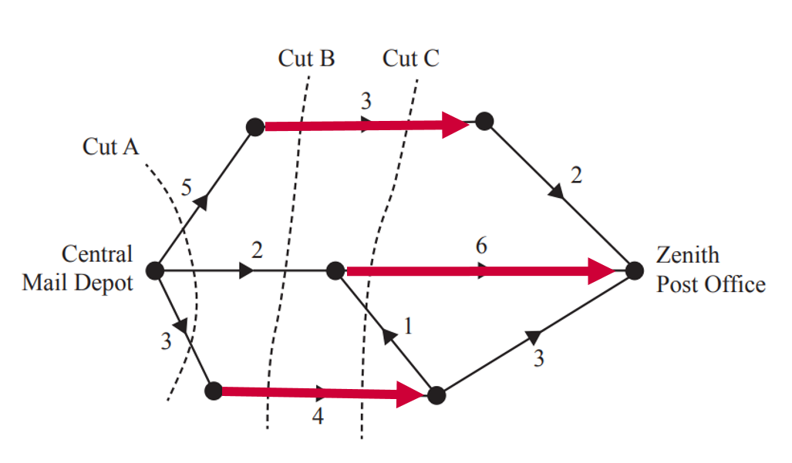

- To determine the maximum flow through the network, calculate all possible cuts and use the maximum flow/minimum cut theorem or solve by inspection.
The maximum flow through this network is 7 deliveries as shown in the network diagram below.
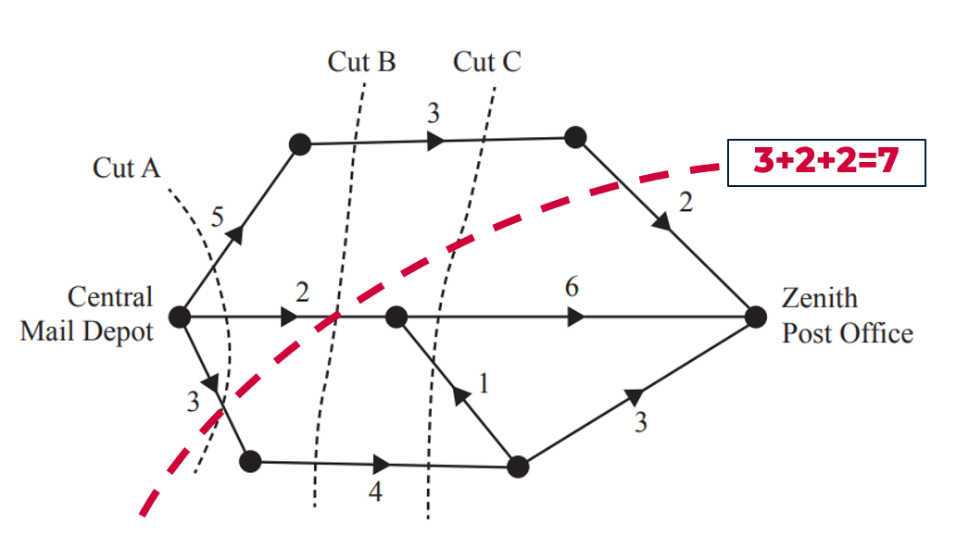

Sample question 13
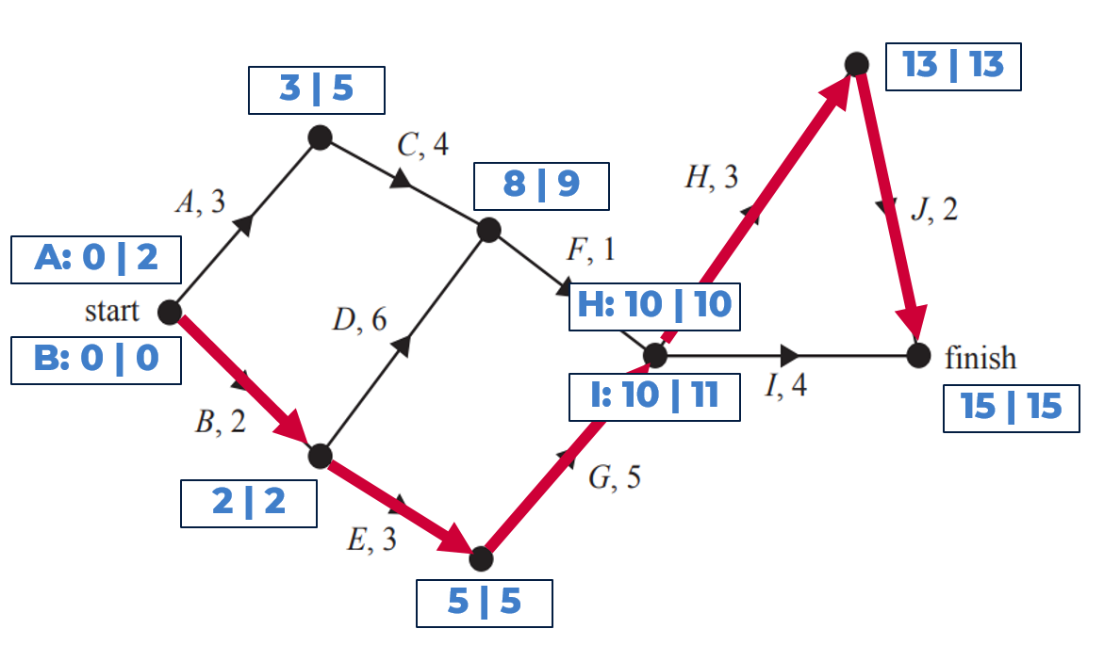
As shown in the network above:
- EST for activity I is 10 hours
- The critical path is B-E-G-H-J
- Activities A and C have a float time of exactly 2 hours each
- “… end of activity E and the start of activity J.

Sample question 14
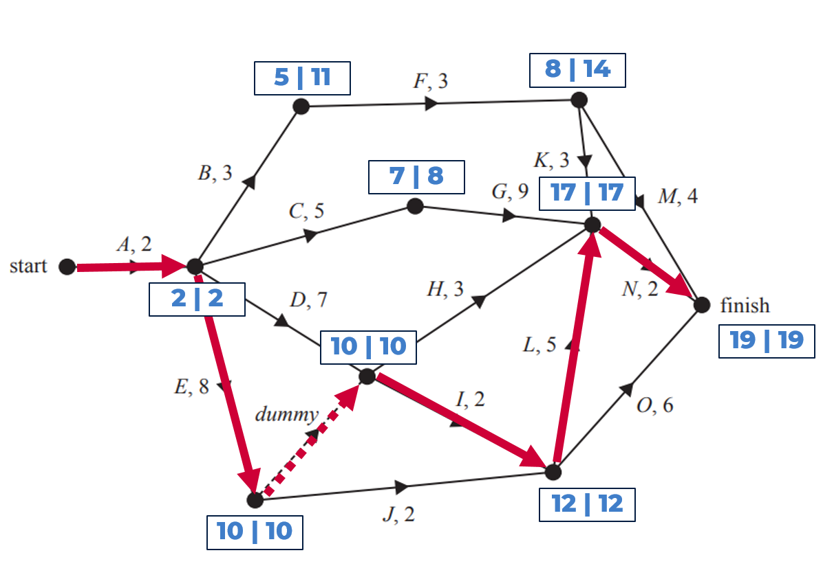
- Immediate predecessors or activity I are activities D and E
- As shown in the network above:
- The other critical path is A-E-I-L-N
- Float time of activity F is $11-5=6$ days

- By reducing activities B, D, G, I, J and L by one day each there are now 3 critical paths as outlined in the diagram below.
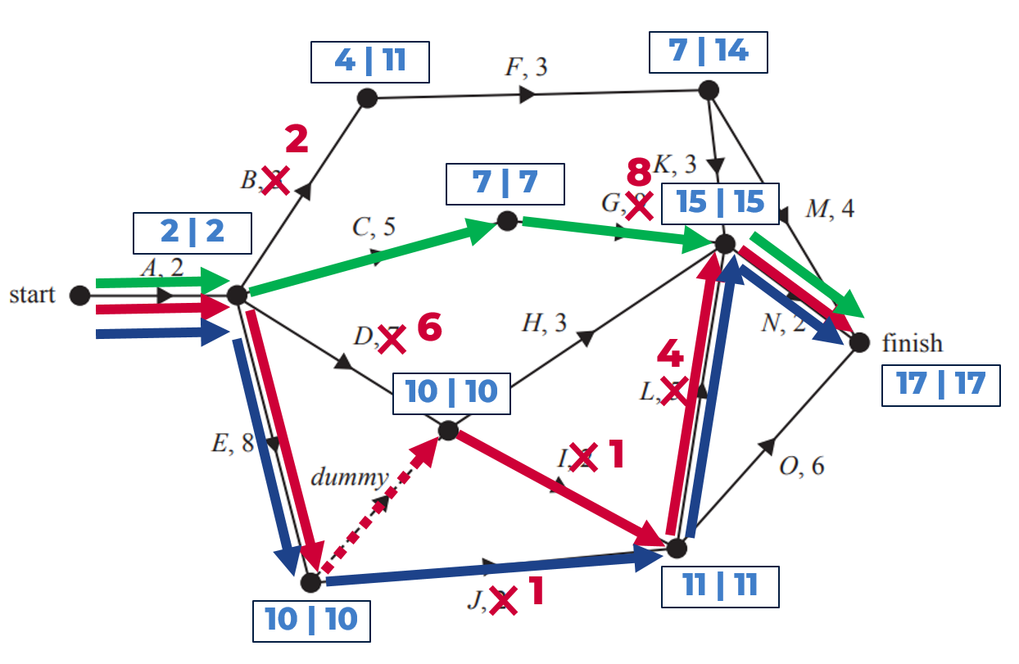
- The minimum completion time for the project is now 17 days
- As only 4 of the reduced activities fall on any of the new critical paths the cost will be $4000.

Sample question 15
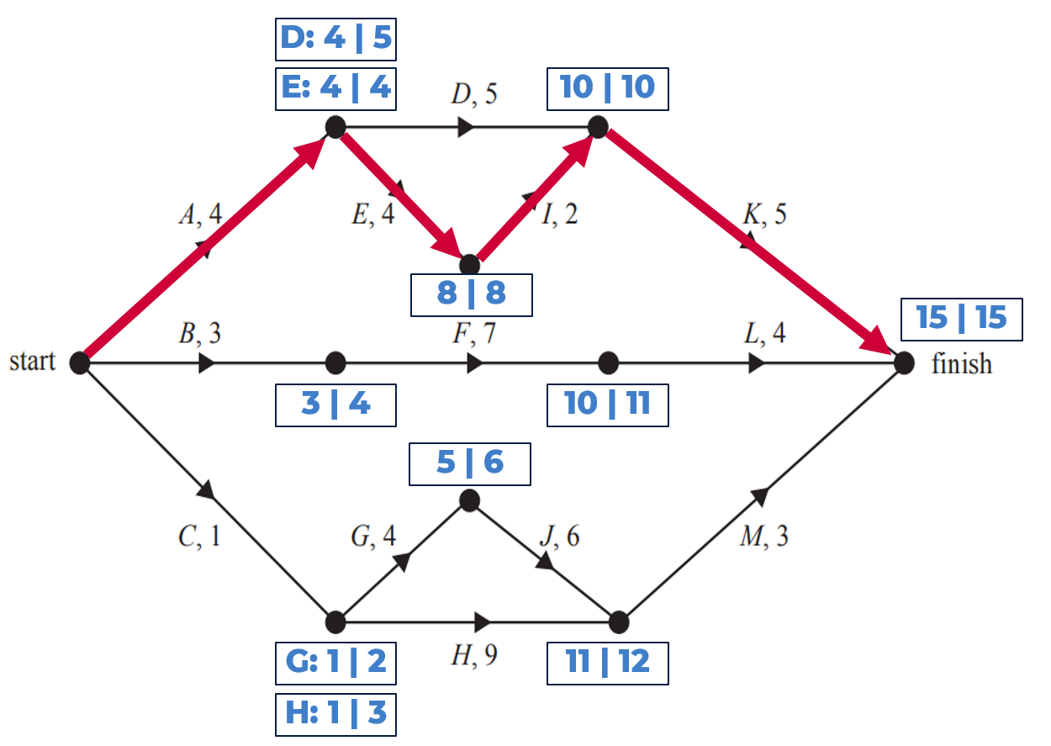
As shown in the network above:
- The EST for activity M is 11 days
- The critical path is: A-E-I-K
- Activity H has a float time of exactly 2 days ($3-1=2$)

Sample question 16

Activity | A | B | C | D | E | F | G | H | J | K | L | M | N
Time (hours) | 8 | 9 | 9 | 7 | 11 | 5 | 11 | 2 | 10 | 10 | 6 | 7 | 9
Immediate predecessors | - | - | - | A | C | A | C | B D E | F | G | H J | N K | H

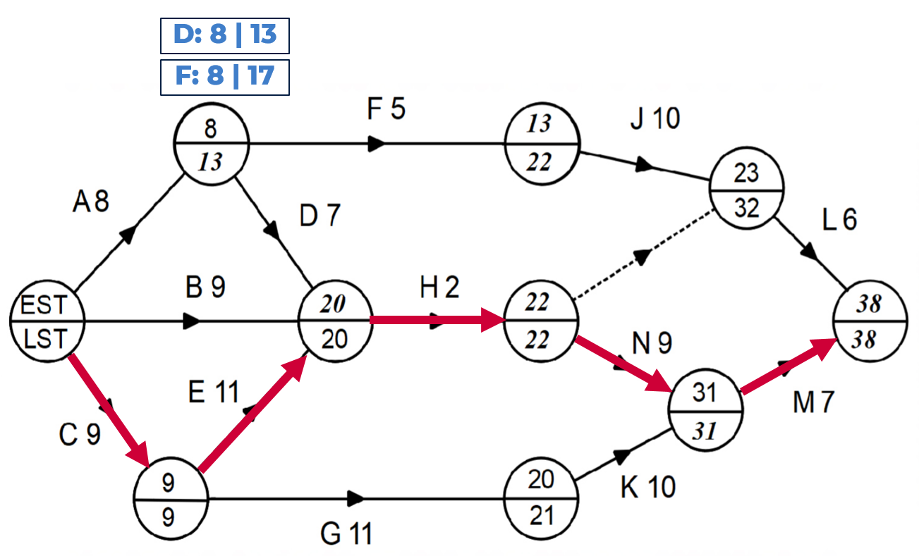

- The critical path is C-E-H-N-M and the minimum duration to complete the project is 38 hours
- Float time of D is 13$-8=5$ hours. Float time for F is $17-8=9$ hours.

Source: Refer to Question 5 from the © WA SCSA 2019 Mathematics Applications calculator-free marking key

Sample question 17
- Network diagrams may vary slightly.
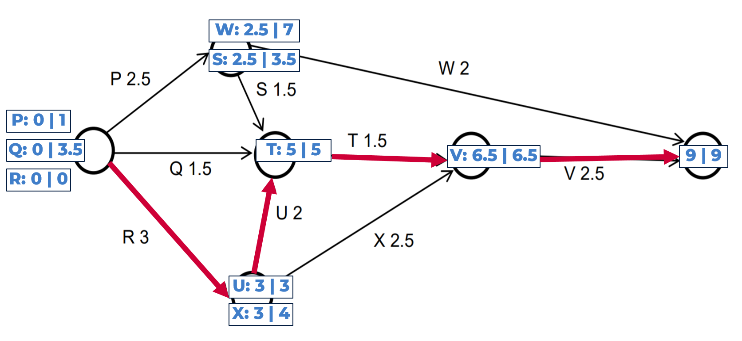

- The critical path is RUTV and the minimum completion time is 9 hours.
- Float times:
- Activity W is $7-2.5=4.5$ hours.
- Activity U is $3-3=0$ hours

Source: Refer to Question 6 from the © WA SCSA 2018 Mathematics Applications calculator-free marking key

Sample question 18
- Network diagrams may vary slightly.
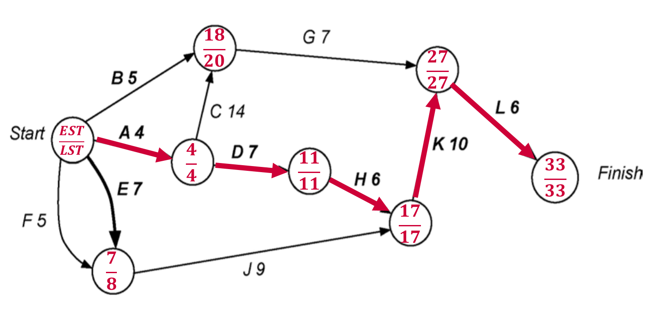
- The critical path is A-D-H-K-L
Minimum completion time is 33 hours
- For activity G the:
Float time is $20-18=2$ hours
Earliest starting time = 18 hours
Latest starting time = 20 hours
- If G is increased by 3 hours, new completion time is 34 hours (ACGL)
If J is increased by 3 hours, new completion time is 35 hours (EJKL)
$∴$ Choose G to ensure minimum completion time is the smallest

Source: Refer to Question 11 from the © WA SCSA 2017 Mathematics Applications calculator-assumed marking key

Sample question 19
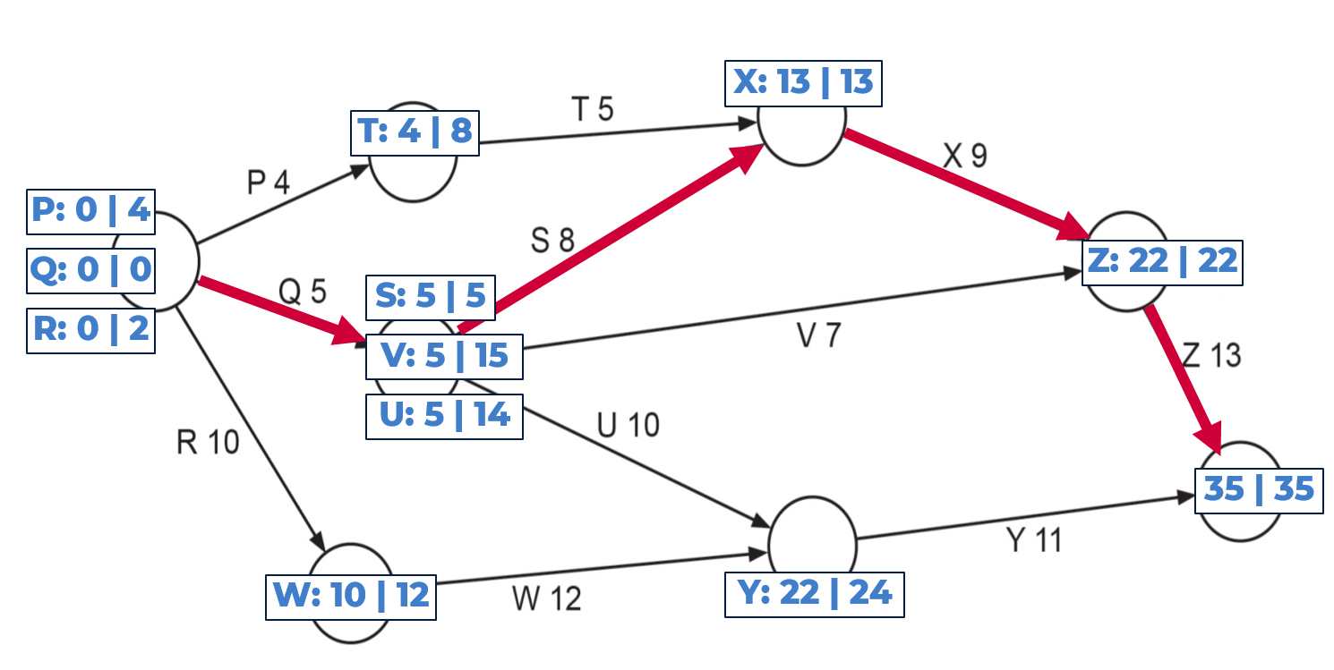
- The critical path is Q-S-X-Z
Minimum completion time is 35 days
- From the network diagram above:
- EST for Activity Y is day 22
- LST for Activity V is day 15
- Float time of Activity U is $14-5=9$ days
- Delaying the start time of activity W by 3 days changes the critical path to R-W-Y
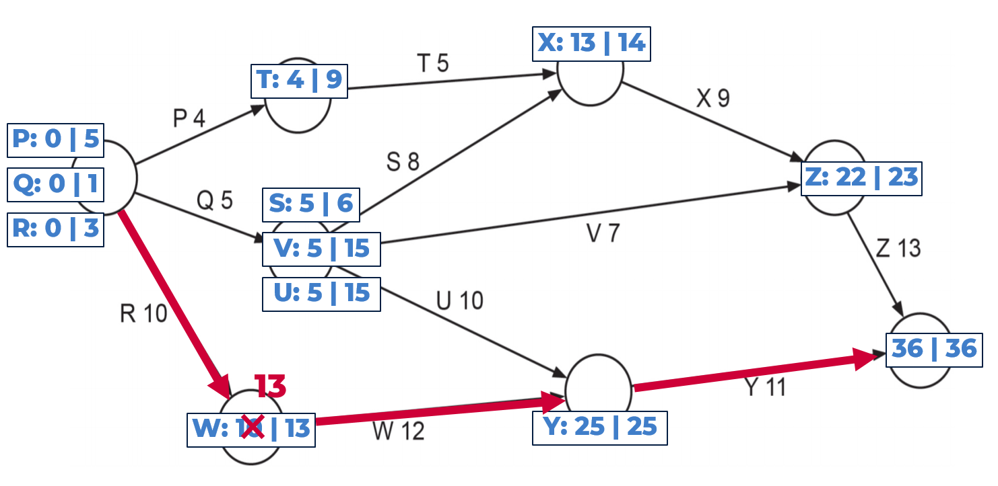
Minimum completion time is now 36 days (an extra day)

Source: Refer to Question 2 from the © WA SCSA 2017 Mathematics Applications calculator-free marking key

Sample question 20
- ABEF = 100
ADF = 100
ACF = 350
ACEF = 200
Gives a total of 750 litres per minute.
Note: Other paths are possible.
- See network below
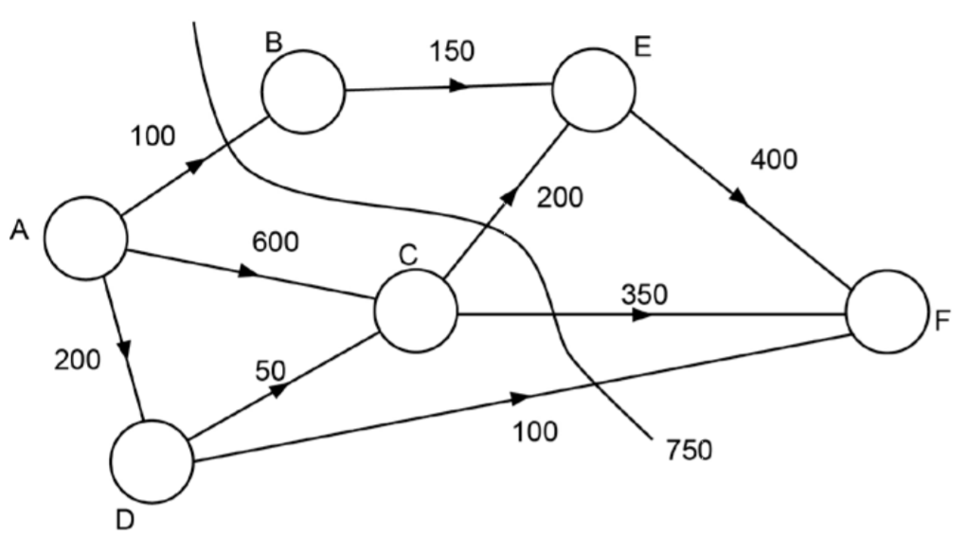
- See network below
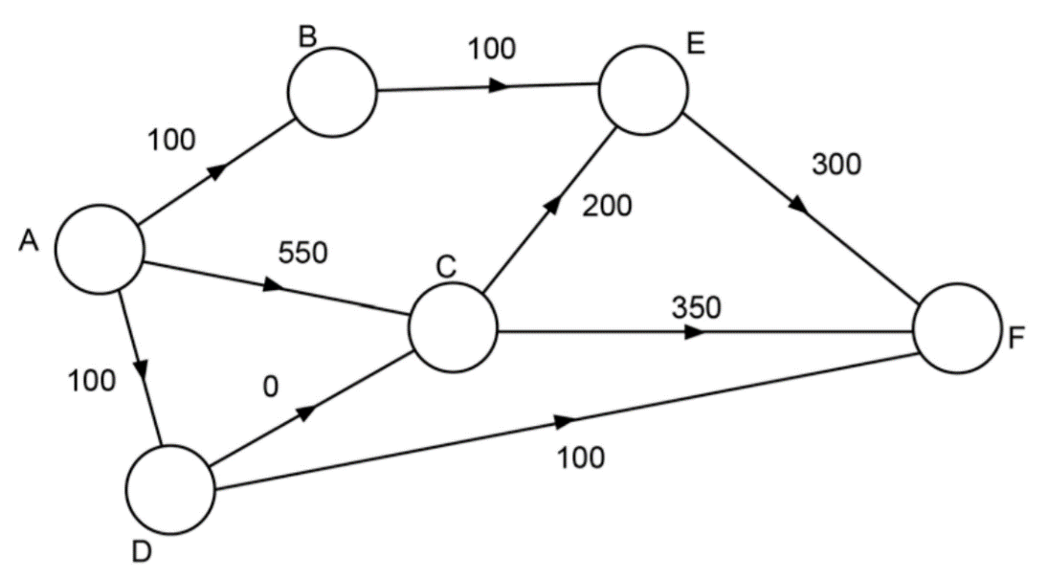
- 550 litres per minute
- 550 – 480 = 70
$∴$DF increases from 100 to 170

Source: Refer to Question 9 from the © WA SCSA 2016 Mathematics Applications calculator-assumed marking key

