Sales forecasting activity – teacher’s guide

Part 1
Use this Sales History Simulator to generate some monthly sales history for your product over the last 20 months, buy entering today’s date into the yellow cell. Assuming your product has a lead time of two months, use the monthly sales history to forecast how many products you product to sell in two months’ time so that you can plan your inventory needs now.
- Run the sales history simulator.
- Enter/overwrite the date with today’s date to generate historical sales data.
- Copy the data.
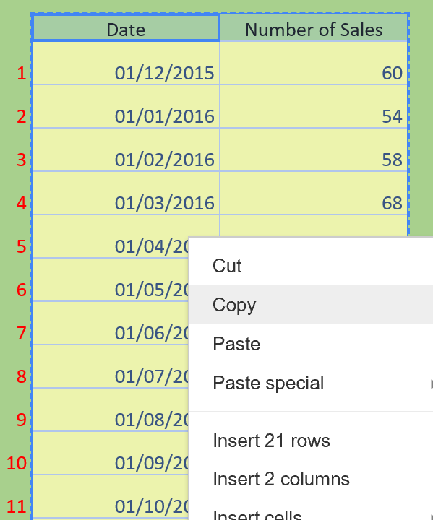

- Paste the data into a spreadsheet, like MS Excel or the spreadsheet view of Geogebra.
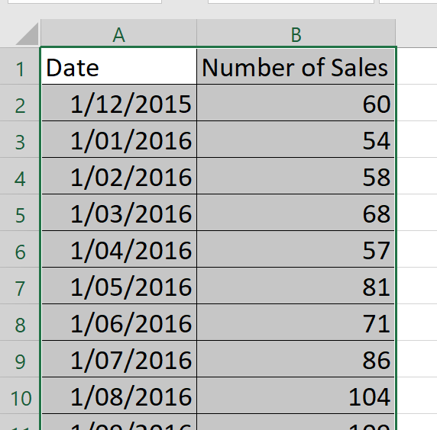
- Select the data and insert a scatterplot.
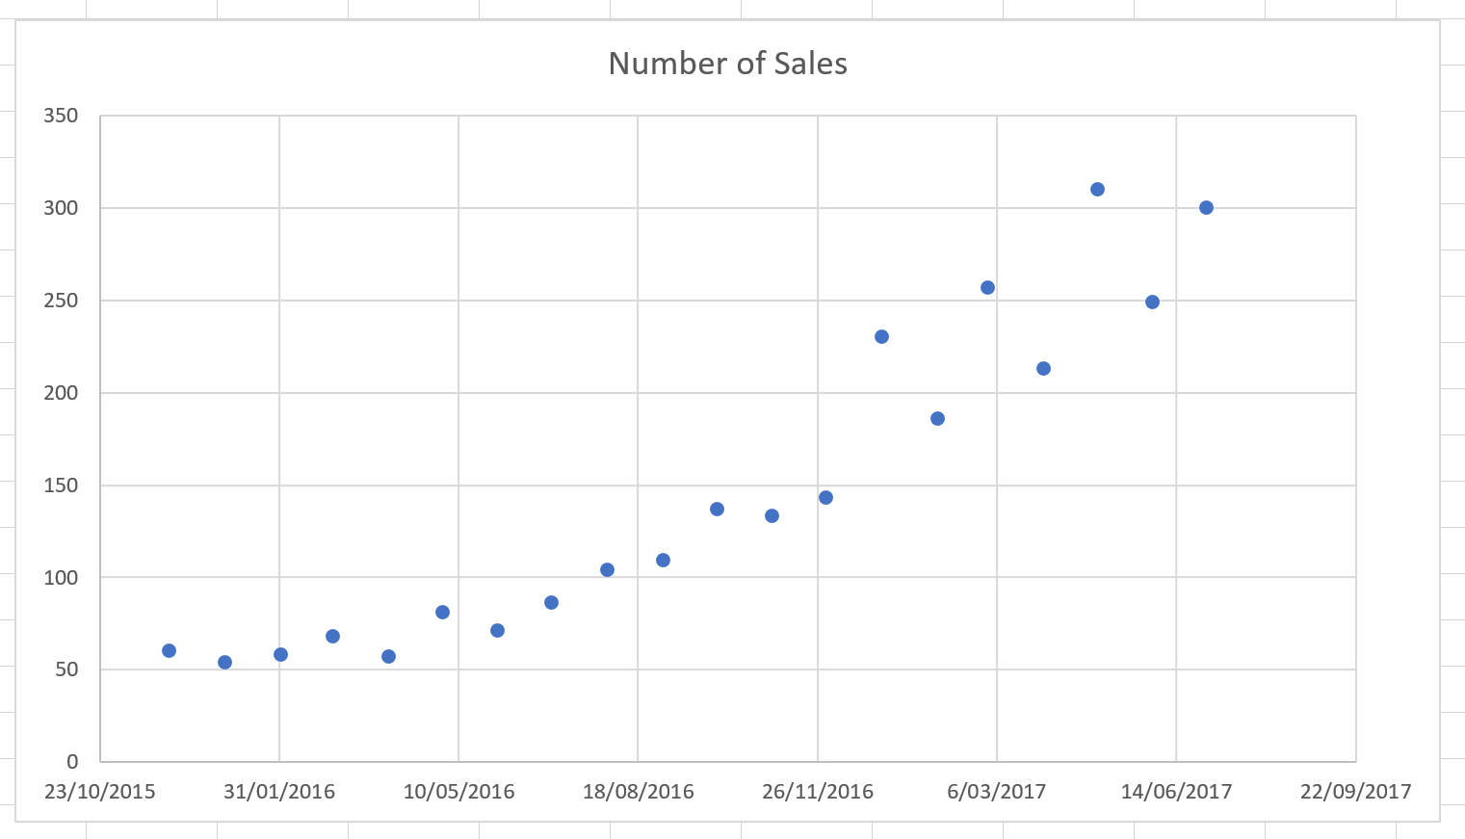

- Right click on any data point and select ‘Add Trendline’.
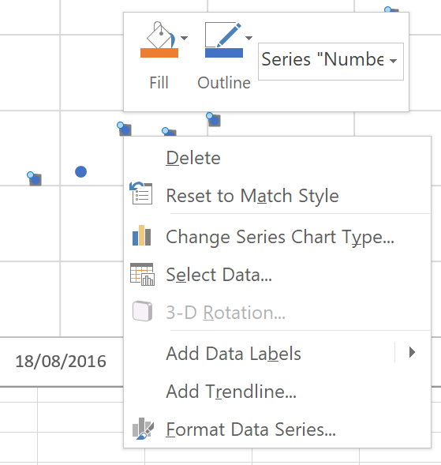
- A least squares regression line will be added to your scatterplot.
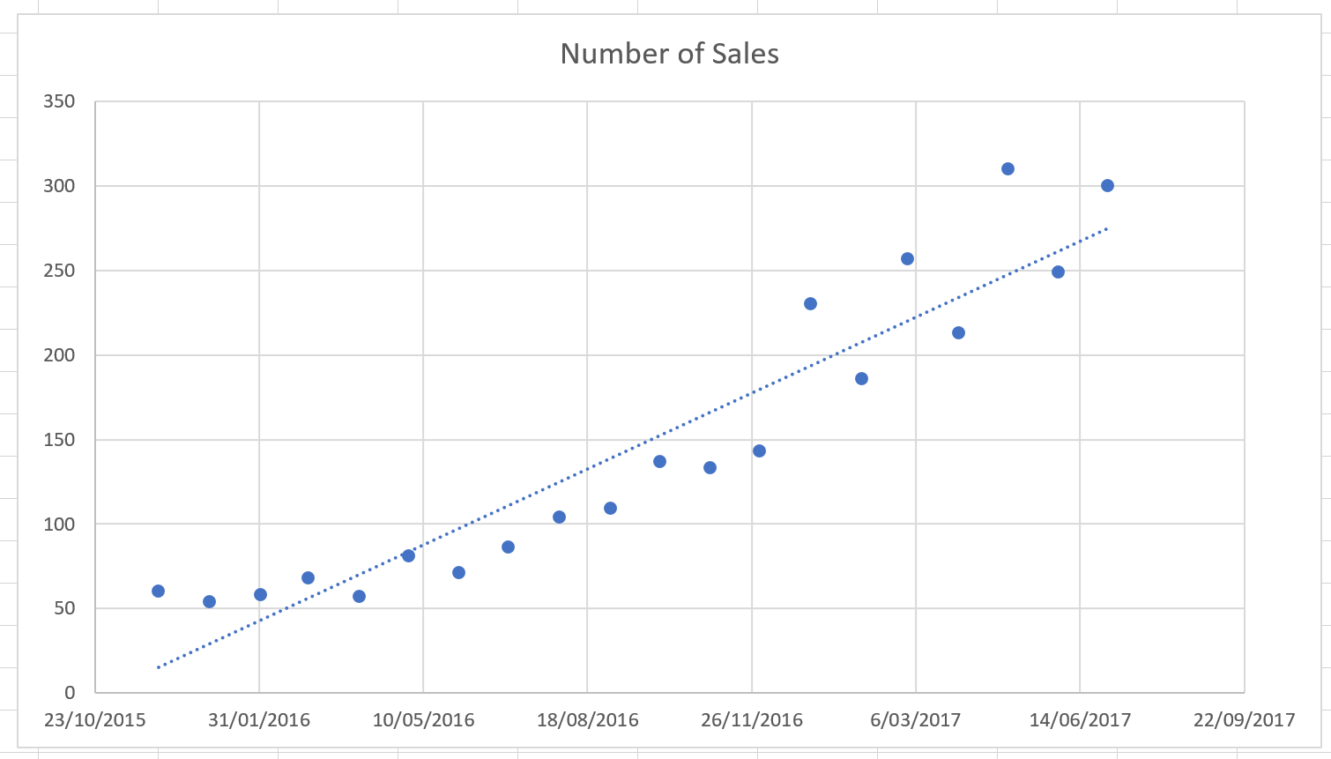

- Select the trendline and increase the forecast periods to 365 periods (days) to extend your trendline into the future.

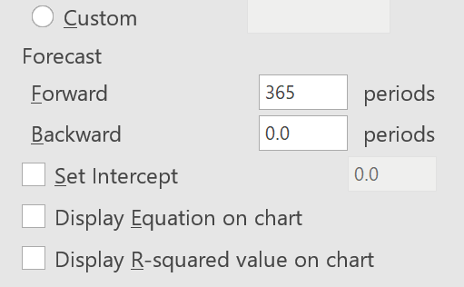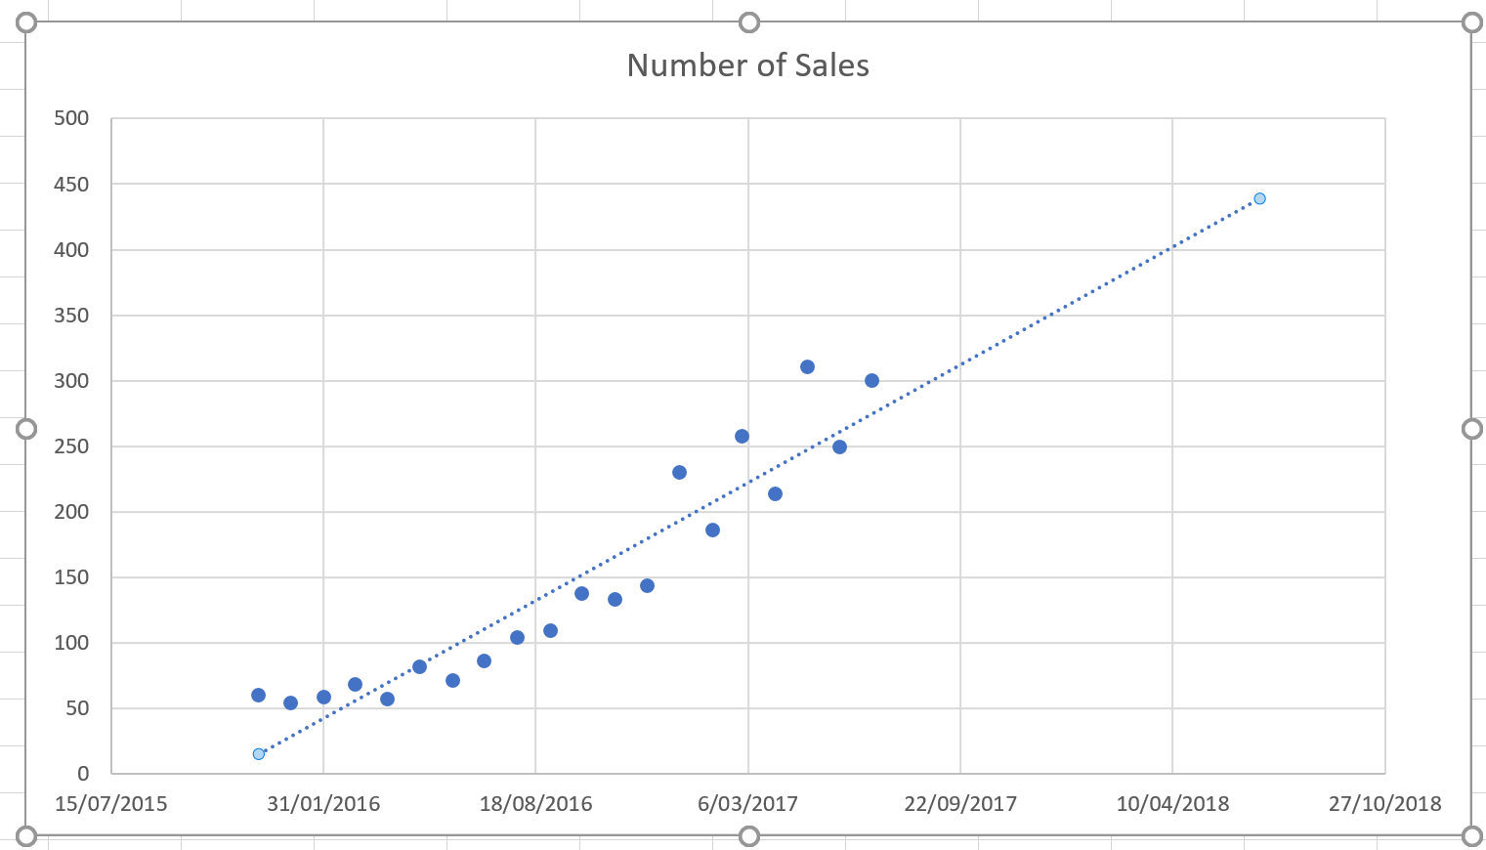
- Right click on the x-axis labels (dates) and ‘Add minor gridlines’.
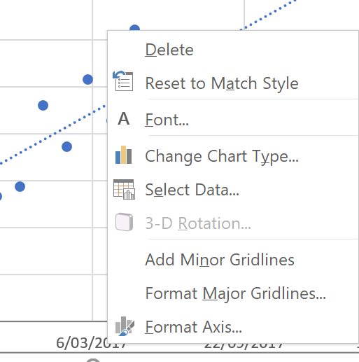

- By using the minor gridlines added to your scatterplot to read from the trendline, predict the sales in two months’ time.
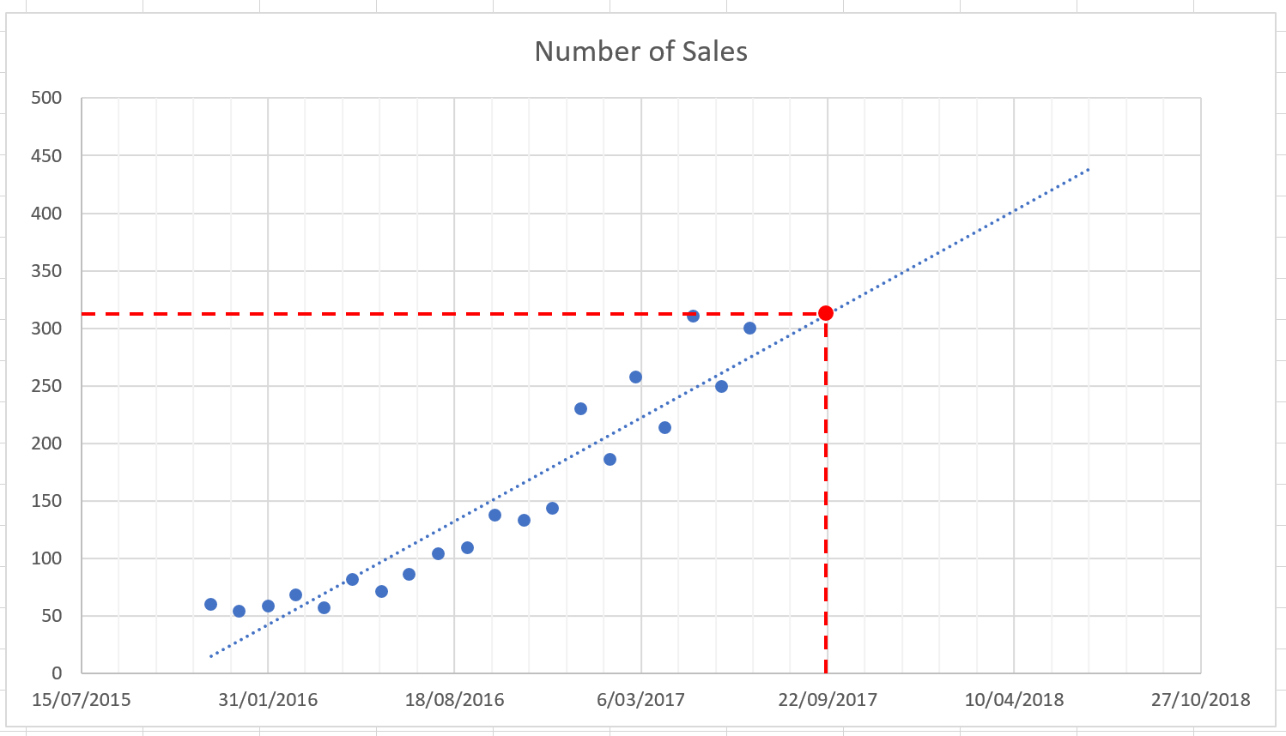
Note – The dashed line and point have been added here to help illustrate the process.
- Investigate non-linear trendlines by selecting the trendline and choosing from the ‘Trendline Options’, such as ‘Exponential’.

Part 2
Using the monthly sales data generated in part 1, investigate the safety stock levels your company should adopt to ensure that 97.5% of all sales are met.
Background information – The sales forecast generated in Part 1 will be variable. This variation can be estimated to be normally distributed about the regression line with a standard deviation calculated from the historical sales data.
- Using the spreadsheet generated in Part 1, select the regression line on the scatterplot and check the box for ‘Display Equation on chart’. The algebraic model for the regression line will be displayed on the scatterplot.
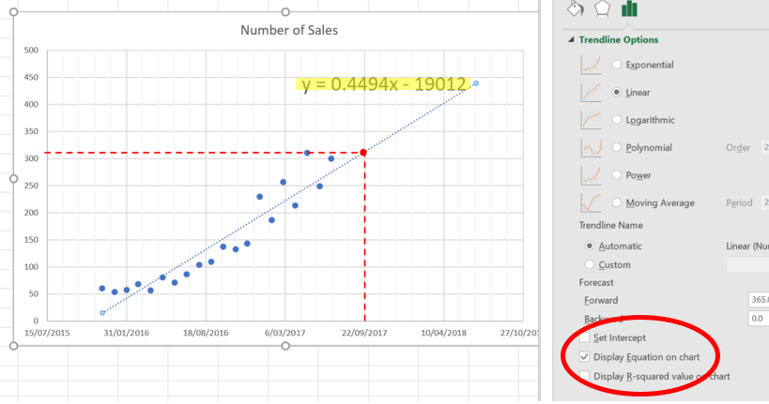

- Select cells C2:C21 and format them as ‘Number’ with 0 decimal places.
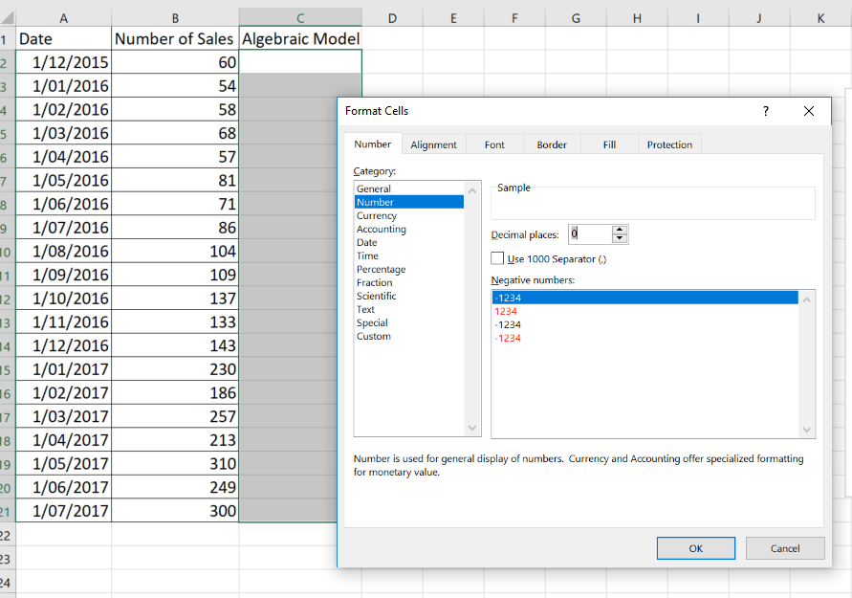
- Use the model to generate a table of values for the dates in column A. For the example above, enter the formula ‘=0.4994*A2-19012’ into cell C2. Please note, the coefficients of the algebraic model will change according to your algebraic model.
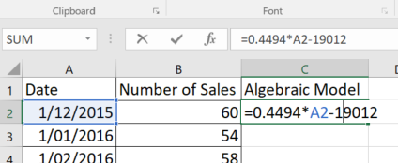

- Apply the algebraic model to all the dates by copying the contents of cell C2 to all the cells.
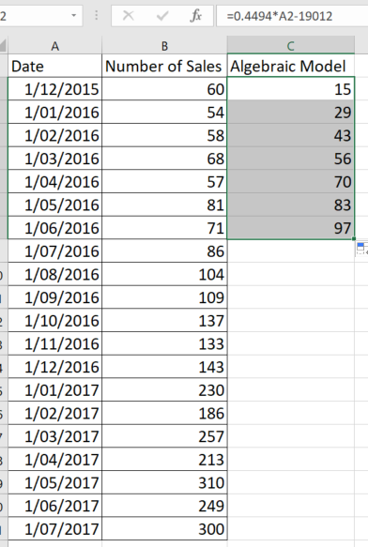
- Calculate the variation of the data off the model in column D by applying the formula ‘=B2-C2’ into the cell D2.
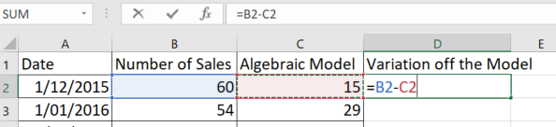

- Copy cell D2 to all the cells.
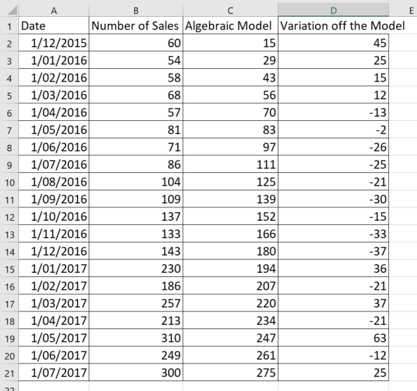
- Select a cell below the variation off the model cells (for example, cell D23) and enter ‘=STDEV.P(’
  - Note – STDEV.P is an excel function for calculating the standard deviation for a population.
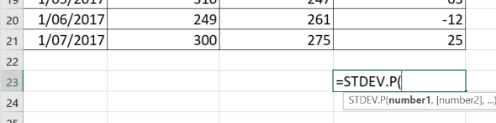

- Select the variation of the model cells and hit enter to generate the standard deviation for the population.
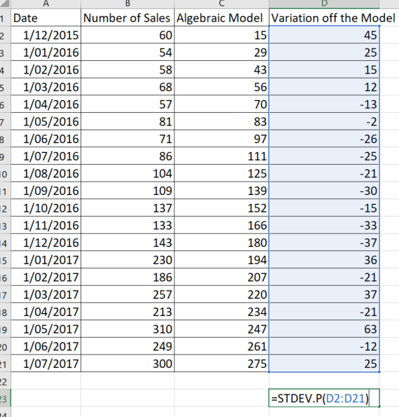
- Using the standard deviation from step 8, we can determine with 97.5% accuracy that the actual sales value in two months’ time will not be more than two standard deviations above the forecasted value. Therefore, a safety stock of two standard deviations will be sufficient to satisfy 97.5% of all potential sales.
  - In the example above, the standard deviation is 29 (rounded to whole units). Therefore, a safety stock of 58 units will satisfy 97.5% of all potential sales.

