How-to guide: desmos regression analysis

Part 1: Making a scatterplot
- Enter your data into desmos.
Method 1: Press plus, then table and then manually enter data.
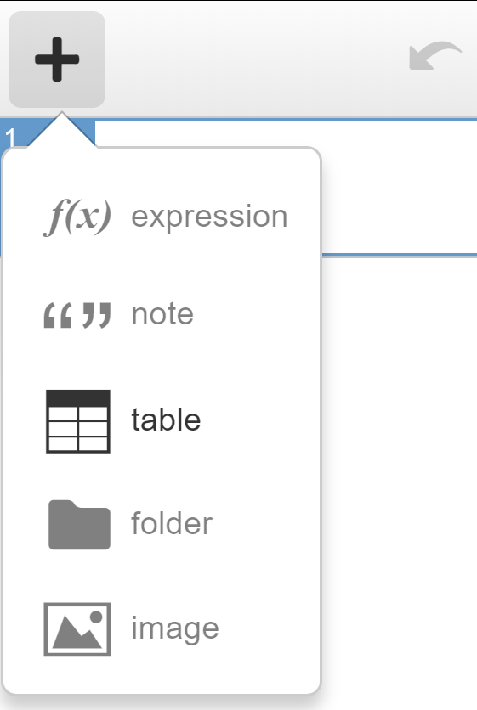
Method 2: If the data exist in a table such as in a MS Word document or MS Excel spreadsheet, copy the data and paste it into desmos
- Click into a blank rectangle next to a number
- Press Ctrl V to paste.
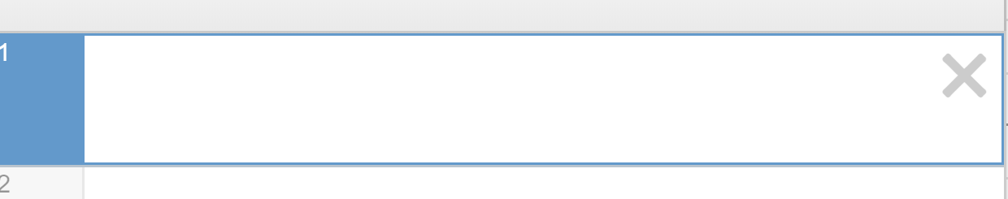
- The headers of the table can be renamed by clicking into the appropriate location.
- A scatterplot will automatically appear.
- Settings can be adjusted using the settings menu by clicking the spanner on the right hand side of the Cartesian plane.

Part 2: Fitting a line of best fit by eye using Desmos.
- Add a line. Type y=mx+c into a blank row. Select all to add sliders for m and c.
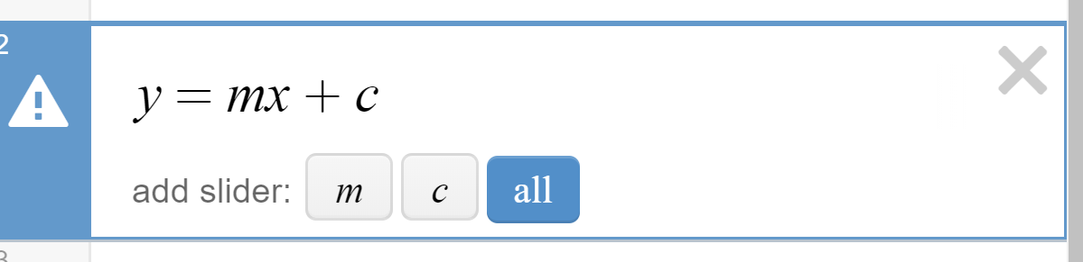
- Use the sliders for m and c to adjust the gradient and y intercept of the line until you believe it represents a line of best fit.

Part 3: Least squares regression line
- Add a least square regression line by typing into a blank row: y1~mx1+c
- y1 and x1 are used as they are the headers in the table.
- The 1s will automatically subscript in desmos

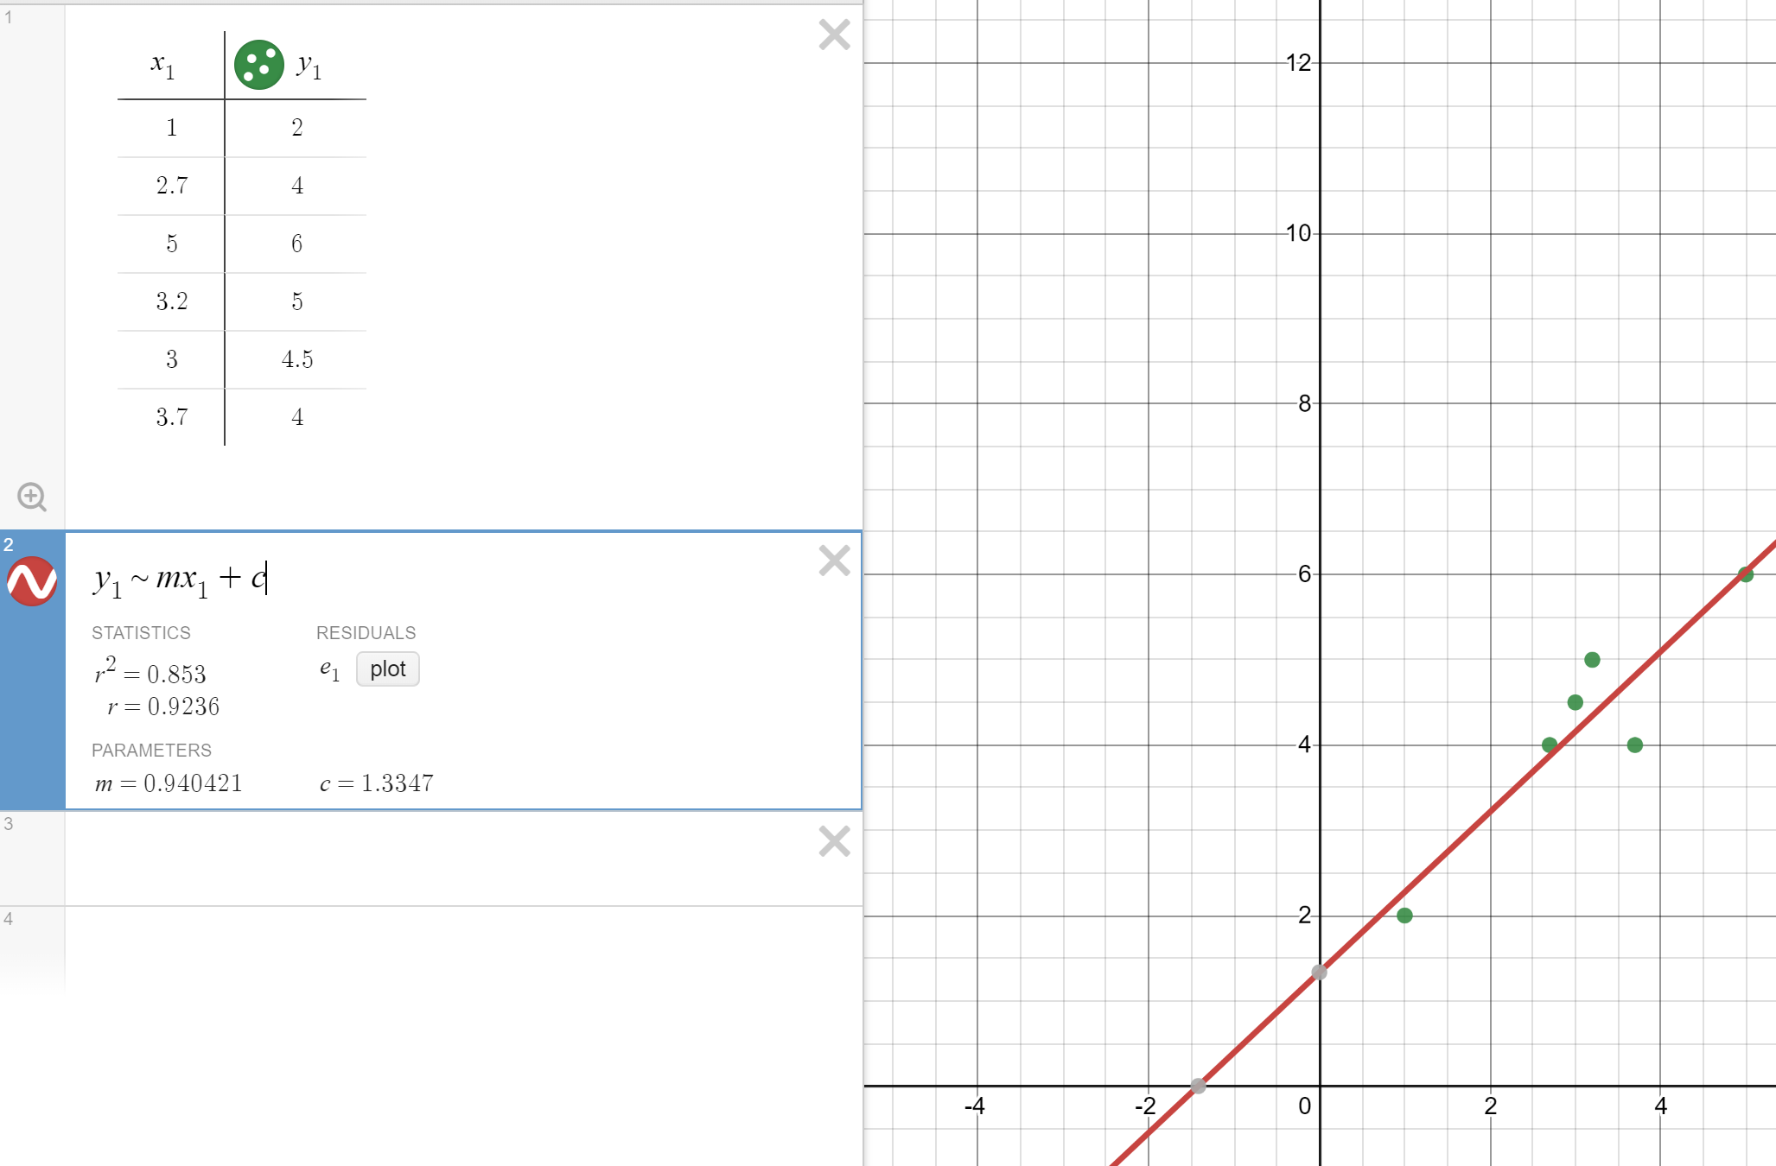
- The equation of the least squares regression line can be recorded using the parameter values for m and c.
- The correlation coefficient, r, is automatically shown when a least squares regression line is added.
- Residuals can be plotted by clicking plot.
- Note on forecasting with desmos
- Algebraic method: Substitute into the equation of the least squares regression line to forecast.
- Graphical method: You may need to adjust the data range if you wish to forecast a value outside of the original data range using the graph. Select the spanner then adjust the axis values as required.
