Critical path analysis

Maximum flow minimum cut
- Find a minimum cut and the maximum flow in the following networks

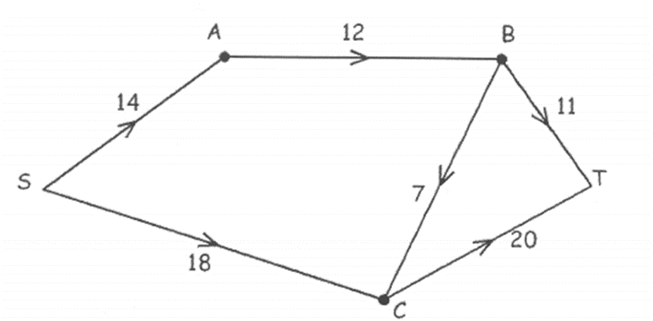

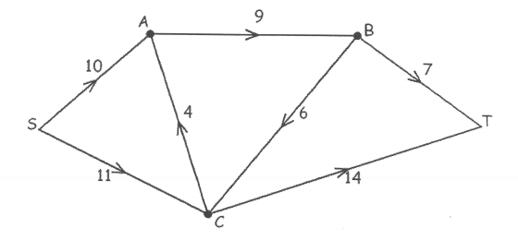
- Find the maximum flow through the following networks and verify by finding the minimum cut.

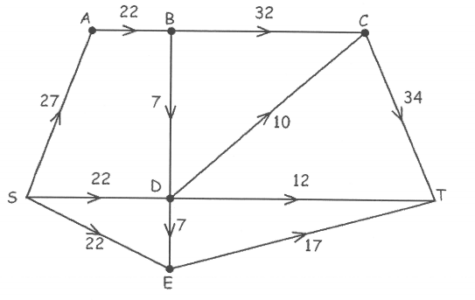

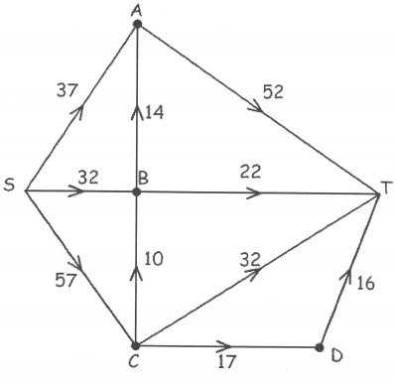
- Find the maximum flow through the following network and a corresponding minimum cut.
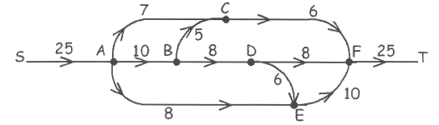
Identify how you could increase the maximum flow by 1 if you can change the capacity of one edge.
- An oil company has a underground tank and wishes to transport its product to a tanker truck. The capacities of the various routes through pipes are shown in the diagram below.
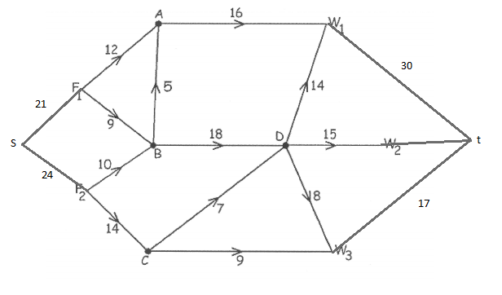
- Find the maximum number of units of oil that can be transported through the network and determine if the demand of 40 units can be met.
- Verify by finding the minimum cut
- What is the outflow of the source?

Maximum flow minimum cut solutions
Note: The maximum flow in the solutions may be able to be achieved in other ways. There may be additional cuts equal to the minimum cut shown
- Find a minimum cut and the maximum flow in the following networks

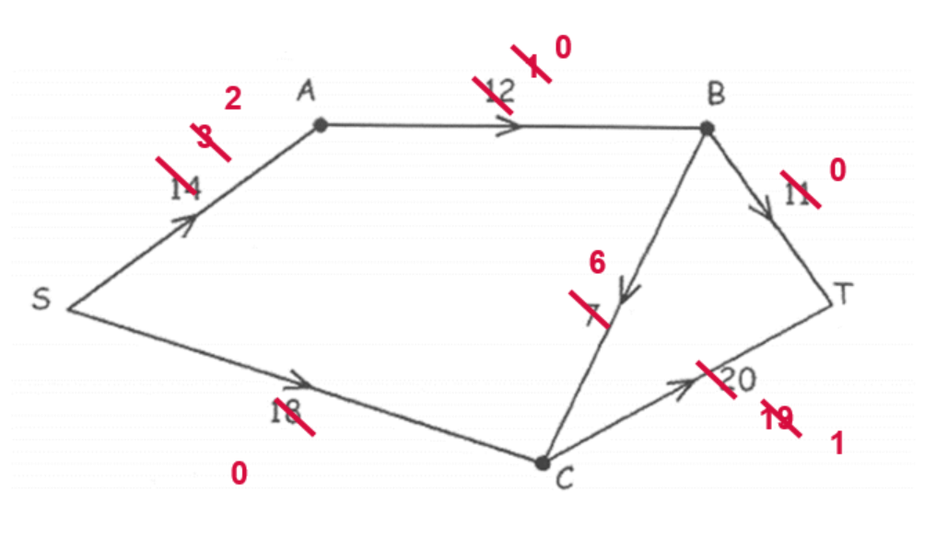
$$S-A-B-T=11$$
$$S-A-B-C-T=1$$
$$S-C-T=18$$
$$Maximum flow capacity=11+1+18=30$$

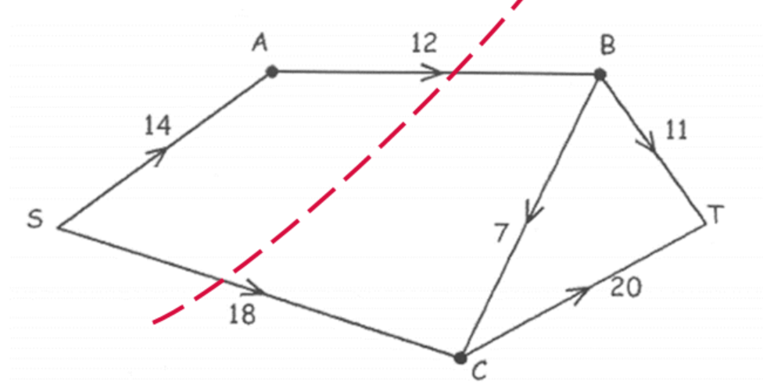
$$Capacity of the minimum cut=12+18=30$$
This is the minimum cut as the maximum flow is equal to the minimum cut.

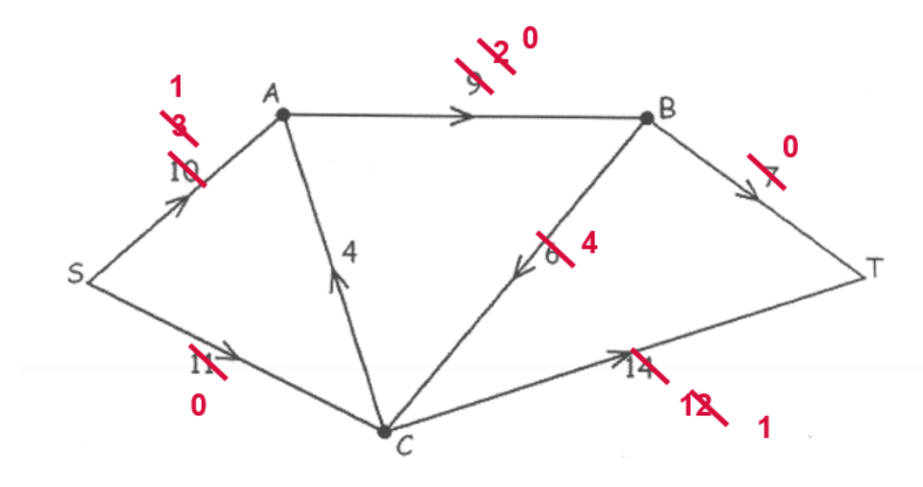
$$S-A-B-T=7$$
$$S-A-B-C-T=2$$
$$S-C-T=11$$
$$Maximum flow capacity=7+2+11=20$$
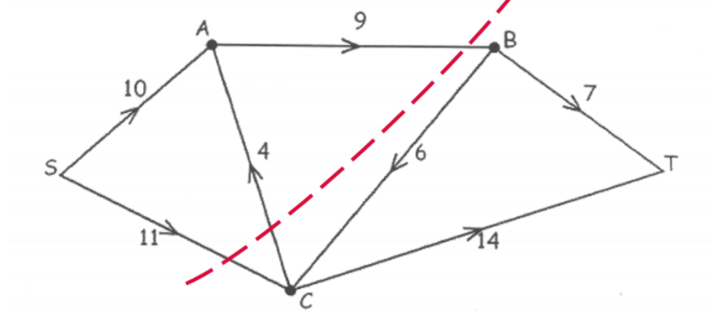
$$Capacity of the minimum cut=9+11=20$$
This is the minimum cut as the maximum flow is equal to the minimum cut.
CA is disregarded as it is flowing from the sink side of the cut to the source side of the cut.

- Find the maximum flow through the following networks and verify by finding the minimum cut.

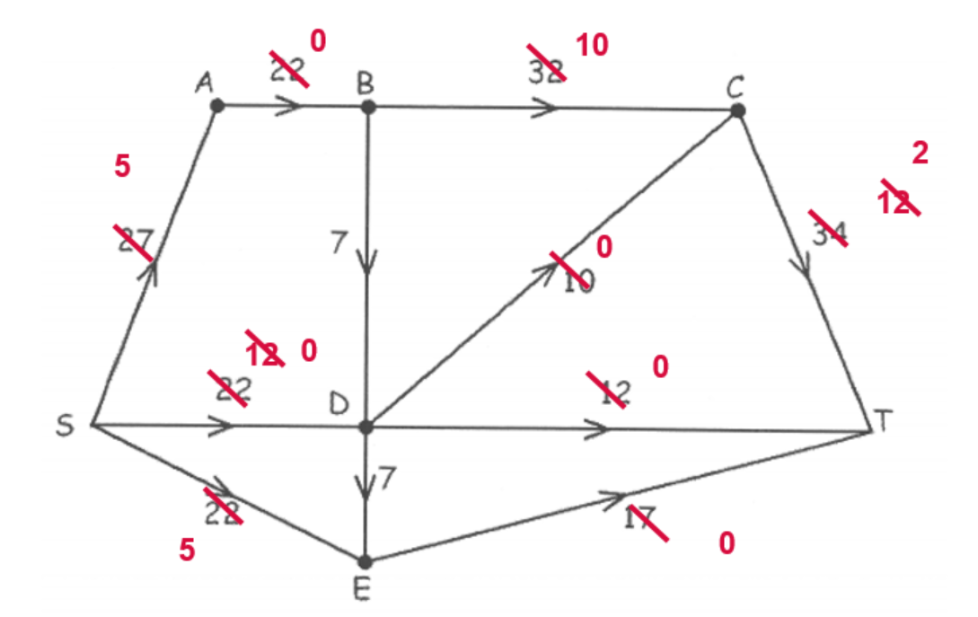
$$S-A-B-C-T=22$$
$$S-E-T=17$$
$$S-D-C-T=10$$
$$S-D-T=12$$
$$Maximum flow capacity=22+17+10+12=61$$
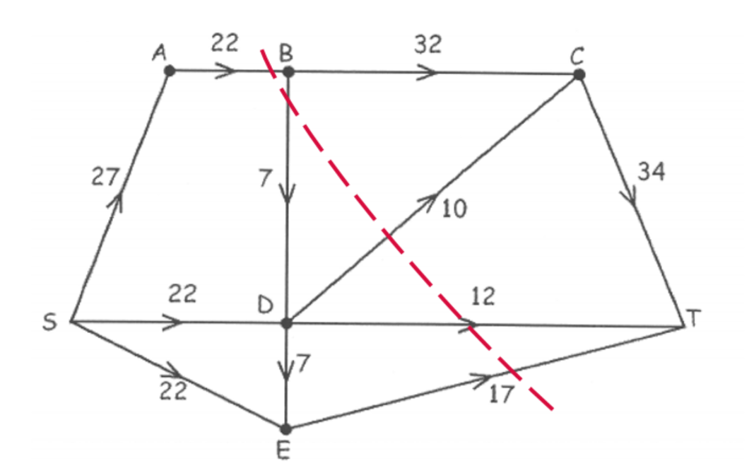
$$Capacity of the minimum cut=22+10+12+17=61$$
This is the minimum cut as the maximum flow is equal to the minimum cut.
BD is disregarded as it is flowing from the sink side of the cut to the source side of the cut.

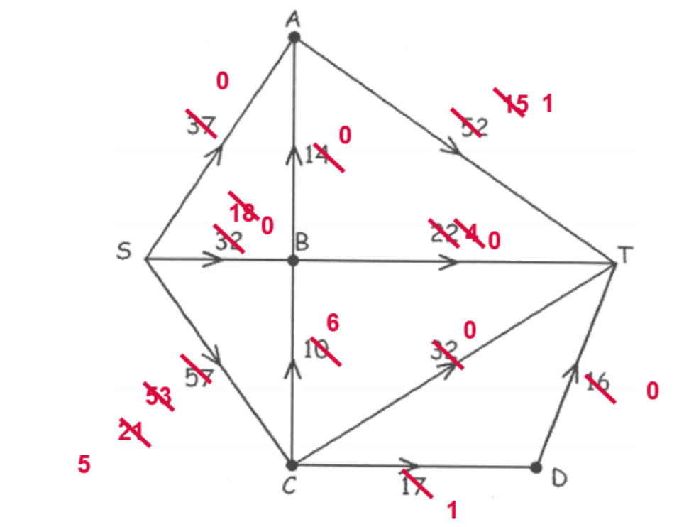
$$S-A-T=37$$
$$S-B-A-T=14$$
$$S-B-T=18$$
$$S-C-B-T=4$$
$$S-C-T=32$$
$$S-C-D-T=16$$
$$Maximum flow capacity=37+14+18+4+32+16=121$$

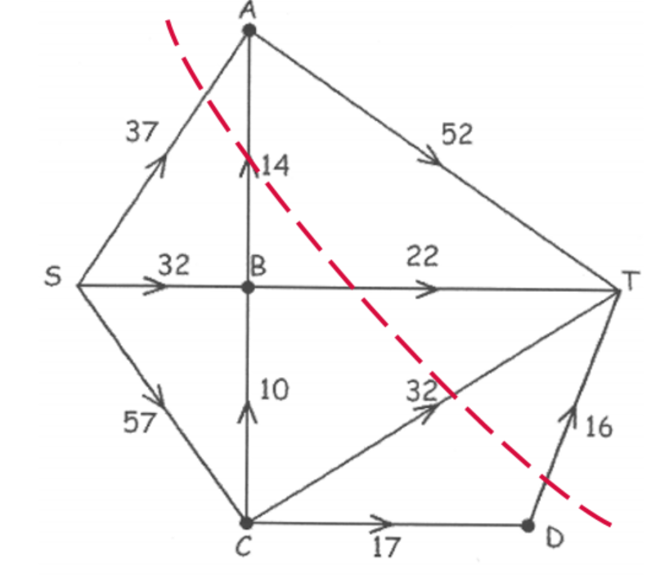
$$Capacity of the minimum cut=37+14+22+32+16=121$$
This is the minimum cut as the maximum flow is equal to the minimum cut.

- Find the maximum flow through the following network and a corresponding minimum cut.

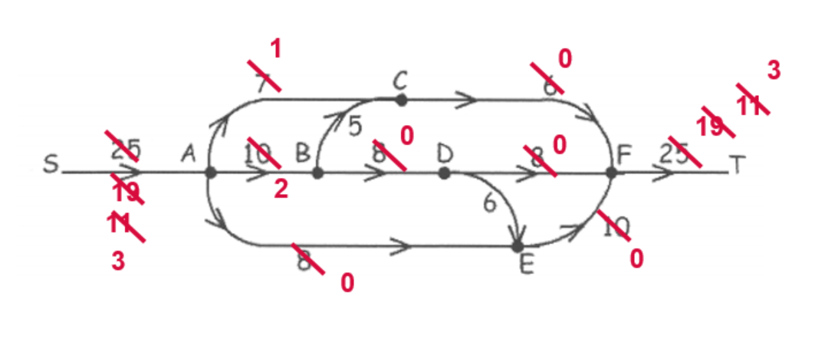
$$S-A-C-F-T=6$$
$$S-A-B-D-F-T=8$$
$$S-A-E-F-T=8$$
$$Maximum flow capacity=6+8+8=22$$
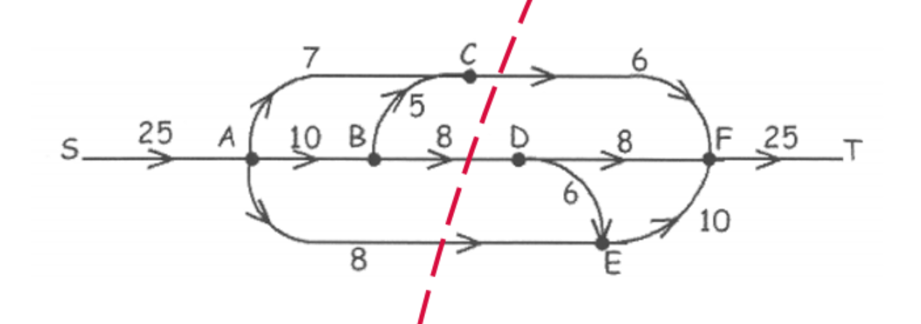
$$Capacity of the minimum cut=6+8+8=22$$
This is the minimum cut as the maximum flow is equal to the minimum cut.

Identify how you could increase the maximum flow by 1 if you can change the capacity of one edge.
Increase the capacity of CF by 1. This would increase the maximum flow to 23.

- An oil company has a underground tank and wishes to transport its product to a tanker truck. The capacities of the various routes through pipes are shown in the diagram below.
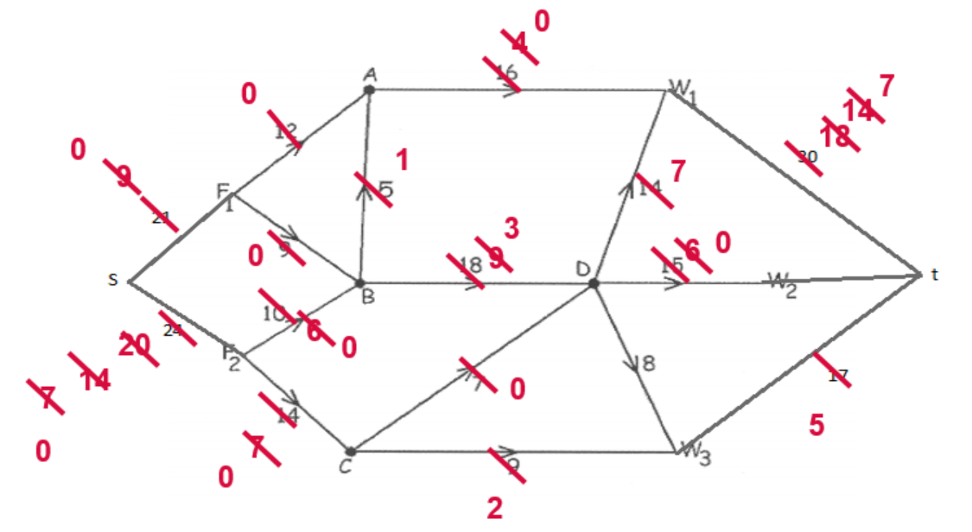
- Find the maximum number of units of oil that can be transported through the network and determine if the demand of 40 units can be met.
$$s-F_{1}-A-W_{1}-t=12$$
$$s-F_{1}-B-D-t=9$$
$$s-F_{2}-B-A-W_{1}-t=4$$
$$s-F_{2}-B-D-t=6$$
$$s-F_{2}-C-D-W_{1}-t=7$$
$$s-F_{2}-C-W_{3}-t=7$$
$$Maximum flow capacity=12+9+4+6+7+7=45$$
The demand of 40 units is met.
- Verify by finding the minimum cut
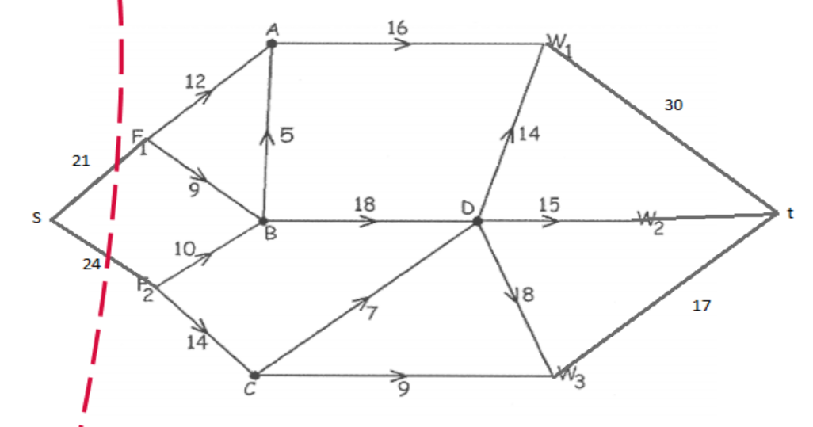
$$Capacity of the minimum cut=21+24=45$$
This is the minimum cut as the maximum flow is equal to the minimum cut.
- What is the outflow of the source?
$$Source outflow=21+24=45$$

