Maximum flow minimum cut methods
The PowerPoint resource maximum-flow-minimum-cut-methods.PPTX contains animations for the pushing flow examples. It also contains several other sample questions examined using the trial and error.

Trial and error
The first method relies on identifying all cuts through the network.
The weight of each cut is found by adding the weights of all edges passing through the cut in the direction of source to sink.
The minimum cut is that with the minimum weight.

Example: Find the maximum flow and identify the minimum cut.
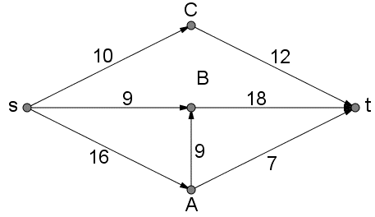
There are many cuts that could be made to this network.
Some sample cuts are shown below. There are many other cuts that could be made to this network. Others not shown would include the cut through sC, Bt and At.
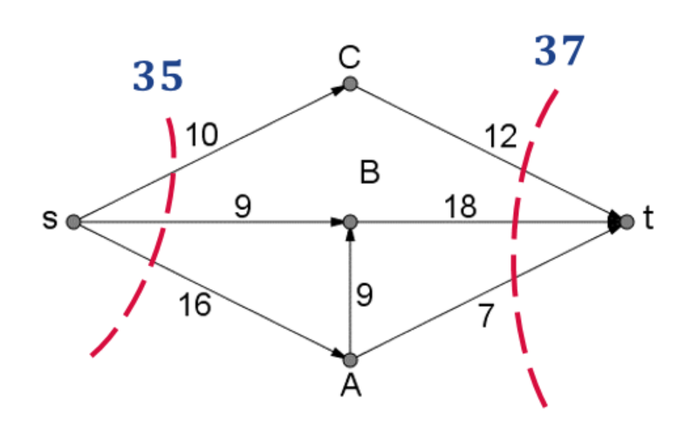
How are these numbers calculated?
The first cut passes through sC, sB and sA. $flow cut=10+9+6=35$
The second cut passes through Ct, Bt and At. $flow cut=12+18+7=37$
A third cut is shown in the diagram below.

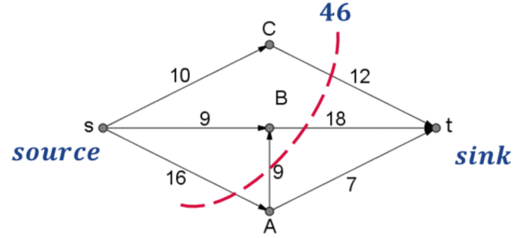
This cut passes through Ct, Bt, AB and At.
AB is disregarded as it is flowing from the sink side of the cut to the source side of the cut.
$$flow cut=10+9+6=35$$
Once an exhaustive list of cuts is made then 35 can be identified as the minimum cut and the maximum flow will be 35.

Pushing flow
Choose one path at a time from source to sink and push the maximum flow through the network, the paths capacity.
Option 1: Reduce the capacity on the edges used to reflect its excess flow capacity (capacity remaining).
Option 2: Record the capacity that has been “pushed” through the edge, then the difference between this and the edges flow capacity is the excess flow capacity.
Continue this with other paths from source to sink which contain no zero edges (they have excess flow capacity).

Example 1: Find the maximum flow and identify the minimum cut.
Choose a path with no zero edges. $s-C-t,$ the maximum flow through this path is 10. (The minimum edge weight on the path)
$$s-C-t=10$$
Update the diagram to show the remaining capacity.
Option 1: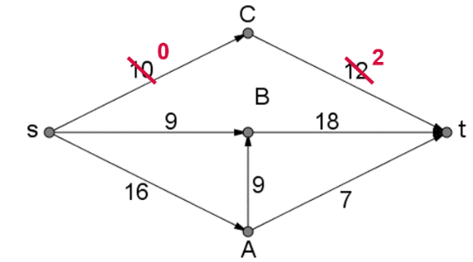Option 2: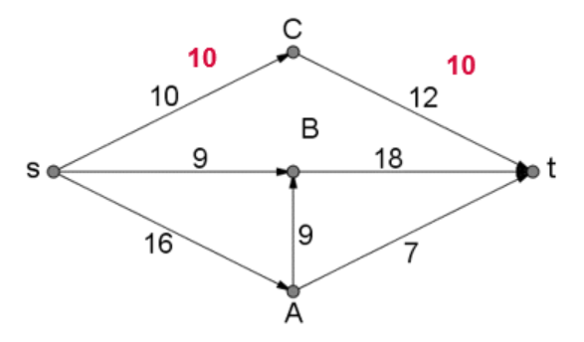
Note: In the remaining examples in this document option one is utilised.
Choose a path with no zero edges. $s-B-t,$ the maximum flow through this path is 9.
$$s-B-t=9$$
Update the diagram to show the remaining capacity.
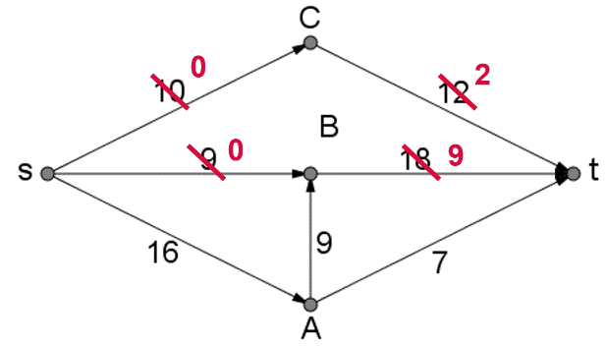
Choose a path with no zero edges. $s-A-t,$ the maximum flow through this path is 7.
$$s-A-t=7$$
Update the diagram to show the remaining capacity.
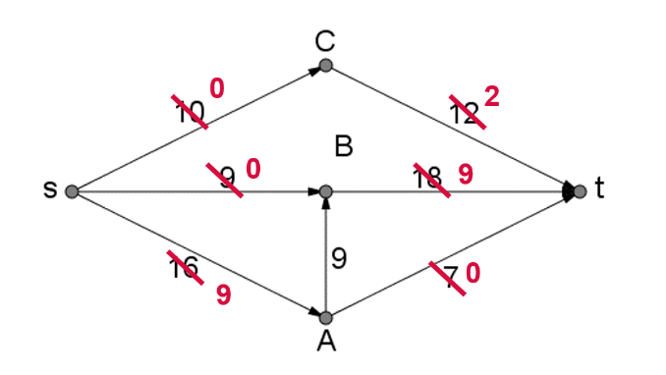
Choose a path with no zero edges. $s-A-B-t,$ the maximum flow through this path is 9.
$$s-A-B-t=9$$
Update the diagram to show the remaining capacity.
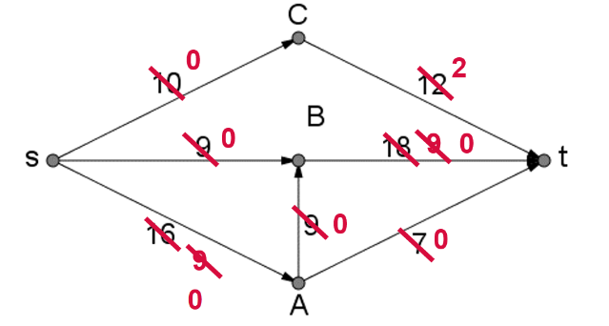
There are no more paths that can be chosen.
The maximum flow is obtained by adding up each flow we pushed through the network.
$$s-C-t=10$$
$$s-B-t=9$$
$$s-A-t=7$$
$$s-A-B-t=9$$
$$Maximum flow=10+9+7+9=35$$
Minimum cuts can be identified from this diagram. The minimum cut will only pass through edges of zero. There are multiple minimum cuts in this network.
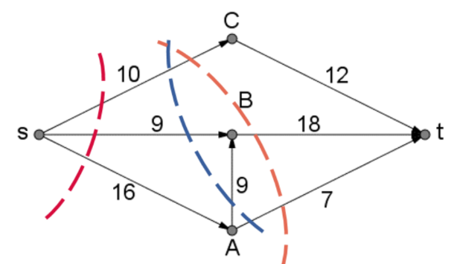
Value of the cuts:
$$10+9+16=35$$
$$10+18+7=35$$
$$10+9+9+7=35$$

Example 2: Find the maximum flow and identify the minimum cut.
Note: By convention a lower case s and t are used for the source and sink respectively. The following network diagrams were made using Graph Creator which only allows the use of capital letters.
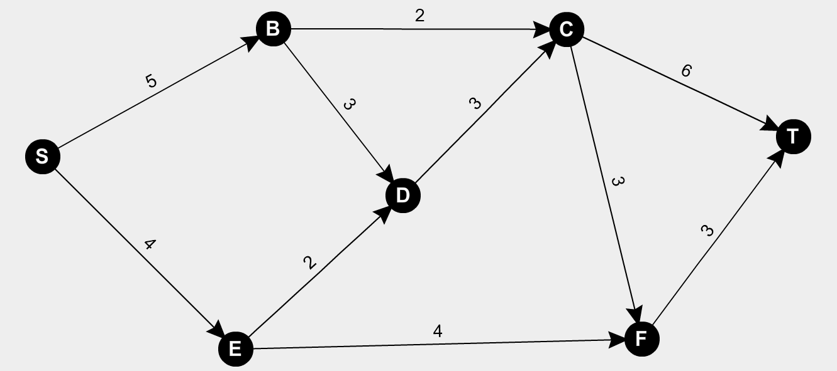
Choose a path with no zero edges. $S-B-C-T,$ the maximum flow through this path is 2.
$$S-B-C-T=2$$
Update the diagram to show the remaining capacity.
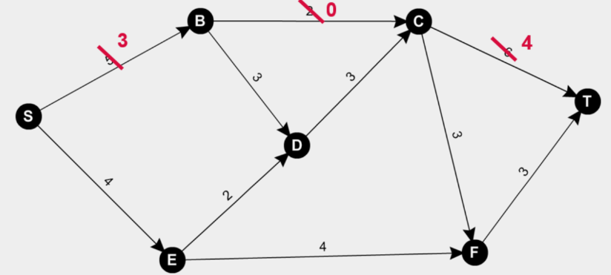
Choose a path with no zero edges. $S-B-D-C-T,$ the maximum flow through this path is 3.
$$S-B-D-C-T=3$$
Update the diagram to show the remaining capacity.
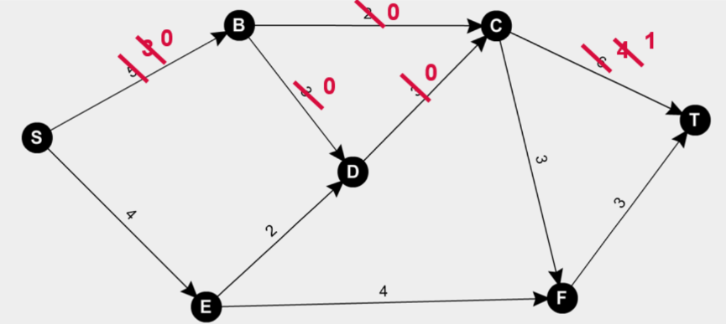
Choose a path with no zero edges. $S-E-F-T,$ the maximum flow through this path is 3.
$$S-E-F-T=3$$
Update the diagram to show the remaining capacity.
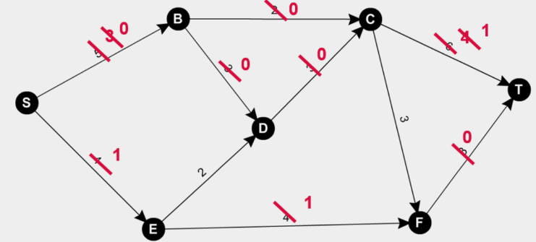
There are no more paths that can be chosen.
The maximum flow is obtained by adding up each flow we pushed through the network.
$$S-B-C-T=2$$
$$S-B-D-C-T=3$$
$$S-E-F-T=3$$
$$Maximum flow=2+3+3=8$$
Minimum cuts can be identified from this diagram. The minimum cut will only pass through edges of zero. There is only one minimum cut in this network.
Note: The edges cut cannot flow into each other.
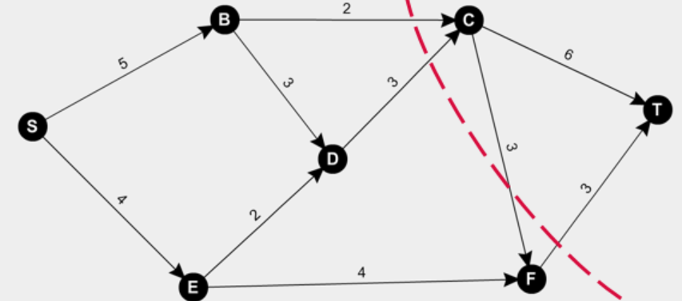
This cut passes through BC, DC, CF and FT.
CF is disregarded as it is flowing from the sink side of the cut to the source side of the cut.
Value of the cut:
$$2+3+3=8$$

Pushing flow – a cautionary note
The identification of the minimum cut as passing through edges of only zero is important in identifying if the maximum flow (minimum cut) has been found.

Example 3: Find the maximum flow and identify the minimum cut.
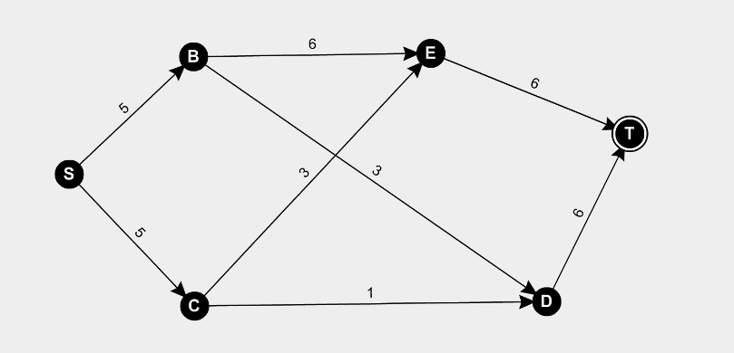
Choose a path with no zero edges. $S-B-E-T,$ the maximum flow through this path is 5.
$$S-B-E-T=5$$
Update the diagram to show the remaining capacity.
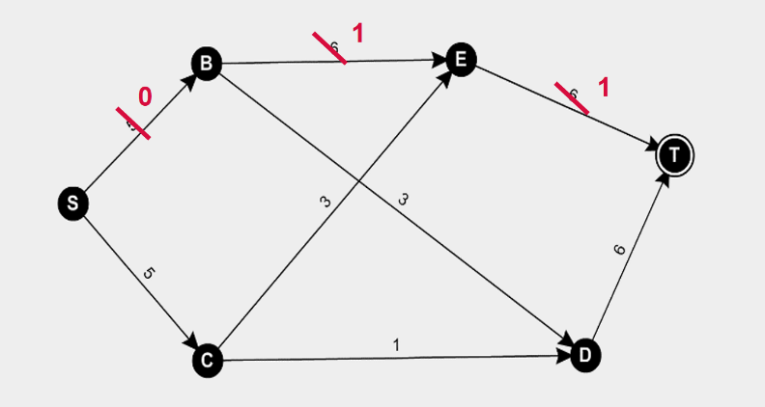
Choose a path with no zero edges. $S-C-E-T,$ the maximum flow through this path is 1.
$$S-C-E-T=1$$
Update the diagram to show the remaining capacity.
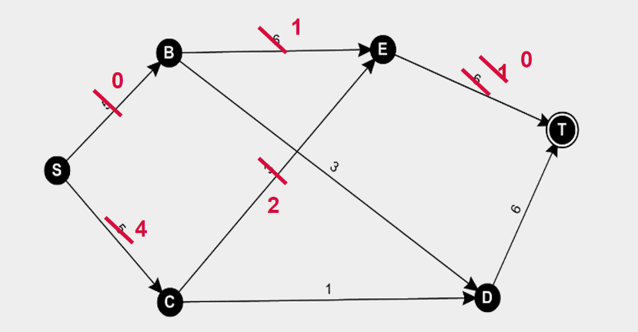
Choose a path with no zero edges. $S-C-D-T,$ the maximum flow through this path is 1.
$$S-C-D-T=1$$
Update the diagram to show the remaining capacity.
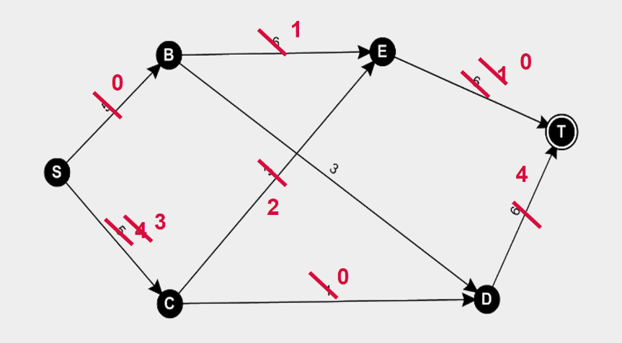
There are no more non-zero paths from source to sink and we have pushed through a capacity of $5+1+1=7$.
A minimum cut cannot be identified form the diagram as there is no cut which only passes through edges of zero.
By inspection/exhaustion the minimum cut can be identified as follows:
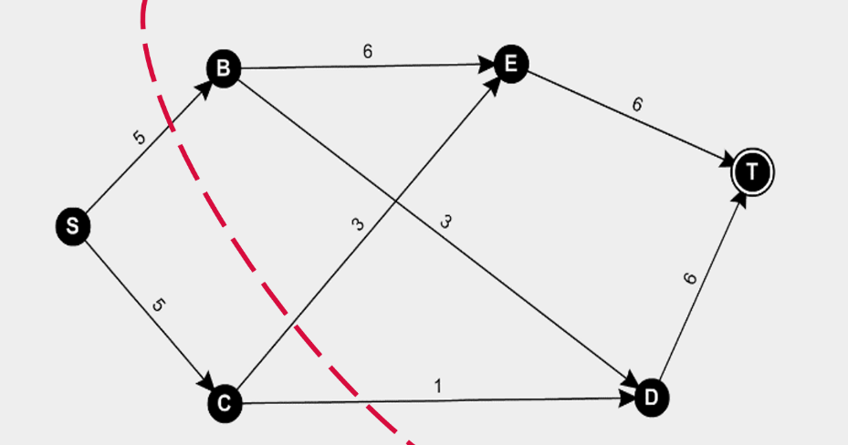
$$Maximum flow=2+3+3=8$$
The previous method had capacity left in the edge CE.
Let’s push flow through here first.
$$S-C-E-T=3$$
Update the diagram to show the remaining capacity.
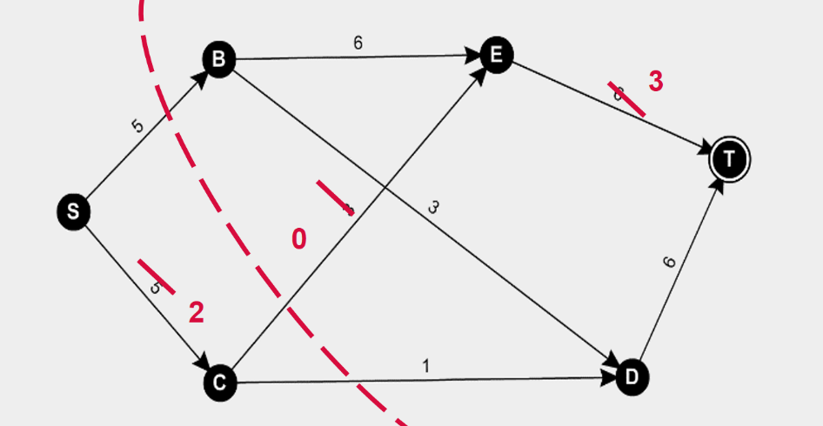
Choose a path with no zero edges. $S-B-E-T,$ the maximum flow through this path is 3.
$$S-B-E-T=3$$
Update the diagram to show the remaining capacity.
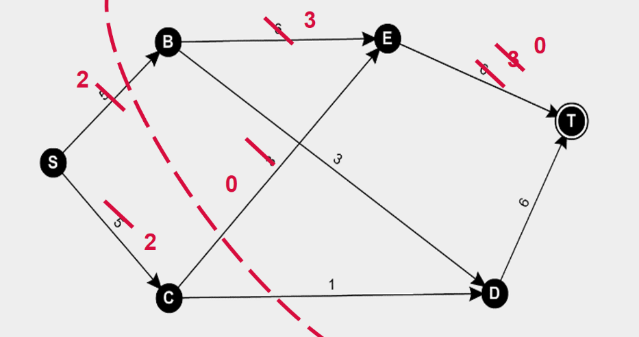
Choose a path with no zero edges. $S-B-D-T,$ the maximum flow through this path is 2.
$$S-B-D-T=2$$
Update the diagram to show the remaining capacity.
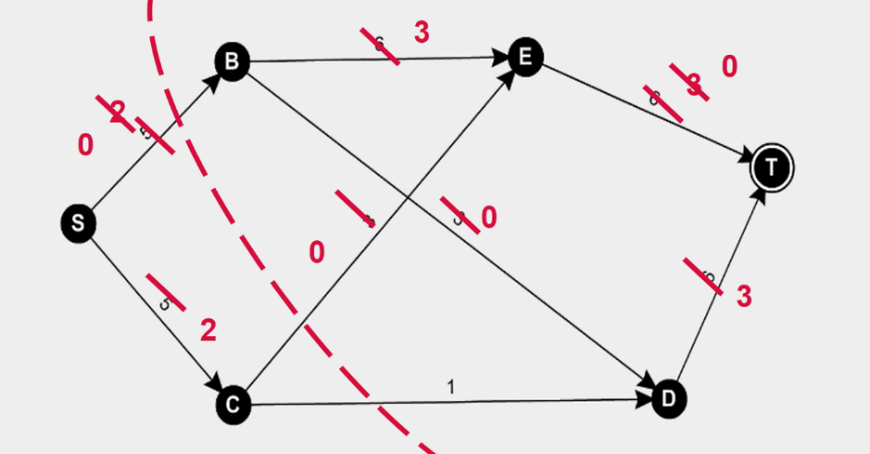
Choose a path with no zero edges. $S-C-D-T,$ the maximum flow through this path is 1.
$$S-C-D-T=1$$
Update the diagram to show the remaining capacity.
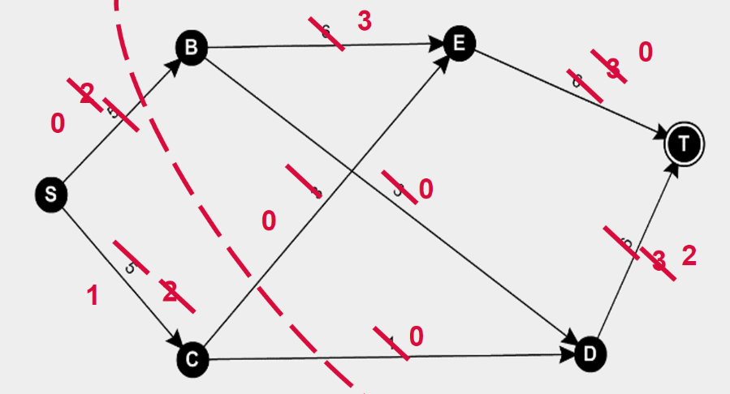
$$S-C-E-T=3$$
$$S-B-E-T=3$$
$$S-B-D-T=2$$
$$S-C-D-T=1$$
$$Maximum flow=3+3+2+1=8$$
Reference: Finding the Maximum Flow and Minimum Cut within a Network

