Critical path analysis

Australia’s trades with Asia
Australia exports coal all around the world. One of the biggest importers is from China.

Sydney to Shanghai via Japan
The table below shows all the ports that ships must sail between to get from Sydney to Shanghai through Japan.

Starting Port | Finishing Port | Total Amount of Coal Transported (in tonnes)
Sydney | Newcastle | 50
Sydney | Brisbane | 50
Newcastle | Brisbane | 30
Newcastle | Tokyo | 80
Brisbane | Tokyo | 80
Brisbane | Masan | 100
Tokyo | Masan | 30
Masan | Shanghai | 70
- Draw a network that represents the information in the table above.
- What is the maximum amount of coal that can be transported from Sydney to Shanghai using this network? (The flow capacity)
The start of the network is called the source and is often labelled $s$. The end of the network is called the sink and is often labelled $t$.
- Identify the source and sink in this network.
The excess flow capacity of an edge is the capacity of the edge minus the flow through the edge. Edges with zero excess flow capacity are said to be saturated.
- Identify the saturated edges or shipping routes.
- Identify the excess capacity on the remaining edges or shipping routes.
- The demand for coal in Shanghai was 70 tonnes. Does this network meet the demand?
- The total amount of coal supplied needs to be increased by 10 tonnes (i.e. demand is increased to 80). If the capacity of only one edge could be increased, which one should it be?

Sydney to Shanghai via Jakarta or Hong Kong
The table below shows the route that runs through Indonesia. There are only 3 types of ships that carry the coal in this direction. A container ship that holds 50 tonnes, a Dry Bulk ship that holds 70 tonnes, and a Tanker that holds 120 tonnes.

Starting Port | Finishing Port | Type of Ship
Sydney | Newcastle | Container
Sydney | Brisbane | Container
Newcastle | Jakarta | Dry Bulk
Newcastle | Hong Kong | Tanker
Brisbane | Jakarta | Dry Bulk
Brisbane | Hong Kong | Tanker
Jakarta | Shanghai | Dry Bulk
Hong Kong | Shanghai | Container
- Draw a network that represents the information in the table above.
- What is the maximum amount of coal that can be transported from Sydney to Shanghai using this network? (The flow capacity)
- Identify the source and sink in this network.
- Identify the saturated edges or shipping routes.
- Identify the excess capacity on the remaining edges or shipping routes.
- The demand for coal in Shanghai was 120 tonnes. Does this network meet the demand?
- By changing the type of one ship, meet the demand of 120 tonnes.

Australia’s trades with Asia – Solutions

Sydney to Shanghai via Japan
- Draw a network that represents the information in the table above.
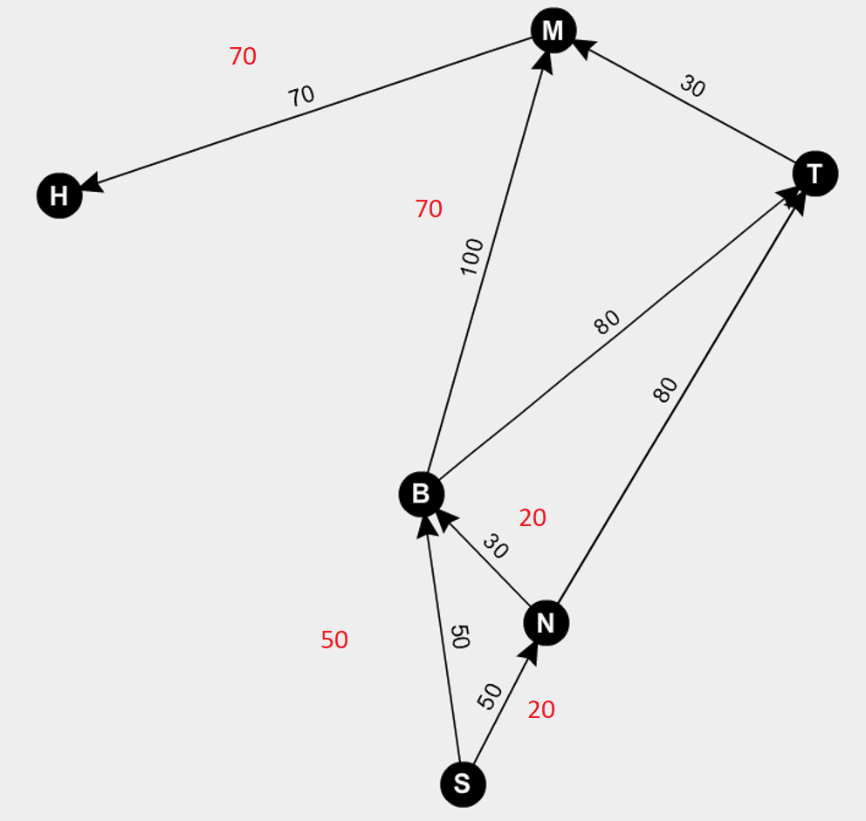
Note: Shanghai is labelled H.

- What is the maximum amount of coal that can be transported from Sydney to Shanghai using this network? (The flow capacity)
70 tonnes
Note: There are multiple solutions, one is shown in red and this is used for the rest of the questions.
- Identify the source and sink in this network.
Source is Sydney, sink is Shanghai
- Identify the saturated edges or shipping routes.
Masan to Shanghai, Sydney to Brisbane
- Identify the excess capacity on the remaining edges or shipping routes.
Sydney to Newcastle 30 tonnes, Newcastle to Brisbane 10 tonnes, Newcastle to Tokyo 80 tonnes, Brisbane to Tokyo 80 tonnes, Tokyo to Masan 30 tonnes and Brisbane to Masan 30 tonnes.
- The demand for coal in Shanghai was 70 tonnes. Does this network meet the demand?
Yes. 70 tonnes are shipped.
- The total amount of coal supplied needs to be increased by 10 tonnes (i.e. demand is increased to 80). If the capacity of only one edge could be increased, which one should it be?
Masan to Shanghai

Sydney to Shanghai via Jakarta or Hong Kong
- Draw a network that represents the information in the table above.
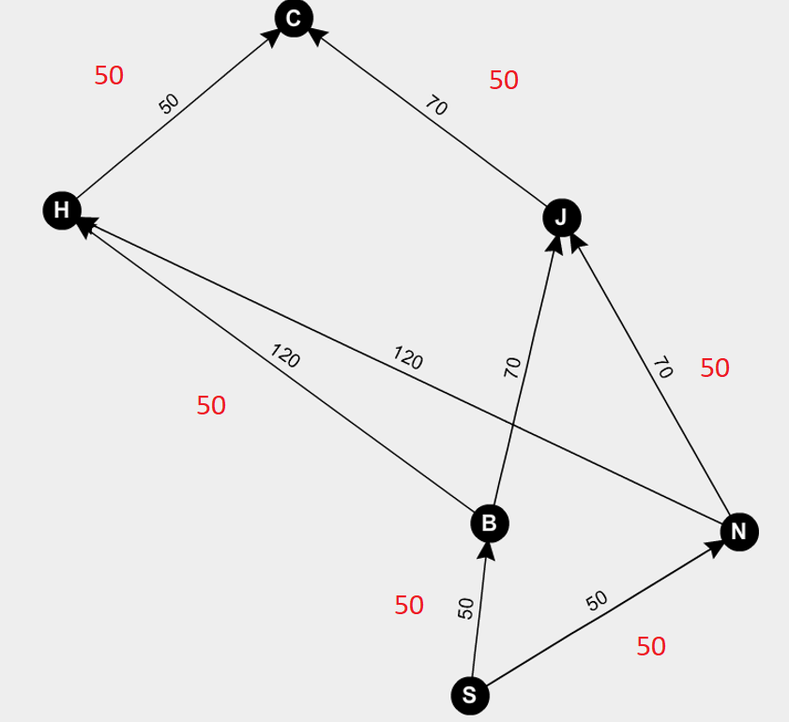
Note: Shanghai is labelled C.
- What is the maximum amount of coal that can be transported from Sydney to Shanghai using this network? (The flow capacity)
100 tonnes
Note: There are multiple solutions, one is shown in red and this is used for the rest of the questions.
- Identify the source and sink in this network.
Source is Sydney, sink is Shanghai
- Identify the saturated edges or shipping routes.
Hong Kong to Shanghai, Sydney to Brisbane, Sydney to Newcastle
- Identify the excess capacity on the remaining edges or shipping routes.
Brisbane to Hong Kong 70 tonnes, Newcastle to Hong Kong 120 tonnes, Newcastle to Jakarta 20 tonnes, Brisbane to Jakarta 70 tonnes and Jakarta to Shanghai 20 tonnes.
- The demand for coal in Shanghai was 120 tonnes. Does this network meet the demand?
No. Only 100 tonnes is shipped.
- By changing the type of one ship, meet the demand of 120 tonnes.
Change either ship out of Sydney to be a dry bulk. This will allow the additional 20 tonnes to reach Hong Kong via Jakarta.

