Königsberg bridge problem

Königsberg bridge problem
Königsberg is the name for a former German city that is now called Kaliningrad in Russia.
Below is a simple diagram that shows its four sections of land connected by seven bridges.
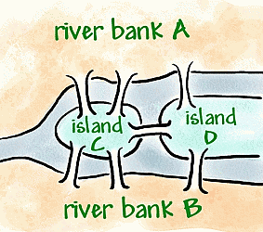
Source: nrich.maths.org

Activities
- Beginning at any point in the town, can you find a path that passes over all seven bridges exactly once?
- Draw a network diagram to represent this situation. Use the letters in the image to label your vertices.

Possible discussion prompts
- Introduce the concept of a network diagram to demonstrate how to simplify the Konigsberg bridge map using vertices and edges. Note: Vertices and edges will need to be defined.
- Students may like to make a network diagram representing the Konigsberg bridge problem using pipe cleaners and modelling clay.
- Discuss that if it is possible to start at a vertex (or node), and trace out the whole network without having to retrace over any of the edges, the network is called traversable. Students are to investigate the other networks contained in the Konigsberg bridge investigation and decide whether any of them are traversable or not. The purpose of this activity is not the terminology but to determine whether it is possible to solve the problem.
- Introduce the concepts of a degree and odd and even vertices. Students could label the degree of each vertex in their task, also stating whether they are odd or even.
- Teacher to lead students to discover the conditions for a network to be traversable. i.e. All vertices must be of an even degree or there must be exactly two odd vertices.
- Students to use these conditions to determine that the Königsberg Bridge problem is unsolvable.

Solution
- There is no solution.
- Network diagram


