Find the area of the triangle

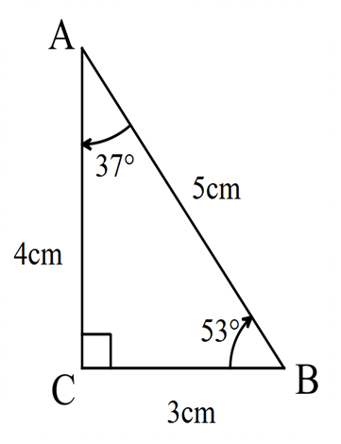

Method 1
$$A=\frac{1}{2}bh \\ A=\frac{1}{2}×4×3 \\ A=6cm^{2}$$

Method 2
$$A=\frac{1}{2}ab\sin{C} \\ A=\frac{1}{2}×3×4×\sin{90} \\ A=6cm^{2}$$
Or
$$A=\frac{1}{2}×3×5×\sin{53} \\ A≈6{cm}^{2}$$
Note: $53°$ has been rounded in the diagram

Method 3 Heron’s Rule
$s=\frac{a+b+c}{2}and A=\sqrt{s\left(s-a\right)\left(s-b\right)\left(s-c\right)}$ $$∴s=\frac{3+4+5}{2} \\ s=6 \\ A=\sqrt{6\left(6-3\right)\left(6-4\right)\left(6-5\right)} \\ A=\sqrt{36} \\ A={6cm}^{2}$$

