Simultaneous equations
A company makes and sells fidget spinners. They are sold on eBay for $8 each.

Step 1 – income
Using a spreadsheet or desmos, make a table of values showing the Income (I) for different quantities sold (n). For example, 0, 10, 20, 30… 110

Step 2 – costs
The fixed overhead expenses are $515 and it costs the manufacturer $2.50 for each fidget spinner made.
Using a spreadsheet or desmos, make a table of values for the number sold (n = 0, 10, 20, 30… 110) against the cost to produce this number of fidget spinners.
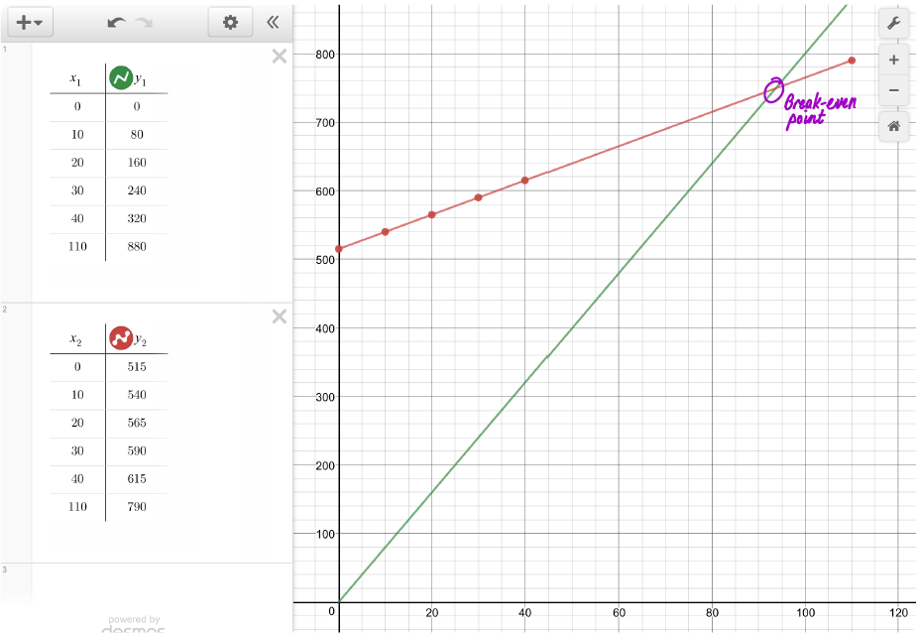

Step 3 – questions to consider
- What is the break-even point?
Answer: From the graph $(93.6, 749)$
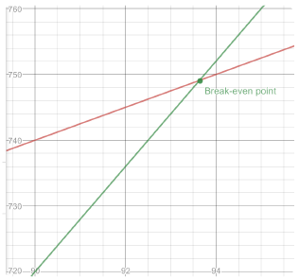
- What does this mean in terms of the number of fidget spinners and the cost/income?
Answer: 94 fidget spinners would need to be sold for the income to be greater than the costs.
- What is the slope of the income line?
Answer: 8
- What is the Income equation ($I$) if $n$ is the number of fidget spinners sold?
Answer: $I=8n$
- What is the slope of the cost line?
Answer: 2.5
- What is the Cost equation ($C$) if $n$ is the number of fidget spinners sold (remember to add in the fixed costs)?
Answer: $C=515+2.5n$
- If the fixed costs of $515 were reduced, with everything else remaining equal, describe how the break-even point would change (in relation to the graph)?
Answer: The break-even point would move towards the origin.

