Year 12 Mathematics Standard 2

Assessment task
MS-A4 Types of relationships and MS-S4 Bivariate data analysis

Driving question
How well can mathematics be used to model internet sensations?

Outcomes
- MS2-12-1 uses detailed algebraic and graphical techniques to critically evaluate and construct arguments in a range of familiar and unfamiliar contexts
- MS2-12-2 analyses representations of data in order to make inferences, predictions and draw conclusions
- MS2-12-6 solves problems by representing the relationships between changing quantities in algebraic and graphical forms
- MS2-12-9 chooses and uses appropriate technology effectively in a range of contexts, and applies critical thinking to recognise appropriate times and methods for such use
- MS2-12-10 uses mathematical argument and reasoning to evaluate conclusions, communicating a position clearly to others and justifying a response
All outcomes referred to in this unit come from Mathematics Standard Sage 6 Syllabus © NSW Education Standards Authority (NESA) for and on behalf of the Crown in right of the State of New South Wales, 2017

Learning across the curriculum

General capabilities
- Critical and creative thinking
- Ethical understanding
- Information and communication technology capability
- Intercultural understanding
- Literacy
- Numeracy
- Personal and social capability

Other learning across the curriculum areas
- Civics and citizenship
- Difference and diversity
- Work and enterprise

Task

Part A: Infectious disease simulation I
The following is a simple simulation of the growth of an infectious disease designed to be run with a class or many classes combined.
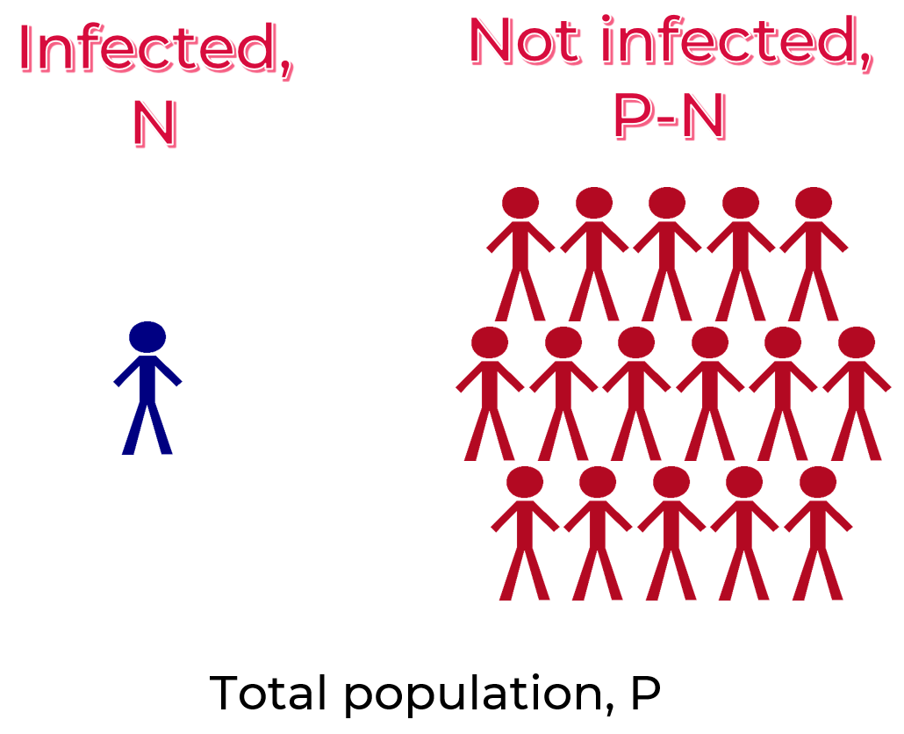
Firstly, an infected person, generation zero, is chosen. Everybody else is uninfected. The infected person is given a die to roll. Each roll of the die represents a generation in the lifetime of the infectious disease. If they roll a six, then they can infect an uninfected person so the total number of infected people becomes two. If they do not roll a six, they do not infect anyone.
For generation one, each infected person rolls a die. If they roll a six, they infect an uninfected person. If they do not roll a six, they do not infect anyone.
This continues for all generations until the population is infected.
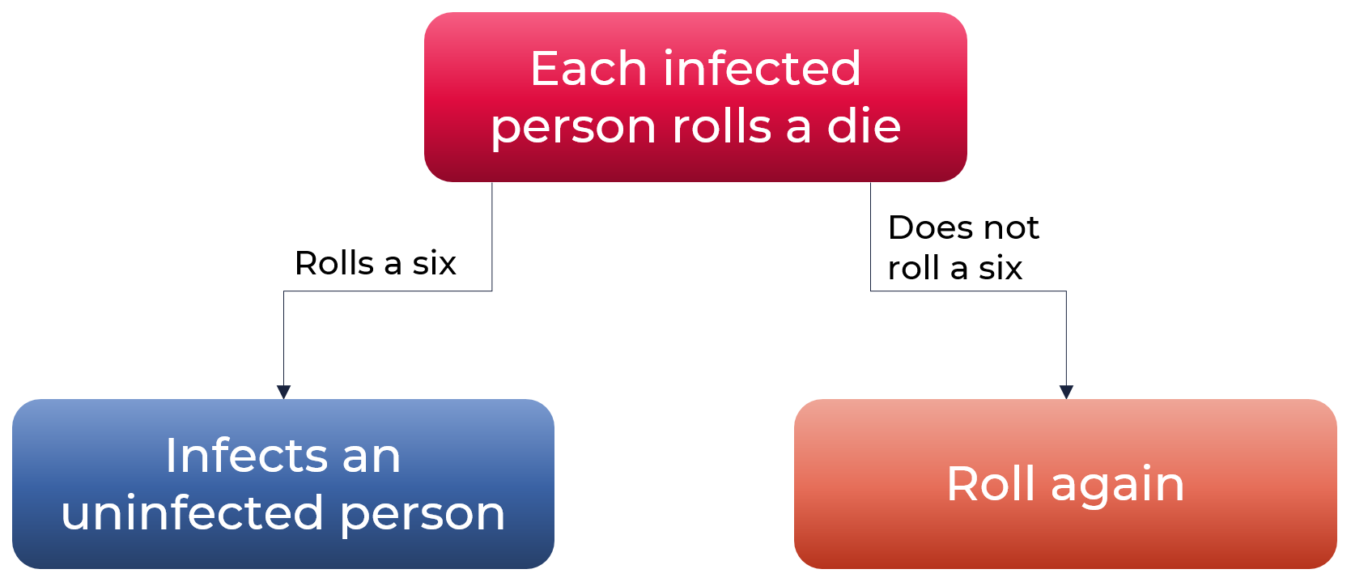
During the simulation, you need to complete the information in the table below. The New Infections, R, is the number of new infections for each generation represented by the number of sixes rolled.
Generation, t | Number infected, N | New infections, R
0 | 1
1
2
3
In this section, you are to investigate the effect of the number of infected people, N, on the new infection cases, R.
- Informally describe how the number of new infections, R, changes as the number of infected people, N, increases. As part of your description, consider how many new infections are generated when the number of infected people is zero.
- Using technology, or otherwise, generate a scatterplot of the new infections, R, against the number infected, N.
- Add a line of best fit to the scatterplot and use it to determine a linear model linking R to N. Use your understanding of the situation to develop a model that represents the situation best and comment on the decisions made.
- Consider your whole school is infected, how many new infections would this generate, using your model?
- How many infected people would generate 100 new infections, using your model?
- In your own words, describe the linear model linking R to N making reference to its context.
In this section, you are to investigate how the infected population grows with each generation.
- Informally describe how the number of infections, N, changes as the generations, t, increase.
- Use technology to generate a scatterplot of the number of infected people, N, against the generation, t.
- Use technology to determine an exponential model of the form $N=Ae^{kt}$, where $A$ and $k$ are constants, by using sliders to determine $A$ and $k$; or by developing a regression exponential model.
- Use the model to determine how many generations would be needed to infect the whole of your school, including students and staff.
- From the exponential model, describe what $A$ represents in this context.
- The exponential model generated describes, very simply, the growth of an infectious disease; however, it is not very realistic. Identify and describe any aspects of the simulation that are unrealistic, and why?

Part B: Infectious disease simulation 2
As a class, or individually, run the lesson described on the Creative Learning Exchange website, Lesson 5: The infection game. Run the simulation until the population is infected. At the end of the simulation, collate the results to complete the table below.
Generation, t | Number infected (zeroes), N | New infections (zeroes), R
0 (start) | 1
1
2
3
In this section, you are to investigate the effect of the number of infected people, N, on the new infection cases, R, for this simulation.
- Informally describe how the number of new infections, R, changes as the number of infected people, N, increases. As part of your description, consider how many new infections are generated when the number of infected people is zero.
- Using technology, or otherwise, generate a scatterplot of the new infections, R, against the number infected, N. Describe the shape of the scatterplot.
- Use technology, or otherwise, to determine the most suitable model to fit the scatterplot (in the context of the simulation).
- Use the model to determine the number of infected people, N, when the number of new infections, R, is greatest.
- What are the limitations of this model?
- Using technology, generate a new scatterplot of the number of infected people, N, against the generations, t. Describe the scatterplot, making reference to stages at the start, middle and end.

Part C: Modelling internet sensations
Parts A and B have been designed to provide students with some of the skills needed to model internet sensations. The mathematics used for analysing and predicting the lifetime of infectious diseases can be applied to internet sensations and is acknowledged in the phrase “going viral”.
For this part of the task, students need to determine an internet sensation of their choice, use Google Trends to determine the number of hits per day, modify the data and use mathematical modelling techniques to describe the number of infected people, N, over the lifetime, t, of the internet sensation.

For information on accessing data and modifying it for the purposes of this task, use the resource modifying-data-from-google-trends.DOCX.

Part D: How well can mathematics be used to model internet sensations?
Using and making reference to your responses to Parts A to C, answer the driving question “How well can mathematics be used to model internet sensations?”. In your own words, explain your reasons with examples from Parts A to C to support your position.

What to submit
- Evidence of an authentic assignment. This may take the form of screenshots of the applications used and models generated with annotations.
- All data collected and generated from the simulation presented using appropriate tables.
- All formula, working and calculations required, either written by hand or typed. If screenshots have been provided, the formulas used need to be clearly annotated.
- All reasoning and justification, either written by hand or typed.

Success criteria
Fluency, understanding and communication | Problem solving, reasoning and justification

Criteria | Working towards developing | Developing | Developed | Well developed | Highly developed
Part A  Questions 1 to 6  MS2-12-1,  MS2-12-2,  MS2-12-6,  MS2-12-7,  MS2-12-9,  MS2-12-10 | Generates a scatterplot of R against N. | Describes how R changes with N.  Comments on the number of new infections, R, when the number infected, N, is zero. | Develops a linear model linking R and N.  Applies the linear model to find solutions to problems. | Describes how the linear model has been adjusted to fit the context of the scenario.  Describes the linear model in the context of the scenario.
Part A  Questions 7 to 12  MS2-12-1,  MS2-12-2,  MS2-12-6,  MS2-12-7,  MS2-12-9,  MS2-12-10 | Generates a scatterplot of N against t. | Describes how N changes with t.  Describes the value of A, from the model, in the context of the question. | Develops an exponential model.  Applies the exponential model to find the number of generations to infect the school. | Describes unrealistic aspects of the simulation.
Part B  Questions 1 to 5  MS2-12-1,  MS2-12-2,  MS2-12-6,  MS2-12-7,  MS2-12-9,  MS2-12-10 | Generates a scatterplot of R against N. | Describes how R changes with N.  Attempts to develop a suitable model. | Develops a suitable model.  Applies the model to determine the greatest value of R. | Develops a suitable model that considers the context of the question.  Describes the limitations of the model.
Part B  Question 6  MS2-12-1,  MS2-12-2,  MS2-12-6,  MS2-12-7,  MS2-12-9,  MS2-12-10 | Generates a scatterplot of N against t. | Describes the scatterplot with reference to the start, middle and end stages.
Part C  MS2-12-1,  MS2-12-2,  MS2-12-6,  MS2-12-7,  MS2-12-9,  MS2-12-10 | Identifies an internet sensation and locates data for its lifetime. | Downloads and modifies the data for the purpose of analysis. | Develops an appropriate mathematical model of N against t for a stage of its lifetime. | Develops mathematical models of N against t that describe the various stages of its lifetime.
Part D |  |  |  | Generates part of a coherent argument when justifying a position when answering the driving question “How well can mathematics be used to model internet sensations?” | Generates a coherent and comprehensive argument to justify a position when answering the driving question “How well can mathematics be used to model internet sensations?”

Notes
- Any non-attempt in a section will be deemed zero. Marks can only be attributed to attempted responses.
- Corresponding question numbers are shown in brackets.

Note to staff
The success criteria above has been designed for students and staff alike to use. Students should be presented the rubric as part of the assessment task package. Students and staff follow the process of the task downwards through the rubric and the depth of responses, for each element, across the rubric. Students should be encouraged to use the rubric to self-assess their progress as an assessment-as-learning strategy.
The aim of the assessment task is to develop students’ deep content knowledge. This is reflected in the descriptors, working towards developing through to highly developed. The level of skill and understanding required in each part of the task is different; some parts require highly developed or well-developed skills, other parts only capture a developing skill set.
None of the working mathematically elements are distinct and when demonstrating one element, you are invariably demonstrating another. As an example, communication runs concurrently through all the other working mathematically elements. Students cannot respond to this assessment without communicating in some form. However, it is envisaged that there is a general progression through the working mathematically elements, starting with fluency and leading to understanding, problem solving, reasoning and justification, with increasingly higher levels of communication accompanying each element. Careful consideration has been given to the position of the success criteria statements so they reflect the working mathematically elements demonstrated.
This assessment task has been designed to illuminate the style of questions and the types of responses needed to elicit deep content knowledge, however, staff are encouraged to use and adapt the assessment task and the success criteria to their school context. Staff may like to enhance or amend sections of the task. Staff may like to adapt the rubric to assign marks to the descriptors in order to differentiate between responses that address the same statement. All changes are the responsibility of the staff using the assessment.

