Simultaneous equations
A company makes and sells fidget spinners. They are sold on eBay for $8 each.

Step 1 – income
Using a spreadsheet or Desmos, make a table of values showing the Income (I) for different quantities sold (n). For example, 0, 10, 20, 30… 110

Spreadsheet
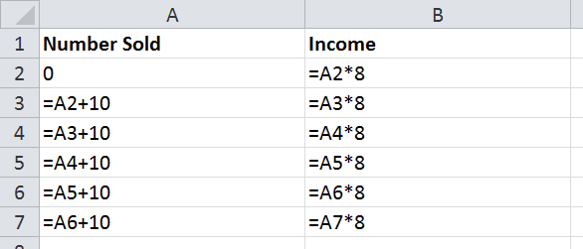

Desmos

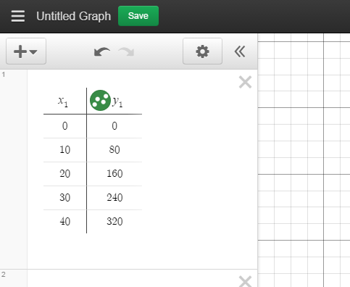

Create a graph with a spreadsheet or Desmos to show this information.

Step 2 – costs
The fixed overhead expenses are $515 and it costs the manufacturer $2.50 for each fidget spinner made.
Using a spreadsheet or Desmos, make a table of values for the number sold (n = 0, 10, 20, 30… 110) against the cost to produce this number of fidget spinners.

Spreadsheet
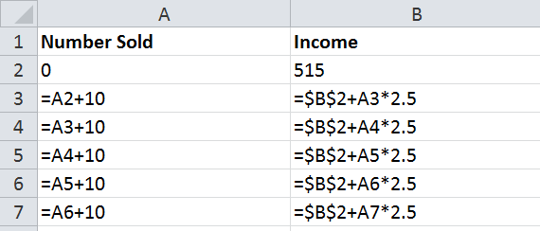

Desmos
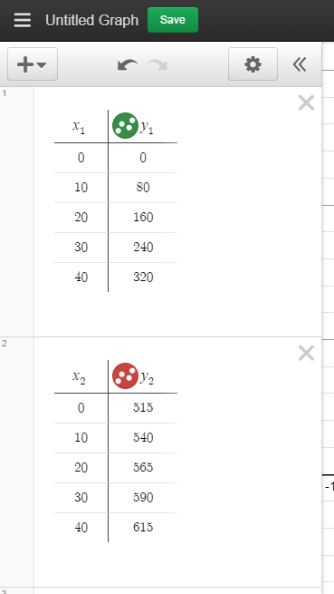
Create a graph with your spreadsheet or Desmos to show this information.

Step 3 – questions to consider
- What is the break-even point?
- What does this mean in terms of the number of fidget spinners and the cost/income?
- What is the slope of the income line?
- What is the Income equation (I) if n is the number of fidget spinners sold?
- What is the slope of the cost line?
- What is the Cost equation (C) if n is the number of fidget spinners sold (remember to add in the fixed costs)?
- If the fixed costs of $515 were reduced, with everything else remaining equal, describe how the break-even point would change (in relation to the graph)?

