 All mixed up

Draw a line between each graph and the equation that best describes them. Each line should pass through a letter and a number. Use these to break the code.

Q: What do you call a cricketer who is an eels supporter?

A:

|  | N/A |  |  |  |  | N/A |  |  |  | L |  |  |
| --- | --- | --- | --- | --- | --- | --- | --- | --- | --- | --- | --- | --- |
| 1 | N/A | 2 | 1 | 3 | 1 | N/A | 4 | 5 | 6 | N/A | 7 | 3 |

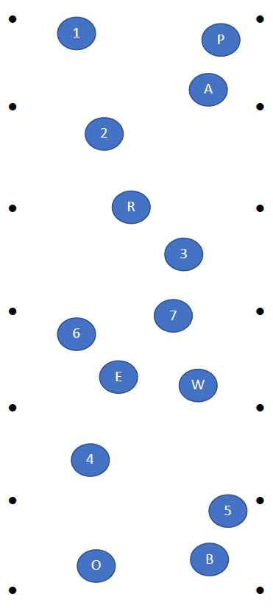Graph

Graph

Graph

Graph

Graph

Graph

Graph