NESA exemplar question solutions

A4.2 Non-linear equations
Solutions for questions from the NESA topic guidance related to types of relationships.
- An exponential expression such as $M=1.5{(1.2)}^{x}$ can be used to calculate the mass $M$ kg of a baby orangutan at age $x$ months. This model applies for a limited time, up to $x=6$. Calculate the mass of a baby orangutan at the age of three months.

Solution: When $x=3$
$$M=1.5{(1.2)}^{3} \\ =2.592$$$=2.6 kg$ (correct to 1 decimal place)

$∴$ The mass of a baby orangutan at the age of three months is 2.6 kg (correct to 1 decimal place).

- Sketch at least 10 rectangles that have the same perimeter. Record length versus area in a table. Sketch the resulting function and use the graph to determine the rectangle with maximum area. Describe this rectangle.
Solution:
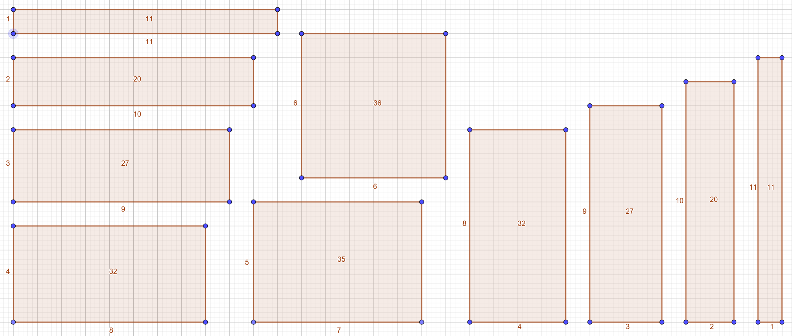
Length | 11 | 10 | 9 | 8 | 7 | 6 | 5 | 4 | 3 | 2
Area | 11 | 20 | 27 | 32 | 35 | 36 | 35 | 32 | 27 | 20

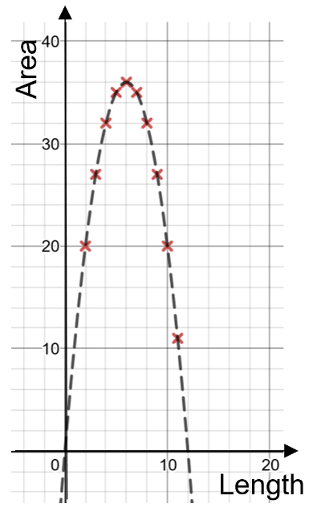
The resulting function forms a parabola. The maximum turning point represents the side length which will result in a rectangle with the maximum area. This rectangle will actually be a square. In this example the rectangle with the maximum area is a square with side lengths equal to $6$cm.
On the Earth, the equation $d=4.9t^{2}$ can be used to express the distance ($d$ metres) that an object falls in $t$ seconds, if air resistance is ignored. Investigate the equations for the moon and for other planets: for example, on the moon the equation is $d=0.8t^{2}$.
Create a table of values for the function $d=4.9t^{2}$ either manually or by using a spreadsheet, and use the table to answer questions such as: How long does it take for an object to fall 300 m?
Solution:
Time ($t$ seconds) | 2 | 4 | 6 | 8 | 10 | 12
Distance ($d$ metres) | 19.6 | 78.4 | 176.4 | 313.6 | 490 | 705.6

Using the table, it would take between $6$ and $8$ seconds for an object to drop 300 m on Earth.
Using substitution:
When $d=300$
$$300=4.9t^{2}$$
$$\frac{300}{4.9}=t^{2}$$
$$t=\sqrt{\frac{300}{4.9}}$$
$$t=7.824607964$$
$t=8$ seconds (correct to the nearest second)

- Inverse variation can be used to find how much each person contributes when a cost is shared. For example, a household has $306 in bills. Create a table and draw a graph to show how much each person pays if there are 2, 3, 4 or 5 people contributing equally to pay bills.

Solution: $c=\frac{306}{n}$

Number of people ($n$) | 2 | 3 | 4 | 5
Each person’s contribution ($c$) | $153 | $102 | $76.50 | $61.20

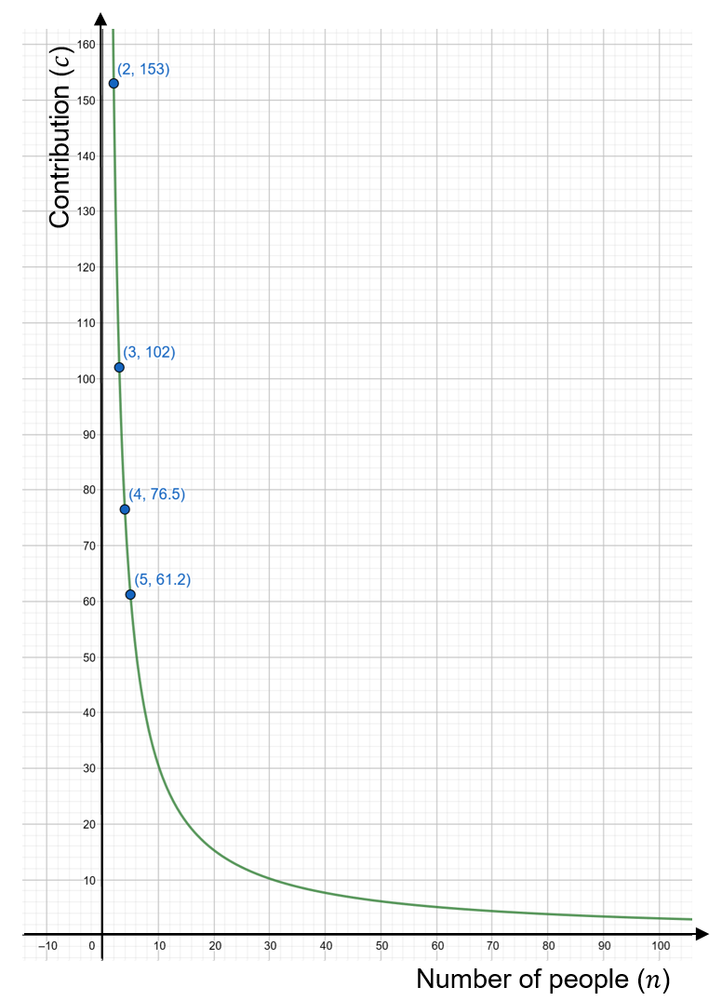

- Anjali is investigating stopping distances for a car travelling at different speeds. To model this she uses the equation $d=0.01s^{2}+0.7s$, where $d$ is the stopping distance in metres and $s$ is the car’s speed in km/h. The graph of this equation is drawn below.
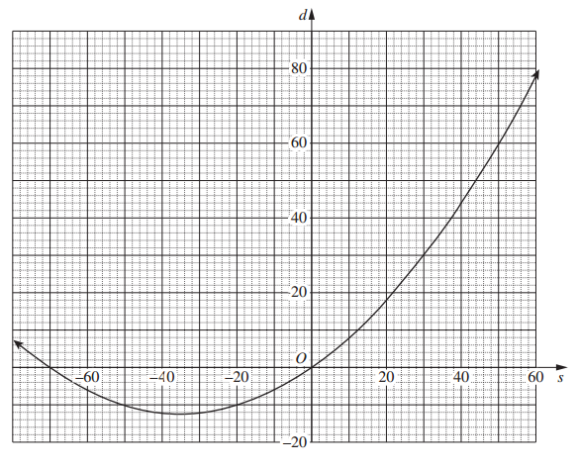
- Anjali knows that only part of the curve applies to her model for stopping distance. In your writing booklet, using a set of axes sketch the part of this curve that applies for stopping distances.

Solution: The only part of the curve that applies is $s≥0$ as it is impossible to have negative time or distance.

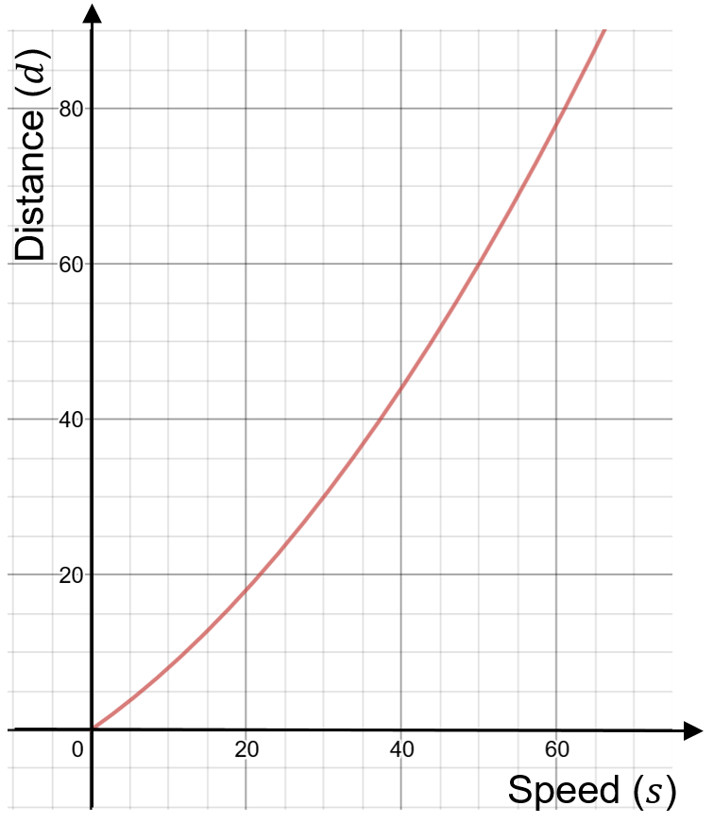

- What is the difference between the stopping distances in a school zone when travelling at a speed of $40$ km/h and when travelling at a speed of $70$ km/h?

Solution: When $s=40$
$$d=0.01{(40)}^{2}+0.7(40)$$
$$d=44 m$$

When $s=70$
$$d=0.01{(70)}^{2}+0.7(70)$$
$$d=98 m$$

Difference $=98-44$
Difference $=54 m$

$∴$ The difference between the stopping distances in a school zone when travelling at a speed of $40$ km/h and when travelling at a speed of $70$ km/h is $54$ metres.

- In 2010, the city of Thagoras modelled the predicted population of the city using the equation $P=A{(1.04)}^{n}$. That year, the city introduced a policy to slow its population growth. The new predicted population was modelled using the equations $P=A{(b)}^{n}.$ In both equations, $P$ is the predicted population and $n$ is the number of years after 2010. The graph shows the two predicted populations.
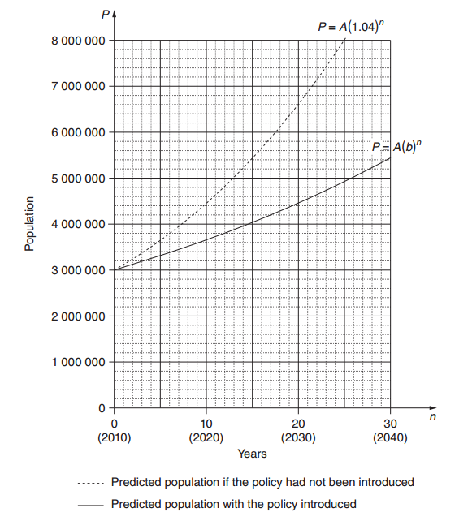

- Use the graph to find the predicted population of Thagoras in 2030 if the population policy had NOT been introduced.

Solution: from the graph the predicted population in 2030 is $6 600 000$ people.

- In each of the two equations given, the value of $A$ is $3 000 000$. What does $A$ represent?

Solution: $A$ represents the initial population in 2010 before the policy was introduced.

- The guess-and-check method is to be used to find the value of $b$, in $P=A{(b)}^{n}.$

- Explain, with or without calculations, why $1.05$ is not a suitable first estimate for $b$.

Solution: It is not suitable for the first estimate for $b$ to be $1.05$ as $1.05$ is greater than $1.04$ which represents a population increasing at a faster rate than the predicted population if the policy had not been introduced. The policy aimed to slow the population and thus the value for $b$ needs to be less than $1.04$ in order to do so.

- With $n=20$ and $P=4 460 000$, use the guess-and-check method and the equation $P=A{(b)}^{n}$ to estimate the value of $b$ to two decimal places. Show at least TWO estimate values for $b$, including calculations and conclusions.

Solution: When $n=20$ and $P=4 460 000$
$$4 460 000=3 000 000{(b)}^{20}$$
$$\frac{4 460 000}{3 000 000}=b^{20}$$
$$∴b^{20}=1.486666\dot{6}$$

Try: When $b=1.02$
$${(1.02)}^{20}=1.485947396$$

Try: When $b=1.03$
$${(1.03)}^{20}=1.806111235$$

Try: When $b=1.025$
$${(1.025)}^{20}=1.63861644$$

The value for $b$ is between $1.02$ and $1.025$.
$∴b=1.02$ (correct to two decimal places)

- The city of Thagoras was aiming to have a population under $7 000 000$ in 2050. Does the model indicate that the city will achieve this aim? Justify your answer with suitable calculations.

Solution: When $n=40$ and using $b=1.02$
$$P=3 000 000{(1.02)}^{40}$$
$$P=6624118.991$$

The model $P=3 000 000{(1.02)}^{n}$ indicates that the population will reach approximately $6 624 118$ people. This is under the required $7 000 000$ and thus achieves this aim.

