Group activity – graphs resource

Graph 1
You have 2 minutes to discuss within your group and write down one feature you observe from the two linear graphs below.
$y=x$ (red) and $y=2x$ (blue)
If another group has already written down an observation, read it and write something different.
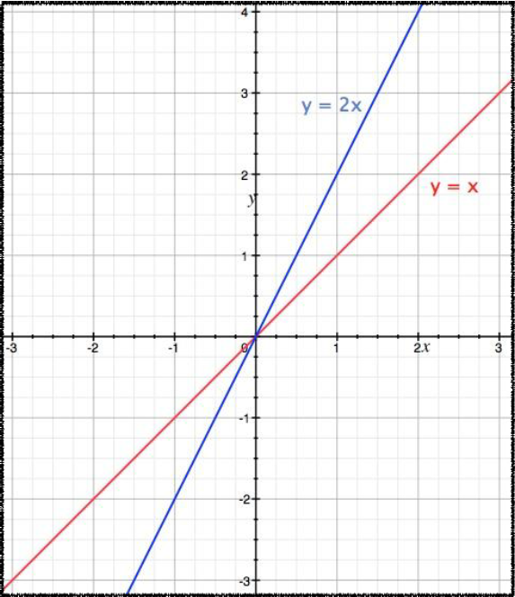

Graph 2
You have 2 minutes to discuss within your group and write down one feature you observe from the two linear graphs below.
$y=x$ (red) and $y=-x$ (blue)
If another group has already written down an observation, read it and write something different.
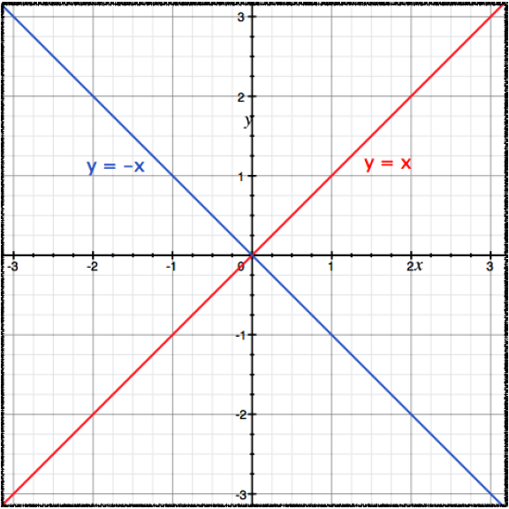

Graph 3
You have 2 minutes to discuss within your group and write down one feature you observe from the two linear graphs below.
$y=x+1$ (red) and $y=2x+3$ (blue)
If another group has already written down an observation, read it and write something different.
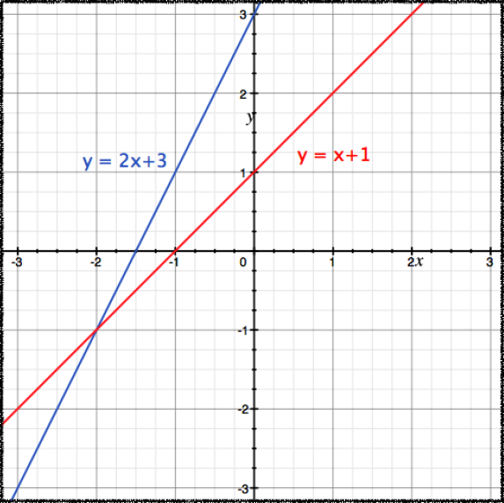

Graph 4
You have 2 minutes to discuss within your group and write down one feature you observe from the two linear graphs below.
$y=3x-6$ (red) and $y=x-3$ (blue)
If another group has already written down an observation, read it and write something different.
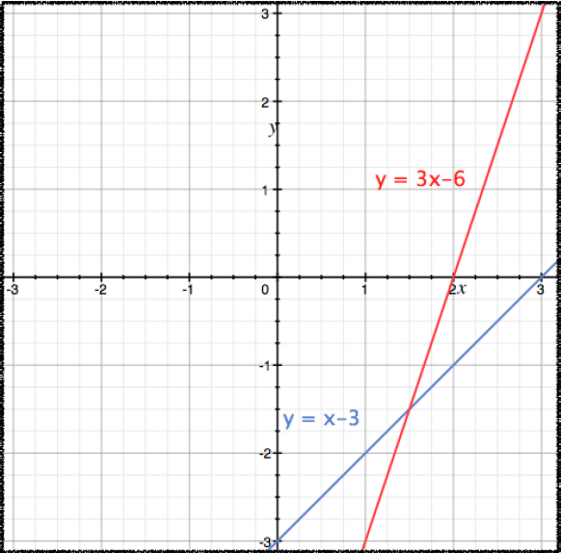

Graph 5
You have 2 minutes to discuss within your group and write down one feature you observe from the two linear graphs below.
$2x-y=0$ (red) and $x+y=3$ (blue)
If another group has already written down an observation, read it and write something different.
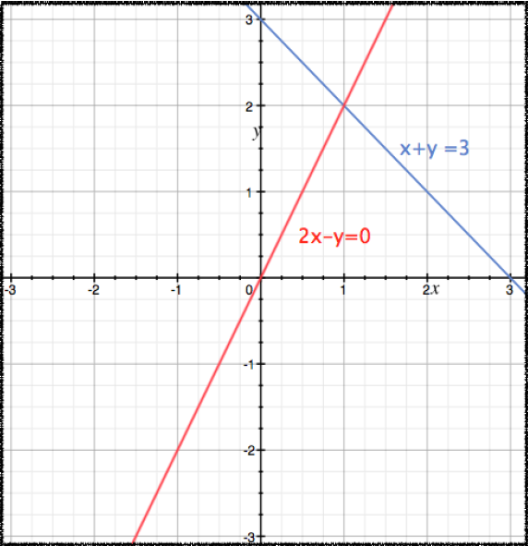

Graph 6
You have 2 minutes to discuss within your group and write down one feature you observe from the two linear graphs below.
$y=x+2$ (red) and $y=x-1$ (blue)
If another group has already written down an observation, read it and write something different.
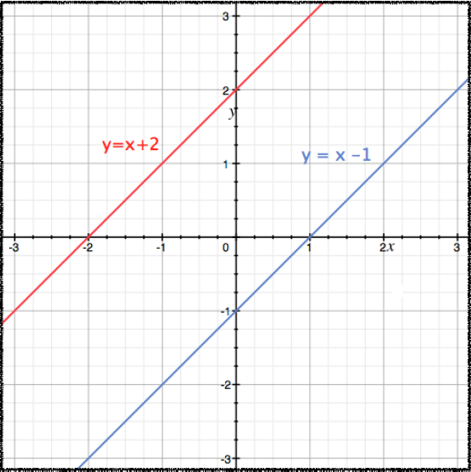

Graph 7
You have 2 minutes to discuss within your group and write down one feature you observe from the two linear graphs below.
$2x+y+1=0$ (red) and $4x+2y+2=0$ (blue)
If another group has already written down an observation, read it and write something different.
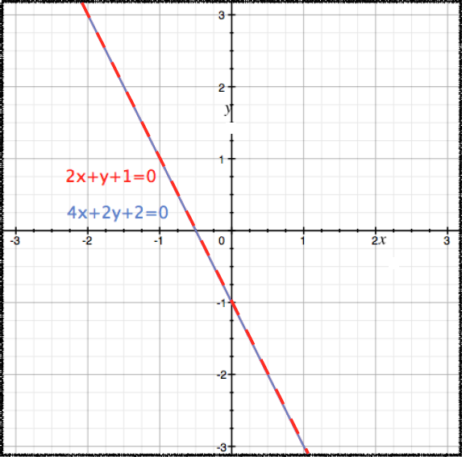

Graph 8
You have 2 minutes to discuss within your group and write down one feature you observe from the two linear graphs below.
$x+y=2$ (red) and $y=2x+-2$ (blue)
If another group has already written down an observation, read it and write something different.
