Tetrahedron proof
$ABCD$ is a regular tetrahedron. $M$ is the midpoint of $CD$. Find the size of $∠AMB$.
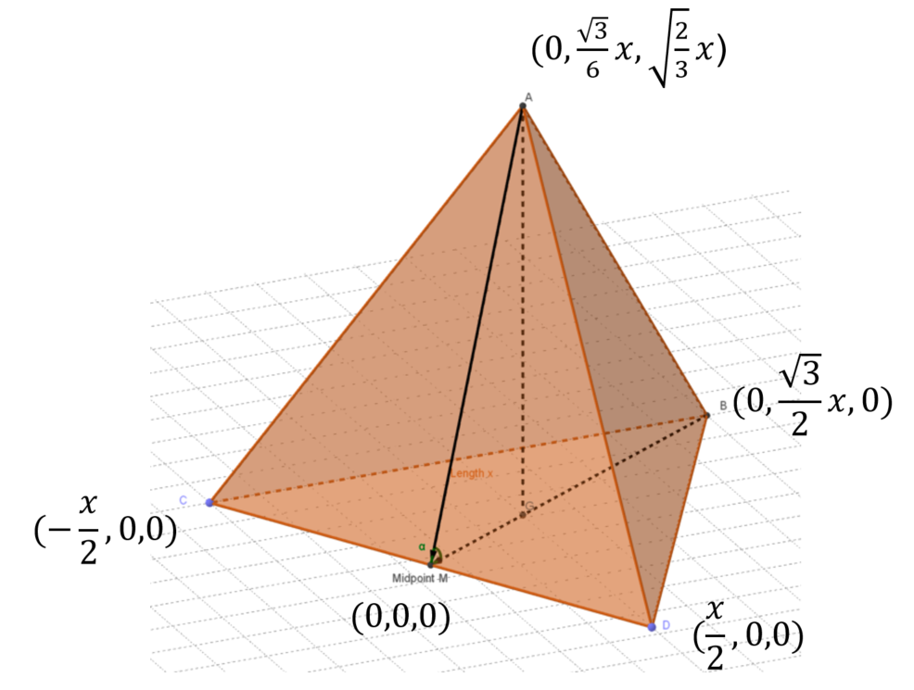
www.geogebra.org/m/j5ycxbuk

Let M be the origin $\left(0,0,0\right)$.
Point $G$ is the centroid of the triangle $ABC$,
$$∴MG=\frac{\vec{MA}+\vec{MB}+\vec{MC}}{3}=\left(\begin{matrix}0 \\ \frac{\sqrt{3}}{6}x \\ 0\end{matrix}\right)$$
$\overset{→}{BM}=\left(\begin{matrix}0 \\ -\frac{\sqrt{3}}{2}x \\ 0\end{matrix}\right)$ and $|\overset{→}{BM}|=\frac{√3}{2}x$
$$\overset{→}{AM}=\left(\begin{matrix}0 \\ -\frac{\sqrt{3}}{6}x \\ -\sqrt{\frac{2}{3}}x\end{matrix}\right)$$
$$|\overset{→}{AM}|=\sqrt{{\left(0\right)}^{2}+{\left(-\frac{√3}{6}x\right)}^{2}+{\left(-\sqrt{\frac{2}{3}}x\right)}^{2}}$$
$$=\frac{√3}{2}x$$
$$\cos{θ}=\frac{\overset{→}{BM}.\overset{→}{AM}}{|\overset{→}{BM}||\overset{→}{AM}|}$$
$$\cos{θ}=\frac{\left(\begin{matrix}0 \\ -\frac{\sqrt{3}}{2}x \\ 0\end{matrix}\right).\left(\begin{matrix}0 \\ -\frac{\sqrt{3}}{6}x \\ -\sqrt{\frac{2}{3}}x\end{matrix}\right)}{\frac{√3}{2}x×\frac{√3}{2}x}$$
$$=\frac{0+\frac{3}{12}x^{2}+0}{\frac{3}{4}x^{2}}$$
$$∴cos{θ}=\frac{1}{3}$$
$$θ=70.5$$

