Year 12 Mathematics Extension 2
MEX-V1 Further work with vectors | Unit duration
The topic Vectors involves mathematical representation of a quantity with magnitude and direction and its geometrical depiction. This topic provides a modern language and approach to explore and explain an array of object behaviours in a variety of contexts from theoretical or real-life scenarios.  A knowledge of vectors enables the understanding of objects in two and three dimensions and ways in which this behaviour can be expressed, including the consideration of position, location and movement. Vectors are easy to generalise to multiple topics and fields of study, including engineering, structural analysis and navigation. | 8 weeks

Subtopic focus | Outcomes
The principal focus of this subtopic is to extend the concept of vectors to three dimensions, as well as develop the understanding of vectors to include representations of lines. Vectors are used to represent quantities with magnitude and direction and this representation allows for exploration of situations such as geometrical proofs.  Students develop an understanding of vector notations and how to manipulate vectors to allow geometrical situations to be explored further. | A student:  - uses vectors to model and solve problems in two and three dimensions MEX12-3  - applies various mathematical techniques and concepts to model and solve structured, unstructured and multi-step problems MEX12-7  - communicates and justifies abstract ideas and relationships using appropriate language, notation and logical argument MEX12-8

Prerequisite knowledge | Assessment strategies
The material in this topic builds on content from the Year 12 Mathematics Extension 1 topic of ME-V1 Introduction to Vectors. | - Summative Assessment: “How well can 3D motion be modelled?” investigation style assessment task in which students apply vector and parametric representations to describe paths of motion in 3D and use them to analyse the situation.
All outcomes referred to in this unit come from Mathematics Extension 2 Syllabus
© NSW Education Standards Authority (NESA) for and on behalf of the Crown in right of the State of New South Wales, 2017

Glossary of terms
Term | Description
Coincident | If two vectors are coincidental, then their directions are the same, although their magnitudes may be different
Column vector notation | A vector in two or three dimensions can be represented in column vector notation. For example $\underset{\sim }{v}=4\underset{\sim }{i}+5\underset{\sim }{j}+6\underset{\sim }{k}$ can be represented as the ordered triple $\underset{\sim }{v}=\left(4,5,6\right)$ and in column vector notation as $\underset{\sim }{v}=\left(\begin{matrix}4 \\ 5 \\ 6\end{matrix}\right)$.
Component form of a vector | The component form of a vector describes the projections of a vector in the $x$, $y$ and $z$-directions. It can be expressed as an ordered triple (in 3 dimensions) or by a linear combination of unit vectors $\underset{\sim }{i}$, $\underset{\sim }{j}$ and $\underset{\sim }{k}$.
Displacement vector | A displacement vector describes the displacement from one point to another. It is also called a relative vector.
Ordered triples | Ordered triples is an extension of the ordered paired notation for denoting a coordinate on a 2D Cartesian plane. It is used to denote the position of a point in 3D space. For example the ordered triple $(1, 4, 5)$ denotes a point where the $x$-ordinate is $1$, the $y$-ordinate is $4$ and the $z$-ordinate is $5$.
Orthogonal | Orthogonal means perpendicular or at right angles.
Orthographic projection | Orthographical projection is a method of viewing a 3D object in 2 dimensions by projecting the object onto a plane perpendicular to the line of sight.
Parallelepiped | In geometry, a parallelepiped is a three-dimensional figure formed by six parallelograms.
Position vector | The position vector of a point $P$ in the plane is the vector joining the origin to $P$.
Scalar | A scalar is a quantity with magnitude but no direction.

Lesson sequence | Content  Students learn to: | Suggested teaching strategies and resources | Date and initial | Comments, feedback, additional resources used
Introduction to vectors in 3D  (1 or 2 lessons) | V1.1: Introduction to three-dimensional vectors  - understand and use a variety of notations and representations for vectors in three dimensions  - define the standard unit vectors $\underset{\sim }{i}$, $\underset{\sim }{j}$ and $\underset{\sim }{k}$  - express and use a vector in three dimensions in a variety of forms, including component form, ordered triples and column vector notation | In two dimensions we use the Cartesian Plane. How do we locate points in three dimensions?  - Recall 2 dimensional vectors in the plane as defined by a distance in the $x$ direction and a distance in the $y$ direction. Adding a third axis $z$ perpendicular to the $XY$ plane, allows a vector to be defined in 3 dimensions. Teacher describes the conventional labelling of axes in a right handed system.  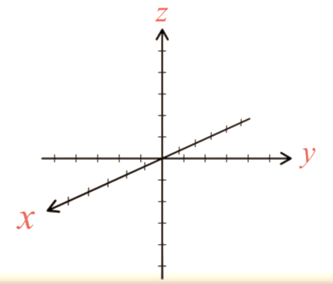  - Students watch Plotting points and vectors in 3D with Geogebra (duration 7:06) then practise plotting points in Geogebra in 3D Graphics mode, using coordinate triples. Students save file. As an enrichment activity, students could create a three dimensional model of the solar system, similar to this Geogebra resource by entering heliocentric Cartesian coordinates from the Solar system calculator website.  - Key question: Where are the points $(0, y, z)$, $(x, 0, z)$ and $(x,y, 0)$ located?  - A parallelepiped can be used to demonstrate three dimensional vectors.  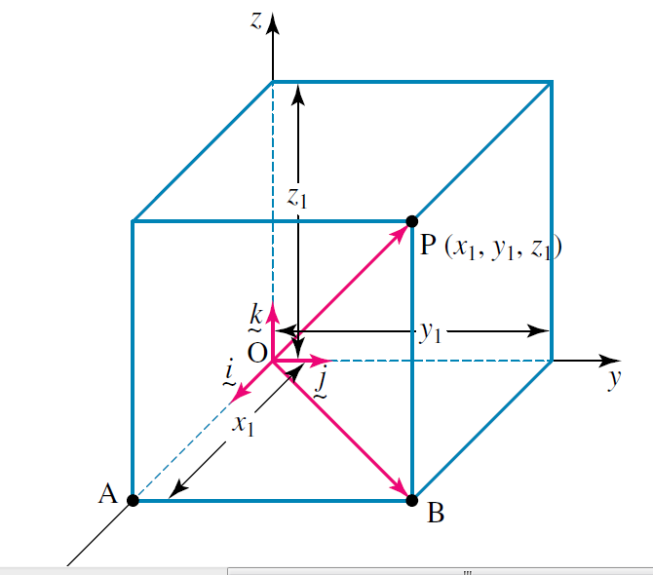  - Students use their saved file and coordinates from previous Geogebra activity to draw (position) vectors from the origin to each point.  - Distinguish between cartesian coordinates and a vector. Cartesian coordinates describe a single point. A vector $\underset{\sim }{a}$ describes an infinite number of lines in space parallel to $\underset{\sim }{a}$.  How many vectors are the same as vector $\underset{\sim }{a}$?  - Students identify same vectors in a three dimensional cuboid, for example identify three vectors equal to $\underset{\sim }{a}$.  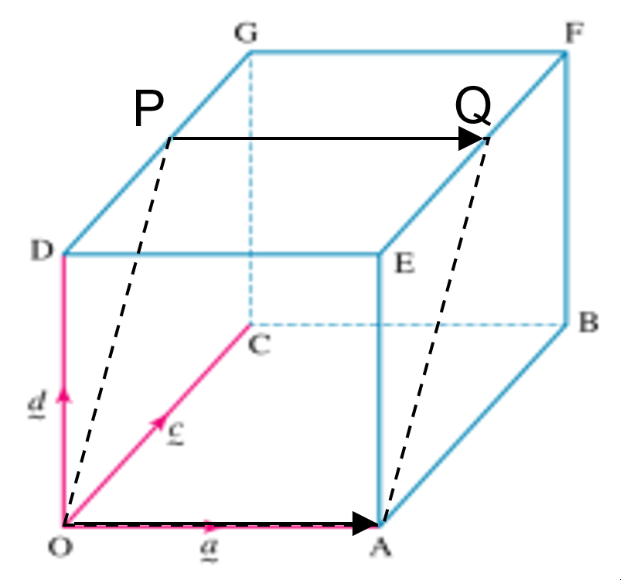  - Students could confirm be sketching that if the vectors $\vec{OA}$ and $\vec{PQ}$ are equal but not coincident, then they must lie in the same plane.  Unit vectors in 3 dimensions  In two dimensions we use scalar multiples of the unit vectors $\underset{\sim }{i}$ and $\underset{\sim }{j}$ to express vectors in their component form. How do we express vectors in three dimensions?  - Students watch Visualising unit vectors (duration 3:46)  - Students can refer back to their previous Geogebra activity to express those vectors in component form  - Students extend their knowledge of vectors in two dimensions into three dimensions. This could be done as a class group, brainstorming or mind-mapping on the board or it could be done as a pairs or small group activity where students complete a table of comparisons using the comparing-vectors-in-2-and-3D worksheet. Students should keep the table to add the various vector operations as they are encountered. This can act as a topic summary.  Resource: comparing-vectors-in-2-and-3D.DOCX  - Students need to:  - convert vectors between component, ordered triples and column vector forms  - Represent vector quantities by directed line segments, and use appropriate symbols for vectors  - Express a point $A$ as the position vector $\vec{OA}$ from the origin  - Use $\underset{\sim }{a}$ and $\vec{OA}$ notation for a vector
Vector Arithmetic in 3D  (1 lesson) | - perform addition and subtraction of three-dimensional vectors and multiplication of three-dimensional vectors by a scalar algebraically and geometrically, and interpret these operations in geometric terms | Vector arithmetic in 3D  - Students add vector addition, subtraction and multiplication by a scalar in two dimensions to their comparison table, geometrically and algebraically. Students brainstorm what these would look like in three dimensions. These could then be demonstrated in Geogebra or by watching the basic vector operations in this Basic vector operations in Geogebra (duration 8:30).  - Students can investigate three dimensional vector addition using the Geogebra 3D vector addition interactive  - Students prove vector results algebraically in three dimensions and establish the laws for commutativity and associativity  Commutative $\underset{\sim }{a}+\underset{\sim }{b}=\underset{\sim }{b}+\underset{\sim }{a}$  Associative $\left(\underset{\sim }{a}+\underset{\sim }{b}\right)+\underset{\sim }{c}=\underset{\sim }{a}+(\underset{\sim }{b}+\underset{\sim }{c})$  - Suggested activities:  - Add vectors end-to-end, and component-wise. Students should understand that the magnitude of a sum of two vectors is typically not the sum of the magnitudes.  - Understand vector subtraction $\underset{\sim }{v}-\underset{\sim }{w}$ as $\underset{\sim }{v}+(-\underset{\sim }{w)}$, where $\underset{\sim }{w}$ is the additive inverse of $-\underset{\sim }{w}$, with the same magnitude as w and pointing in the opposite direction.  - Guiding question: What does vector subtraction mean?  - Represent vector subtraction geometrically by connecting the tips in the appropriate order, and perform vector subtraction component-wise.  - Represent scalar multiplication graphically by scaling vectors and possibly reversing their direction; perform scalar multiplication component-wise, e.g., as $c\left(v_{x},v_{y}\right)=(cv_{x},cv_{y})$  - Compute the magnitude of a scalar multiple $c\underset{\sim }{v}$ using $\left|c\underset{\sim }{v}\right|=\left|c\right||\underset{\sim }{v}|$. Compute the direction of $c\underset{\sim }{v}$ knowing that when $c|\underset{\sim }{v}|≠0$, the direction of $c\underset{\sim }{v}$ is either along $\underset{\sim }{v}$ (for $c > 0$) or against $c\underset{\sim }{v}$ (for $c < 0$).  - The following resource provides solutions to the exemplar questions from the NESA’s topic guidance. This should be referenced throughout this unit.  - Resource: mex-v1-sample-questions.DOCX  - NESA key question: If $a$, $b$ and $c$ are the position vectors of $A$, $B$ and $C$ respectively, what is the geometric implication of the statement $a-b=k\left(c-b\right)$?  If $k≠0$ then $A$, $B$ and $C$ are collinear.  If $k=1$ then Point $A=$Point $C$.  If $0<k<1$ then $A$ lies on segment $BC$.  If $k>1$ then $C$ lies on segment $AB$.  If $k<0$ then $B$ lies on segment $AC$
Calculating the Magnitude of a Vector in 3D  (1 lesson) | V1.2: Further operations with three-dimensional vectors  - define, calculate and use the magnitude of a vector in three dimensions  - establish that the magnitude of a vector in three dimensions can be found using:  $$\left|x\underset{\sim }{i}+y\underset{\sim }{j}+z\underset{\sim }{k} \right|=\sqrt{x^{2}+y^{2}+z^{2}}$$  - convert a non-zero vector $\underset{\sim }{u}$ into a unit vector $\overset{^}{\underset{\sim }{u}}$ by dividing by its length:  $\overset{^}{\underset{\sim }{u}}=\frac{\underset{\sim }{u}}{\left|\underset{\sim }{u}\right|}$ | Calculating Magnitude of a Vector in 3D  - Students could watch the Length of a 3-Dimensional Vector video (duration 7:55) to develop the formula for magnitude in three dimensions using Pythagoras theorem  - Investigation: By plotting the point $(1,2,3)$ say in a parallelepiped as below, use three dimensional geometry to compute the length of the vector $\left(\begin{matrix}1 \\ 2 \\ 3\end{matrix}\right)$. Students should then generalise this result for the point $\left(x, y, z\right)$ and vector $\left(\begin{matrix}x \\ y \\ z\end{matrix}\right)$.  - Students should then use the formula to perform calculations in three dimensions using column, ordered triple and component form.  - Students can use the Calculating vector magnitude in Geogebra to enter the components of a vector and see the new value of the magnitude.  - Students could graph vectors in Geogebra and graphically compare their length with the algebraic calculation.  Calculating the Unit Vector  - Using the formula for $|x\underset{\sim }{i}+y\underset{\sim }{j}+z\underset{\sim }{k}|$ students can now extend the formula for a unit vector into three dimensions, by verifying that given a specific vector, say $\underset{\sim }{u}=\left(\begin{matrix}1 \\ 2 \\ 3\end{matrix}\right)$ then $\left|\frac{\underset{\sim }{u}}{\left|\underset{\sim }{u}\right|}\right|=1$ and generalising this to the vector $\left(\begin{matrix}x \\ y \\ z\end{matrix}\right)$. Lead students to determine the unit vector $\underset{\sim }{\overset{^}{u}}=\frac{\underset{\sim }{u}}{\left|\underset{\sim }{u}\right|}$.  - Students can verify this using the applet Multiplying a Vector in 3D by a Scalar  - Students should find unit vectors in three dimensions in component, column and ordered triple vectors.  - NESA sample questions  - Draw a diagram to illustrate the position vector $3\underset{\sim }{i}-\underset{\sim }{j}+2\underset{\sim }{k}$.  - If $u=(6, -2, 4)$ and $v=\left(-1, 3, 4\right)$ express the vectors $u+v$ and $v-\frac{1}{2}u$ as ordered triples find $\hat{u}$.  - Find all possible values of $c$ if $\left|\vec{AB}\right|=\sqrt{94}$ where $A(0, 3, c)$ and $B(-3,-1,-6)$.  - Use vector methods to locate the midpoint of the interval joining the points$\left(x_{1}, y_{1}, z_{1}\right)$ and $\left(x_{2}, y_{2}, z_{2}\right)$.  - Given that $a=\vec{AB}$ and $\frac{2}{3}a=\vec{AC}$, describe the geometric relationship between $A, B$ and $C$.  - Use vector methods to find the coordinates of the point that divides the interval joining $A(2,-3, 10)$ and $B(-3, 12, 0)$ in the ratio $2:3$.  - $In PQR, M$ is the midpoint of $PQ$ and $N$ is the midpoint of $PR$. Use vector methods to prove that $MN∥RQ$ and $MN=\frac{1}{2}RQ$.  - Classify the triangle formed by joining the points $A(-1, 3, 3)$, $B(2, 5, 4)$ and $C(0, 3, 2)$.  - The four points $A(-1, 3, 3)$, $B(2, 5, 4)$, $C(0, 3, 2)$ and $D(x, y, z)$ form a parallelogram. Find $x$, $y$ and $z$.
Applying the Scalar Product in 3D  (2 lessons) | - define and use the scalar (dot) product of two vectors in three dimensions AAM  - define and apply the scalar product $\underset{\sim }{u}⋅\underset{\sim }{v}$ to vectors expressed in component form, where  $\underset{\sim }{u}⋅\underset{\sim }{v}=x_{1}y_{1}+x_{2}y_{2}+x_{3}y_{3}=\sum_{i=1}^{3}{x_{i}y_{i}}$, $\underset{\sim }{u}=x_{1}\underset{\sim }{i}+x_{2}\underset{\sim }{j}+x_{3}\underset{\sim }{k}$and  $$\underset{\sim }{v}=y_{1}\underset{\sim }{i}+y_{2}\underset{\sim }{j}+y_{3}\underset{\sim }{k}$$  - extend the formula $\underset{\sim }{u}⋅\underset{\sim }{v}=\left|\underset{\sim }{u}\right|\left|\underset{\sim }{v}\right|\cos{θ}$ for three dimensions and use it to solve problems | Applying scalar product to 3D  - Extend $\underset{\sim }{u}⋅\underset{\sim }{v}$ to three dimensions  - Guiding question: How can we find the angle between two vectors in three dimensions?  - Students revisit geometric meaning of dot product in two dimensions by watching the Scalar product of two vectors visualised video (duration 6:01) and recall that the dot product of u and v is the orthogonal projection of u onto v multiplied by the length of v and vice versa.  - Students could add scalar (dot) product to their comparison table.  For vectors $\underset{\sim }{a}$ and $\underset{\sim }{b}$  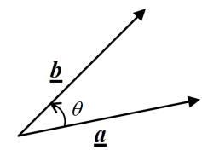  In coordinate form  $$\underset{\sim }{a}.\underset{\sim }{b}=\left(\begin{matrix}x_{1} \\ y_{1}\end{matrix}\right)⋅\left(\begin{matrix}x_{2} \\ y_{2}\end{matrix}\right)=x_{1}x_{2}+y_{1}y_{2}=\left|\underset{\sim }{a}\right|\left|\underset{\sim }{b}\right|\cos{θ}$$  Or  $$\underset{\sim }{a}⋅\underset{\sim }{b}=\left(\begin{matrix}x_{1} \\ y_{1} \\ z_{1}\end{matrix}\right)⋅\left(\begin{matrix}x_{2} \\ y_{2} \\ z_{2}\end{matrix}\right)=x_{1}x_{2}+y_{1}y_{2}+z_{1}z_{2}=\left|\underset{\sim }{a}\right|\left|\underset{\sim }{b}\right|\cos{θ}$$  - Students should find dot products for vectors in component form, column form or as ordered triples.  - Students should prove the results that  - $\underset{\sim }{a}⋅\underset{\sim }{a}=\left|\underset{\sim }{a}\right|\left|\underset{\sim }{a}\right|\cos{0}={\left|\underset{\sim }{a}\right|}^{2}$  - $\underset{\sim }{a}⋅\left(\underset{\sim }{b}+\underset{\sim }{c}\right)=\underset{\sim }{a}.\underset{\sim }{b}+\underset{\sim }{a}.\underset{\sim }{c}$  - $\underset{\sim }{a}⋅\underset{\sim }{b}=\underset{\sim }{b}⋅\underset{\sim }{a}$
Geometric Results in 3D  (1 lesson) | V1.3: Vectors and vector equations of lines  - use Cartesian coordinates in two and three-dimensional space  - recognise and find the equations of spheres | Applying Cartesian coordinates to 3D  - Extend the point from a plane to the point in the space where we need an ordered triple$(a, b, c)$of real numbers and show how$xy$,$xz$ and$yz$ planes divide Cartesian plane into 8 octants.  - Demonstrate the importance of using Cartesian coordinates in real life by taking examples from describing position, location of air transport, map projections, latitude and longitude etc.  - Extend the distance formula from two dimensional plane to three dimensional space.  - For two points $P(x_{1},y_{1},z_{1})$ and $Q(x_{2},y_{2},z_{2})$,the distance $PQ$ can be calculated using the formula  $$d=\sqrt{{\left(x_{2}-x_{1}\right)}^{2}+{\left(y_{2}-y_{1}\right)}^{2}+{\left(z_{2}-z_{1}\right)}^{2}}$$  Determining the equation of a sphere  - Students should revisit the equation for a circle in 2D and extend it into 3D. Students should be challenged to recognise the sphere and describe it.  - Derive the equation of the sphere using the Pythagoras Theorem or Distance Formula centred at the origin.  $$x^{2}+y^{2}+z^{2}=r^{2}$$  - Extend the equation to represent translation of the sphere in all 3 directions. The equation of the sphere with radius $r$ centred at $(a,b,c)$ is  $${(x-a)}^{2}+({y-b)}^{2}+({z-c)}^{2}=r^{2}$$  - Students need to be able to:  - recognise the equation of sphere and find its centre and radius  - find the centre and radius of a sphere by using the techniques of completing the square  - state the equation of the sphere from the given sketch  - find the equation of the sphere given the end points of the diameter.  - Teaching activity: watch the YouTube video general equation of a sphere (Duration 13:08)
Defining Linear Functions in 3D  (1 lesson) | - use vector equations of curves in two or three dimensions involving a parameter, and determine a corresponding Cartesian equation in the two-dimensional case, where possible (ACMSM104) AAM | Defining Linear Functions in 3D  - Explore lines in space through class discussion on the key questions such that  - What minimal information do we need to define and find the equation of a line in two dimensions  - What minimal information do we need to determine the equation of a straight line in 3D space  - During the discussion, with the help of the teacher, students will remind themselves that to find the equation of a straight line they need either one point and the gradient of the line, or two points on the line.  - The teacher can recall the formula $y-y_{1}=m(x-x_{1})$ where $m$ is the gradient of the line and $(x_{1},y_{1})$ is a point on the line.  - Using the previous knowledge and foundational understanding, students can determine that minimal information required to determine the equation of a straight line is a point on the line and direction of the line. They can conclude that in three dimensional space, the equation of the line can be determined if a point with position vector $\underset{\sim }{a}$ and a direction vector $\underset{\sim }{b}$ is given.  - The teacher can derive the equation of a line  $\underset{\sim }{r}=\underset{\sim }{a}+ λ\underset{\sim }{b}$ passing through a fixed point with position vector $\underset{\sim }{a}$ and parallel to a given vector $\underset{\sim }{b}$.  - Students can watch vector equation of a line (duration 16:44).  - The teacher can explain that the vector equation of line is in a form using parametric equations and to deduce the Cartesian equation of the line passing through a fixed point with position vector $\underset{\sim }{a}$ and parallel to given vector $\underset{\sim }{b}$, they need to equate the coefficients of $i$ and $j$.  For example if $\underset{\sim }{r}=\underset{\sim }{a}+ λ\underset{\sim }{b}$,  $\underset{\sim }{a}=5i+j+3k$ and $\underset{\sim }{b}=i+4j-2k$  Therefore $\underset{\sim }{r}=5i+j+3k+λ(i+4j-2k)$  or $\underset{\sim }{r}=(5+λ)i+(1+4λ)j+(3-2λ)k$ on equating the coefficients of $i$, $j$ and $k$ we get the parametric equations which are:  $$x=5+λ$$  $$y=1+4λ$$  $z=3-2λ$  By rearranging the equations to make the parameter $λ$ the subject, we can obtain the Cartesian equation of the line  $$\frac{x-5}{1}=\frac{y-1}{4}=\frac{z-3}{-2}=λ$$  - This video tutorial created by the Curriculum Support Team for Mathematics, demonstrates how to represent a linear function in 3D in vector form from Cartesian equations.  - Watch 3D cartesian to vector representation (duration 2:37), created by the Curriculum Support Team for Mathematics, demonstrates how to represent a linear function in 3D using Cartesian equations from a vector representation.
Determining the Vector Equation of a Line through Two Points  (1 lesson) | - understand and use the vector equation $\underset{\sim }{r}=\underset{\sim }{a}+λ\underset{\sim }{b}$ of a straight line through points $A$ and $B$ where $R$ is a point on $AB$, $\underset{\sim }{a}=\vec{OA}$,  $\underset{\sim }{b}=\vec{AB}$, $λ$ is a parameter and  $$\underset{\sim }{r}=\vec{OR}$$  - determine a vector equation of a straight line or straight-line segment, given the position of two points or equivalent information, in two and three dimensions (ACMSM105) | Vector equations in 3D  - Lead students to determine a vector equation of a line passing through two points $A\left(x_{1},y_{1}\right)$ and $B(x_{2},y_{2})$ can be determined by identifying the position vector and the direction vector. The direction vector can be calculated by finding $\left(\begin{matrix}x_{2}-x_{1} \\ y_{2}-y_{1}\end{matrix}\right)$ in 2D.  - Therefore the vector equation of a line in 2D is given by  $\underset{\sim }{r}=\left(\begin{matrix}x_{1} \\ y_{1}\end{matrix}\right)+λ\left(\begin{matrix}x_{2}-x_{1} \\ y_{2}-y_{1}\end{matrix}\right)$  Or  $$\underset{\sim }{r}=\left(\begin{matrix}x_{2} \\ y_{2}\end{matrix}\right)+ω\left(\begin{matrix}x_{2}-x_{1} \\ y_{2}-y_{1}\end{matrix}\right)$$  - Discuss the rearranged form $\underset{\sim }{r}=\left(1-λ\right)\vec{OA}+λ\vec{OB}$ or $\underset{\sim }{r}=\left(1-λ\right)\left(\begin{matrix}x_{1} \\ y_{1}\end{matrix}\right)+λ\left(\begin{matrix}x_{2} \\ y_{2}\end{matrix}\right)$  - Discuss when $0≤λ≤1$ the position vector $\underset{\sim }{r}$ represents points within the segment $AB$. For all other values of $λ$, $\underset{\sim }{r}$ represents points on the line through $AB$, outside of the segment $AB$.  - Lead students to extend on their understanding of 2D vector equations of a linear function into the 3D vector equation:  $$\underset{\sim }{r}=\left(\begin{matrix}x_{1} \\ y_{1} \\ z_{1}\end{matrix}\right)+λ\left(\begin{matrix}x_{2}-x_{1} \\ y_{2}-y_{1} \\ z_{2}-z_{1}\end{matrix}\right)$$  or  $$\underset{\sim }{r}=(1-λ)\left(\begin{matrix}x_{1} \\ y_{1} \\ z_{1}\end{matrix}\right)+λ\left(\begin{matrix}x_{2} \\ y_{2} \\ z_{2}\end{matrix}\right)$$  - Lead students to consider that setting $λ=\frac{1}{2}$ defines the midpoint on the segment $AB$  - Extend this idea to consider when $λ=\frac{1}{3}$ which defines a point $\frac{1}{3}$ of the way along the segment $AB$ and therefore splits the segment $AB$ in the ratio $1:2$ internally.  - Students can watch this 3D Cartesian to Vector Representation .(duration 7:43) to find the equation of a line passing through two points  - Watch 3D Line through 2 points (duration 3:02), created by the Curriculum Support Team for Mathematics, which demonstrates how to represent a linear function in 3D in vector form from two given points on the line.
Interpreting the Vector Equation of a Line  (1 lesson) | - make connections in two dimensions between the equation $\underset{\sim }{r}=\underset{\sim }{a}+ λ\underset{\sim }{b}$ and $y=mx+c$ | Interpreting the Vector Equation of a Line  - Discuss the vector equation of the line in the form of $\underset{\sim }{r}=\underset{\sim }{a}+ λ\underset{\sim }{b}$ in 2D.  - Any linear 2D graph needs a direction and a point on the line. With just the direction the line wouldn’t have a specific path and could effectively be anywhere.  - With only a given point, the line wouldn’t have a specific direction.  Students should revisit gradient intercept of a line in 2D, given by $y=mx+c$ where $m$ is the gradient of the line, which can be thought of as the DIRECTION of the line, and $c$ is $y$-intercept of the line, which can be considered as the location or POSITION of the line.  - Further to the above discussion, students can note that the gradient can't be used in three dimensions while a direction vector can be used in both two dimensions and three dimensions.  - Therefore the vector equation of a line is an efficient method that can be used in both 2D and 3D.  - Students need to be led to make connections with the direction vector and rates of change, by building on the idea of the gradient being a rate of change in 2D.  Consider the following vector equation for a moving particle  $\underset{\sim }{r}=\left(\begin{matrix}x_{1} \\ y_{1} \\ z_{1}\end{matrix}\right)+t\left(\begin{matrix}α \\ β \\ γ\end{matrix}\right)$ where $t$ represents time in seconds.  At time $t=0$ the particle has an initial position $\left(\begin{matrix}x_{1} \\ y_{1} \\ z_{1}\end{matrix}\right)$  At time $t=1$ the particle’s displacement will change by $\left(\begin{matrix}α \\ β \\ γ\end{matrix}\right)$. In other words, in $1$ second the change of displacement is $\left(\begin{matrix}α \\ β \\ γ\end{matrix}\right)$. Therefore the direction vector $\left(\begin{matrix}α \\ β \\ γ\end{matrix}\right)$ is the velocity vector $\underset{\sim }{v}$ for the particle.  The speed of the particle is equal to $|\underset{\sim }{v}|$ which equals $\sqrt{α^{2}+β^{2}+γ^{2}}$
Determining Parallel and Perpendicular Lines in 3D  (1 lesson) | - determine when two lines in vector form are parallel  - determine when intersecting lines are perpendicular in a plane or three dimensions | Determining Parallel Lines  - Students need to brainstorm all the different ways that lines can be related to each other in the space and be led to the idea that lines can be parallel, perpendicular or skew.  - Students need to build on their understanding of linear functions in 2D, that lines are parallel in two dimensions if they have the same gradient or slope.  - Similarly students can investigate that if the lines are parallel, then the components of the direction vectors of both lines should be proportional.  ie) If $\underset{\sim }{r_{1}}=\underset{\sim }{a_{1}}+t\underset{\sim }{b_{1}}$ and $\underset{\sim }{r_{2}}=\underset{\sim }{a_{2}}+s\underset{\sim }{b_{2}}$ represent vector equations for the linear function $l_{1}$ and $l_{2}$ respectively, then $l_{1}∥l_{2}$ if $b_{1}=b_{2}$ or $b_{1}=kb_{2}$, where $k$ is a constant.  - Students may like to watch Parallel, intersecting, skew and perpendicular lines .(duration 10:37)  - 3D Testing parallel lines (duration 2.13),created by the Curriculum Support Team for Mathematics, demonstrates how to identify or test parallel lines in 3D.  Determining Perpendicular Lines  - Use the dot product of two vectors to show that if the two vectors $\underset{\sim }{u}$ and $\underset{\sim }{v}$ are perpendicular ,then $\underset{\sim }{u}⋅\underset{\sim }{v}=0$  - The intersecting lines $\underset{\sim }{r}=\underset{\sim }{a}+ λ\underset{\sim }{b}$ and $\underset{\sim }{r}=\underset{\sim }{c}+ μ\underset{\sim }{d}$ are perpendicular if $\underset{\sim }{b}⋅\underset{\sim }{d}=0$  - 3D Test for Intersecting and Perpendicular (duration 3:43), created by the Curriculum Support Team for Mathematics, demonstrates how to identify perpendicular and intersecting lines in 3D.
Determining if a Point Lies on a Line in 3D  (1 lesson) | - determine when a given point lies on a given line in vector form | Determining if a Point Lies on a Line in 3D  - Use the vector equation $\underset{\sim }{r}=\underset{\sim }{a}+ λ\underset{\sim }{b}$ to compare the components on both sides of the equations. If you get the value of $λ$ same in all cases, the point lies on the line otherwise not.  For example, does the point $A(1, 0, 3)$ lie on  the line $\underset{\sim }{r}=\left(\begin{matrix}-2 \\ 3 \\ 5\end{matrix}\right)+t\left(\begin{matrix}3 \\ -1 \\ -2\end{matrix}\right)$?  Firstly determine the parametric equations  $$x=-2+3t$$  $$y=3-t$$  $$z=5-2t$$  By substituting the ordinates of the point $A$ into each parametric equation, determine the value for the parameter $t.$  ie) $x=-2+3t ⇒1=-2+3t⇒t=1$  $$y=3-t ⇒0=3-t⇒t=3$$  $$z=5-2t ⇒3=5-2t⇒t=1$$  As the parameter $t$ is inconsistent across all the parametric equations, the point $A$ does not lie on the line
Using Vectors to Prove Geometric Results  (1 lesson) | - prove geometric results in the plane and construct proofs in three dimensions (ACMSM102) | Proving geometric results  - Define the triangle centres: Circumcentre, Centroid and Orthocentre. These are not explicitly referenced in the syllabus but have been referenced in the NESA topic guidance. Students will benefit by gaining familiarity with these definitions and their properties.  - Students should be familiar with properties of triangle centres, for example the position vector for the centroid $X$ of the triangle $∆ABC$ is given by  $\overset{→}{OX}=\frac{\overset{→}{OA}+\overset{→}{OB}+\overset{→}{OC} }{3}$ where $A$, $B$ and $C$ are vertices of the triangle.  Staff may like to refer to these resources  - Geogebra app for Centroid  - Properties of triangle centres  - Eulers line through the triangle centres  - Proofs for triangle centres (PowerPoint Presentation)  - Teaching activity  - Vectors Core 4 Revision in 15 minutes (duration 15:56) providing trigonometric results using vectors  - NESA Sample Questions  - Find the angle between two given non-zero vectors.  - Determine if two non-zero vectors are perpendicular or parallel.  - If $ABCDEFGH$ is a rectangular prism as illustrated below, and $M$ is the midpoint of $EF$, use vector methods to find the size of $∠BHF$ and $∠BHM$.  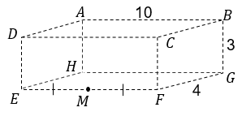  - Use vector methods to prove that the angle in a semicircle is a right angle.  Resource: Vector proof in Geogebra  - $ABCD$ is a regular tetrahedron. $M$ is the midpoint of $CD$. Find the size of $∠AMB$.  Resource: Tetrahedron-proof-using-vectors.DOCX  - The circumcentre of a triangle is the centre of the circle that passes through each of the vertices. The centroid is the point of intersection of the angle bisectors of a triangle. Let $O$ be the circumcentre and $G$ the centroid of $∆ABC$. $H$ is the point of $OG$ such that $\vec{OH}=3 \vec{OG}$. Prove that $\vec{AH}⊥\vec{BC}$.  Resource: NESA-centroid-question-solution.DOCX
Defining Curves in 3D  (1 or 2 lessons) | - use vector equations of curves in two or three dimensions involving a parameter, and determine a corresponding Cartesian equation in the two-dimensional case, where possible (ACMSM104) AAM | Defining Curves in 3D  - Students need to be led to the conclusion that Cartesian representations can represent surfaces or planes easily but are less effective at representing curves, compared to parametric or vector equations. When defining curves in 3D, parametric or vector equations are preferable and open up more opportunities to analyse given situations.  - Lead students to investigate the curve of the function $r$ which is defined in parametric form as  $r(t)=(t , t^{2}, 2t+1)$, which should be interpreted as  $x=t$; $y=t^{2}$; and $z=2t+1$  - Lead students to complete the table of values for the function $r$ to gain familiarity with using the parametric form.  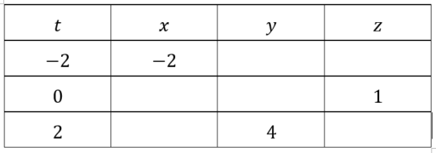  - Use Geogebra in 3D view to investigate the curve by entering $r=\left(t, t^{2},2t+1\right)$ into the input box.  - Pair the parametric equations to eliminate $t$ and form Cartesian equations relating $x$, $y$ and $z.$  ie) $x=t ⟹t=x$  substituting into $y=t^{2}$ and $z=2t+1$ generates  $y=x^{2}$ and $z=2x+1$  and $z=2t+1 ⟹t=\frac{z-1}{2}$  substituting into $y=t^{2}$ generates $y={\left(\frac{z-1}{2}\right)}^{2}$  Lead students to interpret these results as follows  - $y=x^{2}$: when viewing the function $r$ perpendicular to the $xy$–plane the curve is a parabola.  - $z=2x+1$: when viewing the function $r$ perpendicular to the $xz$–plane the curve is linear.  - $y={\left(\frac{z-1}{2}\right)}^{2}$: when viewing the function $r$ perpendicular to the $yz$–plane the curve is a parabola.  - Use Geogebra to verify these results.  - Students need to be familiar with the following types of curves, provided by NESA  - $r(t)=(t^{2}, t^{3}, 1)$ [note that $x≥0$ as $x=t^{2}$]  - $r(t)=(\sin{t}, \cos{t}, t)$  - $r(t)=(t^{2}, \cos{t}, t)$  - $r(t)=(t, e^{t}, \frac{1}{t})$  - This video tutorial created by the Curriculum Support Team for Mathematics, demonstrates how to interpret curves in 3D defined by parametric equations.  Finding tangents to curves in 3D  - This is an extension activity but opens up assessment task opportunities.  - Consider the curve $r\left(t\right)=(x\left(t\right),y\left(t\right),z\left(t\right))$, where the $x$, $y$ and $z$ ordinates are functions of the parameter $t$.  - The direction vector for $r$ at the point when $t=a$ is given by $\left(\begin{matrix}x'(a) \\ y'(a) \\ z'(a)\end{matrix}\right)$, where $x^{'}\left(t\right)=\frac{dx(t)}{dt},$ and the tangent to the curve is given by $T\left(λ\right)=\left(\begin{matrix}x(a) \\ y(a) \\ z(a)\end{matrix}\right)+λ\left(\begin{matrix}x'(a) \\ y'(a) \\ z'(a)\end{matrix}\right)$

Reflection and evaluation
Please include feedback about the engagement of the students and the difficulty of the content included in this section. You may also refer to the sequencing of the lessons and the placement of the topic within the scope and sequence. All ICT, literacy, numeracy and group activities should be recorded in Comments, Feedback, Additional Resources Used sections.

