Sample question solutions

Further proofs by mathematical induction
- Use mathematical induction to prove that for all integers $n≥3,$
$$\left(1-\frac{2}{3}\right)\left(1-\frac{2}{4}\right)\left(1-\frac{2}{5}\right)…\left(1-\frac{2}{n}\right)=\frac{2}{n\left(n-1\right)}$$
Step 1: Base case: Prove true for $n=3$
$$LHS=\left(1-\frac{2}{3}\right)=\frac{1}{3}$$
$$RHS=\frac{2}{3\left(3-1\right)}=\frac{2}{6}=\frac{1}{3}=LHS$$
$∴$True for $n=3$

Step 2: Assume that the statement is true for $n=k$
$$\left(1-\frac{2}{3}\right)\left(1-\frac{2}{4}\right)\left(1-\frac{2}{5}\right)…\left(1-\frac{2}{k}\right)=\frac{2}{k\left(k-1\right)}$$
Step 3: Inductive step: Prove the statement to be true for $n=k+1$
Show $\left(1-\frac{2}{3}\right)\left(1-\frac{2}{4}\right)\left(1-\frac{2}{5}\right)…\left(1-\frac{2}{k+1}\right)=\frac{2}{(k+1)\left(k+1-1\right)}$
$$RHS=\frac{2}{k(k+1)}$$
$$LHS=\left(1-\frac{2}{3}\right)\left(1-\frac{2}{4}\right)\left(1-\frac{2}{5}\right)…\left(1-\frac{2}{k}\right)\left(1-\frac{2}{k+1}\right)$$
Now, $\left(1-\frac{2}{3}\right)\left(1-\frac{2}{4}\right)\left(1-\frac{2}{5}\right)…\left(1-\frac{2}{k}\right)=\frac{2}{k\left(k-1\right)}$, from step 2 (the assumption)
$$LHS=\frac{2}{k\left(k-1\right)}\left(1-\frac{2}{k+1}\right) \\ =\frac{2}{k\left(k-1\right)}\left(\frac{k+1}{k+1}-\frac{2}{k+1}\right) \\ =\frac{2}{k\left(k-1\right)}×\frac{k-1}{k+1} \\ =\frac{2}{k\left(k+1\right)} \\ =RHS$$
$$∴\left(1-\frac{2}{3}\right)\left(1-\frac{2}{4}\right)\left(1-\frac{2}{5}\right)…\left(1-\frac{2}{k+1}\right)=\frac{2}{(k+1)\left(k+1-1\right)}$$

Step 4: Concluding statement: If true for $n=k$, proven true for $n=k+1$. Since true for $n=3$, true for $n=3+1=4$, $n=4+1=5$, … therefore, true for all integers $n≥3$.

- Prove that $7^{n}+{19}^{n}$ is divisible by $13$ if $n$ is odd

Step 1: Base case: Prove true for $n=1$
$7^{1}+{19}^{1}=26=2×13$, which is divisible by 13
$∴$True for $n=1$

Step 2: Assume that the statement is true for $n=k,$ where $k$ is an odd integer.
$7^{k}+{19}^{k} =13M$, where $M$ is an integer
or $7^{k}=13M-{19}^{k}$ and ${19}^{k} =13M-7^{k}$

Step 3: Inductive step: Prove the statement to be true for $n=k+2,$where $k$ is an odd integer
Show $7^{k+2}+{19}^{k+2} =13P$, where $P$ is an integer
$$LHS=7^{2}(7^{k})+{19}^{2}({19}^{k})$$
Now, $7^{k}=13M-{19}^{k}$ from step 2. (the assumption)
$$LHS= 49\left(13M-{19}^{k}\right)+361\left({19}^{k}\right) \\ =49×13M-49×{19}^{k}+361×{19}^{k} \\ =49×13M+312×{19}^{k}$$
$=13\left(49M+24×{19}^{k}\right),$ which is divisible by 13 as $49M+24×{19}^{k}$ is an integer.

Step 4: Concluding statement: If true for $n=k$, proven true for $n=k+2$. Since true for $n=1$, true for $n=1+2=3$, $n=3+2=5$, … therefore, true for any odd number $n$.

- Prove that $n^{2}+2n$ is a multiple of $8$ if $n$ is even

Step 1: Base case: Prove true for $n=2$
$2^{2}+2×2=8$, which is divisible by 8
$∴$True for $n=2$

Step 2: Assume that the statement is true for $n=k,$ where $k$ is an even integer.
$k^{2}+2k =8M$, where $M$ is an integer
or $k^{2}=8M-2k$

Step 3: Inductive step: Prove the statement to be true for $n=k+2,$where $k$ is an even integer
Show $({k+2)}^{2}+2(k+2) =8P$, where $P$ is an integer
$$LHS=k^{2}+4k+4+2k+4$$
Now, $k^{2}=8M-2k$ from step 2 (the assumption)
$$LHS= 8M-2k+4k+4+2k+4 \\ =8M+4k+8$$
Now, $k=2g$, as $k$ is even.$$=8M+4×2g+8$$
$=8(M+g+1),$ which is divisible by 8 as $(M+g+1)$ is an integer.

Step 4: Concluding statement: If true for $n=k$, proven true for $n=k+2$. Since true for $n=2$, true for $n=2+2=4$, $n=4+2=6$, … therefore, true for any even number $n$.

Proofs by mathematical induction involving sigma notation
- $\sum_{k=1}^{n}{k}=\frac{n(n+1)}{2}$

Step 1: Base case: Prove true for $n=1$
$$LHS=\sum_{k=1}^{1}{k}=1$$
$$RHS=\frac{1\left(1+1\right)}{2}=1=LHS$$
$∴$True for $n=1$

Step 2: Assume that the statement is true for $n=m$
$\sum_{k=1}^{m}{k}=\frac{m(m+1)}{2}$ or$1+2+3+…+m=\frac{m(m+1)}{2}$

Step 3: Inductive step: Prove the statement to be true for $n=m+1,$
Show $\sum_{k=1}^{m+1}{k}=\frac{(m+1)(m+1+1)}{2}$
$$RHS=\frac{(m+1)(m+2)}{2}$$
$$LHS=\sum_{k=1}^{m+1}{k} \\ =1+2+3+…+m+\left(m+1\right)$$
Now, $1+2+3+…+m=\frac{m(m+1)}{2}$ from step 2 (the assumption)
$$LHS= \frac{m(m+1)}{2}+(m+1) \\ =\frac{m\left(m+1\right)+2(m+1)}{2} \\ =\frac{(m+1)(m+2)}{2} \\ =RHS$$
$$∴\sum_{k=1}^{m+1}{k}=\frac{(m+1)(m+1+1)}{2}$$

Step 4: Concluding statement: If true for $n=m$, proven true for $n=m+1$. Since true for $n=1$, true for $n=1+1=2$, $n=2+1=3$, … therefore, true for any integer $n≥1$.

- $\sum_{n=1}^{N}{n^{2}=\frac{N\left(N+1\right)\left(2N+1\right)}{6}}$ (NESA topic guidance)

Step 1: Base case: Prove true for $N=1$
$$LHS=\sum_{n=1}^{1}{n^{2}}=1^{2}=1$$
$$RHS=\frac{1\left(1+1\right)(2×1+1)}{6}=\frac{1\left(2\right)(3)}{6}=\frac{6}{6}=1=LHS$$
$∴$True for $N=1$

Step 2: Assume that the statement is true for $N=k$
$\sum_{n=1}^{k}{n^{2}=\frac{k\left(k+1\right)\left(2k+1\right)}{6}}$ or$1^{2}+2^{2}+3^{2}+…+k^{2}=\frac{k\left(k+1\right)\left(2k+1\right)}{6}$

Step 3: Inductive step: Prove the statement to be true for $N=k+1,$
Show $\sum_{n=1}^{k+1}{n^{2}=\frac{(k+1)\left(k+1+1\right)\left(2(k+1)+1\right)}{6}}$
$$RHS=\frac{(k+1)\left(k+2\right)\left(2k+3\right)}{6}$$
$$LHS=\sum_{n=1}^{k+1}{n^{2}} \\ =1^{2}+2^{2}+3^{2}+…+k^{2}+{\left(k+1\right)}^{2}$$
Now, $1^{2}+2^{2}+3^{2}+…+k^{2}=\frac{k\left(k+1\right)\left(2k+1\right)}{6}$ from step 2 (the assumption)
$$LHS= \frac{k\left(k+1\right)\left(2k+1\right)}{6}+{\left(k+1\right)}^{2} \\ =\frac{k\left(k+1\right)\left(2k+1\right)+6{\left(k+1\right)}^{2}}{6} \\ =\frac{\left(k+1\right)k\left(2k+1\right)+6(k+1)(k+1)}{6} \\ =\frac{\left(k+1\right)(k\left(2k+1\right)+6\left(k+1\right))}{6} \\ =\frac{\left(k+1\right)(2k^{2}+k+6k+6)}{6} \\ =\frac{\left(k+1\right)(2k^{2}+7k+6)}{6} \\ =\frac{\left(k+1\right)(k+2)(2k+3)}{6} \\ =RHS$$
$$∴\sum_{n=1}^{k+1}{n^{2}=\frac{(k+1)\left(k+1+1\right)\left(2(k+1)+1\right)}{6}}$$

Step 4: Concluding statement: If true for $N=k$, proven true for $N=k+1$. Since true for $n=1$, true for $N=1+1=2$, N$=2+1=3$, … therefore, true for any integer $N≥1$.

- $\sum_{k=1}^{n}{k^{3}=\frac{n^{2}{\left(n+1\right)}^{2}}{4}}$

Step 1: Base case: Prove true for $n=1$
$$LHS=\sum_{k=1}^{1}{k^{3}}=1^{3}=1$$
$$RHS=\frac{1^{2}{\left(1+1\right)}^{2}}{4}=\frac{4}{4}=1=LHS$$
$∴$True for $n=1$

Step 2: Assume that the statement is true for $n=m$
$\sum_{k=1}^{m}{k^{3}=\frac{m^{2}{\left(m+1\right)}^{2}}{4}}$ or $1^{3}+2^{3}+3^{3}+…+m^{3}=\frac{m^{2}{\left(m+1\right)}^{2}}{4}$

Step 3: Inductive step: Prove the statement to be true for $n=m+1,$
Show $\sum_{k=1}^{m+1}{k^{3}=\frac{({m+1)}^{2}{\left(m+1+1\right)}^{2}}{4}}$
$$RHS=\frac{({m+1)}^{2}{\left(m+2\right)}^{2}}{4}$$
$$LHS=\sum_{k=1}^{m+1}{k^{3}} \\ =1^{3}+2^{3}+3^{3}+…+m^{3}+{\left(m+1\right)}^{3}$$
Now, $1^{2}+2^{2}+3^{2}+…+m^{2}=\frac{m^{2}{\left(m+1\right)}^{2}}{4}$ from step 2 (the assumption)
$$LHS= \frac{m^{2}{\left(m+1\right)}^{2}}{4}+{\left(m+1\right)}^{3} \\ =\frac{m^{2}{\left(m+1\right)}^{2}+4{\left(m+1\right)}^{3}}{4} \\ =\frac{m^{2}{\left(m+1\right)}^{2}+4{(m+1)\left(m+1\right)}^{2}}{4} \\ =\frac{{(m}^{2}+4(m+1)){\left(m+1\right)}^{2}}{4} \\ =\frac{{(m}^{2}+4m+4){\left(m+1\right)}^{2}}{4} \\ =\frac{{\left(m+2\right)}^{2}{\left(m+1\right)}^{2}}{4} \\ =RHS$$
$$∴\sum_{k=1}^{m+1}{k^{3}=\frac{({m+1)}^{2}{\left(m+1+1\right)}^{2}}{4}}$$

Step 4: Concluding statement: If true for $n=m$, proven true for $n=m+1$. Since true for $n=1$, true for $n=1+1=2$, $n=2+1=3$, … therefore, true for any integer $n≥1$.

- $\sum_{k=1}^{n}{\left(2k+1\right)=n^{2}+2n}$

Step 1: Base case: Prove true for $n=1$
$$LHS=\sum_{k=1}^{1}{(2k+1)}=(2×1+1)=3$$
$$RHS=1^{2}+2×1=3=LHS$$
$∴$True for $n=1$

Step 2: Assume that the statement is true for $n=m$
$\sum_{k=1}^{m}{\left(2k+1\right)=m^{2}+2m}$ or $\left(2×1+1\right)+\left(2×2+1\right)+(2×3+1)+…+(2m+1)=m^{2}+2m$

Step 3: Inductive step: Prove the statement to be true for $n=m+1,$
Show $\sum_{k=1}^{m+1}{\left(2k+1\right)={(m+1)}^{2}+2(m+1)}$
$$RHS=m^{2}+2m+1+2m+2 \\ =m^{2}+4m+3$$
$$LHS=\sum_{k=1}^{m+1}{(2k+1)} \\ =\left(2×1+1\right)+\left(2×2+1\right)+\left(2×3+1\right)+…+\left(2m+1\right)+(2\left(m+1\right)+1)$$
Now, $\left(2×1+1\right)+\left(2×2+1\right)+(2×3+1)+…+(2m+1)=m^{2}+2m$ from step 2 (the assumption)
$$LHS= m^{2}+2m+\left(2\left(m+1\right)+1\right) \\ =m^{2}+2m+2m+3 \\ =m^{2}+4m+3 \\ =RHS$$
$$∴\sum_{k=1}^{m+1}{\left(2k+1\right)={(m+1)}^{2}+2(m+1)}$$
Step 4: Concluding statement: If true for $n=m$, proven true for $n=m+1$. Since true for $n=1$, true for $n=1+1=2$, $n=2+1=3$, … therefore, true for any integer $n≥1$.

- $\sum_{k=1}^{n}{k2^{k}=\left(n-1\right)\left(2^{n+1}\right)+2}$

Step 1: Base case: Prove true for $n=1$
$$LHS=\sum_{k=1}^{n}{k2^{k}}=1×2^{1}=2$$
$$RHS=\left(1-1\right)\left(2^{1+1}\right)+2=0+2=2=LHS$$
$∴$True for $n=1$

Step 2: Assume that the statement is true for $n=m$
$\sum_{k=1}^{m}{k2^{k}=\left(m-1\right)\left(2^{m+1}\right)+2}$ or
$$\left(1×2^{1}\right)+\left(2×2^{2}\right)+(3×2^{3})…+(m2^{m})=\left(m-1\right)\left(2^{m+1}\right)+2$$

Step 3: Inductive step: Prove the statement to be true for $n=m+1,$
Show$\sum_{k=1}^{m+1}{k2^{k}=\left(m+1-1\right)\left(2^{m+1+1}\right)+2}$
$$RHS=\left(m\right)\left(2^{m+2}\right)+2 \\ LHS=\sum_{k=1}^{m+1}{k2^{k}} \\ =\left(1×2^{1}\right)+\left(2×2^{2}\right)+\left(3×2^{3}\right)…+\left(m2^{m}\right)+(\left(m+1\right)2^{m+1})$$
Now, $\left(1×2^{1}\right)+\left(2×2^{2}\right)+(3×2^{3})…+(m2^{m})=\left(m-1\right)\left(2^{m+1}\right)+2$ from step 2 (the assumption)
$$LHS= \left(m-1\right)\left(2^{m+1}\right)+2+\left(m+1\right)2^{m+1} \\ =\left(m-1+m+1\right)2^{m+1}+2 \\ =\left(2m\right)2^{m+1}+2 \\ =m×2^{1}×2^{m+1}+2 \\ =(m)(2^{m+2})+2 \\ =RHS \\ ∴\sum_{k=1}^{m+1}{k2^{k}=\left(m+1-1\right)\left(2^{m+1+1}\right)+2}$$

Step 4: Concluding statement: If true for $n=m$, proven true for $n=m+1$. Since true for $n=1$, true for $n=1+1=2$, $n=2+1=3$, … therefore, true for any integer $n≥1$.

- $\sum_{n=1}^{N}{\frac{1}{\left(2n+1\right)\left(2n-1\right)}=}\frac{N}{2N+1}$ (NESA topic guidance)

Step 1: Base case: Prove true for $N=1$
$$LHS=\sum_{n=1}^{1}{\frac{1}{\left(2n+1\right)\left(2n-1\right)}=}\frac{1}{(2×1+1)(2×1-1)}=\frac{1}{(3)(1)}=\frac{1}{3}$$
$$RHS=\frac{1}{2×1+1}=\frac{1}{3}=LHS$$
$∴$True for $N=1$

Step 2: Assume that the statement is true for $N=k$
$\sum_{n=1}^{k}{\frac{1}{\left(2n+1\right)\left(2n-1\right)}=}\frac{k}{2k+1}$ or
$\frac{1}{(2×1+1)(2×1-1)}+\frac{1}{(2×2+1)(2×2-1)}+…+\frac{1}{\left(2k+1\right)\left(2k-1\right)}=\frac{k}{2k+1}$

Step 3: Inductive step: Prove the statement to be true for $N=k+1,$
Show $\sum_{n=1}^{k+1}{\frac{1}{\left(2n+1\right)\left(2n-1\right)}=}\frac{k+1}{2(k+1)+1}$
$$RHS=\frac{k+1}{2k+3}$$$LHS=\sum_{n=1}^{k+1}{\frac{1}{\left(2n+1\right)\left(2n-1\right)}}$
$=\frac{1}{(2×1+1)(2×1-1)}+\frac{1}{(2×2+1)(2×2-1)}+…+\frac{1}{\left(2k+1\right)\left(2k-1\right)}+\frac{1}{\left(2(k+1)+1\right)\left(2(k+1)-1\right)}$

Now, $\frac{1}{(2×1+1)(2×1-1)}+\frac{1}{(2×2+1)(2×2-1)}+…+\frac{1}{\left(2k+1\right)\left(2k-1\right)}=\frac{k}{2k+1}$ from step 2 (the assumption)
$$LHS= \frac{k}{2k+1}+\frac{1}{\left(2\left(k+1\right)+1\right)\left(2\left(k+1\right)-1\right)} \\ =\frac{k}{2k+1}+\frac{1}{\left(2k+3\right)\left(2k+1\right)} \\ =\frac{k\left(2k+3\right)+1}{\left(2k+3\right)\left(2k+1\right)} \\ =\frac{2k^{2}+3k+1}{\left(2k+3\right)\left(2k+1\right)} \\ =\frac{\left(2k+1\right)\left(k+1\right)}{\left(2k+3\right)\left(2k+1\right)} \\ =\frac{k+1}{2k+3} \\ =RHS$$
$$∴\sum_{n=1}^{k+1}{\frac{1}{\left(2n+1\right)\left(2n-1\right)}=}\frac{k+1}{2(k+1)+1}$$
Step 4: Concluding statement: If true for $N=k$, proven true for $N=k+1$. Since true for $N=1$, true for $N=1+1=2$, $N=2+1=3$, … therefore, true for any integer $N≥1$.

Prove results using mathematical induction

Inequalities:
- $2^{n}>n^{2}$, for positive integers $n>4$

Step 1: Base case: Prove true for $n=5$
$$RHS=5^{2}=25$$
$$LHS=2^{5}=32$$
$$LHS>RHS$$
$∴$True for $n=1$

Step 2: Assume that the statement is true for $n=k$
$$2^{k}>k^{2}$$
Step 3: Inductive step: Prove the statement to be true for $n=k+1$
Show $2^{k+1}>{(k+1)}^{2}$ by proving $2^{k+1}-{\left(k+1\right)}^{2}>0$

$2^{k+1}-{\left(k+1\right)}^{2}={2⋅2}^{k}-k^{2}-2k-1>2k^{2}-k^{2}-2k-1=k^{2}-2k-1>0$ for $k>4$ as $k^{2}$ increases quicker ($\frac{d}{dk}\left(k^{2}\right)=2k)$ than $-2k-1$ decreases ($\frac{d}{dk}\left(-2k-1\right)=-2)$
$∴2^{k+1}-{\left(k+1\right)}^{2}>0$ and $2^{k+1}>{(k+1)}^{2}$

Step 4: Concluding statement: If true for $n=k$, proven true for $n=k+1$. Since true for $n=5$, true for $n=5+1=6$, $n=6+1=7$, … therefore, true for all integers $n>4$.

- Prove by mathematical induction that: $\frac{1}{4}n^{4}<\sum_{r=1}^{n}{r^{3}≤}n^{4}$ (NESA topic guidance)
Step 1: Base case: Prove true for $n=1$
$$RHS=1^{4}=1$$
$$LHS=\frac{1}{4}×1^{4}=\frac{1}{4}$$
$$Centre=\sum_{r=1}^{1}{r^{3}=1^{3}=1}$$
$$LHS<Centre≤RHS$$
$∴$True for $n=1$

Step 2: Assume that the statement is true for $n=k$
$$\frac{1}{4}k^{4}<\sum_{r=1}^{k}{r^{3}≤}k^{4}$$
Step 3: Inductive step: Prove the statement to be true for $n=k+1$
Show $\frac{1}{4}{(k+1)}^{4}<\sum_{r=1}^{k+1}{r^{3}≤}({k+1)}^{4}$
$LHS=\frac{1}{4}\left(k^{4}+4k^{3}+6k^{2}+4k+1\right)=$ $\frac{1}{4}k^{4}+k^{3}+\frac{3}{2}k^{2}+k+1$
$$RHS=k^{4}+4k^{3}+6k^{2}+4k+1$$
$$Centre=\sum_{r=1}^{k+1}{r^{3}=1^{3}+2^{3}+...+k^{3}+{\left(k+1\right)}^{3}} \\ =\sum_{r=1}^{k}{r^{3}+{\left(k+1\right)}^{3}}$$
Compare the centre to the LHS from the assumption. Now $\sum_{r=1}^{k}{r^{3}>}\frac{1}{4}k^{4}$
$$\sum_{r=1}^{k}{r^{3}+{\left(k+1\right)}^{3}}>\frac{1}{4}k^{4}+{\left(k+1\right)}^{3} \\ =\frac{1}{4}k^{4}+k^{3}+3k^{2}+3k+1$$
$$=\frac{1}{4}(k^{4}+{4k}^{3}+12k^{2}+12k+4) \\ >\frac{1}{4}(k^{4}+{4k}^{3}+6k^{2}+4k+1) \\ =\frac{1}{4}{(k+1)}^{4}$$
Compare the centre to the RHS from the assumption. Now $\sum_{r=1}^{k}{r^{3}≤}k^{4}$
$$\sum_{r=1}^{k}{r^{3}+{\left(k+1\right)}^{3}}<k^{4}+{\left(k+1\right)}^{3}$$
$$=k^{4}+k^{3}+3k^{2}+3k+1 \left(Given k≥1, 3k^{2}<6k^{2} and 3k<4k\right)$$
$$<k^{4}+4k^{3}+6k^{2}+4k+1 \\ =({k+1)}^{4}$$
and $\sum_{r=1}^{n}{r^{3}=}n^{4}$ when $n=1$
$$∴\sum_{r=1}^{k+1}{r^{3}≤}({k+1)}^{4}$$

$$∴\frac{1}{4}{(k+1)}^{4}<\sum_{r=1}^{k+1}{r^{3}≤}({k+1)}^{4}$$

Step 4: Concluding statement: If true for $n=k$, proven true for $n=k+1$. Since true for $n=1$, true for $n=1+1=2$, $n=2+1=3$, … therefore, true for all integers $n≥1$.

- Let $x$ be a fixed, non-zero number satisfying $x>-1$.
Use the method of mathematical induction to prove that ${\left(1+x\right)}^{n}>1+nx$ for $n=2, 3,…$ and hence deduce that ${\left(1-\frac{1}{2n}\right)}^{n}>\frac{1}{2}$ for $n=2, 3,…$

Prove that ${\left(1+x\right)}^{n}>1+nx$ for $n=2,3,…$
Step 1: Base case: Prove ${\left(1+x\right)}^{n}>1+nx$ for $n=2$
$LHS={\left(1+x\right)}^{2}=x^{2}+2x+1>1+2x$ as $x^{2}>0$
$$RHS=1+2x$$
$$∴LHS>RHS$$
Step 2: Assume that the statement is true for $n=k$
i.e. ${\left(1+x\right)}^{k}>1+kx$
Step 3: Inductive step: Prove the statement to be true for $n=k+1$.
$$Show {\left(1+x\right)}^{k+1}>1+\left(k+1\right)x$$
$$LHS={\left(1+x\right)}^{k+1} \\ ={\left(1+x\right)\left(1+x\right)}^{k}$$
$$>\left(1+x\right)\left(1+kx\right)$$
$$=1+x+kx+kx^{2}$$
$$=1+\left(k+1\right)x+kx^{2}$$
$>1+\left(k+1\right)x$ as $kx^{2}>0$
$$=RHS$$
$$∴{\left(1+x\right)}^{k+1}>1+\left(k+1\right)x$$
Step 4: Concluding statement: If true for $n=k$, proven true for $n=k+1$. Since true for $n=2$, true for $n=2+1=3$, $n=3+1=4$, … therefore, true for all integers $n≥2$.

Deduce that ${\left(1-\frac{1}{2n}\right)}^{n}>\frac{1}{2}$ for $n=2,3,…$
$${\left(1+x\right)}^{n}>1+nx$$
$Substitute x=-\frac{1}{2n}$
$${\left(1-\frac{1}{2n}\right)}^{n}>1+n\left(-\frac{1}{2n}\right) \\ =1-\frac{1}{2} \\ =\frac{1}{2}$$

Algebra:

- Show that ${4n}^{3}+18n^{2}+23n+9$ can be written as $\left(n+1\right)\left(4n^{2}+14n+9\right).$

$$\left(n+1\right)\left(4n^{2}+14n+9\right)=4n^{3}+14n^{2}+9n+4n^{2}+14n+9 \\ =4n^{3}+18n^{2}+23n+9 (as required)$$

- Using the result in part 1, or otherwise, prove by mathematical induction that, for $n≥1,$
$1×3+3×5+5×7+⋯+\left(2n-1\right)\left(2n+1\right)=\frac{1}{3}n\left(4n^{2}+6n-1\right).$ (NESA topic guidance)

Step 1: Base case: Prove true for $n=1$
$$LHS=\left(2×1-1\right)\left(2×1+1\right)=1×3=3$$
$$RHS=\frac{1}{3}×1\left(4×1^{2}+6×1-1\right)=\frac{1}{3}×1\left(4+6-1\right)=3$$
$$LHS=RHS$$
$∴$True for $n=1$

Step 2: Assume that the statement is true for $n=k$
$$1×3+3×5+5×7+⋯+\left(2k-1\right)\left(2k+1\right)=\frac{1}{3}k\left(4k^{2}+6k-1\right).$$

Step 3: Inductive step: Prove the statement to be true for $n=k+1$
Show $1×3+3×5+5×7+⋯+\left(2(k+1)-1\right)\left(2(k+1)+1\right)=\frac{1}{3}(k+1)\left(4{(k+1)}^{2}+6(k+1)-1\right).$

$$RHS=\frac{1}{3}\left(k+1\right)\left(4{\left(k+1\right)}^{2}+6\left(k+1\right)-1\right)$$
$$=\frac{1}{3}(k+1)(4k^{2}+14k+9)$$

$$LHS=1×3+3×5+5×7+⋯+(2k-1)(2k+1)+\left(2(k+1)-1\right)\left(2(k+1)+1\right)$$
$$=\frac{1}{3}k\left(4k^{2}+6k-1\right)+(2k+1)(2k+3)$$
$$=\frac{1}{3}\left(4k^{3}+6k^{2}-k+3\left(2k+1\right)\left(2k+3\right)\right)$$
$$=\frac{1}{3}\left(4k^{3}+6k^{2}-k+12k^{2}+24k+9\right)$$
$=\frac{1}{3}(4k^{3}+18k^{2}+23k+9)$ using part i)
$$=\frac{1}{3}(k+1)(4k^{2}+14k+9)$$
$$=RHS$$

$$∴1×3+3×5+5×7+⋯+\left(2(k+1)-1\right)\left(2(k+1)+1\right)=\frac{1}{3}(k+1)\left(4{(k+1)}^{2}+6(k+1)-1\right).$$

Step 4: Concluding statement: If true for $n=k$, proven true for $n=k+1$. Since true for $n=1$, true for $n=1+1=2$, $n=2+1=3$, … therefore, true for all integers $n≥1$.

Divisibility:
- $3^{2n+4}-2^{2n}$ is divisible by 5 for any positive integer $n$

Step 1: Base case: Prove true for $n=1$
$3^{2×1+4}-2^{2×1}=3^{6}-2^{2}=729-4=725$which is divisible by 5 ($725=5×145$)
$∴$True for $n=1$

Step 2: Assume that the statement is true for $n=k$
$3^{2k+4}-2^{2k} =5M$, where $M$ is an integer
$$3^{2k+4}=5M+2^{2k}$$

Step 3: Inductive step: Prove the statement to be true for $n=k+1$
Show $3^{2(k+1)+4}-2^{2(k+1)} =5P$, where $P$ is an integer
$$LHS=3^{2k+2+4}-2^{2k+2}$$
$$=3^{2}×3^{2k+4}-2^{2}×2^{2k}$$
Now, $3^{2k+4}=5M+2^{2k}$from step 2 (the assumption)
$$=9\left(5M+2^{2k}\right)-4×2^{2k}$$
$$=5×9M+9×2^{2k}-4×2^{2k}$$
$$=5×9M+5×2^{2k}$$
$=5(9M+2^{2k})$, which is divisible by 5 as $(9M+2^{2k})$ is an integer

Step 4: Concluding statement: If true for $n=k$, proven true for $n=k+1$. Since true for $n=1$, true for $n=1+1=2$, $n=2+1=3$, … therefore, true for any positive integer $n$.

- Find the values of $2^{n+2}+3^{2n+1}$ when $n=0, 1, 2$ and $3$. Make a conjecture about a number which divides $2^{n+2}+3^{2n+1}$ and prove your conjecture by induction. (divisible by 7) (NESA Topic guidance)

When $n=0$, $2^{n+2}+3^{2n+1}=2^{0+2}+3^{2*0+1}=2^{2}+3^{1}=4+3=7$
When $n=1$, $2^{n+2}+3^{2n+1}=2^{1+2}+3^{2*1+1}=2^{3}+3^{3}=8+27=35$
When $n=2$, $2^{n+2}+3^{2n+1}=2^{2+2}+3^{2*2+1}=2^{4}+3^{5}=16+243=259$
When $n=3$, $2^{n+2}+3^{2n+1}=2^{3+2}+3^{2*3+1}=2^{5}+3^{7}=32+2187=2219$

$$7=1×7$$
$$35=5×7$$
$$259=37×7$$
$$2219=317×7$$

Conjecture: $2^{n+2}+3^{2n+1}$ is divisible by 7 when $n≥0$

Step 1: Base case: Prove true for $n=0$
$2^{0+2}+3^{2*0+1}=2^{2}+3^{1}=4+3=7$which is divisible by 7
$∴$True for $n=0$

Step 2: Assume that the statement is true for $n=k$
$2^{k+2}+3^{2k+1} =7M$, where $M$ is an integer
$$2^{k+2}=7M-3^{2k+1}$$

Step 3: Inductive step: Prove the statement to be true for $n=k+1$
Show $2^{k+1+2}+3^{2(k+1)+1} =5P$, where $P$ is an integer
$$LHS=2×2^{k+2}+3^{2k+2+1}$$
Now, $2^{k+2}=7M-3^{2k+1}$from step 2 (the assumption)
$$=2×\left(7M-3^{2k+1}\right)+{3^{2}×3}^{2k+1}$$
$$=7×2M-2×3^{2k+1}+{9×3}^{2k+1}$$
$$=7×2M+{7×3}^{2k+1}$$
$=7\left(2M+3^{2k+1}\right)$, which is divisible by 7 as $\left(2M+3^{2k+1}\right)$ is an integer.

Step 4: Concluding statement: If true for $n=k$, proven true for $n=k+1$. Since true for $n=0$, true for $n=0+1=1$, $n=1+1=2$, … therefore, true any whole number $n≥0$.

Calculus:
- Prove that for any positive integer $n$ , $\frac{d}{dx}(x^{n})=nx^{n-1}$

Step 1: Base case: Prove true for $n=1$
$$RHS=1×x^{1-1}=1×x^{0}=1$$
$$LHS=\frac{d}{dx}\left(x^{1}\right)=\frac{d}{dx}(x)$$
By first principles $f^{'}\left(x\right)=\lim_{h→0}{\frac{f\left(x+h\right)-f(x)}{h}}$
$$\frac{d}{dx}\left(x\right)=\lim_{h→0}{\frac{(x+h)-x)}{h}}=\lim_{h→0}{\frac{h}{h}}=\lim_{h→0}{1}=1$$
$∴$True for $n=1$

Step 2: Assume that the statement is true for $n=k$
$$\frac{d}{dx}(x^{k})=kx^{k-1}$$
Step 3: Inductive step: Prove the statement to be true for $n=k+1$
Show $\frac{d}{dx}\left(x^{k+1}\right)=\left(k+1\right)x^{k-1+1}$
$$RHS=\left(k+1\right)x^{k}$$
$$LHS=\frac{d}{dx}(x×x^{k})$$
Using the product rule$,$
$$=\frac{d}{dx}(x)×x^{k}+\frac{d}{dx}(x^{k})×x$$
Now,$\frac{d}{dx}\left(x\right)=1$ from step 1 and $\frac{d}{dx}(x^{k})=kx^{k-1}$from step 2 (the assumption)
$$=1×x^{k}+kx^{k-1}×x$$
$$=1×x^{k}+kx^{k}$$
$$=\left(k+1\right)x^{k}$$
$$=RHS$$
$$∴\frac{d}{dx}\left(x^{k+1}\right)=\left(k+1\right)x^{k-1+1}$$

Step 4: Concluding statement: If true for $n=k$, proven true for $n=k+1$. Since true for $n=1$, true for $n=1+1=2$, $n=2+1=3$, … therefore, true for any positive integer $n$.

- Use integration by parts to show that for $n≥2, \int_{0}^{π}{\sin^{n}{x}dx}=\frac{n-1}{n}\int_{0}^{π}{\sin^{n-2}{x}dx}$ (NESA topic guidance)

Step 1: Base case: Prove true for $n=2$
$$LHS=\int_{0}^{π}{\sin^{2}{x}dx}$$
Using the double angle formula for cosine:
$$=\int_{0}^{π}{\frac{1}{2}\left(1-cos2x\right)dx}$$
$$=\frac{1}{2}\int_{0}^{π}{\left(1-cos2x\right)dx}$$
$$={\frac{1}{2}\left[x-\frac{1}{2}sin2x\right]}_{0}^{π}$$
$$=\frac{1}{2}\left[\left(π-\frac{1}{2}sin2π\right)-\left(0-\frac{1}{2}sin\left(2⋅0\right)\right)\right]$$
$$=\frac{1}{2}\left[\left(π-0\right)-\left(0-0\right)\right]$$
$$=\frac{π}{2}$$
$$RHS=\frac{2-1}{2}\int_{0}^{π}{\sin^{2-2}{x}dx}$$
$$=\frac{1}{2}\int_{0}^{π}{\sin^{0}{x}dx}$$
$$=\frac{1}{2}\int_{0}^{π}{1dx}$$
$$={\frac{1}{2}\left[x\right]}_{0}^{π}$$
$$=\frac{1}{2}\left(π-0\right)$$
$$=\frac{π}{2}$$
$$=LHS$$

$∴$True for $n=2$

Step 2: Assume that the statement is true for $n=k$
$$\int_{0}^{π}{\sin^{k}{x}dx}=\frac{k-1}{k}\int_{0}^{π}{\sin^{k-2}{x}dx}$$

Step 3: Inductive step: Prove the statement to be true for $n=k+1$
Show $\int_{0}^{π}{\sin^{k+1}{x}dx}=\frac{(k+1)-1}{k+1}\int_{0}^{π}{\sin^{(k+1)-2}{x}dx}$
$$RHS=\frac{k}{k+1}\int_{0}^{π}{\sin^{k-1}{x}dx}$$
Let$I=LHS=\int_{0}^{π}{\sin^{k+1}{x}dx}$
$$=\int_{0}^{π}{{\sin{x}⋅sin}^{k}{x}dx}$$
Using integration by parts:$\int{uv^{'}dx}=uv-\int{vu^{'}}dx$
$$let u=\sin^{k}{x} and v^{'}=\sin{x}$$
$$Then u^{'}=\operatorname{kcos}{x\sin^{k-1}{x}} and v=-\cos{x}$$
$$I={\left[-\cos{x}\sin^{k}{x}\right]}_{0}^{π}-\int_{0}^{π}{-\cos{x⋅kcos{x\sin^{k-1}{x}}}dx}$$
$$=\left[\left(-\cos{π}\sin^{k}{π}\right)-\left(-\cos{0}\sin^{k}{0}\right)\right]+\int_{0}^{π}{kcos^{2}{x⋅{\sin^{k-1}{x}}}dx}$$
$$=\int_{0}^{π}{k\left(1-sin^{2}{x}\right){⋅{\sin^{k-1}{x}}}dx}$$
$$=k\int_{0}^{π}{\left(\sin^{k-1}{x}-\sin^{k+1}{x}\right)dx}$$
$$=k\int_{0}^{π}{\sin^{k-1}{x}dx}-k\int_{0}^{π}{\sin^{k+1}{x}dx}$$
$$I=k\int_{0}^{π}{\sin^{k-1}{x}dx}-kI$$
$$I+kI= k\int_{0}^{π}{\sin^{k-1}{x}dx}$$
$$(k+1)I= k\int_{0}^{π}{\sin^{k-1}{x}dx}$$
$I=\frac{k}{k+1}\int_{0}^{π}{\sin^{k-1}{x}dx}$ as required.
$$∴\int_{0}^{π}{\sin^{k+1}{x}dx}=\frac{(k+1)-1}{k+1}\int_{0}^{π}{\sin^{(k+1)-2}{x}dx}$$

- $\frac{d^{n}y}{dx^{n}}=\left(x+n\right)e^{x}$ for $n=1,2,3,…$ when $y=xe^{x}$.

Step 1: Base case: Prove true for $n=1$
$$RHS=\left(x+1\right)e^{x}$$
$$LHS=\frac{d^{1}y}{dx^{1}}$$
$$=\frac{dy}{dx}$$
$$=\frac{d}{dx}\left(xe^{x}\right)$$
Apply the product rule with $u=x$, $v=e^{x}$, $u^{'}=1 and v^{'}=e^{x}$
$$=e^{x}+xe^{x}$$
$$=\left(x+1\right)e^{x}$$
$$=RHS$$
$∴$True for $n=1$

Step 2: Assume that the statement is true for $n=k$
$$\frac{d^{k}y}{dx^{k}}=\left(x+k\right)e^{x}$$
Step 3: Inductive step: Prove the statement to be true for $n=k+1$
Show $\frac{d^{k+1}y}{dx^{k+1}}=\left(x+k+1\right)e^{x}$
$$LHS=\frac{d}{dx}\left(\frac{d^{k}y}{dx^{k}}\right)$$
Now, $\frac{d^{k}y}{dx^{k}}=\left(x+k\right)e^{x}$from step 2 (the assumption)
$$=\frac{d}{dx}\left(\left(x+k\right)e^{x}\right)$$
Apply the product rule with $u=(x+k)$, $v=e^{x}$, $u^{'}=1 and v^{'}=e^{x}$
$$=1⋅e^{x}+e^{x}(x+k)$$
$$=\left(x+k+1\right)e^{x}$$
$$=RHS$$
$$∴\frac{d^{k+1}y}{dx^{k+1}}=\left(x+k+1\right)e^{x}$$

Step 4: Concluding statement: If true for $n=k$, proven true for $n=k+1$. Since true for $n=1$, true for $n=1+1=2$, $n=2+1=3$, … therefore, true for any positive integer $n$.

- $\frac{d^{n}y}{dx^{n}}=\frac{n!}{{\left(1-x\right)}^{n+1}}$ for $n=1, 2, 3,…$ when $y=\frac{1}{1-x}$

Step 1: Base case: Prove true for $n=1$
$RHS=\frac{1!}{{\left(1-x\right)}^{1+1}}=\frac{1}{{\left(1-x\right)}^{2}}$
$$LHS=\frac{d^{1}y}{dx^{1}}$$
$$=\frac{dy}{dx}$$
$$=\frac{d}{dx}\left(\frac{1}{1-x}\right)$$
$$=\frac{d}{dx}{\left(1-x\right)}^{-1}$$
$$=-1×-1×{\left(1-x\right)}^{-2}$$
$$=\frac{1}{{\left(1-x\right)}^{2}}$$
$$=RHS$$
$∴$True for $n=1$

Step 2: Assume that the statement is true for $n=k$
$$\frac{d^{k}y}{dx^{k}}=\frac{k!}{{\left(1-x\right)}^{k+1}}$$
Step 3: Inductive step: Prove the statement to be true for $n=k+1$
Show $\frac{d^{k+1}y}{dx^{k+1}}=\frac{(k+1)!}{{\left(1-x\right)}^{k+1+1}}$
$$RHS=\frac{(k+1)!}{{\left(1-x\right)}^{k+2}}$$
$$LHS=\frac{d}{dx}\left(\frac{d^{k}y}{dx^{k}}\right)$$
Now, $\frac{d^{k}y}{dx^{k}}=\frac{k!}{{\left(1-x\right)}^{k+1}}$from step 2 (the assumption)
$$=\frac{d}{dx}\left(\frac{k!}{{\left(1-x\right)}^{k+1}}\right)$$
$$=\frac{d}{dx}\left(k!{\left(1-x\right)}^{-(k+1)}\right)$$
$$=k!×-1×-(k+1)× {\left(1-x\right)}^{-\left(k+1\right)-1}$$
$$=k!\left(k+1\right){\left(1-x\right)}^{-\left(k+2\right)}$$
$$=\frac{(k+1)!}{{\left(1-x\right)}^{k+2}}$$
$$=RHS$$
$$∴\frac{d^{k+1}y}{dx^{k+1}}=\frac{(k+1)!}{{\left(1-x\right)}^{k+1+1}}$$
Step 4: Concluding statement: If true for $n=k$, proven true for $n=k+1$. Since true for $n=1$, true for $n=1+1=2$, $n=2+1=3$, … therefore, true for any positive integer $n$.

Probability:
- Prove by mathematical induction that: ${\left(x+a\right)}^{n}=\sum_{r=0}^{n}{{}_{ }^{n}{C_{r}}}x^{n-r}a^{r}$

Step 1: Base case: Prove true for $n=0$
$$LHS={\left(x+a\right)}^{0}=1$$
$$RHS=\sum_{r=0}^{0}{{}_{ }^{0}{C_{r}}}x^{0-r}a^{r}$$
$$={{}_{ }^{0}{C_{0}}x}^{0-0}a^{0}$$
$$=1×1×1$$
$$=1$$
$$=LHS$$
$∴$True for $n=0$

Step 2: Assume that the statement is true for $n=k$
$${\left(x+a\right)}^{k}=\sum_{r=0}^{k}{{}_{ }^{k}{C_{r}}}x^{k-r}a^{r}$$
Step 3: Inductive step: Prove the statement to be true for $n=k+1$
Show ${\left(x+a\right)}^{k+1}=\sum_{r=0}^{k+1}{{}_{ }^{k+1}{C_{r}}}x^{k+1-r}a^{r}$
$$LHS={(x+a)\left(x+a\right)}^{k}$$
Now, ${\left(x+a\right)}^{k}=\sum_{r=0}^{k}{{}_{ }^{k}{C_{r}}}x^{k-r}a^{r}$from step 2 (the assumption)
$=\left(x+a\right)\sum_{r=0}^{k}{{}_{ }^{k}{C_{r}}}x^{k-r}a^{r}$
$=x\sum_{r=0}^{k}{{}_{ }^{k}{C_{r}}}x^{k-r}a^{r}+a\sum_{r=0}^{k}{{}_{ }^{k}{C_{r}}}x^{k-r}a^{r}$
$=\sum_{r=0}^{k}{{}_{ }^{k}{C_{r}}}x^{k+1-r}a^{r}+\sum_{r=0}^{k}{{}_{ }^{k}{C_{r}}}x^{k-r}a^{r+1}$
$=\sum_{r=0}^{k}{{}_{ }^{k}{C_{r}}}x^{k+1-r}a^{r}+\sum_{r=1}^{k+1}{{}_{ }^{k}{C_{r-1}}}x^{k-(r-1)}a^{(r-1)+1}$
$=\sum_{r=0}^{k}{{}_{ }^{k}{C_{r}}}x^{k+1-r}a^{r}+\sum_{r=1}^{k+1}{{}_{ }^{k}{C_{r-1}}}x^{k+1-r}a^{r}$ (splitting out $r=0$ and $r=k+1$ respectively)
$=\sum_{r=1}^{k}{{}_{ }^{k}{C_{r}}}x^{k+1-r}a^{r}+{}_{ }^{k}{C_{0}}x^{k+1-0}a^{0}+\sum_{r=1}^{k}{{}_{ }^{k}{C_{r-1}}}x^{k+1-r}a^{r}+{}_{ }^{k}{C_{k+1-1}}x^{k+1-(k+1)}a^{k+1}$
$=\sum_{r=1}^{k}{{}_{ }^{k}{C_{r}}}x^{k+1-r}a^{r}+x^{k+1}+\sum_{r=1}^{k}{{}_{ }^{k}{C_{r-1}}}x^{k+1-r}a^{r}+a^{k+1}$
$=\sum_{r=1}^{k}{\left({}_{ }^{k}{C_{r}}+{}_{ }^{k}{C_{r-1}}\right)}x^{k+1-r}a^{r}+x^{k+1}+a^{k+1}$ (Given ${}_{ }^{k}{C_{r}}+{}_{ }^{k}{C_{r-1}}={}_{ }^{k+1}{C_{r} see proof below step 4)}$
$=\sum_{r=1}^{k}{{}_{ }^{k+1}{C_{r}}}x^{k+1-r}a^{r}+{}_{ }^{k+1}{C_{0}}x^{k+1-0}a^{0}+{}_{ }^{k+1}{C_{k+1}}x^{k+1-(k+1)}a^{k+1}$
$=\sum_{r=0}^{k+1}{{}_{ }^{k+1}{C_{r}}}x^{k+1-r}a^{r}$
$$=RHS$$
$$∴{\left(x+a\right)}^{k+1}=\sum_{r=0}^{k+1}{{}_{ }^{k+1}{C_{r}}}x^{k+1-r}a^{r}$$

Step 4: Concluding statement: If true for $n=k$, proven true for $n=k+1$. Since true for $n=0$, true for $n=0+1=1$, $n=1+1=2$, … therefore, true for any whole number $n≥0$.

Proof showing ${}_{ }^{k}{C_{r}}+{}_{ }^{k}{C_{r-1}}={}_{ }^{k+1}{C_{r}}$
$${}_{ }^{k}{C_{r}}+{}_{ }^{k}{C_{r-1}}=\frac{k!}{r!\left(k-r\right)!}+\frac{k!}{\left(r-1\right)!\left(k-\left(r-1\right)\right)!}$$
$$=\frac{k!}{r!\left(k-r\right)!}+\frac{k!}{\left(r-1\right)!\left(k-r+1\right)!}$$
$$=\frac{k!}{r\left(r-1\right)!\left(k-r\right)!}+\frac{k!}{\left(r-1\right)!\left(k-r+1\right)\left(k-r\right)!}$$
$$=\frac{\left(k-r+1\right)k!}{r\left(r-1\right)!\left(k-r+1\right)\left(k-r\right)!}+\frac{rk!}{r\left(r-1\right)!\left(k-r+1\right)\left(k-r\right)!}$$
$$=\frac{\left(k-r+1\right)k!+rk!}{r\left(r-1\right)!\left(k-r+1\right)\left(k-r\right)!}$$
$$=\frac{\left(k+1\right)k!}{r\left(r-1\right)!\left(k-r+1\right)\left(k-r\right)!}$$
$$=\frac{\left(k+1\right)!}{r!\left(k-r+1\right)!}$$
$$=\frac{\left(k+1\right)!}{r!\left(\left(k+1\right)-r\right)!}$$
$$={}_{ }^{k+1}{C_{r}}$$

Geometry:
- Prove that the sum of the exterior angles of an $n$-sided plane convex polygon is 360°, $n≥3$
Let $ES_{n}$be the exterior angle sum of an $n$-sided polygon, prove $ES_{n}=360°$

Step 1: Base case: Prove true for $n=3$
$$LHS= ES_{3}$$
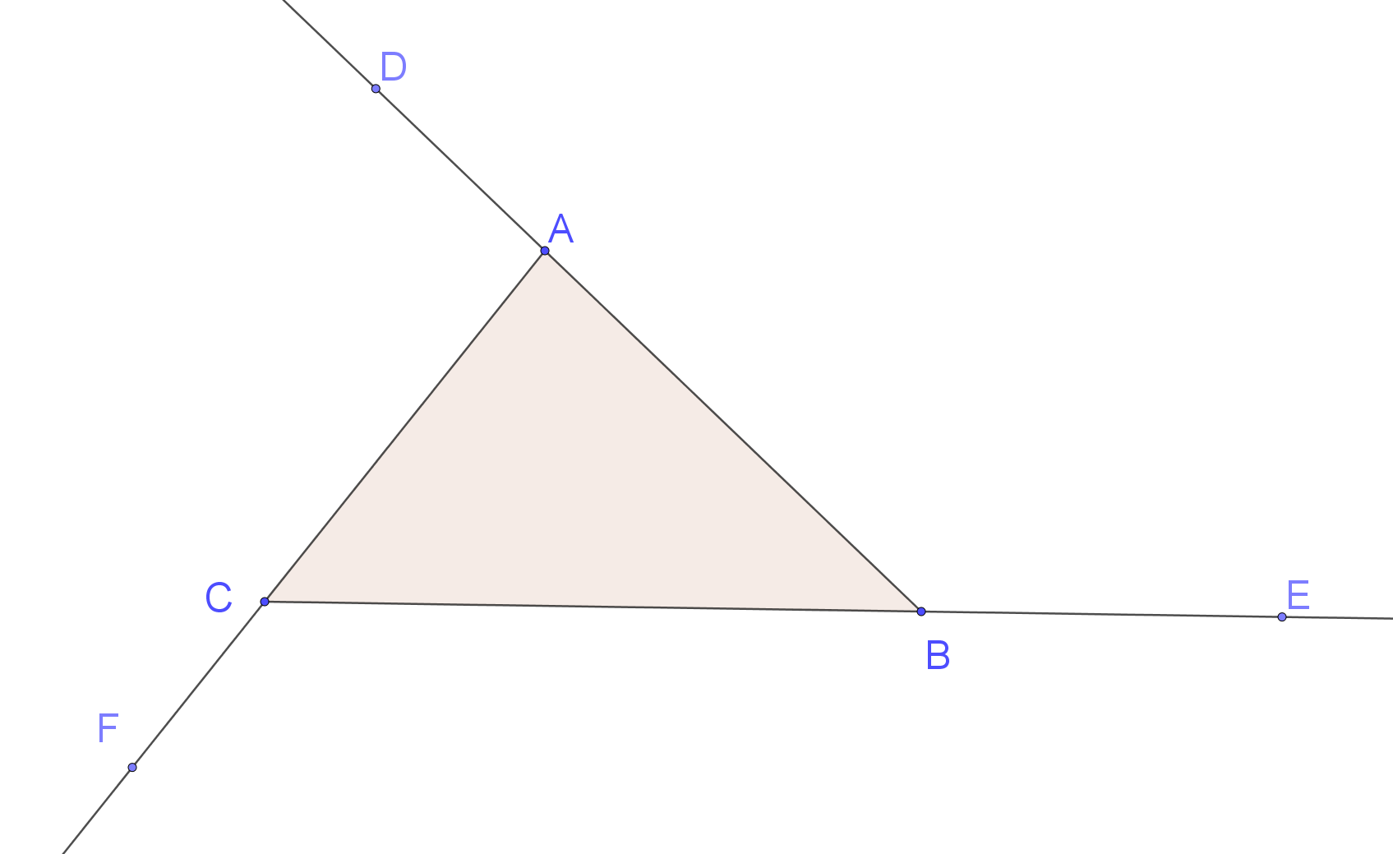
$$ES_{3}=∠DAC+∠FCB+∠EBA$$
$∠DAC+∠CAB=180°$ (supplementary angles)
$∠FCB+∠BCA=180°$ (supplementary angles)
$∠EBA+∠ABC=180°$ (supplementary angles)
$$∠DAC+∠CAB+∠FCB+∠BCA+∠EBA+∠ABC=540°$$
$$∠DAC+∠FCB+∠EBA+\left(∠CAB+∠BCA+∠ABC\right)=540°$$
$∠DAC+∠FCB+∠EBA+180°=540°$ (angle sum of a triangle)
$$∠DAC+∠FCB+∠EBA=540°-180°$$
$$∠DAC+∠FCB+∠EBA=360°$$
$$∴LHS=360°$$
$$=RHS$$
$∴$True for $n=3$

Step 2: Assume that the statement is true for $n=k$
$ES_{k}=360°$

Step 3: Inductive step: Prove the statement to be true for $n=k+1$
Show $ES_{k+1}=360°$
Let the polygon be defined by the points $p_{1}, p_{2}, p_{3},…p_{k},p_{k+1}$, and polygon $k$ is defined by $p_{1}, p_{2}, p_{3},…p_{k},p_{k+1}$(highlighted below)
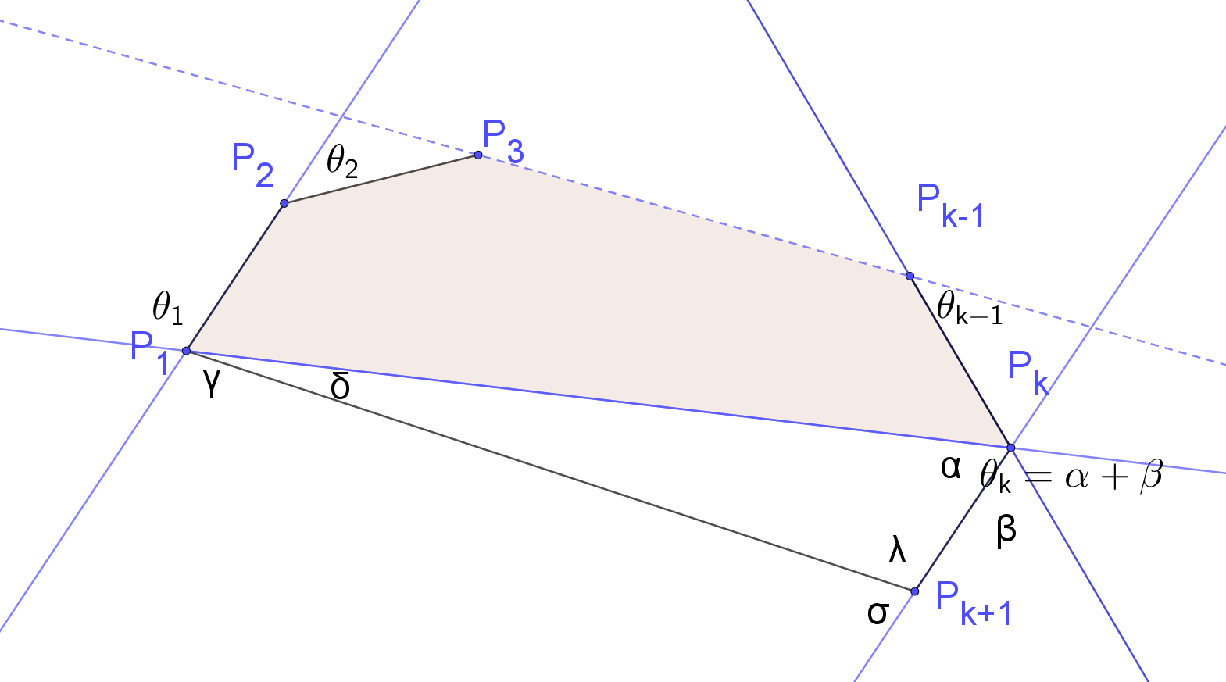
$ES_{k}=θ_{1}+θ_{2}+θ_{3}+…+θ_{k-1}+θ_{k}=360°$(from step 2, the assumption)
$$ES_{k+1}=γ+θ_{2}+θ_{3}+…+θ_{k-1}+β+σ$$
$γ+δ=θ_{1}, γ=θ_{1}-δ$ (vertically opposite angles)
$$β+α=θ_{k}, γ=θ_{k}-α$$
$σ=α+δ$ (exterior angle of a triangle)
$$ES_{k+1}=\left(θ_{1}-δ\right)+θ_{2}+θ_{3}+…+θ_{k-1}+{(θ}_{k}-α)+( α+δ)$$
$$=θ_{1}+θ_{2}+θ_{3}+…+θ_{k-1}+θ_{k}=360°$$
$$∴ES_{k+1}=360°$$
Step 4: Concluding statement: If true for $n=k$, proven true for $n=k+1$. Since true for $n=3$, true for $n=3+1=4$, $n=4+1=5$, … therefore, true for all integers $n≥3$.

- If $n$ straight lines are drawn in the plane, then the total number of intersections cannot exceed $\frac{n(n-1)}{2}$ for $n=1,2,3,…$, $I_{n}=\frac{n(n-1)}{2}$

Step 1: Base case: Prove true for $n=1$
$LHS=I_{1}=0$(zero intersections when one straight line is drawn)
$$RHS=\frac{1(1-1)}{2} =\frac{0}{2}=0$$
$$=LHS$$
$∴$True for $n=1$

Step 2: Assume that the statement is true for $n=k$
$$I_{k}≤\frac{k(k-1)}{2}$$

Step 3: Inductive step: Prove the statement to be true for $n=k+1$
Show $I_{k+1}≤\frac{(k+1)(k+1-1)}{2}$
$$RHS=\frac{\left(k+1\right)k}{2}$$

Let the lines be defined by the $l, l_{2}, l_{3},…l_{k},l_{k+1}$

The maximum number of intersections is equal to the number of intersections from $k$ lines plus all the intersections created by $l_{k+1}$, which is at most $k$intersections if it intersects all other lines.
$$LHS=I_{k+1}≤I_{k}+k$$
Now, $I_{k}≤\frac{k(k-1)}{2}$from step 2 (the assumption)
$$I_{k+1}≤\frac{k(k-1)}{2}+k$$
$$=\frac{k^{2}-k+2k}{2}$$
$$=\frac{k^{2}+k}{2}$$
$$=\frac{k(k+1)}{2}$$
$$=RHS$$

$$∴I_{k+1}≤\frac{(k+1)(k+1-1)}{2}$$

Step 4: Concluding statement: If true for $n=k$, proven true for $n=k+1$. Since true for $n=1$, true for $n=1+1=2$, $n=2+1=3$, … therefore, true for any positive integer $n≥1$.

- Suppose we draw on a plane $n$ lines in ‘general position’, ie with no three concurrent and no two parallel. Let $s_{n}$ be the number of regions into which these lines divide the plane, for example $s_{3}=7$ in the following diagram:
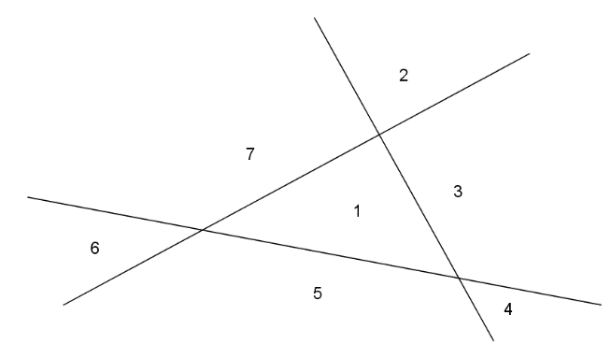
  - By drawing diagrams, find $s_{1}, s_{2}, s_{3}, s_{4}$ and $s_{5}$.

$$s_{1}=2$$
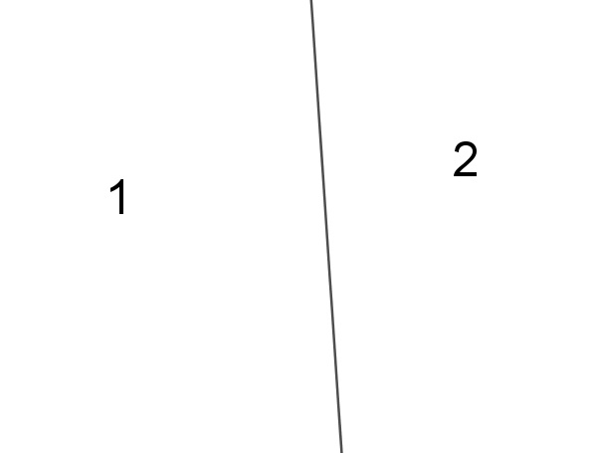
$$s_{2}=4$$
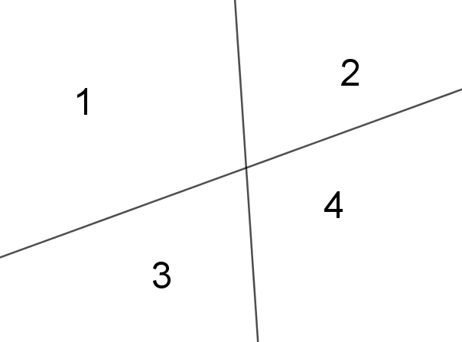
$$s_{3}=7$$
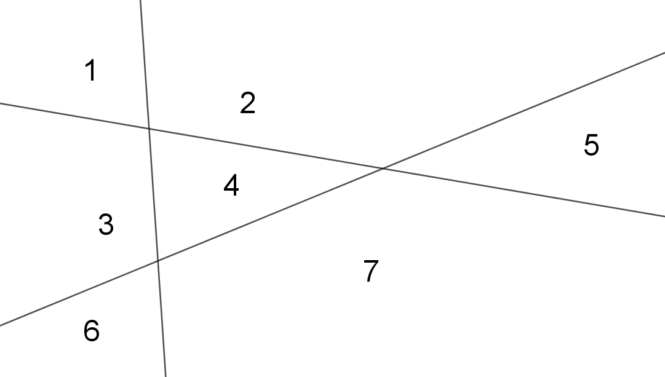
$$s_{4}=11$$
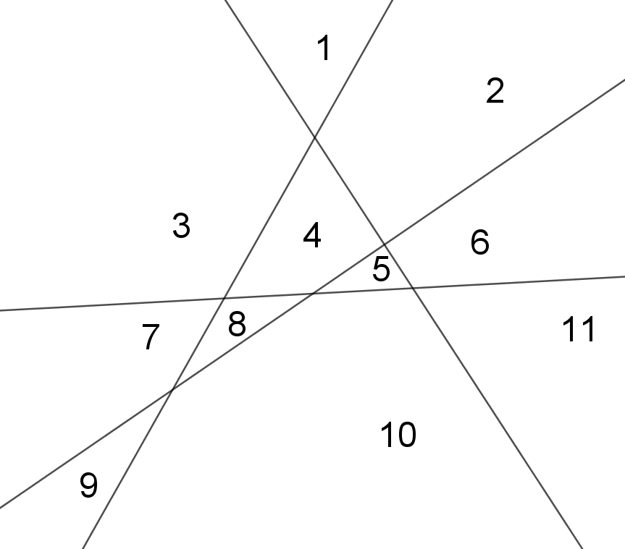

$$s_{5}=16$$
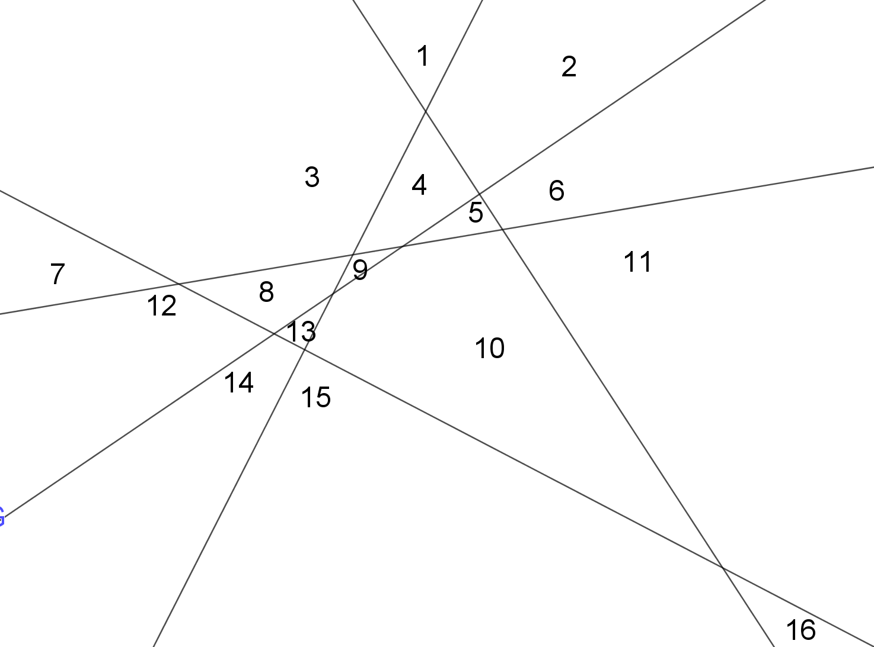
  - From these results, make a conjecture about a formula for $s_{n}$.
Lead the students to the formula:
Method 1: Using a recursive formula:
Recognise that $s_{2}=s_{1}+2, s_{3}=s_{2}+3…$
$$s_{n+1}=s_{n}+\left(n+1\right)$$
$$=s_{n-1}+\left(n-1+1\right)+\left(n+1\right)=s_{n-1}+\left(n+\left(n+1\right)\right)$$
$$=s_{n-2}+\left(n-2+1\right)+n+\left(n+1\right)=s_{n-2}+\left(\left(n-1\right)+n+(n+1)\right)$$
$$=…$$
$$=s_{2}+\left(3+4…+\left(n-1\right)+n+(n+1)\right)$$
$${=s}_{1}+\left(2+3+4…+\left(n-1\right)+n+(n+1)\right)$$
$$=s_{0}+\left(1+2+3+4…+\left(n-1\right)+n+(n+1)\right)$$
$$=1+\left(1+2+3+4…+\left(n-1\right)+n+(n+1)\right)$$
$=1+\frac{\left(n+2\right)\left(n+1\right)}{2}$ (arithmetic sequence with $a=1, number of terms=\left(n+1\right), l=n+1$)
$$s_{n}=1+\frac{n\left(n+1\right)}{2}$$
$$=\frac{n^{2}+n+2}{2}$$
Method 2:
$$s_{n}=\frac{n\left(n-1\right)}{2}+n+1$$
This can be achieved by examining several diagrams in detail such as $s_{4}=11$:
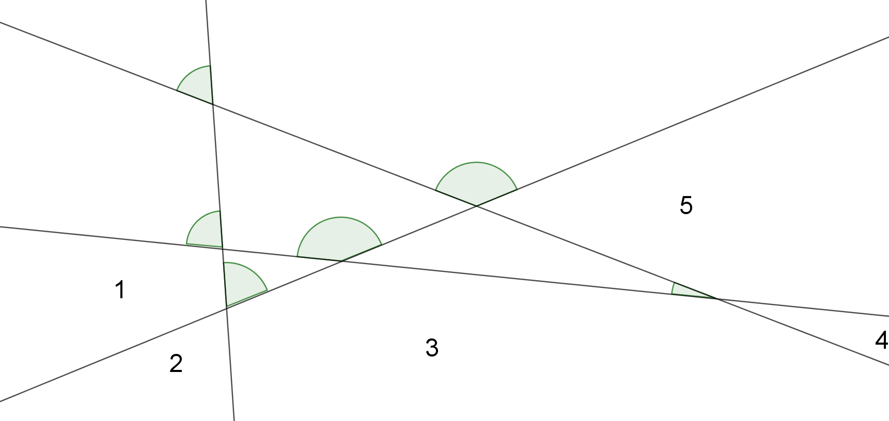
It can be observed every point of intersection is the lowest vertex of some region.
The maximum number of such intersection is $\frac{n(n-1)}{2}$ (see previous question)
There are 5 additional regions, $n+1$ additional regions.

  - Prove this formula by mathematical induction. (NESA topic guidance)
Method 2: Prove $s_{n}=\frac{n^{2}+n+2}{2}$, $n≥0$.
Step 1: Base case: Prove true for $n=1$
$$LHS=s_{1}=2$$
$$RHS=\frac{1^{2}+1-2}{2} =\frac{4}{2}=2$$
$$=LHS$$
$∴$True for $n=1$

Step 2: Assume that the statement is true for $n=k$
$s_{k}=\frac{k^{2}+k+2}{2}$,
Step 3: Inductive step: Prove the statement to be true for $n=k+1$
Show $$s_{k+1}=\frac{({k+1)}^{2}+(k+1)+2}{2}$$
$$RHS=\frac{k^{2}+2k+1+k+1+2}{2}$$
$$=\frac{k^{2}+3k+4}{2}$$
Let the lines be defined by the $l, l_{2}, l_{3},…l_{k},l_{k+1}$
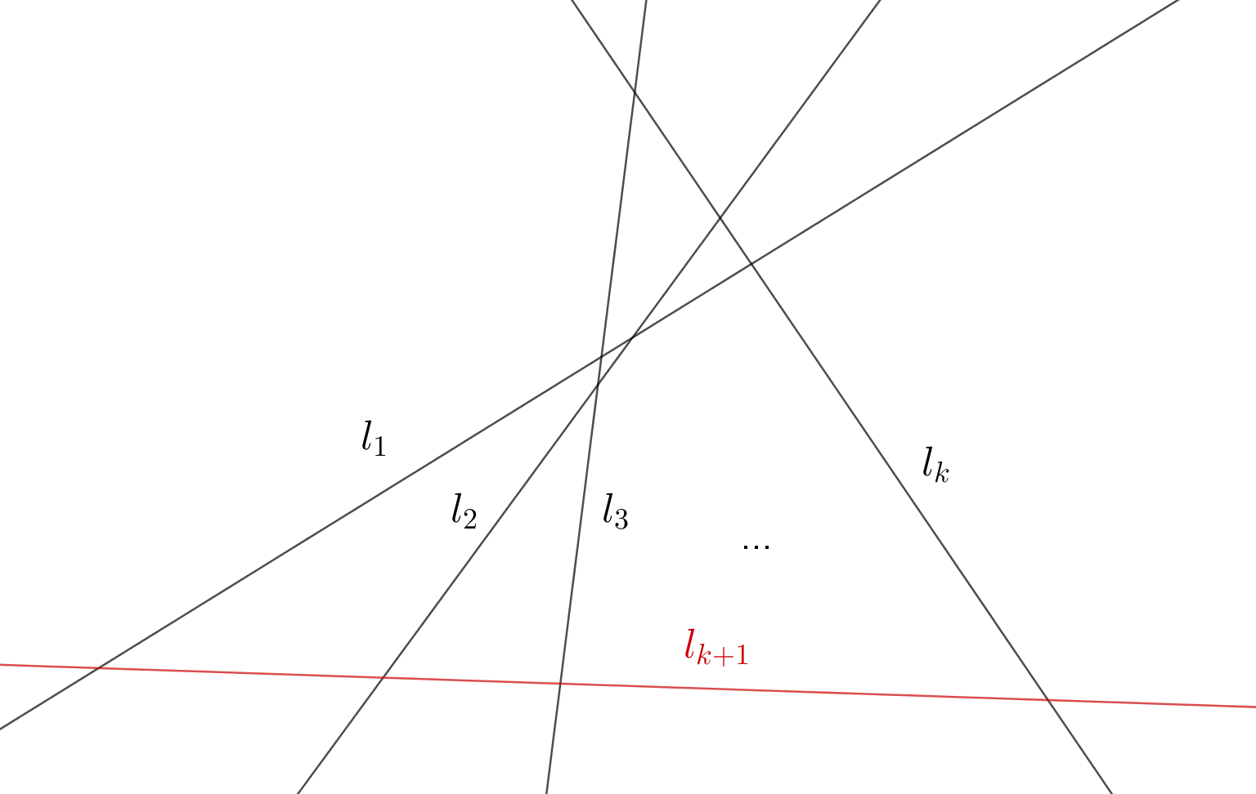
The number of regions can be observed as being the number of regions for $k$ lines plus an additional $k+1$ regions formed when $l_{k+1}$crosses the $k$ existing lines. Note: It can be observed that the additional line creates 5 additional regions when crossing the 4 observable lines.
$$s_{k+1}=s_{k}+\left(k+1\right)$$
Now, $s_{k}=\frac{k\left(k-1\right)}{2}+k+1$from step 2 (the assumption)
$$=\frac{k^{2}+k+2}{2}+k+1$$
$$=\frac{k^{2}+k+2}{2}+\frac{2k+2}{2}$$
$$=\frac{k^{2}+k+2+2k+2}{2}$$
$$=\frac{k^{2}+3k+4}{2}$$
$$=RHS$$
$$∴s_{k+1}=\frac{(k+1)\left((k+1)-1\right)}{2}+(k+1)+1$$
Step 4: Concluding statement: If true for $n=k$, proven true for $n=k+1$. Since true for $n=0$, true for $n=0+1=1$, $n=1+1=2$, … therefore, true for any positive integer $n≥1$.
Method 2: Prove $s_{n}=\frac{n\left(n-1\right)}{2}+n+1$, $n≥0$.
Step 1: Base case: Prove true for $n=1$
$$LHS=s_{1}=2$$
$$RHS=\frac{1(1-1)}{2}+1+1 =\frac{0}{2}+1+1=2$$
$$=LHS$$
$∴$True for $n=1$

Step 2: Assume that the statement is true for $n=k$
$$s_{k}=\frac{k\left(k-1\right)}{2}+k+1$$
Step 3: Inductive step: Prove the statement to be true for $n=k+1$
Show $$s_{k+1}=\frac{(k+1)\left((k+1)-1\right)}{2}+(k+1)+1$$
$$RHS=\frac{\left(k+1\right)k}{2}+k+2$$
Let the lines be defined by the $l, l_{2}, l_{3},…l_{k},l_{k+1}$
The number of regions can be observed as being the number of regions for $k$ lines plus an additional $k+1$ regions formed when $l_{k+1}$crosses the $k$ existing lines. Note: It can be observed that the additional line creates 5 additional regions when crossing the 4 observable lines.
$$s_{k+1}=s_{k}+\left(k+1\right)$$
Now, $s_{k}=\frac{k\left(k-1\right)}{2}+k+1$from step 2 (the assumption)
$$=\frac{k\left(k-1\right)}{2}+k+1+k+1$$
$$=\frac{k\left(k-1\right)}{2}+k+k+2$$
$$=\frac{k\left(k-1\right)}{2}+\frac{2k}{2}+k+2$$
$$=\frac{k^{2}-k+2k}{2}+k+2$$
$$=\frac{k^{2}+k}{2}+k+2$$
$$=\frac{k(k+1)}{2}+k+2$$
$=RHS$
$$∴s_{k+1}=\frac{(k+1)\left((k+1)-1\right)}{2}+(k+1)+1$$

Step 4: Concluding statement: If true for $n=k$, proven true for $n=k+1$. Since true for $n=0$, true for $n=0+1=1$, $n=1+1=2$, … therefore, true for any positive integer $n≥1$.

- For $n ≥ 3$, the sum of the interior angles of a polygon with n vertices is $180(n - 2)°$.
Prove $AS_{n}=180(n - 2)°$

Step 1: Base case: Prove true for $n=3$
$LHS=AS_{3}=180°$ (angle sum of a triangle)
$$RHS=180(3 - 2)° =180°$$
$$=LHS$$
$∴$True for $n=3$

Step 2: Assume that the statement is true for $n=k$
$$AS_{k}=180(k - 2)°$$

Step 3: Inductive step: Prove the statement to be true for $n=k+1$
Show $AS_{k+1}=180(k+1-2)°$
$$RHS=180(k-1)°$$
Let the polygon be defined by the points $p_{1}, p_{2}, p_{3},…p_{k},p_{k+1}$

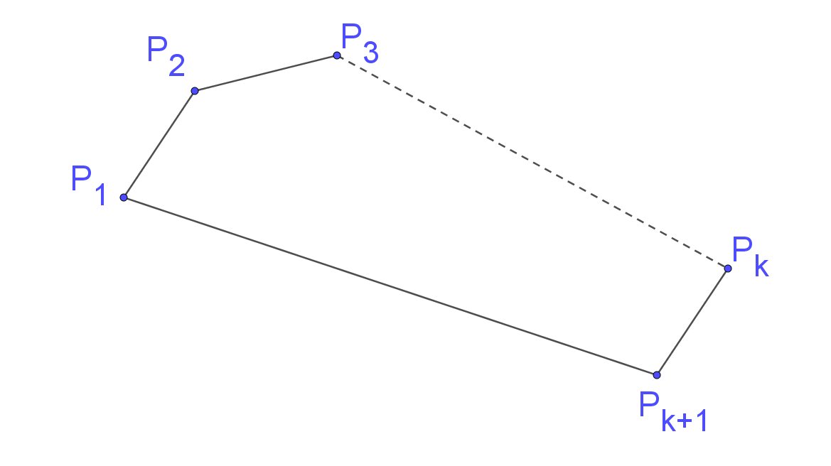
Join $P_{k} and P_{1}$
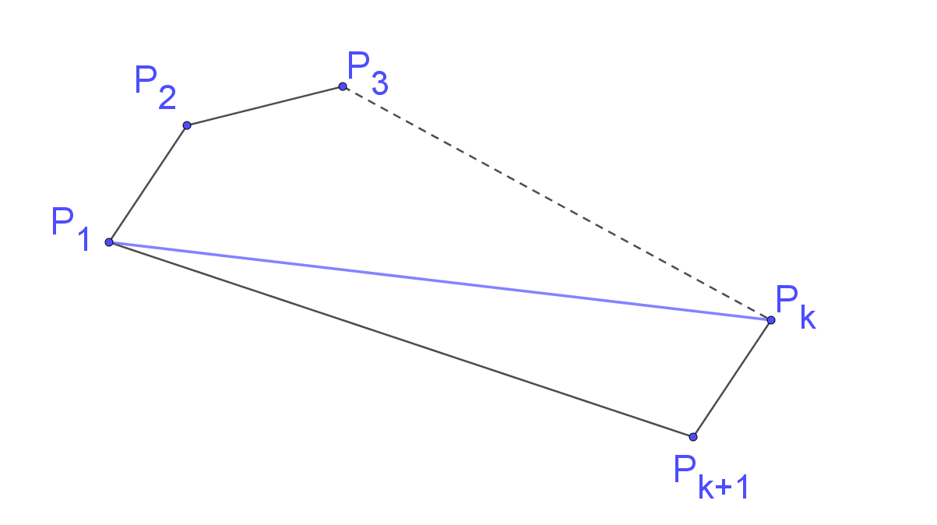
$$LHS=AS_{k+1}$$
$=AS_{k}+180°$ (base case)
Now, $AS_{k}=180(k - 2)°$from step 2 (the assumption)
$$AS_{k+1}=180(k - 2)° +180$$
$$=180(k+1 - 2)°$$
$$=180(k-1)°$$
$$=RHS$$

$$∴ AS_{k+1}=180(k+1-2)°$$

Step 4: Concluding statement: If true for $n=k$, proven true for $n=k+1$. Since true for $n=3$, true for $n=3+1=4$, $n=4+1=5$, … therefore, true for any positive integer $n≥3$.

- An $n$-sided plane convex polygon has $\frac{n(n-3)}{2}$ diagonals for $n=4, 5, 6…$, $d_{n}=\frac{n(n-3)}{2}$

Step 1: Base case: Prove true for $n=3$
$LHS=d_{3}=0$ (diagonals of a triangle)
$$RHS=\frac{3(3-3)}{2} =\frac{0}{2}=0$$
$$=LHS$$
$∴$True for $n=3$

Step 2: Assume that the statement is true for $n=k$
$$d_{k}=\frac{k(k-3)}{2}$$

Step 3: Inductive step: Prove the statement to be true for $n=k+1$
Show $d_{k+1}=\frac{(k+1)(k+1-3)}{2}$
$$RHS=\frac{\left(k+1\right)(k-2)}{2}$$

Let the polygon be defined by the points $p_{1}, p_{2}, p_{3},…p_{k},p_{k+1}$

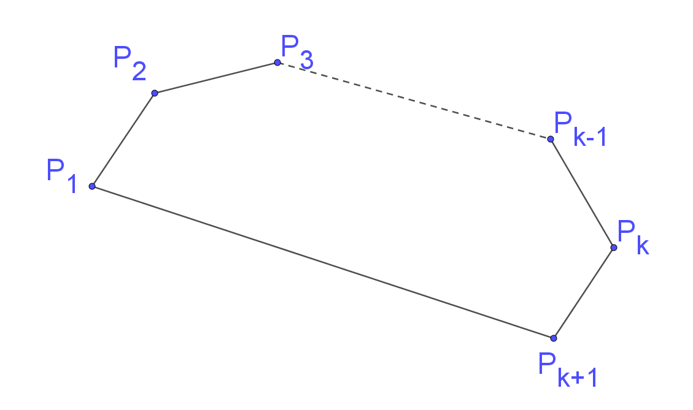
The number of diagonals is equal to the number of diagonals from a polygon with k sides plus all the diagonals from the point $P_{k+1}$and the diagonal from $P_{k}$to $P_{1}$.
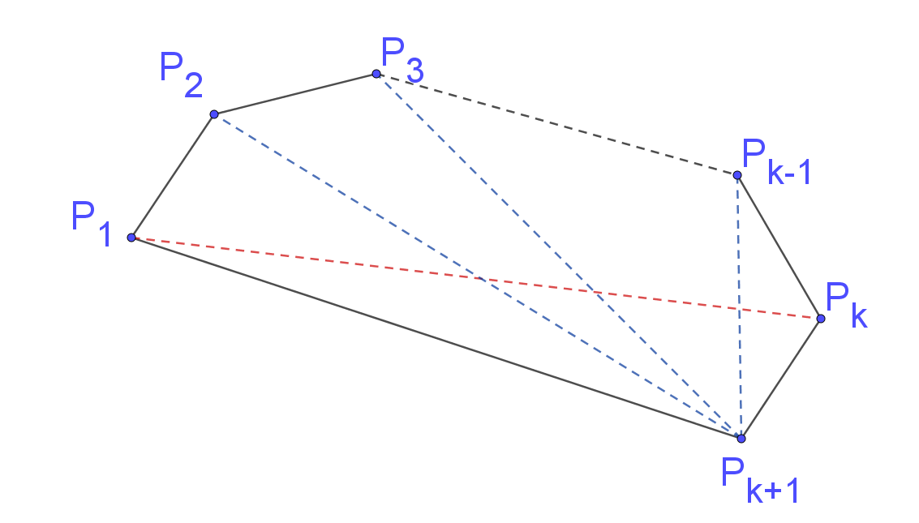
Diagonals from point $P_{k+1}$ join to points $p_{2}, p_{3},…p_{k-1}$, gives ($k-2$) diagonals from $p_{k+1}$ and one diagonal from $p_{1}$ to $p_{k}$.
There is a total of $k-1$ additional diagonals.
$$LHS=d_{k+1}$$
$$=d_{k}+k-1$$
Now, $d_{k}=\frac{k(k-3)}{2}$from step 2 (the assumption)
$$=\frac{k(k-3)}{2}+(k-1)$$
$$=\frac{k^{2}-3k+2k-2}{2}$$
$$=\frac{k^{2}-k-2}{2}$$
$$=\frac{\left(k+1\right)\left(k-2\right)}{2}$$
$$=RHS$$

$$∴d_{k+1}=\frac{(k+1)(k+1-3)}{2}$$

Step 4: Concluding statement: If true for $n=k$, proven true for $n=k+1$. Since true for $n=3$, true for $n=3+1=4$, $n=4+1=5$, … therefore, true for any positive integer $n≥3$.

Proving first-order recursive formula
- A sequence is given by the recursive formula $a_{1}=1, a_{n+1}=2a_{n}+1$ for $n≥1.$ Prove the general formula for the sequence is $a_{n}=2^{n}-1$

Step 1: Base case: Prove true for $n=1$
$${LHS=a}_{1}=1$$
$$RHS=2^{1}-1=1=LHS$$
$∴$True for $n=1$

Step 2: Assume that the statement is true for $n=k$
$$a_{k}=2^{k}-1$$
Step 3: Inductive step: Prove the statement to be true for $n=k+1$
Show $a_{k+1}=2^{k+1}-1$
$LHS=2a_{k}+1$ (recursive formula)
Now, $a_{k}=2^{k}+1$, from step 2 (the assumption)
$$LHS=2\left(2^{k}-1\right)+1 \\ =2×2^{k}-2+1 \\ =2^{k+1}-1 \\ =RHS$$
$$∴a_{k+1}=2^{k+1}-1$$
Step 4: Concluding statement: If true for $n=k$, proven true for $n=k+1$. Since true for $n=1$, true for $n=1+1=2$, $n=2+1=3$, … therefore, true for all integers $n≥1$.
- A sequence is given by the recursive formula $a_{1}=7, a_{n+1}=2a_{n}+3$ for $n≥1.$ Prove the general formula for the sequence is $a_{n}=5(2^{n})-3$

Step 1: Base case: Prove true for $n=1$
$${LHS=a}_{1}=7$$
$$RHS=5\left(2^{1}\right)-3=10-3=7=LHS$$
$∴$True for $n=1$

Step 2: Assume that the statement is true for $n=k$
$$a_{k}=5(2^{k})-3$$

Step 3: Inductive step: Prove the statement to be true for $n=k+1$
Show $a_{k+1}=5(2^{k+1})-3$
$LHS=2a_{k}+3$ (recursive formula)
Now, $a_{k}=5(2^{k})-3$, from step 2 (the assumption)
$$LHS=2\left(5(2^{k})-3\right)+3 \\ =5×2^{1}×2^{k}-6+3 \\ ={5(2}^{k+1})-3 \\ =RHS$$
$$∴a_{k+1}=5(2^{k+1})-3$$

Step 4: Concluding statement: If true for $n=k$, proven true for $n=k+1$. Since true for $n=1$, true for $n=1+1=2$, $n=2+1=3$, … therefore, true for all integers $n≥1$.

- A sequence is given by the recursive formula $a_{1}=1, a_{n+1}={a_{n}}^{2}+(2n+1)$ for $n≥1.$ Prove the general formula for the sequence is $a_{n}=n^{2}$

Step 1: Base case: Prove true for $n=1$
$${LHS=a}_{1}=1$$
$$RHS=1^{2}=1=LHS$$
$∴$True for $n=1$

Step 2: Assume that the statement is true for $n=k$
$$a_{k}=k^{2}$$
Step 3: Inductive step: Prove the statement to be true for $n=k+1$
Show $a_{k+1}={\left(k+1\right)}^{2}$
$LHS={a_{k}}^{2}+(2k+1)$(recursive formula)
Now, $a_{k}=k^{2}$, from step 2 (the assumption)
$$LHS=k^{2}+2k+1 \\ ={\left(k+1\right)}^{2} \\ =RHS$$

Step 4: Concluding statement: If true for $n=k$, proven true for $n=k+1$. Since true for $n=1$, true for $n=1+1=2$, $n=2+1=3$, … therefore, true for all integers $n≥1$.
- A sequence is given by the recursive formula $a_{1}=1, a_{n+1}=(n+1)a_{n}$ for $n≥1.$ Prove the general formula for the sequence is $a_{n}=n!$

Step 1: Base case: Prove true for $n=1$
$${LHS=a}_{1}=1$$
$$RHS=1!=1=LHS$$
$∴$True for $n=1$

Step 2: Assume that the statement is true for $n=k$
$a_{k}=k!$
Step 3: Inductive step: Prove the statement to be true for $n=k+1$
Show $a_{k+1}=\left(k+1\right)!$
$LHS=(k+1)a_{k}$(recursive formula)
Now, $a_{k}=k!$, from step 2 (the assumption)
$$LHS=\left(k+1\right)k! \\ =\left(k+1\right)×1×2×3…×k \\ =1×2×3…×k×\left(k+1\right)$$
$$=\left(k+1\right)!$$
$$=RHS$$
$∴a_{k+1}=\left(k+1\right)!$
Step 4: Concluding statement: If true for $n=k$, proven true for $n=k+1$. Since true for $n=1$, true for $n=1+1=2$, $n=2+1=3$, … therefore, true for all integers $n≥1$.

