Year 12 Mathematics Extension 2
MEX-N2 Using complex numbers | Unit duration
The topic Complex Numbers involves investigating and extending understanding of the real number system to include complex numbers. The use of complex numbers is integral to many areas of life and modern-day technology such as electronics.  A knowledge of complex numbers enables exploration of the ways different mathematical representations inform each other, and the development of understanding of the relationship between algebra, geometry and the extension of the real number system.  The study of complex numbers is important in developing students’ understanding of the interconnectedness of mathematics and the real world. It prepares students for further study in mathematics itself and its applications. | 4 to 5 weeks

Subtopic focus | Outcomes
The principal focus of this subtopic is to develop and to apply knowledge of complex numbers to situations involving trigonometric identities, powers and vector representations in a complex number plane.  Students develop an understanding of the interconnectedness of complex numbers across various mathematical topics and their applications in real life. An important application of complex numbers is that the solutions of polynomial equations of any degree can be written in a form that uses complex numbers. Geometrically, complex numbers are represented as points in a plane and may be represented using polar coordinates or as vectors. In these forms they provide useful models for many scientific quantities and are used, for example in physics and electronics. | A student:  - understands and uses different representations of numbers and functions to model, prove results and find solutions to problems in a variety of contexts MEX12-1  - uses the relationship between algebraic and geometric representations of complex numbers and complex number techniques to prove results, model and solve problems MEX12-4  - applies various mathematical techniques and concepts to model and solve structured, unstructured and multi-step problems MEX12-7  - communicates and justifies abstract ideas and relationships using appropriate language, notation and logical argument MEX12-8

Prerequisite knowledge | Assessment strategies
The material in this topic builds on content from the Mathematics Extension 1 topics of ME-F2 Polynomials and ME-P1 Proof by Mathematical Induction and the Mathematics Extension 2 topic of MEX-N1 Introduction to complex numbers | - Staff should utilise ICT resources, like Geogebra apps, to run simulations and gauge students’ understanding by asking ‘what if’ style questions. Students mastery of key skills can be assessed using mini-whiteboard activities, or similar, to quickly identify misconceptions and direct students toward the intended outcome. Spot tests of key questions can inform future practice, while providing feedback to students.
All outcomes referred to in this unit come from Mathematics Extension 2 Syllabus
© NSW Education Standards Authority (NESA) for and on behalf of the Crown in right of the State of New South Wales, 2017

Glossary of terms
Term | Description
Argument and principal argument of a complex number | When a complex number $z$ is represented by a point $P$ in the complex plane then the argument of $z$, denoted $arg z$, is the angle $θ$ that $OP$ (where $O$ denotes the origin) makes with the positive real axis $O_{x}$, with the angle measured from $O_{x}$.  If the argument is restricted to the interval $(-π, π]$, this is called the principal argument and is denoted by $Arg z$.
Cartesian form of a complex number | The Cartesian form of a complex number ($z$) is$z=x+iy$, where $x$ and $y$ are real numbers and $i$ is the imaginary number. Also known as standard or rectangular form.
Complex conjugate | The complex conjugate of the number $z=a+ib$ is given by $\overline{z}=a-ib$, where $a$ and $b$ are real numbers. A complex number and its conjugate are called a conjugate pair.
Complex plane | A complex plane is a Cartesian plane in which the horizontal axis is the real axis and the vertical axis is the imaginary axis. The complex plane is sometimes called the Argand plane. Geometric plots in the complex plane are known as Argand diagrams.
De Moivre’s theorem | De Moivre’s theorem states that for all integers $n$:  $${[r(cos θ + i sin θ)]}^{n}=r^{n}(cos nθ + i sin nθ)$$  In exponential form, when $r=1,$ De Moivre’s theorem is simply a statement of the law of indices: ${\left(e^{iθ}\right)}^{n}=e^{inθ}$
Euler’s formula | Euler’s formula states that for any real number $θ$: $e^{iθ}=cos θ + i sin θ$
Exponential form of a complex number | The complex number $z=a+ib$ can be expressed in exponential form as$z=re^{iθ}$, where $r$ is the modulus of the complex number and $θ$ is the argument expressed in radians.
Polar form of a complex number | The complex number $z=a+ib$ can be expressed in polar form as:  $z=r cosθ+ri sinθ=r\left(cosθ+i sinθ\right),$ where $r$ is the modulus of the complex number and $θ$ is its argument expressed in radians. This is also known as modulus-argument form.
Roots of unity | A complex number $z$ is an $n$^{th} root of unity if $z^{n}=1$.  The points in the complex plane representing the roots of unity lie on the unit circle and are evenly spaced.

Lesson sequence | Content  Students learn to: | Suggested teaching strategies and resources | Date and initial | Comments, feedback, additional resources used
De Moivre’s theorem (1 lesson) | N2.1: Solving equations with complex numbers  - use De Moivre’s theorem with complex numbers in both polar and exponential form AAM  - prove De Moivre’s theorem for integral powers using proof by induction (ACMSM083)  - use De Moivre’s theorem to derive trigonometric identities such as  $$\sin{3θ}=3\cos^{2}{θ\sin{θ}}-\sin^{3}{θ}$$ | De Moivre’s theorem:  $${z^{n}=[r(cos θ + i sin θ)]}^{n}=r^{n}(cos nθ + i sin nθ)$$  - De Moivre’s theorem formalises the results obtained when evaluating powers of complex numbers expressed in polar form which were examined in N1 Introduction to complex numbers.  - Students use mathematical induction to prove De Moivre’s theorem for integral powers.  - Students use De Moivre’s theorem to prove trigonometric identities.  It is regularly assumed that $r=1$when proving such identities: i.e. $z=\cos{θ}+i\sin{θ}$  - When finding multiple angle results, like $\sin{3θ}$ where $n$ is the multiple, form two statements both starting with ${\left(\cos{θ+i\sin{θ}}\right)}^{n}$.  For statement 1, use De Moivre’s theorem to form an expression in the form $\cos{nθ+i\sin{nθ}}$ and for statement 2, expand the brackets. Finally equate the real or imaginary parts from statements 1 and 2, depending on whether the $cos$ or $sin$ identity is being found.  See the resource de-moivres-theorem.DOCX for model solutions.  - When finding the power of a trig function, use the following identities as they will be used within the solution:  If $z=\cos{θ}+i\sin{θ}$  then $z^{-1}=\cos{-θ}+i\sin{-θ}$  $$=\cos{θ-i\sin{θ}}$$  Therefore $z+z^{-1}=2\cos{θ}$ and $z-z^{-1}=2\sin{θ}i$  $$z^{n}=\cos{nθ}+i\sin{nθ}$$  $$z^{-n}=\cos{-nθ}+i\sin{-nθ}$$  $$=\cos{nθ}-i\sin{nθ}$$  $z^{n}+z^{-n}=2\cos{nθ}$ and $z^{n}-z^{-n}=2\sin{nθ}i$  For finding identities with a power of $\cos^{n}{θ}$ as the subject, like $\cos^{3}{θ}$, form two statements starting with ${\left(z+z^{-1}\right)}^{n}$.  For statement 1, use identity above to form the expression ${\left(2\cos{θ}\right)}^{n}$ and simplify.  $$z+z^{-1}=2\cos{θ}$$  $${\left(z+z^{-1}\right)}^{3}={\left(2\cos{θ}\right)}^{3} \\ =8\cos^{3}{θ}$$  For statement 2, expand the brackets  e.g. if $n=3$ then ${\left(z+z^{-1}\right)}^{3}=z^{3}+3z+3z^{-1}+z^{-3}$  and pair powers of $z$ with similar negative powers.  $$=z^{3}+z^{-3}+3(z+z^{-1})$$  Use the identity above  $$=2\cos{3θ+3(2\cos{θ}})$$  Match the statements 1 and 2 and simplify to determine the desired result.  $$8\cos^{3}{θ}=2\cos{3θ+3(2\cos{θ}})$$  $$\cos^{3}{θ}=\frac{1}{4}\cos{3θ+\frac{3}{4}\cos{θ}}$$  For finding identities with a power of $\sin^{n}{θ}$ as the subject, like $\sin^{3}{θ}$, form two statements starting with ${\left(z-z^{-1}\right)}^{n}$. Repeat the process above using identities and instead.  Sample identities:  - $\sin{3θ}=3\cos^{2}{θ\sin{θ}}-\sin^{3}{θ}$  - $\cos{3θ}=4\cos^{3}{θ}-3\cos{θ}$  - $\tan{3θ=}\frac{3\tan{θ-\tan^{3}{θ}}}{1-3\tan^{2}{θ}}$  - $\tan{4θ}=\frac{4\tan{θ-4\tan^{3}{θ}}}{1-{6tan}^{2}{θ}+\tan^{4}{θ}}$  - $\cos^{4}{θ}=\frac{1}{8}\left(\cos{4θ}+4\cos{2θ+3}\right)$  Resource: de-moivres-theorem.DOCX  Note: This file contains the proof by mathematical inductions and the application of De Moivre’s theorem to prove the sample trigonometric identities.
Quadratic equations  (1 lesson) | N2.1: Solving equations with complex numbers  - determine the solutions of real quadratic equations  - define and determine complex conjugate solutions of real quadratic equations (ACMSM075) AAM  - solve quadratic equations of the form ${ax}^{2}+bx+c=0$, where $a,b,c$ are complex numbers AAM | Real Quadratic equations  - Define real quadratic equations as quadratic equations with real coefficients.  Review the number of roots (solutions) a quadratic equation has: Discriminant $=∆=b^{2}-4ac$  - $∆>0$, 2 unequal real roots (2 solutions)  - $∆=0$, 2 equal real roots (2 equal solutions)  - $∆<0$, no real roots (2 complex solutions)  - The teacher models solving a quadratic equation using the quadratic formula or by completing the square. Example: $z^{2}+4z+7=0$ leads to solutions $z=-2-\sqrt{3}i$ and $z=-2+\sqrt{3}i$  Students note solutions follow the form $a±ib$. They are complex conjugates of each other.  The teacher defines ‘complex conjugate solutions’ as the complex solutions to real quadratic equations which have no real roots.  It can be shown that the complex conjugate solutions satisfy that the:  - $Sum of the roots = \frac{-b}{a}$  - $Product of the roots = \frac{c}{a}$  - Students practice solving quadratic equations with real coefficients.  Quadratic equations with complex coefficients  - The teacher defines these as quadratic equations of the form ${ax}^{2}+bx+c=0$, where $a,b,c$ are complex numbers.  - The teacher models solving quadratic equations with complex coefficients. The resource file contains three examples:  - $ix^{2}-i=0$  This results in two real solutions.  - $ix^{2}-x+12i=0$  - $x^{2}-4\left(1+i\right)x+10i=0$  The solution requires finding the square root of a complex number.  Resource: quadratic-equation-with-complex-coefficients.DOCX  - Students practice solving quadratic equations with complex coefficients.  - Solutions can be checked by substituting back into the original quadratic equation.  - Solutions can be checked using online calculators such as Wolfram alpha or Symbolab  Note: Students may need to review the square root of complex numbers. (See N1 Introduction to complex numbers)
Polynomials  (1 lesson) | N2.1: Solving equations with complex numbers  - determine conjugate roots for polynomials with real coefficients (ACMSM090) AAM  - solve problems involving real polynomials with conjugate roots | Polynomials  - Any polynomial $p\left(x\right)=a_{n}x^{n}+a_{n-1}x^{n-1}+…+a_{1}x{+a}_{0}, a_{n}≠0$, has $n$ real or complex roots.  - If the coefficients are all real, then complex roots occur in conjugate pairs ($a±ib)$  - If the coefficients are complex, the complex roots need not be related.  - Students need to determine the roots of polynomials with real given their complex roots will always occur in conjugate pairs.  - The teacher models the methods to determine conjugate roots for polynomials with real coefficients  The resource file contains solutions for the following examples:  - Factorise and determine the roots to the polynomial $P\left(x\right)=x^{3}-3x^{2}+6x-4$  - Factorise and determine the roots to the polynomial $P\left(x\right)=x^{5}-3x^{3}-4x$  - Factorise and determine the roots to the polynomial $P\left(x\right)=x^{3}+2x^{2}+2x+4$  - Factorise and determine the roots to the polynomial $P\left(x\right)=2x^{4}+2x^{3}-11x^{2}-4x+20$  Methods: Determine a zero by inspection or  look for polynomials which are reducible to quadratics.  - Given $2-3i$ is a zero of $P\left(x\right)=x^{4}-7x^{3}+27x^{2}-47x+26$find all roots of p(x).  Method: Recognise that complex roots always occur in conjugate pairs.  Resource: polynomials-with-complex-roots.DOCX  - Students practice solving real polynomials with conjugate roots.
Complex numbers as vectors  (1 lesson) | N2.2: Geometrical implications of complex numbers  - examine and use addition and subtraction of complex numbers as vectors in the complex plane (ACMSM084) AAM  - given the points representing $z_{1}$ and $z_{2}$, find the position of the points representing $z_{1}+z_{2}$ and $z_{1}-z_{2}$  - describe the vector representing $z_{1}+z_{2}$ or $z_{1}-z_{2}$ as corresponding to the relevant diagonal of a parallelogram with vectors representing $z_{1}$ and $z_{2}$ as adjacent sides | Complex numbers as vectors  - Represent complex numbers as vectors.  The complex number $z=a+ib$ can be represented by the position vector $OA$ where $A$ is the point $(a, b)$  - Given the points representing $z_{1}$ and $z_{2}$  - Find the position of the points representing $z_{1}+z_{2}$ and $z_{1}-z_{2}$.  - On the argand plane, sketch the parallelogram with vectors $z_{1}$ and $z_{2}$ as adjacent sides.  - Describe the vectors $z_{1}+z_{2}$ and $z_{1}-z_{2}$in terms of the relevant diagonals of the parallelogram.  - Students practice using addition and subtraction of complex numbers as vectors in the complex plane.  Resources:  - Complex numbers as vectors Geogebra applet.  - Wootube videos:  - Introduction and addition (duration 9:28)  - Geometric meaning of addition(duration 10:20)  - Subtraction (duration 7:20)  - Geometric meaning of subtraction (duration 7:41)
Geometric interpretation of multiplying complex numbers (1 lesson) | N2.2: Geometrical implications of complex numbers  - examine and use the geometric interpretation of multiplying complex numbers, including rotation and dilation in the complex plane  - recognise and use the geometrical relationship between the point representing a complex number $z=a+ib$, and the points representing $\overline{z}$, $cz$ (where $c$ is real) and $iz$ | Geometric interpretations of multiplying complex numbers:  Dilations in the complex plane  - Examples:  - Let $z=a+ib$, e.g. $z=2+3i$  - Find $cz$ where $c$ is real. Consider a range of values for $c$including where $c$ is greater than $1$ (positive and negative), equal to $±1$ and less than $1$.  - Plot $z$ and $cz$ on an argand diagram.  - Given $z_{n},$ how do you geometrically obtain $cz$?  Summarise: the geometrical relationship between the point representing a complex number $z=a+ib$ and $cz$: Dilation of $\vec{0z}$ by a factor of $c$  The complex conjugate – a reflection  - Example:  - Let $z=a+ib$, e.g. $z=2+3i$  - Find $\overline{z}$  - Plot $z$ and $\overline{z}$ on an argand diagram.  - Given $z,$ how do you geometrically obtain $\overline{z}$?  - Summarise: the geometrical relationship between the point representing a complex number $z=a+ib$ and $\overline{z}$: Reflection of $z$ across the $x$-axis.  Rotations in the complex plane  - Example 1:  - Let $z_{1}=1,$  - By repeatedly multiplying by $i$, find $z_{1},{ z}_{2}$ and$z_{3}.$  i.e. $z_{2}=z_{1}×i$, $z_{3}=z_{2}×i$, $z_{4}=z_{3}×i$  - Plot each point on an argand diagram.  - Given $z_{n},$ how do you geometrically obtain $z_{n+1}$?  - Example 2:  - Let $z_{1}=a+ib$, e.g. $z=2+3i$  - By repeatedly multiplying by $i$, find $z_{1},{ z}_{2}$ and$z_{3}.$  - Plot each point on an argand diagram.  - Given $z_{n},$ how do you geometrically obtain $z_{n+1}$?  - Summarise: the geometrical relationship between the point representing a complex number $z=a+ib$ and $iz$: Anti-clockwise rotation of $z$ about the origin by $90°.$  Resources:  - Visual shown in Geogebra applet  - Wootube: Multiplying complex numbers 1 and 2  - Khan academy: Multiplying complex numbers 1 and 2. Note: Uses $j$ as the complex number.  - Optional: Geometrical implication of multiplying by $-i$  Multiplying complex numbers.  - Example:  - Choose two complex numbers $z_{1}=a+ib$ and $z_{2}=c+id$ where $a, b, c,$and $d$ are real.  - Calculate $z_{1}z_{2}$  - Calculate the modulus and argument of $z_{1}, z_{2}$ and $z_{1}z_{2}$  - Plot $z_{1}, z_{2}$ and $z_{1}z_{2}$ on an argand diagram.  - Given $z_{1}$ and $z_{2},$ how do you geometrically obtain$z_{1}z_{2}$?  - Summarise: the geometrical relationship between $z_{1}$, $z_{2}$and$z_{1}z_{2}$.  It can be useful to reconsider the polar form of each $z_{1}=r_{1}e^{iθ_{1}}$, $z_{2}=r_{2}e^{iθ_{2}}$ and $z_{1}z_{2} =\left(r_{1}r_{2}\right)e^{i(θ_{1}+θ_{2})}$  Resources:  - Geogebra applet on multiplying 1.  - Geogebra applet on multiplying 2  - Geogebra applet examining transformations
Roots of unity  (2 lesson) | N2.2: Geometrical implications of complex numbers  - determine and examine the $n$^{th} roots of unity and their location on the unit circle (ACMSM087)  - determine and examine the $n$^{th} roots of complex numbers and their location in the complex plane (ACMSM088)  - solve problems using $n$^{th} roots of complex numbers AAM | Roots of unity  - Define roots of unit:  A complex number z is an $n$^{th} root of unity if $z^{n}=1$.  i.e. Solutions to the equation $z^{n}=1$.  Note: There are $n$ $n$^{th} roots of unity.  - Key question: If $z^{n}=1$, what is the modulus of $z$?  Show that the modulus of all roots of unity must be 1 and therefore lie on the unit circle.  - Teacher models finding the $n$^{th} roots of unity and the $n$^{th} roots of unity for a given value of $n$. e.g. $n=3$.  - Student investigation: Students find the $n$^{th} roots of unity for $n=1, 2, 3, 4, 5…$ and investigate their location on the unit circle in the argand plane.  Resource:  - Solving roots of unity applet  - roots-of-unity.DOCX. This document contains:  - The modulus of roots of unity  - General solution for $z^{n}=1$  - Modelled solution for $z^{3}=1$  - Student investigation: Roots of unity  Resource: roots-of-unity.DOCX  - Summarise the key findings of the investigation.  - The points in the complex plane representing the roots of unity lie on the unit circle and are evenly spaced.  - See the roots of unity applet, Geogebra applet, or Desmos applet to demonstrate this visually.  - The $n$^{th} roots of unity form an $n$ sided regular polygon with each vertex lying on the unit circle.  - $1$ is always an $n$^{th} root of unity.  - $-1$ is an $n$^{th} root of unity if $n$ is even.  Solve problems using $n$^{th} roots of complex numbers  - Extend the concept that roots of unity are evenly spaced on unit circle in the argand plane:  $n^{th}$ roots of complex numbers are evenly spaced on a circle in the argand plane.  See Showing the $n^{th}$ root of complex numbers are evenly spaced in the resource document: roots-of-unity.DOCX  - Teacher to model finding the $n^{th}$ roots of complex numbers. Examples:  - Solve ${\left(2i\right)}^{\frac{1}{2}}$  Note: This could be solved using the method from N1: Introduction to complex numbers.  - Solve ${\left(\sqrt{3}-i\right)}^{\frac{1}{3}}$ or Find the cube root of $\sqrt{3}-i$ or solve $z^{3}=\sqrt{3}-i$  - Students to practice finding the $n^{th}$ roots of complex numbers.  Resource: roots-of-complex-numbers.DOCX  The resource document contains:  - Showing the $n^{th}$ roots of complex numbers are evenly spaced  - Examples of Finding the $n^{th}$ root of complex numbers  - Solving complex roots applet.
Subsets of the complex plane  (2 lesson) | N2.2: Geometrical implications of complex numbers  - identify subsets of the complex plane determined by relations, for example $|z-3i|≤4$,  $\frac{π}{4}≤Arg(z)≤\frac{3π}{4}$, $Re(z)>Im(z)$ and $|z-1|=2|z-i|$ (ACMSM086) | Subsets of the complex plane  When identifying subsets or regions of the complex plane determined by relations, students should be able to:  - determine the Cartesian equations which represent the relation  - Sketch the graph of the relation  The teacher models identifying subsets or regions using:  - Geometric interpretation:  - $\left|z-z_{1}\right|$and $Arg(z-z_{1})$ is interpreted the same as $\left|z\right|$and $Arg(z)$ except the point of reference or the point the argument is measured from is shifted by $z_{1}$.  - Modulus: Link graphing of the modulus to graphing absolute values:  $\left|z\right|=a$, is the set of all points $a$ units from the origin. Circle with centre $(0, 0)$ and radius $a$.  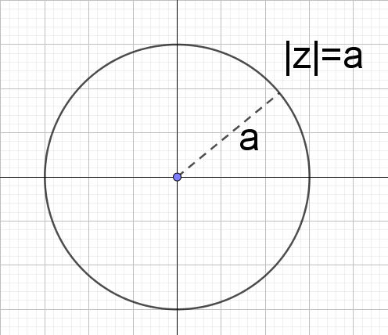  $\left|z\right|≤a$, is the set of all points $a$ units or less from the origin.  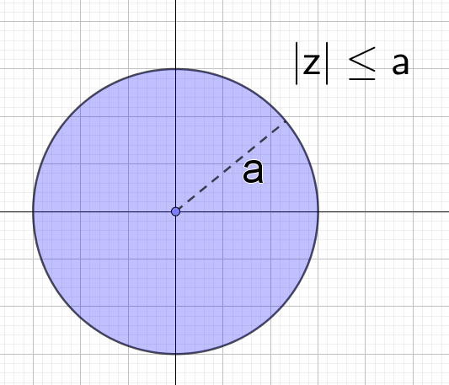  $\left|z-z_{1}\right|=a$, is the set of all points which are $a$ units from $z_{1}$. If $z_{1}=x_{1}+iy_{1}$  Circle with centre $\left(x_{1}, y_{1}\right)$ and radius $a$.  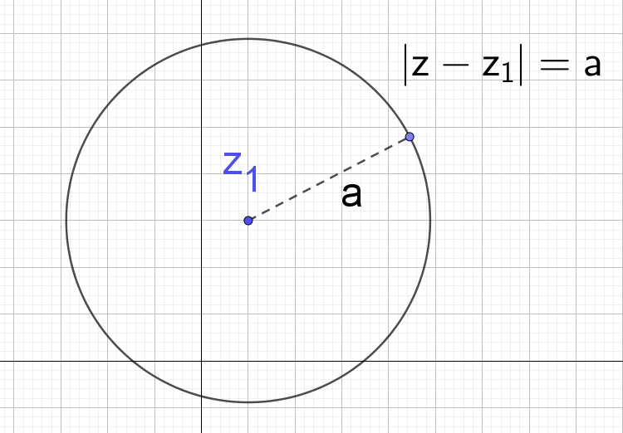  - Argument:  $Arg\left(z\right)=θ,$ set of all points at an angle of $θ$ from the x-axis in the positive direction which is represented by a vector:  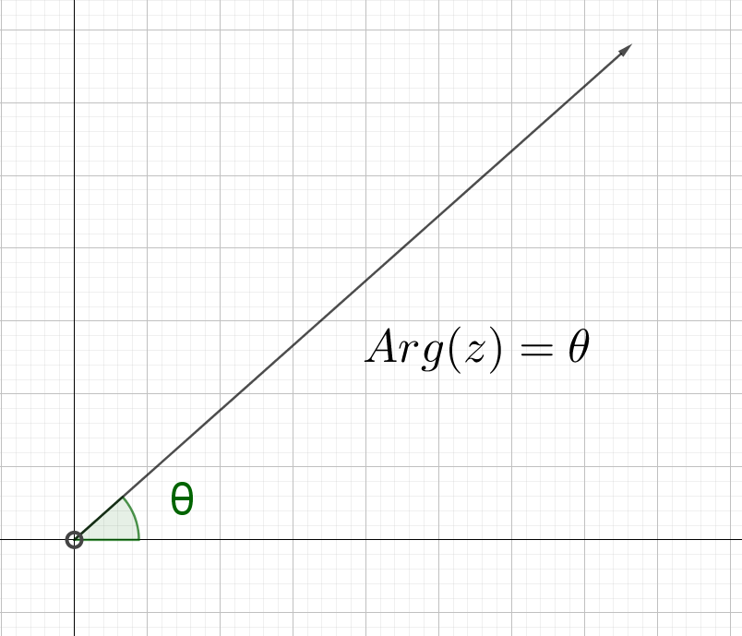  Note: The origin is a hollow circle and is not included in the solution.  $Arg\left(z\right)<θ,$ set of all points at an angle of less than $θ$ from the x-axis in the positive direction  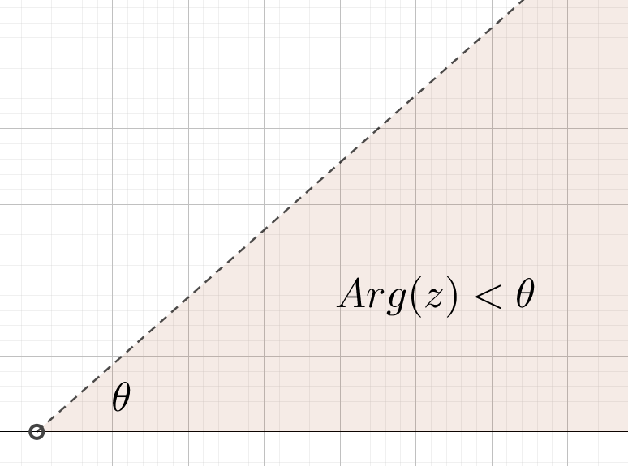  The origin is a hollow circle and is not included in the solution.  $Arg\left(z-z_{1}\right)=θ$, set of all points represented by a vector from $z_{1}$ at an angle of $θ$ from the horizontal.  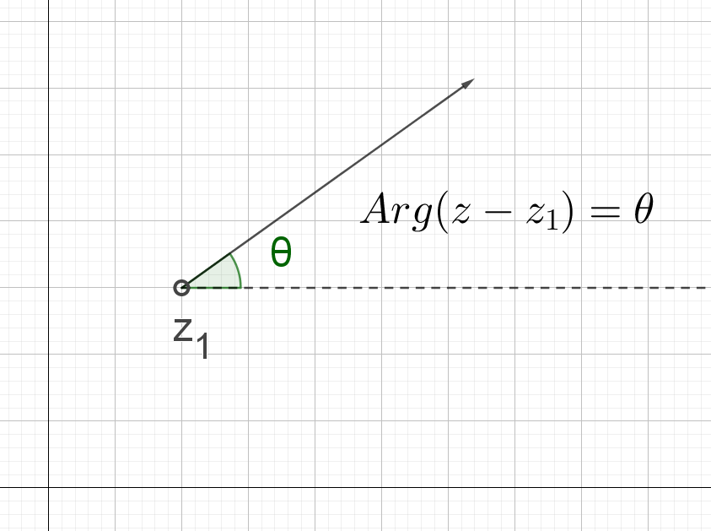  Algebraic interpretation: By letting $z=x+iy$, students can determine the Cartesian relationship determined by the complex relation which can then be graphed.  The following Wootube videos models geometric and algebraic interpretations for a range of examples:  - Introductory examples(duration 10:02)  - Graphing complex inequalities (duration 4:24)  - Shifting the point of reference(duration 11:56)  - Where is the argument measured from? (duration 6:41)  Students are to practice these techniques.  Resource: subsets-of-the-complex-plane.DOCX  The resource document contains examples identifying and graphing subsets:  - $\left|z\right|=3$  - |$z-3i|≤4$  - $|z+3-2i|=5$  - $\frac{π}{4}≤Arg(z)≤\frac{3π}{4}$  - $Re(z)>Im(z)$  - $|z-1|=2|z-i|$  - $4Re\left(z\right)+3Im\left(z\right)=12$  - Arg$\left(z-3+2i\right)=\frac{π}{3}$

Reflection and evaluation
Please include feedback about the engagement of the students and the difficulty of the content included in this section. You may also refer to the sequencing of the lessons and the placement of the topic within the scope and sequence. All ICT, literacy, numeracy and group activities should be recorded in Comments, Feedback, Additional Resources Used sections.

