Simple harmonic motion activity
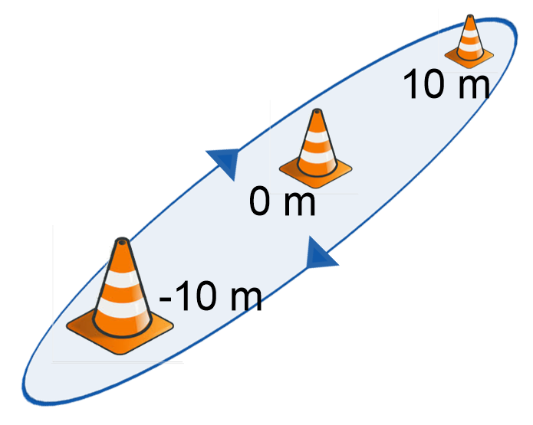
The purpose of this activity is for students to experience simple harmonic motion; to understand when they are moving fastest and when they are accelerating and decelerating; and to establish how this is represented on a Cartesian plane as a function.

Task
- A selected student, student A, is to start running from the cone placed at a displacement of -10 metres towards the other cones. They are to run in a loop around the end cones until they have completed 3 full loops.
- When the student passes the cone at 0 metres, another student, student B, starts the timer. Every time student A passes a cone, student B records the time. It may be easier for students may like to video record this activity and determine the times afterwards.
- Record the times in a table similar to the one below
Time, t | Displacement, d
 | 0
 | 10
 | 0
 | -10
 | 0
 | 10
 | 0
 | -10
 | 0
 | 10
 | 0
 | -10
 | 0
- Use DESMOS or a similar graphing application, to plot the points in the table above. An example is shown below

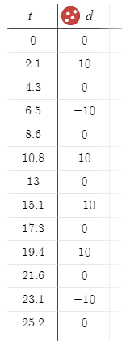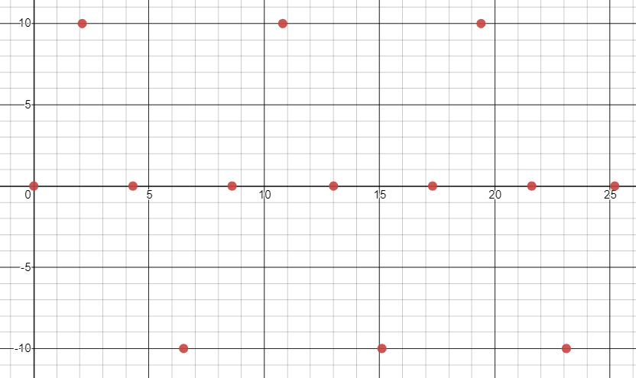
Please note that the headings in the table above have been changed from the defaults of $x_{1}$ and $y_{1}$ to time, $t$, and displacement, $d$.

- Discuss which curve would fit the data best. Lead students towards sine or cosine models and discuss appropriate values for the amplitude and time period (or frequency).
- Develop a model to describe the motion by entering $d\sim 10sin⁡(\frac{2πt}{T})$
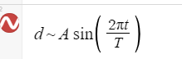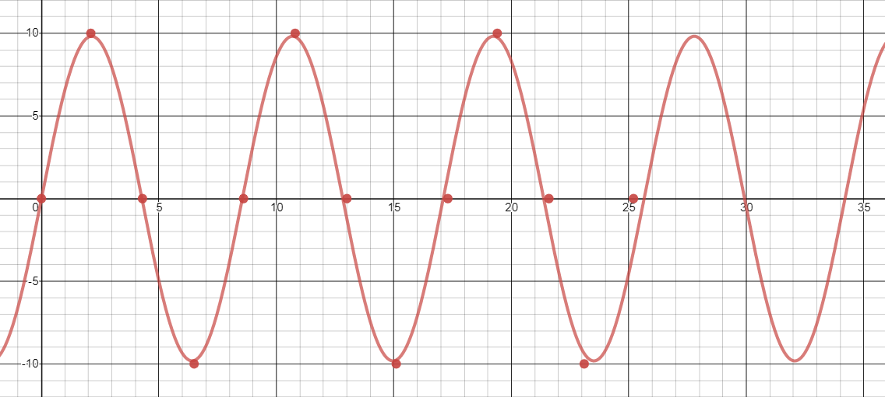
- Key questions to ask at this stage are
  - When was student A running fastest? And how is this represented on the graph?
  - When was student A accelerating? And how is this represented on the graph?
  - When was student A decelerating? And how is this represented on the graph?
- Consider running the activity again but starting the timer when student A reaches the 10 metre cone. How does this affect the model? Consider starting the timer at other positions.
The DESMOS activity referenced above can be found here

