MEX-M1 Sample questions

M1.1 Simple Harmonic Motion

Introducing simple harmonic motion
- 2014 Mathematics Extension 1 HSC, Question 7
A particle is moving in simple harmonic motion with period $6$ and amplitude $5$. Which is a possible expression for the velocity, $v$, of the particle?
  - $v=\frac{5π}{3}\cos\left(\frac{π}{3}t\right)$
  - $v=5\cos\left(\frac{π}{3}t\right)$
  - $v=\frac{5π}{6}\cos\left(\frac{π}{6}t\right)$
  - $v=5\cos\left(\frac{π}{6}t\right)$
Solution: Standard format of SHM (no phase shift)
$$x=a\sin\left(nt\right)+c$$
$a=5$
$$period=\frac{2π}{n}$$
$$6=\frac{2π}{n}$$
$$n=\frac{π}{3}$$
$$x=5\sin\left(\frac{π}{3}t\right)+c$$
$$v=\dot{x}=\frac{π}{3}×5×\cos\left(\frac{π}{3}t\right)$$
$$=\frac{5π}{3}\cos\left(\frac{π}{3}t\right)$$
∴ a is the correct answer.

- 2014 Mathematics Extension 1 HSC, Question 12 part a.
A particle is moving in simple harmonic motion about the origin, with displacement $x$ metres. The displacement given by $x=2\sin{3t}$, where $t$ is time in seconds. The motion starts when $t=0$.
  - What is the total distance travelled by the particle when it first returns to the origin?
  - What is the acceleration of the particle when it is first at rest?
Solution:
  - $2+2=4m$, given the amplitude is $2m$.
Explanation:
$$x=0$$
$$2\sin{3t}=0$$
$$\sin{3t}=0$$
$$3t=0, π, 2π…$$
$$t=0,\frac{π}{3},\frac{2π}{3}…$$
The particle first returns to the original after $\frac{π}{3}$ seconds.
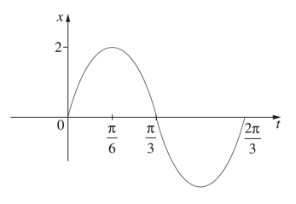
$$Total displacement is 2+2=4m$$
  - When at rest, $\dot{x}=0$
$$\dot{x}=6\cos{3t}$$
$$6\cos{3t}=0$$
$$\cos{3t}=0$$
$3t=\frac{π}{2}$(first solution)
$$t=\frac{π}{6}$$
The particle is first at rest when $t=\frac{π}{6}$ seconds
$$\ddot{x}=-18\sin{3t}$$
when$t=\frac{π}{6}$
$$\ddot{x}=-18\sin\left(3×\frac{π}{6}\right)$$
$$=-18\sin\left(\frac{π}{2}\right)$$
$$=-18$$
$∴$The acceleration of the particle when first at rest is$-18 ms^{-2}$

- 2013 Mathematics Extension 1 HSC, Question 12 part e.
A particle moves along a straight line. The displacement of the particle from the origin is $x$, and its velocity is $v$. The particle is moving so that $v^{2}+9x^{2}=k$, where $k$ is a constant. Show that the particle moves in simple harmonic motion with period $\frac{2π}{3}$.
Solution:
$$v^{2}+9x^{2}=k$$
$$v^{2}=k-9x^{2}$$
$$\frac{1}{2}v^{2}=\frac{1}{2}k-\frac{9}{2}x^{2}$$
$$\ddot{x}=\frac{d}{dx}\left(\frac{1}{2}v^{2}\right)=\frac{d}{dx}\left(\frac{1}{2}k-\frac{9}{2}x^{2}\right)=-9x$$
For SHM, $\ddot{x}=-n^{2}(x-b)$
$∴\ddot{x}=-9x$ moves in SHM with $n=3$and$b=0$
$Period=\frac{2π}{n}=\frac{2π}{3}$ as required.

Determining the speed during SHM
- A particle is moving along the x-axis in simple harmonic motion. The displacement of the particle is $x$ metres. The particle is at rest when $x =-2$ and when $x =8$. It takes 6 seconds to travel from $x =-2$ to $x = 8$.
What is the maximum speed of the particle?
  - $\frac{5}{6}π$ ms⁻¹
  - $\frac{4}{3}π$ ms⁻¹
  - $\frac{5}{3}π$ ms⁻¹
  - $\frac{10}{3}π$ ms⁻¹
Solution: Draw a diagram to represent the situation.
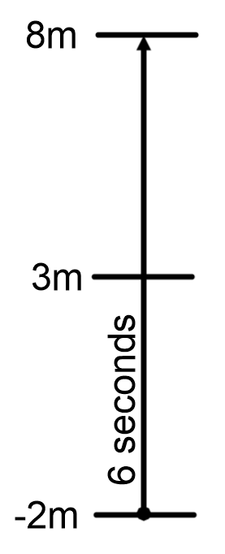
$∴T (period)=12s$ and $n=\frac{2π}{T}=\frac{π}{6}$
Centre of motion is hallway between $-2$m and $8$m, i.e. at $3$m
$$\ddot{x}=-n^{2}\left(x-3\right)$$
$$\frac{d}{dx}\left(\frac{1}{2}v^{2}\right)=-n^{2}\left(x-3\right)$$
$$\frac{1}{2}v^{2}=-n^{2}\int{\left(x-3\right)}.dx$$
$$\frac{1}{2}v^{2}=-n^{2}\left(\frac{x^{2}}{2}-3x\right)+C$$
$$v^{2}=-n^{2}\left(x^{2}-6x\right)+C$$when $x=8$, $v=0$
$$0= -n^{2}\left(8^{2}-6×8\right)+C$$
$$C=16n^{2}$$$∴v^{2}=n^{2}\left(16+6x-x^{2}\right)$
$$s=\sqrt{v^{2}}=\sqrt{n^{2}\left(16+6x-x^{2}\right)}$$
The maximum speed is at the centre of the motion, when $x=3$
$$∴s=\sqrt{{\left(\frac{π}{6}\right)}^{2}\left(16+6×3-3^{2}\right)} \\ =\frac{5}{6}π ms^{-1}$$$∴$a is the correct answer.

Solving Problems with SHM
- 2016 Mathematics Extension 1 HSC, Question 13 part a.
The tide can be modelled using simple harmonic motion. At a particular location, the high tide is 9 metres and the low tide is 1 metre. At this location the tide completes full periods every 25 hours. Let t be the time in hours after the first high tide today.
  - Explain why the tide can be modelled by the function $x=5+4\cos\left(\frac{4πt}{25}\right)$

Solution:
From reference sheet: $x=\operatorname{acos}\left(nt+α\right)+c$
High tide = maximum = 9
Low tide = minimum = 1
$∴a=\frac{9-1}{2}=4$
Period, $T=\frac{25}{2};$ (two tides per day)
$\frac{25}{2}= \frac{2π}{n}$
$∴n=\frac{4π}{25}$
$t=0$ at high tide so $α=0$
$$∴9=4\cos\left(\frac{4π}{25}×0\right)+C$$
$$C=5$$

$∴x=5+4\cos\left(\frac{4πt}{25}\right)$

  - The first high tide tomorrow is at 2 am. What is the earliest time tomorrow at which the tide is increasing at the fastest rate?

Solution:
$x=5+4\cos\left(\frac{4πt}{25}\right)$
$\frac{dx}{dt}=-4∙\frac{4π}{25}\sin\left(\frac{4πt}{25}\right)$
$\frac{d^{2}x}{dt^{2}}=\frac{-16π}{25} ∙\frac{4π}{25}\cos\left(\frac{4πt}{25}\right)$
Increasing fastest when $\frac{d^{2}x}{dt^{2}}=0$
$\cos\left(\frac{4πt}{25}\right)=0$
$∴\frac{4πt}{25}=\frac{π}{2}, \frac{3π}{2}, ⋯$
$t=\frac{25}{8}, \frac{75}{8}, ⋯$
Tide is decreasing (going out) when $t=\frac{25}{8}$ as $\frac{dx}{dt}=-\frac{16π}{25}\sin\left(\frac{4π}{25}×\frac{25}{8}\right)=-\frac{16π}{25}$
$∴$ Tide is increasing (coming in) when $t=\frac{75}{8}=9\frac{3}{8}$ as $\frac{dx}{dt}=-\frac{16π}{25}\sin\left(\frac{4π}{25}×\frac{75}{8}\right)=\frac{16π}{25}$
So $9\frac{3}{8}$ hours after $2$ am makes the time $11:22\frac{1}{2}$ am ($11:22:30$ am)
(or $11\frac{3}{8}$ hours after midnight).

- The deck of a ship was $2.4m$ below the level of a wharf at low tide and $0.6m$ above wharf level at high tide. Low tide was at 8.30 am and high tide at 2.35 pm. Find when the deck was level with the wharf, if the motion of the tide was simple harmonic.
Solution:
Amplitude: $a=\frac{2.4+0.6}{2}=1.5 m$
Let 8.30am be $t=0$, the low tide
The wharf is 0.6m below the high tide, $height=1.5-0.6=0.9$
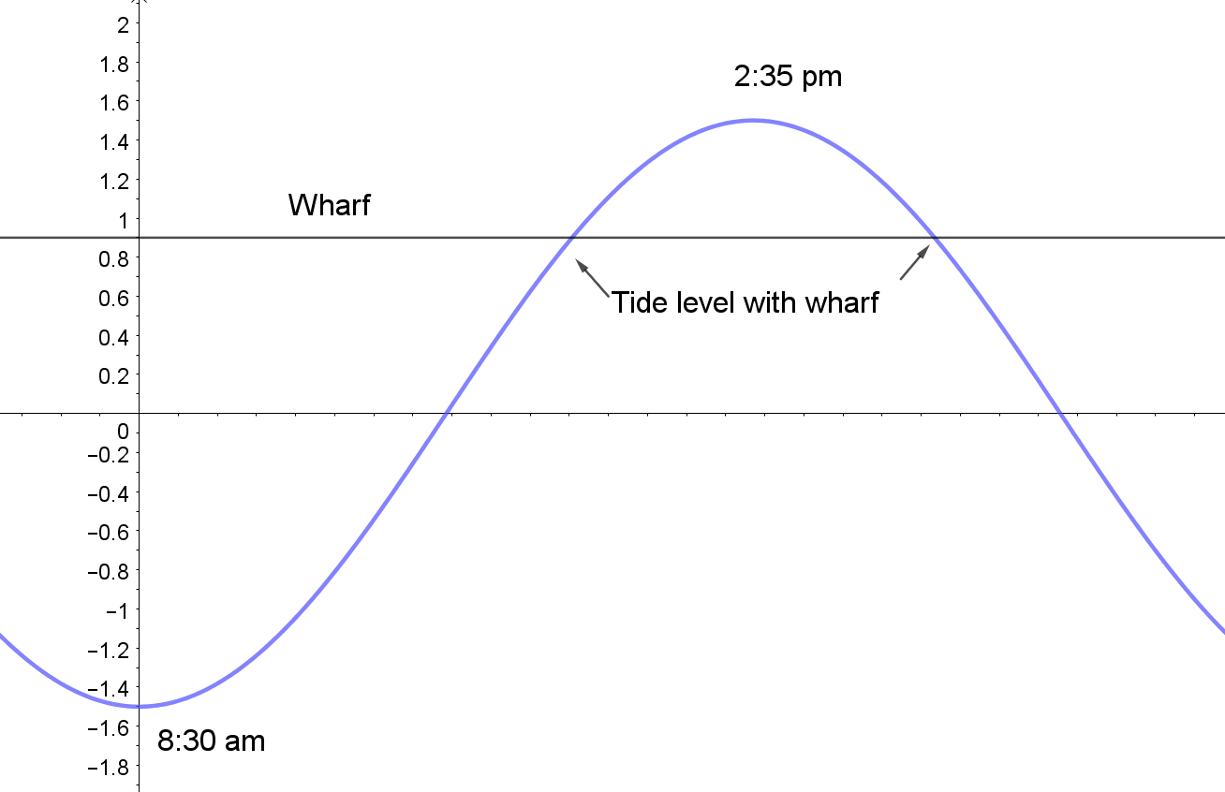
Let $x=-acos\left(nt\right)$
Period is twice the time from 8:30am to 2:35pm,
$$6 hours and 5 minutes=21900 seconds$$
$$T=2×21900=43800$$
$$n=\frac{2π}{T}=\frac{2π}{43800}$$
$$x=-1.5cos\left(\frac{2π}{43800}t\right)$$
Solve $x=0.9$
$$-1.5cos\left(\frac{2π}{43800}t\right)=0.9$$
$$\cos\left(\frac{2π}{43800}t\right)=-\frac{0.9}{1.5}$$
$$\frac{2π}{43800}t=\cos^{-1}\left(-\frac{0.9}{1.5}\right)$$
$$t=\frac{43800}{2π}\cos^{-1}\left(-\frac{0.9}{1.5}\right)$$
$$=\frac{43800}{2π}×2.21…$$
$$=15435.8375…seconds$$
$$=4 hours 17 minutes (correct to the nearest minute)$$
Which refers to $12:47$ pm that day.

M1.2: Modelling motion without resistance

Introduction to mechanics
- 2018 VCE Specialist Mathematics examination 2, Section A Question 16
The diagram below shows a mass being acted on by a number of forces whose magnitudes are labelled. All forces are measured in newtons and the system is in equilibrium.
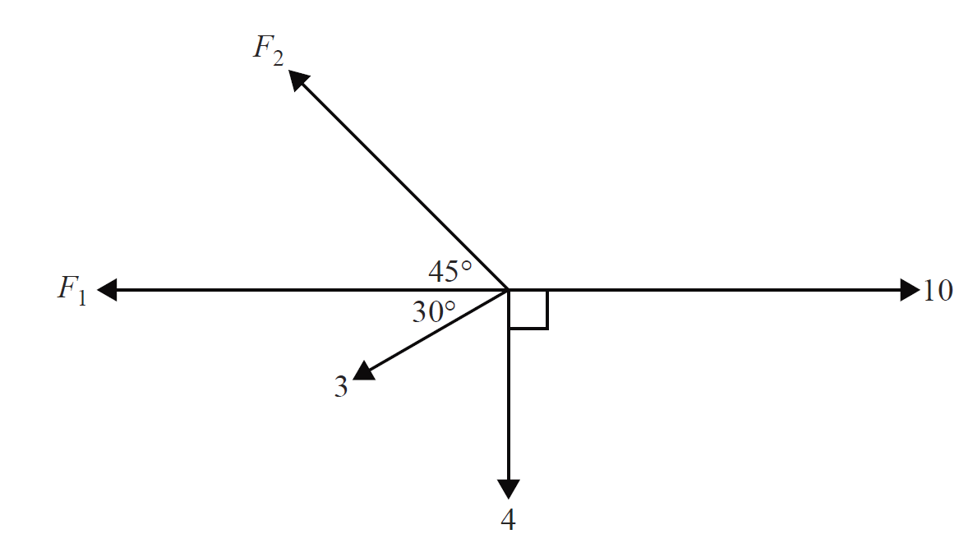
The value of $F_{2}$ is
  - $\frac{\sqrt{2}}{2}\left(8+3\sqrt{3}\right)$
  - $\frac{11\sqrt{2}}{2}$
  - $\frac{3\sqrt{2}}{2}$
  - $7.78$
  - $7.0$
Solution: To be in equilibrium vertical and horizontal forces must have a net of zero.
Find the vertical component of the force of 3 newtons.
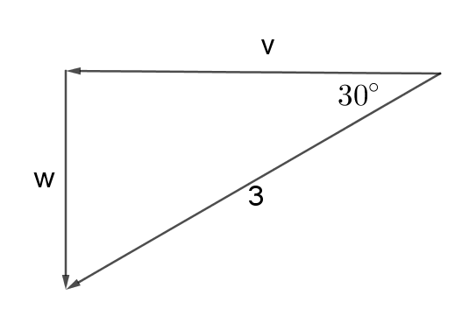
$$\sin{30}=\frac{w}{3}$$
$$w=3×\sin{30}$$
$$=1.5 newtons$$
Vertical forces:
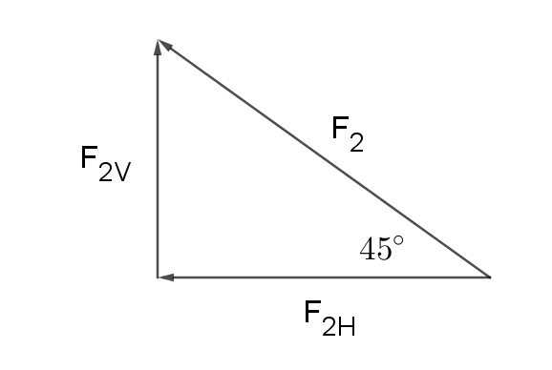
$$F_{2V}=1.5+4$$
$$=5.5 newtons$$
$$\sin{45}=\frac{5.5}{F_{2}}$$
$$F_{2}=\frac{5.5}{\sin{45}}$$
$=\frac{5.5}{\frac{1}{\sqrt{2}}}$
$$=5.5\sqrt{2}$$
$$=\frac{11\sqrt{2}}{2}$$
$∴$b is the correct answer.

- 2018 VCE Specialist Mathematics examination 1, Question 1
Two objects of masses $5$ kg and $8$ kg are attached by a light inextensible string that passes over a smooth pulley. The $8$ kg mass is on a smooth plane inclined at $30°$ to the horizontal. The $5$ kg mass is hanging vertically, as shown in the diagram below.
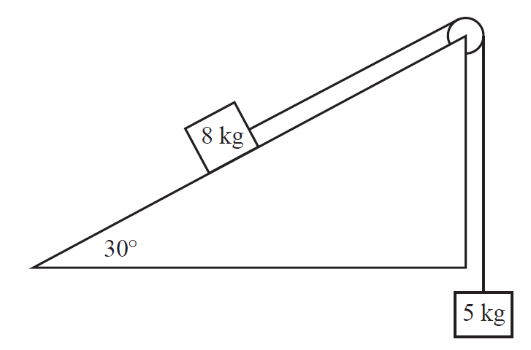
  - On the diagram above, show all forces acting on both masses.
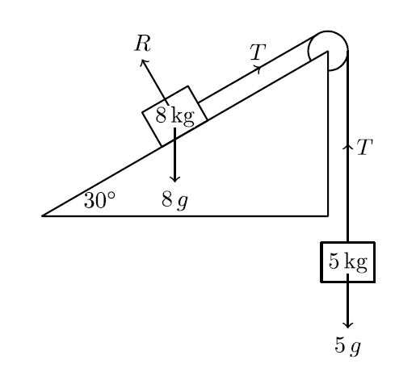
  - Find the magnitude, in $ms^{-2}$, and state the direction of the acceleration of the $8$ kg mass.
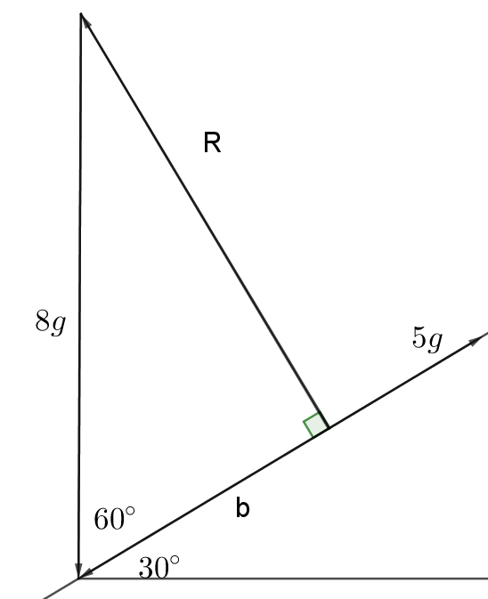
$$\cos{60}=\frac{b}{8g}$$
$$8g×\cos{60}=b$$
$$b=4g$$
$Net Force=5g-4g=g N$ up the plane
$$F=ma$$
$$m=5+8=13$$
$$g=13a$$
$$a=\frac{g}{13}$$
$∴$ The $8 kg$ mass moves up the plane with an acceleration of $\frac{g}{13}$

- 2017 VCE Specialist Mathematics examination 2, Section A Question 17
Forces of 10 N and 8 N act on a body as shown below.
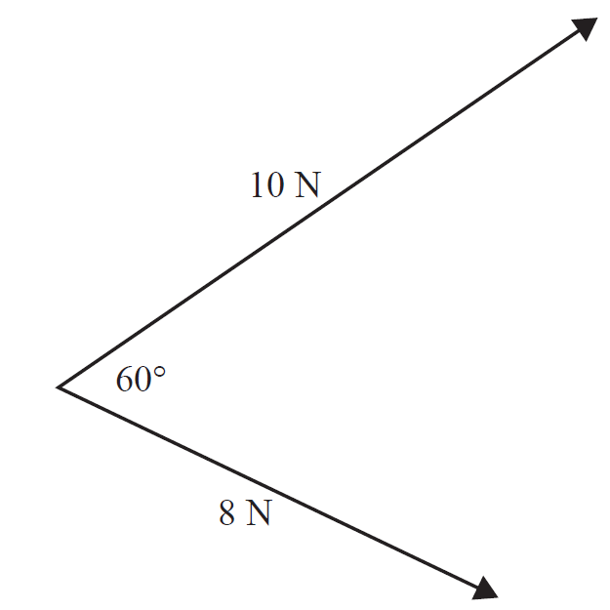
The resultant force acting on the body will, correct to one decimal place, have
  - magnitude 15.6 N and act at 26.3° to the 10 N force.
  - magnitude 9.2 N and act at 49.1° to the 10 N force.
  - magnitude 15.6 N and act at 33.7° to the 10 N force.
  - magnitude 9.2 N and act at 70.9° to the 10 N force.
  - magnitude 15.6 N and act at 49.1° to the 10 N force.

Solution: Add the vectors tip to tail:
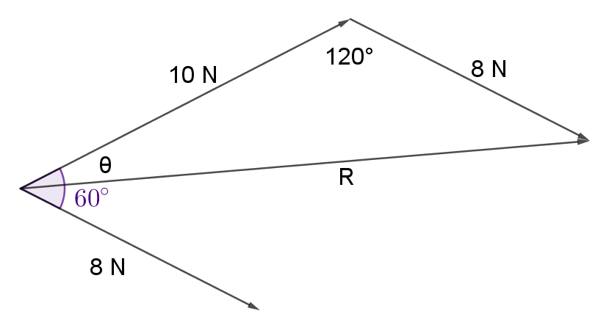
Use the cosine rule:
$$R^{2}={10}^{2}+8^{2}-2×10×8×\cos{120}$$
$$=100+64-160×-0.5$$
$$=244$$
$$R=\sqrt{244}$$
$$=15.6 N (1 dp)$$
Use the sine rule:
$$\frac{\sin{θ}}{8}=\frac{\sin{120}}{\sqrt{244}}$$
$$θ=\sin^{-1}\left(\frac{8\sin{120}}{\sqrt{244}}\right)$$
$$≈26.3°$$
$∴$a is the correct answer.

- 2016 VCE Specialist Mathematics examination 2, Section A Question 14
Two light strings of length 4 m and 3 m connect a mass to a horizontal bar, as shown below. The strings are attached to the horizontal bar 5 m apart.
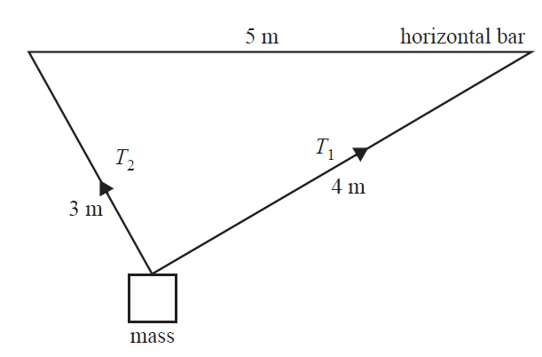
Given the tension in the longer string is $T_{1}$ and the tension in the shorter string is $T_{2}$, the ratio of the tensions $\frac{T_{1}}{T_{2}}$ is
  - $\frac{3}{5}$
  - $\frac{3}{4}$
  - $\frac{4}{5}$
  - $\frac{5}{4}$
  - $\frac{4}{3}$
Diagram with additional information: The triangle is right angles, $T_{1}$ makes an angle of $\tan^{1}\left(\frac{3}{4}\right)$ with the horizontal bar.
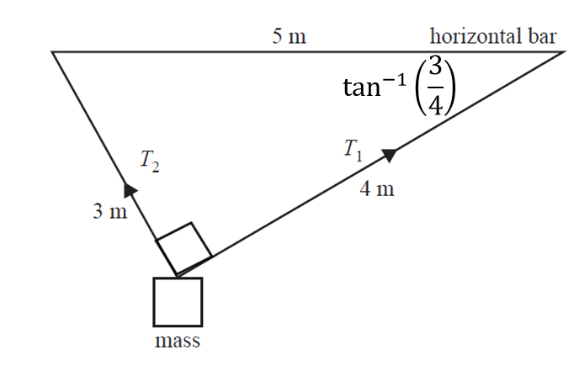
Draw a force diagram:
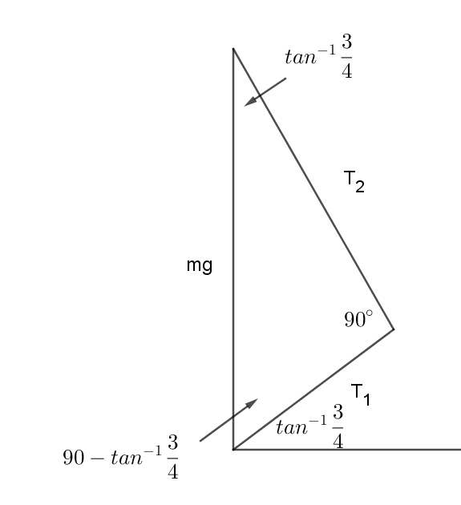
The angle between $mg$ and $T_{1}$ is $90-\tan^{-1}{\frac{3}{4}}$ (complementary angles)
The angle between$mg$ and $T_{2}$ is $\tan^{-1}{\frac{3}{4}}$ (angle sum of a triangle)
$$\tan\left(\tan^{-1}{\frac{3}{4}}\right)=\frac{T_{1}}{T_{2}}$$
$$\frac{3}{4}=\frac{T_{1}}{T_{2}}$$
∴ b is the correct answer.

Determining and applying equations of motion (constant acceleration)
- 2018 VCE Specialist Mathematics examination 2, Section A Question 15
A constant force of magnitude P newtons accelerates a particle of mass $8$ kg in a straight line from a speed of $4 ms^{–1}$ to a speed of $20 ms^{–1}$ over a distance of $15 m$.
The magnitude of $P$ is
  - $9.8$
  - $12.5$
  - $12.8$
  - $100$
  - $102.4$
Solution:
$$v^{2}=u^{2}+2ax$$
$${20}^{2}=4^{2}+2×a×15$$
$$400=16+30a$$
$$384=30a$$
$$a=\frac{384}{30}$$
$$F=ma$$
$$=8×\frac{384}{30}$$
$$=102.4$$
$∴$ e is the correct answer.
- 2017 VCE Specialist Mathematics examination 1, Question 9
A particle of mass $2$ kg with initial velocity $3\underset{\sim }{i}+2\underset{\sim }{j} ms^{-1}$ experiences a constant force for $10$ seconds. The particle’s velocity at the end of the $10$-second period is $43\underset{\sim }{i}-18\underset{\sim }{j} ms^{-1}$.
  - Find the magnitude of the constant force in newtons.
Solution: Acceleration is the change in velocity over the change in time.
$$\ddot{x}=\frac{\left(43\underset{\sim }{i}-18\underset{\sim }{j}\right)-\left(3\underset{\sim }{i}+2\underset{\sim }{j}\right)}{10}=\frac{40\underset{\sim }{i}-20\underset{\sim }{j}}{10}=4\underset{\sim }{i}-2\underset{\sim }{j}$$
$$F=ma=2×\left(4\underset{\sim }{i}-2\underset{\sim }{j}\right)=8\underset{\sim }{i}-4\underset{\sim }{j}$$
$$\left|F\right|=\sqrt{8^{2}+{\left(-4\right)}^{2}}$$
$$=\sqrt{80}$$
$$=4\sqrt{5}$$
  - Find the displacement of the particle from its initial position after $10$ seconds.
$$\ddot{x}=4\underset{\sim }{i}-2\underset{\sim }{j}$$
$$\dot{x}=\int{4\underset{\sim }{i}-2\underset{\sim }{j}}dt$$
$$=4t\underset{\sim }{i}-2t\underset{\sim }{j}+c$$
$\dot{x}=3\underset{\sim }{i}+2\underset{\sim }{j}$ when $t=0$
$$3\underset{\sim }{i}+2\underset{\sim }{j}=c$$
$$\dot{x}=4t\underset{\sim }{i}-2t\underset{\sim }{j}+3\underset{\sim }{i}+2\underset{\sim }{j}=\left(4t+3\right)\underset{\sim }{i}-(2t-2)\underset{\sim }{j}$$
$$x=\int_{0}^{10}{\left(\left(4t+3\right)\underset{\sim }{i}-(2t-2)\underset{\sim }{j}\right)dt}$$
$$={\left[\left(2t^{2}+3t\right)\underset{\sim }{i}-\left(t^{2}-2t\right)\underset{\sim }{j}\right]}_{0}^{10}$$
$$=\left(\left(2{×10}^{2}+3×10\right)\underset{\sim }{i}-\left({10}^{2}-2×10\right)\underset{\sim }{j}\right)-0$$
$$=230\underset{\sim }{i}-80\underset{\sim }{j}$$

Determining and applying equations of motion (non-constant acceleration)
- 2016 VCE Specialist Mathematics examination 2, Section A Question 15
A variable force of F newtons acts on a $3$ kg mass so that it moves in a straight line. At time t seconds, $t≥0$, its velocity $v$ metres per second and position $x$ metres from the origin are given by $v=3–x^{2}$.
It follows that
  - $F=-2x$
  - $F=-6x$
  - $F=2x^{3}-6x$
  - $F=6x^{3}-18x$
  - $F=9x-3x^{2}$
Solution
$$v=3-x^{2}$$
$$v^{2}=9-6x^{2}+x^{4}$$
$$\frac{1}{2}v^{2}=\frac{9}{2}-3x^{2}+\frac{x^{4}}{2}$$
$$\ddot{x}=\frac{d}{dx}\left(\frac{1}{2}v^{2}\right)=\frac{d}{dx}\left(\frac{9}{2}-3x^{2}+\frac{x^{4}}{2}\right)=-6x+2x^{3}=2x^{3}-6x$$
$$F=ma=3\left(2x^{3}-6x\right)=6x^{3}-18x$$
$∴$ d is the correct answer.

M1.3: Resisted motion

Analysing motion through a resisting medium
- An object is moving on a smooth horizontal plane at $20 ms^{-1}$in a resisted medium. The resistance force acting on the particle is proportional to the square of the speed and is the only force acting on the particle throughout the duration of its motion. After $10$ metres, the particle moves at $4 ms^{-1}$.
  - Show that the model for velocity in terms of displacement is equal to $$v=20e^{-\frac{\operatorname{xln}{5}}{10}}$$
Solution:
$$F∝v^{2}$$
$$F=nv^{2}$$
$$F=ma$$
$$nv^{2}=ma$$
$$\frac{n}{m}v^{2}=a$$
$rv^{2}=a,$where$r=\frac{n}{m}$
$$a=v\frac{dv}{dx}$$
$$rv^{2}= v\frac{dv}{dx}$$
$$rv=dv/dx$$
$$\frac{1}{rv}=\frac{dx}{dv}$$
$$\frac{1}{v}dv=r dx$$
$$\int{\frac{1}{v}dv}=\int{rdx}$$
$$\ln{v}=rx+c$$
$$x=0, v=20$$
$$\ln{20}=0r+c$$
$$c=\ln{20}$$
$$x=10,v=4$$
$$\ln{4}=10r+c$$
Substitute $c=\ln{20}$
$$\ln{4}=10r+\ln{20}$$
$$\ln{4}-\ln{20}=10r$$
$$\ln{\frac{4}{20}}=10r$$
$$\frac{1}{10}\ln{\frac{1}{5}}=r$$
$$r=\frac{\ln{5^{-1}}}{10}=\frac{-\ln{5}}{10}$$
$$\ln{v}=-\frac{\ln{5}}{10}x+\ln{20}$$
$$\ln{v}=-\frac{x\ln{5}}{10}+\ln{20}$$
$$v=e^{-\frac{x\ln{5}}{10}+\ln{20}}$$
$$v=e^{\ln{20}}e^{-\frac{x\ln{5}}{10}}$$
$$v=20e^{-\frac{x\ln{5}}{10}}$$

  - Calculate the velocity of the object after 12 metres.
$$v=20e^{-\frac{12\ln{5}}{10}}$$
$$=2.8991…ms^{-1}$$

  - Develop a model for displacement as a function of time, describing the motion of the particle.
$$v=20e^{-\frac{x\ln{5}}{10}}$$
$$\frac{dx}{dt}=20e^{-\frac{x\ln{5}}{10}}$$
$$\frac{dt}{dx}=\frac{1}{20}e^{\frac{x\ln{5}}{10}}$$
$$\int{1 dt}=\frac{1}{20}\int{e^{\frac{x\ln{5}}{10}}}dx$$
$$t=\frac{1}{2\ln{5}}e^{\frac{x\ln{5}}{10}}+c$$
$$x=0,t=0$$
$$0=\frac{1}{2\ln{5}}+c$$
$$c=-\frac{1}{2\ln{5}}$$
$$t=\frac{1}{2\ln{5}}e^{\frac{x\ln{5}}{10}}-\frac{1}{2\ln{5}}$$
$$t=\frac{1}{2\ln{5}}\left(e^{\frac{x\ln{5}}{10}}-1\right)$$
$$2t\ln{5}=e^{\frac{x\ln{5}}{10}}-1$$
$$e^{\frac{x\ln{5}}{10}}=2t\ln{5}+1$$
$$\frac{x\ln{5}}{10}=\ln\left(2t\ln{5}+1\right)$$
$$x=\frac{10\ln\left(2t\ln{5}+1\right)}{\ln{5}}$$

  - Develop a model for velocity as a function of time.
$$x=\frac{10\ln\left(2t\ln{5}+1\right)}{\ln{5}}=\frac{10}{ln5}\ln\left(2t\ln{5}+1\right)$$
$$\dot{x}=\frac{10}{\ln{5}}×\frac{2\ln{5}}{2t\ln{5}+1}$$
$$=\frac{20}{2t\ln{5}+1}$$

  - State the limitations of the model

The exponential function is always greater than zero, i.e. $e^{-x}>0$. It approaches the horizontal asymptote $y=0$ which is when $x=0$, but never reaches it. Given that the model for velocity $v=20e^{-\frac{12\ln{5}}{10}}$ comprises of a function of this type, this model will never reach $v=0$. Therefore this model indicates that the object will never become stationary or stop, whereas in reality it will. This model is appropriate to describe the motion of the object until it becomes close to stopping.

Solving problems involving motion upwards and downwards in a resisting medium
- 2018 Mathematics Extension 2 HSC, Question 14 part b.
A falling particle experiences forces due to gravity and air resistance. The acceleration of the particle is $g – kv^{2}$, where $g$ and $k$ are positive constants and $v$ is the speed of the particle. (Do NOT prove this.)
Prove that, after falling from rest through a distance, $h$, the speed of the particle is $\sqrt{\frac{g}{k}\left(1-e^{-2kh}\right)}$.
Solution:
$$\ddot{x}=g – kv^{2}$$using $\ddot{x}=v\frac{dv}{dx}$
$$v\frac{dv}{dx}=g – kv^{2}$$
$$\frac{dv}{dx}=\frac{g – kv^{2}}{v}$$
$$\frac{dx}{dv}=\frac{v}{g – kv^{2}}$$
$$\int{1} dx=-\frac{1}{2k}\int{\frac{-2kv}{g – kv^{2}}}$$
$$x=-\frac{1}{2k}\ln\left(g – kv^{2}\right)+c$$
$$x=0,v=0$$
$$0=-\frac{1}{2k}\ln\left(g – k×0^{2}\right)+c$$
$$c=\frac{1}{2k}\ln{g}$$
$$x=-\frac{1}{2k}\ln\left(g – kv^{2}\right)+\frac{1}{2k}\ln{g}$$
$$x=-\frac{1}{2k}\ln\left(\frac{g – kv^{2}}{g}\right)$$
$Let x=h$ and $v=s$
$$h=-\frac{1}{2k}\ln\left(\frac{g – ks^{2}}{g}\right)$$
$$-2kh=\ln\left(\frac{g – ks^{2}}{g}\right)$$
$$e^{-2kh}=\frac{g – ks^{2}}{g}$$
$$ge^{-2kh}=g – ks^{2}$$
$$ks^{2}=g-ge^{-2kh}$$
$$ks^{2}=g\left(1-e^{-2kh}\right)$$
$$s^{2}=\frac{g}{k}\left(1-e^{-2kh}\right)$$
$s=±\sqrt{\frac{g}{k}\left(1-e^{-2kh}\right)}$ but $s$ is acting in a positive direction (the direction of motion)
$∴s=±\sqrt{\frac{g}{k}\left(1-e^{-2kh}\right)}$as required.
- 2013 Mathematics Extension 2 HSC, Question 15 part d.
A ball of mass $m$ is projected vertically into the air from the ground with initial velocity $u$. After reaching the maximum height $H$ it falls back to the ground. While in the air, the ball experiences a resistive force$kv^{2}$, where $v$ is the velocity of the ball and$k$ is a constant. The equation of motion when the ball falls can be written as
$m\dot{v} =mg -kv^{2}$(Do NOT prove this.)
  - Show that the terminal velocity $v_{T}$ of the ball when it falls is $\sqrt{\frac{mg}{k}}$
Solution:
Terminal velocity occurs when acceleration is zero, i.e. $\dot{a=v=0}$
$$mg -kv_{T}^{2}=0$$
$$kv_{T}^{2}=mg$$
$$v_{T}^{2}=\frac{mg}{k}$$
$$v_{T}=±\sqrt{\frac{mg}{k}}$$
$$v_{T}=\sqrt{\frac{mg}{k}}$$
  - Show that when the ball goes up, the maximum height $H$ is
$$H=\frac{v_{T}^{2}}{2g}\ln\left(1+\frac{u^{2}}{v_{T}^{2}}\right)$$
Solution: Produce equations of motion for the upwards trajectory:

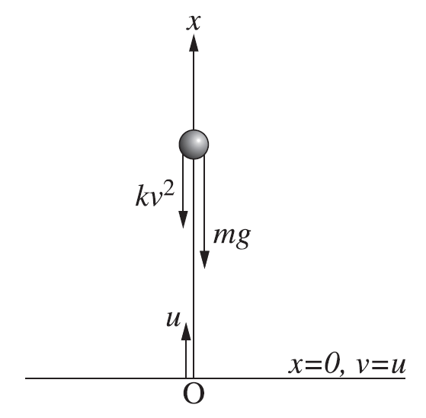
$$F=ma or m\dot{v}$$
$$m\dot{v}=-mg-kv^{2}$$
$$m\dot{v}=-mg\left(1+\frac{kv^{2}}{mg}\right)$$
$$m\dot{v}=-mg\left(1+\frac{v^{2}}{v_{T}^{2}}\right)$$
$$\dot{v}=-g\left(1+\frac{v^{2}}{v_{T}^{2}}\right)$$
$$\dot{v}=\frac{-g}{v_{T}^{2}} \left(v_{T}^{2}+v^{2}\right)$$
using $\dot{v}=v\frac{dv}{dx}$
$$v\frac{dv}{dx}=\frac{-g}{v_{T}^{2}} \left(v_{T}^{2}+v^{2}\right)$$
$$\frac{dv}{dx}=\frac{-g}{v_{T}^{2}} \left(\frac{v_{T}^{2}+v^{2}}{v}\right)$$
$$\frac{dx}{dv}=\frac{{-v}_{T}^{2}}{g} \left(\frac{v}{v_{T}^{2}+v^{2}}\right)$$
$$\int{1} dx=\frac{{-v}_{T}^{2}}{g}\int{\frac{v}{v_{T}^{2}+v^{2}}} dv$$
$$x=\frac{{-v}_{T}^{2}}{2g}\ln\left(v_{T}^{2}+v^{2}\right)+c$$
$$x=0,v=u$$
$$0=\frac{{-v}_{T}^{2}}{2g}\ln\left(v_{T}^{2}+u^{2}\right)+c$$
$$c=\frac{v_{T}^{2}}{2g}\ln\left(v_{T}^{2}+u^{2}\right)$$
$$x=\frac{{-v}_{T}^{2}}{2g}\ln\left(v_{T}^{2}+v^{2}\right)+\frac{v_{T}^{2}}{2g}\ln\left(v_{T}^{2}+u^{2}\right)$$
$$x=\frac{v_{T}^{2}}{2g}\left(\ln\left(v_{T}^{2}+u^{2}\right)-\ln\left(v_{T}^{2}+v^{2}\right)\right)$$
$$=\frac{v_{T}^{2}}{2g}\ln\left(\frac{v_{T}^{2}+u^{2}}{v_{T}^{2}+v^{2}}\right)$$
$$x=H when v=0$$
$$H=\frac{v_{T}^{2}}{2g}\ln\left(\frac{v_{T}^{2}+u^{2}}{v_{T}^{2}+0}\right)$$
$$=\frac{v_{T}^{2}}{2g}\ln\left(\frac{v_{T}^{2}}{v_{T}^{2}}+\frac{u^{2}}{v_{T}^{2}}\right)$$
$H=\frac{v_{T}^{2}}{2g}\ln\left(1+\frac{u^{2}}{v_{T}^{2}}\right)$ as required.

  - When the ball falls from height $H$it hits the ground with velocity $w.$ Show that
$$\frac{1}{w^{2}}=\frac{1}{u^{2}}+\frac{1}{v_{T}^{2}}$$
Solution: Produce equations of motion for the downwards trajectory:
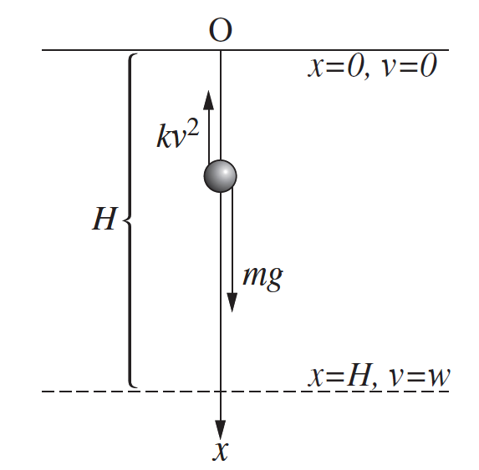
$$F=ma or m\dot{v}$$
$$m\dot{v}=mg-kv^{2}$$
$$m\dot{v}=mg\left(1-\frac{kv^{2}}{mg}\right)$$
$$m\dot{v}=mg\left(1-\frac{v^{2}}{v_{T}^{2}}\right)$$
$$\dot{v}=g\left(1-\frac{v^{2}}{v_{T}^{2}}\right)$$
$$\dot{v}=\frac{g}{v_{T}^{2}} \left(v_{T}^{2}-v^{2}\right)$$
using $\dot{v}=v\frac{dv}{dx}$
$$v\frac{dv}{dx}=\frac{g}{v_{T}^{2}} \left(v_{T}^{2}-v^{2}\right)$$
$$\frac{dv}{dx}=\frac{g}{v_{T}^{2}} \left(\frac{v_{T}^{2}-v^{2}}{v}\right)$$
$$\frac{dx}{dv}=\frac{v_{T}^{2}}{g} \left(\frac{v}{v_{T}^{2}-v^{2}}\right)$$
$$\int{1} dx=\frac{v_{T}^{2}}{g}\int{\frac{v}{v_{T}^{2}-v^{2}}} dv$$
$$x=\frac{{-v}_{T}^{2}}{2g}\ln\left(v_{T}^{2}-v^{2}\right)+c$$
$$x=0,v=0$$
$$0=\frac{{-v}_{T}^{2}}{2g}\ln\left(v_{T}^{2}-0^{2}\right)+c$$
$$c=\frac{v_{T}^{2}}{2g}\ln\left(v_{T}^{2}\right)$$
$$x=\frac{{-v}_{T}^{2}}{2g}\ln\left(v_{T}^{2}-v^{2}\right)+\frac{v_{T}^{2}}{2g}\ln\left(v_{T}^{2}\right)$$
$$x=\frac{v_{T}^{2}}{2g}\left(\ln\left(v_{T}^{2}\right)-\ln\left(v_{T}^{2}-v^{2}\right)\right)$$
$$=\frac{v_{T}^{2}}{2g}\ln\left(\frac{v_{T}^{2}}{v_{T}^{2}-v^{2}}\right)$$
$$x=H when v=w$$
$$H=\frac{v_{T}^{2}}{2g}\ln\left(\frac{v_{T}^{2}}{v_{T}^{2}-w^{2}}\right)$$
From part b, $H=\frac{v_{T}^{2}}{2g}\ln\left(1+\frac{u^{2}}{v_{T}^{2}}\right)$
$$\frac{v_{T}^{2}}{2g}\ln\left(1+\frac{u^{2}}{v_{T}^{2}}\right)=\frac{v_{T}^{2}}{2g}\ln\left(\frac{v_{T}^{2}}{v_{T}^{2}-w^{2}}\right)$$
$$1+\frac{u^{2}}{v_{T}^{2}}=\frac{v_{T}^{2}}{v_{T}^{2}-w^{2}}$$
$$\frac{{v_{T}^{2}+u}^{2}}{v_{T}^{2}}=\frac{v_{T}^{2}}{v_{T}^{2}-w^{2}}$$
$$\left({v_{T}^{2}+u}^{2}\right)\left(v_{T}^{2}-w^{2}\right)=v_{T}^{2}⋅v_{T}^{2}$$
$$v_{T}^{2}⋅v_{T}^{2}-v_{T}^{2}{⋅w}^{2}+u^{2}⋅v_{T}^{2}-u^{2}⋅w^{2}=v_{T}^{2}⋅v_{T}^{2}$$
$$-v_{T}^{2}{⋅w}^{2}+u^{2}⋅v_{T}^{2}-u^{2}⋅w^{2}=0$$
Divide through by $v_{T}^{2}{⋅w}^{2}⋅u^{2}$
$$-\frac{v_{T}^{2}{⋅w}^{2}}{v_{T}^{2}{⋅w}^{2}⋅u^{2}}+\frac{u^{2}⋅v_{T}^{2}}{v_{T}^{2}{⋅w}^{2}⋅u^{2}}-\frac{u^{2}⋅w^{2}}{v_{T}^{2}{⋅w}^{2}⋅u^{2}}=0$$
$$-\frac{1}{u^{2}}+\frac{1}{w^{2}}-\frac{1}{v_{T}^{2}}=0$$
$\frac{1}{w^{2}}=\frac{1}{u^{2}}+\frac{1}{v_{T}^{2}}$ as required.

- 2014 Mathematics Extension 2 HSC, Question 14 part c.
A high speed train of mass $m$ starts from rest and moves along a straight track. At time t hours, the distance travelled by the train from its starting point is $x$ km, and its velocity is$v$ km/h.
The train is driven by a constant force$F$ in the forward direction. The resistive force in the opposite direction is $Kv^{2}$, where $K$ is a positive constant. The terminal velocity of the train is $300$ km/h.
  - Show that the equation of motion for the train is $m\ddot{x}=F\left[1-{\left(\frac{v}{300}\right)}^{2}\right]$
$$m\ddot{x}=F-Kv^{2}$$
Terminal velocity occurs when acceleration is zero, i.e. $\ddot{x}=0$ when $v=300$
$$0=F-K{×300}^{2}$$
$$K{×300}^{2}=F$$
$$K=\frac{F}{{300}^{2}}$$
$$m\ddot{x}=F-\frac{F}{{300}^{2}}v^{2}$$
$$m\ddot{x}=F\left(1-\frac{v^{2}}{{300}^{2}}\right)$$
$m\ddot{x}=F\left(1-{\left(\frac{v}{300}\right)}^{2}\right)$ as required.

  - Find, in terms of $F$ and $m$, the time it takes the train to reach a velocity of $200$ km/h.
$$m\ddot{x}=F\left(1-{\left(\frac{v}{300}\right)}^{2}\right)$$
$$\ddot{x}=\frac{F}{m}\left(1-{\left(\frac{v}{300}\right)}^{2}\right)$$
$$\frac{dv}{dt}=\frac{F}{m}\left(1-\frac{v}{300}\right)\left(1+\frac{v}{300}\right)$$
$$\frac{dt}{dv}=\frac{m}{F}×\frac{1}{\left(1-\frac{v}{300}\right)\left(1+\frac{v}{300}\right)}$$
$$\int{1} dt=\frac{m}{F}\int{\frac{1}{\left(1-\frac{v}{300}\right)\left(1+\frac{v}{300}\right)}}dv$$

$$\frac{1}{\left(1-\frac{v}{300}\right)\left(1+\frac{v}{300}\right)}≡\frac{A}{1-\frac{v}{300}}+\frac{B}{1+\frac{v}{300}}$$
$$1≡A\left(1+\frac{v}{300}\right)+B(1-\frac{v}{300})$$
when $v=300$
$$1=2A$$
$$A=\frac{1}{2}$$

when $v=-300$
$$1=2B$$
$$B=\frac{1}{2}$$

$$t=\frac{m}{2F}\int{\frac{1}{\left(1-\frac{v}{300}\right)}+}\frac{1}{\left(1+\frac{v}{300}\right)}$$
$$t=\frac{300m}{2F}\left(-\ln\left(1-\frac{v}{300}\right)+\ln\left(1+\frac{v}{300}\right)\right)+c$$
$$t=\frac{150m}{F}\left(-\ln\left(\frac{300-v}{300}\right)+\ln\left(\frac{300+v}{300}\right)\right)+c$$
$$t=\frac{150m}{F}\ln\left(\frac{\frac{300+v}{300}}{\frac{300-v}{300}}\right)+c$$
$$=\frac{150m}{F}\ln\left(\frac{300+v}{300-v}\right)+c$$
$$t=0,v=0$$
$$0=\frac{150m}{F}\ln\left(\frac{300+0}{300-0}\right)+c$$
$$0=\frac{150m}{F}\ln{1}+c$$
$$c=0$$
$$t=\frac{150m}{F}\ln\left(\frac{300+v}{300-v}\right)$$
$$subsitute v=200$$
$$t=\frac{150m}{F}\ln\left(\frac{300+200}{300-200}\right)$$
$t=\frac{150m}{F}\ln\left(5\right)$ hours

M1.4: Projectiles and resisted motion

Solving problems with projectiles in resisted motion
- An object of mass $m$ is fired from ground level at $u ms^{-1}$ at an angle of 30° with air resistance proportional to the square of the velocity.
You may assume the following equations of motion:
Upwards trajectory: $m⋅\ddot{y_{u}}=mg+k{\dot{y_{u}}}^{2}$
Downwards trajectory: $m⋅\ddot{y_{d}}=mg-k{\dot{y_{d}}}^{2}$
Horizontal trajectory: $m⋅\ddot{x}=-k{\dot{x}}^{2}$

$$u_{y}=u\sin{30}=\frac{u}{2}ms^{-1}$$
$$u_{x}=u\cos{30}=\frac{u\sqrt{3}}{2}ms^{-1}$$
Show that the maximum height reached is $H=\frac{m}{2k}\ln\left(\frac{4mg}{4mg+ku^{2}}\right)$
$$m⋅\dot{y_{u}}\frac{d\dot{y_{u}}}{dy_{u}}=mg+k{\dot{y_{u}}}^{2}$$
$$\frac{d\dot{y_{u}}}{dy_{u}}= \frac{mg+k{\dot{y_{u}}}^{2}}{m\dot{y_{u}}}$$
$$\frac{dy_{u}}{d\dot{y_{u}}}=\frac{m\dot{y_{u}}}{mg+k{\dot{y_{u}}}^{2}}$$
$$\int{1} dy_{u}=m\int{\frac{\dot{y_{u}}}{mg+k{\dot{y_{u}}}^{2}}} d\dot{y_{u}}$$
$$y_{u}=\frac{m}{2k}\ln\left(mg+k{\dot{y_{u}}}^{2}\right)+c$$
When $y_{u}=0, \dot{y_{u}}=\frac{u}{2}$
$$0=\frac{m}{2k}\ln\left(mg+\frac{ku^{2}}{4}\right)+c$$
$$c=-\frac{m}{2k}\ln\left(\frac{4mg+ku^{2}}{4}\right)$$
$$y_{u}=\frac{m}{2k}\ln\left(mg+k{\dot{y_{u}}}^{2}\right)-\frac{m}{2k}\ln\left(\frac{4mg+ku^{2}}{4}\right)$$
$$y_{u}=\frac{m}{2k}\ln\left(\frac{4mg+4k{\dot{y_{u}}}^{2}}{4mg+ku^{2}}\right)$$

The maximum height, $y_{u}=H$ reached is when $\dot{y_{u}}=0$
$$H=\frac{m}{2k}\ln\left(\frac{4mg+4k×0^{2}}{4mg+ku^{2}}\right)$$
$$H=\frac{m}{2k}\ln\left(\frac{4mg}{4mg+ku^{2}}\right)$$

