Year 12 Mathematics Extension 1
ME-V1 Introduction to vectors | Unit duration
The topic Vectors involves mathematical representation of a quantity with magnitude and direction and its geometrical depiction. This topic provides a modern language and approach to explore and explain a range of object behaviours in a variety of contexts from theoretical or real-life scenarios. A knowledge of vectors enables the understanding of the behaviour of objects in two dimensions and ways in which this behaviour can be expressed, including the consideration of position, displacement and movement. The study of vectors is important in developing students’ understanding of an object’s representation and behaviour in two dimensions using a variety of notations, and how to use these notations effectively to explore the geometry of a situation. Vectors are used in many fields of study, including engineering, structural analysis and navigation. | 13-18 lessons

Subtopic focus | Outcomes
The principal focus of this subtopic is to introduce the concept of vectors in two dimensions, use them to represent quantities with magnitude and direction, and understand that this representation can allow for the exploration of situations such as geometrical proofs.  Students develop an understanding of vector notations and how to manipulate vectors to allow geometrical situations to be explored further. The example of projectile motion as an application of vectors is then introduced. These concepts are explored further in the Mathematics Extension 2 course. | A student:  - applies concepts and techniques involving vectors and projectiles to solve problems ME12-2  - chooses and uses appropriate technology to solve problems in a range of contexts ME12-6  - evaluates and justifies conclusions, communicating a position clearly in appropriate mathematical forms ME12-7

Prerequisite knowledge | Assessment strategies
The material in this topic builds on content from Trigonometry, from Stage 5; MA-C4 Integral Calculus, from Year 12 Mathematics Advanced; ME-C1 Rates of Change from Year 11 Mathematics Extension 1; and ME-C2 Further Calculus Skills and ME-C3 Applications of Calculus, from Year 12 Mathematics Extension 1. | If you jumped on another planet, how far would you leap?  - me-v1-if-you-jumped-on-another-planet.DOCX
All outcomes referred to in this unit come from Mathematics Extension 1 Syllabus
© NSW Education Standards Authority (NESA) for and on behalf of the Crown in right of the State of New South Wales, 2017

Glossary of terms
Term | Description
Column vector notation | A vector, $\underset{\sim }{a}$, in two dimensions can be represented in column vector notation. For example, the ordered vector pair $\underset{\sim }{a}=\left(4, 5\right)$ can be represented in column vector notation as: $\underset{\sim }{a}=\left(\begin{matrix}4 \\ 5\end{matrix}\right)$.
Component form of a vector | The component form of a vector, $\underset{\sim }{v}$, expresses the vector in terms of unit vectors $\underset{\sim }{i}$, a unit vector in the $x$-direction, and $\underset{\sim }{j}$, a unit vector in the $y$-direction. For example, the ordered vector pair $\underset{\sim }{v}=\left(4, 3\right)$ can be represented as: $\underset{\sim }{v}=4\underset{\sim }{i}+3\underset{\sim }{j}$.
Displacement vector | A displacement vector describes the displacement from one point to another. It is also called a relative vector.
Position vector | The position vector of a point $P$ in the plane is the vector joining the origin to $P$.
Scalar | A scalar is a quantity with magnitude but no direction.

Lesson sequence | Content | Suggested teaching strategies and resources | Date and initial | Comments, feedback, additional resource used
Introduction to vectors  (1 lesson) | V1.1: Introduction to vectors  - define a vector as a quantity having both magnitude and direction, and examine examples of vectors, including displacement and velocity (ACMSM010)  - explain the distinction between a position vector and a displacement (relative) vector | - Note: For solutions to the examples included in this unit, see  me-v1-introduction-to-vectors-solutions.DOCX  Identifying scalars and vectors  - Introduce the topic by highlighting that some quantities are scalars as they have a magnitude only e.g. length, area and mass, while other quantities are vectors as they have a magnitude and direction e.g. force, displacement and velocity.  Resource: Identifying scalars and vectors, me-v1-introduction-to-vectors-solutions.DOCX  - Compare vectors with scalars and their applications: displacement vs distance and velocity vs speed.  - Compare the definitions of displacement and distance using differencebetween.net.  - Compare the definition of a position vector and a displacement vector using amsi.org.
The notations and representations of vectors  (1-2 lessons) | - Define and use a variety of notations and representations for vectors in two dimensions (ACMSM014)  - use standard notations for vectors, for example: $\underset{\sim }{a}, \overset{⃑}{AB}, a$  - represent vectors graphically in two dimensions as directed line segments  - define unit vectors as vectors of magnitude 1, and the standard two-dimensional perpendicular vectorsand  - Express and use vectors in two dimensions in a variety of forms, including component form, ordered pairs and column vector notation | Definitions and notations  - Vectors can be represented geometrically as directed line segments or arrows. The arrow specifies the direction of the vector and the length is its magnitude. These arrows are ‘floating’ in the number plane and can move freely. The starting point is called the ‘initial point’ and the finishing point is called the ‘terminal point’, though these terms are not specified in the syllabus.  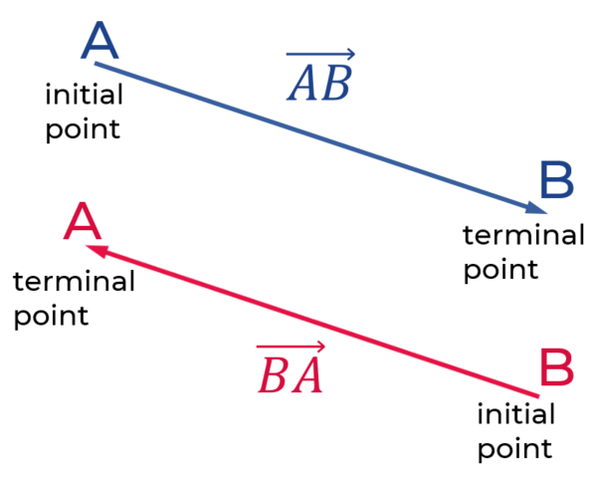  - Note: $\overset{→}{AB}$ is different from $\overset{→}{BA}$. Both vectors have the same magnitude but point in opposite directions. They are negatives of each other, i.e. $\overset{→}{BA}=-\overset{→}{AB}$.  - Discuss that the magnitude or length of a vector can be calculated using Pythagoras’ theorem.  - Define a unit vector as a vector with magnitude equal to 1.  - The unit vectors pointing in the direction of the positive $x$- and  $y$-axes are used frequently and they are called $i$ and $j$ respectively.  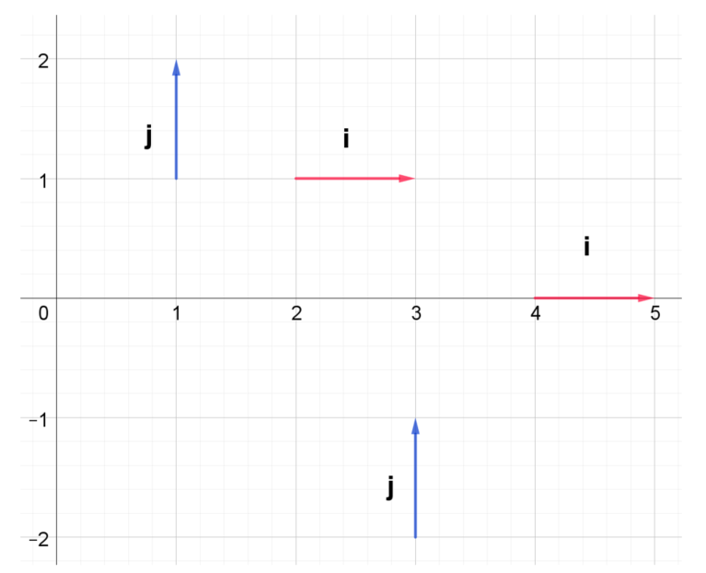  - Define the zero or null vector as a vector with magnitude equal to 0.  - Explore various vector notations: the ‘tilde’ notation is used for writing vectors (e.g.$\underset{\sim }{P}$), but in print, it is sometimes represented using lowercase boldface (e.g. p). When typesetting, remember that if vectors are written in bold, they must not be italicised to avoid confusion. This rule does not apply if you are typesetting using the ‘tilde’ notation. Additionally, if a vector is drawn from point $A$ to point $B$, it can be denoted as $\overset{→}{AB}$. Students need to be exposed to a variety of notations.  - Use vector equality to emphasise that two vectors are equal if they have the same magnitude and direction, regardless of position in the plane. As above, if they have the same magnitude but opposite direction, then the vectors are the negatives of each other.  Expressing vectors in a variety of forms  - Vectors can be written in a variety of forms, for example:  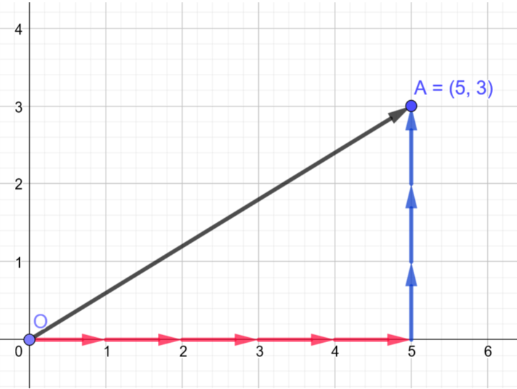  The vector $\overset{→}{OA}$ can be expressed as an ordered pair, $\vec{OA}=(5,3)$, as a column vector, $\vec{OA}=\left[{5 \atop 3}\right]$ or in component form,$\vec{OA}=5\overset{̰}{i}+3\overset{̰}{j}$.  - As vectors have magnitude and direction, if the terminal point is to the left or below the initial point, the corresponding component would be negative. Teachers can use GeoGebra resources such as vectors – introduction (1) to demonstrate this. For example, any vector, $p$, whose final point is 2 left and 5 above the initial point can be written as $p=-2i+5j$ in component form, $p=\left(-2,5\right)$ as an ordered pair and $p=\left[{-2 \atop 5}\right]$ in column vector notation.  - When covering the variety of forms, ensure that students do not confuse the notations with coordinates or combinations.  Vector notation examples  - Write vector $\overset{→}{OA}$as a column vector, an ordered pair and in component form.  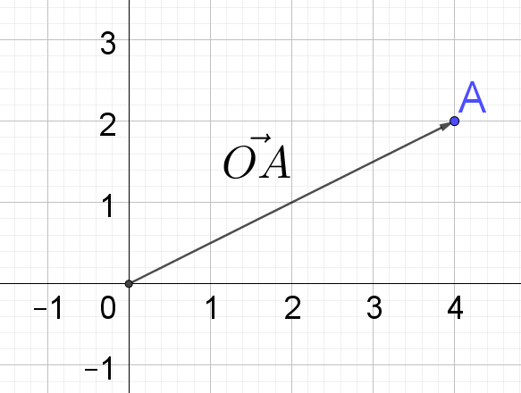  - On a Cartesian plane:  - Plot two points $A$ and $B$  - Plot two additional points $C$ and $D$ and draw vectors $\overset{→}{AC}$ and $\overset{→}{DB}$ such that $\overset{→}{AC}=3\underset{\sim }{i}+\underset{\sim }{j}$ and $\overset{→}{DB}=-5\underset{\sim }{i}+3\underset{\sim }{j}$  Resource: Vector notation, me-v1-vectors-examples-solutions.DOCX  Position and displacement vectors  - A position vector gives the displacement of a position relative to the origin. $\vec{OB}=2\overset{̰}{i}+5\overset{̰}{j}$ = $\left(2,5\right)=\left[{2 \atop 5}\right]$  - A displacement vector gives the displacement of a position relative to a second position.  $\overset{⃑}{CD}=2\overset{̰}{i}+5\overset{̰}{j}$ = $\left(2,5\right)=\left[{2 \atop 5}\right]$  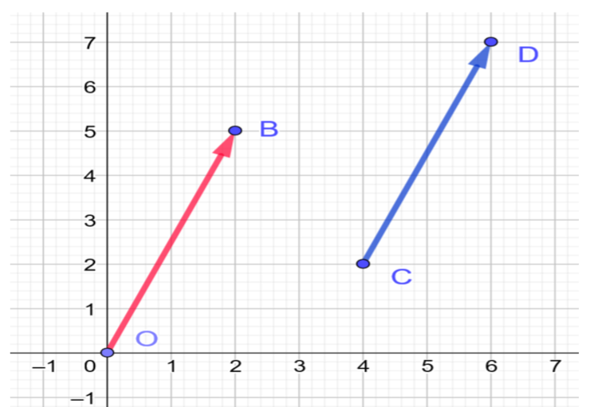  - It must be noted that the position vector cannot be moved as the origin is its initial point, while the displacement vector can be moved. A displacement vector is also referred to as a relative vector.  - Use the position vector investigation to show how the displacement vector relates to the position vector.
Operating with vectors  (1-2 lessons) | - Perform addition and subtraction of vectors and multiplication of a vector by a scalar algebraically and geometrically, and interpret these operations in geometric terms AAM  - graphically represent a scalar multiple of a vector (ACMSM012)  - use the triangle law and the parallelogram law to find the sum and difference of two vectors  - define and use addition and subtraction of vectors in component form (ACMSM017)  - define and use multiplication by a scalar of a vector in component form (ACMSM018) | Defining the zero vector and scalar multiple of a vector  - Emphasise that the zero vector, 0 (typeset in boldface) or $\underset{\sim }{0}$, has zero magnitude and points in every direction. It is also parallel to every vector.  - Using graphing software, show that the multiplication of a vector by a scalar, $λ$, stretches (if $\left|λ\right|>1$) and shrinks (if $\left|λ\right|<1$) the vector. The direction is also reversed if the scalar is a negative ($λ<0$). This can be used to show that the negative of a vector is the same as multiplying a vector by $–1$.  - Scaling vectors shows the process of the components of the vector being multiplied by the scalar, e.g. if $p=\left(\begin{matrix}2 \\ 5\end{matrix}\right)$, then $3p=\left(\begin{matrix}6 \\ 15\end{matrix}\right)$.  - Emphasise that multiplying a vector by $-1$ reverses the direction of the vector. In the diagram, the vectors u, 2u and –u are shown.  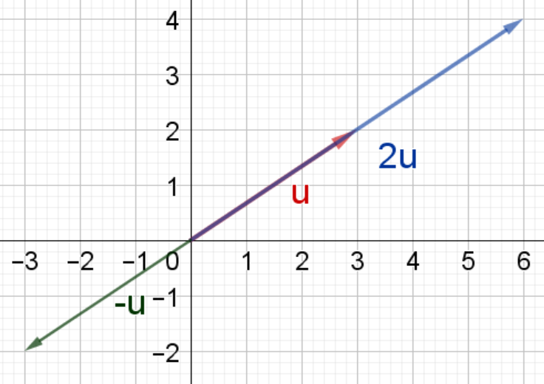  Multiplying a vector by a scalar examples  - If $\overset{̰}{u}=5\overset{̰}{i}-2\overset{̰}{j}$ calculate $4\overset{̰}{u}$.  - On a blank page draw a vector $\underset{\sim }{v}$. Use this to draw vectors $3\underset{\sim }{v}, -2\underset{\sim }{v}$and $\frac{1}{2}\underset{\sim }{v}$.  - If $\underset{\sim }{u}=3\underset{\sim }{i}+7\underset{\sim }{j}$, find $3\underset{\sim }{u}, -2\underset{\sim }{u}$and $\frac{1}{2}\underset{\sim }{u}$.  Resource: Multiplying a vector by a scalar, me-v1-vectors-examples-solutions.DOCX  Adding vectors  - Algebraically, vectors can be added by adding the corresponding components. For example, if $\overset{̰}{v}=3\overset{̰}{i}+7\overset{̰}{j}$ and $\overset{̰}{u}=5\overset{̰}{i}-3\overset{̰}{j}$, then $\overset{̰}{v}+ \overset{̰}{u}=3\overset{̰}{i}+7\overset{̰}{j}+5\overset{̰}{i}-3\overset{̰}{j}$ and $∴\overset{̰}{v}+ \overset{̰}{u}=8\overset{̰}{i}+4\overset{̰}{j}$  Geometrically, $\overset{̰}{v}+ \overset{̰}{u}$ can be represented by arranging the vectors $\overset{̰}{v}$ and $\overset{̰}{u}$ using the ‘head to tail’ method. This means drawing a displacement vector $\overset{̰}{u}$ (which is equal to position vector $\overset{̰}{u}$) such that its tail is placed on the head of the position vector $\overset{̰}{v}$.  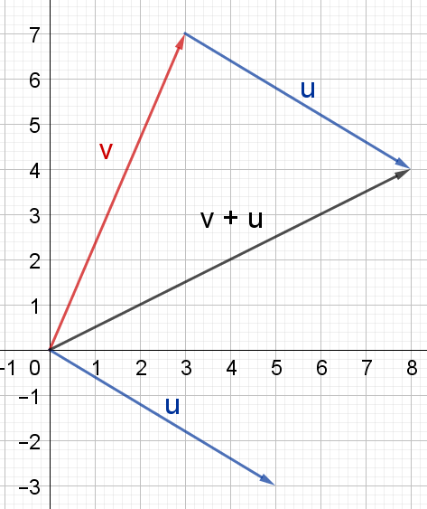  The sum of the vectors has the same initial point as the first vector and the same terminal point as the second vector. This is shown in the diagram as $v+u$. The resulting shape is a triangle, and this is known as the triangle law of addition. Vector addition and vector component addition are useful resources for visualising this process.  - Students could plot 3 points (A, B and C) on a Cartesian plane and construct vectors, $\overset{→}{AB}$, $\overset{→}{BC}$ and $\overset{→}{AC}$ and discuss the relationship between the vectors.  For example, in the diagram below, $\overset{→}{AB}$+$\overset{→}{BC}=\overset{→}{AC}$.  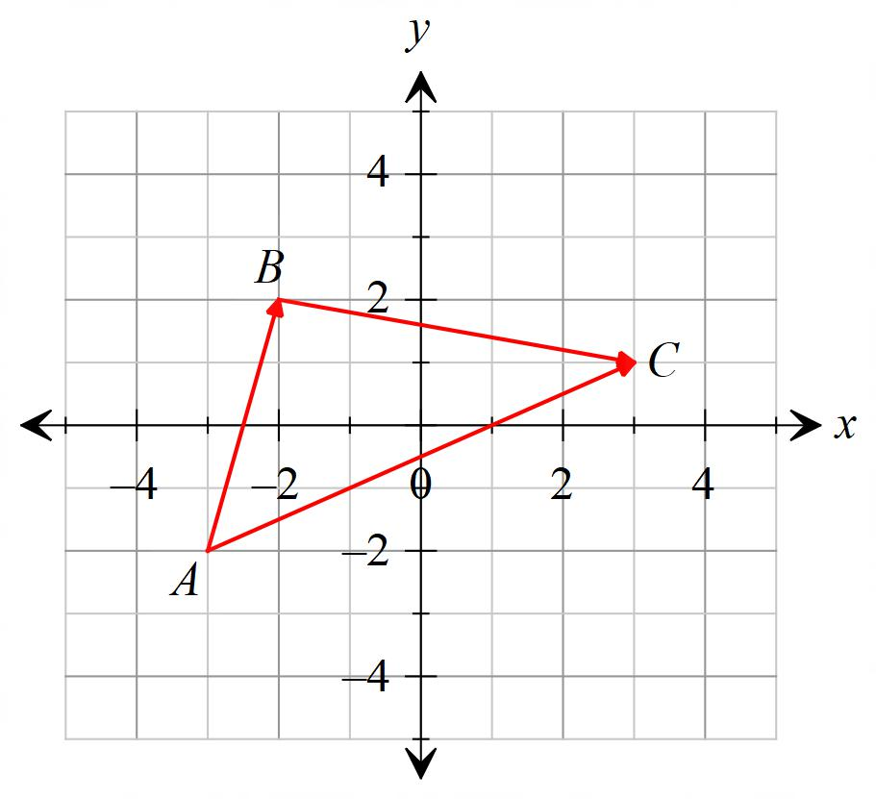  - Students to show that vector addition is commutative,  $\underset{\sim }{u}+\underset{\sim }{v}=\underset{\sim }{v}+\underset{\sim }{u}$, by considering the resultant vectors for $\underset{\sim }{u}+\underset{\sim }{v}$ and $\underset{\sim }{v}+\underset{\sim }{u}$ in vector addition. The parallelogram law of addition also demonstrates that the resultant vectors for $\underset{\sim }{u}+\underset{\sim }{v}$ and $\underset{\sim }{v}+\underset{\sim }{u}$ are equal.  - Students to show that vector addition is associative,  $\left(\underset{\sim }{u}+\underset{\sim }{v}\right)+\underset{\sim }{w}=\underset{\sim }{u}+\left(\underset{\sim }{v}+\underset{\sim }{w}\right)$, by considering the resultant vectors for the left hand side and right hand side of the associative law. Associative law for vector addition is a useful tool for visualising this.  - Students to solve a variety of addition problems using both algebraic and graphical approaches.  Subtracting vectors  - Algebraically, vectors can be subtracted by subtracting the corresponding components of the second vector from the first vector. For example, if $\overset{̰}{v}=6\overset{̰}{i}-4\overset{̰}{j}$and $\overset{̰}{u}=7\overset{̰}{i}-\overset{̰}{j}$, then  $$\overset{̰}{v}- \overset{̰}{u}=6\overset{̰}{i}-4\overset{̰}{j}-\left(7\overset{̰}{i}-\overset{̰}{j}\right) \\ \overset{̰}{v}- \overset{̰}{u}=6\overset{̰}{i}-4\overset{̰}{j}-7\overset{̰}{i}+\overset{̰}{j} \\ \overset{̰}{v}- \overset{̰}{u}=-\overset{̰}{i}-3\overset{̰}{j}$$  - Vector subtraction can be thought of as adding a vector to the negative of another vector. Subtracting a vector is the same as adding its opposite. i.e. $\underset{\sim }{u}-\underset{\sim }{v}=\underset{\sim }{u}+\left(-\underset{\sim }{v}\right)$. Vector subtraction, vector subtraction and vector component subtraction are useful resources for visualising this process.  - The triangle law and parallelogram law can also be used to understand subtraction $\underset{\sim }{u}-\underset{\sim }{v}$. The parallelogram law applet for  $\underset{\sim }{u}-\underset{\sim }{v}$ shows by the method for vector addition that  $\underset{\sim }{v}+\left(\underset{\sim }{u}-\underset{\sim }{v}\right)=\underset{\sim }{u}$.  Adding and subtracting vectors examples  - Given $\vec{OA}=$ 8$\underset{\sim }{i}-3\underset{\sim }{j}$and $\vec{OB}=3\underset{\sim }{i}+2\underset{\sim }{j}$:  - Find the vector $\vec{AB}.$  - Explain the relationship between $\vec{AB}$, $\vec{OA}$and $\vec{OB}.$ $\vec{AB}=?$  - Confirm the relationship numerically.  - If $\underset{\sim }{v}=3\underset{\sim }{i}+7\underset{\sim }{j}$ and $u=-5\underset{\sim }{i}-3\underset{\sim }{j}$, calculate $\overset{̰}{v} +\overset{̰}{u}$  - Consider the vectors $\underset{\sim }{u}=3\underset{\sim }{i}-2\underset{\sim }{j}$ and $\underset{\sim }{v}=\underset{\sim }{i}+4j$. Find:  - $\underset{\sim }{u}+ \underset{\sim }{v}$  - $\underset{\sim }{u}- \underset{\sim }{v}$  - $\underset{\sim }{v}- \underset{\sim }{u}$  - Confirm the results for a. to b. by geometrically representing these on a Cartesian plane.  - If $\underset{\sim }{v}=5\underset{\sim }{i}+4\underset{\sim }{j}$, $\underset{\sim }{u}=-3\underset{\sim }{i}-7\underset{\sim }{j}$ and $\underset{\sim }{w}=5\underset{\sim }{i}-4\underset{\sim }{j},$match each statement to its component form.  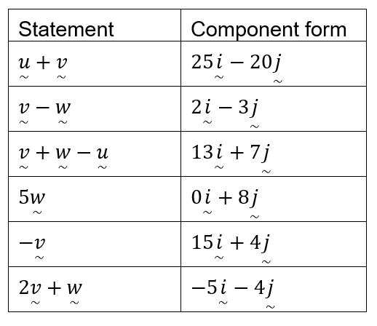  Resource: Adding and subtracting vectors, me-v1-vectors-examples-solutions.DOCX
The magnitude and direction of a vector  (2 lessons) | V1.2: Further operations with vectors  - define, calculate and use the magnitude of a vector in two dimensions and use the notation $\left|\underset{\sim }{u}\right|$ for the magnitude of a vector $\underset{\sim }{u}=x\underset{\sim }{i}+y\underset{\sim }{j}$  - prove that the magnitude of a vector, $\underset{\sim }{u}=x\underset{\sim }{i}+y\underset{\sim }{j}$, can be found using:  $$\left|\underset{\sim }{u}\right|=\left|x\underset{\sim }{i}+y\underset{\sim }{j}\right|=\sqrt{x^{2}+y^{2}}$$  - identify the magnitude of a displacement vector $\vec{AB}$ as being the distance between the points $A$ and $B$  - convert a non-zero vector $\underset{\sim }{u}$ into a unit vector $\overset{^}{\underset{\sim }{u}}$ by dividing by its length: $\overset{^}{\underset{\sim }{u}}=\frac{\underset{\sim }{u}}{\left|\underset{\sim }{u}\right|}$  - define and use the direction of a vector in two dimensions | Magnitude of a vector  - The magnitude of a vector is the length of a vector. The magnitude of a vector, $\underset{\sim }{u,}$ is written as $\left|\underset{\sim }{u}\right|$. This follows from Pythagoras’ theorem and the formula can be derived using a position vector $\left(\begin{matrix}x \\ y\end{matrix}\right)$ on the number plane by calculating the length of its horizontal and vertical components. This can be extended to any displacement vector $\overset{→}{AB}$ where students may apply the distance formula to calculate the magnitude.  - The magnitude of a vector, $\underset{\sim }{u}=x\underset{\sim }{i}+y\underset{\sim }{j}$, is  $\left|\underset{\sim }{u}\right|=\left|x\underset{\sim }{i}+y\underset{\sim }{j}\right|=\sqrt{x^{2}+y^{2}}$.  - Highlight that vectors that are not equal can still have the same magnitude.  - When practising questions, students should be given an opportunity to recognise that for any vector $\underset{\sim }{u}$ and a scalar $λ$,  $\left|λ\underset{\sim }{u}\right|=\left|λ\right|\left|\underset{\sim }{u}\right|$. However, the same cannot be said for vector addition and vector subtraction, i.e. $\left|\underset{\sim }{u}+\underset{\sim }{v}\right|≠\left|\underset{\sim }{u}\right|+\left|\underset{\sim }{v}\right|$. This can be shown algebraically and visually by considering a triangle representing vector addition.  Magnitude of a displacement vector  - For a displacement vector $\vec{AB}$, the magnitude is the distance between the points.  - To find the magnitude of $\vec{AB}$ given $\vec{OA}$ and $\vec{OB}$  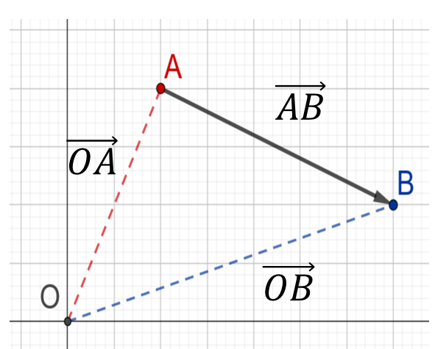  - Method 1: Use the distance formula to find the distance between A and B.  - Method 2: Find $\vec{AB}=\vec{OB}-\vec{OA}$and then calculate the magnitude using the previous method.  Unit vectors  - Students could represent several unit position vectors on an interactive number plane. Lead students to the idea that the terminal point of each unit position vector lies on the unit circle.  - The unit vector in the direction of a non-zero vector, $\underset{\sim }{u}$, is written using the ‘hat’ notation as $\overset{^}{\underset{\sim }{u}}$ and is pronounced, “hat of u” or “u hat”. To ensure deep understanding, it may be useful to discuss how to deduce the unit vector for any vector, i.e. if a vector needs to be divided by its magnitude and this is done to the components of the vector so that the magnitude of the unit vector is 1. Then provide the formula for a unit vector,$\overset{̰}{\hat{u}}=\frac{\overset{̰}{u}}{\left|\overset{̰}{u}\right|}$.  Magnitude of a vector examples  - If $\underset{\sim }{u}=8\underset{\sim }{i}-6\underset{\sim }{j}$, find the:  - magnitude of the vector $\underset{\sim }{u}$.  - unit vector $\overset{̰}{\hat{u}}$  - If $\underset{\sim }{v}=\underset{\sim }{i}+7\underset{\sim }{j}$, find the:  - magnitude of the vector $\underset{\sim }{u}$.  - unit vector $\overset{̰}{\hat{v}}$  - Given $\vec{OA}=$ 4$\underset{\sim }{i}-3\underset{\sim }{j}$and $\vec{OB}=-2\underset{\sim }{i}+3\underset{\sim }{j}$, find the magnitude of $\vec{AB}$  Resource: Magnitude of a vector, me-v1-vectors-examples-solutions.DOCX  Direction of a vector  - Teachers may wish to briefly discuss how the angles of straight lines are calculated using $m=\tan{θ}$ and link this to finding the direction of vectors as an angle in the anti-clockwise direction from the positive $x$-axis. For any non-zero vector, $\underset{\sim }{u}=x\underset{\sim }{i}+y\underset{\sim }{j}$ that makes an angle of $θ$ with the positive $x$-axis, $θ=\tan^{-1}\left(\frac{y}{x}\right)$ where $θ∈[0,2π)$. This can be derived using a position vector on the Cartesian plane  - Students should practise finding the horizontal and vertical components of a vector, given its magnitude,$\left|\underset{\sim }{u}\right|$, and direction, $θ$, by deriving $x=\left|\underset{\sim }{u}\right|\cos{θ}$ and $y=\left|\underset{\sim }{u}\right|\sin{θ}$, using right-angled triangles.  Direction of a vector examples  - A particle is projected from the origin with an initial velocity of $5\underset{\sim }{i}+3\underset{\sim }{j} {ms}^{-1}$. What is the angle of projection?  - A particle is projected from the origin with an initial velocity of $-2\underset{\sim }{i}+3\underset{\sim }{j} {ms}^{-1}$. What is the angle of projection?  Resource: Direction of a vector, me-v1-vectors-examples-solutions.DOCX
Scalar (dot) product of two vectors  (2-3 lessons) | - define, calculate and use the scalar (dot) product of two vectors $\underset{\sim }{u}=x_{1}\underset{\sim }{i}+y_{1}\underset{\sim }{j}$ and  $\underset{\sim }{v}=x_{2}\underset{\sim }{i}+y_{2}\underset{\sim }{j}$ AAM  - apply the scalar product, $\underset{\sim }{u}⋅\underset{\sim }{v}$, to vectors expressed in component form, where  $$\underset{\sim }{u}⋅\underset{\sim }{v}=x_{1}x_{2}+y_{1}y_{2}$$  - use the expression for the scalar (dot) product,  $\underset{\sim }{u}⋅\underset{\sim }{v}=\left|\underset{\sim }{u}\right|\left|\underset{\sim }{v}\right|\cos{θ}$ where $θ$ is the angle between vectors $\underset{\sim }{u}$ and $\underset{\sim }{v}$ to solve problems  - demonstrate the equivalence, $\underset{\sim }{u}⋅\underset{\sim }{v}=\left|\underset{\sim }{u}\right|\left|\underset{\sim }{v}\right|\cos{θ}=x_{1}x_{2}+y_{1}y_{2}$ and use this relationship to solve problems  - establish and use the formula $\underset{\sim }{v}⋅\underset{\sim }{v}={\left|\underset{\sim }{v}\right|}^{2}$  - calculate the angle between two vectors using the scalar (dot) product of two vectors in two dimensions | Algebraic definition of scalar (dot) product  - The scalar product is more informally known as the dot product due to the dot notation used.  - If $\underset{\sim }{u}=x_{1}\underset{\sim }{i}+y_{1}\underset{\sim }{j}$ and $\underset{\sim }{v}=x_{2}\underset{\sim }{i}+y_{2}\underset{\sim }{j}$, then the scalar (dot) product of the two vectors is defined as the sum of the products of the corresponding components i.e. $\underset{\sim }{u}⋅\underset{\sim }{v}=x_{1}x_{2}+y_{1}y_{2}$. This result is a scalar number, not a vector.  Geometric definition of scalar (dot) product  - Geometrically, the scalar (dot) product is $\underset{\sim }{u}⋅\underset{\sim }{v}=\left|\underset{\sim }{u}\right|\left|\underset{\sim }{v}\right|\cos{θ}$.  - Students could investigate the various values of the dot product using dot product insight.  Proof of scalar (dot) product expression and demonstration of equivalence  - To formalise the proof of the scalar product, two vectors $\underset{\sim }{u}$ and $\underset{\sim }{v}$ can be drawn so that their tails meet, with an angle, $θ$, in between them.  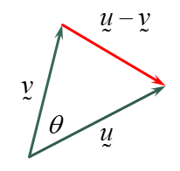  $${\left|\underset{\sim }{u}-\underset{\sim }{v}\right|}^{2}={\left|\underset{\sim }{u}\right|}^{2}+{\left|\underset{\sim }{v}\right|}^{2}-2\left|\underset{\sim }{u}\right|\left|\underset{\sim }{v}\right|cosθ \\ {\left(x_{1}-x_{2}\right)}^{2}+{\left(y_{1}-y_{2}\right)}^{2}=x_{1}^{2}+y_{1}^{2}+x_{2}^{2}+y_{2}^{2}-2\left|\underset{\sim }{u}\right|\left|\underset{\sim }{v}\right|\cos{θ} \\ -2x_{1}x_{2}-2y_{1}y_{2}=-2\left|\underset{\sim }{u}\right|\left|\underset{\sim }{v}\right|\cos{θ} \\ x_{1}x_{2}+y_{1}y_{2}=\left|\underset{\sim }{u}\right|\left|\underset{\sim }{v}\right|\cos{θ} \\ \underset{\sim }{u}⋅\underset{\sim }{v}=\left|\underset{\sim }{u}\right|\left|\underset{\sim }{v}\right|\cos{θ}$$  So, $\underset{\sim }{u}⋅\underset{\sim }{v}=\left|\underset{\sim }{u}\right|\left|\underset{\sim }{v}\right|\cos{θ}=x_{1}x_{2}+y_{1}y_{2}$  An alternative proof of equivalence  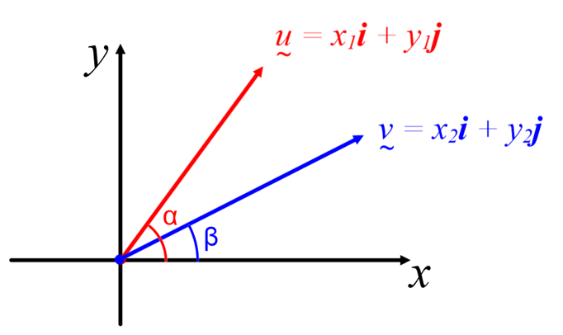  - $\underset{\sim }{u}.\underset{\sim }{v}=\left|\underset{\sim }{u}\right|\left|\underset{\sim }{v}\right|\cos{(α-β)}$  $$\underset{\sim }{u}.\underset{\sim }{v}=\left|\underset{\sim }{u}\right|\left|\underset{\sim }{v}\right|(cos\left(α\right)\cos\left(β\right)+\sin\left(α\right)sin⁡(β))$$  $$\underset{\sim }{u}.\underset{\sim }{v}=\left|\underset{\sim }{u}\right|\cos\left(α\right)\left|\underset{\sim }{v}\right|\cos\left(β\right)+\left|\underset{\sim }{u}\right|\sin\left(α\right)\left|\underset{\sim }{v}\right|\sin\left(β\right)$$  $$\underset{\sim }{u}.\underset{\sim }{v}=x_{1}x_{2}+y_{1}y_{2}$$  as $x_{1}=|\underset{\sim }{u}|cos⁡(α)$ and $y_{1}=|\underset{\sim }{u}|sin⁡(α)$,…  - Teachers should demonstrate using examples that dot product is commutative, $\underset{\sim }{u}⋅\underset{\sim }{v}=\underset{\sim }{v}⋅\underset{\sim }{u}$, and distributive, $\underset{\sim }{a}.(\underset{\sim }{u}+\underset{\sim }{v})=\underset{\sim }{a}.\underset{\sim }{u}+\underset{\sim }{a}.\underset{\sim }{v}$.  - After further practice with a variety of problems, teachers could establish the dot product of a vector with itself,  $\underset{\sim }{v}⋅\underset{\sim }{v}=\left|\underset{\sim }{v}\right|\left|\underset{\sim }{v}\right|\cos{0°}={\left|\underset{\sim }{v}\right|}^{2}$. Also $\left|\underset{\sim }{v}\right|=\sqrt{\underset{\sim }{v}⋅\underset{\sim }{v}}$.  - Students could find the dot product of pairs of unit vectors in the direction of positive $x$ and positive $y$axes, i.e. $\underset{\sim }{i}⋅\underset{\sim }{i}=1$, $\underset{\sim }{i}⋅\underset{\sim }{j}=0$ and $\underset{\sim }{j}⋅\underset{\sim }{j}=1$  Dot product examples  - $\underset{\sim }{u}=-3\underset{\sim }{i}-7\underset{\sim }{j}$, If $\underset{\sim }{v}=5\underset{\sim }{i}+4\underset{\sim }{j}$ and $\underset{\sim }{w}=5\underset{\sim }{i}-4\underset{\sim }{j}:$  - Calculate $\underset{\sim }{u}⋅\underset{\sim }{v}$  - Find the angle between $\underset{\sim }{v}$ and $\underset{\sim }{u}$  - Show the distributive property holds, i.e.  $$\underset{\sim }{v}⋅\left(\underset{\sim }{u}+\underset{\sim }{w}\right)=\underset{\sim }{v}⋅\underset{\sim }{u}+\underset{\sim }{v}⋅\underset{\sim }{w}$$  - A, B and C are points defined by the position vectors $\underset{\sim }{a}=\underset{\sim }{i}+3\underset{\sim }{j}$, $\underset{\sim }{b}=2\underset{\sim }{i}+\underset{\sim }{j}$ and $\underset{\sim }{c}=\underset{\sim }{i}-2\underset{\sim }{j}$ respectively. Find the size of $∠ABC$.  - If $\overset{̰}{v}=\underset{\sim }{i}+7\underset{\sim }{j}$ and $\overset{̰}{u}=8\underset{\sim }{i}-6\underset{\sim }{j}$, find $\underset{\sim }{u}⋅\underset{\sim }{v}$ and hence find the angle between $\underset{\sim }{u}$and$\underset{\sim }{v}$ (to the nearest degree).  Resource: Dot product, me-v1-vectors-examples-solutions.DOCX
Parallel and perpendicular vectors  (1 lesson) | - examine properties of parallel and perpendicular vectors and determine if two vectors are parallel or perpendicular (ACMSM021) | Parallel and perpendicular vectors  - The dot product has very important applications in determining if two vectors are parallel or perpendicular.  Perpendicular vectors  - For perpendicular vectors (or orthogonal vectors), the dot product equals 0 since  $\underset{\sim }{u}⋅\underset{\sim }{v}=\left|\underset{\sim }{u}\right|\left|\underset{\sim }{v}\right|\cos{90°}=\left|\underset{\sim }{u}\right|\left|\underset{\sim }{v}\right|×0=0$.  Parallel vectors  - Students may complete the parallel vectors investigation.  - For parallel vectors, the angle between the two vectors equals $0°$ or $180°$. From the geometric definition, teachers can show that the dot product of vectors in the same direction is $\underset{\sim }{u}⋅\underset{\sim }{v}=\left|\underset{\sim }{u}\right|\left|\underset{\sim }{v}\right|\cos{0°}=\left|\underset{\sim }{u}\right|\left|\underset{\sim }{v}\right|$ and the dot product for vectors pointing in opposite directions is  $\underset{\sim }{u}⋅\underset{\sim }{v}=\left|\underset{\sim }{u}\right|\left|\underset{\sim }{v}\right|\cos{180°}=-\left|\underset{\sim }{u}\right|\left|\underset{\sim }{v}\right|$.  - Students should then be guided to understand that parallel vectors are scalar multiples of each other. i.e. If $\underset{\sim }{u}$ and $\underset{\sim }{v}$ are parallel then $\underset{\sim }{u}=λ\underset{\sim }{v}$, where $λ$ is a scalar. This is the favoured method for identifying parallel vectors.  Parallel and perpendicular vectors examples  - If $\underset{\sim }{v}=6\underset{\sim }{i}+4\underset{\sim }{j}$, $\underset{\sim }{u}=2\underset{\sim }{i}-3\underset{\sim }{j}$, $\underset{\sim }{w}=12\underset{\sim }{i}-18\underset{\sim }{j}$  - Show $\underset{\sim }{u}$and $\underset{\sim }{v}$are perpendicular  - Show $\underset{\sim }{u}$and $\underset{\sim }{w}$are parallel  - If $\underset{\sim }{a}=x\underset{\sim }{i}+2\underset{\sim }{j}$ is perpendicular to vector $\underset{\sim }{b}=2\underset{\sim }{i}-\underset{\sim }{j}$, find $x$.  - If $\underset{\sim }{a}=-6\underset{\sim }{i}+y\underset{\sim }{j}$ is parallel to vector $\underset{\sim }{b}=2\underset{\sim }{i}-4\underset{\sim }{j}$, find $y$.  Resource: Direction of a vector, me-v1-vectors-examples-solutions.DOCX
Projection of one vector onto another  (1 lesson) | - define and use the projection of one vector onto another (ACMSM022) | Vector projection  - Introduce the idea that vector projection is the overlay of one vector on to another. When referring to vector projection, it is important to state the vector being projected and the vector being projected on to, i.e. the vector projection of $\underset{\sim }{u}$ onto $\underset{\sim }{v}$ generates a vector in the direction of $\underset{\sim }{v}$. The vector projection of $\underset{\sim }{v}$ onto $\underset{\sim }{u}$ generates a different resulting vector in the direction of $\underset{\sim }{u}$.  - Students can investigate vector projection. Emphasise examples where there is an obtuse angle between the vectors as the projection is in the opposite direction of the second vector.  - We call $\underset{\sim }{a}$ the vector projection of $\underset{\sim }{u}$ in the direction of $\underset{\sim }{v}$. This is denoted as ${proj}_{\underset{\sim }{v}}\underset{\sim }{u}$.  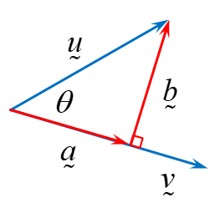  - $\underset{\sim }{u}=\underset{\sim }{a}+\underset{\sim }{b}$  - $\underset{\sim }{a}=k\underset{\sim }{v}$  $$\underset{\sim }{b}∙\underset{\sim }{v}=0$$  $$\left(\underset{\sim }{u}-\underset{\sim }{a}\right)∙\underset{\sim }{v}=0$$  $$\left(\underset{\sim }{u}-k\underset{\sim }{v}\right)∙\underset{\sim }{v}=0$$  $$\underset{\sim }{u}∙\underset{\sim }{v}-k\underset{\sim }{v}∙\underset{\sim }{v}=0$$  $$\underset{\sim }{u}∙\underset{\sim }{v}=k\underset{\sim }{v}∙\underset{\sim }{v}$$  $$\frac{\underset{\sim }{u}∙\underset{\sim }{v}}{\underset{\sim }{v}∙\underset{\sim }{v}}=k$$  $$\underset{\sim }{a}=\frac{\underset{\sim }{u}∙\underset{\sim }{v}}{\underset{\sim }{v}∙\underset{\sim }{v}}\underset{\sim }{v}$$  Now,  $$\underset{\sim }{a}=\frac{\underset{\sim }{u}∙\underset{\sim }{v}}{\underset{\sim }{v}∙\underset{\sim }{v}}\underset{\sim }{v}$$  $$\underset{\sim }{a}=\frac{\underset{\sim }{u}∙\underset{\sim }{v}}{{\left|\underset{\sim }{v}\right|}^{2}}\underset{\sim }{v}$$  $$\underset{\sim }{a}=\left(\frac{\underset{\sim }{u}∙\underset{\sim }{v}}{\left|\underset{\sim }{v}\right|}\right)\frac{\underset{\sim }{v}}{\left|\underset{\sim }{v}\right|}$$  $$\underset{\sim }{a}=\left(\overset{̰}{u}∙\overset{̰}{\hat{v}} \right)\overset{̰}{\hat{v}}$$  Or  $\underset{\sim }{a}=(\left|\underset{\sim }{u}\right|cosθ$)$\overset{̰}{\hat{v}}$  - Note:  $$\frac{\underset{\sim }{u}∙\underset{\sim }{v}}{\left|\underset{\sim }{v}\right|}=\frac{\left|\underset{\sim }{u}\right|\left|\underset{\sim }{v}\right|cosθ}{\left|\underset{\sim }{v}\right|}$$  $$\frac{\underset{\sim }{u}∙\underset{\sim }{v}}{\left|\underset{\sim }{v}\right|}=\left|\underset{\sim }{u}\right|cosθ$$  This is known as the scalar projection of $\underset{\sim }{u}$ onto $\underset{\sim }{v}$.  If $\underset{\sim }{u}=\underset{\sim }{x_{1} i}+y_{1}\underset{\sim }{j}$, which makes an angle $θ$ in an anti-clockwise direction to the $x$-axis, then $x_{1}$ is the scalar projection of $\underset{\sim }{u}$ onto $i$ (or the $x$-axis) and $x_{1}i$ is the vector projection of $\underset{\sim }{u}$ onto $i$. Similarly, $y_{1}$ is the scalar projection of $\underset{\sim }{u}$ onto $j$ (or the $y$-axis) and $y_{1}j$ is the vector projection of $\underset{\sim }{u}$ onto $j$.  Vector projection examples  - Let $\underset{\sim }{a}=\underset{\sim }{i}+3\underset{\sim }{j}$ and $\underset{\sim }{b}=\underset{\sim }{i}-\underset{\sim }{j}$,  - find the scalar projection of $\underset{\sim }{a}$ onto $\underset{\sim }{b}$.  - find the vector projection of $\underset{\sim }{a}$ in the direction of $\underset{\sim }{b}$.  - Let $\underset{\sim }{a}=\underset{\sim }{i}+3\underset{\sim }{j}$ and $b=\underset{\sim }{i}-\underset{\sim }{j}$, find the vector projection of $\underset{\sim }{a}$ in the direction $\underset{\sim }{b}$.  Resource: Vector projection, me-v1-vectors-examples-solutions.DOCX
Vectors and geometry  (1 lesson) | - prove geometric results and construct proofs involving vectors in two dimensions including but not limited to proving that: AAM  - the diagonals of a parallelogram meet at right angles if and only if it is a rhombus (ACMSM039)  - the midpoints of the sides of a quadrilateral join to form a parallelogram (ACMSM040)  - the sum of the squares of the lengths of the diagonals of a parallelogram is equal to the sum of the squares of the lengths of the sides (ACMSM041) | Vectors and geometry  - Note: Teachers should ensure that students are familiar with geometry concepts up to Stage 5. It would be useful to review the properties of quadrilaterals as a precursor to this topic.  - Teachers can introduce the geometric results/proofs by demonstrating the result using a visual. Geogebra samples are given for the three examples explicitly mentioned in the syllabus:  - the diagonals of a parallelogram meet at right angles if and only if it is a rhombus  - the midpoints of the sides of a quadrilateral join to form a parallelogram  - the sum of the squares of the lengths of the diagonals of a parallelogram is equal to the sum of the squares of the lengths of the sides  - Students should construct geometric proofs with vectors for the three examples explicitly mentioned in the syllabus and others.  Resource: Proving geometric results, me-v1-vectors-examples-solutions.DOCX  - Note: Demonstrate that vectors make it easier to write geometric proofs by showing a completed proof with and without vectors.  - When practising questions, teachers should emphasise that equal sides do not imply equal vectors, though they would be equal in magnitude e.g. an equilateral triangle represented using vectors contains at least three vectors of equal magnitude but different directions. Similarly, a shape with parallel sides can be represented using vectors that are scalar multiples of each other. Teachers should also emphasise that if a collection of vectors form a polygon, then the result is the same as the zero vector.  - Students should be given the opportunity to complete a variety of questions, beginning with scaffolded solutions. Teachers and students are encouraged to reconstruct diagrams using GeoGebra and manipulate them to help deconstruct the question and the properties of the plane shapes.
Vectors in the physical world  (1 lesson) | - solve problems involving displacement, force and velocity involving vector concepts in two dimensions (ACMSM023) AAM | Modelling motion in two dimensions  - When an object travels in two (or more) dimensions, vectors are used to fully record and study its motion. The general principles of kinematics (studied in MA–C1.4 and MA–C3.1) still apply; but the position $\underset{\sim }{r}\left(t\right)=x\underset{\sim }{i}+y\underset{\sim }{j}$, velocity $\underset{\sim }{v}\left(t\right)=v_{x}\underset{\sim }{i}+v_{y}\underset{\sim }{j}$ and acceleration $\underset{\sim }{a}\left(t\right)=a_{x}\underset{\sim }{i}+a_{y}\underset{\sim }{j}$ of the object are vector quantities with both magnitude and direction.  - Students should be familiar with the idea of $v=\frac{dx}{dt}$ and $a=\frac{dv}{dt}=\frac{d^{2}x}{dt^{2}}$ making it fairly straight forward to go to the understanding that $\underset{\sim }{v}\left(t\right)=\dot{\underset{\sim }{r}}\left(t\right)=\frac{d\underset{\sim }{r}}{dt}$ and $\underset{\sim }{a}\left(t\right)=\ddot{\underset{\sim }{r}}\left(t\right)=\frac{d\underset{\sim }{v}}{dt}$. Teachers need to highlight that time is not denoted using vector notation.  - Determining velocity and acceleration require the use of differentiation or integration.  - Rules of differentiation for vectors:  - The derivative of a unit vector equals zero.  - The derivative of the constant vector $a\underset{\sim }{i}$equals zero.  - The derivative of a vector $x\underset{\sim }{i}$ whose scalar coefficient $x\left(t\right)$ is a function of time is given by $\frac{d(x\underset{\sim }{i})}{dt}=\frac{dx}{dt}\underset{\sim }{i}$  - The derivative of the sum of two vectors is the sum of the derivative of each vector. In the case of the position vector  $\underset{\sim }{r}=x\underset{\sim }{i}+y\underset{\sim }{j}$: $\frac{d\underset{\sim }{r}}{dt}=\frac{dx}{dt}\underset{\sim }{i}+\frac{dy}{dt}\underset{\sim }{j}$  - It is worthwhile at this point to discuss the logic and derivation of these rules. From the above it should then be established that:  $$\underset{\sim }{v}\left(t\right)=\dot{\underset{\sim }{r}}\left(t\right)=\frac{d\underset{\sim }{r}}{dt}=\frac{dx}{dt}\underset{\sim }{i}+\frac{dy}{dt}\underset{\sim }{j}$$  $$\underset{\sim }{a}\left(t\right)=\ddot{\underset{\sim }{r}}\left(t\right)=\frac{d\underset{\sim }{v}}{dt}=\frac{dv_{x}}{dt}\underset{\sim }{i}+\frac{dv_{y}}{dt}\underset{\sim }{j}=\frac{d^{2}x}{dt^{2}}\underset{\sim }{i}+\frac{d^{2}y}{dt^{2}}\underset{\sim }{j}$$  Students should apply these rules in reverse for integration.  - Important points to note:  - The displacement of a particle is the change of its position over a given time interval. Displacement vector $=\underset{\sim }{r}\left(T+∆t\right)-\underset{\sim }{r}\left(T\right)$  - The distance is a scalar quantity as it has magnitude and not direction. Therefore, the distance of a particle from the origin is given by the magnitude of the position vector, $\underset{\sim }{r}\left(t\right)$.  - Speed is a scalar quantity as it has magnitude but not direction. Therefore, the speed of a particle is the magnitude of the velocity vector, $\underset{\sim }{v}\left(t\right)$.  - The direction of the motion is in the direction parallel to the velocity vector.  - If the position vector is $\underset{\sim }{r}(t)=x\underset{\sim }{i}+y\underset{\sim }{j}$, then the parametric equations for the coordinates of the path are $x(t)$ and $y(t)$. The Cartesian equation for the motion of the particle is $y(x)$ which can be obtained from the parametric equations$x(t)$ and $y(t)$.  - If two objects collide then they must be at the same point at the same time. Using vector notation, the two objects must share the same position vector at a specific time.  - Students may like to run the following activities  - This interactive game from nctm.org challenges students to interpret and determine vectors in order to position a boat at a particular destination. Students should explore the static and dynamic modes.  - Relative velocity and riverboat problems at physicsclassroom.com provides supplementary materials and examples for 2D motion.  - This youtube clip from CrashCourse is an introductory tutorial for modelling 2D motion.  Modelling motion examples  - In still water, Jacques can swim at 3 m/s. Jacques is at point A on the edge of a canal, and considers point B directly opposite. A current is flowing from the left at a constant speed of 1 m/s. If Jacques dives in straight towards B, and swims without allowing for the current, what will his actual speed and direction be? (answers correct to 1 decimal place)  - Jacques wants to swim directly across the canal to point B. At what angle should Jacques aim to swim in order that the current will correct his direction? And what will Jacques’ actual speed be? (answers correct to 1 decimal place)  Resource: Modelling motion, me-v1-vectors-examples-solutions.DOCX
Modelling projectile motion  (1 – 2 lessons) | V1.3: Projectile Motion  - understand the concept of projectile motion, and model and analyse a projectile’s path assuming that:  - the projectile is a point  - the force due to air resistance is negligible  - the only force acting on the projectile is the constant force due to gravity, assuming that the projectile is moving close to the Earth’s surface  - model the motion of a projectile as a particle moving with constant acceleration due to gravity and derive the equations of motion of a projectile AAM  - represent the motion of a projectile using vectors  - recognise that the horizontal and vertical components of the motion of a projectile can be represented by horizontal and vertical vectors  - derive the horizontal and vertical equations of motion of a projectile  - understand and explain the limitations of this projectile model | Introducing projectile motion  - Projectile motion is an important application of vectors. It is helpful to introduce the concept of forces and its different applications, in order to prepare students for the study of projectile motion. Some iPhone, iPad and Android Apps allow students to play with objects and gain an intuitive understanding of forces and movements.  - Students need to have a sound understanding that the projectile is a point moving within 2 dimensions, the vertical and the horizontal. For the projectiles considered in this course, the only force acting on the projectile is the force due to gravity.  - At this point it would be helpful to expose students to some simulations to get a feel for what is happening within the horizontal and vertical motion. Staff could use the following sites  - Projectile motion – 1  - Horizontal and vertical components of velocity  - Projectile motion – 2  - The science of NFL football  - Staff need to lead discussions regarding initial acceleration, velocity and displacement for both the horizontal and vertical components of the motion as well as what is happening throughout the motion to each component. This will assist students with developing a deeper understanding.  - It is useful at this point to also discuss the vectors that represent the velocity and acceleration of the motion.  Modelling projectile motion using equations of motion  - Students should be guided to start with $\ddot{x}=0$ from their understanding that there is no force acting on horizontal motion (at least in the motion considered as part of this course). From  $\ddot{x}=0$ and their understanding of initial velocity and displacement they can then use integral calculus to derive the equations for horizontal velocity and displacement.  - Students should be guided to start with $\ddot{y}=-g$ from their understanding that the only force acting on vertical motion is gravity. From $\ddot{y}=-g$ and their understanding of initial velocity and displacement they can then use integral calculus to derive the equations for vertical velocity and displacement.  - After the initial discussions of the vectors that describe projectile motion students should now formally represent the path of a projectile using vectors.  - Students should use vector analysis to combine both horizontal direction and vertical direction and derive the formula of velocity and displacement in the vector form.
Solving projectile motion problems  (1 – 2 lessons) | - use equations for horizontal and vertical components of velocity and displacement to solve problems on projectiles  - apply calculus to the equations of motion to solve problems involving projectiles (ACMSM115) AAM | Using equations of motion to solve problems involving projectiles  - Explain the meaning of key terms such as time of flight, greatest range and greatest (or maximum) height.  - Use Angry Bird and/or other projectile motion simulation tools to help students understand the effect of initial velocity and initial vertical displacement. In addition, let students apply the formula to confirm the calculation.  - Explore the conditions for the time of flight as the time it takes for the particle to reach the ground. That is $t$ when $y=0$.  - Explore the conditions for maximum range as the displacement when the particle ends its flight. That is, $x$ at the time $y=0$. Develop an understanding that the angle of projection that will give the maximum range is $45°$.  - Explain the conditions for greatest height as $y$ at the time $\dot{y}=0$.  - Students should be given time to think about these situations numerically first and then solve for the general case.  - Explore that the equation of motion of $y$ with respect to $x$ is derived by combining the horizontal and vertical displacements, $x$ and $y$, by eliminating $t$.  Projectile motion examples  - A projectile is launched off a cliff 15$m$ above the ground at an angle of $30°$ to the horizontal with an initial velocity of $12 m/s$.  - Calculate the Initial velocities  - Find the horizontal components of motion  - Find the vertical components of motion  - Find the time of the flight  - Find the range of the projectile  - Find the final velocity of the projectile  - Calculate the maximum height the projectile reaches  - Derive the Cartesian equation of the trajectory ($y$ as a function of $x$)  - A projectile is launched at an angle of $θ°$ to the horizontal with an initial velocity of $u m/s$. Assuming no air resistance, show the maximum range is achieved when $θ=45° or\frac{π}{4}$.  - 2011 Mathematics Extension 1 HSC, question 6, part b  The diagram shows the trajectory of a ball thrown horizontally, at speed v ms–1, from the top of a tower h metres above ground level.  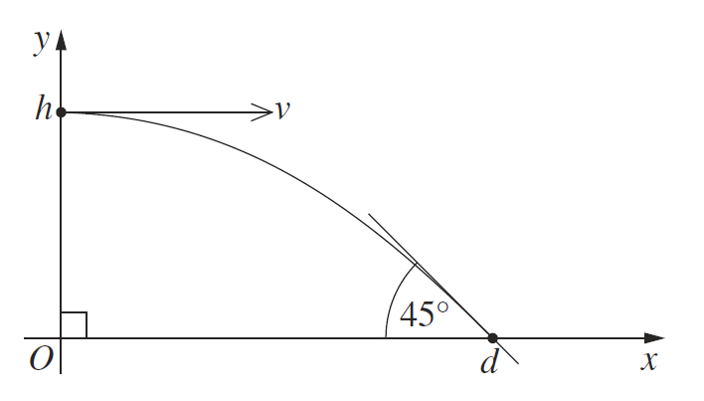  The ball strikes the ground at an angle of $45°$, $d$ metres from the base of the tower, as shown in the diagram. The equations describing the trajectory of the ball are $x=vt$ and $y=h-\frac{1}{2}gt^{2}$, where $g$ is the acceleration due to gravity, and $t$ is time in seconds.  - Prove that the ball strikes the ground at time $t=\sqrt{\frac{2h}{g}}$seconds.  - Hence, or otherwise, show that $d=2h$.  Resource: Projectile motion, me-v1-vectors-examples-solutions.DOCX

Reflection and evaluation
Please include feedback about the engagement of the students and the difficulty of the content included in this section. You may also refer to the sequencing of the lessons and the placement of the topic within the scope and sequence. All information and communications technologies (ICT), literacy, numeracy and group activities should be recorded in the ‘Comments, feedback, additional resources used’ section.

