ME-T3 unit worked solutions

Lesson: Converting expressions to $R\cos{(x±α)}$ and $R\sin{(x±α)}$

Example 1: Show $\sqrt{3} cos{x}+\sin{x}=2\cos\left(x-\frac{π}{6}\right)$
Let $\sqrt{3} cos{x}+\sin{x}=R\cos\left(x-α\right)$
Expanding the right hand side gives,
$$\sqrt{3} cos{x}+\sin{x}= R\cos{xcosα}+R\sin{xsinα}$$
Equating the coefficients gives,
$\sqrt{3}=Rcosα$ and $1=Rsinα$
Since sine and cosine are positive, $α$ must be a 1st quadrant angle.
Calculate $R$ by forming a right angle triangle and applying Pythagoras’ theorem or using the trigonometric identity $\sin^{2}α+\cos^{2}α=1$
Method 1:
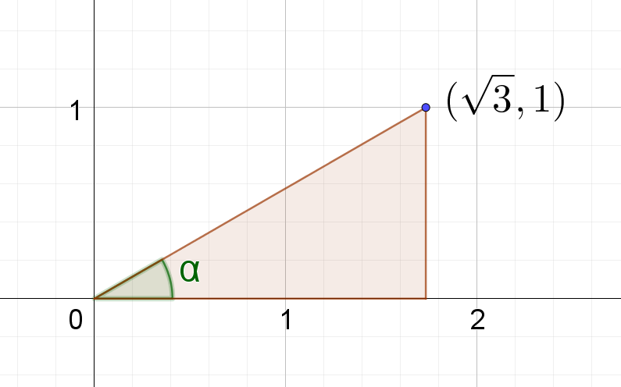
$$R^{2}={\sqrt{3}}^{2}+1^{2}$$
$$R^{2}=4$$
$$R=2$$
Method 2:
By squaring and adding the equations $\sqrt{3}=Rcosα$ and $1=Rsinα$ we obtain
$${\sqrt{3}}^{2}+1^{2}=R^{2}cos^{2}α+R^{2}sin^{2}α$$
$$3+1=R^{2}\left(cos^{2}α+sin^{2}α\right)$$
$$4=R^{2}$$
$$R=2$$
Calculate $α$, noting that because sine and cosine are positive, $α$ must be a first quadrant angle.
$$\frac{1}{\sqrt{3}}=\frac{Rsinα}{Rcosα}$$
$$\frac{1}{\sqrt{3}}=tanα$$
$$α=\frac{π}{6}$$
$$∴\sqrt{3} cos{x}+\sin{x}=2\cos\left(x-\frac{π}{6}\right)$$

Example 2: Find 4 expressions equivalent to $\sqrt{3} cos{x}+\sin{x}$

Expression 1
From the worked example above, $f(x)=\sqrt{3} cos{x}+\sin{x}=2\cos\left(x-\frac{π}{6}\right)$

Expression 2
Let $\sqrt{3} cos{x}+\sin{x}=R\cos\left(x+α\right)$
Expand the right hand side: $\sqrt{3} cos{x}+\sin{x}= R\cos{xcosα}-R\sin{xsinα}$
Equate the coefficients: $\sqrt{3}=Rcosα$ and $1=-Rsinα$ or $-1=Rsinα$
Since sine is negative and cosine is positive, $α$ must be a 4th quadrant angle.
Find $R$ by forming a right angle triangle in the 4th quadrant and applying Pythagoras’ theorem, or using the trigonometric identity $\sin^{2}α+\cos^{2}α=1.$Obtain $R=2$.
Find $α$
$\frac{-1}{\sqrt{3}}=\frac{Rsinα}{Rcosα}$
$$\frac{-1}{\sqrt{3}}=tanα$$
$$α=\frac{11π}{6}$$
$$∴\sqrt{3} cos{x}+\sin{x}=2\cos\left(x+\frac{11π}{6}\right)$$
This second expression follows logically from the first since $-\frac{π}{6}=\frac{11π}{6}$. It represents a phase shift of $2π$ radians.

Expression 3
Let $\sqrt{3} cos{x}+\sin{x}=R\sin\left(x+α\right)$
Expand the right hand side: $\sqrt{3} cos{x}+\sin{x}= R\sin{xcosα}+R\cos{xsinα}$
Equate the coefficients: $\sqrt{3}=Rsinα$ and $1=Rcosα$
Since sine and cosine are positive, $α$ must be a 1st quadrant angle.
Find $R$ by forming a right angle triangle in the 1st quadrant and applying Pythagoras’ theorem or using the trigonometric identity $\sin^{2}α+\cos^{2}α=1.$Obtain $R=2$.
Find $α$
$\frac{\sqrt{3}}{1}=\frac{Rsinα}{Rcosα}$
$$\sqrt{3}=tanα$$
$$α=\frac{π}{3}$$
$$∴\sqrt{3} cos{x}+\sin{x}=2\sin\left(x+\frac{π}{3}\right)$$

Expression 4
Let $\sqrt{3} cos{x}+\sin{x}=R\sin\left(x-α\right)$
Expand the right hand side: $\sqrt{3} cos{x}+\sin{x}= R\sin{xcosα}-R\cos{xsinα}$
Equate the coefficients: $\sqrt{3}=-Rsinα or-\sqrt{3}=Rsinα$ and $1=Rcosα$
Since sine is negative and cosine is positive, $α$ must be a 4th quadrant angle.
Find $R$ by forming a right angle triangle in the 4th quadrant and applying Pythagoras’ theorem or using the trigonometric identity $\sin^{2}α+\cos^{2}α=1.$Obtain $R=2$.
Find $α$
$\frac{-\sqrt{3}}{1}=\frac{Rsinα}{Rcosα}$
$$-\sqrt{3}=tanα$$
$$α=\frac{5π}{3}$$
$$f(x)=\sqrt{3} cos{x}+\sin{x}=2\sin\left(x-\frac{5π}{3}\right)$$
This second expression follows logically from the third since $-\frac{5π}{3}=\frac{π}{3}$. It represents a phase shift of $2π$ radians.

Example 3: Graph a function $f(x)=a cos{x}+b\sin{x}$ by converting it to $f(x)=R\cos{(x±α)}$ or $f(x)=R\sin{(x±α)}$
Graph $f(x)=\sqrt{3} cos{x}+\sin{x}$ by converting it to $f(x)=R\cos{(x+α)}$.
From the worked example in the unit, $f(x)=\sqrt{3} cos{x}+\sin{x}=2\cos\left(x-\frac{π}{6}\right)$
The graph is a cosine function with an amplitude of 2, period of $2π$ and the phase shifted to the right, $\frac{π}{6}$ radians.
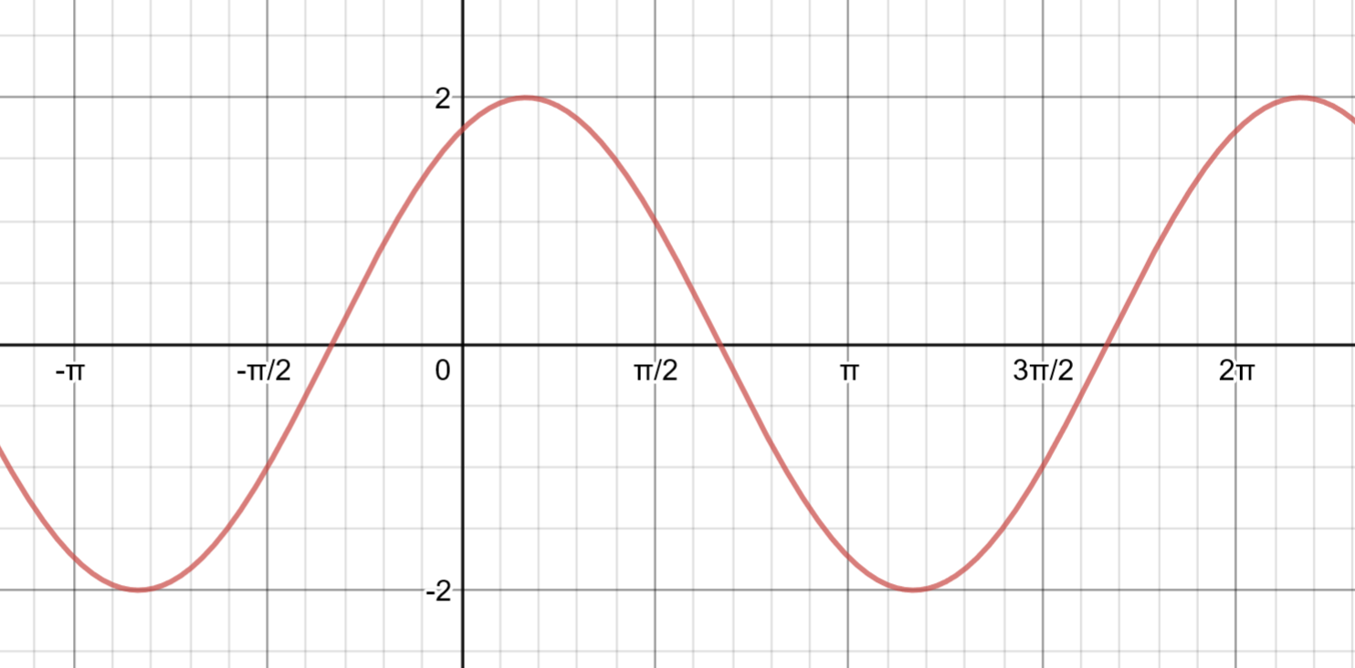

Lesson: Solving equations of the form $$a\cos{x}+b\sin{x}=c$$

Example 1: Solve $4cos x+ 3 sin x=3$ in the domain $[0, 2π]$
Let $4cosx+3sin{x}=R\cos\left(x-α\right)$
Expand the right hand side: $4 cos{x}+3sin{x}= R\cos{xcosα}+R\sin{xsinα}$
Equate the coefficients: $4=Rcosα$ and 3$=Rsinα$
Since sine and cosine are positive, $α$ must be a 1st quadrant angle.
Find $R$ by forming a right angle triangle in the 1st quadrant and applying Pythagoras’ theorem or using the trigonometric identity $\sin^{2}α+\cos^{2}α=1.$Obtain $R=5$
Find $α$
$\frac{3}{4}=\frac{Rsinα}{Rcosα}$
$$\frac{3}{4}=tanα$$
$$α=0.643…$$
$$∴\sqrt{3} cos{x}+\sin{x}=5\cos\left(x-0.643…\right)$$

Solving $4 cos x + 3 sin x = 3$ in the domain $[0, 2π]$ is equivalent to solving $5\cos\left(x-0.643…\right)=3$in the domain $\left[-0.643…, 5.639…\right]$
$$5\cos\left(x-0.643…\right)=3$$
$$\cos\left(x-0.643…\right)=\frac{3}{5}$$
$x-0.643…=\cos^{-1}\left(\frac{3}{5}\right)$ or $x-0.643…=2π-\cos^{-1}\left(\frac{3}{5}\right)$
$$x=1.570…or 5.999…$$
Note: $1.570…=\cos^{-1}\left(\frac{3}{5}\right)+\tan^{-1}\left(\frac{3}{4}\right)=\frac{π}{2}$ which can be observed by forming a right angle triangle.
The solution can be checked by graphing $y=4cos x + 3 sin x$ and $y=3$ and reading the points of intersection or by graphing $y=4cos x + 3 sin x-3$ and reading the $x$ intercepts in the domain. The graphical solutions shown use dotted blue lines to signify the domain.

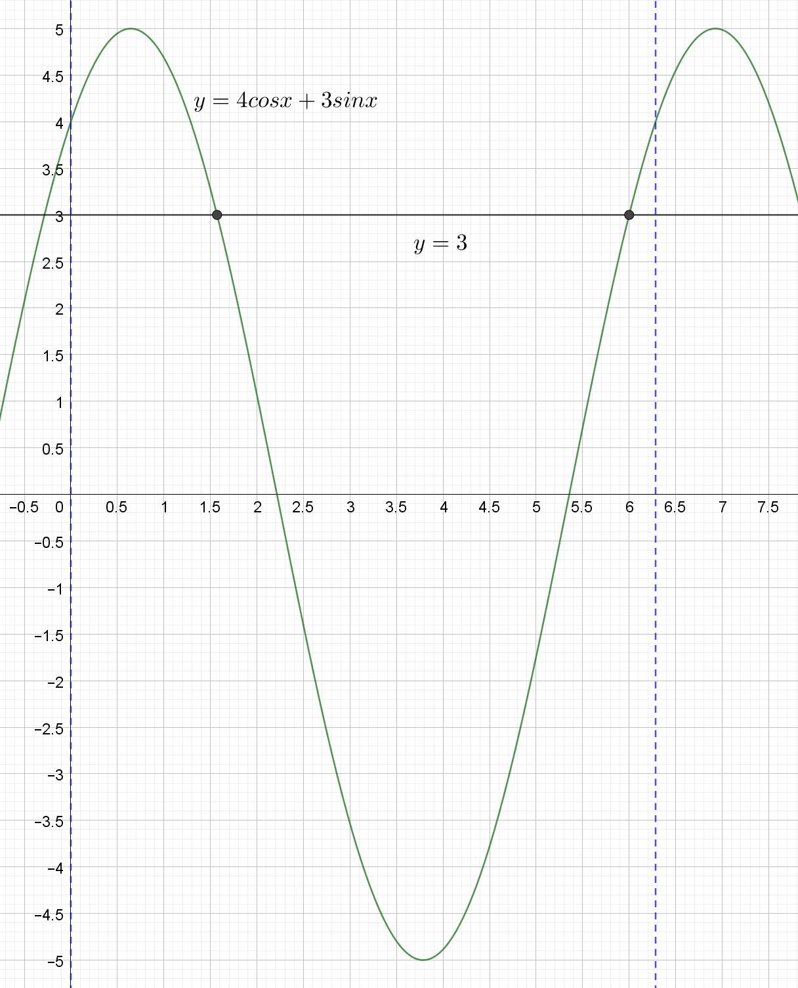

Lesson: Solving equations using factorisation and/or compound angle results

Example 1: Solve $\tan\left(x-\frac{π}{3}\right)=\frac{1}{\sqrt{3}}$ in the domain $\left[0, 2π\right]$
$$0≤x≤2π$$
$$-\frac{π}{3}≤x-\frac{π}{3}≤\frac{5π}{3}$$
Since $\tan\left(x-\frac{π}{3}\right)=\frac{1}{\sqrt{3}},$ the tangent ratio is positive and is in the 1st and 3rd quadrants.
$x-\frac{π}{3}=\frac{π}{6}$ or $x-\frac{π}{3}=\frac{7π}{6}$, check both solutions line in the domain$-\frac{π}{3}≤x-\frac{π}{3}≤\frac{5π}{3}$
$x=\frac{π}{2}$ or $\frac{3π}{2}$
Check the solutions by considering the points of intersection of $y=\tan\left(x-\frac{π}{3}\right)$ and $y=\frac{1}{\sqrt{3}}$
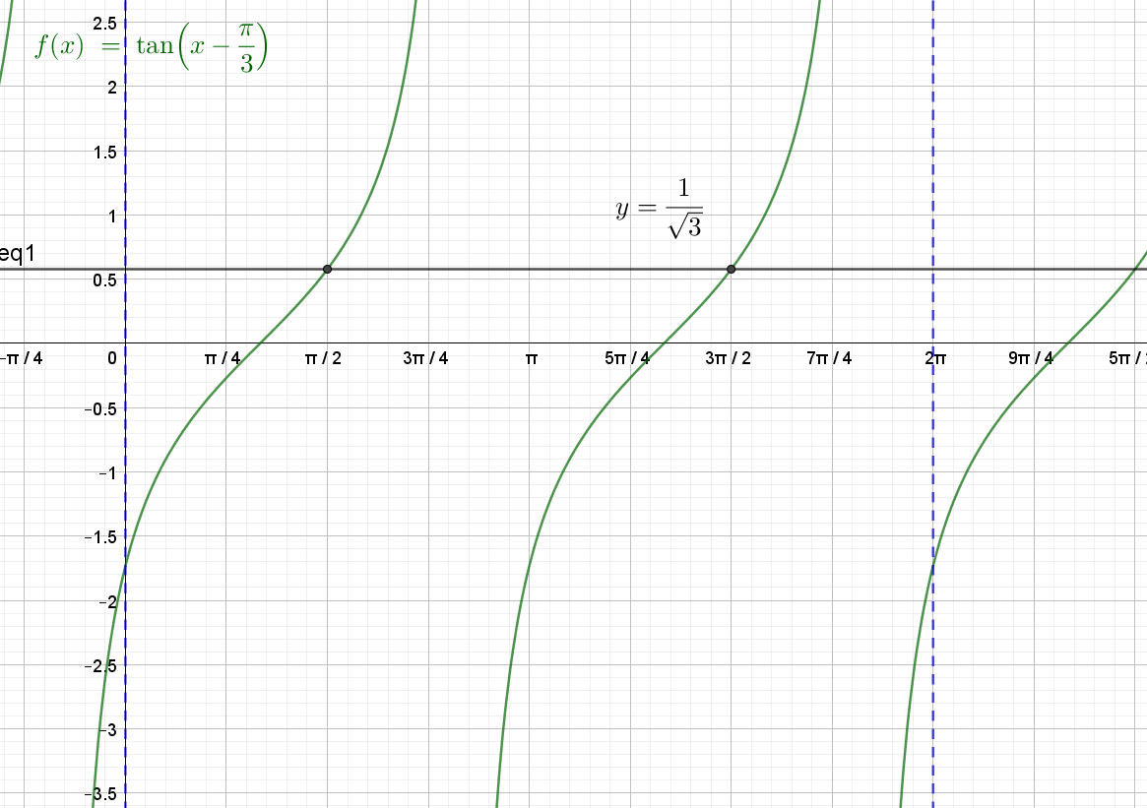

Example 2: Solve $sinxcos\frac{π}{4}+cosxsin\frac{π}{4}=\frac{1}{2}$ in the domain $[-π, π]$

$$sinxcos\frac{π}{4}+cosxsin\frac{π}{4}=sin\left(x+\frac{π}{4}\right)=\frac{1}{2}$$
$$-π≤x≤π$$
$$-\frac{3π}{4}≤x+\frac{π}{4}≤\frac{5π}{4}$$
Since $sin\left(x+\frac{π}{4}\right)=\frac{1}{2},$ the sine ratio is positive and is in the 1st and 2nd quadrants
$x+\frac{π}{4}=\frac{π}{6}$ or $x+\frac{π}{4}=\frac{5π}{6}$, check both solutions line in the domain$-\frac{3π}{4}≤x+\frac{π}{4}≤\frac{5π}{4}$
$x=\frac{-π}{12}$ or $\frac{7π}{12}$
Check the solutions by considering the points of intersection of $y=sinxcos\frac{π}{4}+cosxsin\frac{π}{4}$ and $y=\frac{1}{2}$.
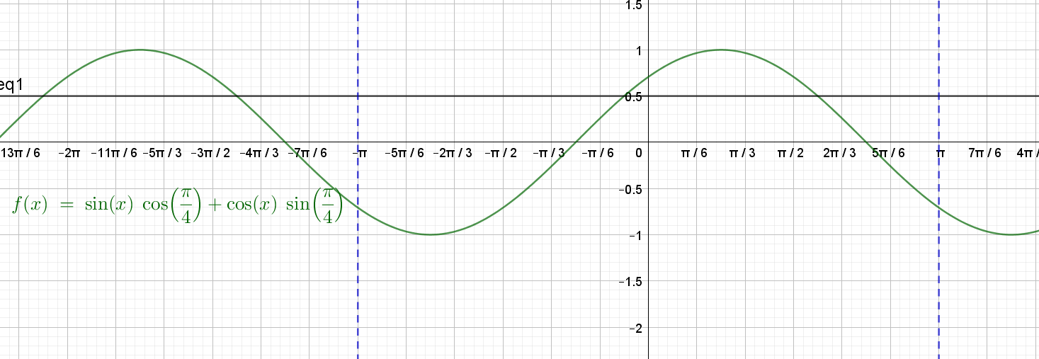

Example 3: Solve $sinxcos\frac{π}{4}-cosxsin\frac{π}{4}=\frac{1}{2}$ in the domain $[-π, π]$
$$sinxcos\frac{π}{4}+cosxsin\frac{π}{4}=sin\left(x-\frac{π}{4}\right)=\frac{1}{2}$$
$$-π≤x≤π$$
$$-\frac{5π}{4}≤x-\frac{π}{4}≤\frac{3π}{4}$$
Since $sin\left(x-\frac{π}{4}\right)=\frac{1}{2},$ the sine ratio is positive and is in the 1st and 2nd quadrants
$x-\frac{π}{4}=\frac{π}{6}$ or $x-\frac{π}{4}=\frac{5π}{6}$, check both solutions line in the domain$-\frac{5π}{4}≤x+\frac{π}{4}≤\frac{3π}{4}$
$\frac{5π}{6}$ lies outside this domain. Convert this to an equivalent angle in the domain i.e. $\frac{-7π}{6}$
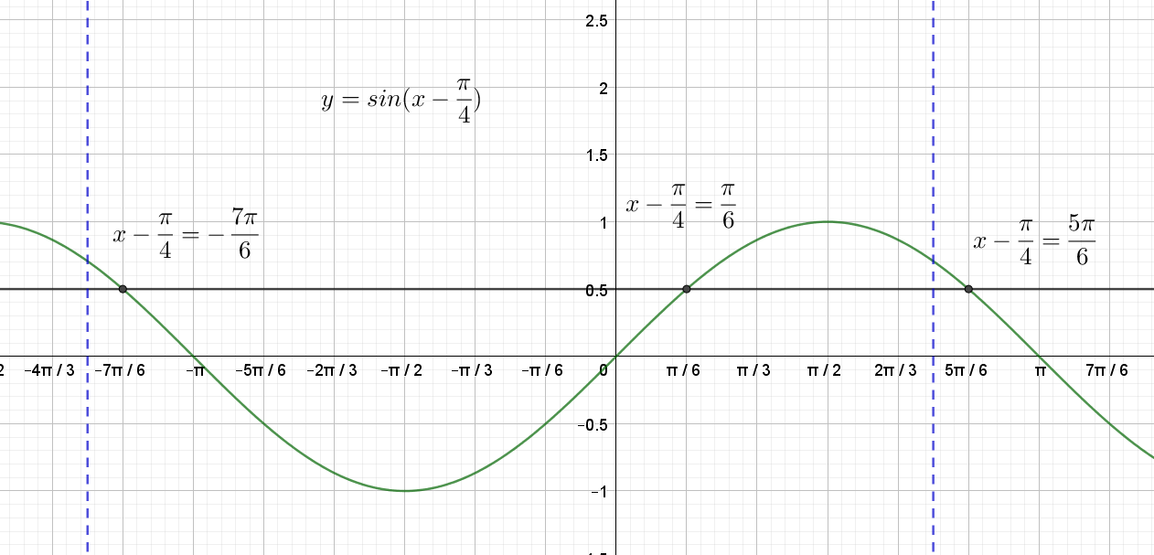
$x-\frac{π}{4}=\frac{π}{6}$ or $x-\frac{π}{4}=\frac{-7π}{6}$
$x=\frac{5π}{12}$ or $\frac{-11π}{12}$

Check the solutions by considering the points of intersection of $y=sinxcos\frac{π}{4}-cosxsin\frac{π}{4}$ and $y=\frac{1}{2}$.
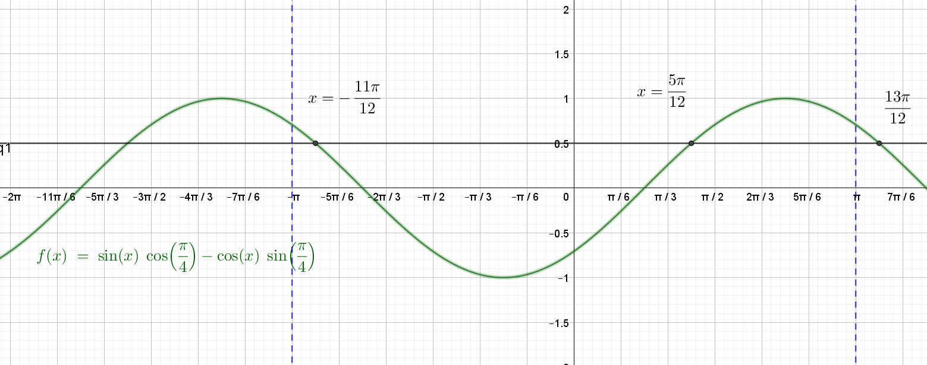

Without adjusting for the domain of $x-\frac{π}{4}$, we would have obtained the solutions $\frac{5π}{12}$ and $\frac{13π}{12}$. The second of which can be observed to lie outside the given domain.

Example 4: Solve $\cos^{2}{x+cosx=}\sin^{2}x$ in the domain $[0, 2π]$
Substitute $\sin^{2}x=1-\cos^{2}x$
$$\cos^{2}{x+cosx=}1-\cos^{2}x$$
$$2\cos^{2}{x+cosx-1=}0$$
$$\left(2\cos{x}-1\right)\left(\cos{x}+1\right)=0$$
$2\cos{x}-1=0$ or $\cos{x}+1=0$
$\cos{x}=\frac{1}{2}$ or $\cos{x}=-1$
$$x=\frac{π}{3},π,\frac{5π}{3}$$
The solution can be checked by considering the$x$ intercepts of the graph of $y=2\cos^{2}{x+cosx-1}$ or $y=\cos^{2}{x-\sin^{2}x+cosx}$.
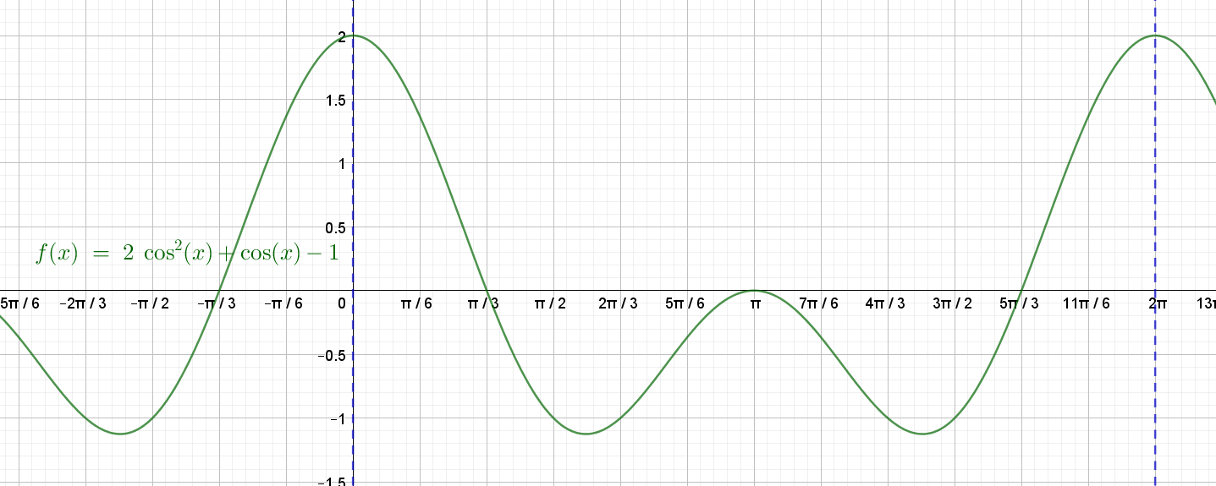

Lesson: Solving equations using double angle results

Example 1: Solve $\tan{2x=}\sqrt{3}$ in the domain $\left[0, 2π\right]$
$$0≤x≤π$$
$$0≤2x≤4π$$
The tangent ratio is positive so the solution will lie in the 1st and 3rd quadrants.
$$\tan{2x=}\sqrt{3}$$
$$2x=\frac{π}{3}, \frac{4π}{3}, \frac{7π}{3}, \frac{10π}{3}$$
$$x=\frac{π}{6}, \frac{2π}{3}, \frac{7π}{6}, \frac{5π}{3}$$
Check the solutions by considering the points of intersection of $y=tan{2x=}$ and $y=\sqrt{3}$
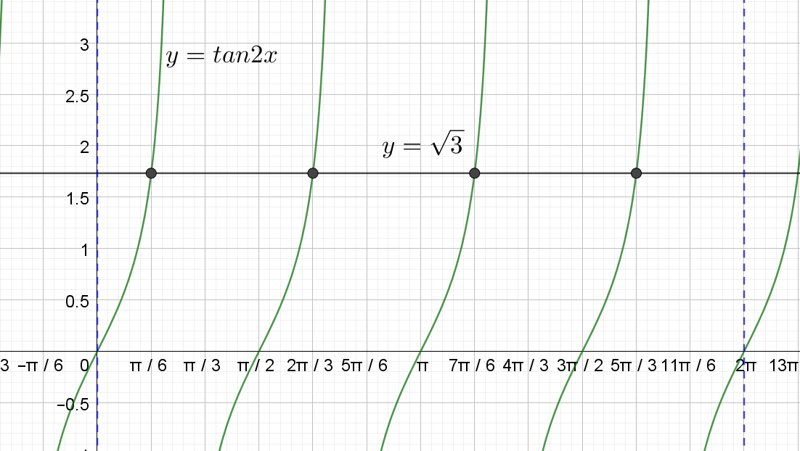

Example 2: Solve $\cos^{2}{x-}\sin^{2}x=\frac{1}{\sqrt{2}}$ in the domain $\left[-π, π\right]$
Substitute $\cos^{2}{x-}\sin^{2}x=cos\left(2x\right)$
$$\cos\left(2x\right)=\frac{1}{\sqrt{2}}$$
$$-π≤x≤π$$
$$-2π≤2x≤2π$$
The cosine ratio is positive so the solution will lie in the 1st and 4th quadrants.
$$2x=\frac{-7π}{4}, \frac{-π}{4}, \frac{π}{4}, \frac{7π}{4}$$
$$x=\frac{-7π}{8}, \frac{-π}{8}, \frac{π}{8}, \frac{7π}{8}$$
Check the solutions by considering the points of intersection of $y=\cos^{2}{x-}\sin^{2}x$ and $y=\frac{1}{\sqrt{2}}$
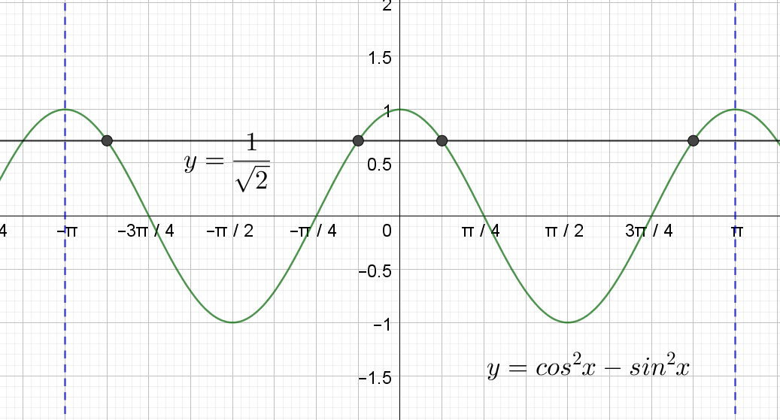

Example 3: Solve $\cos{2x=}sinx$ in the domain $\left[0, 2π\right]$
Substitute ${\cos\left(2x\right)=cos}^{2}{x-}\sin^{2}x$
$$cos^{2}{x}{-}\sin^{2}x=\sin{x}$$
$$1-{2sin}^{2}x=\sin{x}$$
$$0={2sin}^{2}x+\sin{x}-1$$
$$0=\left(2\sin{x}-1\right)\left(\sin{x+1}\right)$$
$$\sin{x}=\frac{1}{2} or-1$$
The first sine ratio is positive so the solution will lie in the 1st and 2nd quadrants
$$x=\frac{π}{6},\frac{5π}{6},\frac{3π}{2}$$
Check solutions from the$x$ intercepts of the graph of $y=\cos{2x-}sinx$
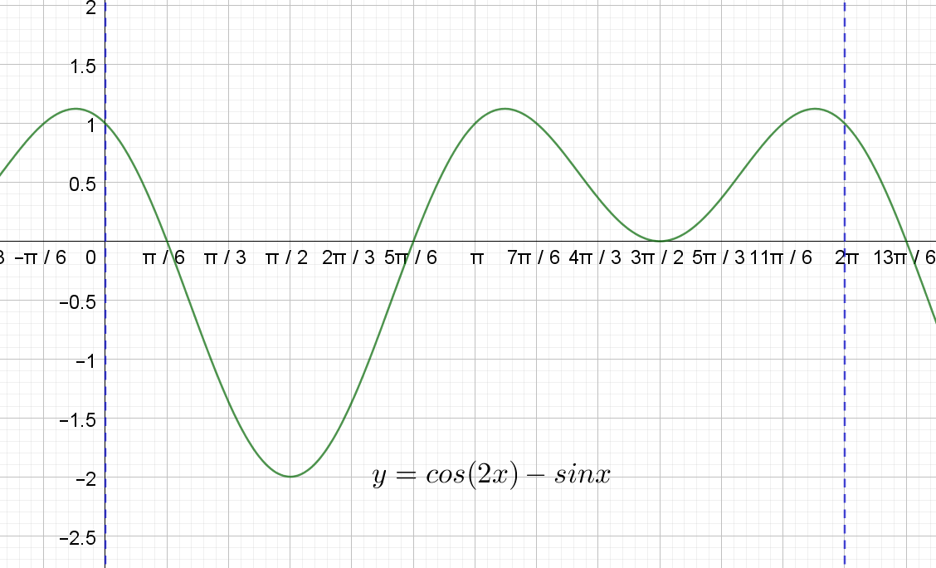

Example 4: Solve $\sin{2x=}sinx$ in the domain $\left[0, 2π\right]$
Substitute $\sin{2x=}2\cos{x}\sin{x}$
$$2\cos{x}\sin{x}=\sin{x}$$
$$2\cos{x}\sin{x}-\sin{x}=0$$
$$\sin{x}\left(2\cos{x}-1\right)=0$$
$$\sin{x}=0 or \cos{x}=\frac{1}{2}$$
The cosine ratio is positive, so the solution to this ratio will lie in the 1st and 4th quadrants
$$x=0,\frac{π}{3}, π,\frac{5π}{3},2π$$
Check solutions from the $x$ intercepts of the graph of $y=\sin{2x-}sinx$
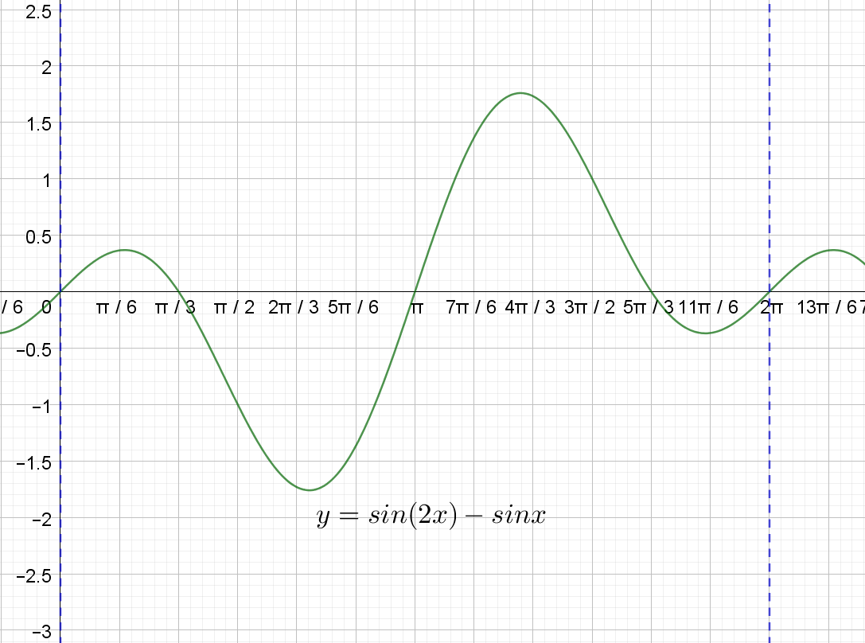

Lesson: Solving equations using the t-formulae

Example 1: Solve $4cosx + 3sinx=3$ using the result
$t=tan\frac{x}{2}$ in the domain $\left[0, 2π\right]$
Given $t=tan\frac{x}{2}$ then substitute $\sin{x}=\frac{2t}{1+t^{2}}$ and $\cos{x=}\frac{1-t^{2}}{1+t^{2}}$
$$4⋅\frac{1-t^{2}}{1+t^{2}}+3⋅\frac{2t}{1+t^{2}}=3$$
$$\frac{4-{4t}^{2}}{1+t^{2}}+\frac{6t}{1+t^{2}}=3$$
$$\frac{4+6t-{4t}^{2}}{1+t^{2}}=3$$
$$4+6t-{4t}^{2}=3+3t^{2}$$
$$0=7t^{2}-6t-1$$
$$0=\left(7t+1\right)\left(t-1\right)$$
$$t=-\frac{1}{7} or 1$$
$tan\frac{x}{2}=-\frac{1}{7}$ or $tan\frac{x}{2}=1$
$$0≤x≤2π$$
$$0≤\frac{x}{2}≤π$$
The 1st tangent ratio is negative and will lie in the 2nd quadrant. The 2nd tangent ratio is positive and will lie in the first quadrant.
$$\frac{x}{2}=π-\tan^{-1}\left(\frac{1}{7}\right), \tan^{-1}\left(1\right)$$
$$\frac{x}{2}=π-\tan^{-1}\left(\frac{1}{7}\right), \frac{π}{4}$$
$$x=5.999…,\frac{π}{2}$$

Lesson: Proofs and applications of trigonometric identities

Example 1: $\cos{3x=4\cos^{3}}x-3\cos{x}$
$$LHS=\cos\left(2x+x\right) \\ =\cos{2x}\cos{x}-\sin{2x}\sin{x} \\ =\left(cos^{2}{x}-sin^{2}{x}\right)\cos{x-}2\sin{x}\cos{x}⋅\sin{x} \\ =\left(2cos^{2}{x}-1\right)\cos{x-}2sin^{2}{x}\cos{x} \\ =2cos^{3}{x-}\cos{x-}2(1-\cos^{2}{x)}\cos{x} \\ =2cos^{3}{x-}\cos{x}-2\cos{x}+2cos^{3}x \\ =4cos^{3}{x-}3\cos{x} \\ =RHS$$
$$∴\cos{3x=4\cos^{3}}x-3\cos{x}$$

Example 2: $\cos{4x=8\cos^{4}x-8\cos^{2}}x+1$
$$LHS=\cos\left(2x+2x\right) \\ =\cos{2x}\cos{2x}-\sin{2x}\sin{2x} \\ =\left(cos^{2}{x}-sin^{2}{x}\right)\left(cos^{2}{x}-sin^{2}{x}\right)-2\sin{x}\cos{x}⋅2\sin{x}\cos{x} \\ =\left(2cos^{2}{x}-1\right)\left(2cos^{2}{x}-1\right)-4sin^{2}{x}cos^{2}{x} \\ =4cos^{4}{x-}4cos^{2}{x+1}-4(1-\cos^{2}{x)}cos^{2}{x} \\ =4cos^{4}{x-}4cos^{2}{x+1}-4cos^{2}{x}+4cos^{4}{x} \\ =4cos^{4}{x-}4cos^{2}{x+1}x+1 \\ =8cos^{4}{x-}8cos^{2}{x+1} \\ =RHS$$
$$∴\cos{4x=8\cos^{4}x-8\cos^{2}}x+1$$

Example 3: $\tan{3x=}\frac{3\tan{x-\tan^{3}x}}{1-3\tan^{2}x}$
$$LHS=\tan\left(2x+x\right) \\ =\frac{\tan{2x}+\tan{x}}{1-\tan{2x}\tan{x}} \\ =\frac{\frac{2\tan{x}}{1-tan^{2}{x}}+\tan{x}}{1-\frac{2\tan{x}}{1-tan^{2}{x}}\tan{x}} \\ =\frac{\frac{2\tan{x}}{1-tan^{2}{x}}+\frac{\tan{x}-tan^{3}{x}}{1-tan^{2}{x}}}{\frac{1-tan^{2}{x}}{1-tan^{2}{x}}-\frac{2tan^{2}{x}}{1-tan^{2}{x}}} \\ =\frac{\frac{2\tan{x}+\tan{x-tan^{3}{x}}}{1-tan^{2}{x}}}{\frac{1-tan^{2}{x}-2tan^{2}{x}}{1-tan^{2}{x}}} \\ =\frac{3\tan{x}-tan^{3}{x}}{1-3tan^{2}{x}} \\ =RHS$$
$$∴\tan{3x=}\frac{3\tan{x-\tan^{3}x}}{1-3\tan^{2}x}$$

Example 4: $\frac{1+\cos{2x}}{\sin{2x}-\cos{x}}=\frac{2\cos{x}}{2\sin{x}-1}$
$$LHS=\frac{1+cos^{2}{x}-sin^{2}{x}}{2\sin{x}\cos{x}-\cos{x}} \\ =\frac{cos^{2}{x}+1-sin^{2}{x}}{\cos{x}(2\sin{x}-1)} \\ =\frac{2cos^{2}{x}}{\cos{x}(2\sin{x}-1)} \\ =\frac{2\cos{x}}{2\sin{x}-1} \\ =RHS$$
$$∴\frac{1+\cos{2x}}{\sin{2x}-\cos{x}}=\frac{2\cos{x}}{2\sin{x}-1}$$

Example 5: Prove $\sin{3x=3sinx-4\sin^{3}}x$. Hence or otherwise solve $3sin{x-4\sin^{3}}x=\frac{\sqrt{3}}{2}$ in the domain $[0, 2π]$
Prove $\sin{3x=3sinx-4\sin^{3}}x$
$$LHS=\sin\left(2x+x\right) \\ =\sin{2x}\cos{x}+\cos{2x}\sin{x} \\ =2\sin{x}\cos{x}⋅cos{x}+\left(cos^{2}{x}-sin^{2}{x}\right)\sin{x} \\ =2\sin{x}cos^{2}{x}+\left(1-2sin^{2}{x}\right)\sin{x} \\ =2\sin{x}\left(1-sin^{2}{x}\right)+\sin{x}-2sin^{3}{x} \\ =2\sin{x}-2sin^{3}{x}+\sin{x}-2sin^{3}{x} \\ =3sinx-4sin^{3}{x} \\ =RHS$$
$∴\sin{3x=3sinx-4\sin^{3}}x$
$$∴\sin{3x=3sinx-4\sin^{3}}x=\frac{\sqrt{3}}{2}$$
Now, $0≤x≤2π$ and $∴0≤3x≤6π$
The sine ratio is positive so the solution will lie in the 1st and 2nd quadrants.
$$3x= \frac{π}{3}, \frac{2π}{3}, \frac{7π}{3}, \frac{8π}{3}, \frac{13π}{3}, \frac{14π}{3}$$
$$x=\frac{π}{9}, \frac{2π}{9}, \frac{7π}{9}, \frac{8π}{9}, \frac{13π}{9}, \frac{14π}{9}$$
Check the solutions by considering the points of intersection of $y=3sin{x-4\sin^{3}}x$ and $y=\frac{\sqrt{3}}{2}$
