Year 11 mathematics extension 1
ME-T1 Inverse trigonometric functions | Unit duration
The topic Trigonometric Functions involves the study of periodic functions in geometric, algebraic, numerical and graphical representations. It extends to exploration and understanding of inverse trigonometric functions over restricted domains and their behaviour in both algebraic and graphical form.  A knowledge of trigonometric functions enables the solving of problems involving inverse trigonometric functions, and the modelling of the behaviour of naturally occurring periodic phenomena such as waves and signals to solve problems and to predict future outcomes.  The study of the graphs of trigonometric functions is important in developing students’ understanding of the connections between algebraic and graphical representations and how this can be applied to solve problems from theoretical or real-life scenarios and situations. | 4 weeks

Subtopic focus | Outcomes
The principal focus of this subtopic is for students to determine and to work with the inverse trigonometric functions.  Students explore inverse trigonometric functions which are important examples of inverse functions. They sketch the graphs of these functions and apply a range of properties to extend their knowledge and understanding of the connections between algebraic and geometrical representations of functions. This enables a deeper understanding of the nature of periodic functions, which are used as powerful modelling tools for any quantity that varies in a cyclical way. | A student:  - uses algebraic and graphical concepts in the modelling and solving of problems involving functions and their inverses ME11-1  - applies concepts and techniques of inverse trigonometric functions and simplifying expressions involving compound angles in the solution of problems ME11-3  - uses appropriate technology to investigate, organise and interpret information to solve problems in a range of contexts ME11-6  - communicates making comprehensive use of mathematical language, notation, diagrams and graphs ME11-7

Prerequisite knowledge | Assessment strategies
The material in this topic builds on the understanding from MA-F1 Working with Functions of the Year 11 Mathematics Advanced course and ME-F1 Further work with Functions of the Year 11 Mathematics Extension 1 course. | - Summative Assessment: Investigating Trigonometric Functions (Assessment of Learning)

All outcomes referred to in this unit come from Mathematics Extension 1 Syllabus
© NSW Education Standards Authority (NESA) for and on behalf of the Crown in right of the State of New South Wales, 2017

Glossary of terms
Term | Description
amplitude | The amplitude of a wave function is the height from the horizontal centre line to the peak (or to the trough) of the graph of the function. Alternatively, it is half the distance between the maximum and minimum values.
asymptote  | An asymptote is a line.  A horizontal asymptote is a horizontal line whose distance from the function $f(x)$ becomes as small as we please for all large values of $x$.  The line $x=a$ is a vertical asymptote if the function $f$ is not defined at $x=a$ and values of $f(x)$ become as large as we please (positive or negative) as $x$ approaches $a$.
dilation  | A dilation stretches or compresses the graph of a function. This could happen either in the $x$ or $y$ direction or both.
discontinuous function | If a function $f(x)$ is not continuous at $x=a$, then $f(x)$ is said to be discontinuous at $x=a$.
domain | The domain of a function is the set of $x$ values of $y=f\left(x\right)$ for which the function is defined. Also known as the ‘input’ of a function.
even function  | Algebraically, a function is even if $f\left(-x\right)=f\left(x\right)$, for all values of $x$ in the domain.  An even function has line symmetry about the $y$-axis.
function | A function $f$ is a rule that associates each element $x$ in a set $S$ with a unique element $f\left(x\right)$ from a set $T$.  The set $S$ is called the domain of $f$ and the set $T$ is called the co-domain of$f$. The subset of $T$ consisting of those elements of $T$ which occur as values of the function is called the range of $f$. The functions most commonly encountered in elementary mathematics are real functions of a real variable, for which both the domain and co-domain are subsets of the real numbers.  If we write $y=f(x)$, then we say that $x$ is the independent variable and $y$ is the dependent variable.
horizontal line test  | The horizontal line test is a method that can be used to determine whether a function is a one-to-one function. If any horizontal line intersects the graph of a function more than once then the function is not a one-to-one function.
interval notation  | Interval notation is a notation for representing an interval by its endpoints. Parentheses and/or square brackets are used respectively to show whether the endpoints are excluded or included.
limit  | The limit of a function at a point $a$, if it exists, is the value the function approaches as the independent variable approaches $a$.  The notation used is: $\lim_{x→a}f\left(x\right)=L$  This is read as ‘the limit of $f(x)$ as $x$ approaches $a$ is $L$’.
odd function  | Algebraically, a function is odd if $f\left(-x\right)=-f\left(x\right)$, for all values of $x$ in the domain.  An odd function has point symmetry about the origin.
phase | When a trigonometric function is translated horizontally, the phase (or phase shift) is the magnitude of this translation.
range (of function)  | The range of a function is the set of values of the dependent variable for which the function is defined.
sketch | A sketch is an approximate representation of a graph, including labelled axes, intercepts and any other important relevant features. Compared to the corresponding graph, a sketch should be recognisably similar but does not need to be precise.
tangent | The tangent to a curve at a given point $P$ can be described intuitively as the straight line that ‘just touches’ the curve at that point. At $P$ the curve has ‘the same direction’ as the tangent. In this sense it is the best straight-line approximation to the curve at point $P.$
vertical line test | The vertical line test determines whether a relation or graph is a function. If a vertical line intersects or touches a graph at more than one point, then the graph is not a function.

Lesson sequence | Content  Students learn to: | Suggested teaching strategies and resources | Date and initial | Comments, feedback, additional resources used
Introduction to inverse trigonometric functions  (1 lesson) | - define and use the inverse trigonometric functions (ACMSM119)  - understand and use the notation $\arcsin{x}$ and $\sin^{-1}x$ for the inverse function of $\sin{x}$ when $-\frac{π}{2}≤x≤\frac{π}{2}$ (and similarly for $\cos{x}$ and $\tan{x})$and understand when each notation might be appropriate to avoid confusion with the reciprocal functions  - use the convention of restricting the domain of $\sin{x}$ to $-\frac{π}{2}≤x≤\frac{π}{2}$, so the inverse function exists. The inverse of this restricted sine function is defined by: ${y=sin}^{-1}x$, $-1≤x≤1$ and $-\frac{π}{2}≤y≤\frac{π}{2}$  - use the convention of restricting the domain of $\cos{x}$to $0≤x≤π$ , so the inverse function exists. The inverse of this restricted cosine function is defined by: ${y=cos}^{-1}x,$ $-1≤x≤1$ and $0≤y≤π$  - use the convention of restricting the domain of $\tan{x}$ to $–\frac{π}{2}<x<\frac{π}{2}$ , so the inverse function exists. The inverse of this restricted tangent function is defined by: $y=\tan^{-1}x$, $x$ is a real number and $–\frac{π}{2}<y<\frac{π}{2}$  - classify inverse trigonometric functions as odd, even or neither odd nor even | Defining inverse trigonometric functions  - Define notation for $arcsin x$, $\sin^{-1} x$ and inverse sine functions of $x$.  - Note: The notation of $\sin^{-1} x$ is not exponential notation. It does not mean $\frac{1}{\sin{x}}$.  - The notation of $arcsin x$ arises because it is the length of an arc on the unit circle for which the sine is $x$.  Investigating curves of trigonometric functions and their respective inverse  - Staff can use this Geogebra applet to demonstrate curves of trigonometric functions, their inverses and their reciprocals. Check the appropriate box to select the trigonometric function and use the slider to construct the curves across the domain given: the blue curves is the trigonometric function; the grey curve is the inverse; and the red dashed curve is the reciprocal.  - Staff should use the horizontal line test to determine potential inverse functions for all trigonometric functions, leading to the idea of restricting the domain.  - Students need to determine that inverse trigonometric functions are a reflection of the respective trigonometric function across the line $y=x$, across their restricted domains.  - Students to need to apply their prior understanding of odd and even functions to inverse trigonometric functions:  - $\sin^{-1}x$ is odd  - $\cos^{-1}x$ is neither  - $\tan^{-1}x$ is odd  Note: the odd functions, $\sin^{-1}x$ and $\tan^{-1}x$, are the only functions to pass through the origin.  - Staff can use this Graphs of inverse trig functions resource from alpha.math.uga.edu to determine odd, even or neither.  - Staff can us the following Geogebra applets:  - Graph of arcsin x  - Characteristics of inverse trigonometric functions
Sketching curves of trigonometric functions  (2 lessons) | - sketch graphs of the inverse trigonometric functions | Sketching curves of the inverse trigonometric functions  - Students need to build on the idea of curves of functions and their inverses are reflections across the line $y=x$.  - Students need to establish the idea that the restricted domain of the trigonometric function links to the restricted range of the inverse trigonometric function; and similarly, the restricted range of the trigonometric function links to the restricted domain of the inverse trigonometric function  - Students need to be exposed to questions involving inverse trigonometric functions with different amplitudes and frequencies, for example  - $y=3\sin^{-1}x$ (consider the effect on the range)  - $y=\cos^{-1}2x$ (consider the effect on the domain)  - $y={5sin}^{-1}3x$  - $y={-cos}^{-1}4x$  - Staff can use the following activities to demonstrate curve sketching  - Geogebra applet for $\arccos{x}$  - Geogebra applet for $\arctan{x}$
Using relationships between trigonometric functions and their inverse  (1 lesson) | - use the relationships  $\sin{(\sin^{-1}{x)}}=x$  and $\sin^{-1}{(\sin{x)}}=x,$  $\cos{(\cos^{-1}{x)}}=x$ and  $$\cos^{-1}{(\cos{x)}}=x,$$  and $\tan{(\tan^{-1}{x)}}=x$ and $\tan^{-1}{(\tan{x)}}=x$  where appropriate,  and state the values of $x$ for which these relationships are valid  - prove and use the properties: $\sin^{-1}\left(-x\right)={-sin}^{-1}{x}$, $\cos^{-1}\left(-x\right)=π-\cos^{-1}{x}$, $\tan^{-1}\left(-x\right)=-\tan^{-1}{x}$ and $\cos^{-1}{x}+\sin^{-1}{x}=\frac{π}{2}$ | Inverse trigonometric functions as inverse functions  - Students apply the relationship between functions and their inverses, i.e. $f\left(f^{-1}\left(x\right)\right)=x$ and $f^{-1}\left(f\left(x\right)\right)=x$, to generate the results  - $\sin{(\sin^{-1}{x)}}=x$and $\sin^{-1}{(\sin{x)}}=x$  - $\cos{(\cos^{-1}{x)}}=x$ and $\cos^{-1}{(\cos{x)}}=x$  - $\tan{(\tan^{-1}{x)}}=x$ and $\tan^{-1}{(\tan{x)}}=x$  Proving the properties of identities  - Consider two congruent triangles $∆OAB$ and $∆OBC$ on a number plane, as shown below.  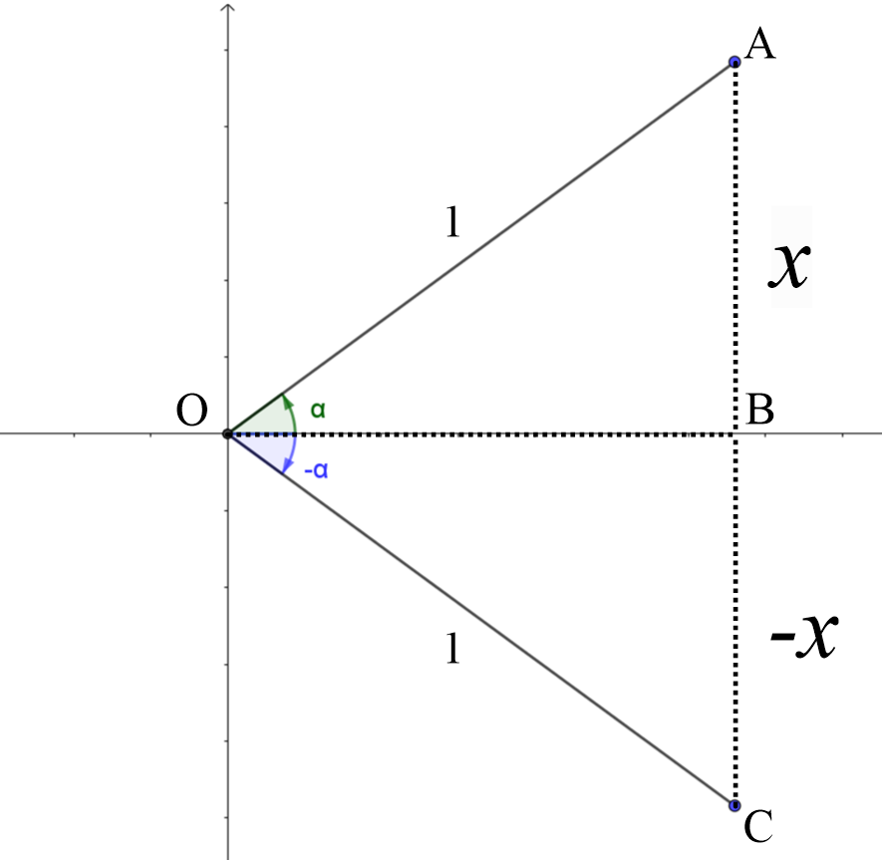  From $∆OAB$, $\sin{α}=x$ and $∴α=\sin^{-1}{x}$  and from $∆OBC$, $\sin{(-α)}=-x$ and $∴-α=\sin^{-1}{(-x}$).  Combining the two equations gives the result $\sin^{-1}\left(-x\right)={-sin}^{-1}{x}$, which proves that the inverse sine function is odd.  - Consider two congruent triangles $∆OAB$ and $∆OCD$ on a number plane, as shown below.  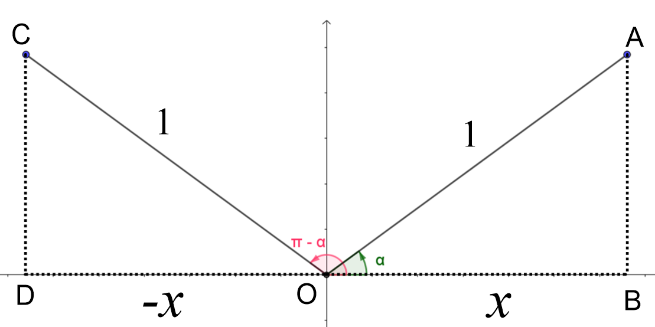  From $∆OAB$, $\cos{α}=x$ and $α=\cos^{-1}{x}$  From $∆OCD$, $\cos{(π-α)}=-x$ and $π-α=\cos^{-1}{(-x)}$  Combining the two equations gives $\cos^{-1}\left(-x\right)=π-\cos^{-1}{x}$  - Consider two congruent triangles $∆OAB$ and $∆OBC$ on a number plane, as shown below.  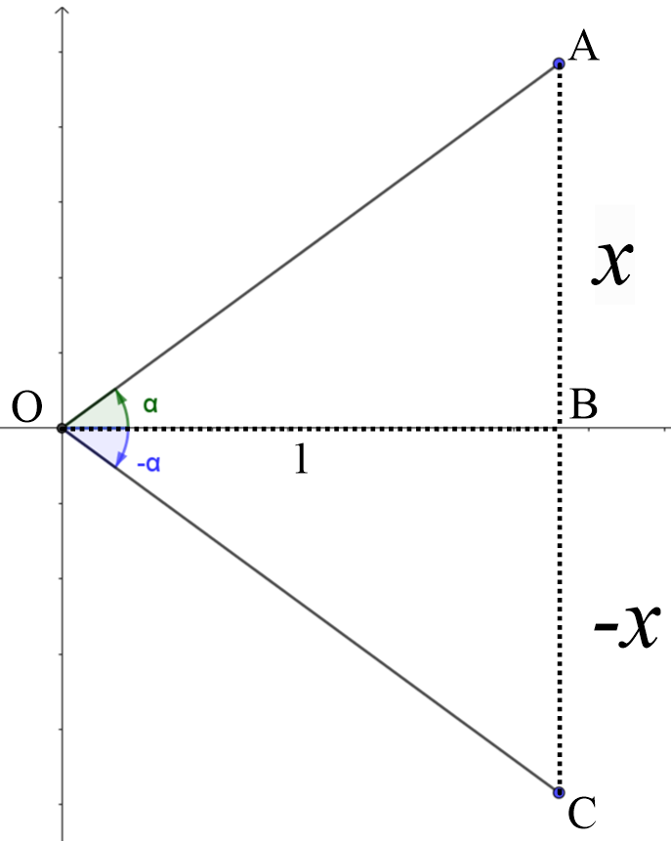  From $∆OAB$, $\tan{α}=x$ and $∴α=\tan^{-1}{x}$  and from $∆OBC$, $\tan{(-α)}=-x$ and $∴-α=\tan^{-1}{(-x}$).  Combining the two equations gives the result $\tan^{-1}\left(-x\right)=-\tan^{-1}{x}$ which proves that the inverse tan function is odd.
Using relationships between trigonometric functions and their inverse  (1 lesson) | - solve problems involving inverse trigonometric functions in a variety of abstract and practical situations AAM | Solving problems using inverse trigonometric functions as models  - Staff can use this Applications of inverse trigonometric functions resource from ck12.org to model real life situations using inverse trigonometric functions  - Use Inverse trig function application - rocket height (duration 4:54) to model rocket height using inverse trigonometric functions.

Reflection and evaluation
Please include feedback about the engagement of the students and the difficulty of the content included in this section. You may also refer to the sequencing of the lessons and the placement of the topic within the scope and sequence. All ICT, literacy, numeracy and group activities should be recorded in Comments, Feedback, Additional Resources Used sections.

