Year 12 Mathematics Extension 1

Assessment task
ME-C3 Applications of calculus

Driving question
Design an ergonomic drinking vessel

Outcomes
- ME12-1 applies techniques involving proof or calculus to model and solve problems
- ME12-4 uses calculus in the solution of applied problems, including differential equations and volumes of solids of revolution
- ME12-6 chooses and uses appropriate technology to solve problems in a range of contexts
- ME12 7 evaluates and justifies conclusions, communicating a position clearly in appropriate mathematical forms
All outcomes referred to in this unit come from Mathematics Extension 1 Syllabus © NSW Education Standards Authority (NESA) for and on behalf of the Crown in right of the State of New South Wales, 2017

Learning across the curriculum

General capabilities
- Critical and creative thinking
- Ethical understanding
- Information and communication technology capability
- Literacy
- Numeracy
- Work and enterprise

Task
During this task, students will investigate the emergence of integral techniques to calculate volumes of solids of revolution and capacities of vessels. Students will apply their skills and understanding to solve problems involving solids of revolution and design a drinking vessel.
The task is broken down into two parts. In Part A, students are asked to solve problems involving volumes of solids of revolution in a given scenario. In Part B, students are asked to apply their understanding to design their own drinking vessel restricted by the volume of material needed to construct the vessel and the capacity of the vessel, shown as a volume.

Part A
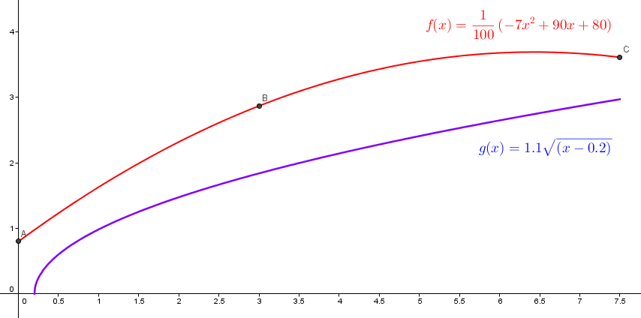

The graph above shows two functions, $f(x)$ and $g(x)$. The function $f(x)$ is a polynomial that has been generated to fit through the points A, B and C shown below.

 | x | y
A | 0 | 0.8
B | 3 | 2.5
C | 7.5 | 2.9

The area bounded by the curves $f(x)$ and $g(x)$ and the lines $x = 0$ and $x = 7.5$ is to be rotated by 360⁰ about the x-axis to form a solid of revolution which is to be used as a design for a drinking vessel.

- Calculate the $x$-intercept for $g(x)$
- Calculate the area between the curves $f(x)$ and $g(x)$, bounded by the lines $x = 0$ and $x = 7.5$

- Show that the maximum volume of liquid the vessel can contain is approximately 101.3 units³.
- By calculating the volume of the solid of revolution created by rotating the area bounded by the curves $f(x)$ and $g(x)$ and the lines $x = 0$ and $x = 7.5$ by 360⁰, find the volume of material required to construct the drinking vessel.
- If the drinking vessel is partly filled to contain 80 units³ of water, calculate the depth of water in the drinking vessel.

Part B
Students are to design a drinking vessel of their choice. The vessel must be constructed using a volume of material between 150 units³ and 250 units³. The vessel must be able to contain a maximum volume of water between 100 units³ and 150 units³. Students need to justify their designs with fully communicated mathematics.

The polynomial function in Part A was generated by plotting suitable points and using the fitPOLY function in Geogebra. Students may like to create points, similar to Part A, to aid their design and use the fitPOLY function, or another suitable polynomial generator, to produce a polynomial function through the points.

Success criteria
Fluency, understanding and communication | Problem solving, reasoning and justification

Criteria | Working towards developing | Developing | Developed | Well developed | Highly developed
Part A
Questions 1 & 2  ME12-1 | Student calculates the x-intercept of the function g(x) | Student uses some integration techniques but is unable to accurately calculate the area. | Student uses integration techniques to both functions to calculate the area.  Student has considered the domains of both functions and adjusted the integrals accordingly
Question 3  ME12-4 |  | Student applies some integration techniques but has not demonstrated the volume correctly. | Student applies integration techniques to correctly show the desired volume.
Question 4  ME12-4 | Student applies some of the correct method to calculate the volume.  No consideration to the domains of the functions given. | Student applies most of the correct method to calculate the volume.  OR  Student has not considered the domains of both functions and has not adjusted the integrals accordingly | Student is able to use integration techniques to both functions to calculate the volume.  Student has considered the domains of both functions and adjusted the integrals accordingly
Question 5  ME12-4 |  | Student has attempted to form an integral equation but is unable to demonstrate any further techniques. | Student demonstrates most of the correct method but has made small errors when using integration techniques | Student is able to apply integration techniques to find the depth of water in the context of the question.
Part B  ME12-1, ME12-4, ME12-6, ME12-7 |  |  | Student attempts to create a design.  Some consideration has been given to the restrictions.  Student is able to communicate some mathematics that justifies part of their design. | Student generates simple functions for the exterior and interior functions of the vessels.  OR  Student has created a design which fulfils most of the requirements.  OR  Their most of their response is fully communicated and mostly justifies their design through appropriate mathematics. | Student generates functions, including polynomials of degree 2 or higher, for the exterior and interior functions of the vessels.  Student has created a design which fulfils the requirements. Their response is fully communicated and fully justifies their design through appropriate mathematics.
Notes
- Any non-attempt in a section will be deemed zero. Marks can only be attributed to attempted responses.
- Corresponding question numbers are shown in brackets.

Note to staff
The success criteria above has been designed for students and staff alike to use. Students should be presented the rubric as part of the assessment task package. Students and staff follow the process of the task downwards through the rubric and the depth of responses, for each element, across the rubric. Students should be encouraged to use the rubric to self-assess their progress as an assessment-as-learning strategy.
The aim of the assessment task is to develop students’ deep content knowledge. This is reflected in the descriptors, working towards developing through to highly developed. The level of skill and understanding required in each part of the task is different; some parts require highly developed or well-developed skills, other parts only capture a developing skill set.
None of the working mathematically elements are distinct and when demonstrating one element, you are invariably demonstrating another. As an example, communication runs concurrently through all the other working mathematically elements. Students cannot respond to this assessment without communicating in some form. However, it is envisaged that there is a general progression through the working mathematically elements, starting with fluency and leading to understanding, problem solving, reasoning and justification, with increasingly higher levels of communication accompanying each element. Careful consideration has been given to the position of the success criteria statements so they reflect the working mathematically elements demonstrated.
This assessment task has been designed to illuminate the style of questions and the types of responses needed to elicit deep content knowledge, however, staff are encouraged to use and adapt the assessment task and the success criteria to their school context. Staff may like to enhance or amend sections of the task. Staff may like to adapt the rubric to assign marks to the descriptors in order to differentiate between responses that address the same statement. All changes are the responsibility of the staff using the assessment.

