Tower of Hanoi

Part 1 – tower of Hanoi investigation
The tower of Hanoi is a mathematical puzzle. It consists of exactly 3 rods and a minimum of 3 disks of different sizes (see figure 1). The aim is to move the disks from their original position so that they are positioned on a new rod in the same order in which they began (see figure 2).
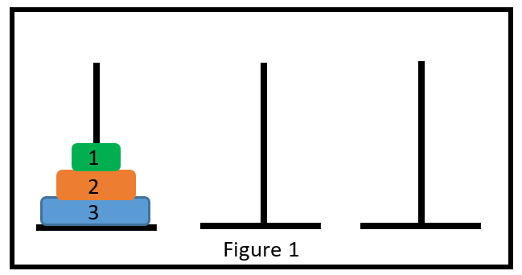
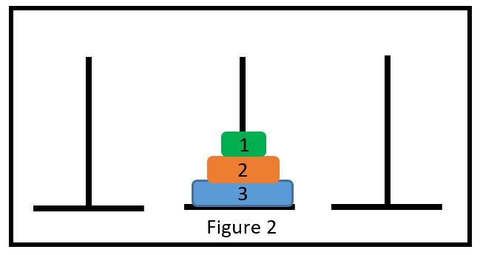
The rules in the game are:
- Only one disk can be moved at a time
- A disk cannot be placed on top of another disk that is smaller than itself
- The aim is to find the minimum number of moves to complete the game.

Complete the table below to show the minimum number of moves required depending on the number of disks involved:

Disks | Minimum number of moves
3
4
5
6
How would you calculate the number moves required to move 10 disks? ________________________________________________________________________________________________________________________________________________________________
How would you calculate the number of moves required to move n disks?
________________________________________________________________________________________________________________________________________________________________

Part 2 - proof of formula
There are two ways to find the minimum number of moves for a tower of n disks:

Series
We can notice that for 3 disks it requires 7 moves minimum.
To move 4 disks, it requires 7 moves to get disks 1, 2 and 3 to a new rod (see figure 3), then one move to get disk 4 onto a different rod (see figure 4) followed by another 7 moves to get disks 1, 2 and 3 on top of disk 4 (figure 5). This is a total of 15 moves.
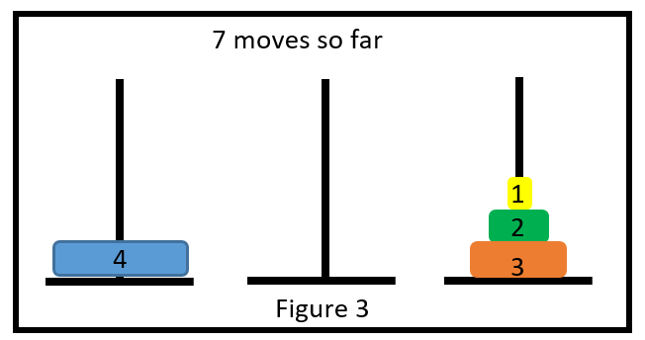
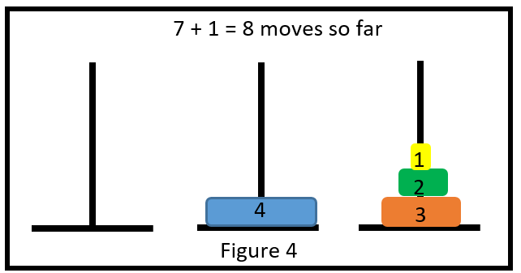
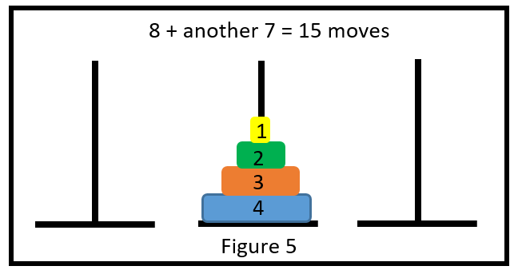
Hence for each new disk, we double the number from the previous result (moving everything except the bottom disk twice) and add 1 (moving the bottom disk once).
So for 5 disks, we move the top 4 disks (15 moves), move the bottom disk once (15 + 1) and then move the top 4 disks back (15 + 1 + 15 = 15 + 16 = 31)
The resultant series begins to look like this:
$7 + 8 + 16 + 32 + 48 + … +2^{n-1}$ where $n$ is the number of disks

Formula
Looking at the totals, starting with 3 disks, the solutions are:
7, 15, 31, 63, 127…
We should notice if we add one to each of these, we get:
8, 16, 32, 64, 128… or $2^{n}$ with $n$ again being the number of disks.
Hence the original and correct solutions are equal to $2^{n} – 1$.

Proof
Clearly the formula is far more useful than the series. Prove by mathematical induction that
$3 + (4 + 8 + 16 + 32 + 48 + … + 2^{n-1}) = 2^{n} – 1$ for integral $n$ with $n ≥ 3$.

