 Identifying the regions between curves

For each of the following graphs, shade the area(s) between the two functions shown

1. A close up of a mans face

   Description generated with very high confidence
2. 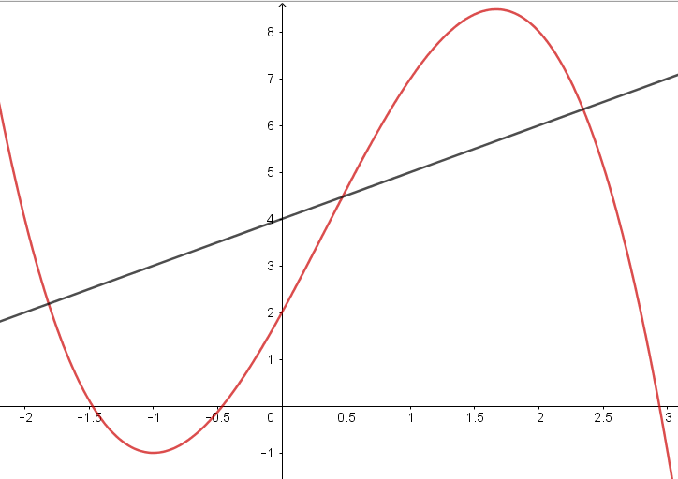
3. A close up of a mans face

   Description generated with very high confidence
4. A close up of a mans face

   Description generated with very high confidence
5. 