Estimating the area for sections of land

During this activity students will apply integral techniques to estimate the area for an irregular section of land, as show on the number plane below.
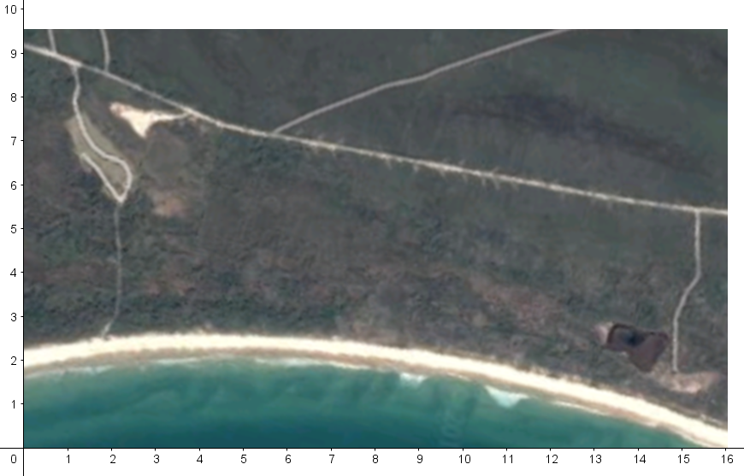
The section of land is the region bounded by the beach to the south, the road that runs approximately west to east and the two tracks that run north to south. Each unit on the number plane is approximately 200 metres.
Students will use polynomial modelling techniques to fit the boundaries formed by the beach and the road and use them to form an integral statement which represents the area of the section of land.
Students will need to use the resource student-file-estimating-the-area-of-a-section-of-land.ggb and teachers may like to refer to the completed Geogebra file teacher-note-estimating-the-area-of-a-section-of-land.ggb.

- Mark four points (A, B, C and D) on the beach, as shown.
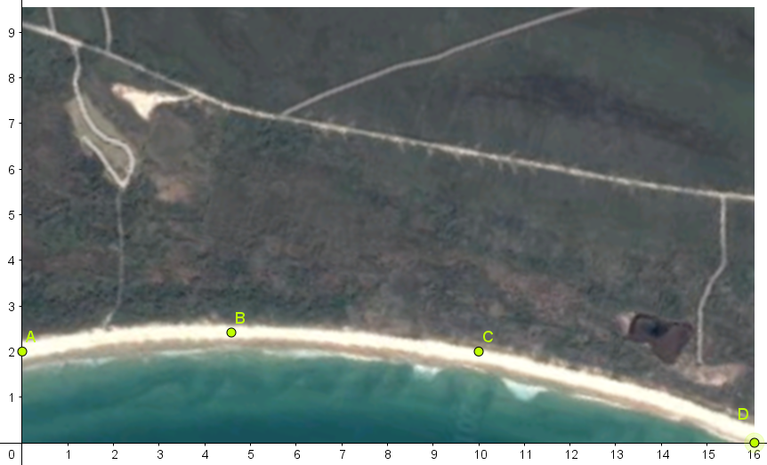
- Input the statement y = fitPOLY[{A,B,C,D},3] to generate a polynomial function that fits these points.
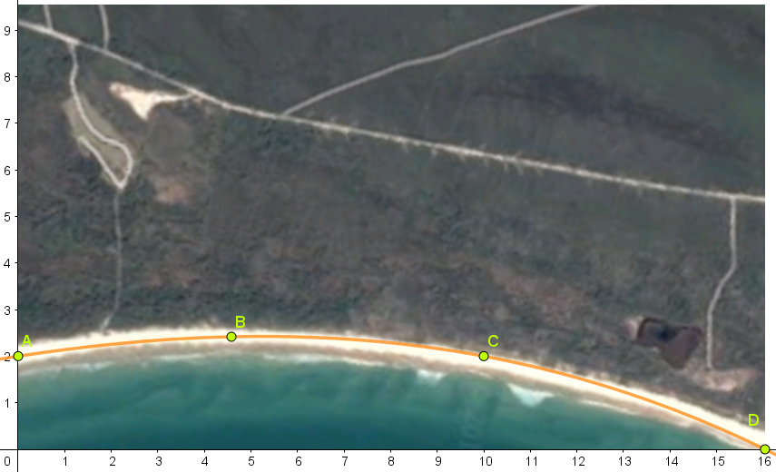
Which generates the polynomial function $y=-0.0003x^{3}-0.012x^{2}+0.153x+2$

- Repeat steps 1 and 2 for the road, as shown
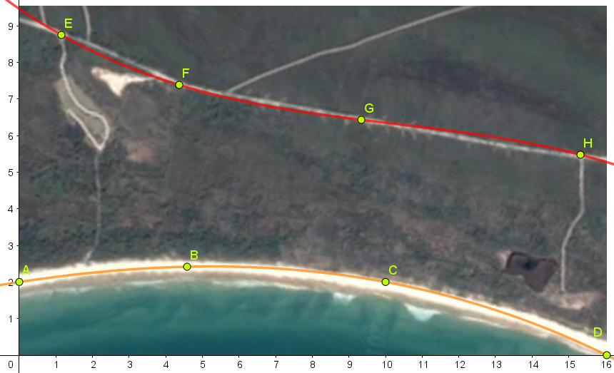
Which generates the polynomial function $y=-0.0018x^{3}+0.055x^{2}-0.6819x+9.4668$

- Input the statements $x=2$ and $x=15$ to approximate the tracks running north to south
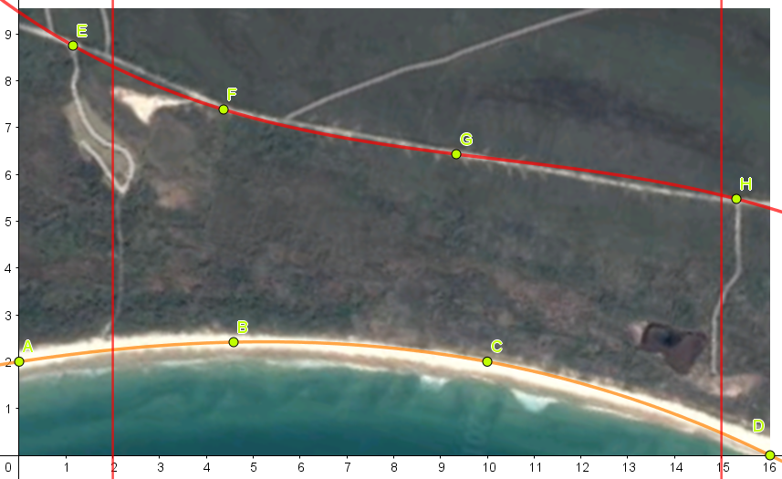
- Use integral techniques to calculate the area of the section in units².

- Use the scale 1 unit = 200 metres, to estimate the area in metres².

