Calculating the area between curves

Example 1
Calculate the areas between the curves defined by $y=x$ and $y={\left(x-2\right)}^{2}$
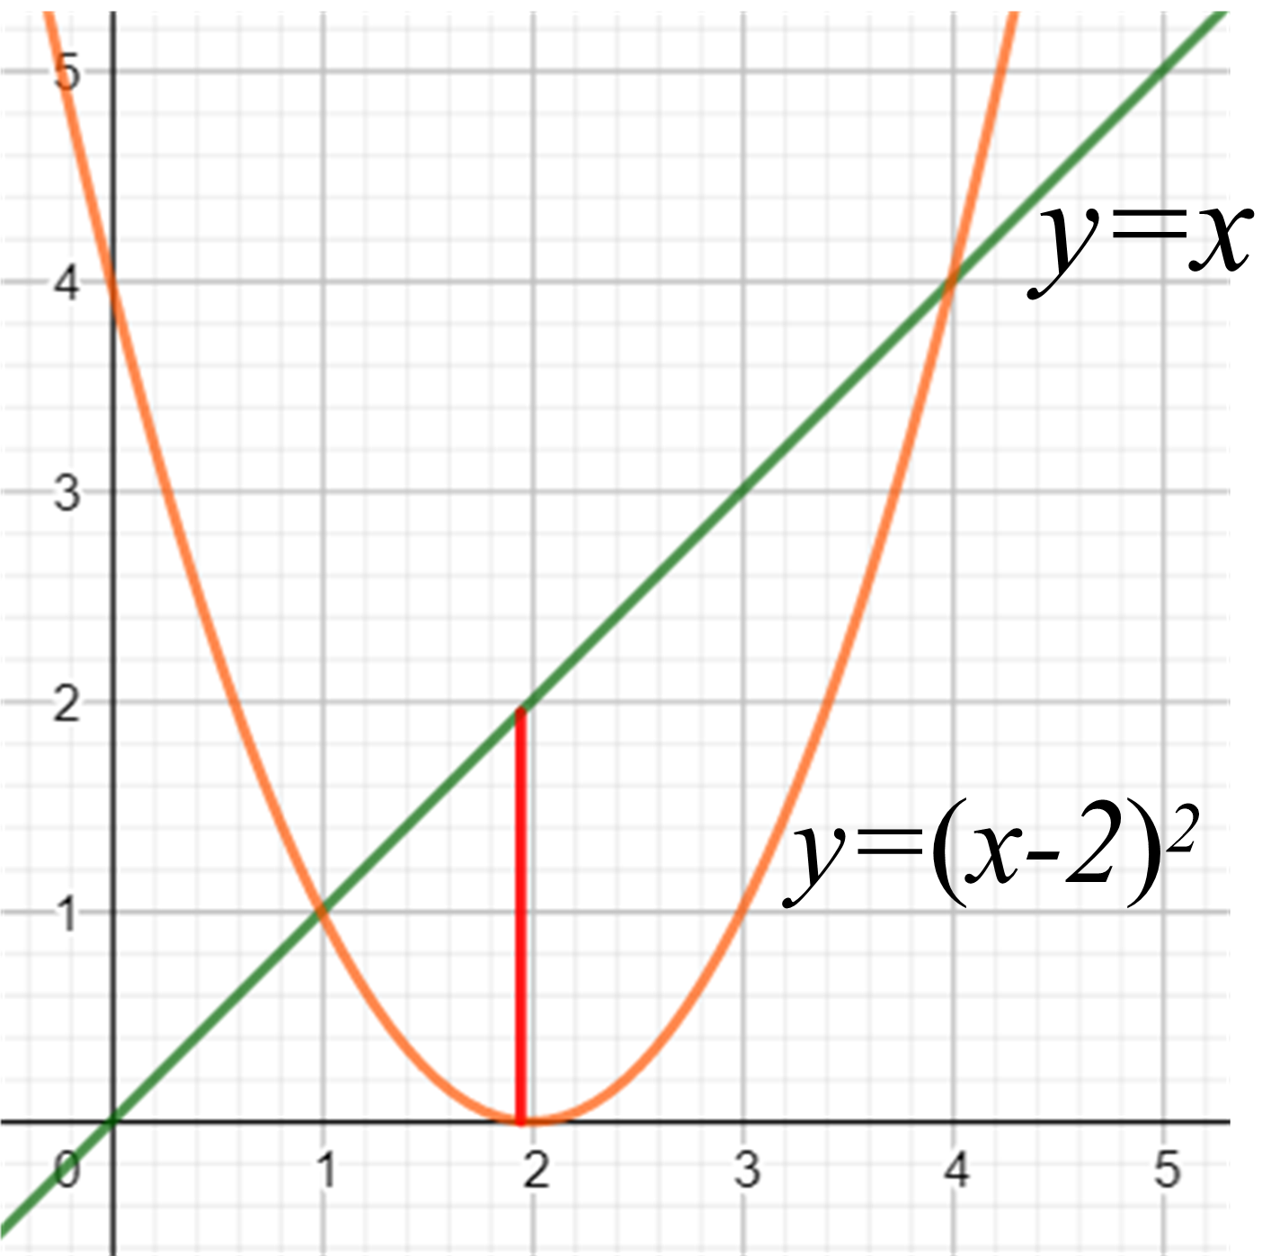
Geogebra applet

Find the points of intersection
$y=x$ - equation 1
$y={\left(x-2\right)}^{2}$ - equation 2
Substitute equation 1 into 2
$$∴x={\left(x-2\right)}^{2}$$
$$x=x^{2}-4x+4$$
$$0=x^{2}-5x+4$$
$$0=(x-1)(x-4)$$
$∴x=1$ and $y=1$
or $x=4$ and $y=4$
$$Area=\int_{x=1}^{x=4}{\left\{x-{\left(x-2\right)}^{2}\right\}.dx}$$

$$=\int_{1}^{4}{\left\{-4+5x-x^{2}\right\}.dx}$$
$$={\left[-4x+\frac{5x^{2}}{2}-\frac{x^{3}}{3}\right]}_{1}^{4}$$
$$=\frac{8}{3}-\left(-\frac{11}{6}\right)$$
$$=\frac{9}{2} unit^{2}$$

Example 2
Calculate the area between the curves $y=x^{3}$ and $y=-x^{3}$ from $x=0$ to $x=1$
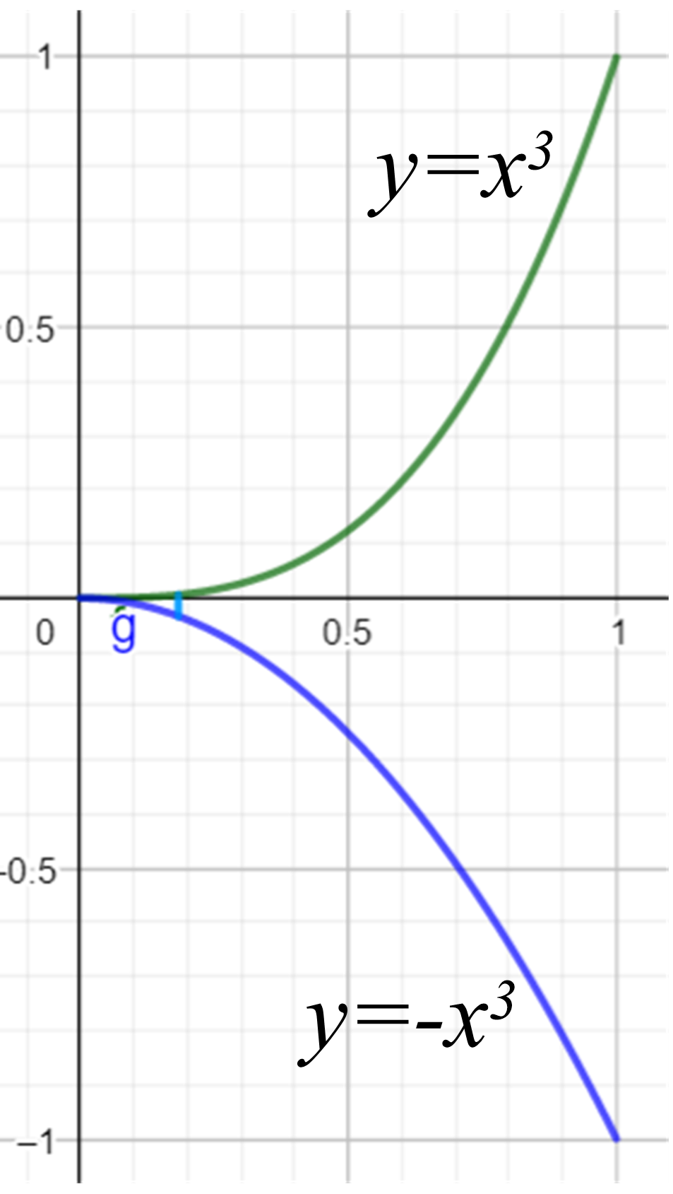
Geogebra applet
$$Area=\int_{0}^{1}{\left\{x^{3}-\left(-x^{3}\right)\right\}.dx}$$
$$=\int_{0}^{1}{2x^{3}.dx}$$
$$={\left[\frac{2x^{4}}{4}\right]}_{0}^{1}$$
$$=\frac{1}{2} units^{2}$$

