Mathematics Advanced

MA-S3 Random Variables

Table of contents
Mathematics Advanced 1
MA-S3 Random Variables 1
Table of contents 2
Syllabus Outcomes 4
Outcomes 4
Content 4
Supplementary Resources 6
Department of Education Resources 6
NESA Resources 6
WOOTUBE 6
Examination-style questions 7
Sample question 1 7
Sample question 2 7
Sample question 3 8
Sample question 4 8
Sample question 5 9
Sample question 6 9
Sample question 7 10
Sample question 8 10
Sample question 9 11
Sample question 10 11
Sample question 11 12
Sample question 12 12
Sample question 13 13
Sample question 14 14
Sample question 15 14
Sample question 16 15
Sample question 17 15
Sample question 18 16
Sample question 19 17
Sample question 20 18
Sample question 21 18
Sample question 22 19
Sample question 23 20
Sample question 24 21
Sample question 25 22
Sample question 26 23
Sample question 27 24
Sample question 28 25
Sample question 29 25
Sample question 30 26
Solutions 27
Sample question 1 27
Sample question 2 27
Sample question 3 27
Sample question 4 28
Sample question 5 28
Sample question 6 28
Sample question 7 28
Sample question 8 29
Sample question 9 29
Sample question 10 29
Sample question 11 30
Sample question 12 31
Sample question 13 32
Sample question 14 32
Sample question 15 33
Sample question 16 33
Sample question 17 34
Sample question 18 34
Sample question 19 34
Sample question 20 35
Sample question 21 35
Sample question 22 36
Sample question 23 37
Sample question 24 38
Sample question 25 39
Sample question 26 40
Sample question 27 41
Sample question 28 42
Sample question 29 42
Sample question 30 43

Disclaimer
This document is to be used to supplement the support teachers are offering students undertaking HSC Mathematics courses. Questions can be printed off for students individually, with or without solutions, or as an entire booklet. Questions have been sourced from various states across Australia and the source of each question has been referenced. Permission to use these resources was provided in June 2020. Solutions for each of the questions can be found at the end of the document.
Outcomes
All outcomes referred to in this booklet are from Mathematics Advanced Syllabus © 2017 NSW Education Standards Authority (NESA) for and on behalf of the Crown in right of the State of New South Wales.

Syllabus Outcomes

Outcomes
A student:
- solves problems using appropriate statistical processes MA12-8
- chooses and uses appropriate technology effectively in a range of contexts, models and applies critical thinking to recognise appropriate times for such use MA12-9
- constructs arguments to prove and justify results and provides reasoning to support conclusions which are appropriate to the context MA12-10

Content

S3.1: Continuous random variables
- use relative frequencies and histograms obtained from data to estimate probabilities associated with a continuous random variable (ACMMM164)
- understand and use the concepts of a probability density function of a continuous random variable AAM
- know the two properties of a probability density function: $f(x)≥0$ for all real $x$ and $\int_{-∞}^{∞}{f\left(x\right)dx}=1$
- define the probability as the area under the graph of the probability density function using the notation $P(X≤r)=\int_{a}^{r}{f\left(x\right)dx}$, where $f(x)$ is the probability density function defined on $\left[a,b\right]$
- examine simple types of continuous random variables and use them in appropriate contexts
- explore properties of a continuous random variable that is uniformly distributed
- find the mode from a given probability density function
- obtain and analyse a cumulative distribution function with respect to a given probability density function
- understand the meaning of a cumulative distribution function with respect to a given probability density function
- use a cumulative distribution function to calculate the median and other percentiles

S3.2: The normal distribution
- identify the numerical and graphical properties of data that is normally distributed
- calculate probabilities and quantiles associated with a given normal distribution using technology and otherwise, and use these to solve practical problems (ACMMM170) AAM
- identify contexts that are suitable for modelling by normal random variables, eg the height of a group of students (ACMMM168)
- recognise features of the graph of the probability density function of the normal distribution with mean $μ$ and standard deviation $σ$, and the use of the standard normal distribution (ACMMM169)
- visually represent probabilities by shading areas under the normal curve, for example identifying the value above which the top 10% of data lies
- understand and calculate the $z$-score (standardised score) corresponding to a particular value in a dataset AAM
- use the formula $z=\frac{x-μ}{σ}$, where $μ$ is the mean and $σ$ is the standard deviation
- describe the $z$-score as the number of standard deviations a value lies above or below the mean
- use $z$-scores to compare scores from different datasets, for example comparing students’ subject examination scores AAM
- use collected data to illustrate the empirical rules for normally distributed random variables
- apply the empirical rule to a variety of problems
- sketch the graphs of $f\left(x\right)=e^{-x^{2}}$ and the probability density function for the normal distribution $f\left(x\right)=\frac{1}{σ\sqrt{2π}}e^{-\frac{({x-μ)}^{2}}{2σ^{2}}}$ using technology
- verify, using the Trapezoidal rule, the results concerning the areas under the normal curve
- use $z$-scores to identify probabilities of events less or more extreme than a given event AAM
- use statistical tables to determine probabilities
- use technology to determine probabilities
- use $z$-scores to make judgements related to outcomes of a given event or sets of data AAM

Supplementary Resources

Department of Education Resources

Units of work
- Year 12 Statistical Analysis 3 MA-S3

HSC hub videos
- Probability density functions Q7 from NESA sample examination paper
- The normal distribtuion Q29 from NESA sample examination paper

NESA Resources
- Advanced Mathematics – Sample examination materials (2020)

WOOTUBE
- Descriptive Statistics and Bivariate Data Analysis

Examination-style questions

Sample question 1
Question 21
The times (in minutes) taken for students to complete a university test are normally distributed with a mean of 200 minutes and standard deviation of 10 minutes.
The proportion of students who complete the test in less than 208 minutes is closest to

- 0.200
- 0.212
- 0.758
- 0.788
- 0.800
Source: © VCAA 2006 Mathematical Methods Written examination 2

Sample question 2
Question 15
A probability density function,$f$, is given by
$$f\left(x\right)=\left\{\begin{aligned}\frac{1}{12}(8x-x^{3}), &0≤x≤2 \\ 0, &elsewhere\end{aligned}\right.$$
The median, $m$, of this function satisfies the equation

- $–{m }^{4}+ 16m^{2} – 6 = 0$
- $–{m }^{4}+ 4m^{2} – 6 = 0$
- $m^{4}-16m^{2}=0$
- $m^{4} – 16m^{2} + 24 = 0.5$
- $m^{4} – 16m^{2} + 24 = 0$
Source: © VCAA 2018 Mathematical Methods Written examination 2

Sample question 3
Question 18
The heights of the children in a queue for an amusement park ride are normally distributed with mean 130 cm and standard deviation 2.7 cm. 35% of the children are not allowed to go on the ride because they are too short. The minimum acceptable height correct to the nearest centimetre is

- 126
- 127
- 128
- 129
- 130
Source: © VCAA 2007 Mathematical Methods Written examination 2

Sample question 4
Question 6
The continuous random variable X has a normal distribution with mean 14 and standard deviation 2. If the random variable Z has the standard normal distribution, then the probability that X is greater than 17 is equal to

- $P(Z > 3)$
- $P(Z < 2)$
- $P(Z < 1.5)$
- $P(Z < –1.5)$
- $P(Z > 2)$
Source: © VCAA 2009 Mathematical Methods Written examination 2

Sample question 5
Question 9
The graph of the probability density function of a continuous random variable, $X$, is shown below
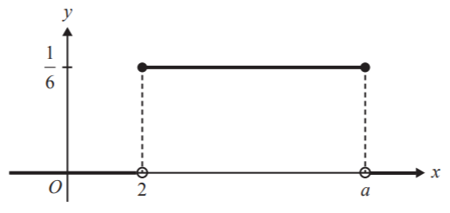
If $a > 2$, then $E(X)$ is equal to
- 8
- 5
- 4
- 3
- 2
Source: © VCAA 2015 Mathematical Methods Written examination 2

Sample question 6
The heights of a large population are normally distributed. The mean of the heights is 155cm and the standard deviation is 11·2 cm.
A person is chosen at random from this group. Between which two values will 99.7% of the population lie?

- 132·6 cm and 177·4 cm
- 155 cm and 177·4 cm
- 121·4 cm and 188·6 cm
- 155 cm and 188·6 cm

Sample question 7
The life of a fully charged smart phone battery is normally distributed with a mean ($μ$) of 18 hours and a standard deviation ($σ$) of 90 minutes.
What is the probability that a battery lasts for at least 15 hours?

- 95%
- 5%
- 99.5%
- 97.5%

Sample question 8
A machine produces bolts with a mean diameter of 11.98 mm and a standard deviation of 0.02 mm. Gauges reject all bolts where the diameter is larger than 12.02 mm or smaller than 11.94 mm.
What percentage of bolts are rejected?

- 2.8%
- 5%
- 0.3%
- 2.65%

Sample question 9
Question 13
The function f is a probability density function with rule
$$f\left(x\right)=\left\{\begin{matrix}ae^{x} & 0≤x≤1 \\ ae & 1≤x≤2 \\ 0 & otherwise\end{matrix}\right.$$
The value of a is
- 1
- $e$
- $\frac{1 }{e}$
- $\frac{1}{2e}$
- $\frac{1 }{2e-1}$
Source: © VCAA 2015 Mathematical Methods Written examination 2

Sample question 10
Question 22
Butterflies of a particular species die $T$ days after hatching, where $T$ is a normally distributed random variable with a mean of 120 days and a standard deviation of $σ$ days.
If, from a population of 2000 newly hatched butterflies, 150 are expected to die in the first 90 days, then the value of $σ$ is closest to

- 7 days
- 13 days
- 17 days
- 21 days
- 37 days
Source: © VCAA 2013 Mathematical Methods Written examination 2

Sample question 11
Question 6b (3 marks)
A plant nursery has two sites where seedlings are grown. The costs at each site are the same, but the seedlings are of different varieties.
At the first nursery site, 848 seedlings are produced in a month. The mean height of the seedlings is 51.0 mm and the standard deviation is 5.36 mm. At the second site, 936 seedlings are grown in the same time period with a mean height of 52.0 mm and a standard deviation of 6.5 mm.
Seedlings with a height between 44.0 mm and 66.0 mm are saleable. All seedlings are sold and all sell for the same price.
If the heights of the seedlings are normally distributed, determine if the claim that the first nursery site is more profitable is reasonable. Show full working. (3 marks)
Source: © QCAA 2017 Mathematics B Paper One

Sample question 12
Question 3 (7 marks)
Waiting times for patients at a hospital emergency department can be up to four hours. The associated probability density function is shown below.
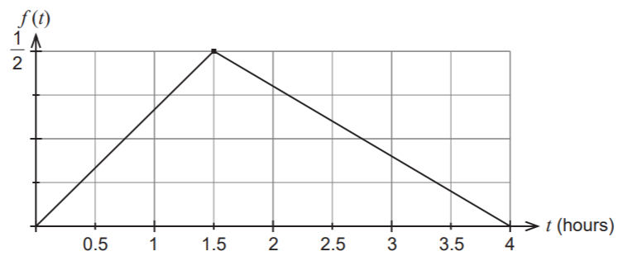
- What is the probability a patient will wait less than one hour? (3 marks)
- What is the probability a patient will wait between one hour and three hours?
(4 marks)
Source: © WA SCSA 2019 Mathematics Methods Calculator-free

Sample question 13
Question 11 (8 marks)
A pizza company runs a marketing campaign based on the delivery times of its pizzas. The company claims that it will deliver a pizza in a radius of 5 km within 30 minutes of ordering or it is free. The manager estimates that the actual time, T, from order to delivery is normally distributed with mean 25 minutes and standard deviation 2 minutes.

- What it the probability that a pizza is delivered free? (1 mark)
- Not in the scope of this course (2 marks)

The company wants to reduce the proportion of pizzas that are delivered free to 0.1%.

- The manager suggests this can be achieved by increasing the advertised delivery time. What should the advertised delivery time be? (2 marks)
After some additional training the company was able to maintain the advertised delivery time as 30 minutes but reduce the proportion of pizzas delivered free to 0.1%.

- Assuming that the original mean of 25 minutes is maintained, what is the new standard deviation of delivery times?(3 marks)
Source: © WA SCSA 2019 Mathematics Methods Calculator-assumed

Sample question 14
Question 6 (10 marks)
The error, X, in digitising a communication signal has a uniform distribution with probability density function given by
$$f\left(x\right)=\left\{\begin{aligned}1, &-0.5<x<0.5 \\ 0, &otherwise\end{aligned}\right.$$

- Sketch the graph of $f (x)$ (2 marks)
- What is the probability that the error is at least 0.35? (1 mark)
- If the error is negative, what is the probability that it is less than –0.35? (2 marks)
- An engineer is more interested in the square of the error. What is the probability that the square of the error is less than 0.09? (2 marks)
Source: © WA SCSA 2019 Mathematics Methods Calculator-free

Sample question 15
Question 10 (5 marks)
The following function is a probability density function on the given interval:
$$f\left(x\right)=\left\{\begin{aligned}{ax}^{2}(x-2), &0≤x≤2 \\ 0, &otherwise\end{aligned}\right.$$

- Find the value of $a$. (3 marks)
- Find the $P(x≥1.2)$ (2 marks)

Source: © WA SCSA 2018 Mathematics Methods Calculator-assumed

Sample question 16
Question 2
For a set of data values that are normally distributed, approximately 68% of the values will lie within one standard deviation of the mean, approximately 95% of the values will lie within two standard deviations of the mean and approximately 99.7% of the values will lie within three standard deviations of the mean.
If the heights of a large group of women are normally distributed with a mean μ = 163 cm and standard deviation σ = 7 cm, use the above information to answer the following questions:

- A statistician says that almost all of the women have heights in the range 142 cm to 184 cm. Comment on her statement. (2 marks)
- Approximately what percentage of women in the group has a height greater than 170 cm? (2 marks)
- Approximately 2.5% of the women are shorter than what height? (2 marks)
Source: © WA SCSA 2018 Mathematics Methods Calculator-free

Sample question 17
Question 11 (9 marks)
A pizza shop estimates that the time $X$ hours to deliver a pizza from when it is ordered is a continuous random variable with probability density function given by
$$f\left(x\right)=\left\{\begin{aligned}\frac{4}{3}-\frac{2}{3}x, &0<x<1 \\ 0, &otherwise\end{aligned}\right.$$

- What is the probability of a pizza being delivered within half an hour of being ordered? (2 marks)
Source: © WA SCSA 2017 Mathematics Methods Calculator-assumed

Sample question 18
Question 1 (5 marks)
Anastasia is a university student. She records the time it takes for her to get from home to her campus each day. The histogram of relative frequencies below shows the journey times she recorded.
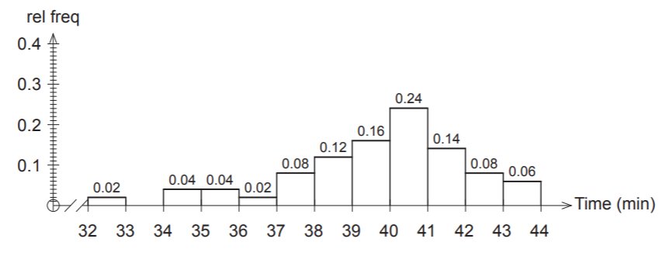
Use the above data to estimate the probability of her next journey from home to her university campus

- Taking her less than 36 minutes. (1 mark)
- Taking at least 35 minutes but no more than 39 minutes. (2 marks)
On three consecutive days, Anastasia needs to be on campus no later than 10 am.

- If she leaves her home at 9:22 am each day, use the above data to estimate the probability that she makes it on or before time on all three days. (2 marks)
Source: © WA SCSA 2017 Mathematics Methods Calculator-free

Sample question 19
Question 2 (6 marks)
Michelle is a soccer goalkeeper and has built a machine to help her practise. The machine will shoot a soccer ball randomly along the ground at or near a goal that is seven metres wide. The machine is equally likely to shoot the ball so that the centre of the ball crosses the goal line anywhere between point A three metres left of the goal, and point B five metres right of the goal, as shown in the diagram below.
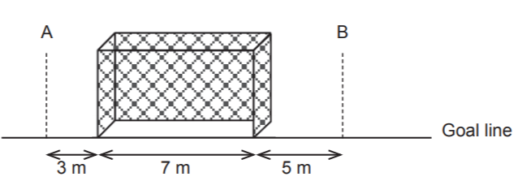

Michelle sets up a trial run without anyone in the goals. Assume the goal posts are of negligible width.
Let the random variable$X$ be the distance the centre of the ball crosses the goal line to the right of point A.
- Complete the graphical representation of the probability density function for the random variable X. (2 marks)
- What is the probability that the machine shoots a ball so that its centre misses the goal to the left? (1 mark)
- What is the probability that the machine shoots a ball so that its centre is inside the goal? (1 mark)
- If the machine shoots a ball so that its centre misses the goal, what is the probability that the ball’s centre misses to the right? (2 marks)
Source: © WA SCSA 2017 Mathematics Methods Calculator-free

Sample question 20
Question 16 (4 marks)
An automated milk bottling machine fills bottles uniformly to between 247 ml and 255 ml. The label on the bottle states that it holds 250 ml.

- Determine the probability that a bottle selected randomly from the conveyor belt of this machine contains less than the labelled amount. (3 marks)
- Calculate the mean of the amount of milk in the bottles. (1 marks)
Source: © WA SCSA 2016 Mathematics Methods Calculator-assumed

Sample question 21
Question 5 (4 marks)
Let $X$ be a normally distributed random variable with a mean of 72 and a standard deviation of 8. Let Z be the standard normal random variable. Use the result that
$P(Z < 1) = 0.84$, correct to two decimal places, to find

- $P(X>80)$ (1 mark)
- $P(64 < X < 72)$ (1 mark)
- $P(X < 64|X < 72)$. (2 marks)
Source: © VCAA 2006 Mathematical Method Written examination paper 1

Sample question 22
Question 6 (4 marks)
The probability density function of a continuous random variable $X$ is given by

$$f\left(x\right)=\left\{\begin{aligned}\frac{x}{12}, &1≤x≤5 \\ 0, &otherwise\end{aligned}\right.$$

- Find $P (X < 3)$ (2 marks)
- If $P (X ≥ a) = \frac{5}{8}$ , find the value of $a$ (2 marks)
Source: © VCAA 2006 Mathematical Method Written examination 1

Sample question 23
Question 2 (5 marks)
Each night when Kim goes to the gym, the time, $T$ hours, that she spends working out is a continuous random variable with probability density function given by

$$f\left(x\right)=\left\{\begin{aligned}4t^{3}-24t^{2}+44t-24, &1≤t≤2 \\ 0, &otherwise\end{aligned}\right.$$

- Sketch the graph of $y = f (t)$ on the axes below. Label any stationary points with their coordinates, correct to two decimal places. (3 marks)
- What is the probability, correct to three decimal places, that she spends less than 75 minutes working out when she goes to the gym? (2 marks)
Source: © VCAA 2006 Mathematical Method Written examination 2

Sample question 24
Question 1 (4 marks)
The time in hours that Sharelle spends training each day is a continuous random variable with probability density function given by

$$f\left(x\right)=\left\{\begin{aligned}\frac{1}{64}(6-x)(x-2)(x+2), &2≤x≤6 \\ 0, &elsewhere\end{aligned}\right.f\left(x\right)$$

- Sketch the probability density function, and label the local maximum with its coordinates, correct to two decimal places. (2 marks)
- What is the probability, correct to four decimal places, that Sharelle spends less than 3 hours training on a particular day? (2 marks)

Source: © VCAA 2008 Mathematical Method Written examination 2

Sample question 25
Question 3 (4 marks)
The Bouncy Ball Company (BBC) makes tennis balls whose diameters are normally distributed with mean 67 mm and standard deviation 1 mm. The tennis balls are packed and sold in cylindrical tins that each hold four balls. A tennis ball fits into such a tin if the diameter of the ball is less than 68.5 mm.

- What is the probability, correct to four decimal places that a randomly selected tennis ball produced by BBC fits into a tin? (2 marks)
BBC management would like each ball produced to have diameter between 65.6 and
68.4 mm.

- What is the probability, correct to four decimal places that the diameter of a randomly selected tennis ball made by BBC is in this range? (2 marks)
Source: © VCAA 2009 Mathematical Method Written examination 2

Sample question 26
Question 4 (7 marks)
The Lorenz birdwing is the largest butterfly in Town A.
The probability density function that describes its life span, $X$, in weeks, is given by
$$f\left(x\right)=\left\{\begin{aligned}\frac{4}{625}(5x^{3}-x^{4}), &0≤x≤5 \\ 0, &elsewhere\end{aligned}\right.$$

- In a sample of 80 Lorenz birdwing butterflies, how many butterflies are expected to live longer than two weeks, correct to the nearest integer? (2 marks)
- Find $P(25 ≤ T ≤ 55)$ (2 marks)
- What is the probability that a Lorenz birdwing butterfly lives for at least four weeks, given that it lives for at least two weeks, correct to four decimal places? (2 marks)
The wingspans of Lorenz birdwing butterflies in Town A are normally distributed with a mean of 14.1 cm and a standard deviation of 2.1 cm.

- Find the probability that a randomly selected Lorenz birdwing butterfly in Town A has a wingspan between 16 cm and 18 cm, correct to four decimal places. (1 mark)
Source: © VCAA 2019 Mathematical Method Written examination 2

Sample question 27
Question 3 (6 marks)
The time Jennifer spends on her homework each day varies, but she does some homework every day.
The continuous random variable $T$, which models the time,$t$, in minutes, that Jennifer spends each day on her homework is expressed by the function
$$f\left(t\right)=\left\{\begin{matrix}\frac{1}{625}\left(t-20\right) & 20≤t≤45 \\ \frac{1}{625}\left(70-t\right) & 45≤t≤70 \\ 0 & elsewhere\end{matrix}\right.$$

- Sketch the graph of $f$on the axes provided below (3 marks)
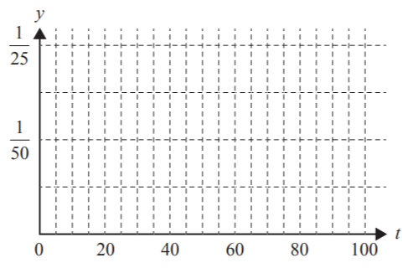

- Show that it is a continuous probability distribution. (1 mark)
- Find the probability that Jennifer spends between half an hour and 1 hour on homework each day. (2 marks)
Source: © VCAA 2017 Mathematical Method Written examination 2

Sample question 28
Question 19 (2 marks)
A global financial institution transfers a large aggregate data file every evening from offices around the world to its Hong Kong head office. Once the file is received it must be processed in the company’s data warehouse. The time $T$required to process a file is normally distributed with a mean of 90 minutes and a standard deviation of 15 minutes.

- An evening is selected at random. What is the probability that it takes more than two hours to process the file? (2 marks)
Source: © WA SCSA 2017 Mathematics Methods Calculator-assumed

Sample question 29
Question 3 (2 marks)
Mani is a fruit grower. After his oranges have been picked, they are sorted by a machine, according to size. Oranges classified as medium are sold to fruit shops and the remainder are made into orange juice.
The distribution of the diameter, in centimetres, of medium oranges is modelled by a continuous random variable, $X$, with probability density function
$$f\left(x\right)=\left\{\begin{aligned}\frac{3}{4}{\left(x-6\right)}^{2}(8-x), &6≤x≤8 \\ 0, &otherwise\end{aligned}\right.$$

Find the probability that a randomly selected medium orange has a diameter greater than 7 cm. (2 marks)
Source: © VCAA 2015 Mathematical Method Written examination 2

Sample question 30
The time taken, in minutes, to resolve a computer software problem is denoted by $T$. It is modelled by a probability density function
$$f\left(x\right)=\left\{\begin{aligned}kt, &0≤t≤8 \\ 0, &otherwuse\end{aligned}\right.$$
- Find the value of $k$. (2 marks)
- Find $P(T<5)$ (1 mark)
- Calculate the median time to resolve a problem, to the nearest second. (2 marks)

Solutions

Sample question 1
$$z=\frac{208-200}{10}=0.8$$
$$P\left(X<208\right)=P\left(Z<0.8\right)=0.7881$$

Answer = D
Source: © VCAA 2006 Mathematical Methods Assessment Report paper 2

Sample question 2

$$\int_{0}^{m}{f\left(x\right)dx=\frac{1}{2}}$$
$$\int_{0}^{m}{f\left(x\right)dx=-\frac{m^{4}}{48}+\frac{m^{2}}{3}=\frac{1}{2}}$$
$$-\frac{m^{4}}{48}+\frac{m^{2}}{3}-\frac{1}{2}=0$$
$$m^{4}-16m^{2}+24=0$$

Answer = E
Source: © VCAA 2018 Mathematical Methods Assessment Report paper 2

Sample question 3
$$P\left(Z<\frac{x-130}{2.7}\right)=0.35$$
$$\frac{x-130}{2.7}=-0.39$$
$$x=128.947=129$$

Answer = D
Source: © VCAA 2007 Mathematical Methods Assessment Report paper 2

Sample question 4
$$P\left(X>17\right)=P\left(z>\frac{17-14}{2}\right)=P\left(Z>1.5\right)$$
Because of the symmetry of the normal curve $P\left(Z>1.5\right)=P(Z<-1.5)$

Answer = D
Source: © VCAA 2009 Mathematical Methods Assessment Report paper 2

Sample question 5
Area of the rectangle $=\frac{1}{6}\left(a-2\right)=1$
$a=8.$ Since it is a uniform distribution, the expected value is halfway between 2 and 8, which is 5.

Answer = B
Source: © VCAA 2015 Mathematical Methods Assessment Report paper 2

Sample question 6
Approximately 99.7% of the population lies with 3 standards deviations of the mean.

155 + 3 x 11.2 = 188.6
155 – 3 x 11.2 = 121.4

Answer = C

Sample question 7
15 hours is 2 standard deviations below the mean. Only 2.5% of the population lies below 2 standard deviations of the mean. Therefore P(X<15) = 97.5%

Answer = D

Sample question 8
11.94 and 12.02 are both 2 standard deviations away from the mean.

Approximately 95% of the population lies within 2 standard deviation of the mean. This means that only 5% of the population lies outside of this range. Therefore, only 5% of the bolts will be rejected.

Answer = B

Sample question 9
$$\int_{0}^{1}{ae^{x}dx+\int_{1}^{2}{ae}dx=1}$$
$$\left[ae-a\right]+\left[2ae-ae\right]=1$$
$$a\left(2e-1\right)=1$$
$$a=\frac{1}{2e-1}$$

Answer = E
Source: © VCAA 2015 Mathematical Methods Assessment Report paper 2

Sample question 10

$$P\left(T≤90\right)=\frac{150}{2000}$$
$$P\left(Z≤-1.43\right)=0.075$$

$$\frac{90-120}{σ}=-1.4395$$
$$σ=20.84…≈21 days$$

Answer = D
Source: © VCAA 2013 Mathematical Methods Assessment Report paper 2

Sample question 11
Site A: $μ=51.0 and σ=5.36$
$$z_{1}=\frac{44-51}{5.36} and z_{2}=\frac{66-51}{5.36}$$
$z_{1}≈-1.31 and z_{2}≈2.80$
$P\left(z_{2}\right)-P\left(z_{1}\right)=0.9974-0.0951=0.9023$ using z-score table
$0.9023×848≈765$ seedlings sold

Site B: $μ=52.0 and σ=6.5$
$$z_{1}=\frac{44-52}{6.5} and z_{2}=\frac{66-52}{6.5}$$
$z_{1}≈-1.23 and z_{2}≈2.15$
$P\left(z_{2}\right)-P\left(z_{1}\right)=0.9842-0.1093=0.8749$ using z-score table
$0.8749×936≈819$ seedlings sold

Since the fixed costs are the same and the seedlings are sold for the same price, the nursery on the second site (Site B) is more profitable because they sell more seedlings. This is contrary to the statement that the first site is more profitable.
Source: © QCAA 2017 Mathematics B Assessment Report

Sample question 12
- Required probability is the area of the triangle that has base 1 unit
The height of the triangle is $\frac{2}{3}×\frac{1}{2}=\frac{1}{3}$$$P\left(T≤1\right)=\frac{1}{2}×1×\frac{1}{3}=\frac{1}{6}$$

- $P\left(1≤T≤3\right)=1-P\left(0≤T≤1\right)-P\left(3≤T≤4\right)$
$P\left(0≤T≤1\right)=\frac{1}{6}$ from part a)
For $1.5≤t≤4$
$$f\left(t\right)=-\frac{0.5}{2.5}t+c=-\frac{t}{5}+c$$
$$f\left(4\right)=0$$
$$0=-\frac{4}{5}+c⇒\frac{4}{5}$$
$$f\left(t\right)=-\frac{t}{5}+\frac{4}{5}$$
$$P\left(3≤T≤4\right)=\frac{1}{5}\int_{3}^{4}{\left(-t+4\right)dt=\frac{1}{5}{\left[-\frac{t^{2}}{2}+4t\right]}_{3}^{4}}$$
$$=\frac{1}{5}\left[-8+16+ \frac{9}{2}-12\right]=\frac{1}{10}$$
$$P\left(1≤T≤3\right)=1-\frac{1}{10}-\frac{1}{6}=\frac{22}{30}=\frac{11}{15}$$

Source: © WA SCSA 2019 Mathematics Methods Calculator-free marking key

Sample question 13
- $P\left(T>30\right)=P\left(Z>\frac{30-25}{2}\right)=P\left(Z>2.5\right)=1-0.9938=0.0062$
- Binomial – not within scope of this course
- $P\left(Z>z\right)=0.001⇒z=3.0902⇒t=25+3.0902 ×2=31.2 \text{minutes}$
- $z=\frac{30-25}{σ}=3.0902⇒σ=\frac{30-25}{3.0902}=1.6 \text{minutes}$

Source: © WA SCSA 2019 Mathematics Methods Calculator-assumed marking key

Sample question 14

- $P\left(X>0.35\right)=Area=0.15$
- $P\left(X<-0.35 | X<0\right)=\frac{P(X<-0.35∩X<0)}{P(X<0)}=\frac{P(X<-0.35)}{P(X<0)}=\frac{0.15}{0.5}=0.3$
- $P\left(X^{2}<0.09\right)+P\left(-0.3<X<0.3\right)=0.6$

Source: © WA SCSA 2019 Mathematics Methods Calculator-free marking key

Sample question 15
- If pdf on domain then $\int_{0}^{2}{f\left(x\right)dx=1}$
$$\int_{0}^{2}{f\left(x\right)dx=1}$$
$$\int_{0}^{2}{{ax}^{2}\left(x-2\right)dx=-\frac{4a}{3}}$$
$$∴-\frac{4a}{3}=1$$
$$∴a=-\frac{3}{4}$$

- $\int_{1.2}^{2}{\frac{-3x^{2}(x-2)}{4}}dx=0.5248$

Source: © WA SCSA 2018 Mathematics Methods Calculator-assumed marking key

Sample question 16
- Her comment is appropriate as the range corresponds to 3 standard deviations above and below the mean, which equates to approximately 99.7% of the group.

- $170-163⇒1$ SD above
Percentage = $\frac{100-68}{2}=16$

- Percentage = 100 – 2 x 2.5 = 95%
2 SDs below = 163 – 14 = 149 cm

Source: © WA SCSA 2018 Mathematics Methods Calculator-free marking key

Sample question 17
- $P\left(X<0.5\right)=\int_{0}^{0.5}{\left(\frac{4}{3}-\frac{2}{3}x\right)dx=\left[{\frac{4}{3}x-\frac{1}{3}x^{2}}_{0}^{0.5}\right]=\frac{2}{3}-\frac{1}{12}=\frac{7}{12}≈0.5833}$
OR
$$P\left(X<0.5\right)=\text{Area of trapezium=}\frac{1}{4}\left(\frac{4}{3}+1\right)=\frac{7}{12}$$

Source: © WA SCSA 2017 Mathematics Methods Calculator-assumed marking key

Sample question 18
- $P\left(T≤36\right)=0.02+0.04+0.04=0.1$
- $P(35≤T≤39)=0.04+0.02+0.08+0.12=0.26$
- $P\left(T≤38\right)=0.02+0.04+0.04+0.02+0.08=0.2$$$\text{3 consecutive days = }{0.2}^{3}=0.008$$
Source: © WA SCSA 2017 Mathematics Methods Calculator-free marking key

Sample question 19

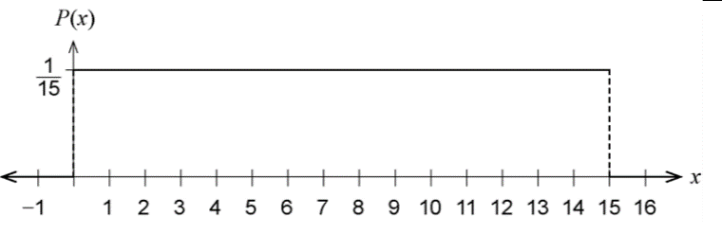

- $\frac{3}{15}$
- $\frac{7}{15}$
- $P\left(R | M\right)=\frac{P(R∩M)}{P(M)}=\frac{\frac{5}{15}}{\frac{8}{15}}=\frac{5}{8}$
Source: © WA SCSA 2017 Mathematics Methods Calculator-free marking key

Sample question 20
- $P\left(X<250\right)=\frac{3}{8}$
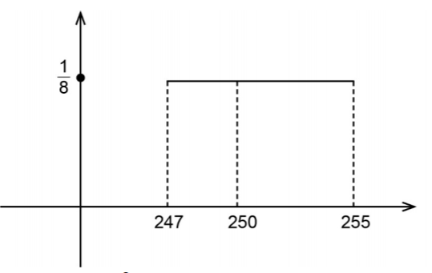
- Mean = $\frac{255+247}{2}=251$
Source: © WA SCSA 2016 Mathematics Methods Calculator-assumed marking key

Sample question 21
- $P\left(X>80\right)=P\left(Z>1\right)=1-P\left(Z<1\right)=1-(0.5+0.34)=0.16$

- $P\left(64<X<72\right)=P\left(-1<Z<0\right)=0.34$

- $Pr⁡(X<64\left|X<72)=\frac{P(X<64)}{P(X<72)}=\frac{P(Z<-1)}{P(Z<0)}=\frac{0.16}{0.5}\right.=0.32$
Source: © VCAA 2006 Mathematical Methods Assessment Report paper 1

Sample question 22
- $\int_{1}^{3}{\frac{x}{12}dx={\left[\frac{x^{2}}{24}\right]}_{1}^{3}}$
$$=\left[\left(\frac{9}{24}\right)-\left(\frac{1}{24}\right)\right]$$
$$=\frac{1}{3}$$
- If $P\left(X≥a\right)=\frac{5}{8}$ then $\frac{a^{2}}{24}-\frac{1}{24}=\frac{5}{8} ⟹a^{2}=16$
$$a=4$$

Source: © VCAA 2006 Mathematical Methods Assessment Report paper 1

Sample question 23
- $f\left(t\right)=4t^{3}-24t^{2}+44t-24$
$$f^{'}\left(t\right)=12t^{2}-48t+44$$
$$f^{'}\left(t\right)=4(3t^{2}-12t+11)$$
$$t=2±\frac{\sqrt{3}}{3}$$
$t=2-\frac{\sqrt{3}}{3}$ only, since $t=2+\frac{\sqrt{3}}{3}$ is outside of the domain
An approximation for $2-\frac{\sqrt{3}}{3}≈1.42$
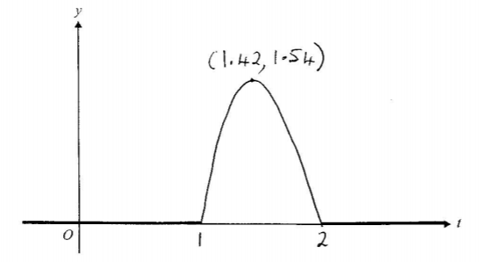
- 75 minutes = 1.25 hours
$$\int_{1}^{1.25}{\left(4t^{3}-24t^{2}+44t-24\right)dt}={\left[t^{4}-8t^{3}+22t^{2}-24t\right]}_{1}^{1.25}$$
$$≈0.191$$

Source: © VCAA 2006 Mathematical Methods Assessment Report paper 2

Sample question 24
- $f\left(x\right)=\frac{1}{64}(6-x)(x-2)(x+2)$
$$f\left(x\right)=\frac{1}{64}(6-x)(x^{2}-4)$$
$$f\left(x\right)=\frac{1}{64}(6x^{2}-24-x^{3}+4x)$$
$$f^{'}\left(x\right)=\frac{1}{64}(12x-3x^{2}+4)$$

- Let $f^{'}\left(x\right)=0$ and solve for $x$using the quadratic formula
$$x=2±\frac{4\sqrt{3}}{3}$$
$x=2+\frac{4\sqrt{3}}{3}$ only since $x=2-\frac{4\sqrt{3}}{3}$ is outside of the domain
$x≈4.31$ maximum $(4.31 , 0.38)$
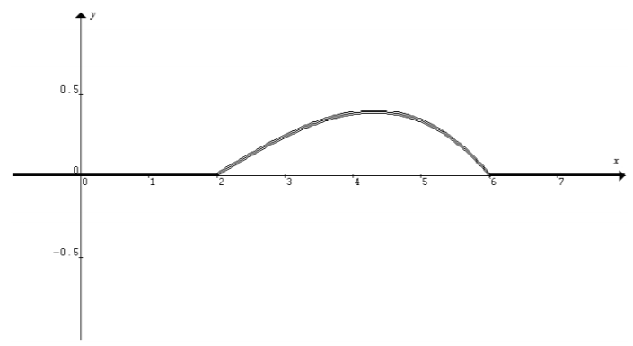
- $\int_{2}^{3}{\frac{1}{64}\left(6-x\right)\left(x-2\right)\left(x+2\right)dx=\frac{1}{64}\int_{2}^{3}{\left(6x^{2}-24-x^{3}+4x\right)dx}}$$$=\frac{1}{64}{\left[2x^{3}-24x-\frac{1}{4}x^{4}+2x^{2}\right]}_{2}^{3}$$$≈0.1211$ correct to 4 decimal places

- $\int_{2}^{6}{x f\left(x\right)dx=\frac{1}{64}\int_{2}^{6}{\left(6x^{3}-24x-x^{4}+4x^{2}\right)dx}}≈4.1333 hours$ correct to 4 decimal places

Source: © VCAA 2008 Mathematical Methods Assessment Report paper 2

Sample question 25
- $μ=67 mm, σ=1 mm$
$$z=\frac{68.5-67}{1}$$
$$z=1.5$$
$$P(X<68.5)≈0.9332$$

$$z_{1}=\frac{65.6-67}{1} \\ z_{1}=-1.4 \\ z_{2}=\frac{68.4-67}{1} \\ z_{2}=1.4$$
$$P\left(65.6<X<68.4\right)≈0.91924-0.080757 \\ ≈0.8385$$
Source: © VCAA 2009 Mathematical Methods Assessment Report paper 2

Sample question 26
- $80{\int_{2}^{5}{\frac{4}{625}\left(5x^{3}-x^{4}\right)dx=80×\frac{4}{625}\left[\frac{5}{4}x^{4}-\frac{1}{5}x^{5}\right]}}_{2}^{5} ≈73 butterflies$

- $P(X≥4\left|X≥2)=\frac{\int_{4}^{5}{\frac{4}{625}\left(5x^{3}-x^{4}\right)dx}}{\int_{2}^{5}{\frac{4}{625}}\left(5x^{3}-x^{4}\right)dx}\right.$ $$=\frac{{\left[\frac{5}{4}x^{4}-\frac{1}{5}x^{5}\right]}_{4}^{5}}{{\left[\frac{5}{4}x^{4}-\frac{1}{5}x^{5}\right]}_{2}^{5}} \\ ≈0.2878$$

- $μ=14.1 cm$ $σ=2.1 cm$
$$z_{1}=\frac{16-14.1}{2.1} \\ z_{1}≈0.90 \\ z_{2}=\frac{18-14.1}{2.1} \\ z_{2}≈1.86$$
$$P\left(16<X<18\right)≈0.96835-0.8172 \\ ≈0.1512$$

Source: © VCAA 2019 Mathematical Methods Assessment Report paper 2

Sample question 27

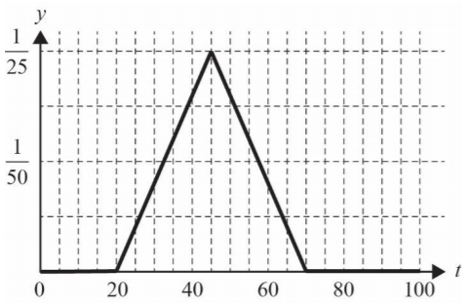
- $\int_{45}^{70}{\frac{1}{625}\left(70-t\right)dt+\int_{20}^{45}{\frac{1}{625}\left(t-20\right)dt=\frac{1}{2}×\left(75-20\right)×\frac{1}{25}}}$$$=1$$
Hence it is a continuous probability density function.
N/B The area was calculated using area of a triangle, not the definite integral.

- Again, using the area of a triangle to calculate the area under the probability density function between 60 and 30 minutes:
$$P\left(30≤T≤60\right)=1-2(\frac{1}{2}×10×\frac{10}{625}) \\ =1-0.16 \\ =0.84$$
Source: © VCAA 2017 Mathematical Methods Assessment Report paper 2

Sample question 28
$μ=90 min$ $σ=15 min$
$$z=\frac{120-90}{15} \\ z=2 \\ P\left(T>2\right)≈0.0228$$
Source: © WA SCSA 2017 Mathematics Methods Calculator-assumed marking key

Sample question 29
$$\int_{7}^{8}{\frac{3}{4}{\left(x-6\right)}^{2}}\left(8-x\right)dx=\frac{3}{4} \\ \int_{7}^{8}{\left(-x^{3}+20x^{2}-132x+288\right)dx}=\frac{3}{4}{\left[\frac{-x^{4}}{4}+\frac{20x^{3}}{3}-66x^{2}+288x\right]}_{7}^{8} \\ =\frac{11}{16} or 0.6875$$
Source: © VCAA 2015 Mathematical Methods Assessment Report paper 2

Sample question 30
- Let $\int_{0}^{8}{kt dt=1}$
$$k\int_{0}^{8}{t dt=1} \\ k{\left[\frac{t^{2}}{2}\right]}_{0}^{8}=1 \\ k\left[\left(32\right)-(0)\right]=1 \\ k=\frac{1}{32}$$

- ${\int_{0}^{5}{\frac{1}{32}t dt=\frac{1}{32}\left[\frac{t^{2}}{2}\right]}}_{0}^{5}$
$$=\frac{1}{32}\left[\left(\frac{25}{2}\right)-\left(0\right)\right] \\ =\frac{25}{64}$$

- Let $\int_{0}^{b}{\frac{1}{32}t dt=0.5}$
$$\frac{1}{32}{\left[\frac{t^{2}}{2}\right]}_{0}^{b}=0.5 \\ \frac{b^{2}}{64}=\frac{1}{2} \\ b^{2}=32 \\ b≈5\min{39 sec}$$

