Year 11 Mathematics Advanced
This document references the Mathematics Advanced Stage 6 Syllabus © NSW Education Standards Authority (NESA) for and on behalf of the Crown in right of the State of New South Wales, 2017.

Assessment: MA-S1 Probability and Discrete Probability Distributions

Driving question: Do casinos always win?

Outcomes
- MA11-7 uses concepts and techniques from probability to present and interpret data and solve problems in a variety of contexts, including the use of probability distributions
- MA11-8 uses appropriate technology to investigate, organise, model and interpret information in a range of contexts
- MA11-9 provides reasoning to support conclusions which are appropriate to the context

Learning across the curriculum
General capabilities
- Critical and creative thinking
- Ethical understanding
- Information and communication technology capability
- Literacy
- Numeracy
- Work and enterprise

Context
Students are to investigate discrete probability distributions and use them to design the rules for a dice simulation game. Students will need to generate a discrete probability distribution and use techniques to calculate expectation, to inform the rules and conditions of the game.
There are two key objectives for this task
- Students understand that the best estimate of what will happen in the future (probability) is given by analysing what has happened in the past (statistics)
- Students understand that more information (more trials) leads to a more accurate prediction (probability)

Background
During this task students will use the Microsoft Excel spreadsheet application, or Google Sheets, to simulate a rolling dice experiment. Students will need to use Excel functions and protocols to create and run the simulation.
Two functions that students need to be familiar with are
- RandBetween(a, b): RandBetween generates a random number between the parameters a and b. For example RandBetween(1, 6) will generate random numbers between 1 and 6, and will therefore simulate a regular 6-sided dice. Using this function multiple times within the same statement can simulate rolling multiple dice. For example RandBetween(1, 6) + RandBetween(1, 6) simulates the rolling of two dice with the sum of their results taken.
- Countif(range, value): Countif counts the frequency of a number, value, within a given range of numbers, range. If the given range, range, contains the list of values 1, 5, 3, 7, 2, 4, 6, 5 then the value of Countif(range, 5) would equal 2, as the number 5 appears twice in the range of values. The range, range, will take the form of addresses or references to cells in Excel ie) A1:A10 references cells A1 to A10.
Students will need to perform the simulation in three parts
- Develop/run the simulation
- Analyse the simulation
- Interpret the simulation

Develop/Run the Simulation
- Generate statements using the Randbetween function above to simulate a trial. In the example below, the statement simulates the sum of three regular dice ranging from 3 to 18.
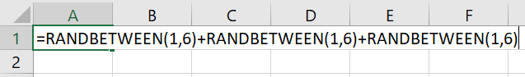
- Copying the statement over multiple cells will generate multiple trials. As you copy the statement, it will regenerate a new random number for each cell but it is not important for the purposes of this simulation.
Start by copying the statement across from cells A1 to J1.
- As the cells A1 to J1 are copied through more rows, the number of trials increases. Copy the cells A1 to J1 through to row 5000 to generate 50 000 trials.

Analysing the Simulation
- Create a new sheet and rename it Discrete Prob Distribution
- Create a table with row headers Sum X, P(X) and Frequency. List the possible sums from rolling the three dice across the Sum row, in this case 3 to 18.
- The CountIf function should be used to populate the frequency row by referencing the range of cells in the previous sheet. For example entering =CountIf(Sheet1!$A$1:$J$5000,B1) will count all the items in cells A1 to J5000 from Sheet1 which have a value equal to the value in the cell B1.
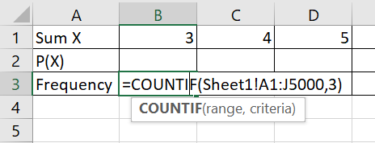
- Generate statements for each cell in the Frequency row. Note that the results from your spreadsheet will look similar but different to the ones shown below.
- Find the total frequency by adding =SUM(B3:Q3) into cell R3. This takes the sum of the values in the cells from B3 to Q3. Note, this value should be consistent with the 50 000 trials on the previous sheet. This will be used to calculate the estimates for the probabilities in the row above.
- Calculate the estimate for P(X=3) in cell B2 by entering =B3/$R$3, which divides the value in cell B3 (frequency) by the value in cell R3 (total frequency).
- Complete for each of the cells in the probability row.
- Add a row total for the probability row by adding =SUM(B2:Q2) to cell R2. Note, that this should equal 1.
- The top two rows of the table are the Discrete Probability Distribution for this experiment. Show the distribution by inserting a column graph into your spreadsheet.
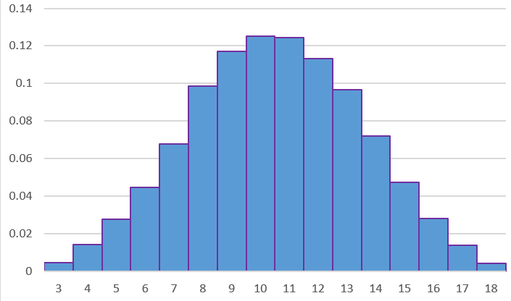
- With the Discrete Probability Distribution complete, the analysis of the financial expectation can start which will inform the decisions regarding the rules of the game.

Task

Part 1
Students need to analyse at least one chance-based game played at a casino. This will involve simulating the game using techniques outlined above, generating a Discrete Probability Distribution and using it to determine the financial expectation of the game. Students can reference any conclusions drawn at this stage when providing an argument to the driving question, “Do casinos always win?”

Part 2
Students are asked to design and create a dice simulation game. The outcomes of the game will depend on the total score of the dice rolled in each trial. Students can determine how many dice are used and how many faces are on each dice, ie) the dice do not have to be regular 6-sided dice and none of the dice needs to be the same as the others. The decisions students make regarding the dice will affect the Discrete Probability Distribution.
Using the method for calculating Financial Expectation, students need to determine rules for a game so that the Financial Expectation for the game is between -$0.05 and -$0.10.
Students will need to clearly determine the rules for:
- winning and how much is won
- losing and how much is lost
- replaying without winning or losing
Students will need to present clear and accurate mathematics to justify that their design satisfies the criteria.

Part 3
Students need to critically evaluate all aspects of chance-based casino games to determine an argument to the driving question, “Do casinos always win?”
Students need to structure a response that refers to the modelling and mathematical methods or concepts detailed in this assessment.
Their response should evaluate two components
- Randomness and the discrete probability distribution
- The financial expectation
As part of the evaluation, students should provide
- A description of each component: What it is? How is it calculated? Why is it important?
- A thorough list of pros versus cons for each component, with references made to examples in the assessment. Any limitations of the component should be listed here.
- A generalised statement that summarises the findings from the pros versus cons for the component.
- Suggestions for improvement, if they exist, justified by mathematics.
The final justification statement should answer the driving question by referencing the evaluation statements above.

What to submit
- Evidence of an authentic simulation. This may take the form of screenshots of the spreadsheet with annotations or the spreadsheet.
- All data generated and recorded from the simulation presented using appropriate tables and graphs.
- All formula, working and calculations required, either written by hand or typed. If screenshots have been provided, the formulas used need to be clearly annotated.
- All reasoning and justification, either written by hand or typed.

Success criteria
Fluency, understanding and communication | Problem solving, reasoning and justification

Criteria | Working towards developing | Developing | Developed | Well developed | Highly developed
Part 1: Develop the simulation  (MA11-7 MA11-8) | Students are able to reproduce ICT techniques to simulate some trials but cannot demonstrate an understanding of why they are doing it. | Students use ICT techniques to simulate the conditions of one casino game accurately for a large amount of trials, showing an understanding of the technique. | Students use ICT techniques to simulate the conditions of at least one casino game accurately for a large amount of trials, showing transferable understanding and modelling techniques. | Students add an annotation to their mathematics to explain their reasoning. Students explain, in their own words, the importance of a large number of trials and the connection between relative frequency and probability.
Part 1: Analysing the simulation  (MA11-7 MA11-8) | Students are able to demonstrate the some of the skills necessary to develop a discrete probability distribution table. | Students are able to develop a table for the discrete probability distribution from the outcomes of the trial, for one casino game. There is little to no evidence that understanding is transferable to more than one situation. | Students are able to develop a table for the discrete probability distribution from the outcomes of the trial, for at least one casino game.
Part 1: Interpreting the simulation  (MA11-7 MA11-8 MA11-9) | Students are able to show some skill when calculating an aspect of financial expectation, without any evidence of understanding. | Students are able to calculate the financial expectations for one casino game. There is little to no evidence that understanding is transferable to more than one situation. | Students are able to calculate the financial expectations for at least one casino game, showing transferable understanding and modelling techniques. | Students are able to interpret the financial expectation and represent it in their own words and in context.
Part 2: Design and develop the simulation  (MA11-7 MA11-8 MA11-9) | Students are able to demonstrate the skills necessary to develop the simulation. | Students have designed and developed a simulation with conceptual flaws. There are elements that have not been considered. | Students design and develop a simulation using a variety of conditions to produce a unique discrete probability distribution. | Students explain the choices and decisions made during the design. This may take the form of how many dice and the weighing of each dice.
Part 2: Analysing the simulation  (MA11-7 MA11-8 MA11-9) | Students are able to demonstrate the some of the skills necessary to develop a discrete probability distribution table. | Students are able to demonstrate the process of completing a table for the discrete probability distribution. | Students are able to develop a table for the discrete probability distribution from the outcomes of the trial, for at least one casino game. | Students add an annotation to explain their initial observations from the probability distribution table. This may take the form of commenting on the most and least likely outcomes and provide some insight into their initial thoughts for designing the rules.
Part 2: Determining the rules for the game  (MA11-7 MA11-8 MA11-9) | Student can only demonstrate the some skill of calculating financial expectation without linking it to the context of the question. | Students attempt to generate a set of rules and can calculate aspects of the financial expectation. Financial expectation is not negative.  Students are able to accurately describe and explain each component of the assessment task. | Students design a set of rules that satisfy the financial expectation conditions set. | Students justify, through mathematical evidence, that the financial expectation conditions are met.
Part 3: Evaluation  (MA11-7 MA11-8 MA11-9) |  | Students are able to accurately describe and explain each component of the assessment task. | Students are able to provide an exhaustive list of pros and cons for each component. | They are able to form generalised statements from the pros and cons and are able to make suggestions for improvements, if they exist. The improvements are supported by mathematics. | Students provide a convincing argument to support their opinion to the driving question.

Note – Any non-attempt in a section will be deemed zero. Marks can only be attributed to attempted responses.

Note to staff
This assessment task is intended to stimulate students’ critical and creative thinking and develop a stronger ethical understanding around the theme of the driving question, “Do casinos always win?” The assignment requires students to simulate and critically analyse chance-based casino games to develop an informed understanding of gambling. The intention of the task is consistent with the Life Ready course (formerly Crossroads), which is focused on encouraging students to think critically, solve problems and make informed decisions related to independence, health, safety and wellbeing. Support materials for this course may be accessed from the department website at https://education.nsw.gov.au/teaching-and-learning/curriculum/key-learning-areas/pdhpe/life-ready/support-materials.
The success criteria above has been designed for students and staff alike to use. Students should be presented the rubric as part of the assessment task package. Students and staff follow the process of the task downwards through the rubric and the depth of responses, for each element, across the rubric. Students should be encouraged to use the rubric to self-assess their progress as an assessment-as-learning strategy.
The aim of the assessment task is to develop students’ deep content knowledge. This is reflected in the descriptors, working towards developing through to highly developed. The level of skill and understanding required in each part of the task is different; some parts require highly developed or well-developed skills, other parts only capture a developing skill set.
None of the working mathematically elements are distinct and when demonstrating one element, you are invariably demonstrating another. As an example, communication runs concurrently through all the other working mathematically elements. Students cannot respond to this assessment without communicating in some form. However, it is envisaged that there is a general progression through the working mathematically elements, starting with fluency and leading to understanding, problem solving, reasoning and justification, with increasingly higher levels of communication accompanying each element. Careful consideration has been given to the position of the success criteria statements so they reflect the working mathematically elements demonstrated.
This assessment task has been designed to illuminate the style of questions and the types of responses needed to elicit deep content knowledge, however, staff are encouraged to use and adapt the assessment task and the success criteria to their school context. Staff may like to enhance or amend sections of the task. Staff may like to adapt the rubric to assign marks to the descriptors in order to differentiate between responses that address the same statement. All changes are the responsibility of the staff using the assessment.

