Interval notation matching task
- From the following table, each entry contains a representation of an interval. Match each of the interval notations with its equivalent representations.

Interval notation 1 | Interval notation 2 | Interval
$$[3, 5]$$ | $$-3<x<5$$ | 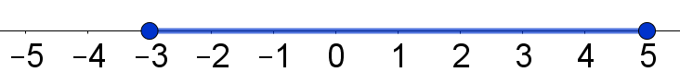
$$(3, 5)$$ | $$-5≤x<3$$ | 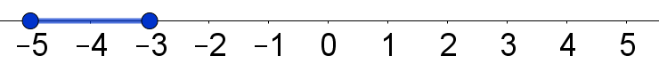
$$[3, 5)$$ | $$-5<x<3$$ | 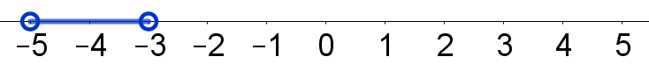
$$(3, 5]$$ | $$3≤x≤5$$
$$[-5,-3]$$ | $$-3≤x≤5$$ | 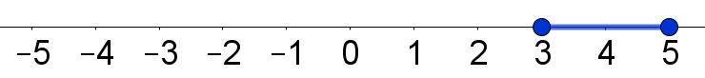
$$(-5,-3)$$ | $$-5≤x<-3$$ | 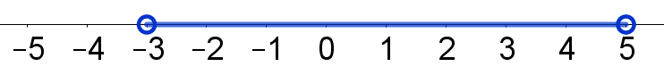
$$[-5,-3)$$ | $$-5≤x≤3$$ | 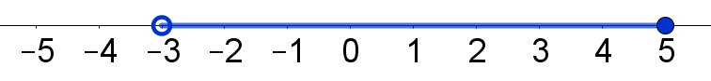
$$(-5,-3]$$ | $$-5≤x≤-3$$ | 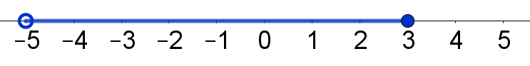
$$[-3, 5]$$ | $$-3≤x<5$$ | 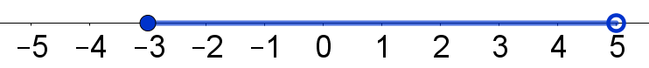
$$(-3, 5)$$ | $$3<x<5$$ | 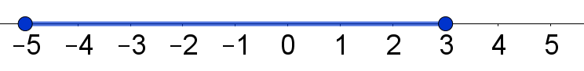
$$[-3, 5)$$ | $$3<x≤5$$
$$(-3, 5]$$ | $$-5<x≤3$$ | 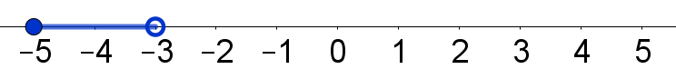
$$[-5, 3]$$ | $$-3<x≤5$$ | 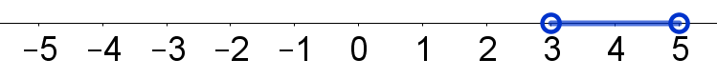
$$(-5, 3)$$ | $$-5<x<-3$$ | 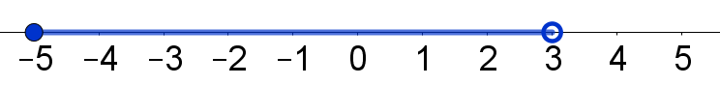
$$[-5, 3)$$ | $$3≤x<5$$ | 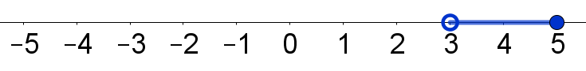
$$(-5, 3]$$ | $$-5<x≤-3$$ | 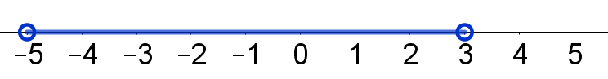

Solutions

Interval notation 1 | Interval notation 2 | Interval
$$[3, 5]$$ | $$3≤x≤5$$
$$(3, 5)$$ | $$3<x<5$$
$$[3, 5)$$ | $$3≤x<5$$
$$(3, 5]$$ | $$3<x≤5$$
$$[-5,-3]$$ | $$-5≤x≤-3$$
$$(-5,-3)$$ | $$-5<x<-3$$
$$[-5,-3)$$ | $$-5≤x<-3$$
$$(-5,-3]$$ | $$-5<x≤-3$$
$$[-3, 5]$$ | $$-3≤x≤5$$
$$(-3, 5)$$ | $$-3<x<5$$
$$[-3, 5)$$ | $$-3≤x<5$$
$$(-3, 5]$$ | $$-3<x≤5$$
$$[-5, 3]$$ | $$-5≤x≤3$$
$$(-5, 3)$$ | $$-5<x<3$$
$$[-5, 3)$$ | $$-5≤x<3$$
$$(-5, 3]$$ | $$-5<x≤3$$

