Investigating transformations

Investigating transformations of exponential and logarithmic functions

Instructions
Using DESMOS, you will investigate exponential and logarithmic graphs and their translations and dilations. You will also investigate how these variations impact on the domain and range of the graph.

Exponential functions
Enter the equation shown below into DESMOS. This will create a slider for a, b, c and k that you can adjust to see their effects on the graph. Follow the instructions below to complete the investigation.
$$y={ka}^{x+b}+c$$
- Adjust your sliders to sketch the graph of $y=2^{x}$ and fill-in the required details below.

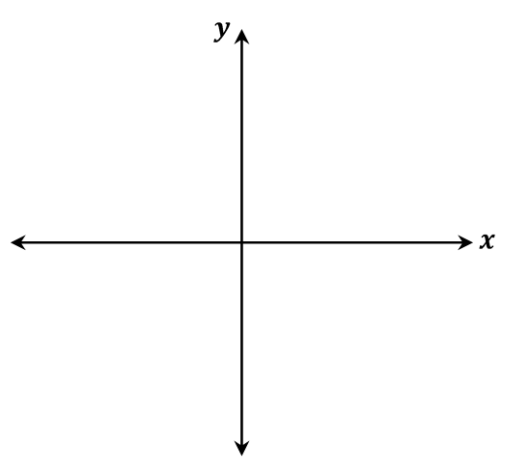
  - Equation: $y=2^{x}$
  - Domain:
  - Range:
  - x-intercept:
  - y-intercept:
  - Asymptote/s:
  - Odd/even/neither:

- Keeping $k=1, b=0$, and $c=0$, adjust you’re ‘$a$’ slider and observe its effect on the graph. You need only worry about values of $a>0$. What happens when $a>1$? What happens when $0<a<1$? Write a summary of your findings.
- Keeping $a=2$, $b=0$ and $c=0$, adjust your ‘$k$’ slider and observe its effect on the graph. What happens if k is negative? Write a summary of your findings.
- Returning to $k=1$, $b=0$, and keeping $a=2$, adjust your slider for ‘$c$’ and observe its effect on the graph. What happens if c is negative? Write a summary of your findings.
- Lastly, keeping $a=2$, $c=0$ and $k=1$adjust your slider for ‘$b$’ and observe its effect on the graph. What happens if $b$ is negative? Write a summary of your findings.

Logarithmic functions
Enter the equation shown below into DESMOS.
$$y=k\log_{a}{x}+c$$
- Adjust your sliders to sketch the graph of $y=\log_{10}x$ and fill-in the required details below.
  - Equation: $y=\log_{10}x$
  - Domain:
  - Range:
  - x-intercept:
  - y-intercept:
  - Asymptote/s:
  - Odd/even/neither:

- Keeping $a=10$, adjust your slider for ‘$k$’ to see its effect on the graph. What happens if $k$ is negative? Write a summary of your findings.
- Keeping $a=10$ and returning $k=1$, adjust your slider for ‘$c$’ to see its effect on the graph. What happens if $c$is negative? Write a summary of your findings.
- Keeping $k=1$ and $c=0$, adjust your slider for ‘$a$’ to see is effect on the graph. You only need to worry about values of $a>0$. What happens if $a>1$? What happens if $0<a<1$? Write a summary of your findings.

