Applications of periodic phenomena
The study of trigonometric functions is important in developing an understanding of periodic phenomena. Utilising the properties of periodic functions, mathematical models have been developed that describe the behaviour of many naturally occurring periodic phenomena, such as vibrations or waves, as well as oscillatory behaviour found in pendulums, electric currents and radio signals.

Activity 1 – electric currents
Most electricity in residences come in the form of an alternating current. The current completes a full forward and reverse cycle during a set period.
- In the United States of America, electricity is supplied at 120 volts with a frequency of 60Hz. This means the current completes a full cycle 60 times per second. A graph displays this below:
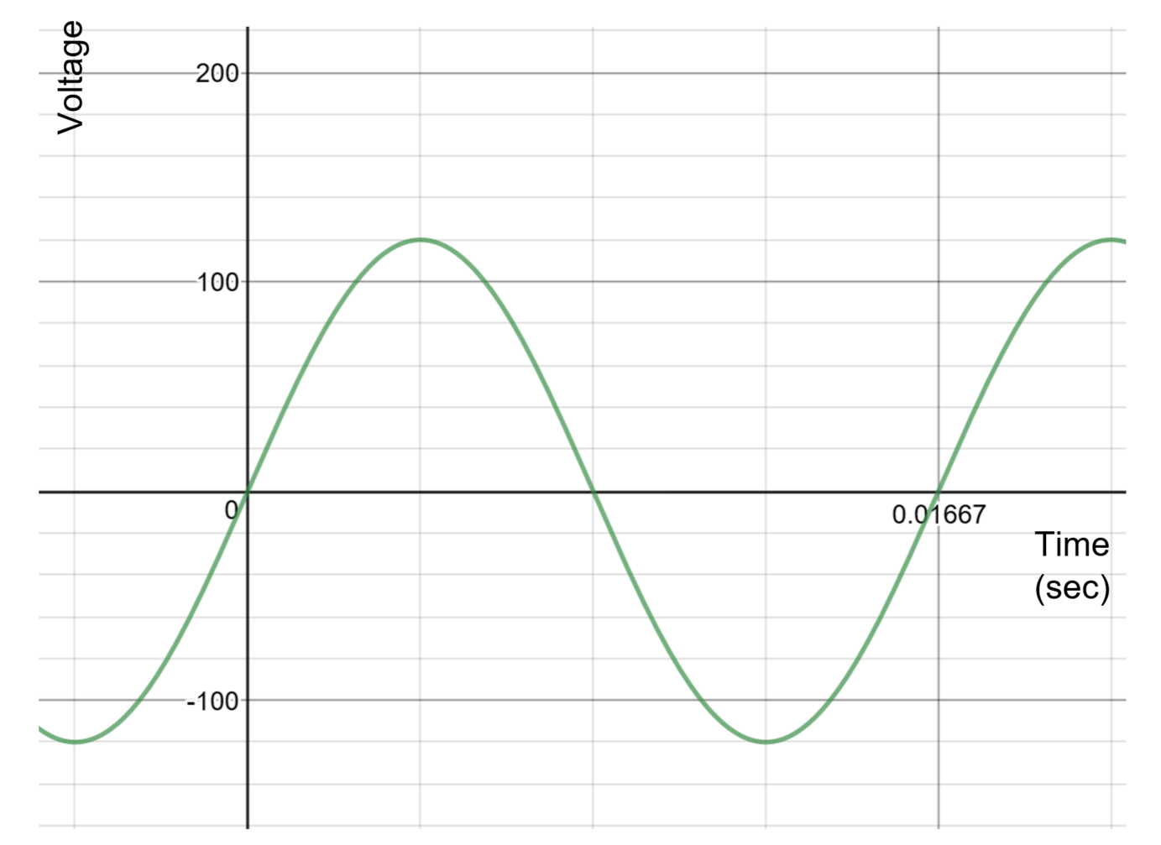
  - Find the equation of the relationship between voltage and time
  - Can you find another equation?

- In Australia, electricity is supplied at 230 volts with a frequency of 50Hz. This means that current completes a full cycle 50 times per second.
  - Sketch a graph of this relationship.
  - Find the equation of the relationship between voltage and time.
  - Can you find another equation?

- Choose another country. Find the voltage supplied and its frequency.

Country | Voltage (volts) | Frequency (Hz)
  - Sketch a graph of this relationship
  - Find the equation of the relationship between voltage and time.
  - Can you find another equation?

Activity 2 – radio waves
Commercial AM radio works using low or medium frequency radio waves. AM radio uses amplitude modulation. AM radio has a long range, but its sound quality is affected by interference.
Commercial FM radio works using, high, very high or ultra high frequency radio waves. FM radio uses frequency modulation.
Activity:
- Design a trigonometric function and graph that has a wavelength representative of AM or FM radio.
Refer to live sicence for appropriate wavelengths.
- Examine the graphs of amplitude modulation on PCMag. Select and graph a carrier wave, modulating wave and the modulated result where the frequency of the carrier wave is ten times the frequency of the modulating wave.
Example of amplitude modulation:
Carrier wave: $y = sin(20x)$
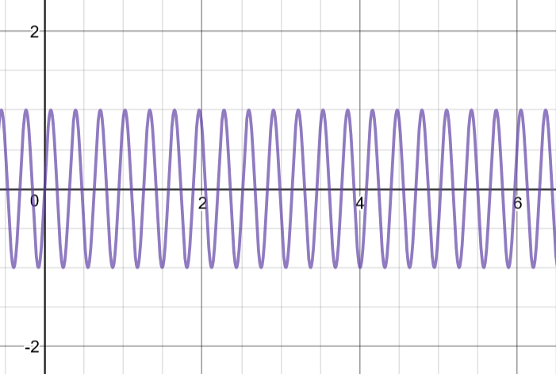
Modulating wave: $y = sin(x)$
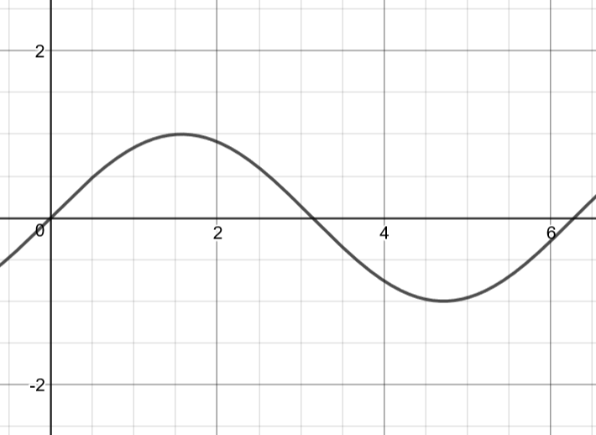

Modulated result: $y = sin(20x)×sin⁡(x)$
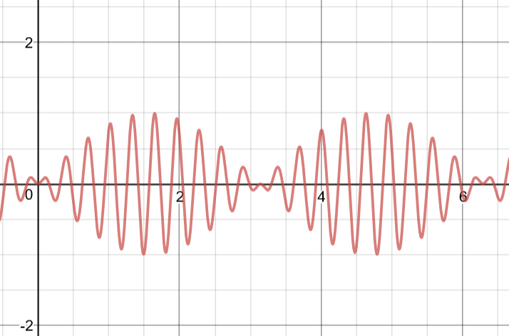
Note: Frequency modulation is more challenging to model. A basic example is $y=cos(2x+2sinx)$. For a general form, refer to information at Stanford University.

